UBND THÀNH PHỐ HỒ CHÍ MINH | CỘNG HÒA XÃ HỘI CHỦ NGHĨA VIỆT NAM
TRƯỜNG CAO ĐẲNG LÝ TỰ TRỌNG | Độc lập - Tự do - Hạnh phúc
THÀNH PHỐ HỒ CHÍ MINH
ĐỀ THI KẾT THÚC HỌC PHẦN LÝ THUYẾT
HỌC KỲ: I NĂM HỌC: 2020 – 2021
Bậc đào tạo: TRUNG CẤP ( 19T2 )
Học phần: Anh Văn 2
Lớp: 19T2 - Ngày thi: ____ / ____ / 2021
Thời gian thi: 60 phút (không kể thời gian phát đề)
Mã đề 001

Thí sinh không được sử dụng tài liệu, nộp lại đề sau khi thi
Bài thi này gồm 50 câu, mỗi câu 0.2 điểm.

1/ Which month has 30 days?
a March b January c April d February
2/ Trees change colors in the ____ .
a fall b autumn c summer d Both a&b are correct.
3/ She's going to send postcards ___ her family ___ Europe.
a to - at b to - from c from - from d to - to
4/ We're going ___ tomorrow morning.
a to sightseeing b to sightsee c sightseeing d Both b&c are correct.
5/ ___ you ___ to go home soon?
a Aren't - go b Aren't - going c Do - going d Are - go
6/ It's going to ___ about 2 hours to go home.
a buy b spend c lose d take
7/ I'm ____ any pictures.
a going to take b going to not take c not going to take d taking
8/ I'm going to ___ a lot of time to relax by the pool.
a make b be c have d visit
9/ ___ you want to see something beautiful, visit Kyoto.
a But b If c Although d All are correct
10/ Make sure you ___ hotel reservations early.
a take b visit c spend d make
11/ You can ___ the Golden Gate Bridge.
a hike to b bike c drive over d Both a&c are correct.
12/ The best time to go is during the dry season ___ the nights are cool and the days are dry.
a what b when c which d where
13/ It's a study abroad program so I'm going to stay at a ___.
a ruin b volunteer c dorm d season
14/ I'm going to get ___ early and run ___ the river path.
a up - along b on - up c on - in d along - up
15/ ___ the evening, I'm going to relax and watch a movie.
a To b On c At d In
16/ On Sunday, I plan to do a short run just to ___ loose.
a make b play c take d stay
17/ I ___ my friends every day.
a check b die c text d turn off
18/ She always ___ her phone before class.
a turn on b turns off c turn off d Both a&c are correct.
19/ I want to ___ my messages before the meeting.
a die b check c turn on d arrive
20/ She never ___ off her phone.
a turn b turns c turned d is turning
21/ ___ some coffee and join us in the meeting room.
a Wait b Grab c Arrive d Text
22/ Did you wait ___ Kevin?
a of b at c for d to
23/ Did Martin study ___ the test?
a at b for c of d to
24/ Did you and Tania watch the game ___ night?
a on b ago c last d in
25/ Did they ___ your house?
a stay at b stayed in c stays at d stayed at
26/ Susan ___ the pizza, but she didn't like it.
a stopped b tried c stayed d texted
27/ They ___ a party a month ago.
a planed b plannd c planned d plan
28/ ___ a lovely dog! It looks like a sheep.
a Why b What c How d What is
29/ Don't worry ___ it. Let me do that.
a about b on c to d at
30/ More people are getting hurt ___ walking and texting.
a what b in which c while d why
31/ Some cities are trying to ___laws but it's really difficult.
a arrive b pass c email d turn on
32/ They can make the cell phone screen ___, so you can see what is in front of you!
a patent b traffic c parent d transparent
33/ ___ you ever late for the meeting?
a Are b Have c Do d Did
34/ You should ___ in the mountains.
a go hiking b go shopping c play the piano d None is correct.
35/ Shaun likes ___ read books ___ the future.
a to - -- b to - about c -- - about d about - to
36/ We love to go shopping___ food ___ a family.
a to - for b for - as c for - in d Both a&b are correct.
37/ I don't like ___ soccer. I prefer ___ the guitar.
a to play/ playing b playing/ plays c to play/ to playing d Both a&c are correct.
38/ We like to go shopping ___.
a together b each other c to get there d another
39/ I like going to museums, ____ I'm with you.
a through b as far as c in spite of d as long as
40/ - You have a nice camera! - Thanks. I like to take ___.
a pictures b concerts c photos d Both a&c are correct.
41/ - Do you exercise? - _____.
a Yes. I enjoy working out at the gym. b Really? Do you like going to museums?
c Me too. I love to play classical music. d Really? I enjoy reading non-fiction.
42/ In origami, you mostly need ___ papers.
a square b triangle c round d circle
43/ In origami, you can make lots of different ___.
a shapes b animals c kits d Both a&b are correct.

Questions 44 through 46 refer to the following advertisement
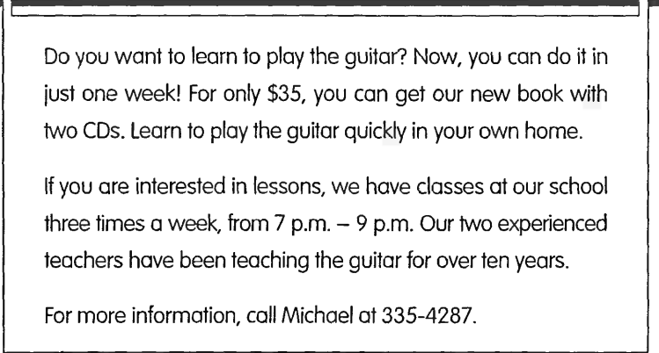

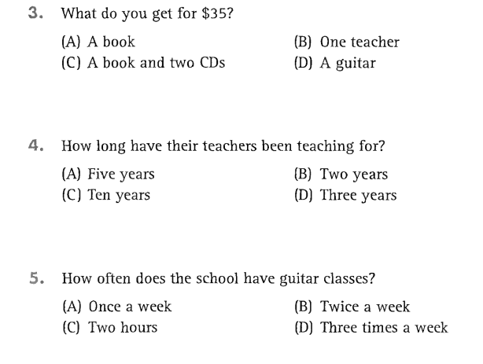
46
45
44
Questions 47 through 50 refer to the following letters
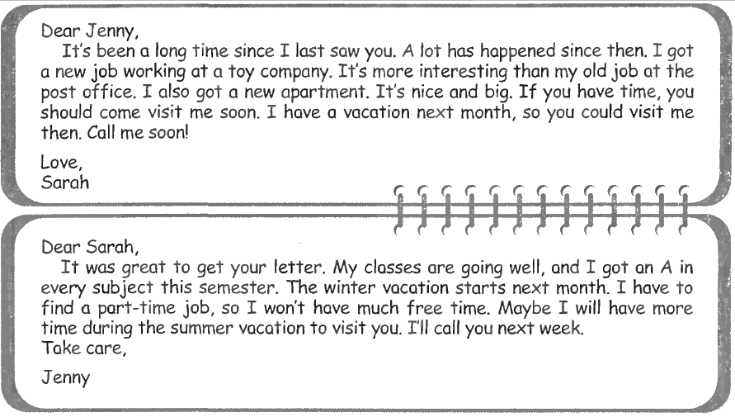
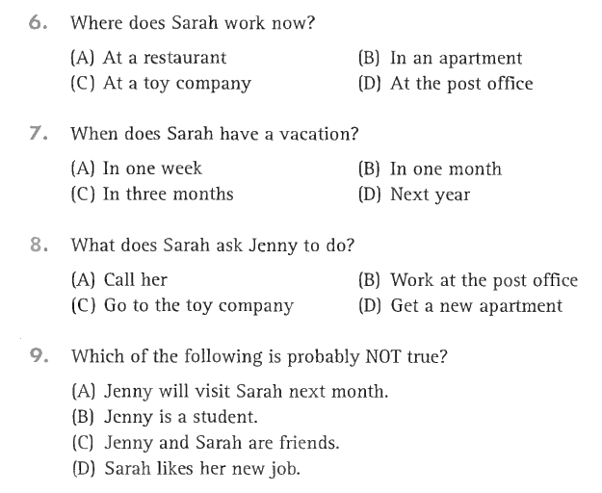
50
49
48
47
_______Hết_______
GHI CHÚ: CÁN BỘ COI THI KHÔNG ĐƯỢC GIẢI THÍCH GÌ THÊM.
TRƯỞNG KHOA TRƯỞNG BỘ MÔN GIẢNG VIÊN RA ĐỀ
(Ký tên và ghi rõ họ tên) (Ký tên và ghi rõ họ tên) (Ký tên và ghi rõ họ tên)

