UBND THÀNH PHỐ HỒ CHÍ MINH | CỘNG HÒA XÃ HỘI CHỦ NGHĨA VIỆT NAM
TRƯỜNG CAO ĐẲNG LÝ TỰ TRỌNG | Độc lập - Tự do - Hạnh phúc
THÀNH PHỐ HỒ CHÍ MINH
ĐỀ THI KẾT THÚC HỌC PHẦN LÝ THUYẾT
HỌC KỲ: I NĂM HỌC: 2020 – 2021
Bậc đào tạo: TRUNG CẤP ( 19T2 )
Học phần: Anh Văn 2
Lớp: 19T2 - Ngày thi: ____ / ____ / 2021
Thời gian thi: 60 phút (không kể thời gian phát đề)
Mã đề 002

Thí sinh không được sử dụng tài liệu, nộp lại đề sau khi thi
Bài thi này gồm 50 câu, mỗi câu 0.2 điểm.
1/ I ___ my friends every day.
a die b check c text d turn off
2/ I ___ my phone in the mornings.
a text b die c turn on d arrive
3/ Can you please ___ the phone? I'm busy.
a answer b text c die d arrive
4/ In my job, I ___ people around the world.
a email b turn on c finish d Both a&c are correct.
5/ Where's Diana? The meeting ___ five minutes ago.
a tested b started c emailed d arrived
6/ She never ___ off her phone.
a turns b is turning c turn d turned
7/ My car didn't start this morning ___ I waited for the bus.
a so b but c because d although
8/ OK. See you ___ five minutes.
a in b between c on d at
9/ Did they ___ your house?
a stayed at b stay at c stays at d stayed in
10/ Susan ___ the pizza, but she didn't like it.
a texted b tried c stayed d stopped
11/ They didn't ask us ___ the meeting.
a with b of c on d about
12/ They ___ a party a month ago.
a plan b planed c plannd d planned
13/ Our car___ last night. We couldn't go home on time.
a didn't start b didn't started c didn't turn d didn't text
14/ Some cities are trying to ___laws but it's really difficult.
a email b arrive c turn on d pass
15/ Who ___ you yesterday?
a emailed b email did c email d did emailed
16/ I'm sorry I ___ the meeting this morning.
a stoped b missed c text d planed
17/ His birthday is in September. His wife's birthday is in the ___ month, October.
a next b later c last d before
18/ Which month has 30 days?
a February b April c March d January
19/ We're going to the ___ this summer.
a spring b beach c postcard d ski
20/ Flowers begin to bloom in the ___.
a winter b autumn c summer d spring
21/ She's going to send postcards ___ her family ___ Europe.
a to - from b to - at c from - from d to - to
22/ She's going to send ___ her family postcards ___ Europe.
a to - from b -- - from c -- - to d -- - at
23/ My boss is going to ___ by the pool this afternoon.
a take b buy c got d relax
24/ We're going ___ tomorrow morning.
a to sightseeing b to sightsee c sightseeing d Both b&c are correct.
25/ ___ you ___ to go home soon?
a Aren't - going b Do - going c Are - go d Aren't - go
26/ - ___ are you going to be there? - A week.
a When b How often c Where d How long
27/ - What are you going to ___ then? - I'm going to ___ surfing.
a make - take b do - go c make - go d go - take
28/ It's really difficult to go snow skiing in the middle of ___ .
a summer b winter c wintertime d All are correct.
29/ In March, that's the cherry ___ season.
a reservation b skiing c blossom d vacation
30/ Make sure you ___ hotel reservations early.
a spend b make c take d visit
31/ Summer is the ___ crowded time to visit.
a best b better c most d much more
32/ There is also The Presidio and Muir ___ in San Francisco.
a Forests b Jungles c Woods d All are correct.
33/ I'm going to buy groceries that will help me ___ up energy and not be hungry.
a get b take c learn d keep
34/ My sister likes ___ ___ every morning.
a to go - running b to go - to run c going - running d Both a&c are correct.
35/ Maura likes to play the guitar ___ night ___ work.
a on/ on b at/ on c at/ after d Both a&b are correct.
36/ He loves ____ out at a gym.
a working b getting c playing d Both a&b are correct.
37/ I would rather ___ the guitar!
a to play b play c playing d to playing
38/ I don't like ___ soccer. I prefer ___ the guitar.
a to play/ to playing b to play/ playing c playing/ plays d Both a&c are correct.
39/ I like going to museums, ____ I'm with you.
a as far as b in spite of c through d as long as
40/ He ___ to go to museums. He doesn't ___ to go to the concerts.
a love/ love b loves/ love c loves/ loves d love/ loves
41/ - Do you exercise? - _____.
a Really? Do you like going to museums? b Me too. I love to play classical music.
c Really? I enjoy reading non-fiction. d Yes. I enjoy working out at the gym.
42/ Did you know that you can ___ remote control cars?
a drive b build c ride d Both a&b are correct.
43/ Origami is the Japanese art of ___ paper into shapes.
a doing b sharing c taking d folding
Questions 44 through 47 refer to the following letters

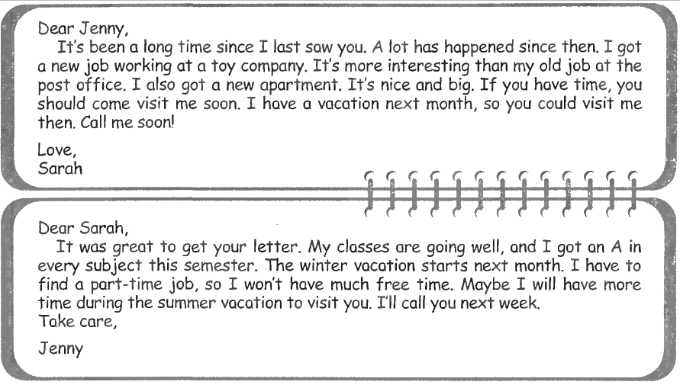

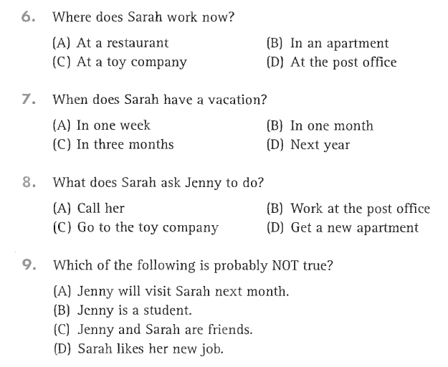
47
46
45
44

Questions 48 through 50 refer to the following advertisement
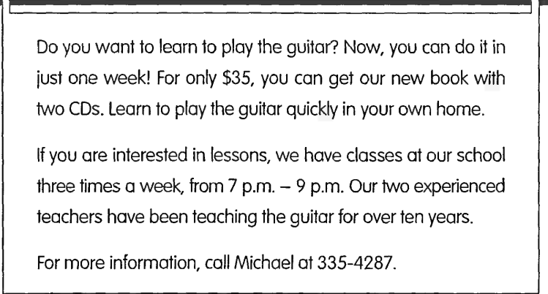

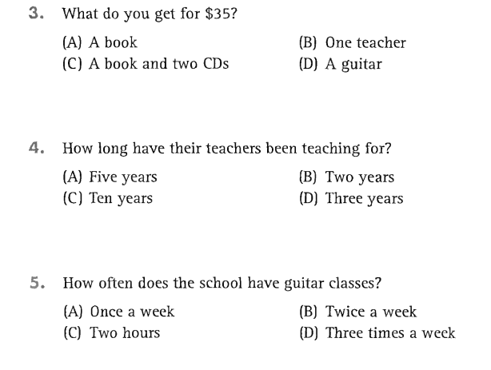
49
50
48
_______Hết_______
GHI CHÚ: CÁN BỘ COI THI KHÔNG ĐƯỢC GIẢI THÍCH GÌ THÊM.
TRƯỞNG KHOA TRƯỞNG BỘ MÔN GIẢNG VIÊN RA ĐỀ
(Ký tên và ghi rõ họ tên) (Ký tên và ghi rõ họ tên) (Ký tên và ghi rõ họ tên)

