UBND THÀNH PHỐ HỒ CHÍ MINH | CỘNG HÒA XÃ HỘI CHỦ NGHĨA VIỆT NAM
TRƯỜNG CAO ĐẲNG LÝ TỰ TRỌNG | Độc lập - Tự do - Hạnh phúc
THÀNH PHỐ HỒ CHÍ MINH
ĐỀ THI KẾT THÚC HỌC PHẦN LÝ THUYẾT
HỌC KỲ: I NĂM HỌC: 2020 – 2021
Bậc đào tạo: TRUNG CẤP ( 19T2 )
Học phần: Anh Văn 2
Lớp: 19T2 - Ngày thi: ____ / ____ / 2021
Thời gian thi: 60 phút (không kể thời gian phát đề)
Mã đề 003

Thí sinh không được sử dụng tài liệu, nộp lại đề sau khi thi
Bài thi này gồm 50 câu, mỗi câu 0.2 điểm.
1/ I like ___ to museums with my daughters.
a to go b going c to do d Both a&b are correct.
2/ ___ my neighborhood, we play soccer every Saturday.
a For b Onto c In d To
3/ My sister likes ___ ___ every morning.
a going - running b to go - to run c to go - running d Both a&c are correct.
4/ He loves ____ out at a gym.
a playing b working c getting d Both a&b are correct.
5/ I ___ reading books.
a like b am liking c do like d Both a&c are correct.
6/ We like to go shopping ___.
a to get there b each other c together d another
7/ - You have a nice camera! - Thanks. I like to take ___.
a photos b concerts c pictures d Both a&c are correct.
8/ - I play the piano. - ____.
a Really? I enjoy reading non-fiction. b Me too. I love to play classical music.
c Yes. I enjoy working out at the gym. d Really? Do you like going to museums?
9/ Have you ever thought ___ starting a new hobby?
a for b about c to d into
10/ There are kits to get you ___.
a to start b started c starting d start
11/ Origami is the Japanese art of ___ paper into shapes.
a doing b sharing c folding d taking
12/ You can do rock climbing ___ a gym.
a outside b inside c in front d Both a&b are correct.
13/ My roommates get tired ___ listening ___ me.
a of - of b of - to c to - to d to - of
14/ I think sports are boring ___ to my playing guitar!
a compared b compares c compare d Both a&c are correct.
15/ I practice karate every weekend, and now I have a yellow ___.
a camp b age c belt d climb
16/ I work in an office where everyone ___ basketball.
a comics b organize c follows d patents
17/ I ___ my friends every day.
a text b check c turn off d die
18/ I ___ my phone in the mornings.
a text b die c arrive d turn on
19/ I want to ___ my messages before the meeting.
a turn on b check c die d arrive
20/ Our guests are going to ____ our house tomorrow afternoon.
a start b arrive c text d Both a&c are correct.
21/ I called her phone ___ she didn't answer.
a therefore b when c so d but
22/ OK. See you ___ five minutes.
a on b in c at d between
23/ Did you wait ___ Kevin?
a of b for c to d at
24/ The train ___ at the station.
a stoped b stop c stopped d Both a&c are correct.
25/ They didn't ask us ___ the meeting.
a with b on c about d of
26/ They ___ a party a month ago.
a planed b plannd c plan d planned
27/ ___ a lovely dog! It looks like a sheep.
a What is b What c Why d How
28/ Did you send ___ text messages today?
a much b some c any d Both a&c are correct.
29/ ___ most people, the answer to that question is 'yes'.
a At b On c About d For
30/ Studies around the world show that people send ___ of text messages every day.
a dozens b much c hundreds d Both a or c are correct.
31/ Some companies are now making ___ especially for texting while walking.
a dozens b passes c apps d grabs
32/ They can make the cell phone screen ___, so you can see what is in front of you!
a transparent b traffic c patent d parent
33/ Wayne arrived ___ the morning train.
a at b on c for d in
34/ His birthday is in September. His wife's birthday is in the ___ month, October.
a next b later c last d before
35/ We're going to travel 2 weeks, from ___ 27 to April 10.
a February b May c March d Both a&b are correct.
36/ Our trip is going to take 2 months. We'll begin in August and end in ___.
a September b November c October d Both a&c are correct.
37/ We're going ___rent this house ___ six months.
a to - to b to - for c for - to d for - for
38/ Which month has 30 days?
a February b January c March d April
39/ Remember to buy ___ in Mexico.
a souvenirs b photographers c picnic d sightseeing
40/ ___ you ___ to go home soon?
a Aren't - go b Aren't - going c Do - going d Are - go
41/ It's going to ___ about 2 hours to go home.
a buy b take c lose d spend
42/ I'm not going to ___ pictures.
a take b take some c take any d make
43/ I'm going to ___ in a nice hotel for 3 days.
a take b spend c visit d stay

Questions 44 through 46 refer to the following letter

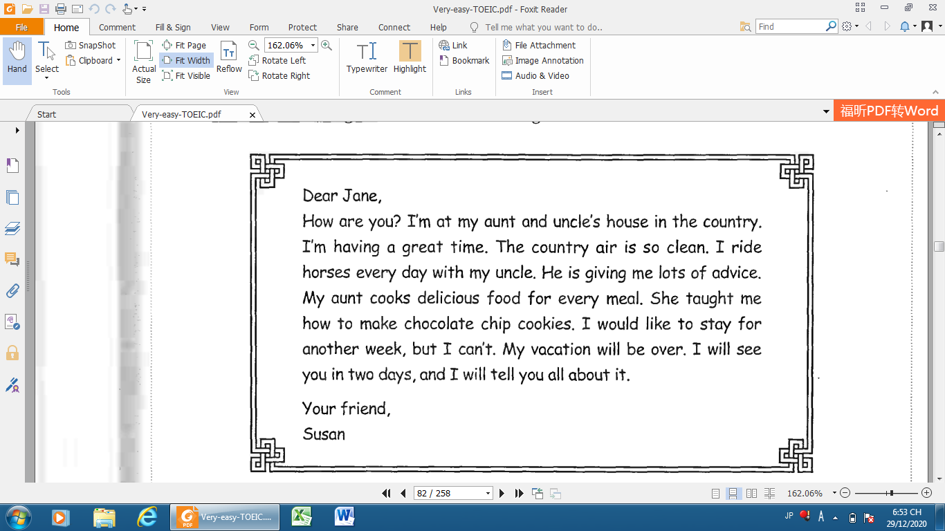

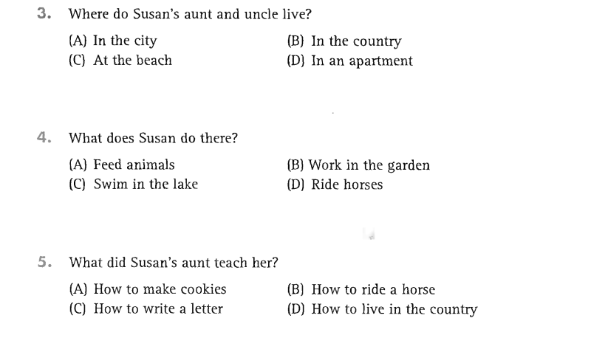
44
46
45
44

Questions 47 through 50 refer to the following table and email

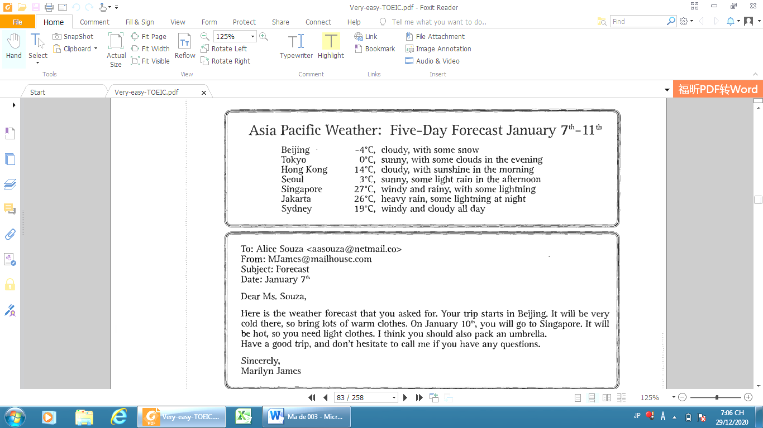

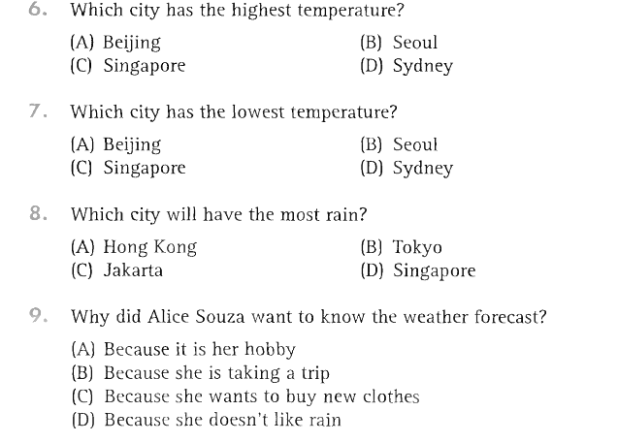
50
49
48
47

_______Hết_______
GHI CHÚ: CÁN BỘ COI THI KHÔNG ĐƯỢC GIẢI THÍCH GÌ THÊM.
TRƯỞNG KHOA TRƯỞNG BỘ MÔN GIẢNG VIÊN RA ĐỀ
(Ký tên và ghi rõ họ tên) (Ký tên và ghi rõ họ tên) (Ký tên và ghi rõ họ tên)

