UBND THÀNH PHỐ HỒ CHÍ MINH | CỘNG HÒA XÃ HỘI CHỦ NGHĨA VIỆT NAM
TRƯỜNG CAO ĐẲNG LÝ TỰ TRỌNG | Độc lập - Tự do - Hạnh phúc
THÀNH PHỐ HỒ CHÍ MINH
ĐỀ THI KẾT THÚC HỌC PHẦN LÝ THUYẾT
HỌC KỲ: I NĂM HỌC: 2020 – 2021
Bậc đào tạo: TRUNG CẤP ( 19T2 )
Học phần: Anh Văn 2
Lớp: 19T2 - Ngày thi: ____ / ____ / 2021
Thời gian thi: 60 phút (không kể thời gian phát đề)
Mã đề 004

Thí sinh không được sử dụng tài liệu, nộp lại đề sau khi thi
Bài thi này gồm 50 câu, mỗi câu 0.2 điểm.
1/ Our trip is going to take 2 months. We'll begin in August and end in ___.
a December b November c January d September
2/ We're going to the ___ this summer .
a spring b ski c beach d postcard
3/ She's going to send postcards ___ her family ___ Europe.
a to - at b to - from c to - to d from - from
4/ It's going to ___ about 2 hours to go home.
a buy b spend c lose d take
5/ That's great! Is it going to ___ a long flight?
a stay b spend c buy d be
6/ I'm not going to ___ pictures.
a take some b take any c take d make
7/ Are you going to ___ San Jose?
a be b take c visit d stay
8/ It's really difficult to go snow skiing in the middle of ___ .
a winter b summer c wintertime d All are correct.
9/ ___ you want to see something beautiful, visit Kyoto.
a But b If c Although d All are correct
10/ Make sure you ___ hotel reservations early.
a make b visit c spend d take
11/ In April, you will enjoy the most ____ temperatures.
a crowded b blossom c moderate d reservation
12/ ___ my next vacation, I'm going to do something different.
a At b In c For d Both b&c are correct.
13/ I'm going to do some ___ work with a group of friends.
a volunteer b dorm c ruin d seasons
14/ Speaking Vietnamese isn't ___ so I have to speak English all the time.
a speaking b allowed c allowing d spoke
15/ ___ the evening, I'm going to relax and watch a movie.
a At b In c On d To
16/ On Sunday, I plan to do a short run just to ___ loose.
a take b stay c make d play
17/ I like ___ to museums with my daughters.
a to go b going c to do d Both a&b are correct.
18/ My grandmother loves to sew ___ she wants to relax.
a in which b which c when d why
19/ They like to sing ___ home.
a at b on c in d to
20/ He tries to ___ yoga twice a week to relax.
a practice b do c play d Both a&b are correct.
21/ He tries to play the guitar ___ least twice a week ___ relax.
a to - to b at - to c at - at d to - at
22/ We love to go shopping___ food ___ a family.
a for - as b for - in c to - for d Both a&b are correct.
23/ I ___ reading books.
a do like b am liking c like d Both a&c are correct.
24/ We don't have anything ___ common!
a in b to c at d on
25/ I like going to museums ____ I'm with you.
a as long as b through c in spite of d as far as
26/ - I read a lot of books. - _____.
a Me too. I love to play classical music. b Good. I enjoy making food.
c Really? Do you like going to museums? d Really? I enjoy reading non-fiction.
27/ - Do you exercise? - _____.
a Really? I enjoy reading non-fiction. b Me too. I love to play classical music.
c Yes. I enjoy working out at the gym. d Really? Do you like going to museums?
28/ - I study art in college. - _____.
a Good. I enjoy making food. b Really? Do you like going to museums?
c Really? I enjoy reading non-fiction. d I enjoy going to the gym.
29/ In origami, you can make lots of different ___.
a animals b shapes c kits d Both a&b are correct.
30/ Rock climbing is fun and good ___ you.
a of b for c on d at
31/ I would rather be ___ karate with my teacher and friends.
a to b on c at d in
32/ It's what Americans call ___ but everybody else calls it football.
a taekwondo b soccer c polo d karate
33/ We can ___ friendly games in the park on the weekends.
a soccer b comic c organize d karate
34/ I ___ my friends every day.
a text b check c turn off d die
35/ Can you please ___ the phone? I'm busy.
a die b text c answer d arrive
36/ In my job, I ___ people around the world.
a finish b turn on c email d Both a&c are correct.
37/ I called her phone ___ she didn't answer.
a but b therefore c so d when
38/ I texted her ___ I emailed her, too.
a because b though c but d and
39/ She never ___ off her phone.
a turned b is turning c turns d turn
40/ My car didn't start this morning ___ I waited for the bus.
a but b although c so d because
41/ OK. See you ___ five minutes.
a at b in c on d between
42/ Did you wait ___ Kevin?
a at b for c to d of
43/ Did they ___ your house?
a stayed at b stayed in c stays at d stay at

Questions 44 through 47 refer to the following table and email

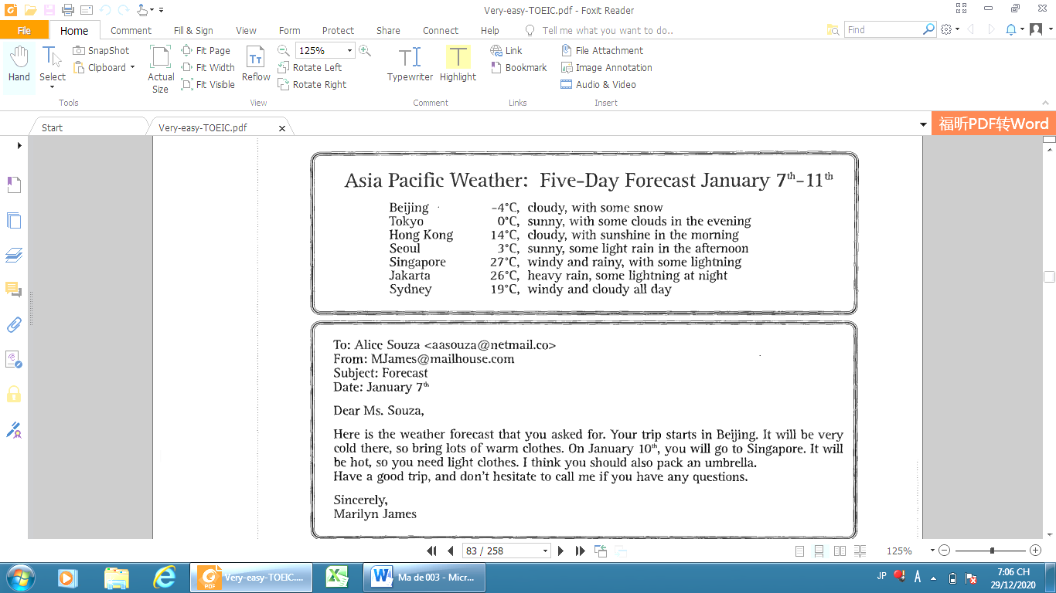
44
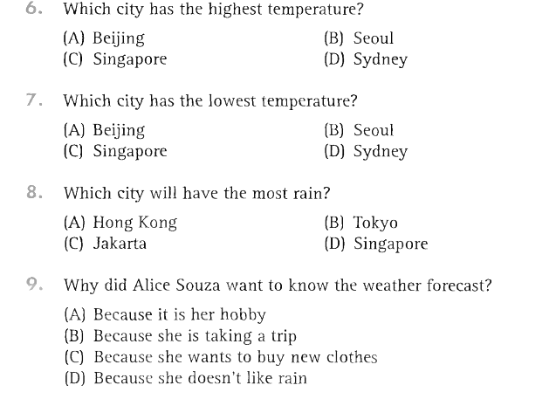
45
46
47

Questions 48 through 50 refer to the following letter

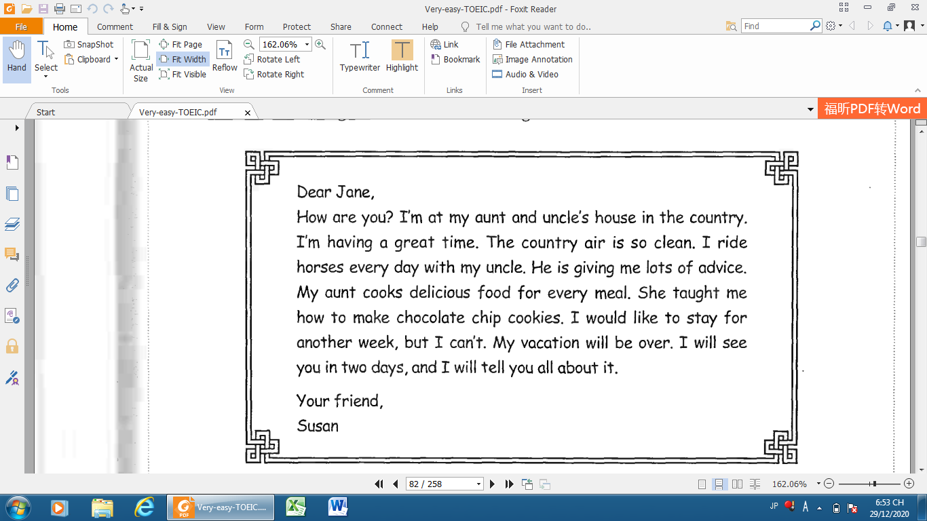

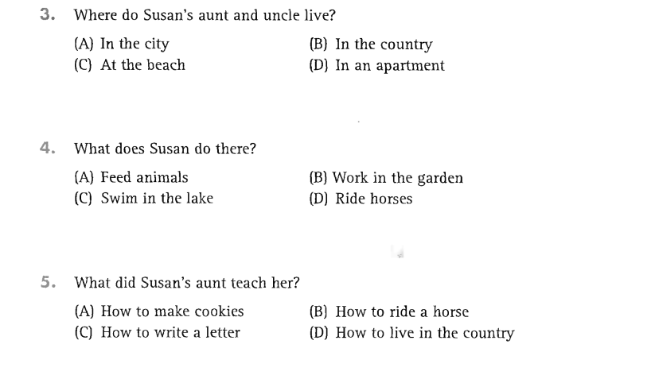
48
49
50
_______Hết_______
GHI CHÚ: CÁN BỘ COI THI KHÔNG ĐƯỢC GIẢI THÍCH GÌ THÊM.
TRƯỞNG KHOA TRƯỞNG BỘ MÔN GIẢNG VIÊN RA ĐỀ
(Ký tên và ghi rõ họ tên) (Ký tên và ghi rõ họ tên) (Ký tên và ghi rõ họ tên)

