UBND THÀNH PHỐ HỒ CHÍ MINH | CỘNG HÒA XÃ HỘI CHỦ NGHĨA VIỆT NAM
TRƯỜNG CAO ĐẲNG | Độc lập - Tự do - Hạnh phúc
LÝ TỰ TRỌNG TP. HỒ CHÍ MINH

ĐỀ THI KẾT THÚC HỌC PHẦN LÝ THUYẾT
HỌC KỲ: II NĂM HỌC: 2019 – 2020

Bậc đào tạo: CAO ĐẲNG (19C1)
Học phần: Tiếng Anh Kinh doanh
Lớp: 19C1-NNA1 Ngày thi: ____ / ____ / 2019
Thời gian thi: 60 phút (không kể thời gian phát đề)
Mã đề
193

-Thí sinh không được sử dụng tài liệu, nộp lại đề sau khi thi
-Bài thi này gồm 40 câu, mỗi câu 0.25 điểm.

I. Choose the correct word or phrase that would best complete the sentence.
1. In American, men tend to avoid ………… and even women do not hug and kiss as much as Europeans.
A. shaking hands B. hugging C. worrying D. drinking
2. One of the important sales techniques is …………
A. selling to people who buy B. quality C. interest D. advertisement
3. ………… describes the strategy of being global and being responsive to local conditions at the same time.
A. McDonald's B. Yahoo C. Glocalization D. Coca-cola
4. This graph shows that …………
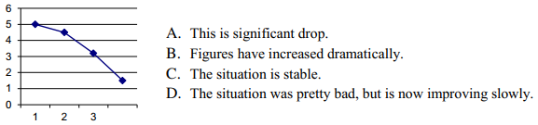
5. Which department deals with billing, salaries, taxes, investment and budgets.
A. Production C. IT
B. Sales and Marketing D. Finance
6. ………… is the buying and selling of products and services on the internet instead of using shops, phones, faxes and letters.
A. E-commerce B. Market C. Supermaket D. Mall
7. In Germany, you must use titles in business, you must not use ………… .
A. eye contact B. first names C. sure names D. host
8. Choose the correct answer which means:part of a company's capital owned by an investor.
A. profit B. award C. share D. punctual
9. ………… is one of Europe's leading electronic commerce businesses.
A. WHO B. QXL C. Amazon D. eBay
10. The government has changed its policy and had a complete change of ………… .
A. view B. opinion C. mind D. heart
11. Event organization and ticket sales create significant ………… , from local football matches to events like the Olympics.
A. business B. skills C. industry D. loan
12. She is very happy because she starts her new ………… today .
A. job B. work C. labour D. post
13. Which department organizes the maintenance of the buildings, including office space.
A. Human resources C. Facilities
B. Production D. Sales and Marketing.
14. The earnings per share last year was $19,980 and this year is $20,070. Which sentence can be used to compare and describe the figures?
A. It's worse than last year C. It's gone down
B. It's virtually the same D. It's slightly more than last year.
15. One day I hope I shall ………… the lottery.
A. gain B. collect C. reach D. win
16. The project will start …………January the first 2020.
A. at B. on C. in D. about
17. Which is NOT a very usual way to say $7.90?
A. seven ninety C. seven dollars ninety
B. seven dollars ninety cents D. seven point ninety dollars.
18. ………… are an effective way for businesses to make face-to-face contacts with potential suppliers and customers.
A. E-commerce B. Trade fairs C. Social network D. Sponsorship
19. This graph shows that
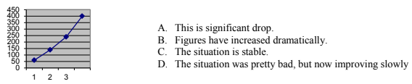
20. It was a big ………… for her to give up her acting career to look after her family.
A. trial B. sacrifice C. endeavour D. test
21. We've decided to …………money in the new business. Hope it's successful!.
A. export B. import C. advertise D. invest
22. This is the time to spend at work after your normal working hours.
A. overtime B. working hours C. retirement D. flexible hours.
23. A person, company, or organization that pays someone to work for them as a member of their staff is a(n) …………
A. employer B. employee C. trainer D. trainee
24. I would be very interested in ………… for that job.
A. entering B. working C. applying D. writing
25. Your business will make …………if your revenue for a year is less than your costs.
A. profit B. loss C. interest D. loan
26. Amazon.com is a (an) …………where people can buy a wide range of goods online.
A. website B. e-mail address C. social network D. market
27. The money you receive from selling a product or service is …………
A. interest B. capital C. profit D. revenue
28. Which department deals with staff and is responsible for recruiting and training?
A. IT C. Human Resources
B. Production D. Finance
II. Reading
A. Read the article and choose the correct answer
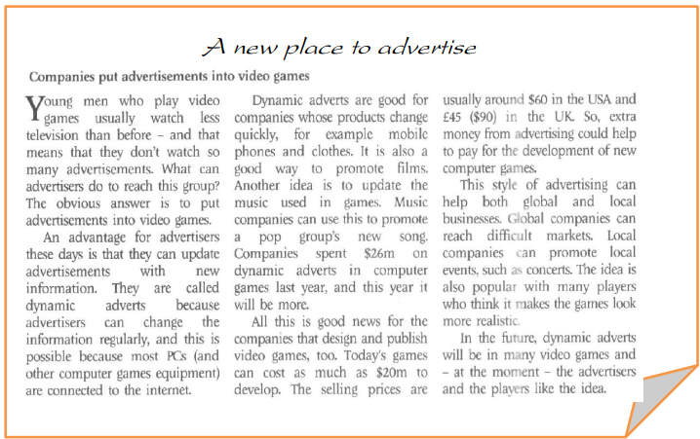
29. Which of these sentences summarizes the article best?
A. Young men will watch more TV in the future.
B. Advertisers use new technology to promote goods.
C. Computer games companies pay for advertisements.
D. All are correct.
30. At the moment, young men who play computer games…………
A. watch too much TV C. don't see the same number of advertisements in the past.
B. don't understand advertisements D. watch TV in the evening.
31. It is possible to change the advertisements in computer games using …………
A. a new machine C. the Internet
B. equipment for adverts D. magazines.
32. Dynamic adverts are useful for ………..
A. products that are expensive C. business services.
B. products that stay the same D. fashionable goods that change design.
33. Computer games companies will probably use the money from advertising to…………
A. develop new companies C. lower the price of computer games.
B. design new games D. public books.
34. Dynamic advertising is ………….
A. unpopular with players.
B. only good for big companies.
C. good for people who speak more than one language.
D. useful for international companies and companies in the home countries.

B. Choose the correct word A-D below to complete the text
How should a company (35.) …………its products or services? Most big companies have an (36.) ………… budget. They advertise their brand on TV, radio, the internet or in (37.) ………… and magazines. Sales (38.) ………… such as free gifts or half price offers are often popular with customers. At conferences and exhibitions some companies put their (39.) ………… on merchandise such as T-shirts and key rings to advertise their (40.) ………… .
35. A. find B. market C. see D. explain
36. A. advertising B. creating C. idea D. publicise
37. A. telephones B. furniture C. newspapers D. colour
38. A. promotions B. meeting C. invoices D. presentation
39. A. drawing B. pens C. business D. logo
40. A. staff B. building C. brand D. competitor.

_______Hết_______

GHI CHÚ: CÁN BỘ COI THI KHÔNG ĐƯỢC GIẢI THÍCH GÌ THÊM.

TRƯỞNG KHOA TRƯỞNG BỘ MÔN GIẢNG VIÊN RA ĐỀ

