UBND THÀNH PHỐ HỒ CHÍ MINH | CỘNG HÒA XÃ HỘI CHỦ NGHĨA VIỆT NAM
TRƯỜNG CAO ĐẲNG LÝ TỰ TRỌNG | Độc lập - Tự do - Hạnh phúc
THÀNH PHỐ HỒ CHÍ MINH

ĐỀ THI KẾT THÚC HỌC PHẦN LÝ THUYẾT
HỌC KỲ: II NĂM HỌC: 2020 – 2021

Bậc đào tạo: CAO ĐẲNG (20C )
Học phần: TIẾNG ANH 2
Lớp: 20C5 - Ngày thi: ____ / ____ / 2021
Thời gian thi: 60 PHÚT (không kể thời gian phát đề)
Đề số 013
- Thí sinh không được sử dụng tài liệu, nộp lại đề sau khi thi.
- Bài thi này gồm 50 câu, mỗi câu 0.2 điểm
- Sau khi dừng file nghe, cán bộ coi thi cho sinh viên 5 phút xem lại bài.

I. LISTENING
A. PART 3: SHORT CONVERSATIONS
Choose the best answer to each question
1. Where does the woman want to go next week?
(A) To the opera
(B) To a play
(C) To the movies
(D) To a musical
2. What does the man say about the musical?
(A) He says the woman might enjoy it
(B) He says he might enjoy it
(C) He says he doesn’t want to go
(D) He says he wants to enjoy it before it finishes next week
3. What does the woman say at the end?
(A) She says that she will go to the musical, but she gets to pick next time
(B) She won’t go to see the musical
(C) She really wants to see the musical
(D) She will go to see the play
B. PART 4: SHORT TALKS
Choose the best answer to each question
4. What kind of advice is this?
(A) When to travel
(B) How to save money
(C) Where to go
(D) What to do
5. What time does the man suggest staying inside?
(A) 11: 00 a.m – 2:00 p.m
(B) 12:00 a.m – 3:00 p.m
(C) 12:00 a.m – 2:00 p.m
(D) 11:00 a.m – 3:00 p.m
6. What does the man recommend doing?
(A) Going on vacation
(B) Eating tropical fruits
(C) Buying sunscreen
(D) Changing your hair color
7. Swing shift jobs are during what times of the day?
(A) 4:30 a.m - 6:00 p.m
(B) 11:00 p.m – 7:00 a.m
(C) 9:00 a.m – 5:00 p.m
(D) 5:00 p.m – 1:00 a.m
8. When do people on graveyard shifts usually work?
(A) During the night
(B) On the weekends
(C) Only during holidays
(D) During the days
9. What is flexi - time?
(A) You work at night
(B) You can choose your own hours
(C) You work only during the day
(D) You work eight to four

II. INCOMPLETE SENTENCES
Choose the word or phrase that best completes the sentence.
10. _______ the form and take it to the counter to be signed.
A. Pay back
B. Try on
C. Fill out
D. Give away
11. James is the one who _______ the scholarship.
A.received
B.gifted
C.lent
D.borrowed
12. This is the village _______ he was born.
A.when
B.how
C.from which
D.in which
13. Nobody knows for _______ Joe is working.
A.why
B.whom
C.that
D.which
14. We don’t agree with the means _______ he solved the problem.
A.by it
B.by that
C.by which
D.with it
15. It is interesting to meet people whose cultural backgrounds _______ from our own.
A.different
B.difference
C.differ
D.differentiate
16. The man _______ you spoke is my uncle.
A.to him
B.to whom
C.whom to
D.to that
17. Mary taught me _______ to play the violin.
A.what
B.where
C.how
D.when
18. Is this _______ you have been looking for?
A.which
B.what
C.how
D.why
19. I would like to buy some of _______ meat.
A. that
B. it
C. these
D. they
20. Many of the audience members at the concert forgot to bring _______ umbrellas.
A. their
B. his
C. our
D. theirs
21. There seem to be some students who are _______ to the new uniform.
A. opposed
B. opposite
C. opposition
D. for
22. Neither Professor Johnson nor his students _______ going to join the project.
A. will
B. is
C. are
D. either
23. Fifty cents _______ how much I owe you.
A. does
B. are
C. do
D. is
24. The couple painted their house _______.
A. herself
B. themselves
C. his or herself
D. himself
25. The weather couldn’t be _______, it’s perfect.
A. colder
B. hotter
C. better
D. summer
26. The longer you practice, _______ accurately you will be able to type.
A. more
B. the
C. the more
D. the most
27. __________ it was a holiday, the doctor performed the emergency surgery on the heart patient.
A. During
B. Even
C. Although
D. So
28. She tried to express her feelings _______ she could.
A. more honest than
B. as honest as
C. more honestly
D. as honestly as
29. Of the three runners, she is by far _______.
A. a runner
B. very slow
C. very fast
D. the fastest
30. Johnny continued to make ___, though he was told not to.
A. noisy
B. sounded
C. loud
D. noise
31. _______ what to do, he just waited until his father arrived.
A. Know not
B. Not know
C. No knowing
D. Not knowing
32. He has travelled to Africa before, _______?
A. does he
B. doesn’t he
C. has he
D. hasn’t he
33. In the coming weeks, we will be organizing several training sessions for _______ employees.
A. interest
B. interests
C. interested
D. interesting
34. I’m afraid we _______ the day very much.
A. not enjoyed
B. enjoyed not
C. didn’t enjoy
D. didn’t enjoyed
35. “Didn’t you _________ _ the exam?” “No, I did not.”
A. succeed
B. pass
C. success
D. graduate
36. The guy _______ was very friendly.
A. that I met
B. whose I met
C. who I met
D. which I met
37. The man _______ car we bought was from Texas.
A. whose
B. which
C. that
D. who
38. Can you see the man _______ is sitting at that table?
A. whose
B. who
C. which
D. whom
39. Vancouver is a really beautiful city. It is very clean, and the air is very _______.
A. smoggy
B. dirty
C. fresh
D. airy
40. Customer reviews indicate that many modern mobile devices are often unnecessarily_______.
A. complication
B. complicates
C. complicate
D. complicated

III. READING COMPREHENSION
Questions 41-43 refer to the following announcement.
Memorandum
To: Supervisors
From: Judy Linquiest, Human Resource Manager
Sub: Probation periods
As of January 1st all new employees will be subject to a 3-month probationary period. Medical, holiday, and flex time benefits will not apply to new staff members until the full 3 months have expired. After the three months have been completed, please contact your employees and inform them that their probationary period has ended. The HR department will contact you by email 2 days in advance to remind you of the date. Thank you for your cooperation.

41. What is the main purpose of this memo?
A. To inform all employees of a new expiration date.
B. To put staff members on probation.
C. To introduce the HR department.
D. To inform supervisors of a change in policy.
42. When does the change come into effect?
A. Today.
B. In 2 days.
C. In 3 months.
D. On January 1st.

Questions 43-45 refer to the following announcement.
FREE SUNGLASSES AND CASE
Purchase a 12-month subscription to Vacation the Nation today and receive a free pair of Sunnies Sunglasses with your very own soft leather case. * To get your free Sunnies follow these 3 easy steps.
1. Purchase a copy of Vacation the Nation, New York's #1 Travel magazine.
2. Fill out the application card (found in the center of the magazine)
3.Mail the card and $21. 95 US to the address provided
*This is a limited time offer only. Application and funds must be received no later than Dec 1st 2004.
Canadian residents should add $3 US for shipping.
Offer not available for residents outside of North America.
43. What is this advertisement for?
A. A summer trip.
B. A travel company.
C. A special deal.
D. A free magazine.
44. How much do the sunglasses cost?
A. They are free with a subscription.
B. They cost $1.
C. They cost $3 Canadian.
D. They cost $21. 95 US.
45. Who cannot benefit from this special deal?
A. Canadians.
B. UK residents.
C. North Americans.
D. US residents.

Questions 46-47 refer to the following notice.
AMARA’S CAFÉ
Customer Appreciation Coupon
Present this coupon to a cashier at your next visit and receive a complimentary beverage with your purchase of a sandwich, salad or dessert! Use your coupon at any time a day, Sunday through Friday (not valid on Saturdays).
We value your opinion!
Visit www. amarascafe.come to view our calendar of events. Complete our online customer survey to be entered into a drawing for a $25 Amara’s coffee card.
46. What free item can be obtained by using this coupon?
A. A sandwich
B. A salad
C. A dessert
D. A drink
47. How might a customer win a prize?
A. By using the coupon on a Sunday
B. By making a purchase on a Saturday
C. By responding to a survey
D. By attending a special event

Questions 48-50 refer to the following instruction.

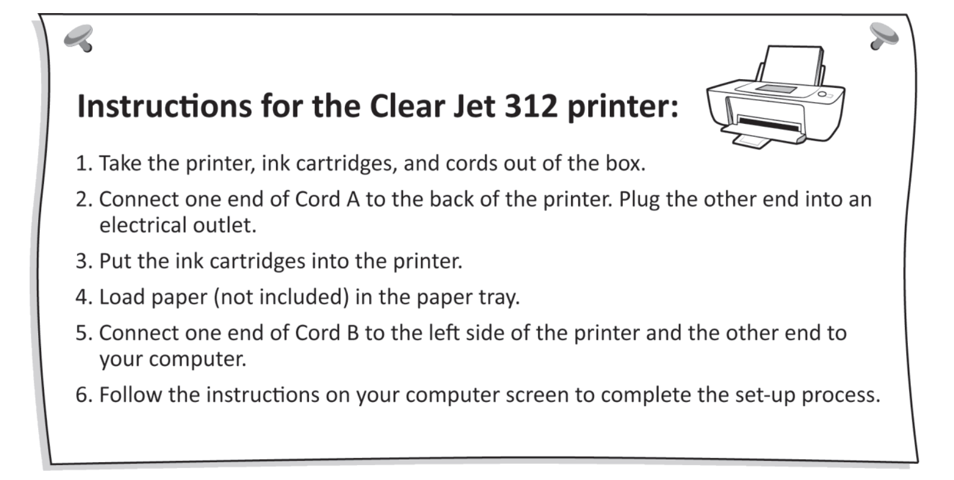

48. What are the instructions for?
A. Setting up a machine
B. Returning a product
C. Repairing a printer
D. Using a computer
49. What is not provided in the box?
A. A printer
B. A cord
C. Ink
D. Paper
50. What should the user do after connecting Cord B?
A. Call for technical help
B. Load the paper tray
C. Turn off the computer
D. Read more instructions
_____Hết_______

GHI CHÚ: CÁN BỘ COI THI KHÔNG ĐƯỢC GIẢI THÍCH GÌ THÊM.

TRƯỞNG KHOA TRƯỞNG BỘ MÔN GIẢNG VIÊN RA ĐỀ

Nguyễn Thành Nam Nguyễn Thị Thu Hà Phạm Thị Thu Hiền

