UBND THÀNH PHỐ HỒ CHÍ MINH | CỘNG HÒA XÃ HỘI CHỦ NGHĨA VIỆT NAM
TRƯỜNG CAO ĐẲNG LÝ TỰ TRỌNG | Độc lập - Tự do - Hạnh phúc
THÀNH PHỐ HỒ CHÍ MINH

ĐỀ THI KẾT THÚC HỌC PHẦN LÝ THUYẾT
HỌC KỲ: II NĂM HỌC: 2020 – 2021

Bậc đào tạo: CAO ĐẲNG (20C )
Học phần: TIẾNG ANH 2
Lớp: 20C5 - Ngày thi: ____ / ____ / 2021
Thời gian thi: 60 PHÚT (không kể thời gian phát đề)
Đề số 014
- Thí sinh không được sử dụng tài liệu, nộp lại đề sau khi thi.
- Bài thi này gồm 50 câu, mỗi câu 0.2 điểm
- Sau khi dừng file nghe, cán bộ coi thi cho sinh viên 5 phút xem lại bài.
I. LISTENING
A. PART 3: SHORT CONVERSATIONS
Choose the best answer to each question
1. Where does the woman want to go next week?
(A) To the opera
(B) To a play
(C) To the movies
(D) To a musical
2. What does the man say about the musical?
(A) He says the woman might enjoy it
(B) He says he might enjoy it
(C) He says he doesn’t want to go
(D) He says he wants to enjoy it before it finishes next week
3. What does the woman say at the end?
(A) She says that she will go to the musical, but she gets to pick next time
(B) She won’t go to see the musical
(C) She really wants to see the musical
(D) She will go to see the play
B. PART 4: SHORT TALKS
Choose the best answer to each question
4. What kind of advice is this?
(A) When to travel
(B) How to save money
(C) Where to go
(D) What to do
5. What time does the man suggest staying inside?
(A) 11: 00 a.m – 2:00 p.m
(B) 12:00 a.m – 3:00 p.m
(C) 12:00 a.m – 2:00 p.m
(D) 11:00 a.m – 3:00 p.m
6. What does the man recommend doing?
(A) Going on vacation
(B) Eating tropical fruits
(C) Buying sunscreen
(D) Changing your hair color
7. Swing shift jobs are during what times of the day?
(A) 4:30 a.m - 6:00 p.m
(B) 11:00 p.m – 7:00 a.m
(C) 9:00 a.m – 5:00 p.m
(D) 5:00 p.m – 1:00 a.m
8. When do people on graveyard shifts usually work?
(A) During the night
(B) On the weekends
(C) Only during holidays
(D) During the days
9. What is flexi - time?
(A) You work at night
(B) You can choose your own hours
(C) You work only during the day
(D) You work eight to four

II. INCOMPLETE SENTENCES
Choose the word or phrase that best completes the sentence.
10. Hiroshi went to ______ sister’s house last week.
A. he
B. his
C. him
D. himself
11. All ______ you have to do is take care of the baby.
A.what
B.that
C.which
D.it
12. My father is ______ me to bring whomever I wish.
A.making
B.allowing
C.letting
D.giving
13. Do you know ______ the winds usually come from in summer.
A.what
B.which
C.when
D.where
14. Not knowing ______ to go, he pulled over to ask directions.
A.what
B.where
C.when
D.why
15. Please say ______ you have on your mind.
A.whatever
B.whichever
C.wherever
D.whenever
16. I’m going to ask him ______ I should do it.
A.what
B.when
C.which
D.that
17. It’s not easy to explain the reason why he has ______ to quit.
A.choice
B.choose
C.chose
D.chosen
18. Either Bill or we ______ supposed to contact Sylvia about the meeting.
A. is
B. could
C. was
D. were
19. Kim Jones, together with her roommate, ______ to write a letter to the campus newspaper.
A. will
B. are
C. is going
D. were going
20. Most of the fish I caught ______ too small to bring home.
A. will
B. am
C. were
D. was
21. The pencil needs to be ______.
A. made
B. used
C. sharpened
D. pointed
22. Two-quarters of the land ______ sold to investors.
A. will
B. have
C. have been
D. has been
23. Sally has been to Europe ______ Peter has.
A. the most times than
B. as many times
C. more times
D. as many times as
24. Jerry had ______ difficulty of all the students in figuring out the problem.
A. a lot of
B. fewest
C. the least
D. some
25. We enjoy skiing ______ they do.
A. as much as
B. as many as
C. as more as
D. as more than
26. He is not a novice reporter ______.
A. any longer
B. some longer
C. any longest
D. some longest
27. This box is ______ as that one.
A. boxier
B. filled with toys
C. a square
D. twice as large
28. I would like you ______ go out with him at night.
A. no
B. not
C. no to
D. not to
29. He may ______ been there before.
A. not have
B. have no
C. haven’t
D. has not
30. My grandfather moves slowly and speaks ______.
A. quiet
B. with quiet
C. quietly
D. in quiet
31. Mr. Lee ______ better than he writes.
A. speaks
B. tells
C. told
D. asks
32. Roger ______ nor flowers when he was in prison.
A. neither saw birds
B. saw birds neither
C. saw neither birds
D. neither did birds
33. My friend Mariette _______ decided to visit me.
A. sudden
B. more sudden
C. suddenly
D. suddenness

34. Alan’s work schedule is much ______ than Bruno’s.
A. regular
B. regularly
C. more regular
D. more regularly
35. _______ the form and take it to the counter
to be signed.
A. Pay back
B. Try on
C. Fill out
D. Give away
36. Do you know the name of the artist _______ painted this portrait?
A. whose
B. which
C. that
D. whom
37. What's the name of that guy _______ party we went to last week?
A. that
B. whose
C. which
D. when
38. Nobody in the classroom _______ able to answer the question about subject verb agreement yesterday.
A. were
B. is
C. will be
D. was
39. Do you know the boy ____ glasses at the back of the class?
A. is wearing
B. wore
C. wearing
D. wear
40. The man whom I _______ with _______ the dean of our faculty.
A. was talking/ were
B. were talking/ were
C. can talk/ were
D. was talking/ was

III. READING COMPREHENSION
Question 41-43 refer to the following article:
Music Festival Returns to Springfield
By Evan Baseman
(November 29)—Event organizers announced yesterday that next year’s Benno Music Festival (BMF) will be held in Springfield from May 17 to May 19. Organizers again expect about 90,000 visitors to attend.
BMF features folk musicians who are familiar to regional and national audiences. Vicky Rose and Ryan Barna performed at BMF last spring, along with the New Two Band and many others. Next year’s line-up of musicians will be announced in January.
“Springfield will welcome BMF for the tenth time next May,” said Mayor Dayana Alvarez. “Residents can expect traffic delays at the time of the event, but in previous years the interruptions have been minor. We love the energy—and the new business—that the festival brings to our city.”

41. Who is Vicky Rose?
A. A news reporter
B. A city official
C. A musician
D. A business owner
42. What is suggested about the festival?
A. It has been held in Springfield before.
B. It usually lasts for four days.
C. It features local artists.
D. It has grown in size.
43. What problem does Mayor Alvarez mention?
A. Business closings
B. Low attendance
C. Extra traffic
D. Loss of electricity

Question 44-46 refer to the following article:

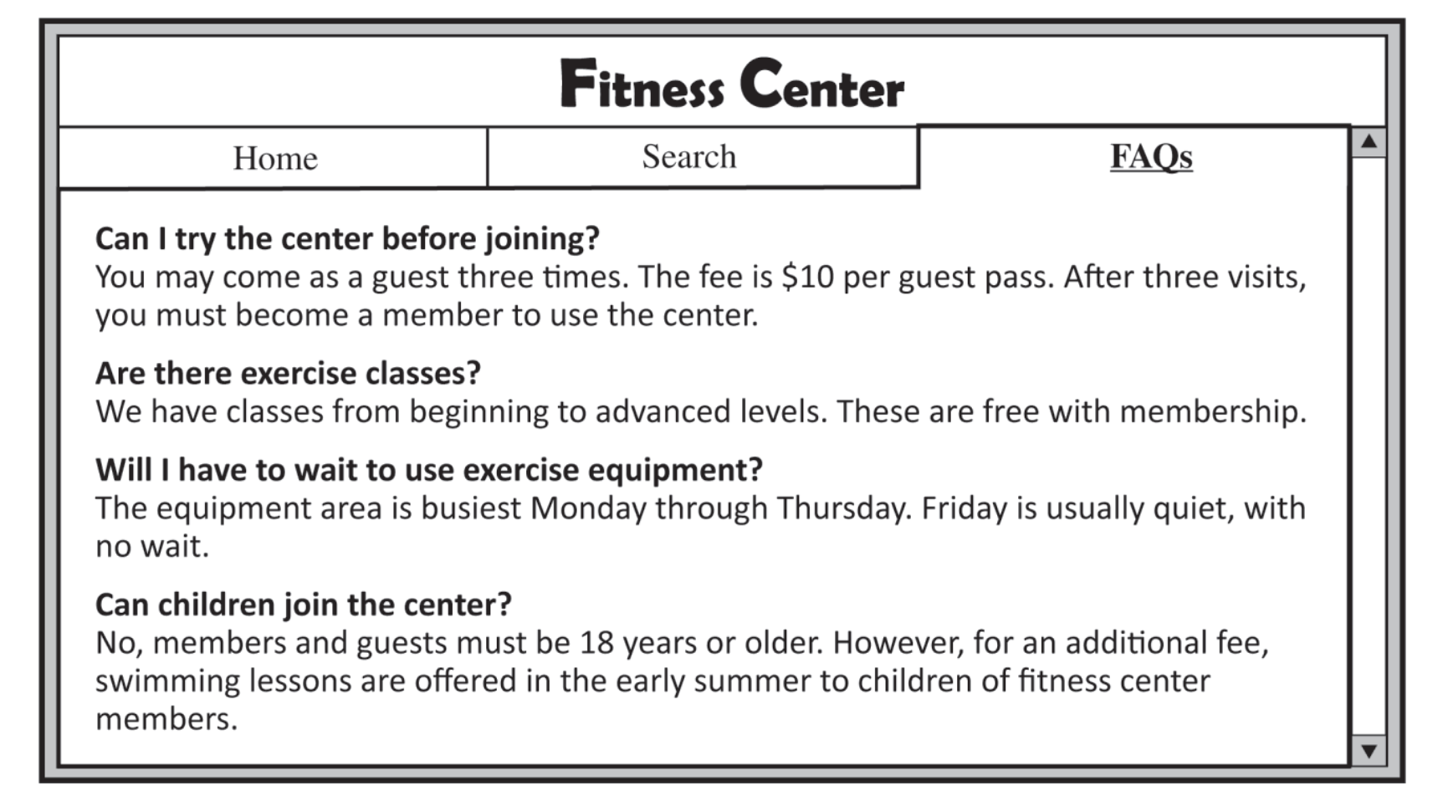

44. What does the fitness center offer free to members?
A. Guest passes
B. Exercise classes
C. Swimming lessons
D. Locker rentals

45. When do fewer people use the exercise equipment?
A. On Mondays B. On Tuesdays
C. On Thursdays D. On Fridays
46. What is stated about the fitness center?
A. It does not open on holidays. B. It has longer hours in summer.
C. It offers group memberships. D. It does not accept children as members.
Questions 47-48 refer to the following invitation.
You’re invited!
Moffitt Art Gallery opened one year ago, and we’re having a party!
Join us for dessert and live music.
Date: November 12
Time: 7:00 p.m. to 10:00 p.m.
Place: Moffitt Art Gallery, 12 Waltham, St. (next to Carlson Park)
Reservations are required by October 31
Call Jenny Peterson at 555-0165

47. What is party for?
A. A child’s birthday B. A graduation
C. An anniversary D. An employee’s retirement
48. What are guests asked to do?
A. Make a reservation B. Bring some food
C. Play some music D. Park on Waltham Street

Questions 49-50 refer to the following notice.
AMARA’S CAFÉ
Customer Appreciation Coupon
Present this coupon to a cashier at your next visit and receive a complimentary beverage with your purchase of a sandwich, salad or dessert! Use your coupon at any time a day, Sunday through Friday (not valid on Saturdays).
We value your opinion!
Visit www. amarascafe.come to view our calendar of events. Complete our online customer survey to be entered into a drawing for a $25 Amara’s coffee card.

49. What free item can be obtained by using this coupon?
A. A sandwich B. A salad
C. A dessert D. A drink
50. How might a customer win a prize?
A. By using the coupon on a Sunday B. By making a purchase on a Saturday
C. By responding to a survey D. By attending a special event

______Hết_______

GHI CHÚ: CÁN BỘ COI THI KHÔNG ĐƯỢC GIẢI THÍCH GÌ THÊM.

TRƯỞNG KHOA TRƯỞNG BỘ MÔN GIẢNG VIÊN RA ĐỀ

Nguyễn Thành Nam Nguyễn Thị Thu Hà Phạm Thị Thu Hiền

