BÀI TẬP CUỐI KÌ
- Mục tiêu:
- Sử dụng các điểm ngữ pháp đã học để ứng dụng vào các kĩ năng đọc hiểu và soạn thảo văn bản đơn giản:
  - Sử dụng danh từ, tính từ, trạng từ phù hợp để miêu tả các bức tranh.
  - Sử dụng động từ ở thì và dạng thức phù hợp để trả lời các câu hỏi về bản thân
  - Sử dụng tổng hợp các điểm ngữ pháp để trả lời cho 1 email ngắn

- Yêu cầu:
- Học viên làm đầy đủ các phần trong bài tập và gửi về email tranthanhtruc@lttc.edu.vn trong 1 file Word/ PDF duy nhất.
- Bài làm ghi rõ họ tên học viên
- Học viên không sao chép bài của nhau hoặc bài sẵn có trên mạng Internet.

- Đề bài:
PART 1: PICTURE DESCRIPTION (2.5ps)
Make simple sentences to describe the pictures below (1 sentence/ picture). Try to use appropriate adjectives and adverbs
Ex: Picture 1: The flowers are very beautiful.

Picture 1:
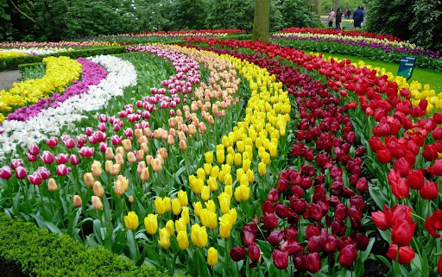
Picture 2: This family has a happy meal.

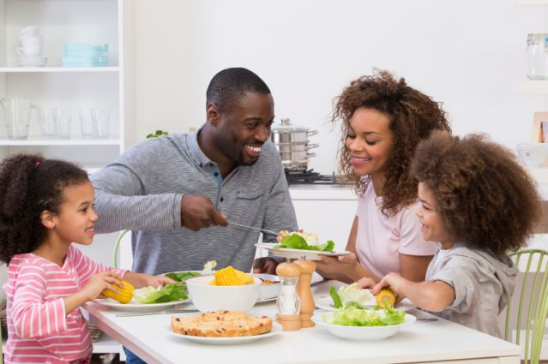

Picture 3: The beach is overcrowded people.

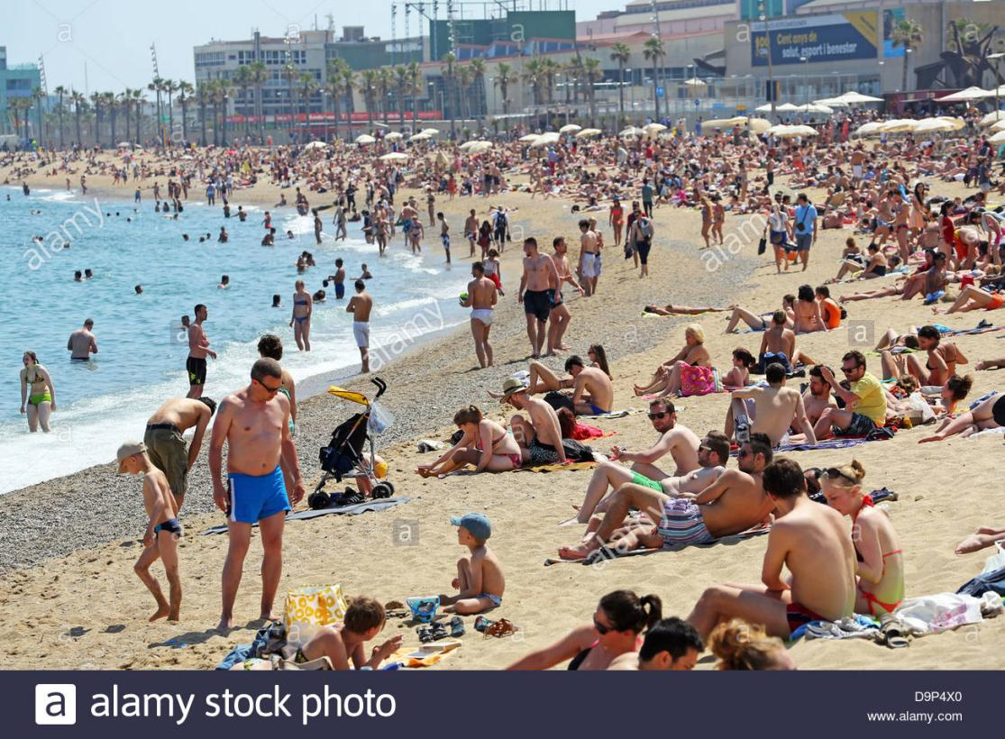

Picture 4: It is a modern and wonderful house.

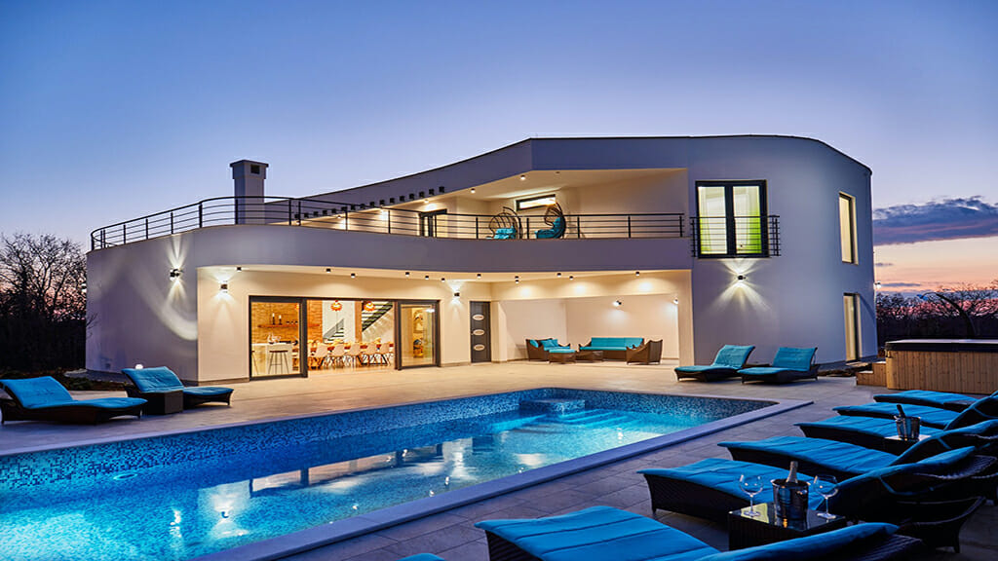

Picture 5: They was bored because the film is bad.



PART 2: QUESTIONS & ANSWERS (5ps)
Answer the following questions about yourself?
- What do you enjoy doing in your free time?
=> I enjoy watching film in my free time to relax my mind.
- What housework do you hate?
=> I hate washing clothes.
- Do you prefer reading books or listening to music? Why?
=> I like reading book because I can widen my knowledge.
- What time do you get up every day?
=> I usually get up at half past six every day.
- What did you do last Tet holiday?
=> I often bought new clothes, made Tet Cake at home and visited my relative.
- What will you do next summer vacation?
=> I will visit Phu Quoc Island in next summer vacation.
- Have you ever been to Da Lat? If, yes, when did you go there? If no, will you come there in the future?
=> Yes,I have. I went to Da Lat in last summer vacation with my friends.
- What is the most delicious food you have ever eaten?
=> Eel soup is the most delicious food which I have ever eaten.
- What do you like to be called by friends? What are you called by your family?
=> I really like to be called John Nguyen by my friends. I am called John Nguyen by my family when I was young.
- Have you ever been recorded with an audio or video recorder? What were you doing?
=> Yes, I have. I was recorded with a video recorder by my mother while I and my father was doing gardening.
PART 3: EMAIL REPLY (2.5ps)
Write a short email to invite someone for dinner.




25, Tran Hung Dao Street, HCM city
October 12th, 2021

Dear Minh,
How are you? I am really happy to hear you have a good trip.
Are you busy this Saturday? It is the great dinner party. How about going there this Saturday evening? I’m sure you’ll like it. It’s at Ron & Morgan Hughes 987 carriage court. Rolling Hills. The dinner party begins at 7.45 P.M, so let’s meet in front of the gate at 7.30. I’m sure that it will be fun
Looking forward to seeing you there.
Please respond 123.456.7890
Have a nice day!
Cheers,
Thắng

