WRITING
1. INTRODUCTION
The writing test consists of three parts which each candidate should finish in maximum 45 minutes.
Part 1: Make a complete sentence (5 sentences)
Part 2: Write a postcard or a note of 25-35 words
Part 3: Write an essay (250 words)
Candidates write an essay on one of the following topics:
- Advantages and disadvantages of online shopping
- Advantages and disadvantages of living in a city
- Advantages and disadvantages of studying online
- Advantages and disadvantages of watching TV
- It is said that “Health is gold”. Do you agree?
- Many people say that eating home-cooked meals for individual and the family is better than eating out. Do you agree or disagree?
- Many people say that learning foreign languages is important in today’s world. Do you agree?
- Air pollution is one of the largest problems the world is facing today.What are some causes of air pollution in your community and what measures can be proposed to solve this problem?
2. SAMPLE PRACTICE
Part 1: Make a complete sentence
- I / used / work / restaurant / when / I / Paris .
- He / not have / money / buy / car.
- We/ have dinner / when / phone/ ring.
- You / ever / ride /roller coaster / ? /
- Watch TV/ be / interesting / than / play games.
- They / not recognize / me / meeting / yesterday.
- This / be / most / expensive / item / shop.
- If / I / be / kind / flower /, / I / be / sunflower.
- We / hope / see / you / birthday party / tonight.
- I / be / interested / read / books.
- You / use to / have / long ponytail?
- She / never / wear / clothes / be /trendy.
- What / you / do / if / you / be / nervous?
- I / not have / an argument / my parents /since / I / be / child.
- Peter and Lisa / be / the phone / six hours.
- If / people / stop / drive cars / there / be / less pollution.
- Kendra / be / fairly outgoing / and /she / make friends / easy.
- It / not be / good idea / compromise / your friends / lot.
- You / enjoy / travel alone / group?
- Try / local foods / be / great way / learn / culture.

Part 2: Write a postcard or a note
Practice 1
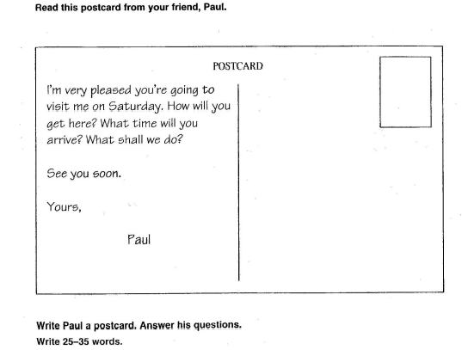
Practice 2
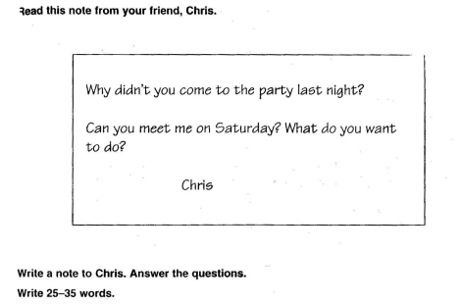
Practice 3
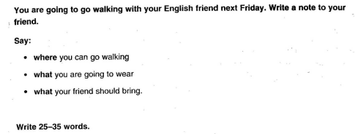

Practice 4
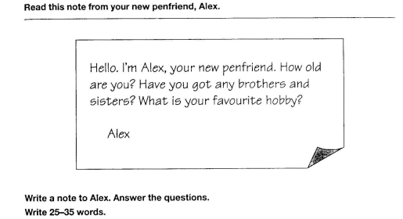
Practice 5
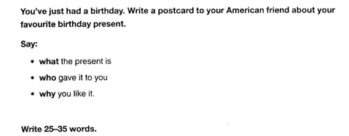

Practice 6
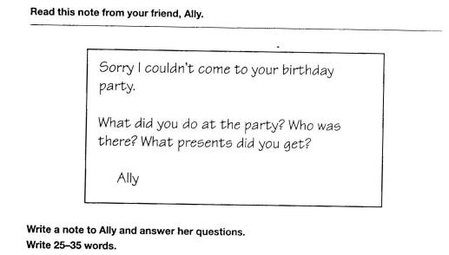
Practice 7
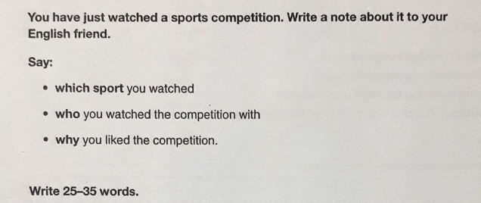
Practice 8
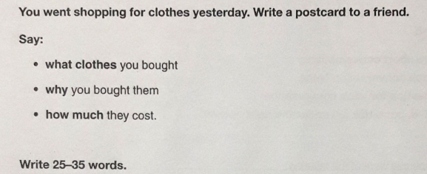
Practice 9
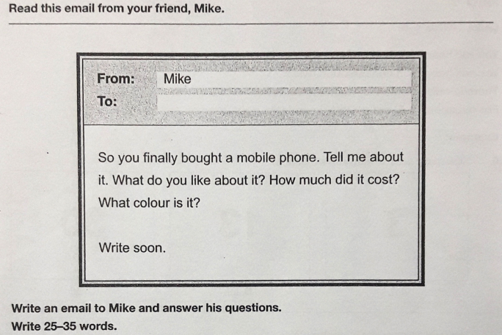
Practice 10


