WRITING
1. INTRODUCTION
The writing test consists of three parts which each candidate should finish in maximum 45 minutes.
Part 1: Make a complete sentence (5 sentences)
Part 2: Write a postcard or a note of 25-35 words
Part 3: Write an essay (250 words)
Candidates write an essay on one of the following topics:
- Advantages and disadvantages of online shopping
- Advantages and disadvantages of living in a city
- Advantages and disadvantages of studying online
- Advantages and disadvantages of watching TV
- It is said that “Health is gold”. Do you agree?
- Many people say that eating home-cooked meals for individual and the family is better than eating out. Do you agree or disagree?
- Many people say that learning foreign languages is important in today’s world. Do you agree?
- Air pollution is one of the largest problems the world is facing today.What are some causes of air pollution in your community and what measures can be proposed to solve this problem?
2. SAMPLE PRACTICE
Part 1: Make a complete sentence
- I / used / work / restaurant / when / I / Paris.
-- I used to work in restaurant when I was in Paris.
- He / not have / money / buy / car.
-- He does not have enough money to buy this car.
- We/ have dinner / when / phone/ ring.
-- We were having dinner when the phone rang.
- You / ever / ride /roller coaster / ? /
-- Have you ever riden roller coaster?
- Watch TV/ be / interesting / than / play games.
-- Watching TV is more interesting than playing games.
- They / not recognize / me / meeting / yesterday.
-- They did not recogize me at the meeting yesterday.
- This / be / most / expensive / item / shop.
-- This is the most expensive item at this shop.
- If / I / be / kind / flower /, / I / be / sunflower.
-- If I were a kind of flower, I would be a sunflower.
- We / hope / see / you / birthday party / tonight.
-- We hope to see you at birthday party tonight.
- I / be / interested / read / books.
-- I am interested in reading books.
- You / use to / have / long ponytail?
-- Did you use to have long ponytail?
- She / never / wear / clothes / be /trendy.
-- She has never worn clothes which is trendy.
- What / you / do / if / you / be / nervous?
-- What would you do if you were nervous?
- I / not have / an argument / my parents /since / I / be / child.
-- I have not had an argument with my parents since I was a child.
- Peter and Lisa / be / the phone / six hours.
-- Peter and Lisa have been on the phone for six hours.
- If / people / stop / drive cars / there / be / less pollution.
-- If people stoped driving cars, there would be less pollution.
- Kendra / be / fairly outgoing / and /she / make friends / easy.
-- Kendra is fairly outgoing and she can make friends easilly.
- It / not be / good idea / compromise / your friends / lot.
-- It is not a good idea to compromise your friends a lot.
- You / enjoy / travel alone / group?
-- Do you enjoy travelling alone or in a group?
- Try / local foods / be / great way / learn / culture.
-- Trying local foods is the great way to learn culture.

Part 2: Write a postcard or a note
Practice 1

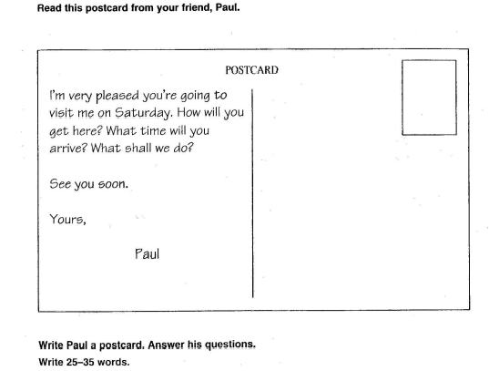
Hi Paul,
I will get your house
by my own car. I will arrive your house at 8am and we can go to Water Market to buy some beer before come back your home enjoy the match.
Yours,
Bardock

Practice 2
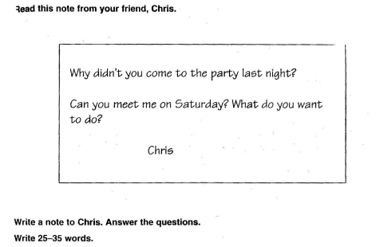
Hi Chris,
I am so sorry because my car got problem suddenly. I tried to contact you but my phone was locked. This Saturday morning, I will get to your home and bring some beer for apology. We will drink to the everning, right?

Yours,
Bardock

Practice 3
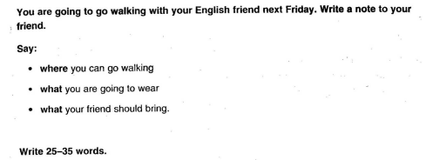
Hi Zeno,
Next Friday, can we walk around the Kio Part to discuss about next exam. Because the weather can be cold, you should wear sweater with gloves and bring an umbrella in case it rains suddenly, I think.
Yours,
Bardock

Practice 4
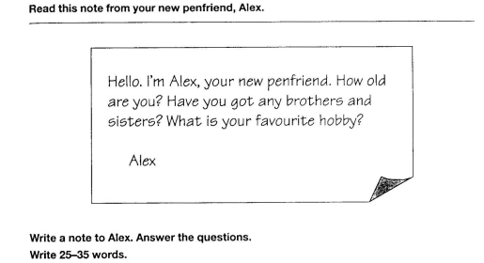
Hi Alex,
I am really pleased when I receive your mail. I am 25 years old and I have one elder sister and one younger brother. My favourite bobby is hangingout with friends. How about you? Please reply soon.
Yours,
Bardock

Practice 5
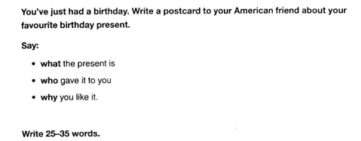
Hi Lunch,
As I promised, I’ll tell you my favourite birthday present. It is the Apple’s newest Iphone. I love it so much because it’s the first present from Zeno.
Yours,
Bardock

Practice 6
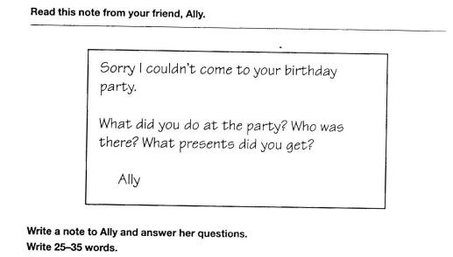
Hi Ally,
Don’t mention it, I was so happy at the party with my parents and our friends. We drunk a lot and sang together. I got a lot of presents from them like: books, phone, Laptop computer,… and I love them all.
Yours,
Bardock

Practice 7
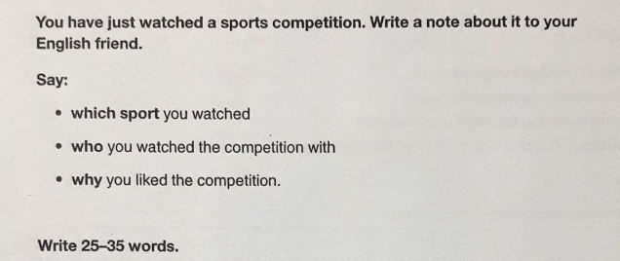
Hi Tenshin,
I just watched a football match between Nakage FC and Hokage FC with Lunch. That was a very exciting match, my favorite player, Krillin of Hokage FC, scored a goal and his team won the match with only one to nil.
Yours,
Bardock

Practice 8
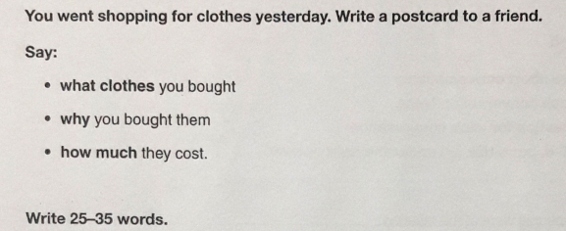
Hi Kenshin,
I just bought T-Shirt with Dragonball logo yesterday at Kaio shop. I am so happy because I have found it for a long time. Especially, I just paid $15 because of VIP member discount.
Yours,
Bardock

Practice 9
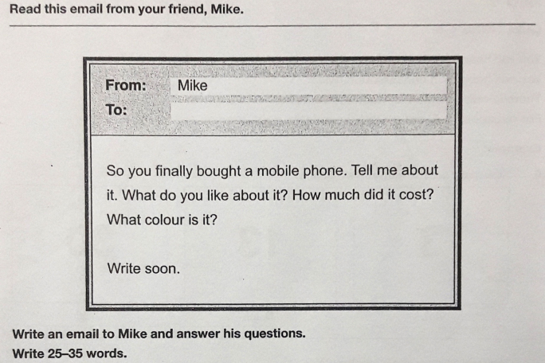
Hi Mike
Yep, I bougt it. It is a black Iphone 13 Pro max with 3 cameras.I love it so much, from now I can take a lot of wonderful pictures with it. It is about $1.500, but my parents paid it for me.
Yours,
Bardock

Practice 10
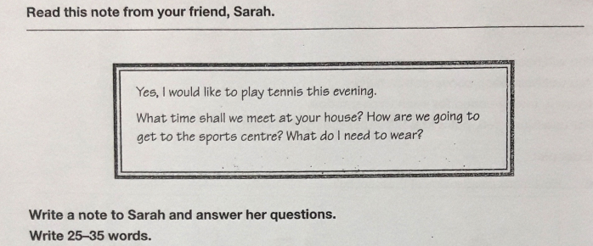
Hi Sarah
Oh, we can meet at 6pm after work at my house. After that, we can catch the 002 bus to get to the sports centre. I think you should wear T-shirt with sport shorts and your new sport shoes.
Yours,
Bardock

