Part 1: Make a complete sentence (5 sentences)
- I / used / work / restaurant / when / I / Paris .
- I used to work in a restaurant when I was in Paris
- He / not have / money / buy / car.
- He doesn’t have enough money to buy a car
- We/ have dinner / when / phone/ ring.
- We were having dinner when the phone rang
- You / ever / ride /roller coaster / ? /
Have you ever ridden a roller coaster?
- Watch TV/ be / interesting / than / play games.
- Watching TV is more interesting than playing games.
- They / not recognize / me / meeting / yesterday.
- They didn't recognize me in the meeting yesterday.
- This / be / most / expensive / item / shop.
- This is the most expensive item in the shop.
- If / I / be / kind / flower /, / I / be / sunflower.
- If I were a kind of flower I would be a sunflower
- We / hope / see / you / birthday party / tonight.
- We hope to see you at the birthday party tonight.
- I / be / interested / read / books.
- I am interested in reading books.
- You / use to / have / long ponytail?
- Did you use to have a long ponytail?
- She / never / wear / clothes / be /trendy.
- She never wears clothes that are trendy.
- What / you / do / if / you / be / nervous?
- What will you do if you are nervous ?
- What do you do if you are nervous ?
- I / not have / an argument / my parents /since / I / be / child.
- I haven’t had an argument with my parents since I was a child.
- Peter and Lisa / be / the phone / six hours.
- Peter and Lisa have been the phone for six hours.
- If / people / stop / drive cars / there / be / less pollution.
- If people stoped driving cars, these would be less pollution.
- Kendra / be / fairly outgoing / and /she / make friends / easy.
- Kendra is fairly outgoing and she makes friends easily.
- It / not be / good idea / argue / your friends / lot.
- It isn’t a good idea to argue with your friends a lots.
- You / enjoy / travel alone / group?
- Do you enioy traveling alone or in a group?
- Try / local foods / be / great way / learn / culture.
- Trying the local foods is a great way to learn a bout the culture.
ng cars, these would be less pollution.
- Kendra / be / fairly outgoing / and /she / make friends / easy.
- Kendra is a fairly outgoing person and she makes friends is very easy.
- It / not be / good idea / compromise /.
- It isn’t a good idea to compromise with your friends a lot.
- You / enjoy / travel alone / group?
- Do you enioy traveling alone or in a group?
- Try / local foods / be / great way / learn / culture.
- Try eating local foods is a great way to learn their culture.

Part 2: Write a postcard or a note of 25-35 words
Practice 1
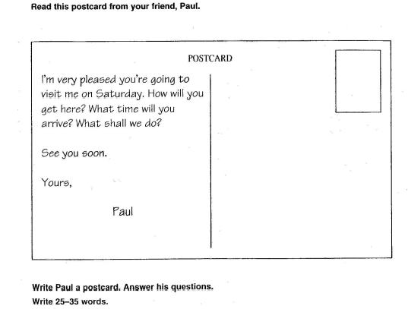
Hello Pual!
I'm planning to visit you on Saturday. I will go to your house by motorbike. I will arrive there at seven o’clock. We'll have a great time to watch movies and cook together.
I am looking forward to seeing you soon.
Your friend,
Maria,

Practice 2
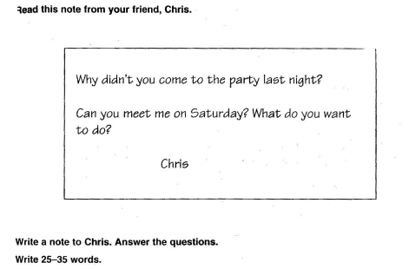
Hi Chris!
Last night, I had an important appointment so that I could’t come to the party with you, don't be sad about that.
Sure, I will meet you on Saturday. We will go shopping together and buy clothes that you like.
Cherry,
Practice 3

Hello my English friend,
Can we go for walk together next Friday. I think Nguyen Hue walking street is a great place for us to go for a walk. I'll wear my favorite T-shirt and jeans. You should bring a few bottles of water to use when we are thirsty.
Hope to see you soon,
Mary,
Practice 4
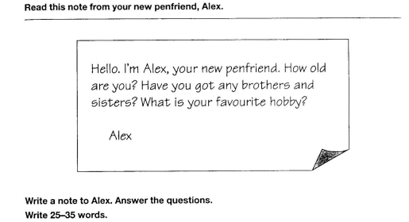
Hello Alex!
My name is Lisa and I’m 23 years old. I have one brother and two sisters in my family. My favorite hobby is watching movies and listening to music with my friends.
Lisa,
Practice 5
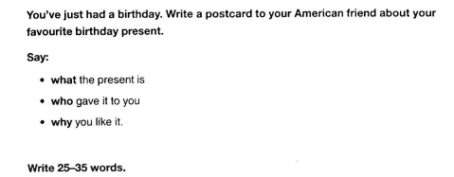
Hello my dear friend,
I want to know I have finished my birthday. I have a smartphone present. My brother bought me the smartphone. Do you know I like it so much because it's very helpful for my study. Okay, see you soon.
Bye,
Practice 6
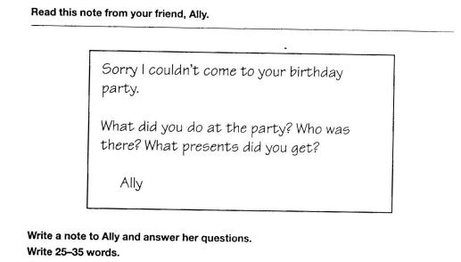
Hi Ally!
It's a pity you couldn’t come to my birthday party. I danced, sang, cut cakes and received many gifts. Linda, Diana, David and Alex were present at the party. They gave a dress, a bracelet, a necklace and a few other gifts.
With love,

Practice 7
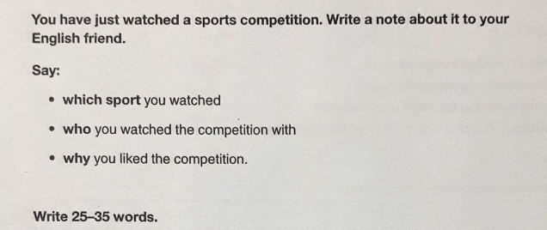
Hello Join!
I want to tell you about a sport that I watched. I watched the football competition with my dad. I really liked it because it gave me a sense of thrill, comfort, relaxation and being myself.
Henry,
Practice 8
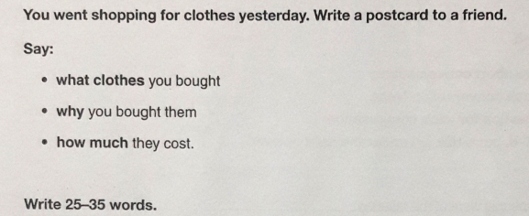
Hello my dear friend.
I bought a new set of clothes yesterday. It consisted of a pair of blue jeans and a white blue shirt, I bought them because the store was on 50% off, and I bought them for $25
Bye! see you soon,
Mary,

Practice 9
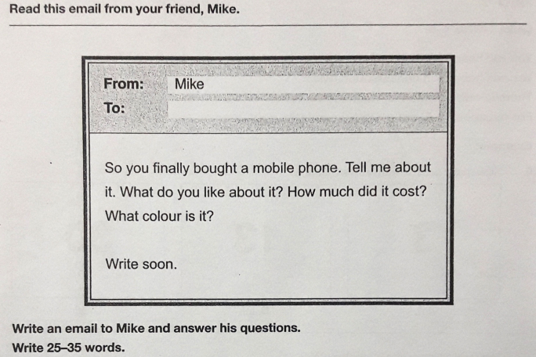
Hello Mike,
Yeah I bought a new phone yesterday. It's called iphone 13 promax. It has big screen, good camera and easy to use. It's 1200$. My phone is black, this is my favorite color.
Bye, see you soon
David,

Practice 10
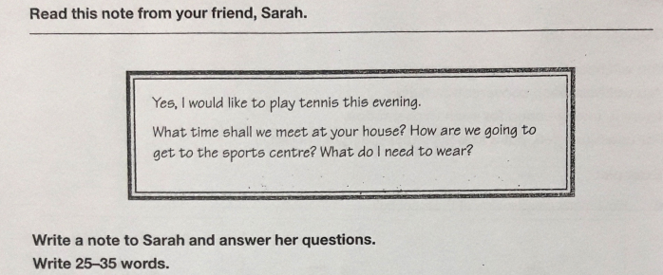
Hello Sarah,
Tonight around 6 pm you can come to my house and I will drive you to the sports center in my own car. You can wear comfortable clothes, preferably a t-shirt, shorts and shoes sport
Bye, see you tonight
Mary,
Part 3: Write an essay (250 words)
- Advantages and disadvantages of living in a city
The development of industry has led to an increase in the population in large cities, I believe that living in the city has both advantages and disadvantages.
Living in the city has some huge advantages. First of all, cities have modern facilities so you can access to the best infrastructure. For example, the roads are better, better schools, modern hospitals,… As a result, you can enjoy the best social services. Secondly, city life offers you a wide variety of entertainment that you can participate in. There are always recreation parks for people to play, clubs and outdoor activities to join, or shopping centres to shop, movies, theaters, concerts... The last advantage is that living in big cities will open avenue for job hunting. The various companies and factories located in the cities, So that if you want to have a successful career or well paid job, stay in the city and find a suitable job as well as expand your knowledge to have chance of promotion.
Beside advantages, living in a city has some problems. Pollution is the most serious issue in the city, which is created by emissions from vehicles and waste by factories. Noise pollution is also annoying the citizens every day. Furthermore, such a large number of vehicles make the road crowded and so the traffic jams occur usually. Additionally, the rate of accidents happening and the rate of crime make people worried when living in the city.
In conclusion, living in city always has advantages and disadvantages. So what we need is learning how to adapt with our living environment.

- Advantages and disadvantages of studying online
In recent years, studying online has become an alternative method of traditional learning. Studying online always brings advantages and disadvantages.
The great advantages of studying online is provides a flexible time and less budgeted learning for students. They are able to learn their favourite subjects on their suitable time that can gives a great opportunity for learners to gain new skills and do other thing in their life. Beside that, studying online offers teachers an efficient way to deliver lessons to students. Online learning has a number of tools such as videos, PDFs, podcasts, and teachers can use all these tools as part of their lesson plans. Another advantage of online education is that it allows students to attend classes from any location of their choice. It also allows schools to reach out to a more extensive network of students, instead of being restricted by geographical boundaries. Additionally, online lectures can be recorded, archived, and shared for future references.
However, studying online has some disadvantages. First of all, studying online requires modern infrastructure and stable network connection. This makes it difficult for students in underdeveloped economic areas. Beside that, in an online class, there are minimal physical interactions between students and teachers. This often results in a sense of isolation for the students. Studying online always has the potential for learners to be cheated without achieving their learning goals.
In conclusion, studying online is a very comfortable and flexible method that has allowed many people to resume their training successfully. However, there are still many important aspects that need to continue working to increase their benefits in the studying online process.
- Advantages and disadvantages of watching TV
Considered as a century invention, TV’s contribution to our life is of great importance. Therefore, television has been present in most homes and the number of people watching TV is increasing. It is a fact that watching TV has both advantages and disadvantages.
Firstly, watching TV helps us update the latest information. Because the news program on TV always provides hot information every day about the political and social situation at home and abroad in Vietnam and around the world. Secondly, by watching TV we can expand knowledge. For example, watching a music program, you can learn more about kinds of music, or watching the animal world program that helps us know more about the strange animals. Finally, watching TV helps to relax after work. Indeed, entertainment programs on TV such as gameshows, movies and music are programs that we can watch when we are stressed.
However, There are also many disadvantages of watching TV. And one of the most important disadvantages of watching television is a waste of time. Instead of doing other jobs such as doing housework, studying and resting, people often spend most of their time to watch TV. This makes work efficiency less. Watching too much TV makes people look like "couch potato". Only in one place to watch TV, lazy to move, food is served to the place so that they can eat while watching TV. These are the reasons why watching TV often become overweight make people look like "couch potato". Especially, watching TV regularly makes people become addicted to TV. They watch TV whenever they are free, ready to spend their sleep time watching their favorite shows. This will lead to a decline in our fitness as well as work and school effective.
In conclusion, this watching TV has both benefits and potential problems. However, if the problems are recognized and managed well, the advantages will outweigh the disadvantages
- It is said that “Health is gold”. Do you agree?
In the life of a person, everyone has ambitions, dreams and at all costs find ways to achieve. However, people forget one thing that is to take care of their health. Because health is the most important valuable asset of human. Therefore, many people say that "health is gold".
Indeed, if you have a good health, you will be in control of your life. Health helps us to have enough strength and alertness to carry out life activities. Having the spirit, full of energy in work and life, facing pressures they can easily overcome, work or life for them is a joy, a goal to strive for. There are good discoveries, new ideas and easy advancement in work. So you can easily succeed at work. Especially you will be loved by many people.
However, if you have a lot of money and a lot of other valuable assets but don't have good health, you will feel nervous, anxious and fatigue facing illness. For example, someone who is very rich but has cancer. They take a lot of gold and silver of accumulated wealth to pay for an expensive hospital bed, to pay for medicines, even at the expense of precious time in life and loved ones. Moreover, they become tired, bewildered, worried and helpless because both wealth and health are lost. Like the saying: "lost money, bad luck"
In conclusion, in all the valuable assets in human life, health is the most important human asset. Therefore, it is necessary to take care of your own health to achieve success in life.
- Many people say that eating home-cooked meals for individual and the family is better than eating out. Do you agree or disagree?
Nowadays, with the rapid development of society. There are many new issues arising, in which food hygiene and safety is an urgent issue that many people are concerned about. So many people say that eating home-cooked meals for individual and the family is better than eating out. Indeed, eating home-cooked meals for individual and the family is good for their health and quality of life.
One of the most important benefits of eating home-cooked meals for individual and the family is help us have a good health. When you cook at home, you can balance and ensure full the nutrients value in each meal for your family. Moreover, cooking at home also helps to ensure food hygiene and safety for your family because the selection of ingredients and cooking is done by yourself. Especially, eating out always has potential dangers to your health. Because you cannot know the source of food as well as food safety and hygiene, you can absorb unhealthy sugar and fat in your body.
Eating home-cooked meals for individual and the family help improve your family's quality of life. Eating at home gives the whole family more time to share and talk together. Moreover, preparing meals together at home can help to connect family members, self-reliance training for children and release pressure. Especially, eating at home save money than eating out.
In conclusion, eating home-cooked meals for individual and the family brings many benefits to your family. Although it takes time to prepare, cooking more meals for your family can protect health and improve your family's quality of life.
7. Many people say that learning foreign languages is important in today’s world. Do you agree?
Many people say that learning a foreign language is important in today's world and I totally agree with the idea because of the following reasons.
Today, foreign languages have become extremely popular, becoming important factors for future career development. Firstly, Learning a foreign language makes you expand relationships in the fastest way, opens up more opportunities for you in life and work. If you are fluent in a second foreign language, your chances of getting a job will be much greater than those who speak only one language. Employers see foreign language skills as an invaluable asset for employees because they have the ability to negotiate with many partners. Furthermore, proficiency in a foreign language motivates and directs you to learn new skills, which gives you a competitive edge.
Learning a foreign language also helps people train their memory because in the process of learning a foreign language, learners must try to memorize vocabulary, grammatical structures, words, the ability to remember and count, The post also got better. Because of that, it is a tool to help prevent dementia & Alzheimer's disease. When learning a foreign language, the brain will automatically find the most effective way to adapt and operate so that we can easily and quickly absorb new sources of knowledge, whether you want to be very proficient or simply achieve it. Fluency in many different languages helps you meet and build lasting relationships with people from all over the world, thereby having the opportunity to understand more cultures as well as participate in new conversations. Very interesting and engaging conversation.
In conclusion, I would like to emphasize that learning a foreign language is very important in today's world.
8. Air pollution is one of the largest problems the world is facing today.What are some causes of air pollution in your community and what measures can be proposed to solve this problem?
Air pollution is the most serious problem of the current time all over the world especially in the large cities because of the huge level of industrialization. There are two problems in terms of causes and remedies that are of concern.
Air pollution is caused by two specific reasons, which can be tackled by using appropriate measures. The first reason to be mentioned is human activities. People always litter everywhere and burn the rubbish without thinking of its consequences. Exhaust fumes from factories and vehicles are too much, so the level of air pollution is higher. Another reason is natural disasters. Drought often happens, which caused forest fires. This makes the air become more contaminated. About effects, Air pollution always has bad effects on our life. People around the world are suffering from respiratory and cardiac problems, and diseases such as cancer affecting other organs of the body too.
To overcome the current air pollution, the state has a policy such as: to encourage people to travel by public transport instead of private cars, not to burn plastic cases and plastic packaging to pollute the air, plant more trees to protect the forests. Above all, it is necessary to raise the awareness of each individual living in society. Each individual, if they know their own sense of self, conscious of protecting the environment in which they live, air pollution will be minimized.
In conclusion, Air pollution is a most serious problem of the current time all over the world. To improve the air quality, We should be conscious in protecting the air environment and taking measures to overcome the problem of air pollution.

