ĐỀ CƯƠNG ÔN TẬP MÔN TIẾNG ANH HỌC KÌ II
- THEORY

Unit 7: Where does she work? | 1. Vocabulary:  Hospital, school, airport, police station, fire station, shop, station, supermarket, zoo, bank.  2. Grammar: Presnt simple and places  Where does she/he work? => He/she works in the bank  Does he/she work in the zoo? => Yes, he/she does  No, he/she doesn’t
Unit 8: It’s hot today | 1. Vocabulary:  Rainy, sunny, windy, snowing, hot, cold, fly a kite, make a snowman, wear coats, go outside.  2. Grammar:  What’s the weather like today? => It’s windy  Put on your coats when it’s cold  Don’t put on your hat when it’s windy
Unit 9: What are you wearing? | 1. Vocabulary: Skirt, scarf, gloves, jeans, boots, shirt, o’clock, a quarter past, a quarter to, half past  2. Grammar: The presnt continuous  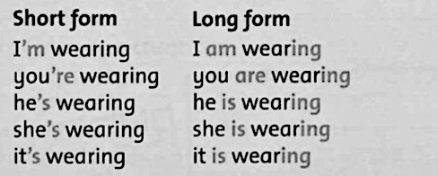

Unit 10: You’re sleeping | 1. Vocabulary: wedding, cake, guests, bride, band, invitation, make a cake, wash the car, brush my hair, take photos  2. Grammar: The present continuous  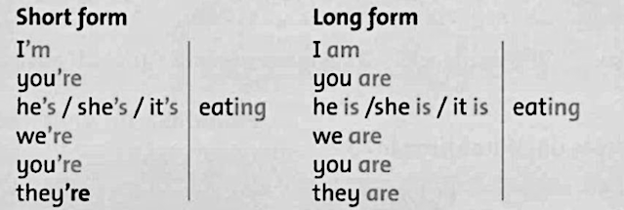  What are you doing? =>  What is he/she doing? =>  What are they doing? =>
Unit 11: Look at all animals | 1. Vocabulary: loud, fast, quiet, fast, slow, cow, goat, horse, sheep, donkey, goose.  2. Grammar: The comparative  This cow is bigger than that cow  This sheep is smaller than that sheep.  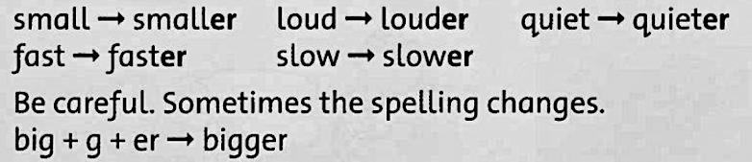
Unit 12: Look at the photos | 1. Vocabulary: kind, naughty, wet, dry, fridge, photo, tidy, untidy, floor, rubbish.  2. Grammar: The past simple of “be”  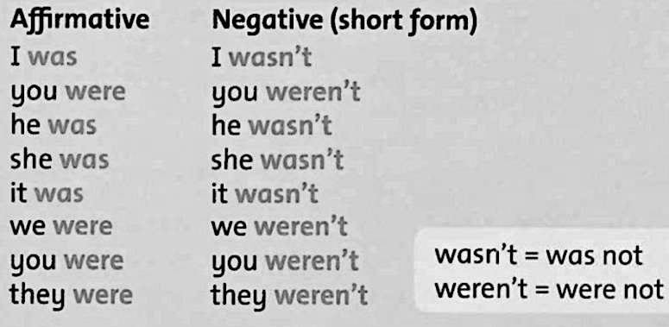

- PRACTICE
REVIEW 1
- Write Do, Does and short answer.
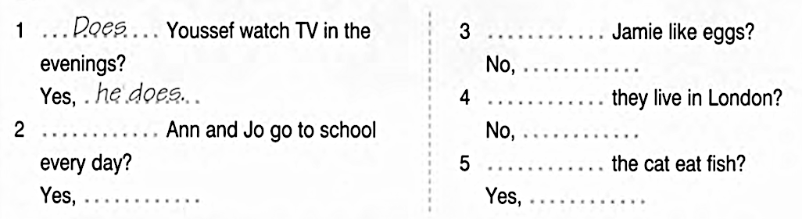
- Read and circle
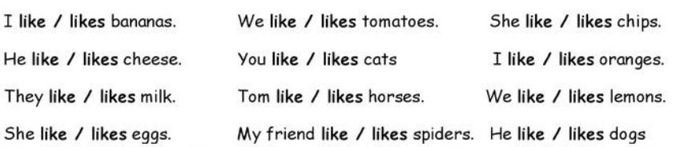
- Write like or likes
- Tom ________________________ chips.
- Mark _______________________ lemon juice.
- I _________https://meet.google.com/jnq-kcuz-pte?authuser=2&hl=vi____________ pizza.
- My cat _____________________ milk
- We ____________________ apples.
- My mother _____________________ dogs
- They _____________________ chocolate.
- My sister ___________________ ice cream.
- You and your friend _______________ cats
- My friends ________________ chicken.
- Write and match
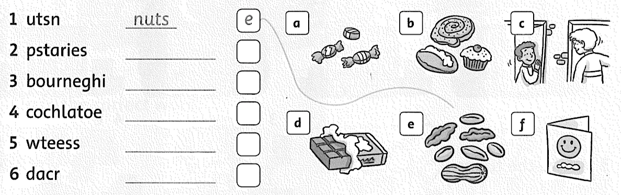

REVIEW 2
- Write the time.
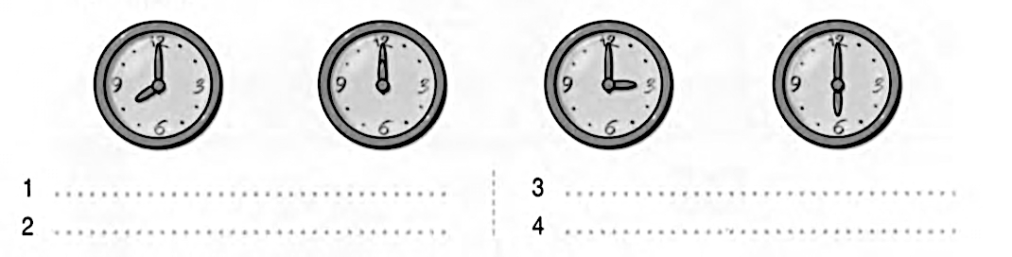
- Look at the pictures. Answer the questions.
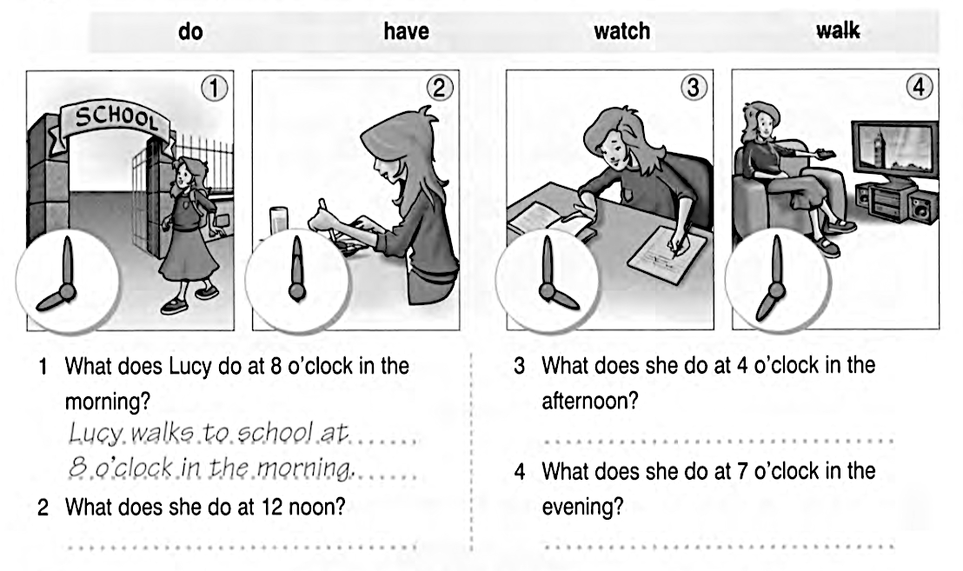
- Make a negative sentences.
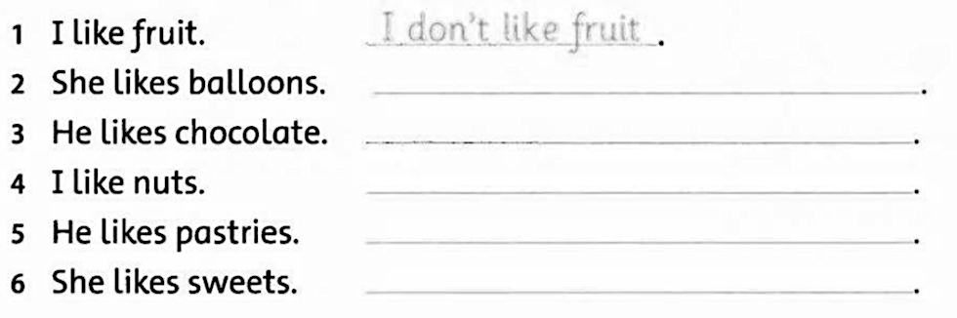
- Write. Use the verbs in bracket.
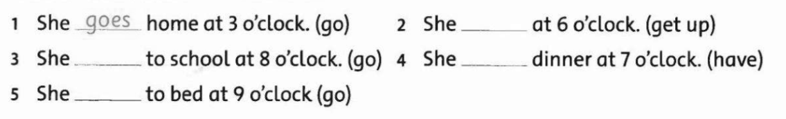

REVIEW 3
- Write questions and answers.
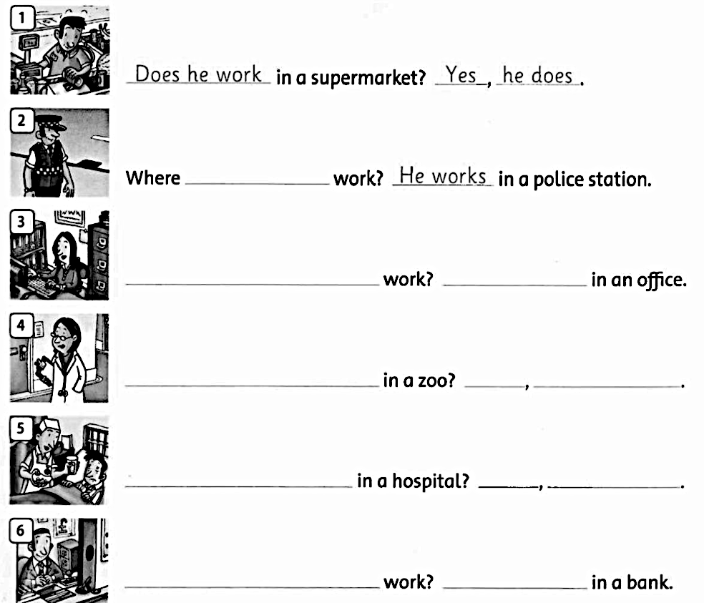
- Look and complete
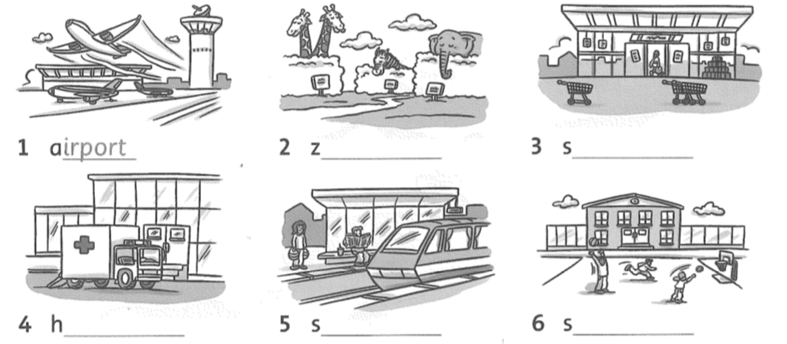

REVIEW 4
- Complete the puzzle.

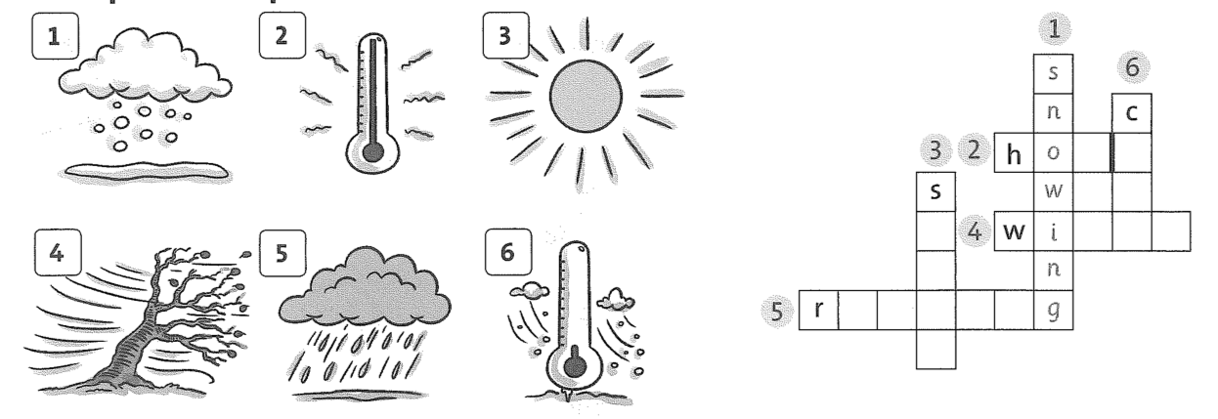
- Look and write
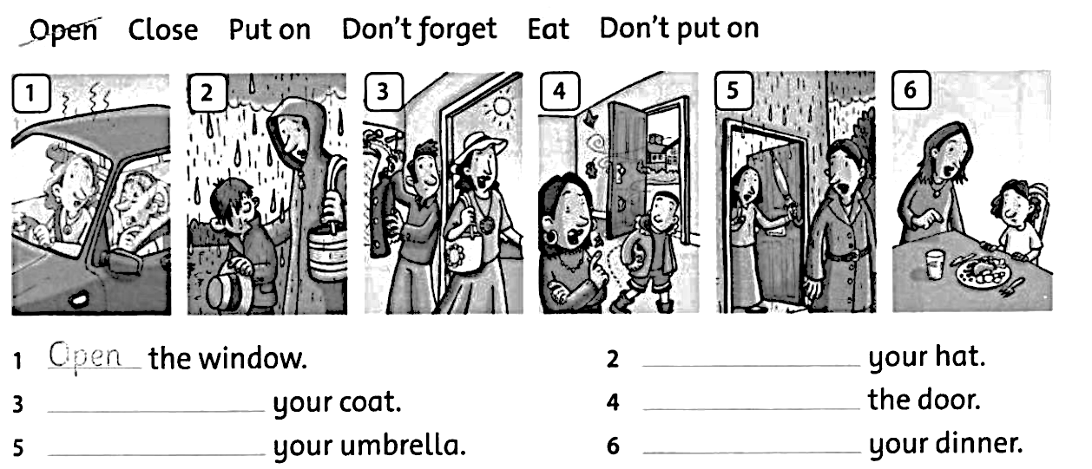
- Match.

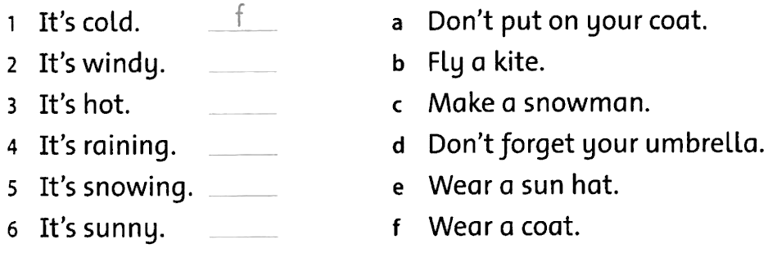

REVIEW 5
- Circle the odd one out. Write.
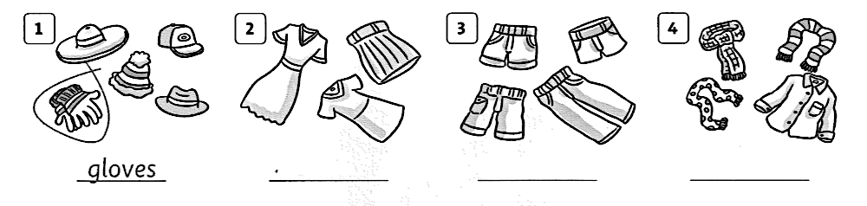
- Complete the times.
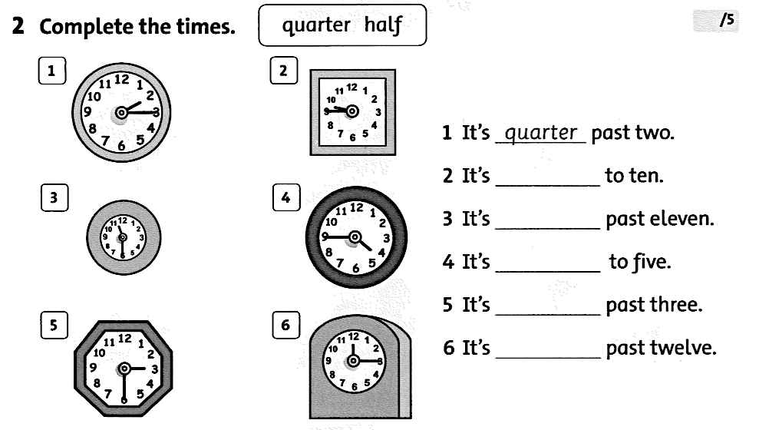
- Write the correct form of the verb in bracket.

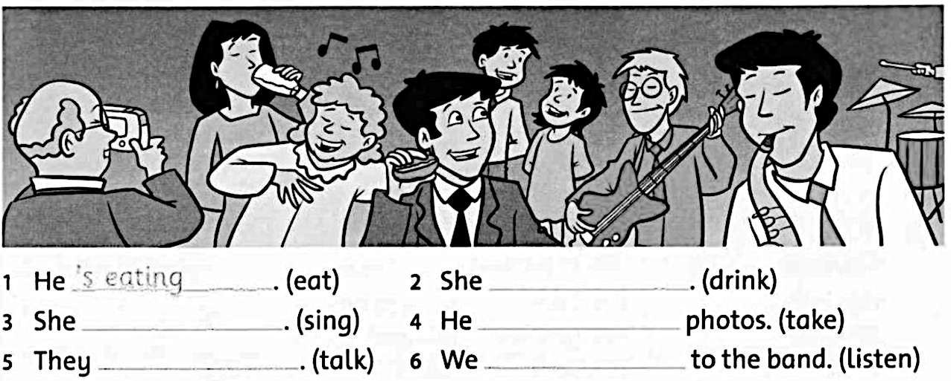

REVIEW 6
- Complete.
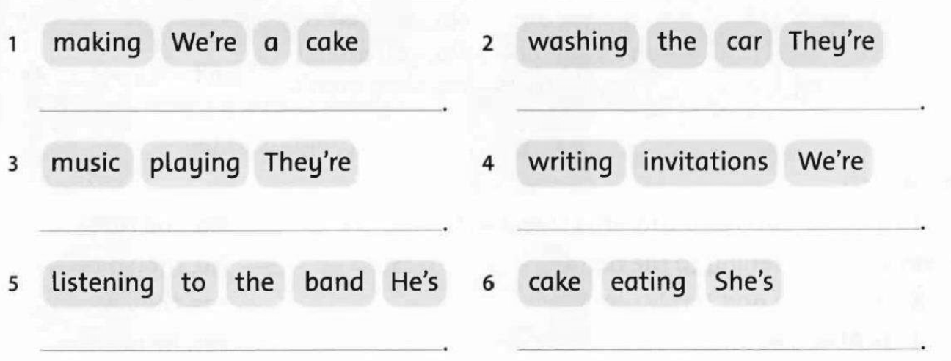
- Look and complete.
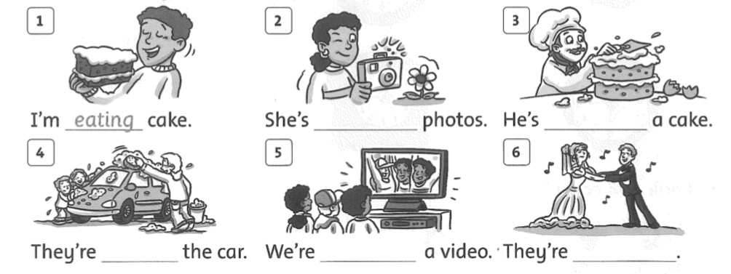
dancing

- Label the pictures.

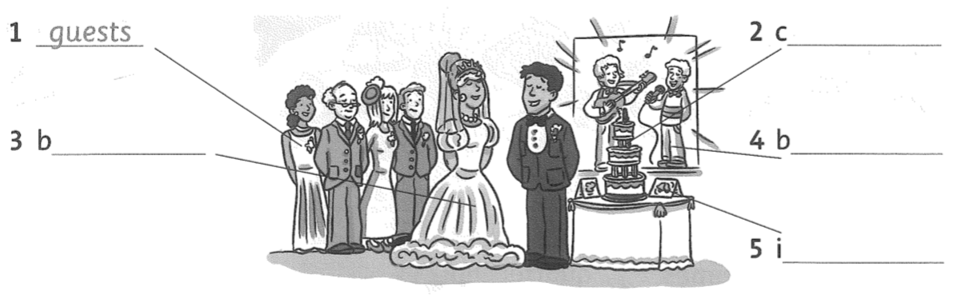

REVIEW 7
- Write. Use than and a comparative adjective.
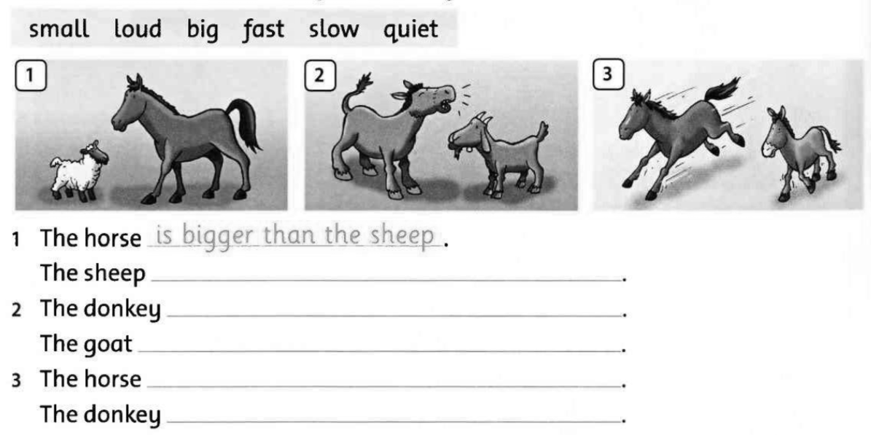
- Tick (V) the correct one.
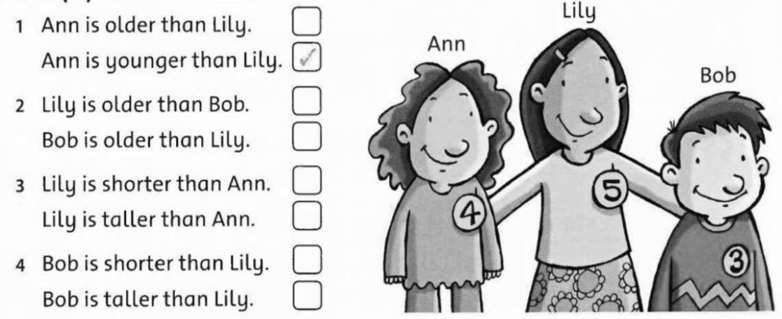

- Write sentences.
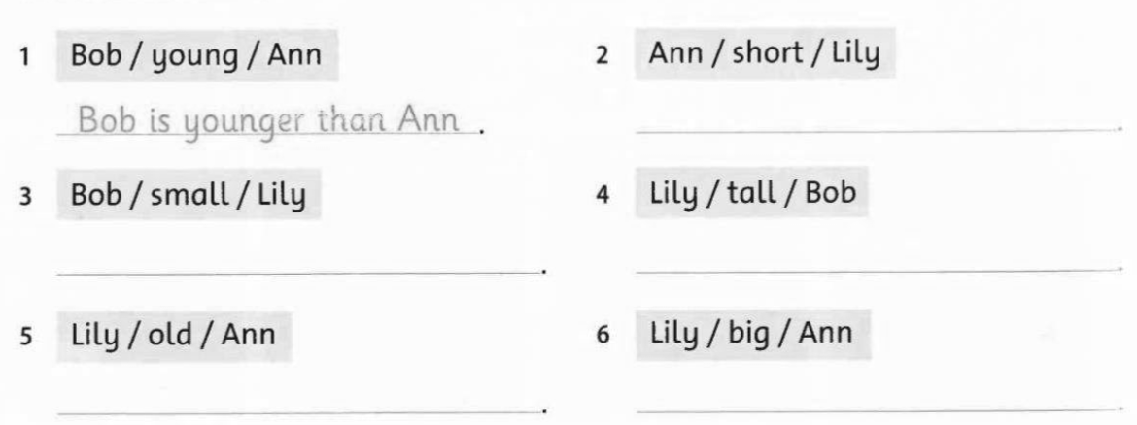

REVIEW 8
- Write the correct answer.
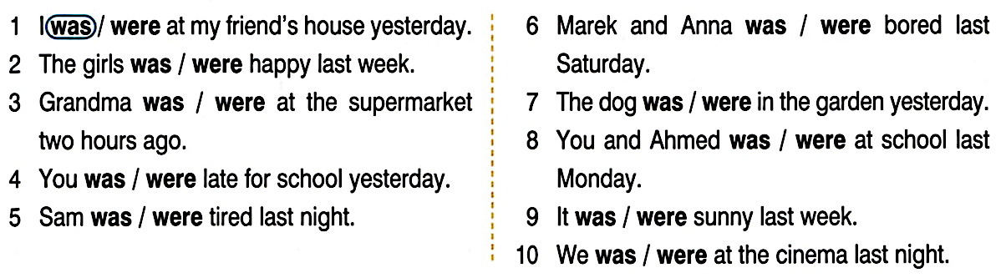
- Where were they yesterday?

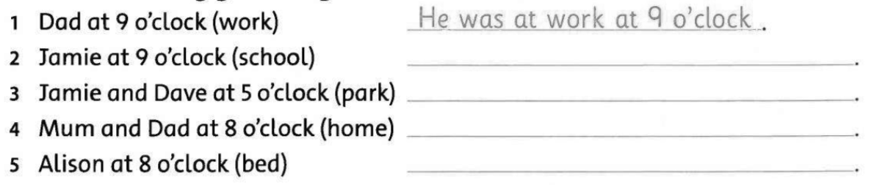

- Write the negative sentences about yesterday

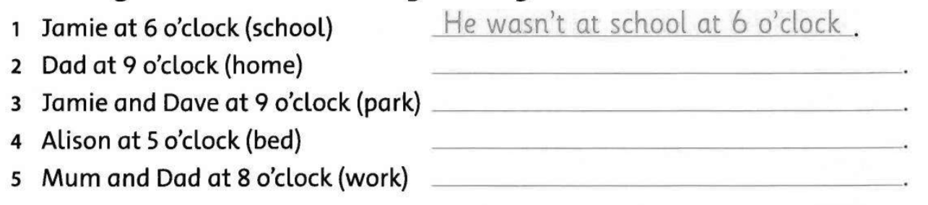
Jamie and Dave Weren’t
Mom and dad Weren’t
Jamie and Dave Weren’t
- Match
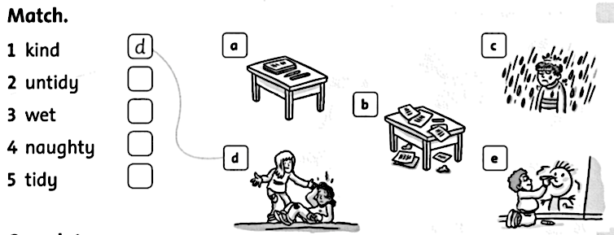

REVIEW 9
- Read and write the name under the pictures.
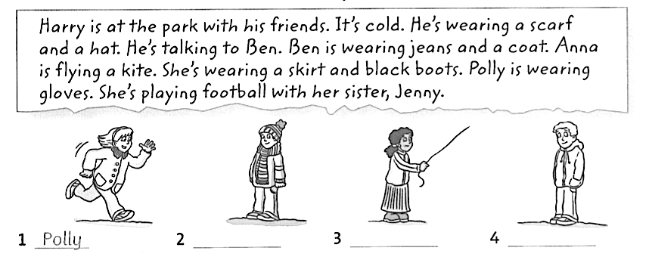
BEN
ANNA
Harry

- Read again. Circle the correct word

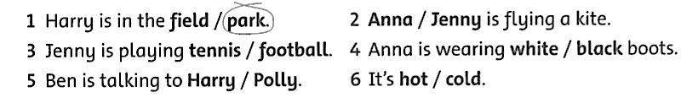

- Read and match
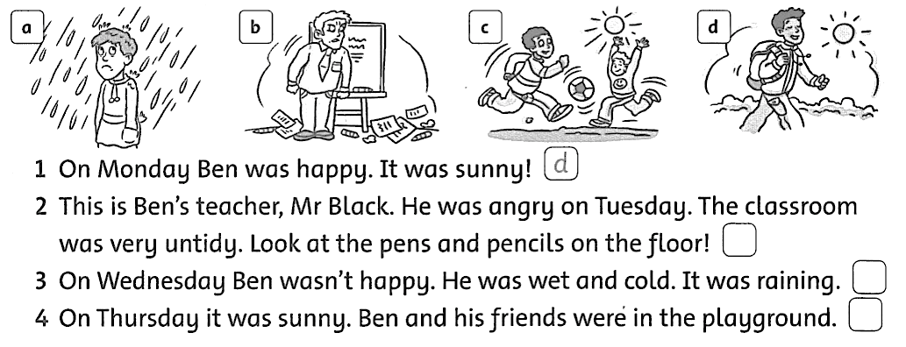
- Read the text again. Write T (true) or F (False)


