UBND THÀNH PHỐ HỒ CHÍ MINH | CỘNG HÒA XÃ HỘI CHỦ NGHĨA VIỆT NAM
TRƯỜNG CAO ĐẲNG LÝ TỰ TRỌNG | Độc lập - Tự do - Hạnh phúc
THÀNH PHỐ HỒ CHÍ MINH
ĐỀ THI KẾT THÚC HỌC PHẦN LÝ THUYẾT
HỌC KỲ: II NĂM HỌC: 2021 – 2022
Bậc đào tạo: TRUNG CẤP (T2)
Mã đề 002

Học phần: TIẾNG ANH 1
Lớp: 21T2-_________ Ngày thi: _______ / _______ / 2022
Thời gian thi: 60 phút (không kể thời gian phát đề)

Thí sinh không được sử dụng tài liệu, nộp lại đề sau khi thi
Bài thi này gồm 50 câu, mỗi câu 0.2 điểm.

Multiple-choice
1/ BRICO Co. holds a fundraising event --------- at the Lincoln Center.
a an annual b annuals c annually d annual
2/ All the people were so shocked that they could ------- say anything.
a hard b hardness c to hardly d hardly
3/ The company will become ------- when the new product is released in March.
a more profitable b profit c profitably d more profitably
4/ We are considering hiring the ------- candidate to handle this project.
a experiences b experiencing c has experienced d most experienced
5/ Mr.Donetti believes that the purchase of real estate is a -------- investment for the future.
a safeness b safely c safe d safety
6/ The two companies agreed -------- on the increase in the price of the raw materials.
a mutually b mutual c mutualness d mutuality
7/ It is impossible to get a refund without the ------- receipt from the store.
a original b originally c origin d originated
8/ We are happy to announce that Kitchenhelp is about to present its --------- website.
a updates b updater c updated d update
9/ We will try our best to resolve any problems as --------- as possible.
a quickest b quickly c quicker d quick
10/ The interviewee answered the questions as -------- as he could.
a better b best c well d good
11/ The ballet performance featured the ------- ballerina in Russia.
a best b well c good d better
12/ He is tall enough -------- volleyball.
a playing b played c play d to play
13/ I ---------- a letter from my old friend last week.
a sent b took c received d gave
14/ Let's go -------- and sit in the sun.
a inside b outside c in d over
15/ I can't see --------- without my glasses.
a clear b heavy c good d clearly
16/ We apologize for the -------------- and thank you for choosing KLY Airlines.
a delaying b delay c to delay d delayed
17/ What happens if I lose my -----------.
a passport b the c high d an
18/ They will move to a different place because of the ------------.
a rent high b high rent c rent highly d highly rent

19/ Mr. Howard called the Service Department to tell them about the television's -----------.
a defectively b defect c defected d defective
20/ High Fashion, In. on Broadway will have a sale to clear out holiday ---------.
a merchandise b merchandises c merchandising d merchants
21/ If this project goes smoothly, we will have more work with ---------- in the future.
a they b them c themselves d theirs
22/ We regret to tell -------- that we cannot deliver your recent orders.
a yours b us c you d yourself
23/ The -------- of the maintenance has to be reduced during the economic crisis.
a costly b costing c more costly d cost
24/ Ms. Page in the Marketing Department is excellent at ---------.
a presenting b presented c present d presentations
25/ Airport security staff will search -------- for any illegal items.
a luggages b some luggages c luggage d a luggage
26/ We shall finally have what is rightfully --------.
a his b we c ours d us
27/ A few -------- wrote positive reviews about the new dessert menu.
a criticize b critical c critics d critic
28/ Kelly Smith is a prospective candidate for an upcoming --------
a promotes b promoting c promotion d promote
29/ Ms. Kelly called -------- this morning, but --------- was out of town.
a him / himself b him / he c he / him d he / himself
30/ ------- are so delighted that you have agreed to work with ---------.
a We / ours b Us / ours c We / us d Ours / we
31/ The woman is -------- the grass.
a lying on b lay c lying d lain
32/ The --------- arrived thirty minutes before her appointment.
a patent b patience c patient d patiently
33/ Mr.Jeff Slim does not spend -------- money on office decorations.
a many b some c a few d much
34/ If you contact --------- , --------- will send you the new brochure.
a ours / us b we / us c us / our d us / we
35/ ------ am sure my grades are worse than --------.
a Mine / yours b I / yours c I / yourself d Mine / yourself
36/ John rarely -------- the country.
a leaving b left c leaves d leave
37/ It ------- a ball.
a are not b aren't c isn't d am not
38/ -------- Luke a teacher ?
a Are b Am c Is d Be
39/ Why ------- they here ?
a are b does c do d is
40/ Where --------- he live ?
a does b is c do d are

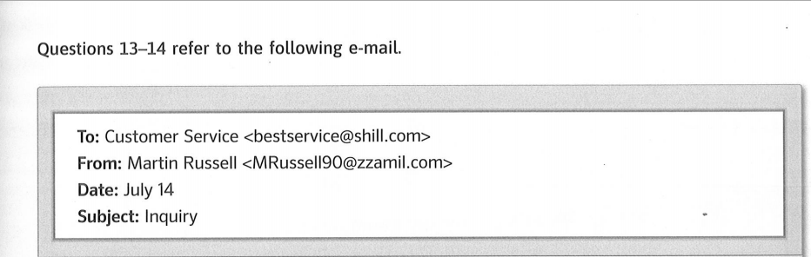
Questions 41-42 refer to the following e-mail.

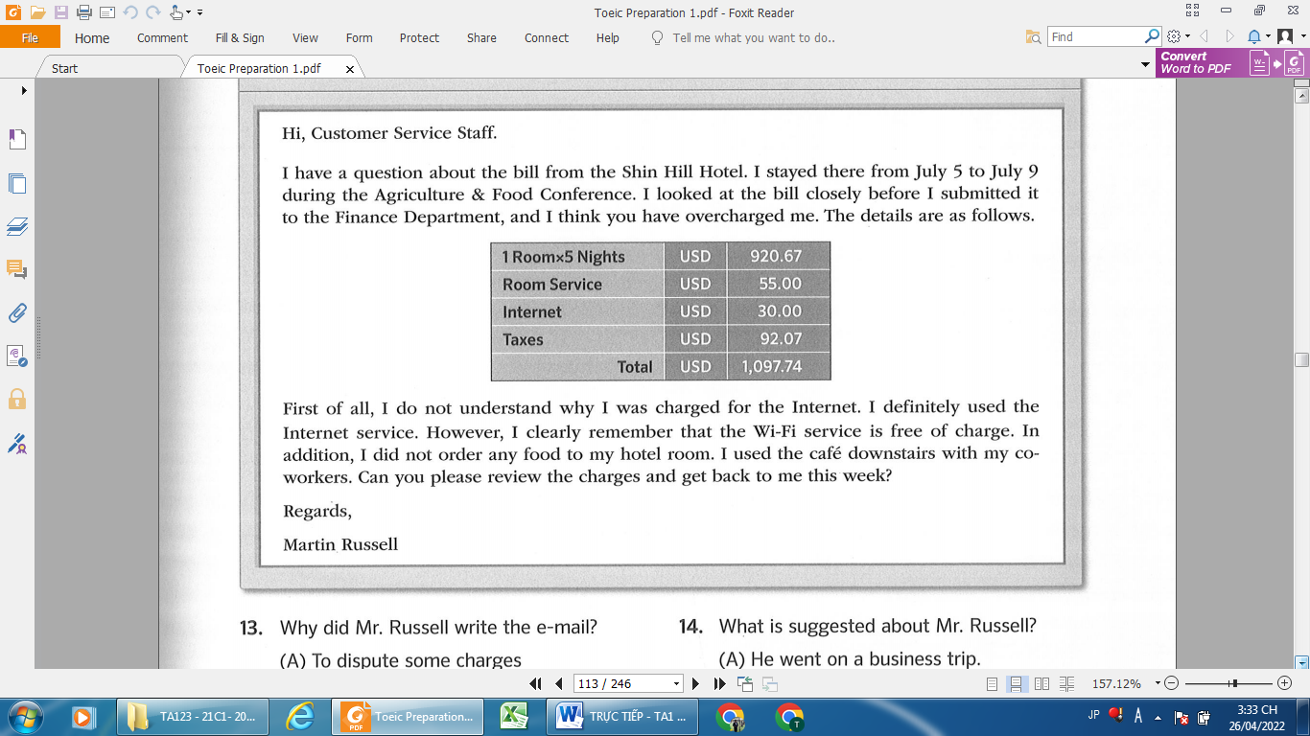

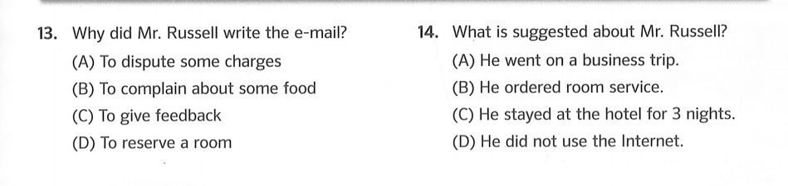
42
41
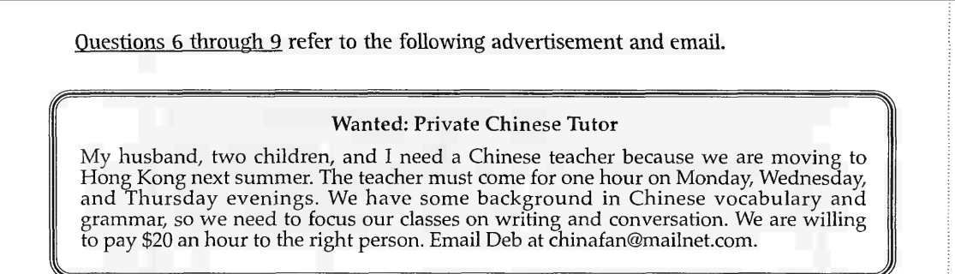
Questions 43-46 refer to the following advertisement and email.

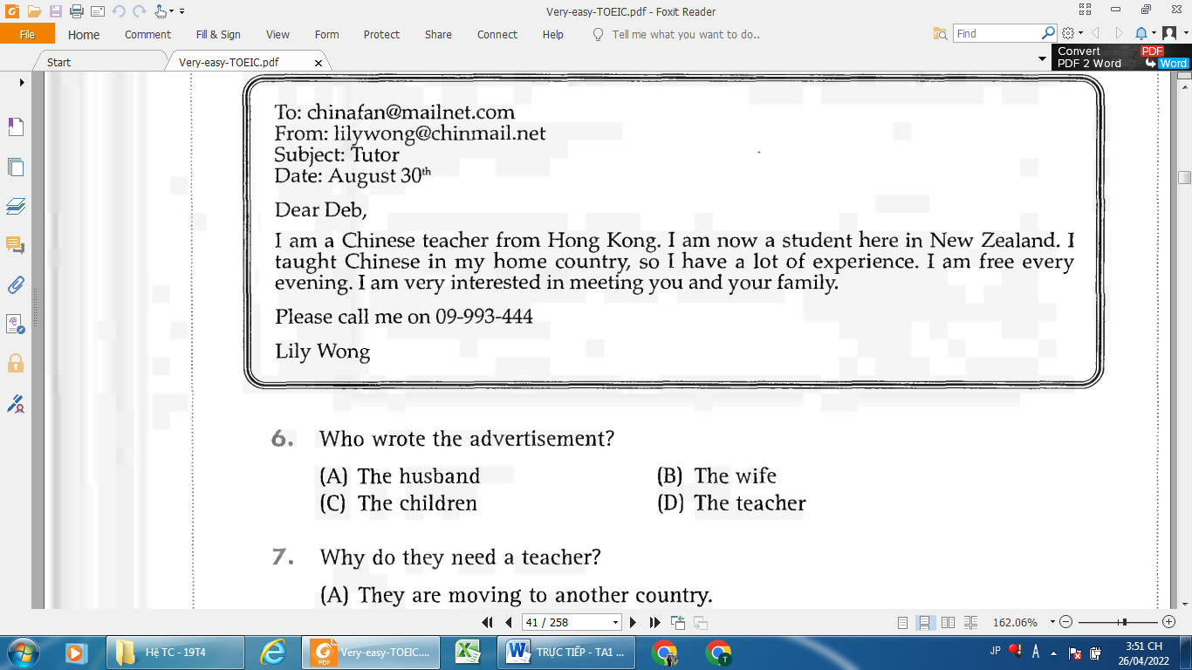

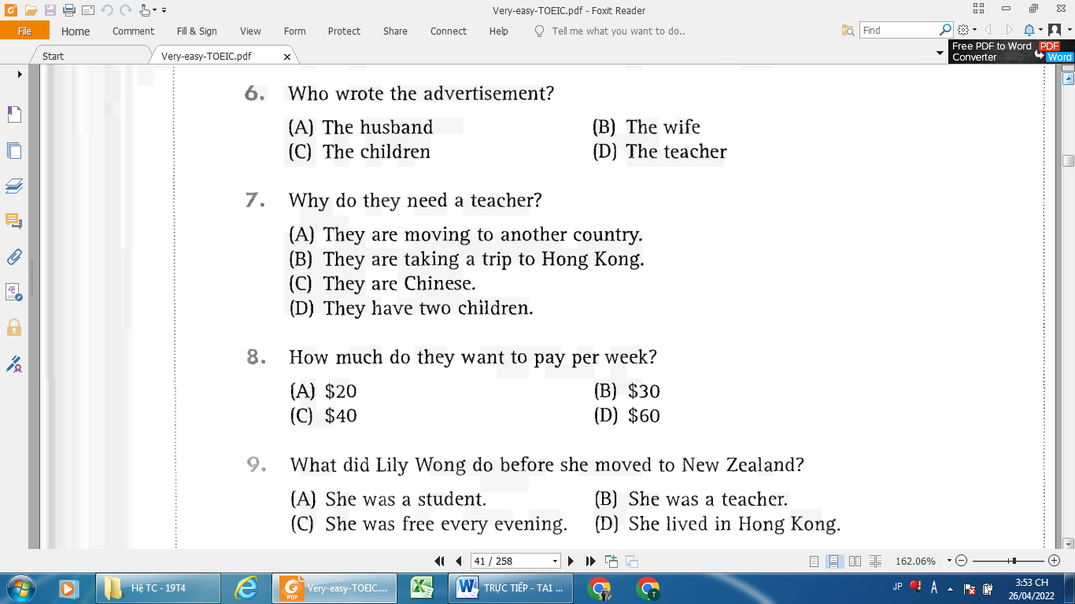
46
45
43
44

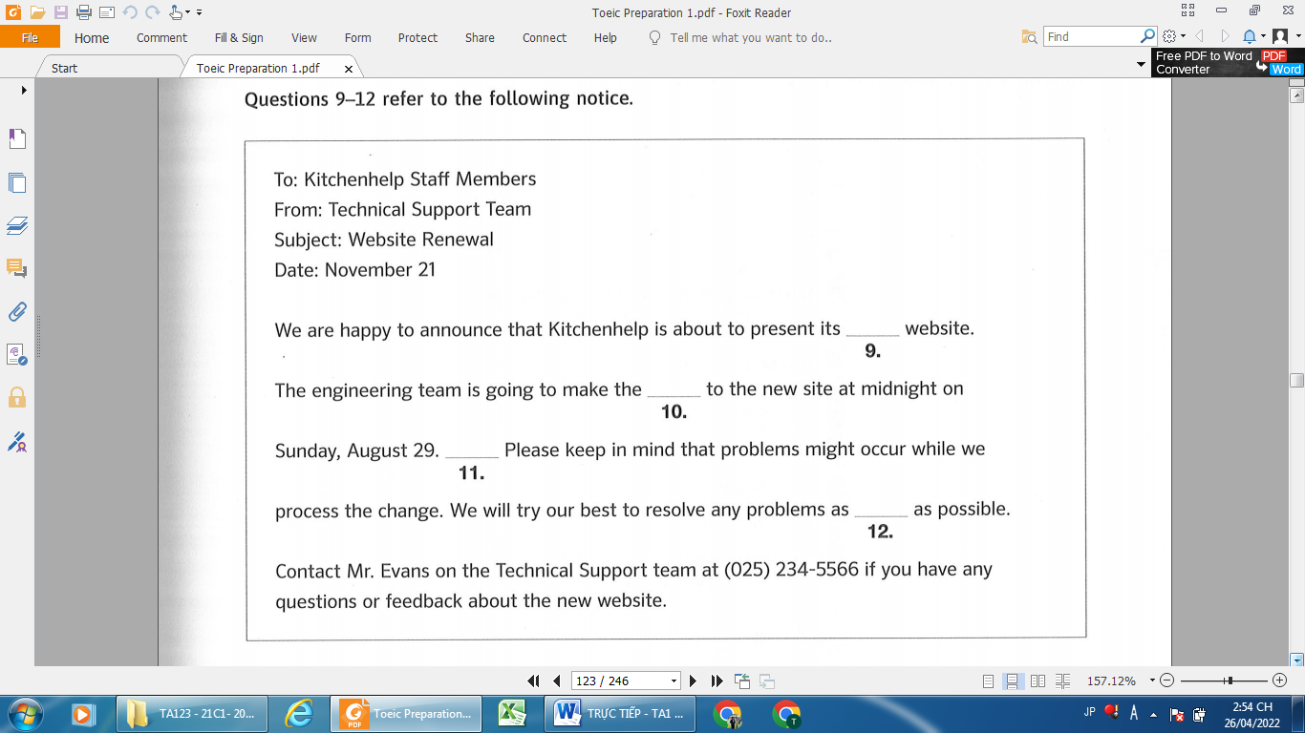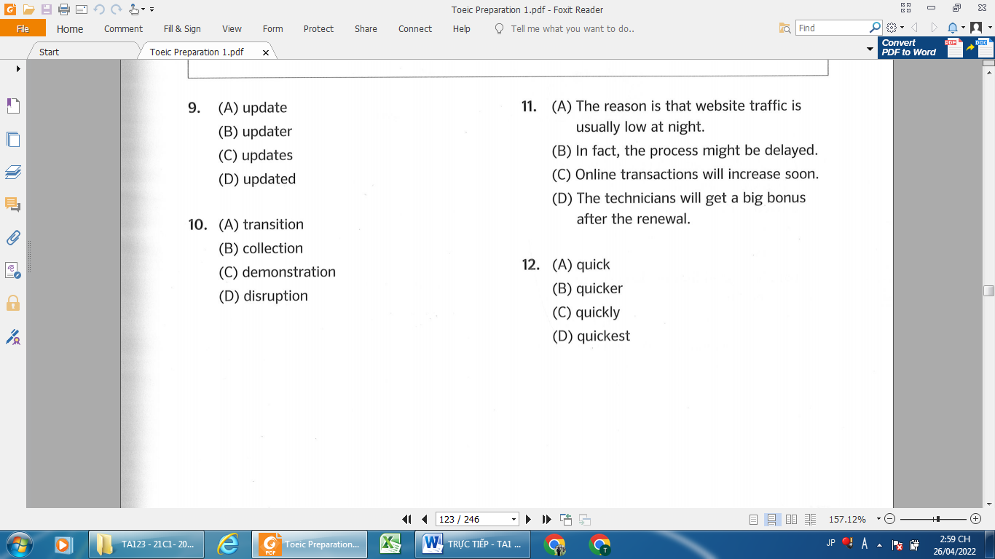
47
47
48
50
49
50
49
48
Questions 47-50 refer to the following notice.
_______Hết_______

GHI CHÚ: CÁN BỘ COI THI KHÔNG ĐƯỢC GIẢI THÍCH GÌ THÊM.

TRƯỞNG KHOA TRƯỞNG BỘ MÔN GIẢNG VIÊN RA ĐỀ
(Ký tên và ghi rõ họ tên) (Ký tên và ghi rõ họ tên) (Ký tên và ghi rõ họ tên)

