UBND THÀNH PHỐ HỒ CHÍ MINH | CỘNG HÒA XÃ HỘI CHỦ NGHĨA VIỆT NAM
TRƯỜNG CAO ĐẲNG LÝ TỰ TRỌNG | Độc lập - Tự do - Hạnh phúc
THÀNH PHỐ HỒ CHÍ MINH
ĐỀ THI KẾT THÚC HỌC PHẦN LÝ THUYẾT
HỌC KỲ: II NĂM HỌC: 2021 – 2022
Bậc đào tạo: TRUNG CẤP (T2)
Mã đề 003

Học phần: TIẾNG ANH 1
Lớp: 21T2-_________ Ngày thi: _______ / _______ / 2022
Thời gian thi: 60 phút (không kể thời gian phát đề)

Thí sinh không được sử dụng tài liệu, nộp lại đề sau khi thi
Bài thi này gồm 50 câu, mỗi câu 0.2 điểm.

Multiple-choice
1/ I am very interested ----------- the information you have given me.
a at b on c of d in
2/ Can you tell me where -------------?
a she is b is she c does she d she does
3/ You have to work -------- for the coming exam.
a more hard b hard c more hardly d hardly
4/ The Le family was sleeping when the mailman -------.
a to come b came c come d comes
5/ We -------- TV at 8 o'clock last night.
a were watching b watched c are watching d watch
6/ I don't know how ------- the game.
a can I play b to play c played d playing
7/ Have you ------- about Hoa since her accident?
a heard b hear c hearing d to hear
8/ The girl enjoys -------- her fitness exercise after classes.
a do b to do c did d doing
9/ I'd like you -------- with me for some days.
a staying b stayed c will stay d to stay
10/ What's wrong -------- the engine? It's making an awful noise.
a to b about c of d with
11/ You can't watch the television - It's broken.
a unplugged b in pieces c not working d unnecessary
12/ I forgot to bring a pen. Can you lend me -------?
a pen b it c one d your
13/ The policy has caused thousands of families --------- suffering.
a necessarily b unnecessarily c necessary d unnecessary
14/ --------- a pet when you were young?
a Have you had b Was you having c Did you have d Do you have
15/ Marie --------- at the age of 86, in 1964.
a has died b died c dies d was died
16/ This food tastes very ---------.
a wonder b wonderfully c deliciously d delicious
17/ We delayed our trip due to the bad weather.
a therefore b because of c however d because
18/ He ------- a prize in the competition last week.
a wins b won c has win d win
19/ My father -------- to work every moring.
a walks b runs c jogs d goes
20/ --------- going to work, he had a big breakfast.
a Than b Before c After d Then

21/ He -------- some prizes for ten years.
a was won b has won c win d won
22/ What ------- the weather like in Ho Chi Minh City yesterday?
a is b has been c was d will be
23/ I ------- this picture 5 years ago.
a am seeing b was seeing c have seen d saw
24/ Millions of Christmas cards --------- every year.
a sent b are sent c is sending d were sent
25/ I don't understand this word. What --------- ?
a does this word mean b does mean this word
c means this word d this word means
26/ I usually ------------ to school.
a going b go c went d goes
27/ They -------- us often.
a visit b visits c to visit d visiting
28/ Tom ---------- every day.
a working b worked c works d work
29/ He always ------- me funny stories.
a to tell b tell c told d tells
30/ Martha and Kevin -------- twice a week.
a swimming b swam c to swim d swim
31/ Lories -------- to Paris every every Sunday.
a travelling b travelled c travels d travel
32/ I -------- a student.
a are b be c am d is
33/ It ------- a ball.
a are not b aren't c isn't d am not
34/ -------- Luke a teacher ?
a Am b Be c Are d Is
35/ They --------- my parents.
a am not b are not c is d is not
36/ We -------- travel every summer.
a dơn't b doesn't c are not d does
37/ -------- you -------- soccer ?
a Aren't - play b Do - play c Are - play d Does - play
38/ --------- this your car ?
a Isn't b Is c Aren't d Both a & b are right.
39/ Why ------- they here ?
a is b do c are d does
40/ What ------- they -------- ?
a do - play b does - play c do - plays d are - play
Questions 41-42 refer to the following note.
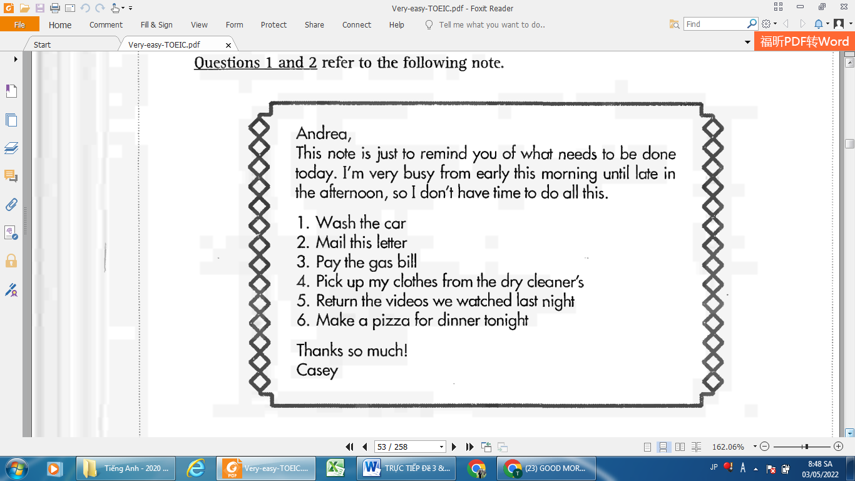
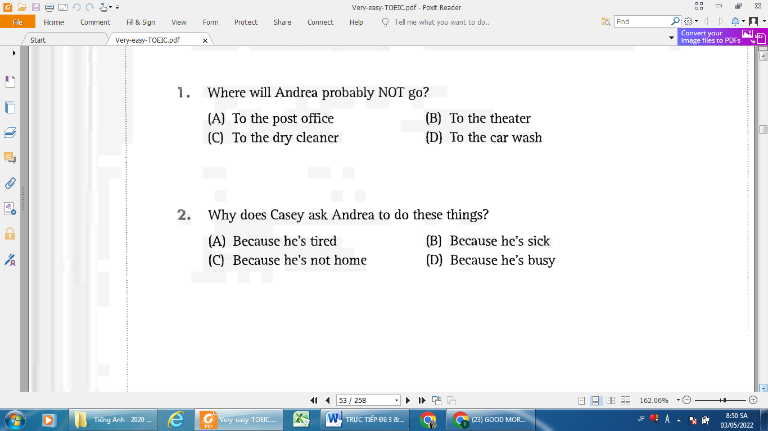
41......
42.....
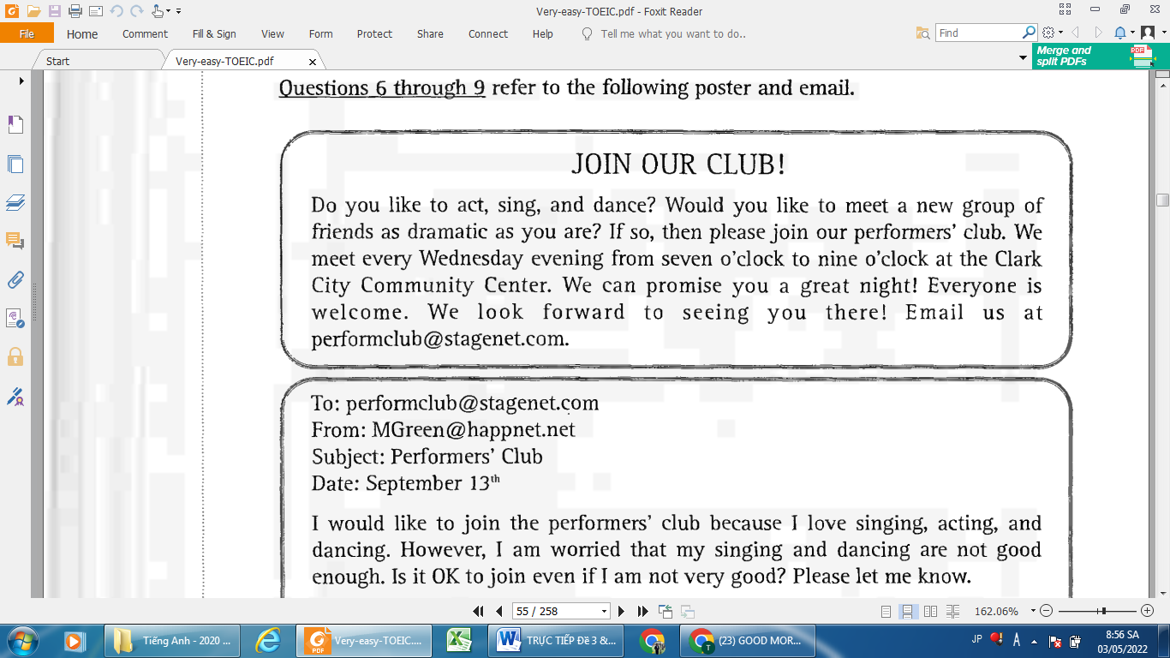
Questions 43-46 refer to the following poster and email.

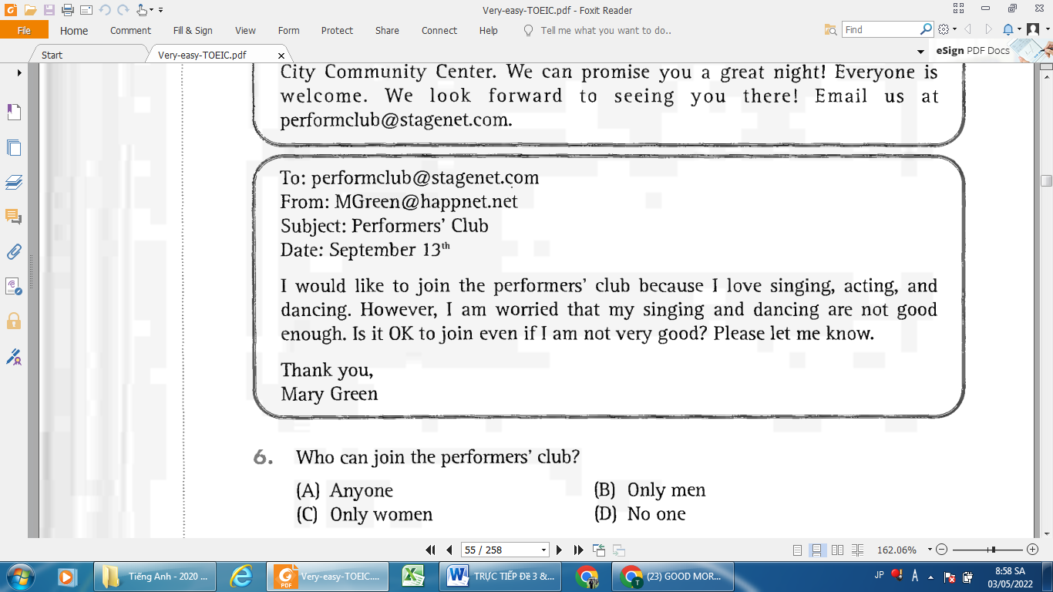
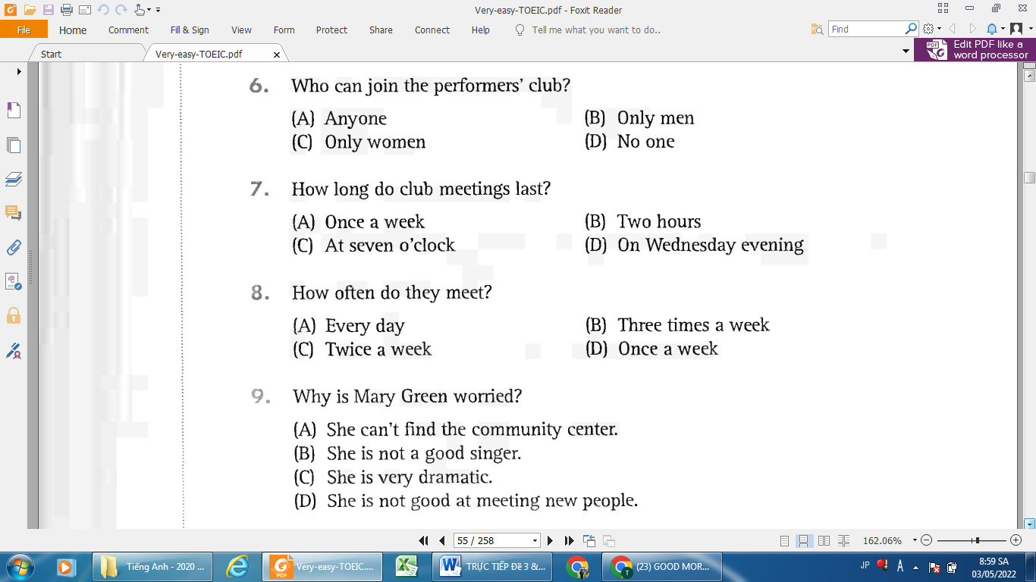
43.
46.
45.
44.
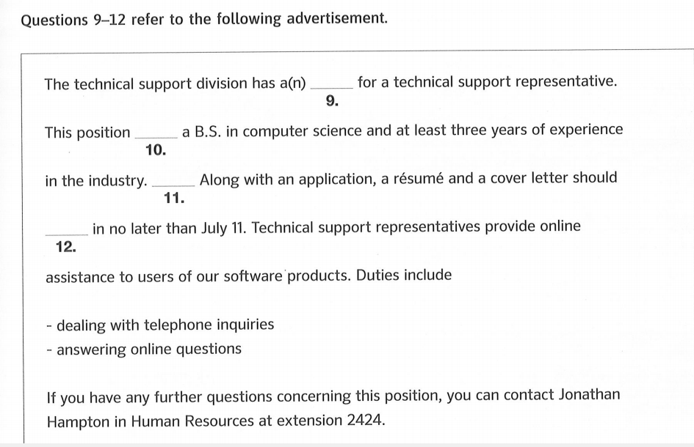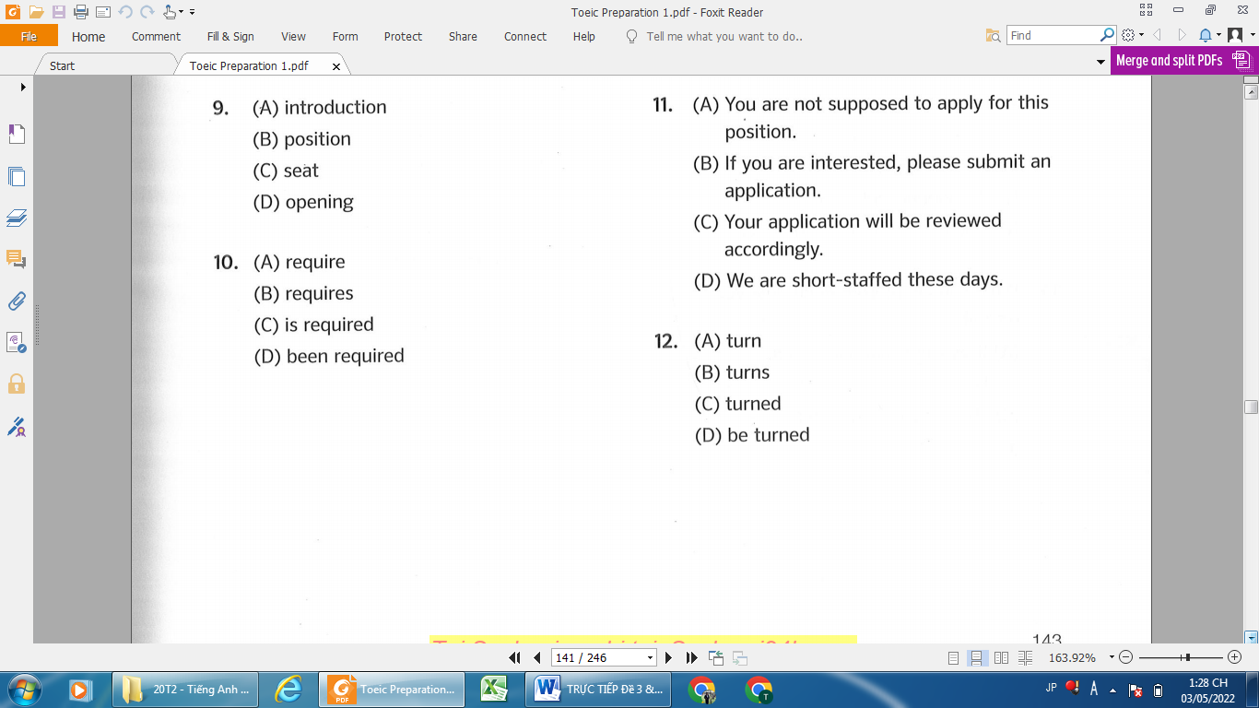
50.
49.
48.
47.
47.
50.
49.
48.
Questions 47-50 refer to the following advertisement.

_______Hết_______

GHI CHÚ: CÁN BỘ COI THI KHÔNG ĐƯỢC GIẢI THÍCH GÌ THÊM.

TRƯỞNG KHOA TRƯỞNG BỘ MÔN GIẢNG VIÊN RA ĐỀ
(Ký tên và ghi rõ họ tên) (Ký tên và ghi rõ họ tên) (Ký tên và ghi rõ họ tên)

