UBND THÀNH PHỐ HỒ CHÍ MINH | CỘNG HÒA XÃ HỘI CHỦ NGHĨA VIỆT NAM
TRƯỜNG CAO ĐẲNG LÝ TỰ TRỌNG | Độc lập - Tự do - Hạnh phúc
THÀNH PHỐ HỒ CHÍ MINH
ĐỀ THI KẾT THÚC HỌC PHẦN LÝ THUYẾT
HỌC KỲ: II NĂM HỌC: 2021 – 2022
Bậc đào tạo: TRUNG CẤP (T2)
Mã đề 004

Học phần: TIẾNG ANH 1
Lớp: 21T2-_________ Ngày thi: _______ / _______ / 2022
Thời gian thi: 60 phút (không kể thời gian phát đề)

Thí sinh không được sử dụng tài liệu, nộp lại đề sau khi thi
Bài thi này gồm 50 câu, mỗi câu 0.2 điểm.

Multiple-choice
1/ I usually ------------ to school.
a go b going c goes d went
2/ They -------- us often.
a visits b to visit c visit d visiting
3/ Tom ---------- every day.
a work b works c working d worked
4/ Martha and Kevin -------- twice a week.
a swim b to swim c swam d swimming
5/ John rarely -------- the country.
a leaves b leave c left d leaving
6/ Lories -------- to Paris every every Sunday.
a travelling b travel c travels d travelled
7/ I ------- cookies twice a month.
a bake b bakes c baking d baked
8/ I -------- a student.
a is b am c are d be
9/ He -------- my son.
a am not b am c are d is
10/ It ------- a ball.
a am not b aren't c isn't d are not
11/ They --------- my parents.
a is not b am not c are not d is
12/ We -------- travel every summer.
a doesn't b dơn't c does d are not
13/ -------- you -------- soccer ?
a Do - play b Are - play c Aren't - play d Does - play
14/ Where --------- he live ?
a are b do c is d does
15/ What ------- they -------- ?
a are - play b do - play c do - plays d does - play
16/ I am very interested ----------- the information you have given me.
a in b of c on d at
17/ Can you tell me where -------------?
a does she b she is c she does d is she
18/ You have to work -------- for the coming exam.
a more hardly b hardly c hard d more hard
19/ The Le family was sleeping when the mailman -------.
a come b came c to come d comes
20/ We -------- TV at 8 o'clock last night.
a watched b are watching c were watching d watch
21/ I don't know how ------- the game.
a can I play b played c playing d to play
22/ Have you ------- about Hoa since her accident?
a hear b heard c to hear d hearing
23/ The girl enjoys -------- her fitness exercise after classes.
a did b doing c to do d do
24/ I'd like you -------- with me for some days.
a will stay b stayed c to stay d staying
25/ What's wrong -------- the engine? It's making an awful noise.
a about b of c with d to
26/ You can't watch the television - It's broken.
a unnecessary b unplugged c in pieces d not working
27/ I forgot to bring a pen. Can you lend me -------?
a pen b one c it d your
28/ The policy has caused thousands of families --------- suffering.
a unnecessary b necessary c necessarily d unnecessarily
29/ --------- a pet when you were young?
a Have you had b Was you having
c Did you have d Do you have
30/ Marie --------- at the age of 86, in 1964.
a died b was died c has died d dies
31/ This food tastes very ---------.
a wonderfully b delicious c deliciously d wonder
32/ We delayed our trip due to the bad weather.
a however b because of c therefore d because
33/ He ------- a prize in the competition last week.
a win b won c has win d wins
34/ My father -------- to work every moring.
a runs b walks c goes d jogs
35/ --------- going to work, he had a big breakfast.
a After b Then c Before d Than
36/ He -------- some prizes for ten years.
a win b won c was won d has won
37/ What ------- the weather like in Ho Chi Minh City yesterday?
a has been b will be c is d was
38/ I ------- this picture 5 years ago.
a am seeing b have seen c saw d was seeing
39/ Millions of Christmas cards --------- every year.
a were sent b sent c are sent d is sending
40/ I don't understand this word. What --------- ?
a means this word b this word means
c does this word mean d does mean this word
Questions 41-44 refer to the following advertisement.
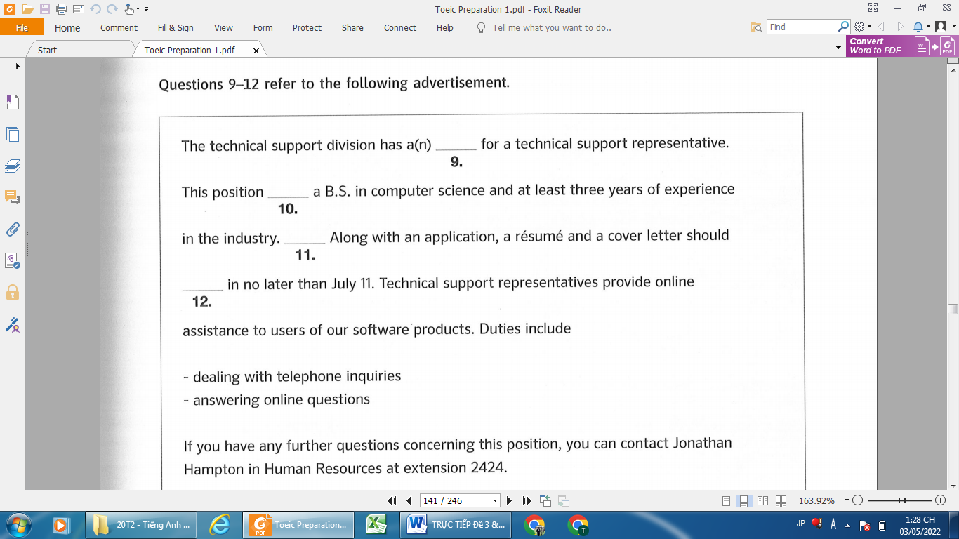
44. 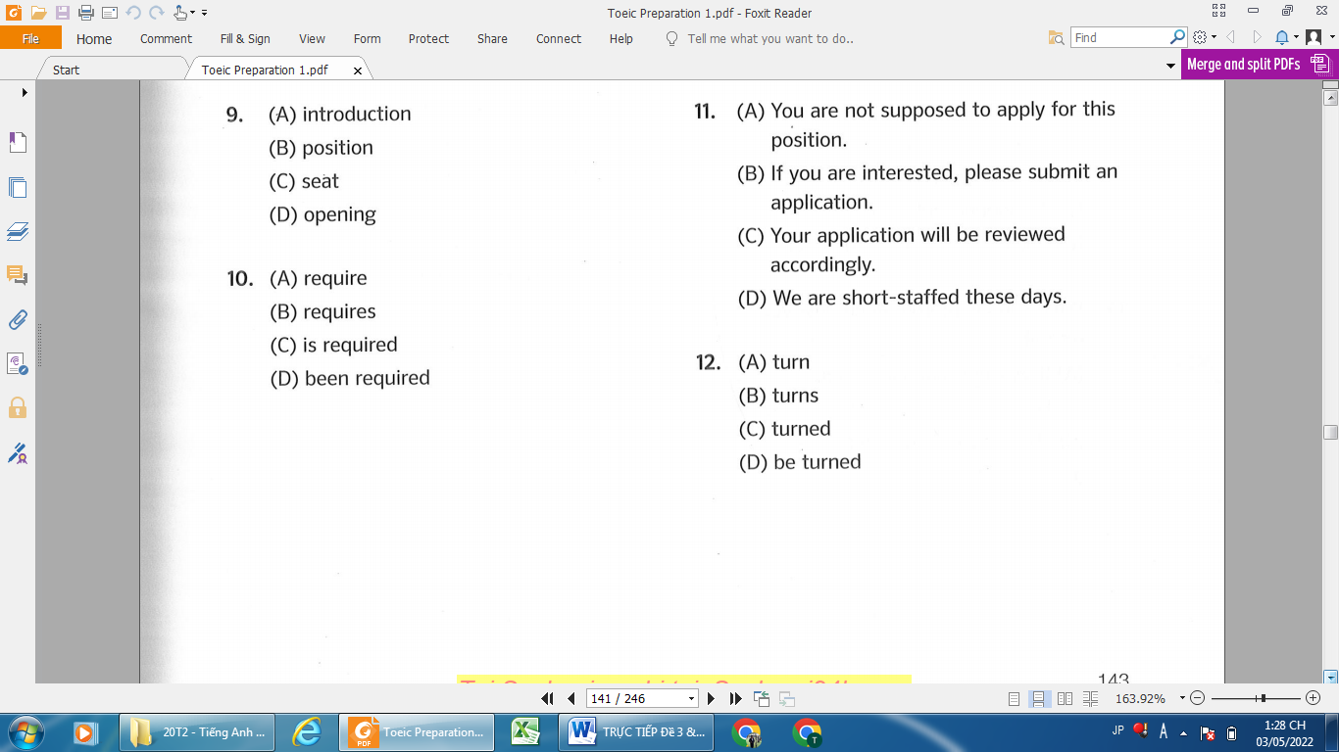
43.
42.
41.
44.
41.
42.
43.
Questions 45-46 refer to the following note.
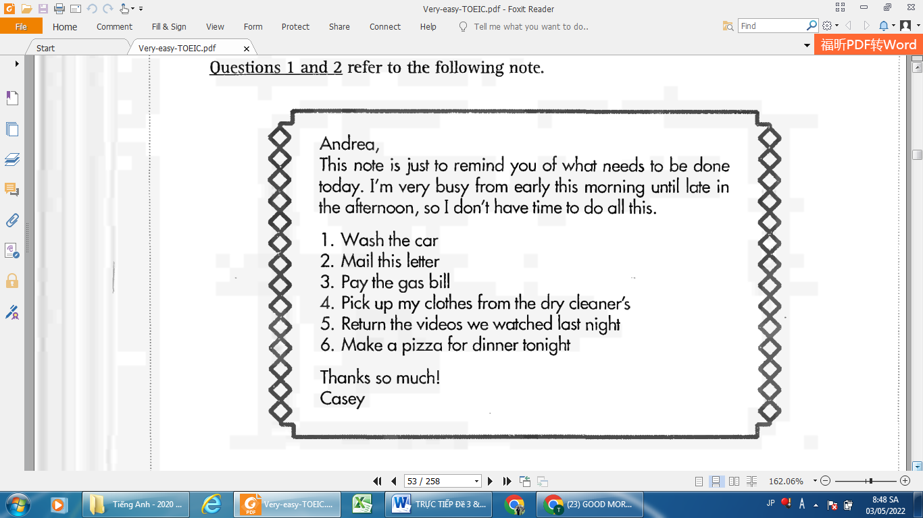

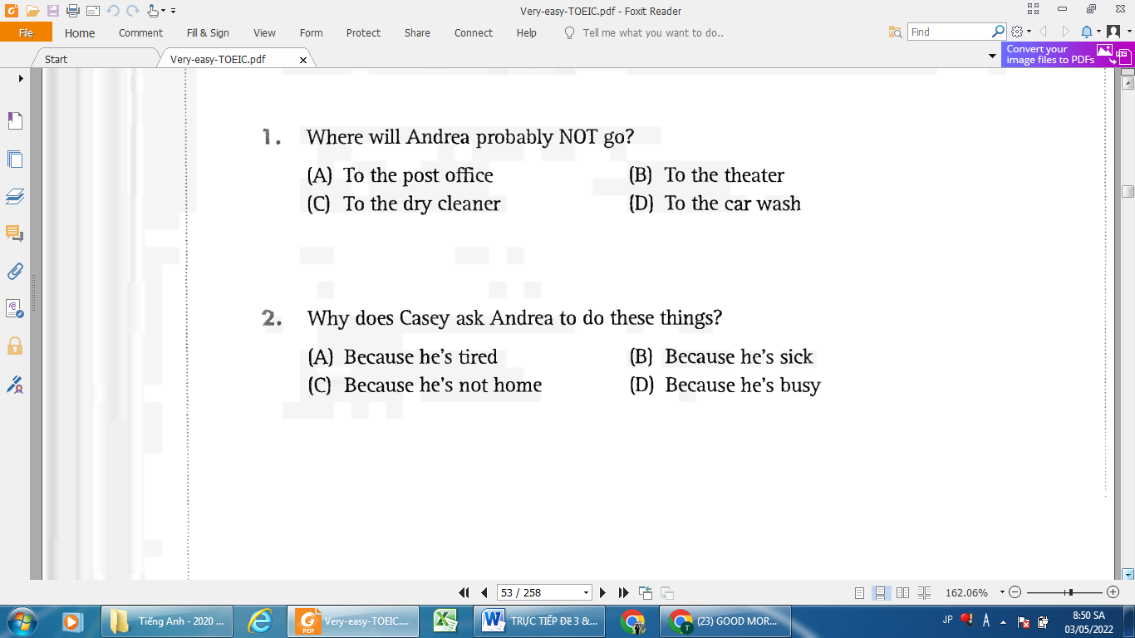
46.
45.
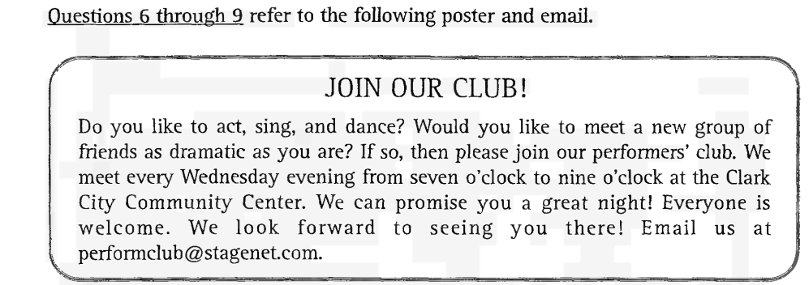
Questions 47-50 refer to the following poster and email.
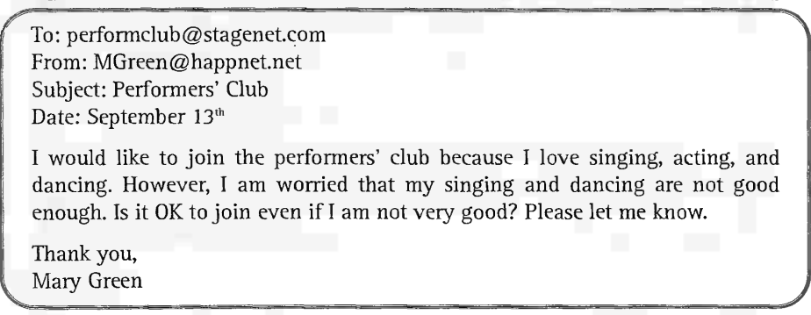
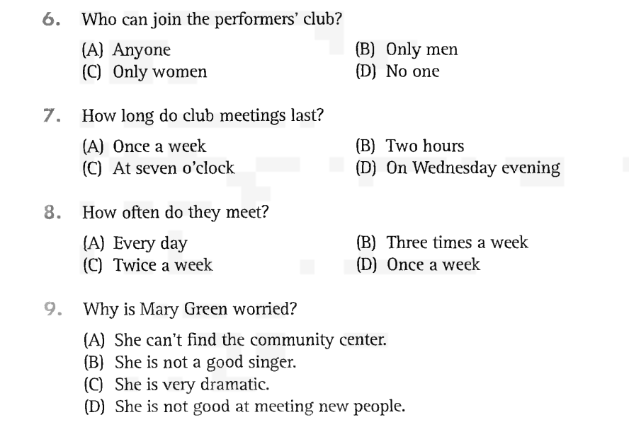
50..
49..
48.
47.
_______Hết_______

GHI CHÚ: CÁN BỘ COI THI KHÔNG ĐƯỢC GIẢI THÍCH GÌ THÊM.

TRƯỞNG KHOA TRƯỞNG BỘ MÔN GIẢNG VIÊN RA ĐỀ
(Ký tên và ghi rõ họ tên) (Ký tên và ghi rõ họ tên) (Ký tên và ghi rõ họ tên)

