UBND THÀNH PHỐ HỒ CHÍ MINH | CỘNG HÒA XÃ HỘI CHỦ NGHĨA VIỆT NAM
TRƯỜNG CAO ĐẲNG LÝ TỰ TRỌNG | Độc lập - Tự do - Hạnh phúc
THÀNH PHỐ HỒ CHÍ MINH

ĐỀ THI KẾT THÚC HỌC PHẦN LÝ THUYẾT
HỌC KỲ: II NĂM HỌC: 2021 – 2022

Bậc đào tạo: CAO ĐẲNG
Học phần: TIẾNG ANH 3
Lớp: 21C - Ngày thi: ____ / ____ / 2022
Thời gian thi: 60 PHÚT (không kể thời gian phát đề)
Đề số 002

CHOOSE THE CORRECT ANSWER FOR EACH QUESTION:
1/ Please let me know ____ you need us to prepare anything.
a. because b. while c. if d. so
2/ ____ we´ve had our disagreements in the past, it would be nice to celebrate Jason´s birthday together.
a. Although b. Because c. While d. If
3/ I´ve decided to come to the party ____.
a. any more b. any way c. anyway d. any longer
4/ People often ask me what it ____ to be an actress.
a. is liking b. like c. is like d. is likes
5/ You have to work very hard and most ____ are in the evening so you have to work very late hours.
a. performances b. intermissions c. famous d. curtains
6/ You have to stand most of the time and you can only rest during the ___.
a. famous b. performances c. intermission d. curtains
7/ I remember when I was a(n) ____, I had to keep the audience quiet.
a. auditorium b. stand c. curtain d. usher
8/ When the ____ goes up and you see the audiences sitting in the ____, it’s a very special feeling.
a. curtain – intermission b. performances - auditorium
c. auditorium – usher d. curtain - auditorium
9/ It’s fun seeing my name in the theater program and being ____ by people in the street.
a. fun b. recognized c. gone d. done
10/ My electricity ____ was really high this month!
a. bill b. thermostat c. energy d. appliance
11/ They are looking for a ____ girl named Anna. She got lost in the park.
a. seven-old-year b. seven-years-old c. seven-old-years d. seven-year-old
12/ Clayton works ____, doesn’t he?
a. part time b. a work c. a job d. partly
13/ I don't know what ____ like to be famous.
a. is it b. it c. is d. it is
14/ Don't forget to change the oil - ____ 3,000 miles.
a. every b. another c. other d. each
15/ I don't go to that language school ____.
a. either b. some c. others d. both
16/ He came late yesterday and so ____.
a. she did b. does she c. she does d. did she
17/ ____ a doctor, Adam rushed over to help the sick child.
a. Is b. Be c. Being d. Was
18/ He scarcely had enough ____ to pay for his dinner.
a. money b. cashes c. moneys d. coin
19/ I have a feeling that ____ is going to happen today.
a. some bad b. bad something c. something bad d. some badly
20/ I didn't feel well, so I ____ early.
a. went home b. went my home c. went to home d. went back my home
21/ I don't like that one ____.
a. too b. either c. alike d. neither
22/ Would you like ____ tea?
a. some b. anything c. few d. little
23/ He has two dogs: one is from England and ____ is from Germany.
a. an other b. the other c. other d. another
24/ Most people think bread is expensive ____ difficult to make.
a. but b. when c. and d. so
25/ However, it is ____ easy and cheap.
a. both b. either c. also d. neither
26/ All you need to make a basic dough ____ flour, milk, a little salt and sugar, and yeast.
a. are b. to be c. be d. is
27/ The sugar is very important to ____ the yeast.
a. active b. actively c. activate d. act
28/ ____ snow, the mountain looks fantastic.
a. Covering b. To cover c. To have covered d. Covered with
29/ Everybody ____ with the results of the meeting.
a. was satisfied b. was satisfy c. satisfied d. was to satisfy
30/ Left alone, the baby ____ into tears.
a. burst b. sobbed c. poured d. cried
31/ Why was the soccer game ____ yesterday?
a. cancelled b. canceling c. cancel d. to cancel
32/ Last week, John ____ an award for his community service.
a. was gave b. gave c. had been given d. was given
33/ A second attempt was made to collect ____ from the space probe.
a. fact b. informations c. data d. knowledges
34/ Once the files are ready, please have them ____ me.
a. sent to b. send to c. send d. sent into
35/ The pictures, ____ by a professional photographer, are going to be on display.
a. which taken b. taken c. were taken d. was taken
36/ I can't ____ it anymore. That website seems to have suddenly vanished.
a. access b. pass c. log out d. reaching
37/ Dick didn't pass the test, ____ did his friend, John.
a. and b. nor c. so d. if
38/ My foot still hurt yesterday, ____ I went to see a doctor.
a. but b. for c. so d. when
39/ He left home early ____ failed to catch the train.
a. but b. and c. or d. therefore
40/ ____ he was cooking, his wife was working in the yard.
a. And b. Yet c. But d. While
41/ He works to support his family, ____ he is in his seventies.
a. because b. during c. despite d. although
42/ I haven't seen him ____ ages.
a. for b. during c. until d. with
43/ Experts say it is very important for children over the age of six to develop a hobby or ____ part in a club.
a. take b. do c. be d. make

Questions 44-45 refer to the following text message.

[Nicky Candela] 11:01 A.M.
Jacob, there have been some changes. Could you stop for some supplies on your way to work?
[Jacob Brosky] 11:04 A.M.
Oh, sure thing. But I thought that we got everything yesterday.
[Nicky Candela] 11:07 A.M.
I just got a call from Ms. Arden's wedding planner. She wants to add 40 cupcakes to her order. I've already put them in the oven, but we're all out of decorative silver beads. Also, we need more yellow icing to mix the right colors.
[Jacob Brosky] 11:08 A.M.
OK, so we need at least two bags of silver beads and four tubes of yellow icing, I'm guessing.
[Nicky Candela] 11:10 A.M.
Exactly. We'll finish that this morning and then begin work on the food items for Mr. and Mrs. Morton's anniversary party.

44. What most likely is Ms. Candela’s job?
a. A store manager
b. A restaurant critic
c. A wedding planner
d. An event caterer

45. At 11:08 am, what does Mr. Brosky most likely mean when he writes, “I'm guessing”?
a. He would like to confirm the details of a request.
b. He believes someone already went to a store.
c. He could not understand a request.
d. He wants to check it he already has some materials.

Questions 46-47 refer to the following ticket.

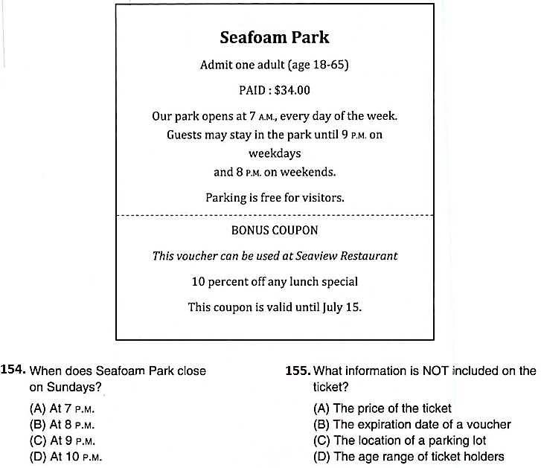

46. When does Seafoam Park close on Sundays?
a. At 7 pm
b. At 8 pm
c. At 9 pm
d. At 10 pm
47. What information is NOT included on the ticket?
a. The price of the ticket
b. The expiration date of a voucher
c. The location of a parking lot
d. The age range of ticket holders

Questions 48-50 refer to the following business letter.

Shangwan Corp.
211 Orchard Street
Thailand
March 14, 2008
Attn: Mr. Andrew Han
Sales Manager
Evergreen Light Bulbs
4-16 Hill Road
Hong Kong

Dear Mr. Han,
Re: Order No. 768197
I regret to inform you that there is a problem with the order we placed recently. On March 7, 2008, we requested an order for 20,000 long-lasting light bulbs. After receiving the shipment, we realized that only 2,000 of them had been shipped.
This discrepancy has caused our company substantial trouble since we had to make an urgent purchase to fill the orders our own customers made.
Please satisfy the missing portion of the order immediately, and make sure that this type of mistake never happens again. Otherwise, we will have no other choice but to turn to other suppliers.
I look forward to reading your response.
Yours sincerely,
T. Leung
Purchasing Officer

48. What is the purpose of the letter?
a. To place an order
b. To ask for supplies
c. To report a problem
d. To ensure cooperation

49. What is stated as a problem?
a. A delayed shipment
b. The wrong amount of an item
c. A complaint made by a customer
d. An inconvenience in shipping methods

50. What does T. Leung ask Evergreen Light Bulbs to do?
a. Contact the purchasing officer
b. Ensure future product quality
c. Send a new order immediately
d. Compensate his company

_______Hết_______
GHI CHÚ: CÁN BỘ COI THI KHÔNG ĐƯỢC GIẢI THÍCH GÌ THÊM.

TRƯỞNG KHOA TRƯỞNG BỘ MÔN GIẢNG VIÊN RA ĐỀ
(Ký tên và ghi rõ họ tên) (Ký tên và ghi rõ họ tên) (Ký tên và ghi rõ họ tên)

Nguyễn Thị Nhuận Nguyễn Thị Thu Hà

