ỦY BAN NHÂN DÂN TP.HCM CỘNG HÒA XÃ HỘI CHỦ NGHĨA VIỆT NAM
TRƯỜNG CĐ LÝ TỰ TRỌNG TPHCM Độc lập – Tự do – Hạnh phúc
********** ******

TEST 45`
HỌC KỲ: II NĂM HỌC: 2021 - 2022 Thời gian: 40’
Đề 1

Bậc đào tạo: CAO ĐẲNG (21C1 - ) Học phần: Tiếng Anh 1

PHIẾU TRẢ LỜI TRẮC NGHIỆM

TÊN: _________________________________________________________
LỚP: ___________________
Tô đen những câu trả lời đúng bằng bút mực. Mỗi câu chỉ tô 1 đáp án.
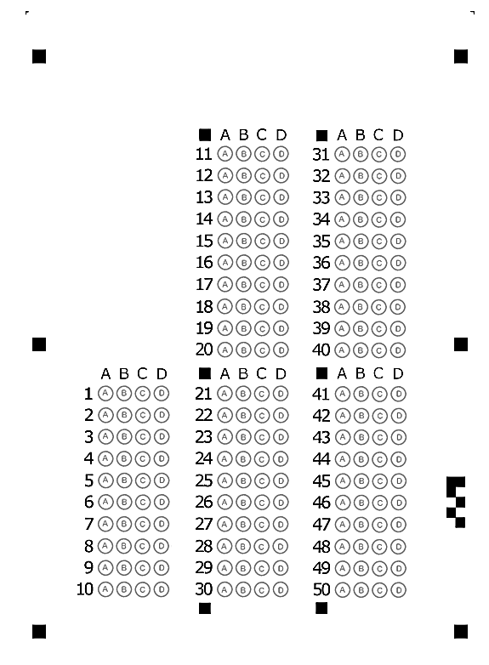

ỦY BAN NHÂN DÂN TP.HCM CỘNG HÒA XÃ HỘI CHỦ NGHĨA VIỆT NAM
TRƯỜNG CĐ LÝ TỰ TRỌNG TPHCM Độc lập – Tự do – Hạnh phúc
********** ******

TEST 45`
HỌC KỲ: II NĂM HỌC: 2021 - 2022 Thời gian: 40’
Đề 2

Bậc đào tạo: cao đẳng (21C1 - ) Học phần: Tiếng Anh 1

PHIẾU TRẢ LỜI TRẮC NGHIỆM

TÊN: _________________________________________________________
LỚP: ___________________
Tô đen những câu trả lời đúng bằng bút mực. Mỗi câu chỉ tô 1 đáp án.

1/ In the case of an ____, take the patient to the emergency room immediately.
a overcome b overnight
c overtime d overdose
2/ Sustainable ____ is a key indicator of the long-term health of the economy.
a product b to produce
c productivity d produce
Đề 1

3/ She traveled ____ Europe.
a for b into
c on d in
4/ They are going to buy drinks ____ the party.
a in b on
c with d for
5/ You can take both ____ them.
a at b of
c on d in
6/ I ____ go to the post office this morning.
a must b ought
c used to d have
7/ Ken should have studied harder; he ____ the test again.
a rejected b failed
c succeeded in d passed
8/ I'd rather ____ shopping tomorrow.
a to go b went c go d going
9/ You ____ tell a lie.
a had not better b not had better
c had better not to d had better not
10/ My sister hopes that you will ____ her invitation.
a accept b excepting
c accepting d except
11/ As you know, school policy is for all teachers to be in their classroom five minutes before the ____ of a lesson.
a start b end
c introduction d finish
12/ All teachers must ____ school policy.
a listen b look
c observe d came back
13/ All things ____, Professor Kim is the best instructor I've ever had.
a considered b considering
c considerable d to consider
14/ Alex ____that he had taken the test five times.
a said b says
c tells d told
15/ Almost every part of our lives ____ computerized over the past 10 years.
a have been b had done
c was d has been
16/ He seems ____ as surprised by the news as we were.
a to being b to was
c was d to have been
17/ Frank ____ a show when Karen got home.
a watched b watch
c was watching d watches
18/ The couple must need a ____ because they have just returned from a long journey.
a pause b stop
c discontinuation d rest
19/ He has studied English ____ he was in elementary school.
a while b as long as c since d during
20/ By the time he arrived at the ____, the movie had ended.
a home b dentist
c theater d doctor's office
21/ I forgot ____ the lights off. I actually turned it off but I forgot that I had done that.
a turning b to turning
c turn d to turn
22/ All I want is ____ to return safe.
a he b for him
c of him d him
23/ Christine promised to meet ____ at the theater.
a we b our
c ours d us
24/ A smoke detector will give your family a chance to escape ____ a fire.
a for the case b at case of
c in case d in the case of
25/ When ____ to resign his position, the manager reacted badly.
a ask b asking
c to ask d asked
26/ She forced him ____ the work.
a did b do c does d to do
27/ Would you mind ____ the window?
a to open b to opening
c opening d if opening
28/ They needed to practice ____ the ball.
a caught b catches
c catching d catch
29/ She asked which chapter _____.
a to read b read
c reading d reads
30/ I gave up ____ abroad for half the year after I had children.
a traveling b to travel
c for traveling d travel
31/ The game tired the players. It is the ____ game.
a tiring b tired
c tires d tire
32/ She hurt herself ____ dinner.
a cook b cooking
c to cook d cooked
33/ ____ a police officer, he chose to run away.
a Facing b Faces
c Face d To facing
34/ _____ on a hill, the hotel commands a fine view.
a To locate b Located
c Locating d Locate
35/ Feeling tired, he decided ____early.
a Leaving b to leaving
c leave d to leave
36/ For a ____ of reasons, he wouldn't accept our offer.
a variant b varying
c variation d variety
37/ Professor Miller requires that all papers be ____ in ink.
a made b copied
c written d formatted
38/ He has his shoes ____ every day.
a put on b bought
c made d shined
39/ This noise is very ____.
a annoying b annoyed
c annoys d annoy
40/ It is not very easy to make her ____ once she gets upset.
a pleasure b pleasing
c pleased d please

1/ ____ tired, he went to bed early.
Đề 2

a Feels b To feeling
c Feeling d Feel
2/ Walking along the street, Tom ____ one of his old friends.
a run in b ran into
c ran in d ran out of
3/ As part of our weekend package we ____ a free massage and use of the sauna to all guests.
a effect b combines
c affect d offer
4/ The boss was ____ to fire his secretary.
a determine b determination
c determined d determining
5/ He has his shoes ____ every day.
a shined b bought
c put on d made
6/ This noise is very ____.
a annoyed b annoys
c annoying d annoy
7/ Two teenagers were among the fourteen people ____.
a arrests b arrest c arrested d arresting
8/ ____ water is not safe for drinking.
a Polluting b Pollutes c Pollute d Polluted
9/ He could easily make himself ____ if he tried.
a understand b understood c understanding d be understood
10/ Some customers were very ____ about the return policy.
a confusing b confuses
c confuse d confused
11/ Christine promised to meet ____ at the theater.
a we b ours
c us d our
12/ A smoke detector is an easy way ____ your family.
a protected b protecting
c protect d to protect
13/ It is very easy ____ one.
a install b installing
c to install d to installing
14/ When we arrived, the film was about ____.
a started b start
c to start d starting
15/ We ____ to inform you that the position has been filled.
a apologize b sorry
c apology d regret
16/ They needed to practice ____ the ball.
a catches b catch
c caught d catching
17/ He ____ decided to quit his job and look for another one.
a belated b last
c finally d delayed
18/ She asked which chapter _____.
a read b reads
c to read d reading
19/ She ____ to giving up her project.
a complained b suggested
c protested d objected
20/ The secretary was working ____ that night.
a overwork b extra work
c overhours d overtime
21/ He ____ the subway every day.
a is taken b takes
c take d took
22/ He ____ the subway now.
a taking b does taking
c takes d is taking
23/ We ____ at a party two months ago.
a meeting b have met
c met d meet
24/ Everyone must be ____ time.
a for b at c to d on
25/ I have recently received several ____ from parents about teachers being late for class.
a complaining b complain
c complains d complaints
26/ We cannot expect our students to be _____ if we are late ourselves.
a intrude b punctual
c power d punch
27/ I'm sort of ____ with his flattery.
a disgusted b disgusting
c to disgust d disgust
28/ These pills will surely ____ your pain.
a ease b easily
c easy d easiness
29/ Mike didn’t ____ at Jill's party last night because he had a headache.
a hang up b make up
c show up d come up
30/ Ever since he arrived, he ____ quietly in the corner.
a sat b sits
c has been sitting d is sitting
31/ He asked her, "____ you like some more coffee?"
a Will b Would c Shall d Do
32/ In the case of an ____, take the patient to the emergency room immediately.
a overnight b overtime
c overcome d overdose
33/ Take the time to fully prepare yourself for interview ____.
a succeeding b succeed
c succession d success
34/ We used ____ talk every day.
a to b for c at d in
35/ I will be there ____ 8.
a at b in c on d for
36/ She had bought that book _____ she met me.
a after b before
c where d while
37/ I ____ go to the post office this morning.
a must b have c used to d ought
38/ Ken should have studied harder; he ____ the test again.
a succeeded in b failed
c rejected d passed
39/ Before she died, the old man ____ to take a walk with her daily.
a used b ought
c might d should
40/ My sister hopes that you will ____ her invitation.
a accepting b excepting
c accept d except

