SYMPOSIUM SCHEDULE

DATE
- Thursday, April 20
- Friday, April 21

TRACKS
- Accreditation
- Assessment
- Discussion Den/Town Hall
- Diversity, Equity and Inclusion
- Building a More Resilient World

Thursday, April 20
8:30 A.M.

Opening Keynote
Thursday, April 20 | 8:30 a.m. – 9:30 a.m. | Building a More Resilient World
The opening plenary of the 2023 ABET Symposium will set the stage for discussions around the theme of resilience and what it will take to overcome today’s great challenges. Following a review of ABET’s impact over the past year and our future goals delivered by ABET President Dr....
+ View more
- 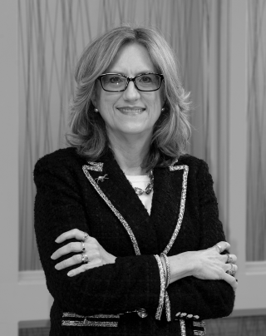

JENNA CARPENTER
Founding Dean and Professor, School of Engineering, Campbell University
- 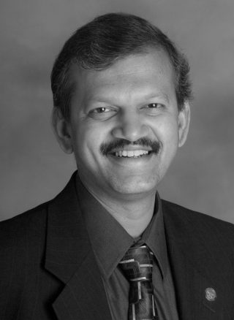

S. K. RAMESH
Professor of Electrical and Computer Engineering, California State University, Northridge
- 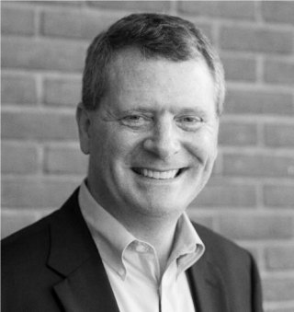

MICHAEL MILLIGAN
Executive Director and Chief Executive Officer, ABET
9:45 A.M.

Creating Computing Assignments to Support Diverse Populations
Thursday, April 20 | 9:45 a.m. – 10:45 a.m. | Accreditation
Although computing curriculum contains primarily technical content, faculty can teach impressionable young minds to value diversity. It can be integrated into the curriculum by creating a diverse backdrop for programming problems and assignments. In 2010, five faculty members at Slippery Rock University (SRU) participated in...
+ View more
- 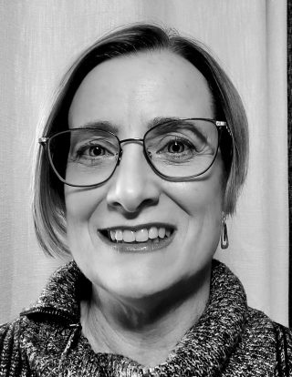

DEBORAH WHITFIELD
Professor of Computer Science, Slippery Rock University
9:45 A.M.

Engineering for One Planet: Helping Engineering Educators Meet ABET Sustainability Criteria
Thursday, April 20 | 9:45 a.m. – 10:45 a.m. | Building a More Resilient World
Engineering for One Planet (EOP) is an initiative to transform engineering education to reflect the growing importance of sustainability in all engineering functions. Catalyzed by The Lemelson Foundation and VentureWell — in collaboration with hundreds of sustainability advocates across sectors, geographies, and lived experiences —...
+ View more
- 

CINDY ANDERSON
Founder and CEO, Alula Consulting
- 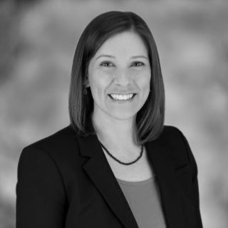

CINDY COOPER
Senior Program Officer, The Lemelson Foundation

MICHAEL MILLIGAN
Executive Director and Chief Executive Officer, ABET
9:45 A.M.

Leveraging Best Assessment Practices for Accreditation Review
Thursday, April 20 | 9:45 a.m. – 10:45 a.m. | Assessment
ABET criteria imply some manner of continuous activities in all the general criteria from students to institutional support. While some of these processes are institutionally and automatically continuous in any academic setting, demonstration of compliance around the Accreditation Policy and Procedure Manual, Criterion 2 (Program...
+ View more
- 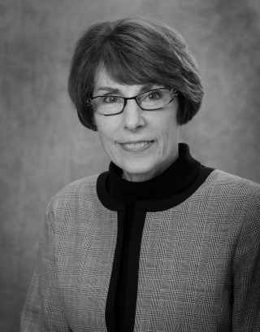

DAINA BRIEDIS
Assistant Dean Emerita for Student Advancement and Program Assessment, Michigan State University
- 

LARRAINE KAPKA
Professor Emeritus, Sinclair College
- 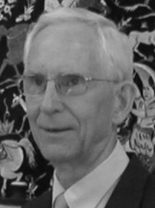

A. JOSEPH TURNER, JR.
Professor Emeritus of Computer Science, Clemson University
- TOREY NALBONE
9:45 A.M.

Getting Started with Program Assessment
Thursday, April 20 | 9:45 a.m. – 10:45 a.m. | Assessment
Are you new to program assessment? Have you volunteered or been assigned the task of leading your program assessment efforts and you need assistance on how to move forward? In this session, the speakers share experiences related to getting started and sustaining program assessment and...
+ View more
- 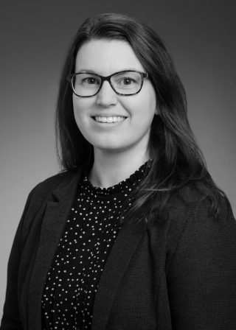

JENNY AMOS
Teaching Professor, University of Illinois at Urbana-Champaign
- 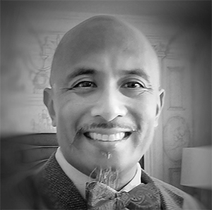

BEN JULIANO
Professor, Computer Science, California State University - Chico
9:45 A.M.

We Are Interested in Seeking ABET Accreditation: Are We Ready?
Thursday, April 20 | 9:45 a.m. – 10:45 a.m. | Accreditation
Considering ABET accreditation for the first time? You can’t miss this session! You will gain a firm understanding of the foundational processes and procedures of the ABET accreditation process, what is needed to prepare for the initial accreditation of a program and where to turn...
+ View more
- 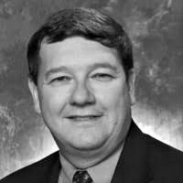

DOUGLAS BOWMAN
Adjunct Accreditation Director of Engineering, ABET
- 

WINSTON EREVELLES
Adjunct Accreditation Director of Engineering, ABET
9:45 A.M.

ANSAC: Accreditation Program Under ANSAC General Criteria
Thursday, April 20 | 9:45 a.m. – 10:45 a.m. | Accreditation
Many programs under the applied sciences have ANSAC approved program criteria including but not limited to: Industrial Hygiene, Safety, Surveying, Facilities Management and Construction Management, while other programs under the natural sciences and mathamatics do not have program criteria. An increasing number of these programs...
+ View more
- 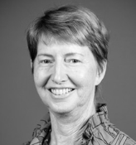

LISA SACHS
Managing Principal Emeritas, Cumming Construction Management
- 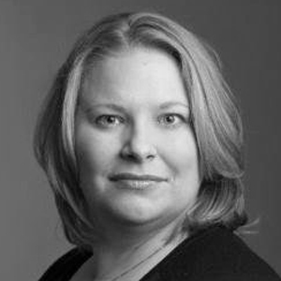

REBECCA POPECK
Survey Project Manager, SPACECO, Inc.
9:45 A.M.

Ask Me Anything: Accreditation Discussion Den
Thursday, April 20 | 9:45 a.m. – 10:45 a.m. | Discussion Den/Town Hall
In our Ask Me Anything (#AMA): Accreditation Discussion Den, attendees are invited to ask any and all accreditation-related questions and our experts will answer them. ABET Chief Accreditation Officer Joe Sussman and Senior Director of Accreditation Operations Jane Emmet will lead the conversation. Each Discussion...
+ View more
- 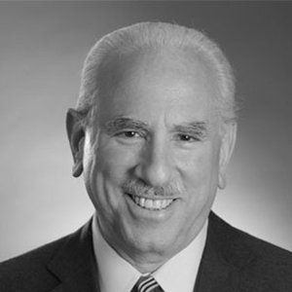

JOE SUSSMAN
Chief Accreditation Officer and Chief Information Officer, ABET
- 

JANE EMMET
Senior Director, Accreditation Operations, ABET
11:15 A.M.

Engineering Change Lab (ECL) USA: Challenges of the 21st Century and Engineering Leadership
Thursday, April 20 | 11:15 a.m. – 12:15 p.m. | Building a More Resilient World
The world is experiencing a wave of change accelerated by technological progress, evolving societal needs and expectations, and growing environmental imperatives. To help society successfully confront these challenges and flourish as this future unfolds, the engineering community must dramatically adapt. We must step up our...
+ View more
- 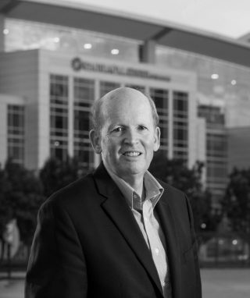

MIKE MCMEEKIN
President & Executive Director, Engineering Change Lab USA
11:15 A.M.

ABET Recognition of Certificates – Piloting and Beyond
Thursday, April 20 | 11:15 a.m. – 12:15 p.m. | Accreditation
Changes in education are rapidly evolving to meet learner and employer needs. Combinations of traditional degrees, certificates, and other professional development credentials are being sought by today’s learners. Employers welcome this trend to maintain a workforce with up-to-date skills. However, employers are challenged to be...
+ View more
- 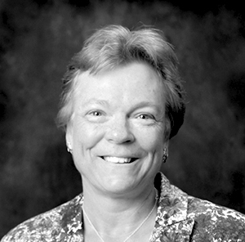

DONNA REESE
Professor Emerita, Mississippi State University
- 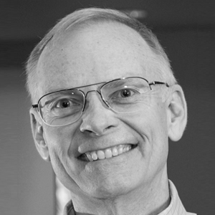

LAWRENCE JONES
Former Distinguished Principal Researcher, Carnegie Mellon University
- 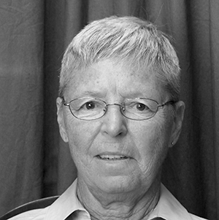

BARBARA PRICE
Professor Emerita, Quantitative Analysis, Georgia Southern University
- 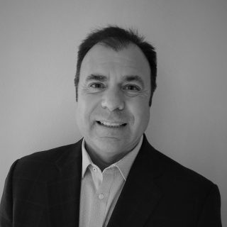

JOHN VIAN
Technical Fellow, Boeing
- 

JESSICA SILWICK
CFO/COO, ABET
11:15 A.M.

Top 10+ Tips for Writing Good Self-Study Reports
Thursday, April 20 | 11:15 a.m. – 12:15 p.m. | Accreditation
This presentation is designed for representatives from ABET accredited programs or those interested in seeking initial ABET accreditation. In either case, the session will help programs proactively prepare for future accreditation reviews by providing guidance on writing effective self-study reports (SSRs). A program’s SSR is...
+ View more

LARRAINE KAPKA
Professor Emeritus, Sinclair College
- 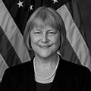

JEAN BLAIR
Professor of Computer Science, United States Military Academy
- 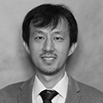

LU YUAN
Professor of Occupational Safety, Health and Environment, Southeastern Louisiana University
- 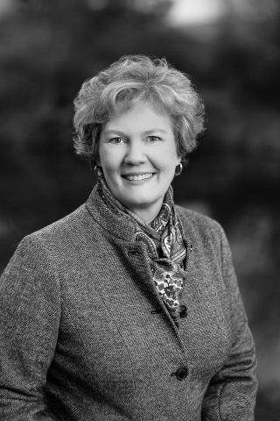

JANET CALLAHAN
Dean, College of Engineering, Michigan Technological University
11:15 A.M.

Ask Me Anything: Assessment Discussion Den
Thursday, April 20 | 11:15 a.m. – 12:15 p.m. | Discussion Den/Town Hall
In our Ask Me Anything (#AMA): Assessment Discussion Den, attendees are invited to ask any and all assessment-related questions and our experts will answer them. Each Discussion Den brings ABET thought leaders together with Symposium attendees for an informal and enlightening discussion on a specific...
+ View more
- 

ROBYN HALL
Director, Professional Programs, ABET
- 

JAMES WARNOCK
Professor and Founding Chair, School of Chemical, Materials and Biomedical Engineering, University of Georgia

DAINA BRIEDIS
Assistant Dean Emerita for Student Advancement and Program Assessment, Michigan State University
11:15 A.M.

ETAC: Common Challenges and Findings
Thursday, April 20 | 11:15 a.m. – 12:15 p.m. | Accreditation
This presentation is designed for representatives from ETAC accredited programs or those interested in seeking ETAC accreditation. In either case, the session will help programs proactively prepare for future accreditation reviews. Two senior members of the ETAC leadership group provide general information related to common...
+ View more
- 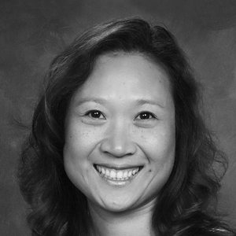

APRIL CHEUNG
Assistant Professor of Practice, Electrical Engineering Technology, Purdue University
- 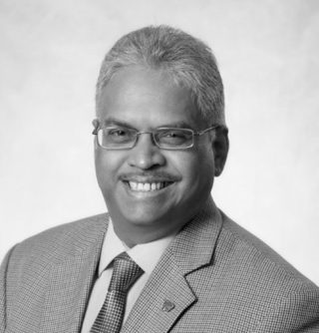

RAJU DANDU
Professor/Director Bulk Solids Innovation Center, Kansas State University Salina
11:15 A.M.

Effective Teamwork Assessment in Online Courses
Thursday, April 20 | 11:15 a.m. – 12:15 p.m. | Assessment
With the convenience of online courses, many students are opting for online alternatives to traditional onsite courses. Universities have responded and have provided courses in a variety of formats to meet student needs. Moving courses online, however, posts a challenge to teamwork assessment that is...
+ View more
- 

GINA COOPER
Senior Professor, DeVry University
- 

JINGDI ZENG
Professor, DeVry University
11:15 A.M.

Use of Performance Indicators for Program Assessment
Thursday, April 20 | 11:15 a.m. – 12:15 p.m. | Assessment
Performance indicators are a critically important educational tool for programs, both in setting course objectives and in helping students understand expectations of their learning by the time they complete the program. As such, performance indicators should be developed through a consensus among the faculty and,...
+ View more
- 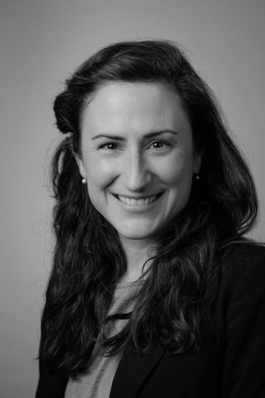

CHRISTINA HADEN
Associate Teaching Professor, Mechanical Engineering & Mechanics, Lehigh University
- 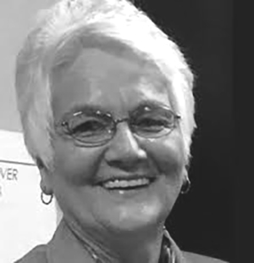

GLORIA ROGERS
Senior Adjunct Director, Professional Offerings, ABET
1:30 P.M.

Boiled Frog or Adapt? Tackling Changes in Higher Education
Thursday, April 20 | 1:30 p.m. – 2:30 p.m. | Accreditation
Society’s expectations of higher education are undergoing rapid and profound change. Increasingly, the value of a college education is being challenged. Prospective students are looking at alternatives to a four-year degree, including such options as boot camps and certificates. Employers are also looking at these...
+ View more

LAWRENCE JONES
Former Distinguished Principal Researcher, Carnegie Mellon University
- 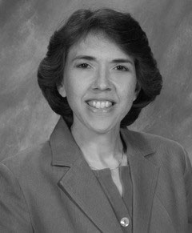

SUSAN SCHALL
Founder and Lead Consultant, SOS Consulting
1:30 P.M.

ESPOL’s Educational Model and Accreditation, and How We Integrate Both
Thursday, April 20 | 1:30 p.m. – 2:30 p.m. | Accreditation
ESPOL’s journey started in 2007, and reached its first objective in 2012 when two programs were ABET accredited, and since then has taken good pace with 13 (68% of total) accredited programs by the end of 2020. ESPOL is the only public university in Ecuador...
+ View more
- 

PAUL HERRERA
Vicerrector (Provost), Escuela Superior Politécnica del Litoral (ESPOL)
1:30 P.M.

New to Leading Program Assessment? Here is My Journey
Thursday, April 20 | 1:30 p.m. – 2:30 p.m. | Assessment
Starting as an assessment leader can seem like a daunting task. You may not have all the answers for your program’s unique needs or know where your journey will lead. This talk showcases the speaker’s perspective of leading program assessment of multiple programs on two...
+ View more
- 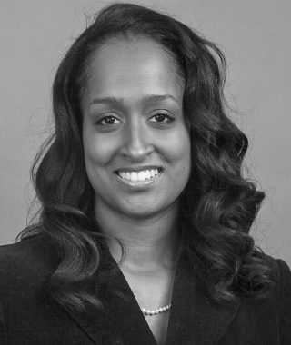

ALISA GILMORE
Associate Professor of Practice, Electrical and Computer Engineering, University of Nebraska – Lincoln
1:30 P.M.

Peace Engineering: Actionable Knowledge
Thursday, April 20 | 1:30 p.m. – 2:30 p.m. | Building a More Resilient World
Peace Engineering is the application of Science, Technology, Engineering, Arts and Mathematics (STEAM) principles, sustainable practices, cultural sensitivity and innovation to promote and support peace, and its profile is rising among institutions around the world. Peace Engineering’s mission is to actively cultivate a culture of...
+ View more
- 

RAMIRO JORDAN
Associate Dean of Engineering for Global Initiatives, University of New Mexico
1:30 P.M.

Understanding the Use of Rubrics in Program Assessment
Thursday, April 20 | 1:30 p.m. – 2:30 p.m. | Assessment
The use of rubrics is common in program assessment. However, not all rubrics are equal in clarity and usefulness. This session will explore ways to develop and use rubrics that will engage faculty through efficient methods and drive meaningful improvements. Topics to be explored are...
+ View more

GLORIA ROGERS
Senior Adjunct Director, Professional Offerings, ABET
- 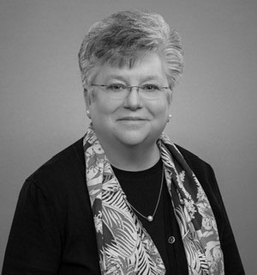

KAREN TARNOFF
Associate Dean, East Tennessee State University
1:30 P.M.

Ask Me Anything: International Accreditation Discussion Den
Thursday, April 20 | 1:30 p.m. – 2:30 p.m. | Discussion Den/Town Hall
In our Ask Me Anything (#AMA): International Accreditation Discussion Den, attendees are invited to ask any and all international accreditation-related questions and our experts will answer them. Join ABET Chief Accreditation Officer Joe Sussman, Senior Director of Accreditation Operations Jane Emmet and Manager of International...
+ View more

JANE EMMET
Senior Director, Accreditation Operations, ABET
- 

SHERRI HERSH
Manager of International Accreditation, ABET
- 

DANIELA IACONA
Director for International Engagement and Governance, ABET

JOE SUSSMAN
Chief Accreditation Officer and Chief Information Officer, ABET
1:30 P.M.

EAC: Tips for Meeting the EAC ABET Criteria
Thursday, April 20 | 1:30 p.m. – 2:30 p.m. | Accreditation
This session will discuss commonly identified shortcomings and how to avoid them when seeking ABET accreditation for an EAC program. In addition, common criteria terminology will be defined and explained to better understand requirements. The presentation will also discuss statistics on shortcoming findings.
- 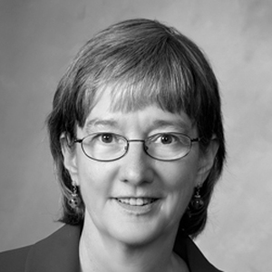

PATSY BRACKIN
Professor of Mechanical Engineering, Rose-Hulman Institute of Technology
- 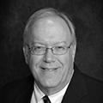

PHILIP SCHENEWERK
Retired Geological and Petroleum Engineer
2:45 P.M.

CAC: Accreditation Anti-Patterns: Common Review Challenges
Thursday, April 20 | 2:45 p.m. – 3:45 p.m. | Accreditation
An anti-pattern is a common response to a recurring problem that is usually ineffective and risks being counter productive. This talk focusses on commonly seen anti-patterns based on the presenters’ experience as PEVs, team chairs and editors. While it does not provide a comprehensive list...
+ View more
- 

MICHAEL OUDSHOORN
Dean of the Webb School of Engineering, High Point University

JEAN BLAIR
Professor of Computer Science, United States Military Academy
- 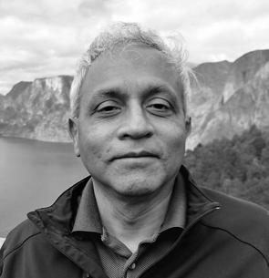

RAJENDRA RAJ
Professor of Computer Science, Rochester Institute of Technology
2:45 P.M.

Using a Human-Centered Engineering Design Framework to Connect ABET Outcomes to Learning Objectives and Performance Indicators in Engineering Courses
Thursday, April 20 | 2:45 p.m. – 3:45 p.m. | Assessment
Anecdotally, engineering faculty often find it challenging to connect ABET outcomes to learning objectives or performance indicators in engineering courses. To support engineering faculty, we developed an evidence-based human-centered engineering design (HCED) framework that connects ABET outcomes to engineering design activities and human-centered design mindsets...
+ View more
- 

SAADEDDINE SHEHAB
Associate Director of Assessment and Research, Siebel Center for Design
- 

TAYLOR TUCKER
Engineering Education Fellow, Siebel Center for Design (SCD), University of Illinois Urbana-Champaign
- 

ALEX PAGANO
Siebel Center for Design Research Scholar

JENNY AMOS
Teaching Professor, University of Illinois at Urbana-Champaign
2:45 P.M.

Engineering for One Planet Workshop: ABET-Aligned Resources to Bring Sustainability into your Classroom
Thursday, April 20 | 2:45 p.m. – 3:45 p.m. | Building a More Resilient World
Are you interested in learning how to integrate sustainability concepts and tools into your engineering curricula while meeting ABET Student Outcomes? Are you looking for free sustainability-focused resources and activities? Do you want to know more about the Engineering for One Planet (EOP) Framework and...
+ View more

CINDY ANDERSON
Founder and CEO, Alula Consulting
- 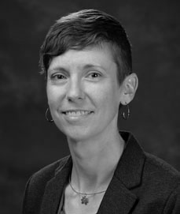

DUSTYN ROBERTS
Practice Associate Professor, University of Pennsylvania
2:45 P.M.

Infusing Diversity, Equity and Inclusion into Engineering Curricula and Culture
Thursday, April 20 | 2:45 p.m. – 3:45 p.m. | Diversity, Equity and Inclusion
In October 2022, Penn State hosted a summit for Big 10+ institutions and others with strong engineering programs. The purpose was to prepare for the upcoming changes to ABET criteria relating to diversity, equity, and inclusion (DEI). Teams of individuals from each institution came together...
+ View more
- 

LAURA GROSSENBACHER
Director of Undergraduate Program Review, College of Engineering, University of Wisconsin-Madison
- 

SARAH ZAPPE
Assistant Dean, Teaching and Learning, Pennsylvania State University
- 

KAREN HIGH
Professor, Department of Engineering & Science Education, Clemson University
- 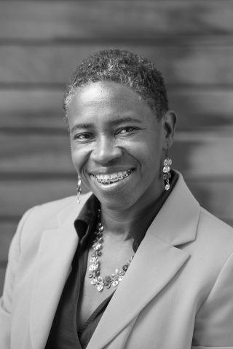

FATIMA ALLEYNE
Director, Community Engagement & Inclusive Practices, University of California, Berkley
2:45 P.M.

Graduate Readiness to Meet Industry Needs for Building a Resilient World
Thursday, April 20 | 2:45 p.m. – 3:45 p.m. | Building a More Resilient World
The ABET Industrial Advisory Council (IAC) provides ABET leadership with the perspectives of major employers on accreditation policy issues, works with company leaders to develop channels for Program Evaluator recruitment from industry and acts as an advocate for the meaning and value of ABET accreditation...
+ View more
- 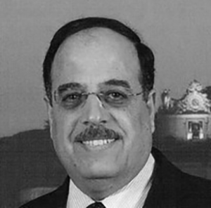

NAGUIB ATTIA
Distinguished Engineer and Vice President (Retired), IBM Global University Programs
- 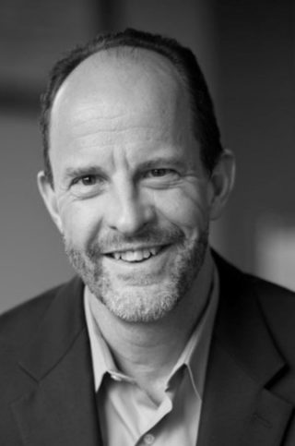

LOUIS GRITZO
Chief Science Officer, FM Global
- 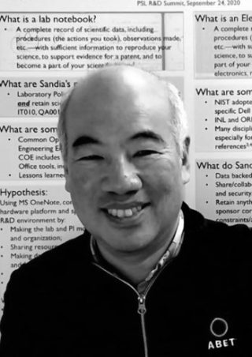

HY TRAN
Senior Scientist, Sandia National Laboratories
- 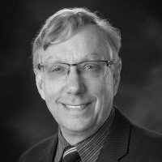

RICHARD HOPE
Chief Technical Officer, Americas, AECOM
2:45 P.M.

Faculty Engagement in the Assessment Process
Thursday, April 20 | 2:45 p.m. – 3:45 p.m. | Assessment
Sustainable program assessment and continuous quality improvement is a human process. Faculty are critical for success as they define student outcomes, assess student learning, evaluate data, design and implement changes, and assess impact. Unfortunately, many programs struggle to maintain sustainable assessment processes because faculty are...
+ View more

JAMES WARNOCK
Professor and Founding Chair, School of Chemical, Materials and Biomedical Engineering, University of Georgia
4:15 P.M.

Inclusion, Diversity, Equity, Accessibility and Sustainability (IDEAS) as Key Drivers for Building a More Resilient World
Thursday, April 20 | 4:15 p.m. – 5:30 p.m. | Diversity, Equity and Inclusion
Inclusion, Diversity, Equity, Accessibility, and Sustainability (IDEAS) are essential elements in building a more resilient world. In this panel session, ABET Claire L. Felbinger Award recipients will share their experiences and insights on the benefits of promoting IDEAS particularly in the face of global crises...
+ View more
- 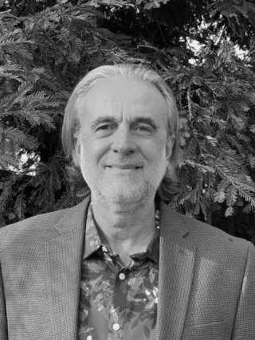

IGNATIOS VAKALIS
Professor of Computer Science, Cuesta Community College
- 

RENETTA TULL
Vice Chancellor of Diversity, Equity and Inclusion, University of California Davis
- 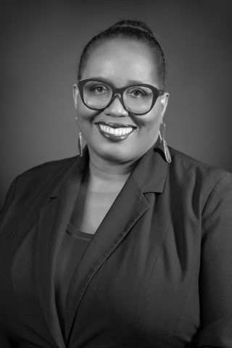

YVETTE E. PEARSON
Vice President for Diversity, Equity and Inclusion, University of Texas at Dallas
- 

RICHARD OLAWOYIN
Associate Professor of Industrial and Systems Engineering, Oakland University
Friday, April 21
8:30 A.M.

Closing Keynote Panel
Friday, April 21 | 8:30 a.m. – 9:50 a.m. | Building a More Resilient World
Exploring the points and insights set out the previous day, the closing plenary of the 2023 ABET Symposium will feature a panel discussion about the need for resilience and the opportunities that current and future problem solvers face. Led by Mike McMeekin, Co-Founder of the Engineering Change...
+ View more

CINDY COOPER
Senior Program Officer, The Lemelson Foundation

RAMIRO JORDAN
Associate Dean of Engineering for Global Initiatives, University of New Mexico

MIKE MCMEEKIN
President & Executive Director, Engineering Change Lab USA
- 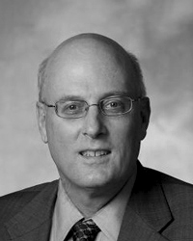

WILLIAM WEPFER
Past President, ABET
- 

DUYEN NGUYEN
Council of Regional Presidents Co-Chair, Engineers Without Borders USA
10:15 A.M.

Ask Me Anything: Accreditation Discussion Den
Friday, April 21 | 10:15 a.m. – 11:15 p.m. | Discussion Den/Town Hall
In our Ask Me Anything (#AMA): Accreditation Discussion Den, attendees are invited to ask any and all accreditation-related questions and our experts will answer them. ABET Chief Accreditation Officer Joe Sussman and Senior Director of Accreditation Operations Jane Emmet will lead the conversation. Each Discussion...
+ View more

JOE SUSSMAN
Chief Accreditation Officer and Chief Information Officer, ABET

JANE EMMET
Senior Director, Accreditation Operations, ABET
10:15 A.M.

Designing Questionnaires to Maximize Validity and Increase Response Rates
Friday, April 21 | 10:15 a.m. – 11:15 a.m. | Assessment
Developing a questionnaire to collect information from students, alumni, employers, internship supervisors and/or other constituents can be a daunting task. This session will provide principles and processes for the development of an effective questionnaire to gather needed data and improve response rates. It will also...
+ View more

GLORIA ROGERS
Senior Adjunct Director, Professional Offerings, ABET
10:15 A.M.

Relevancy: The Fifth ‘R’ of Resilience in Cybersecurity Curricula
Friday, April 21 | 10:15 a.m. – 11:15 a.m. | Building a More Resilient World
Relevant cybersecurity curricula is a critical component of cybersecurity resilience. ‘Relevant’ cybersecurity curriculum a) is pedagogically and technically correct b) provides learning experiences directly applicable to the learners’ interests, aspirations, and cultural experiences, c) uses real-world problems and contexts, and d) is resilient against rapidly...
+ View more
- 

PAIGE ZALEPPA
Director of Operations, SecurEd Inc.
- 

BLAIR THOMAS
Quality Advocate, SecurEd Inc.
- 

SIDD KAZA
Associate Provost for Research and Dean of Graduate Studies, Towson University
- 

BLAIR TAYLOR
Director, Center for Interdisciplinary and Innovation Cybersecurity (Cyber4All)
10:15 A.M.

Online and Hybrid Programs: Program Characteristics and Evaluation Approaches
Friday, April 21 | 10:15 a.m. – 11:15 a.m. | Accreditation
ABET has been visiting entirely online programs for several years. The Criteria remain the same whether the program is online or in-person; however, 100% of the online program visits have some unique characteristics. Currently, 27 institutions have a total of 37 such programs with ABET...
+ View more

BARBARA PRICE
Professor Emerita, Quantitative Analysis, Georgia Southern University
- 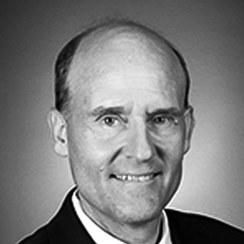

STEPHEN PHILLIPS
Professor of Electrical Engineering/Director, School of Electrical, Computer and Energy Engineering, Arizona State University
10:15 A.M.

An Example of an Effective Program Assessment and Evaluation Process
Friday, April 21 | 10:15 a.m. – 11:15 a.m. | Assessment
Program faculty and administrators often struggle over how to develop and implement effective assessment and evaluation processes that conform to the ABET criteria. Concerns of excessive time, effort and lack of participation are often raised. The purpose of this session is to present an example...
+ View more
- 

MARK ARCHAMBAULT
Assistant Dean of Academics for the College of Engineering and Science and Associate Professor of Aerospace Engineering, College of Engineering and Science, Florida Institute of Technology
10:15 A.M.

The Role of Professional Societies in Promoting DEI
Friday, April 21 | 10:15 a.m. – 11:15 a.m. | Diversity, Equity and Inclusion
The role of professional societies in promoting Diversity, Equity and Inclusion (DEI) has become increasingly important in building a more resilient world. Professional societies have the potential to be influential change agents and can play a significant role in advancing DEI across different industries and...
+ View more
- 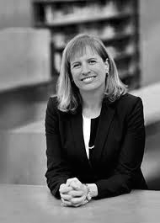

SHARON B. DEVIVO
President and Chief Executive Officer, Vaughn College
- 

DALMA NOVAK
VP of Engineering, Octane Wireless
- 

ASHLEY HUDERSON
STEM and CS Equity Policy Fellow, Office of the Deputy Secretary of Education
- 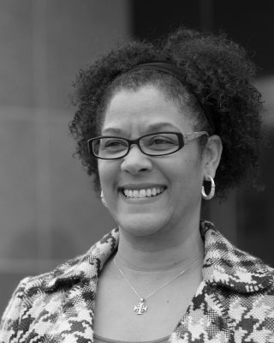

LISA BLACK
Director, Cultural Belonging & Social Ethos, American Society of Civil Engineers
10:15 A.M.

How to Prepare for Your ABET Site Visit
Friday, April 21 | 10:15 a.m. – 11:15 a.m. | Accreditation
Preparing for your ABET site visit can be challenging. This presentation offers insight into the visit process which is one of the most important events in the accreditation cycle. The presentation focuses on what an institution can do to prepare for the visit in order...
+ View more

REBECCA POPECK
Survey Project Manager, SPACECO, Inc.

MICHAEL OUDSHOORN
Dean of the Webb School of Engineering, High Point University
- 

CAROL SCHULTE
Professor (retired), McNeese State University
- 

CHRIS TAYLOR
Professor and EECS Vice Chair, Milwaukee School of Engineering
11:30 A.M.

Criterion 4: Continuous Improvement Best Practices
Friday, April 21 | 11:30 a.m. – 12:30 p.m. | Accreditation
This session is designed as a highly interactive, yet informal and relaxed, conversation between ABET Experts and those Symposium attendees wanting to learn more about the assessment, evaluation, and continuous improvement processes associated with Criterion 4. Case studies involving common Criterion 4 misconceptions will be...
+ View more

JENNY AMOS
Teaching Professor, University of Illinois at Urbana-Champaign
- 

JOHN ESTELL
Professor of Computer Engineering and Computer Science, Ohio Northern University
11:30 A.M.

Supplemental Materials for Site Visits
Friday, April 21 | 11:30 a.m. – 12:30 p.m. | Accreditation
This presentation will provide guidance on supplemental materials for programs preparing for an upcoming accreditation visit, whether virtual or in-person. We will review the scope of materials a program needs to provide evidence to show compliance with the relevant criteria as well as options for...
+ View more
- 

STAN THOMAS
Adjunct Director of Training, ABET
- 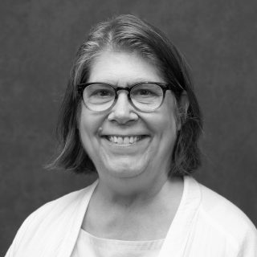

LIZETTE CHEVALIER
Dean, Dr. Robert A. Savoie College of Engineering, University of New Orleans
- 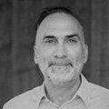

VENANCIO FUENTES
Engineering Technologies/Engineering Science Department Chairperson, County College of Morris
- 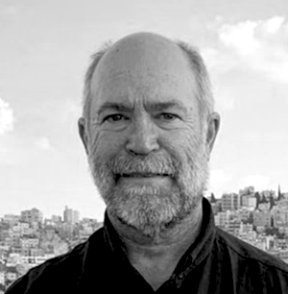

RANDAL KELLER
Professor of Occupational Safety and Health and the Jesse D. Jones Endowed Professor of the College of Science, Murray State University

RAJENDRA RAJ
Professor of Computer Science, Rochester Institute of Technology
11:30 A.M.

Establishing Effective Periodic Review of Program Educational Objectives
Friday, April 21 | 11:30 a.m. – 12:30 p.m. | Assessment
Program Educational Objectives (PEOs), what graduates are expected to attain within a few years of graduation, are the cornerstone of student outcomes-based education. As program faculty, we spend multiple years equipping our students with the skills, knowledge and abilities based on these established PEOs. In...
+ View more

JAMES WARNOCK
Professor and Founding Chair, School of Chemical, Materials and Biomedical Engineering, University of Georgia
11:30 A.M.

Human Centered Engineering for a Sustainable World
Friday, April 21 | 11:30 a.m. – 12:30 p.m. | Building a More Resilient World
Addressing key challenges facing the world demands practitioners in the emerging domain of Human Centered Engineering (HCE). This interdisciplinary and inclusive field of study spans human-centered design, engineering design, art and design, social sciences and business principles. It is concerned with interactive, iterative and creative...
+ View more
- 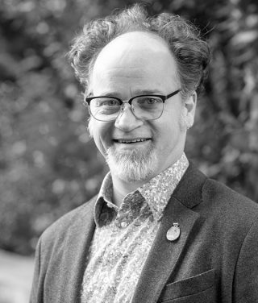

BROCK CRAFT
Associate Teaching Professor, Human Centered Design & Engineering, University of Washington
11:30 A.M.

Promoting Gender Diversity and Retention in Engineering
Friday, April 21 | 11:30 a.m. – 12:30 p.m. | Diversity, Equity and Inclusion
The need for diversity in engineering is more than just about equity and fairness; it is also about recognizing the value of diverse thoughts and how they can spur creative and innovative solutions for a complex and ever-changing world. This is also the motivation for...
+ View more

CHRISTINA HADEN
Associate Teaching Professor, Mechanical Engineering & Mechanics, Lehigh University
11:30 A.M.

Using the FE Exam for Effective Outcomes Assessment
Friday, April 21 | 11:30 a.m. – 12:30 p.m. | Assessment
This session highlights best practices in outcomes assessment using the NCEES Subject Matter Reports to provide participants with information about the strengths and weaknesses of students in a program. The presentation will specifically focus on using the FE results as one tool in assessing the...
+ View more
- 

GRANT CRAWFORD
Professor of Mechanical Engineering, Quinnipiac University
- 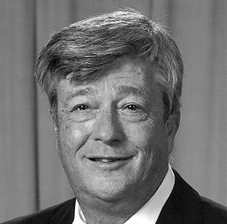

DAVID WHITMAN
Professor Emeritus, University of Wyoming
1:45 P.M.

ABET Assessment Resources and Education Information Session
Friday, April 21 | 1:45 p.m. – 2:45 p.m. | Assessment
Continuous improvement is the heart of the accreditation process. Best practices in the assessment of student learning is central to successfully and continuously improving program processes. Join us to learn more about ABET assessment resources and education to help you improve student learning in your...
+ View more

GLORIA ROGERS
Senior Adjunct Director, Professional Offerings, ABET

JAMES WARNOCK
Professor and Founding Chair, School of Chemical, Materials and Biomedical Engineering, University of Georgia

DAINA BRIEDIS
Assistant Dean Emerita for Student Advancement and Program Assessment, Michigan State University

ROBYN HALL
Director, Professional Programs, ABET
1:45 P.M.

The XPrize and Interdisciplinary Engineering
Friday, April 21 | 1:45 p.m. – 2:45 p.m. | Building a More Resilient World
Bob Jones University created the class Eng 350 Global Challenges in the fall of 2021 for the purpose of bringing together interdisciplinary teams of students to work on global problems like climate change. The Fall 2021 class consisted of engineering students, business students and science...
+ View more
- 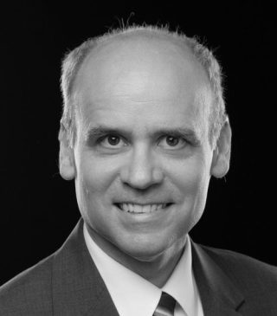

BILL LOVEGROVE
Department Head, Department of Engineering, Bob Jones University
1:45 P.M.

Professional Practice in Computing: Academia, Employers and Lessons from the DEAP
Friday, April 21 | 1:45 p.m. – 2:45 p.m. | Accreditation
ABET accreditation criteria are developed to assure the public that graduates from ABET-accredited programs have the competence to enter professional practice. In the rapidly-evolving disciplines of computing, the perception persists that graduates are not ready for employment and companies are not realistic in their expectations...
+ View more

LAWRENCE JONES
Former Distinguished Principal Researcher, Carnegie Mellon University

RAJENDRA RAJ
Professor of Computer Science, Rochester Institute of Technology

SUSAN SCHALL
Founder and Lead Consultant, SOS Consulting
1:45 P.M.

Sharing the PEV Perspective
Friday, April 21 | 1:45 p.m. – 2:45 p.m. | Accreditation
This talk is designed for a prospective PEV who is interested in having as much information as possible on what the job really entails. The presentation will cover the details of an ABET visit from the perspective of a PEV, from the initial assignment to...
+ View more
- 

JENNIFER BROCK
Associate Dean for Academics and Professor of Mechanical Engineering, University of Alaska Anchorage
1:45 P.M.

Using Data and Visualization in Assessment
Friday, April 21 | 1:45 p.m. – 2:45 p.m. | Assessment
Many programs working to design and implement assessment processes view their work as focused largely on system mechanics including defining learning outcomes, designing or identifying measures, creating and implementing data collection plans and conducting analyses. However, this functional focus on system mechanics may become problematic...
+ View more

KAREN TARNOFF
Associate Dean, East Tennessee State University
3:00 P.M.

EAC Town Hall
Friday, April 21 | 3:00 p.m. – 4:00 p.m. | Discussion Den/Town Hall
- 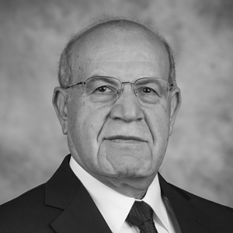

MO HOSNI
Professor and Director of the University Engineering Alliance, Kansas State University
- 

LORRAINE FLEMING
Professor, Howard University

LIZETTE CHEVALIER
Dean, Dr. Robert A. Savoie College of Engineering, University of New Orleans

PATSY BRACKIN
Professor of Mechanical Engineering, Rose-Hulman Institute of Technology
3:00 P.M.

CAC Town Hall
Friday, April 21 | 3:00 p.m. – 4:00 p.m. | Discussion Den/Town Hall

RAJENDRA RAJ
Professor of Computer Science, Rochester Institute of Technology

JEAN BLAIR
Professor of Computer Science, United States Military Academy
- 

SCOTT MURRAY
Staff Data Engineer, Procore Technologies
3:00 P.M.

ETAC Town Hall
Friday, April 21 | 3:00 p.m. – 4:00 p.m. | Discussion Den/Town Hall

CAROL SCHULTE
Professor (retired), McNeese State University

RAJU DANDU
Professor/Director Bulk Solids Innovation Center, Kansas State University Salina

APRIL CHEUNG
Assistant Professor of Practice, Electrical Engineering Technology, Purdue University
3:00 P.M.

ANSAC Town Hall
Friday, April 21 | 3:00 p.m. – 4:00 p.m. | Discussion Den/Town Hall
- 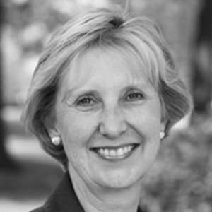

ALICE GREIFE
Dean, College of Health, Science and Technology, University of Central Missouri

RANDAL KELLER
Professor of Occupational Safety and Health and the Jesse D. Jones Endowed Professor of the College of Science, Murray State University
- 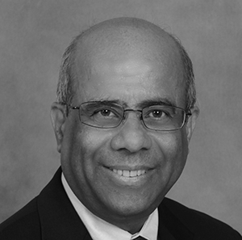

NIAZ LATIF
Professor and Dean, College of Technology, Interim Dean, College of Engineering and Sciences, Purdue University Northwest

SIGN UP FOR SYMPOSIUM UPDATES

Email*
Country/Region
First name*
Last name*
ABET needs the contact information you provide us to contact you about our products and services. You may unsubscribe from these communications at any time. For information on how to unsubscribe, as well as our privacy practices and commitment to protecting your privacy, check out our Privacy Policy.

- Connect with us on LinkedIn!
- Follow us on Facebook!
- Follow us on Twitter!
- Follow us on Instagram!
- ABOUT
- REGISTRATION
- SCHEDULE
- SPEAKERS
- WORKSHOPS
- FAQ
Copyright © ABET 2021
- Privacy Policy
- ABET
- #ABETsymposium

