Name: ____________________________________

ONE-PERIOD TEST

- Suggest a solution for these situations and specify the type of communication you will use.

Scenario A: You work in the customer service department for Walmart. You receive a complaint regarding a customer’s experience in the electronics department of a local store. The customer felt that they were disrespected.
Scenario B: You are a manager at a local food restaurant. A customer recently contacted you via email to tell you that they found a piece of plastic in a hamburger. They are not happy about it and are threatening to sue

- Analyze the 2 situations below and point out the possible responses of Rita in each situation.

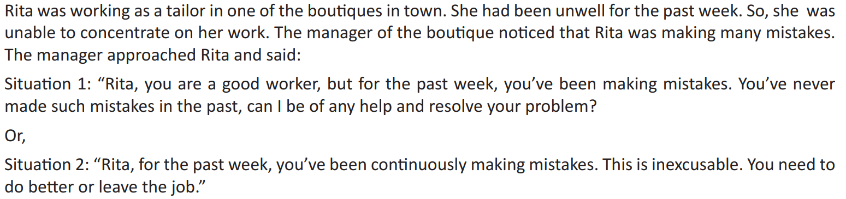

- Read the situations and answer the questions
Situation 1
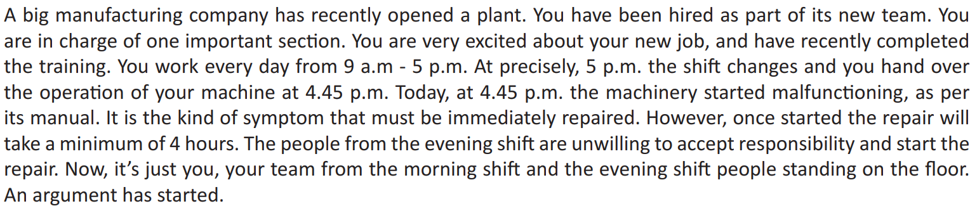

- What is the way forward?
- Is this a case of perception barrier in which both sides have a different opinion about the same issue? How can we overcome this barrier through communication?

Situation 2
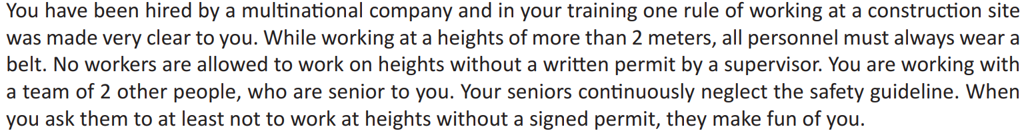

- What are the different ways in which one can try convincing the senior co-workers?
- How should one approach a supervisor with this issue?
- What is the definition of good teamwork here - not complaining against your team or bringing their negligence about their personal safety to supervisor’s attention?

Situation 3
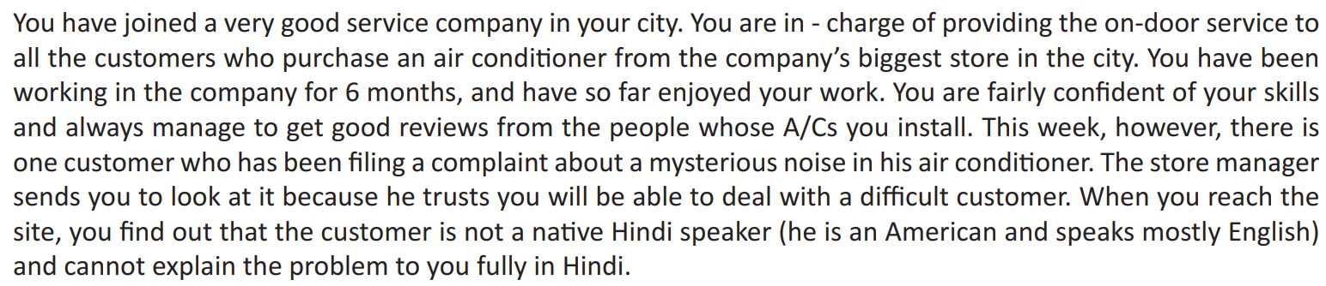

- What is the way forward?
- Is it a good idea to just leave and make the customer wait for some time till someone who understands English can return to service the AC?

Situation 4
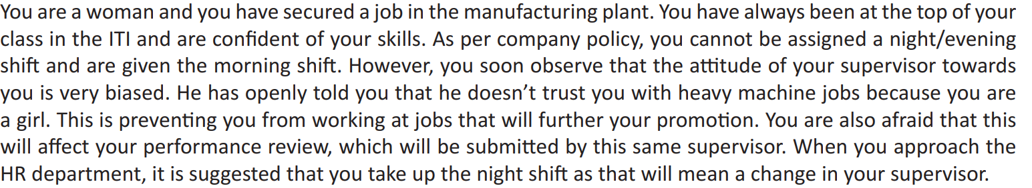

- What is the way forward?
- What are different approaches that can be tried while speaking to the supervisor or the HR?
- Is there something you should avoid doing in this situation? If yes, what?

Situation 5
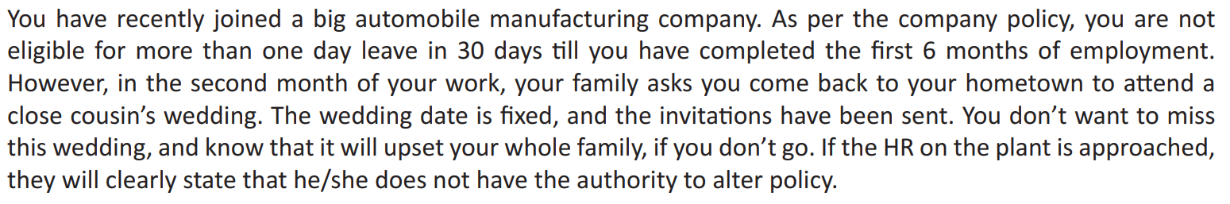
- How will you communicate this to your supervisor and HR?

