UBND THÀNH PHỐ HỒ CHÍ MINH | CỘNG HÒA XÃ HỘI CHỦ NGHĨA VIỆT NAM
TRƯỜNG CAO ĐẲNG | Độc lập - Tự do - Hạnh phúc
LÝ TỰ TRỌNG TP. HỒ CHÍ MINH

ĐỀ THI KẾT THÚC MÔN HỌC
HỌC KỲ: II NĂM HỌC: 2022 – 2023
Bậc đào tạo: CAO ĐẲNG (C1)
Môn học: TIẾNG ANH 3
Lớp: 21C1-HL2_KHCB1 Ngày thi: ____ / ____ / 2023
Thời gian thi: 60 phút (không kể thời gian phát đề)
Mã đề
124
123

- Thí sinh không được sử dụng tài liệu, nộp lại đề sau khi thi
- Bài thi này gồm 50 câu, mỗi câu 0.2 điểm.

Choose the correct answers for the following sentences.

1/ I asked him how long ____ been in America.
a had him b did he had c he had d had he
2/ Rarely ____ work at night.
a do he b does he c he doesn't d he
3/ I drive to school, ____ my brother always cycles.
a even b if c when d whereas
4/ The moment the teacher went out, the students started ____.
a said b telling c saying d talking
5/ ___ yesterday ____ change his mind.
a Not until - he did b Until - did he
c Not until - did he d Not until – he
6/ He is a very ____ person.
a socially b sociable c sociably d society
7/ ____ students in this class are freshmen.
a Almost b Most of c Most of the d Most
8/ ____ people love music.
a Most of the b Almost c Most d Most of
9/ ____ he nor she is right.
a Each b Both c Neither d Either
10/ I don't like that one ____.
a too b either c alike d neither
11/ It's ____ cold.
a terribly b terrible c terror d terrify
12/ Of the two pens, ____ is red and ____ is white.
a another - the other b one - another
c one - the others d one - the other
13/ He has three brothers: ____ is a doctor, ____ is a professor, and ____ is a singer.
a one - another - the other b one - another - the others
c one - an other - the other d one - other - the others
14/ We have five dogs: one is from Scotland, another is from Germany, and ____ are from Spain.
a some b anothers c the other d the others
15/ He is an ____ thinker.
a rapid extremely b extreme rapid c extremely rapid d rapidly extremely
16/ She walks ____.
a rapid b elegantly c extremely d elegant
17/ It grows ____ .
a extremely slowly b slowly extremely
c extremely slow d extreme slowly
18/ That sounds ____.
a interested b interestingly c interesting d interest
19/ Would you like ____ tea?
a some b anything c few d little
20/ He has two dogs: one is from England and ____ is from Germany.
a an other b the other c other d another
21/ Most people think bread is expensive ____ difficult to make.
a but b when c and d so
22/ I never see him without being ____ of his grandfather.
a remember b remained c reminded d memory
23/ You had ____ have your teeth checked at least once a year.
a would b should c worse d better
24/ ____ snow, the mountain looks fantastic.
a Covering b To cover c To have covered d Covered with
25/ Everybody ____ with the results of the meeting.
a was satisfied b was satisfy c satisfied d was to satisfy
26/ ____ I was waiting in line for a visa interview, I ate my lunch.
a Although b Since c Because d While
27/ We didn't need to ____ the fan since the room was not very hot.
a turn off b turn on c put d turn
28/ He wouldn't say anything ____ directly asked a question; he was a man of few words.
a unless b otherwise c since d or else
29/ ____ , I'm retired, I can take a long journey throughout Europe.
a Now that b However c Due to d Thanks to
30/ Left alone, the baby ____ into tears.
a burst b sobbed c poured d cried
31/ Not only does Steve sing at a bar, ____ he also serves the patrons.
a or b still c and d but
32/ During the experiment, people ____ to use calculators if necessary.
a were allowing b were allowed c were let d let
33/ I'm quite sure you will soon grow ____ to the new work environment.
a accustom b accustoming c accustomed d to be accustome
34/ The United Nations ____ to begin fund raising for the earthquake victims.
a is expect b is expected c are expected d are expect
35/ The instructions ____ precisely.
a must follow b must to be followed
c must be followed d must followed
Reading comprehension
Questions 36 through 40 refer to the following fax.

To: Fresh Food Deliveries Ltd.,
From: Hazel’s Coffee and Sandwiches
Re: Order placed February 20Th
Date: February 22nd

I placed an order for supplies on February 20th. The order was delivered this morning. However, some items were either missing or incorrect. This is not first time this has happened.

Below is a list of discrepancies:
I ordered 6 loaves of bread. I did not receive any bread.
I ordered 36 eggs. I received only a few eggs, about 6.
I ordered 5kg of tomatoes, but there weren’t any tomatoes in the delivery.
Also, I ordered some mayonnaise, but there was none in the delivery.

I rely on these supplies to run my business. I have no choice but to choose another deliverer, whom I can trust to get things right every time.

Question 36: What is the purpose of this fax?
- To say thank you for a delivery.
- To make a complaint
- To place an order
- To correct a mistake about a bill
Question 37: When was the fax written?
- February 2nd
- February 20th
- February 12th
- February 22nd
Question 38: How many items were incorrect?
- 36 eggs
- All of them
- Four
- Just the tomatoes
Questions 39: Which one is NOT mentioned in the fax?
- They ordered 6 loaves of bread.
- There weren’t any tomatoes in the delivery.
- There weren some potatoes in the delivery.
- They placed an order for supplies on February 20th .
Question 40: What will be the result of this fax?
- The writer will continue to use Fresh Food deliveries.
- The writer will use a different delivery company.
- The writer will close her business.
- The writer will receive some money back.

Questions 41 through 45 refer to the following memo.

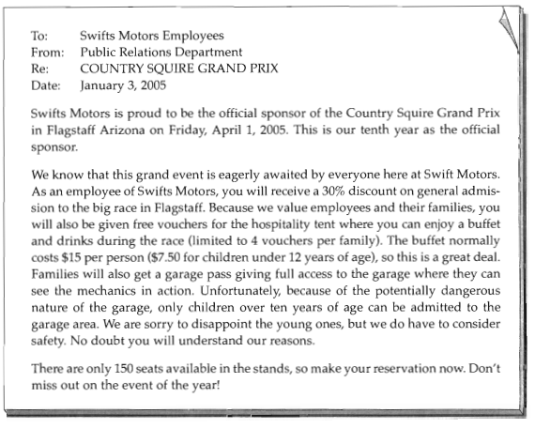
Question 41: Where the buffet located?
- At Swifts Motor
- In the stands
- In the hospitality tent
- In the garage
Question 42: Who is this announcement for?
- The drivers
- Mechanics at the race
- The public
- Company employees
Question 43: What is NOT offered in the announcement?
- A buffet and drinks
- Free general admission
- A garage pass
- A discount on general admission
Question 44: How many times have they held the event up till now?
- For ten times
- Ten years
- At ten
- April 1st, 2005
Question 45: Who cannot enter the mechanics garage?
- Mechanics from other companies
- Employees of Swifts Motors
- Children
- Children who are younger than 10

Incomplete Text:
Questions 46 through 50 refer to the following notice.
Grow your own vegetables. It’s (46)________ you think.
The Bradley Community Allotment Society has 10 new allotments available for local residents. We will distribute them on a first come, first served basis, so if you are (47)________, don’t delay. Annual rent for each allotment is $50 dollars. You will be able to grow a lot of the vegetables you normally buy, so eventually you will be saving money. The Allotment Society will be (48)_______ lessons on how to grow vegetables successfully at the community center this coming weekend. If you are interested in (49)_____________ one of the allotments, (50)____________not come along to the lectures and get some useful tips.
46.a easier b easier than c more easy d the easiest
47.a interesting b interested in c interested d interest
48.a giving b showing c making d taking
49.a rent b rented c renting d to rent
50.a why b how c what d which

_______Hết_______

GHI CHÚ: CÁN BỘ COI THI KHÔNG ĐƯỢC GIẢI THÍCH GÌ THÊM.

TRƯỞNG KHOA TRƯỞNG BỘ MÔN GIẢNG VIÊN RA ĐỀ

Nguyễn Thị Thanh Tú

