UBND THÀNH PHỐ HỒ CHÍ MINH | CỘNG HÒA XÃ HỘI CHỦ NGHĨA VIỆT NAM
TRƯỜNG CAO ĐẲNG | Độc lập - Tự do - Hạnh phúc
LÝ TỰ TRỌNG TP. HỒ CHÍ MINH

ĐỀ THI KẾT THÚC MÔN HỌC
HỌC KỲ: II NĂM HỌC: 2022 – 2023
Bậc đào tạo: CAO ĐẲNG (C1)
Môn học: TIẾNG ANH 3
Lớp: 21C1-HL2_KHCB1 Ngày thi: ____ / ____ / 2023
Thời gian thi: 60 phút (không kể thời gian phát đề)
Mã đề
126
123

- Thí sinh không được sử dụng tài liệu, nộp lại đề sau khi thi
- Bài thi này gồm 50 câu, mỗi câu 0.2 điểm.

Choose the correct answers for the following sentences.
1/ A survey of mobile phone use was conducted ____ the National Telecommunications Institute.
a to b by c of d from
2/ They've arranged a ____ reception for us.
a heating b warm c hospitably d hospital
3/ Experts say it is very important for children over the age of six to develop a hobby or ____ part in a club.
a take b do c be d make
4/ Children can learn important social skills ____ doing something they enjoy.
a and b but c while d yet
5/ She walks ____.
a rapid b elegantly c extremely d elegant
6/ He didn't fail the test; ____, he got the highest score.
a otherwise b on the contrary c else d likewise
7/ _____ after his arrival in Paris, Tom called me at the office.
a Nearly b Simply c Shortly d Briefly
8/ The United Nations ____ to begin fund raising for the earthquake victims.
a is expect b is expected c are expected d are expect
9/ The instructions ____ precisely.
a must follow b must to be followed
c must be followed d must followed
10/ He is a very ____ person.
a socially b sociable c sociably d society
11/ Last year, the shoe company ____ went bankrupt.
a next to b mostly c all d nearly
12/ Meetings will be broadcast ____ a week after they take place.
a substantially b potentially c approximately d comparatively
13/ During the experiment, people ____ to use calculators if necessary.
a were allowing b were allowed c were let d let
14/ I'm quite sure you will soon grow ____ to the new work environment.
a accustom b accustoming c accustomed d to be accustome
15/ They have certainly studied ____ to pass the test.
a enough hardly b enough hard c hardly enough d hard enough
16/ We wish to remind parents that all students must ____ in P.E. lessons.
a take part b have a role c be d study
17/ It is true that it takes a long time to make, ____ the results are worth the wait.
a because of b and c despite d but
18/ A ____ amount of money has been spent on books.
a considerate b considering c considered d considerable
19/ There is no ____ evidence that power lines are a health risk.
a conclusive b final c last d finishing
20/ I'm sure that I would enjoy ____ one, the red wine or the white wine.
a both b some c either d others
21/ Some of the questions were ____ that nobody could answer them.
a too hard b very hard c so hard d not hard
22/ Last week, John ____ an award for his community service.
a was gave b gave c had been given d was given
23/ A second attempt was made to collect ____ from the space probe.
a fact b informations c data d knowledges
24/ I can't ____ it anymore. That website seems to have suddenly vanished.
a access b pass c log out d reaching
25/ The note must explain how long they should be excused ____ class.
a to b by c for d from
26/ Thank you for your ____.
a cooperation b cooperating c considering d doing this
27/ Larry immediately said, 'I can't go, nor ____ want to go'.
a do I b do c I d I do
28/ You need to set it ____ for at least two hours.
a aside b out c along d off
29/ The police saw him going out. --> He ____ going out by the police.
a saw b seen c was seeing d was seen
30/ The ship has ____________.
a be disappeared b been disappeared
c to disappear d disappeared
31/ English ____ here.
a is spoken b speaks c was speak d spoken
32/ The family has _______________ from their vacation already.
a been return b returned c been returned d return
33/ The manager was preoccupied ____ checking the reports.
a at b from c with d in
34/ ____ your child is playing, she will learn skills like turn taking, losing well, and following rules.
a Because b But c For d Even though
35/ Hobbies and clubs are vital for the ____ of your child.
a develop b development c developed d be developed
Reading comprehension
Questions 36 through 40 refer to the following short article.
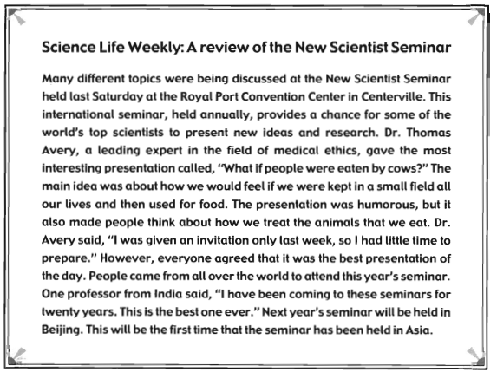

Question 36: Where was the New Scientist Seminar held?
a India
b A field with cows
c Centerville
d Saturday

Question 37: How often is the event held?
a Every year
b Every 2 years
c Every 4 years
d Beijing
Question 38: When did Dr. Avery receive his invitation?
a Last week
b Last weekend
c Last month
d Last year
Question 39: Dr. Avery is an expert in which field?
a A field of cows
b Medical ethics
c India
d Food
Question 40: Where will the next seminar take place?
a Centerville
b India
c Beijing
d Is has not been decided.
Questions 41 through 45 refer to the following sign.
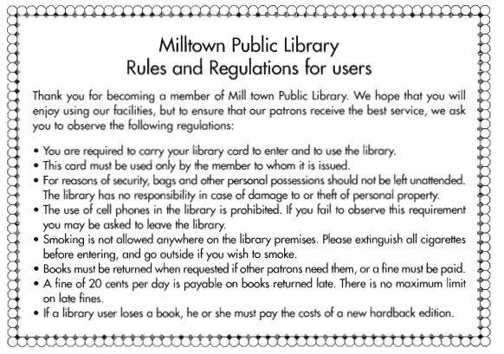
Question 41: Who would need to read this sign?
a People who wants to get a new library card
b Library members
c Librarians
d Parents with children
Question 42: Who may use a member’ library card?
a Only the member
b Anyone
c The member and his or her family
d The member and his or her friends
Question 43: What rule does the library have regarding people’s bags inside the library?
a All bags must be left at the desk
b Bags are not allowed.
c Only small bags are allowed
d People must watch their own bags.
Question 44: How many items were mentioned in regulations?
a All of them
b Just books
c 20 cents
d Eight
Question 45: What is maximum fee for someone who returns their books late?
a There is no maximum free.
b They must buy a new book
c 20 cents
d There is no fee.
Incomplete Text:
Questions 46 through 50 refer to the following article.
Many parents worry that their children don’t eat properly when they go off to university. While some students (46) __________ off instant noodles, they are not the average according to the results of a recent survey. Most of the university sophomores surveyed last month said that they cook for themselves (47) _________ least three times a week. The other days they eat with friends. Many of the students said they take it (48)_________ to cook for each other. On the days that they don’t cook, they said that they often eat cereal. This (49)_________ a bad thing. Most cereals these days are fortified with a wide range of vitamins and minerals. So although it is not the most appetizing diet, provided they don’t (50)___________too many sugary cereals, it is not a completely unhealthy choice of foods.
46. a live b lives c is living d has lived
47. a in b on c at d for
48. a in turns b turns c in to turns d turning
49. a is not b can not c is d has
50 a reject b chose c selected d choose

_______Hết_______

GHI CHÚ: CÁN BỘ COI THI KHÔNG ĐƯỢC GIẢI THÍCH GÌ THÊM.

TRƯỞNG KHOA TRƯỞNG BỘ MÔN GIẢNG VIÊN RA ĐỀ

Nguyễn Thị Thanh Tú

