ỦY BAN NHÂN DÂN THÀNH PHỐ HỒ CHÍ MINH
TRƯỜNG CAO ĐẲNG LÝ TỰ TRỌNG THÀNH PHỐ HỒ CHÍ MINH

BÀI GIẢNG CHI TIẾT

Môn học: TIẾNG ANH ĐÀM PHÁN
Bậc đào tạo: Cao đẳng
Họ và tên giảng viên: Nguyễn Thị Thanh Tú

UNIT 1: PREPARATION
General ideas about negotiation:

What Is Negotiation?
The term negotiation refers to a strategic discussion intended to resolve an issue in a way that both parties find acceptable. Negotiations involve give and take, which means one or both parties will usually need to make some concessions.
Negotiation can take place between buyers and sellers, employers and prospective employees, two or more governments, and other parties. Here is how negotiation works and advice for negotiating successfully.

KEY TAKEAWAYS
- Negotiation is a strategic discussion between two parties to resolve an issue in a way that both find acceptable.
- Negotiations can take place between buyers and sellers, employers and prospective employees, or the governments of two or more countries, among others.
- Successful negotiation usually involves compromises on the part of one or all parties.

How Negotiations Work
Negotiations involve two or more parties who come together to reach some end goal that is agreeable to all those involved. One party will put its position forward, while the other will either accept the conditions presented or counter with its own position. The process continues until both parties agree to a resolution or negotiations break off without one.
Experienced negotiators will often try to learn as much as possible about the other party's position before a negotiation begins, including what the strengths and weaknesses of that position are, how to prepare to defend their positions, and any counter-arguments the other party will likely make.
The length of time it takes for negotiations to conclude depends on the circumstances. Negotiation can take as little as a few minutes, or, in more complex cases, much longer. For example, a buyer and seller may negotiate for minutes or hours for the sale of a car. But the governments of two or more countries may take months or years to negotiate the terms of a major trade deal.
*Importance: Some negotiations require the use of a skilled negotiator such as a professional advocate, a real estate agent or broker, or an attorney.

https://www.investopedia.com/terms/n/negotiation.asp

The Stages of the Negotiation Process
Regardless of what you're negotiating over or with whom, negotiation usually involves several distinct steps.

Preparation
Before negotiations begin, there are a few questions it helps to ask yourself. Those include:
- What do you hope to gain, ideally?
- What are your realistic expectations?
- What compromises are you willing to make?
- What happens if you don't reach your end goal?
Preparation can also include finding out as much as you can about the other party and their likely point of view. In the case of the SUV negotiation above, you could probably find out how much room the dealer has to bargain by looking up actual sales prices for that vehicle online.
Also, marshal any facts that will help you make a persuasive case. If you're negotiating for a new job or a raise at work, for instance, come armed with concrete examples of your accomplishments, including hard numbers if possible. Consider bringing testimonials from satisfied clients and/or coworkers if that will buttress your case.
Many experienced negotiators consider preparation to be the single most important step in the entire process.

Exchanging Information
Once you're prepped for the negotiation, you're ready to sit down with the other party. If they're smart, they have probably prepared themselves, as well. This is the point at which both sides will present their initial positions in terms of what they want and are willing to give in return.
Being able to clearly articulate your wishes is critical to the negotiation process. You may not get everything on your wish list, but the other party, if they want to reach a deal, will have a better idea of what it might take to make that happen. You will have a better idea of their position, and where they might be willing to bend, as well.

Bargaining
Now that both parties have laid out their case, you're ready to start bargaining.
An important key to this step is to hear the other party out and refrain from being dismissive or argumentative. Successful negotiating involves a little give and take on both sides, and an adversarial relationship is likely to be less effective than a collegial one.
Also bear in mind that a negotiation can take time, so try not to rush the process or allow yourself to be rushed.

Closing the Deal
Once both parties are satisfied with the results, it's time to end the negotiations. The next step may be in the form of a verbal agreement or written contract. The latter is usually a better idea as it clearly outlines the position of each party and can be enforced if one party doesn't live up to their end of the bargain.

Tips for Successful Negotiating
Some people may be born negotiators, but many of us are not. Here are a few tips that can help.
- Justify Your Position. Don't just walk into negotiations without being able to back up your position. Bring information to show that you've done your research and you're committed to reaching a deal.
- Put Yourself in Their Shoes. Remember that the other side has things it wants out of the deal, too. What can you offer that will help them reach their goal (or most of it) without giving away more than you want to or can afford to?
- Keep Your Emotions in Check. It's easy to get caught up in the moment and be swayed by your personal feelings, especially ones like anger and frustration. But don't let your emotions cause you to lose sight of your goal.
- Know When to Walk Away. Before you begin the negotiating process, it's a good idea to know what you'll accept as a bare minimum and when you'd rather walk away from the table than continue to bargain. There is no use trying to reach a deal if both sides are hopelessly dug in. Even if you don't want to end negotiations entirely, pausing them can give everyone involved a chance to regroup and possibly return to the table with a fresh perspective.

What Makes a Good Negotiator?
Some of the key skills of a good negotiator are the ability to listen, to think under pressure, to clearly articulate their point of view, and to be willing to compromise, within reason.

What Is ZOPA?
ZOPA is an acronym from the business world. It stands for zone of possible agreement. ZOPA is a way of visualizing where the positions of the parties to a negotiation overlap. It is within that zone that compromises can be reached.

What Is BATNA?
BATNA is another acronym from the world of business, meaning best alternative to a negotiated agreement. It refers to the next course of action a negotiator may take if a negotiation fails to arrive at a satisfactory conclusion. Veteran negotiators often go into a negotiation knowing what their likely BATNA would be, just in case.

The Bottom Line
Negotiating is essential part of day-to-life, the business world, and international affairs. Regardless of what you're negotiating, being a successful negotiator means knowing what you want, trying to understand the other party's (or parties') position, and compromising if necessary. A successful negotiation leaves everyone satisfied that they have gotten a deal they can live with.

1/ Read the article and answer the questions:
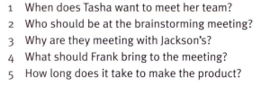
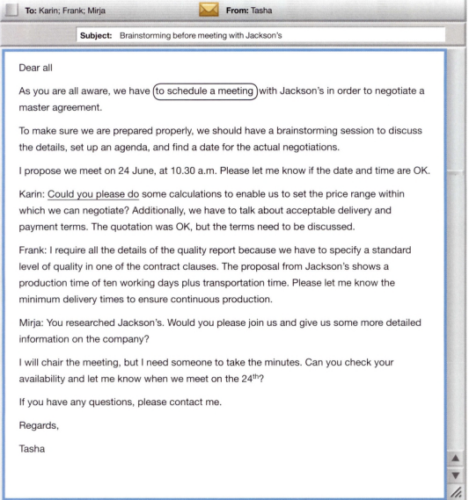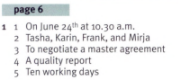
Notes:
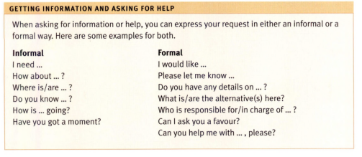
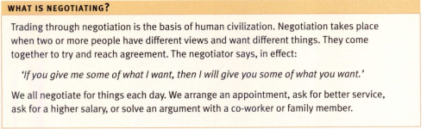
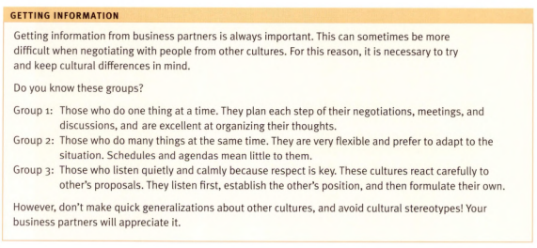
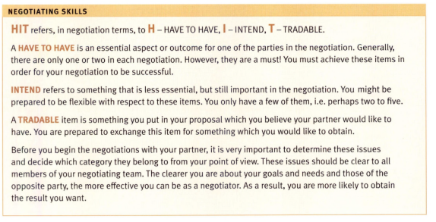
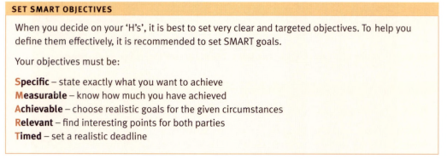
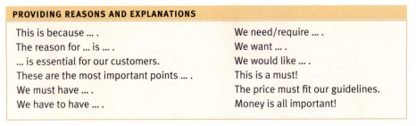
EXERCISE: Students do all of the exercises in unit 1
ANSWER KEY:
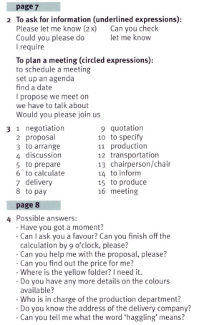
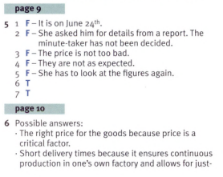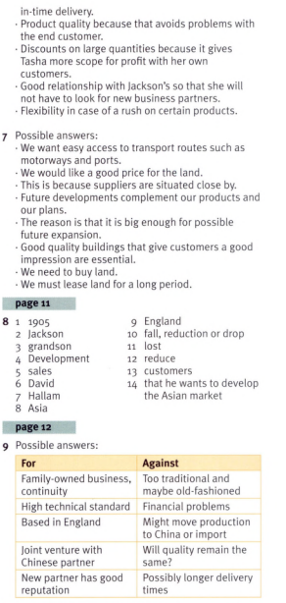

UNIT 2: SETTING OBJECTIVES
Negotiation is the process by which two or more parties meet to discuss an arrangement that ideally, would benefit all parties involved. Negotiations can occur among individuals, such as between a supervisor and employee, or among larger groups, as well as between companies or nations. Purchasing negotiations are a familiar and are also major aspect of business negotiations, but the process also applies to many forms of partnership building, such as establishing terms for collaborative projects. No matter which type of negotiation you undertake, establishing your objectives in advance will help bring about a favorable outcome.

preliminary objectives
The time to start developing your objectives is before you even sit down at the negotiating table. You and your team should carefully think through what you want to get from the negotiation process. Some objectives may straightforward, such as leasing an office under a standard contract. In this case, you might simply want to sign the contract at the agreed-upon price. Complex projects, however, require deeper thinking as you explore the short and long term implications of your negotiation. For example, your objectives for a major new machinery or software development purchase might cover, in addition to basic factors like price, delivery, warranty and payment terms, such advanced considerations as installation time frames, service contracts, operator training and replacement costs.

bracketing your objectives
Once you’ve developed your list of objectives, you should review each of them to develop the maximum desired and minimum acceptable levels. For example, when making a major purchase you would likely have a desired price point along with an higher price point that is still acceptable. You would begin the negotiation by offering a price that is somewhat lower than your desired price point, while keeping in mind the higher level to which you might ultimately agree.
Note where it’s possible trade off your objectives. If you’re acquiring an essential manufacturing component that’s needed right away, you may be willing to go to the higher price point in exchange for expedited delivery. On the other hand, you’re more likely to negotiate a more attractive price If you can accept a longer time frame for the delivery because the item isn’t immediately needed.

your negotiating partner
Knowing and understanding the other person or company involved in your negotiation will help you refine your objectives so that both of you reach a favorable outcome. For example, imagine you are negotiating with a valued employee who pushes for a raise exceeding your company’s current financial limitations. You don’t want to lose this employee, and you do want to provide reasonable recognition for the employee’s contributions to the company. You also know that the employee is a parent of young children, and would welcome the opportunity to be closer to them while working. You might offer a modest raise along with a more flexible work schedule that includes work from home options. This offer may satisfy the employee’s need to feel rewarded for good work, along with the extra incentive of serving family needs.

your circumstances
External circumstances can affect your negotiation process and should be reflected in your development of objectives. Major influences include the state of the economy, or even simply the market position of your negotiating partner. In real estate, the concept of a “buyers’ market” versus a “sellers’ market” succinctly describes this idea. Tough economic times or slow-moving markets enhance a supplier’s willingness to negotiate on price and other parameters of the deal. In strong economic times, suppliers and contractors often have enough demand for their offerings that they don’t need to negotiate on price, although they might respond in your favor to other points of negotiation, such as extending a service contract at no additional cost.

your batna
Having a Best Alternative to a Negotiated Agreement,also known by its acronym, BATNA, gives you an out when your objectives cannot reasonably be met. The BATNA term and concept was developed by the originators of the WIN-WIN negotiating method, Roger Fisher and William Ury, and presented in their book Getting to Yes. Your BATNA is your Plan B, an acceptable option that allows you to amicably cease negotiations and walk away from the table. For example, suppose you're seeking a contractor to work on a project that must be completed in a very specific and limited time frame. You have identified several contractors that would be suitable, but one of them is preferred. You begin negotiations with your preferred contractor, who explains that under the current workload, that they would not be able to meet your deadline. You offer incentives, but the best the contractor could do in the time allotted would be to complete only the first stage of the project. At this point, you and the contractor agree to cease negotiations, while keeping the door open for work on future projects. This outcome was possible because of your BATNA, which is to offer your project request to the other contractors under consideration.
https://bizfluent.com/what-breaks-down-negotiation.html
Notes:
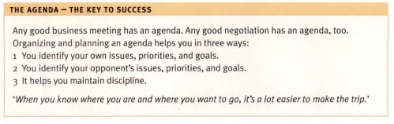
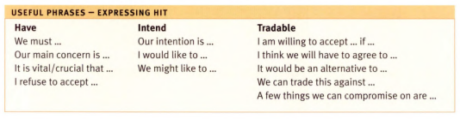
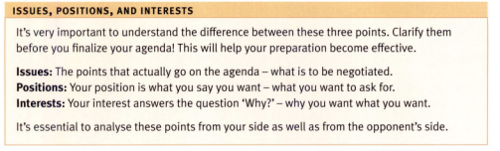
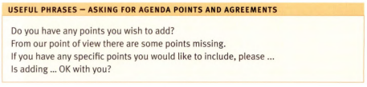
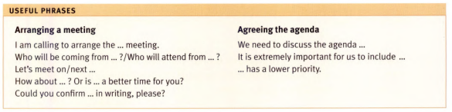
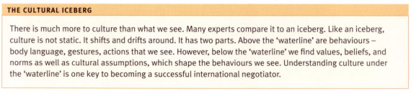
EXERCISE: Students do all of the exercises in unit 2
ANSWER KEY:
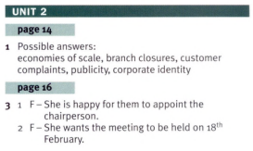
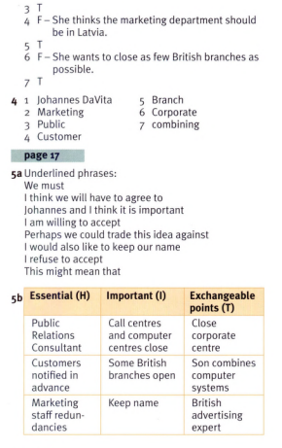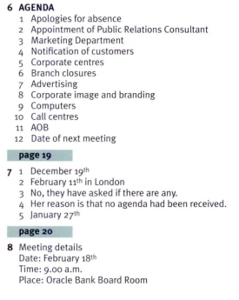
UNIT 3: THE MEETING

Examples of Negotiations
Negotiating can take place between individuals, businesses, governments, and in any other situation where two parties have competing interests. Here are two everyday examples:
Say you plan to buy a new SUV but don't want to pay the full manufacturer's suggested retail price (MSRP). In that case, you might offer what you consider a fair price. The dealer can accept your offer or counter with another price figure. If you have good negotiating skills, you may be able to drive the price down to a level where you're happy and the dealer is still able to walk away with a profit, albeit a slimmer one.

What Is the Manufacturer's Suggested Retail Price (MSRP)?
The manufacturer’s suggested retail price (MSRP) is the price that a product's manufacturer recommends it be sold for at the point of sale. Any retail product can have an MSRP, but the term is frequently used with automobiles. An MSRP is sometimes informally known as the "sticker price."
The MSRP is also referred to as the list price by some retailers. Other higher-priced goods, such as appliances and electronics, may have an MSRP as well.
The MSRP is designed to keep prices at the same level from store to store. But retailers are not required to use this price, and consumers do not always pay the MSRP when they make purchases. Items may be sold for a lower price so a company can reasonably move inventory off shelves, especially in a sluggish economy.

KEY TAKEAWAYS
- The manufacturer’s suggested retail price (MSRP) is the sticker price recommended by a product's producer to retailers.
- They are frequently used in the sale of automobiles, although most retail products come with an MSRP.
- MSRP is different from the invoice price, the price a dealer or retailer pays a manufacturer.
- Many retailers will sell products below the MSRP to reduce inventory, attract more consumers, or during a sluggish economy.
- Conversely, some retailers will set prices higher than the MSRP for products in high demand.

Or, suppose you've been offered a new job but don't consider the salary sufficient. An employer's first compensation offer is often not its best possible offer, so it may have some room to negotiate. In fact, a 2016 survey by the CareerBuilder website found that 73% of employers were open to negotiating a starting salary with job seekers. And if higher pay isn't a possibility, the employer may be willing to offer something additional, such as more vacation time or better benefits.
In both of these examples—as in most successful negotiations—both parties have made compromises, while also achieving their principal goals.
NOTES:
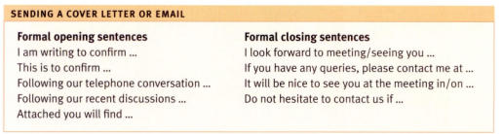
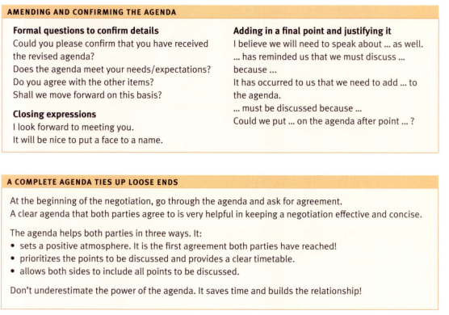
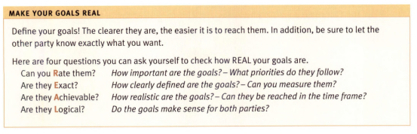
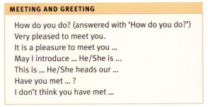
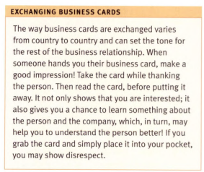
EXERCISE: Students do all of the exercises in unit 3
ANSWER KEY:

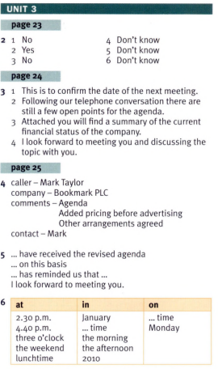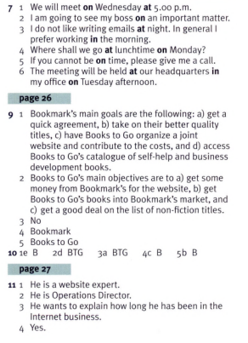
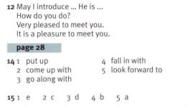
UNIT 4: PROPOSALS

How to Counteroffer in Business Negotiation

Wondering how to counteroffer effectively when your counterpart makes the first move in a business negotiation? Here are three strategies that will help you meet your negotiation goals.
BY KATIE SHONK — ON MAY 23RD, 2023 / DEALMAKING
Imagine you’ve received a salary offer for a new job that’s less than you’d hoped for, or a client has delivered a “take it or leave it” ultimatum. While there is ample advice available to negotiators on how to make the first offer in negotiation, the question of how to counteroffer in business negotiations often goes overlooked. That’s unfortunate, because how you react to another party’s opening offer will have a significant effect on the negotiation’s final outcome. The following deal-making techniques can help you determine how to counteroffer for maximum effectiveness.

Resist Their Anchor.
In a negotiation first offer, the first number or other figure mentioned tends to serves as an anchor that pulls counteroffers in its direction. When receiving a first offer, it’s typically very difficult to ignore the anchor, even if it is completely unreasonable.
For example, suppose you receive a salary offer of $40,000 per year for a job that, based on your research, you believe should have a salary of about $50,000. If you had proposed a salary first, you might have asked for $55,000. But after the hiring manager drops the $40,000 anchor, you are likely to make a lower counteroffer, such as $45,000. Because of this anchoring effect, negotiators are often advised to try to make the first offer.
Wondering how to counteroffer without being anchored? First, resist the urge to respond immediately to the other party’s offer. Ask for time to think it over, and give yourself plenty of time to strategize. Second, make sure you know your BATNA—your best alternative to a negotiated agreement, or the path you’ll follow if you can’t reach a deal with your current counterpart—as well as your target. Aiming for your target, and being sure not to accept anything less than your BATNA, will help lessen the impact of your counterpart’s anchor.

Try Making Multiple Counteroffers.
Simultaneously delivering multiple offers that you value equally, rather than just one offer, can be a useful strategy in negotiation. When you make multiple offers simultaneously, you convey flexibility and gain valuable information about your counterpart’s interests.
For example, after being offered a salary of $40,000 along with two weeks of vacation and three weeks of work travel, you might make three offers that vary on salary, vacation time, and travel. When crafting multiple offers, be sure that you value them equally as your counterpart could end up accepting any one of them on the spot. More likely, you’ll continue haggling further. But presenting multiple offers can be an invaluable way of determining what issues matter most to the other side—and sets you up for creating value in negotiation by making tradeoffs on issues you value more.

Provide a Strong Rationale.
When considering how to counteroffer, don’t overlook the value of a strong rationale. A persuasive rationale can help you re-anchor the discussion and avoid impasse.
In their research, Alice J. Lee of Columbia Business School and Daniel R. Ames of Columbia University compared the effectiveness of two common types of rationales that buyers use when responding to a seller’s opening bid: (1) constraint rationales and (2) disparagement rationales.
A constraint rationale focuses on the buyer’s own limitations, which are often financial. For example, you might respond to a service provider’s high bid by saying, “That’s way over my budget and won’t work for me.” By contrast, a disparagement rationale critiques what the seller is offering. For example, “My understanding is that your services are pretty no-frills. Given what you’re offering, your price seems much too high.”
In their experiments, Lee and Ames found that sellers were significantly more swayed by constraint rationales than by disparagement rationales. Relative to those who received disparagement rationales, sellers who were given constraint rationales also were more optimistic about the odds of reaching agreement and were more likely to recommend their counterpart to a friend. By contrast, sellers may find disparagement rationales to be inaccurate and rude—or they may take buyers at their word when they say they simply can’t afford the deal on the table.
The takeaway: When responding to a seller’s offer, you are likely to get a better deal if you accompany your counteroffer with information about your financial constraints than if you try to diminish the value of what’s being sold.
What other strategies have you employed when determining how to counteroffer?
https://www.pon.harvard.edu/daily/dealmaking-daily/how-to-counteroffer-in-business-negotiation/

How to Master the Art of Negotiation
By
GLENN CURTIS
Glenn Curtis has 12+ years of work experience in strategic and market research, as well as 7+ years as an equity analyst, finance manager, and writer.
Updated May 05, 2022
Reviewed by
ERIKA RASURE
Many people believe that negotiations are "all or nothing," and that there has to be one winner and one loser. Nothing could be further from the truth. While the goal of negotiation is most certainly getting what you want, the fact is that the best deals (the ones that stick) incorporate terms and ideas from both parties.
In this article, we'll provide some tactics and tips that good negotiators use to get what they want. These suggestions may be used in virtually any negotiation process.

KEY TAKEAWAYS
- Negotiating a deal is an essential part of doing business, and relies just as much on personality and soft skills as it does on quantitative analysis and valuation.
- The very first step before sitting at the negotiating table is to prepare. Learn about who you'll be dealing with, do your due diligence, and prepare psychologically.
- When negotiations begin, optimize your strategy based on how the deal will be done: in person; over the phone; or through email.
- Don't accept a bad deal. If your negotiations fail, keep calm and walk away, being careful not to burn any bridges.

Before the Negotiation
Before entering any formal negotiation, it is important for an individual to think about what they want to achieve from the process. To that end, it makes sense to put on paper specific goals or desirable outcomes. Be optimistic. Ask yourself what would be a "home run" in your deal? This could be as simple as the other party conceding entirely to your wishes.
Next, individuals should identify several fall-back positions that they'd be comfortable with that would still get the deal done. The idea is to have thought out as many scenarios as possible.
The next task should be to identify (or try to identify) any potential weaknesses in the opposing party's position. For example, if in a real estate transaction, one party knows that the other party has to sell a certain property or face a liquidity crisis, this is valuable information that can be used in negotiation. Identification of weaknesses is important. That's because it might allow the party that has done its homework to capitalize on the other party's weaknesses and turn negotiations in its favor. At the very least, help both parties to identify an area of middle ground better.
Another pre-negotiation exercise — and it is something that most people don't do but should — is to come up with a list of reasons why their proposal would also be beneficial to the opposing party. The logic is to bring up the key points of this list in the actual negotiation with the counterparty in the hope that the points will advance the cause and/or help to identify some common ground.
Again, using real estate as an example, perhaps one party (in this case a company) could argue that its bid for a particular property is more favorable than others (even though it's lower in terms of dollars) because it is an all-cash offer, as opposed to a riskier financing or a stock swap. By explicitly pointing out the advantages to both parties, the negotiator increases the odds of getting the deal done.

The Negotiation

In-Person
Ideally, each party should identify its goals and objectives at the outset. This allows each participant in the negotiation to know where the other stands. It also establishes a basis for a give-and-take conversation. At this point, each party may offer its fall-back proposals and counter-proposals to hammer out a deal.
That said, beyond the initial back-and-forth of proposals, there are also other things that negotiators can do to enhance their chances of turning the deal in their favor.
Let's use body language analysis as an example.
Was your proposal well received? Positive signs include nodding of the head and direct eye contact. Negative signs include folding of the arms (across the chest), aversion of eye contact, or a subtle head shake as if to say "no." Pay attention next time you ask someone a question. You'll see that more often than not, a person's body language can yield a lot of information regarding their underlying feelings.

By Phone
If negotiation is done over the phone, body language can't be determined. This means that the negotiator must do his best to analyze his counterpart's voice. As a general rule, extended pauses usually mean that the opposing party is hesitant or is pondering the offer. However, sudden exclamations or an unusually quick response (in a pleasant voice) may indicate that the opposing party is quite favorable to the proposal and needs a little nudge to seal the deal.

By E-Mail or Mail
Negotiations done through e-mail or the mail (such as residential real estate transactions) are a different animal altogether.
Here are some tips:
- Words or phrases that leave ambiguity may signal that a party is open to a given proposal. Look specifically for words such as "can," "possibly," "perhaps," "maybe," or "acceptable." Also, if the party uses a phrase such as "anxiously awaiting your reply" or "looking forward to it," this may be a signal that the party is enthusiastic and/or optimistic that an agreement may soon be reached.
- When the opposing party makes an initial offer or a counter-proposal, see if you can incorporate some of those ideas with your own and then seal the deal on the spot. If compromise on a particular issue is not possible, propose other alternatives that you think would be favorable to both parties.
- Finally, a more formal contract reflecting the terms agreed upon during the negotiation is a must. To that end, have an attorney draft a formal contract soon after the negotiation process is completed and make certain that all parties sign it on time.

No Agreement? No Worries
If an agreement cannot be reached in one sitting or one phone call, leave the door open to future negotiations. If possible, schedule further meetings. Don't worry, if worded your request appropriately won't appear overly anxious. To the contrary, it will come across as though you sincerely believe that a deal can be worked out and that you are willing to work to make that happen.
In between negotiations, try to review what took place during the initial meeting mentally. Did the opposing party reveal any weaknesses? Did they imply that other factors may have an impact on the deal? Pondering these questions before the next meeting can give the negotiator a leg up on their counterpart.

The Bottom Line
Not every negotiation can reach a deal that all sides are happy with. Whatever happens, f an agreement can't be reached, agree to part as friends. Never, under any circumstances, burn your bridges. You never know when you might have to cross those rivers again.
https://www.investopedia.com/articles/pf/07/negotiation_tips.asp

What Is Win-Win Negotiation?

Summary
Examine how a poorly implemented win-win negotiation style can fail to deliver business goals and leaves gold on the table.
by Steve Roberts
Ever heard someone say that they “gave away the farm?” Despite our best intentions, we sometimes negotiate too much value away to arrive at an agreement. Even when we enter our talks with high motivations and with a cheery spirit of cooperation, we have to be wary. It’s wise to dip our toes cautiously into the waters to make sure we aren’t about to be devoured by a grinning, hungry shark.
Today, many of us hear that win-win negotiations are all the rage. Academia has in more recent times married win-win to principled negotiation. Yet, it is all too common that most fail to understand that this term represents our achieving a mutually satisfying value-maximizing win-win settlement.
Yes, win-win negotiation is less about the process, less about the “how” of getting there, and more about the destination. That said, this article focuses on how best to get you a win-win outcome whilst keeping your eyes fixed on the elusive win-win negotiation outcome or goal. We are careful to share with you the contexts in which a win-win approach can lose you value in our negotiation training courses.

The Real Win-Win Negotiation Concept
The true meaning of a win-win negotiated settlement is where the agreement reached cannot be improved by any further discussions. So, your outcome cannot be improved for your benefit. Similarly, the agreement for the other side cannot be improved further for their benefit, either. By definition, there is no, or very little, value left on the table, and all creative options have been thoroughly explored and exploited.
NOTES:
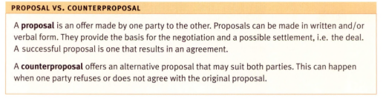
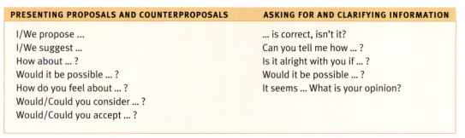
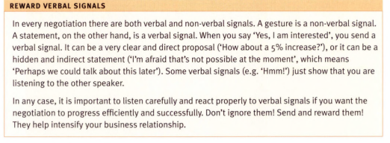
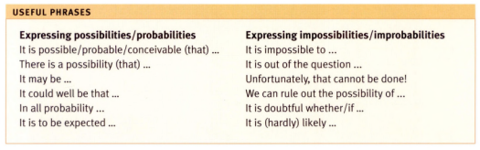
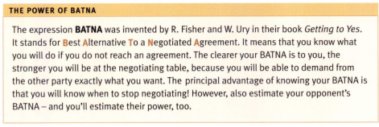
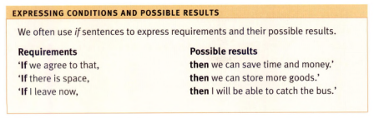
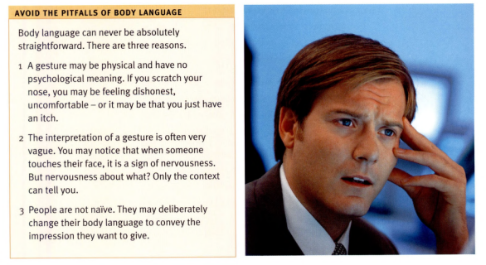
EXERCISE: Students do all of the exercises in unit 4
ANSWER KEY:
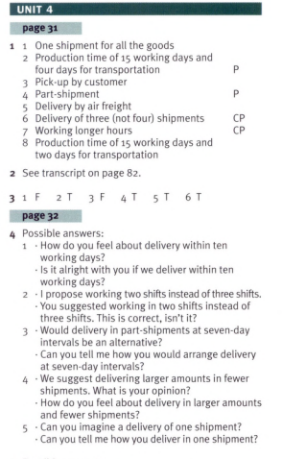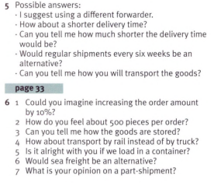
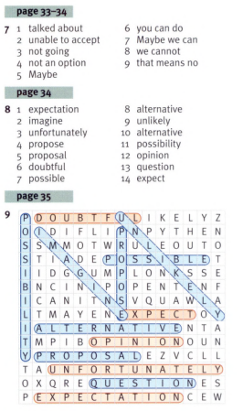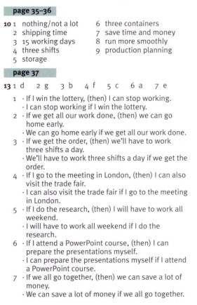
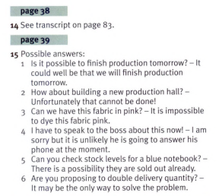

UNIT 5: A NEW OFFER

What Does Not Constitute A Win-Win Deal?
Many negotiators delude themselves into believing they follow a win-win approach and settlement when these negotiators adopt many of the strategies described below. However, putting their agreement under our microscope and look closer, these negotiators would be dismayed to discover that they squandered money and wasted resources.
Positional and tactical negotiators love less experienced negotiators who do not yet sufficiently understand “win-win.” Why? Inexperienced negotiators make for easy targets that are easy to take advantage of. This is simply due to a lack of understanding of the win-win concept on the part of the inexperienced negotiator. Crafty, competitive negotiators employing negotiation tactics all too often strip value from the untrained win-win negotiator.
So, what pitfalls can lead your company or team to miss the rich rewards promised by a win-win settlement?

1. One Size Fits All, Win-Win Approach
It’s fine to have a positive mindset when entering talks, but it pays to be realistic. We should avoid getting bogged down into a mentality of “the end justifies the means” by sacrificing resources or funds to secure that agreement. The Negotiation Experts does not advocate win-win in all situations. Some examples where win-win would not be an appropriate commercial strategy to employ would include:
- Hostile or die-hard positional negotiation participants who look at you through win-lose lenses.
- When you’re bargaining the purchase of a widely available commodity type product or service that makes neither a strategic impact upon your business nor carries a large price tag.
- For distributive business negotiations with one or two variables. There is no room to maneuver, and the side with the more powerful cards will win (skills being roughly equal).

2. Compromise
Many people falsely believe that compromise is a positive approach to gain a win-win deal. This is plainly incorrect. If you look at the definition of the word “compromise,” it means: “A settlement of a dispute in which two or more parties agree to accept something less than they originally wanted.” If one or both sides agree to lower their aspirations, this is hardly a win-win outcome, is it? (Note: Overambition in aspiration due to lack of experience or research is the subject of another article.)

3. The Relationship
Possessing the desire to create a durable relationship in a negotiation is admirable. However, this admirable trait does not guarantee that you will walk out of talks with a win-win agreement to hand. Mutual relationships are the ideal, with each side creating value for their organization and for the other’s organization.
If you find that you’re getting the short end of the stick over and over again, then think through how the other side perceives you and the negotiation frame that’s been set. Almost everyone agrees that it’s important to have good relations with your business partners. However, few will agree with what “good” really means. It’s best you explore this separately as a company and or team, as assumptions are dangerous.

4. Taking Our Time
Many people are under the impression that if they take extra time to negotiate, a win-win settlement is more likely to be achieved. The truth is that many studies on this very subject have revealed that extra time does not make much difference to the quality of the negotiated agreements.

Winning Strategies

1. Ask Smart Questions
When we enter talks prepared, it is most likely that we’ll only have an educated guess as to the other side’s intentions, interests, and priorities. It is a sad truth that in reality, many negotiators do not ask questions to gain a better understanding of the ambitions that lie beneath the other side’s position.
We need to determine whether we can connect our goals to the goals of the other side. The more we know about the other team’s aims, the more we will be able to put together settlement packages that better address the business goals and priorities of both teams. When we know what’s important to the other side, we can build a beneficial and productive agreement that:
- Doesn’t leave gold on the table.
- Utilizes more resources to the advantage of both sides.
- Can save you from stripping away value by making needless concessions.

2. Play Fair
What do we tell the other side about our goals and interests? Reciprocation is essential in negotiations. We have to reveal our goals and interests to provide a better understanding of how the other side might not only meet their needs but ours as well.
It’s best that we begin at the outset by setting the frame of a cooperative mood to increase mutual interaction. Only then should we progress into fact-finding and option generation. The other side will usually mirror our behavior, the virtuous and less than virtuous.
If we start by openly offering information, others will normally reciprocate in kind. Our initiating the volunteering of goals and interests does not necessarily put us at a strategic disadvantage. Provided we set the frame of reciprocation and gain agreement at the outset, and provided we don’t put all our cards on the table (better to trade cards, one for one), reciprocation will likely prevail.
Of course, if the other side refuses to reciprocate at any point, and refuses to give a valid reason, this should be our red flag to stop.
Tip: It’s a bad idea to reveal your BATNA at the outset.

3. Present Multiple Offers
The best win-win agreements often spring from presenting multiple offers rather than a single offer or proposal. The reason is that a single offer or proposal often has an anchoring effect. In contrast, multiple offers tend to stimulate communication.
Multiple offers will often prompt or nudge the other side into providing vital information about their objectives and the true nature of their business ambitions. Negotiating will be more energetic and productive. This is because several options will likely enhance the possibility of finding even more creative solutions than would otherwise have been possible.

4. Third-Party Assistance
Another innovative strategy to maximize your resources effectively is to use a neutral third party to help both sides tease out all goals and interests. In addition, you can ask this third party to suggest an agreement, or for ways in which to improve your existing agreement. Each side should, of course, have the option to veto the third party’s proposals if they uncover better alternatives. A third-party proposal can bring a number of benefits:
- An experienced negotiation expert will often suggest options and proposals that neither negotiating team thought of.
- Both sides can safely share more sensitive information. Since information forms the building blocks required for creative alternatives, this can open doors that were previously not seen. The resultant outcome is more win-win by leaving little to no gold on the table.
- Trust is fostered under the experienced independent third party’s direction. Often, sides don’t share suspicions openly with each other. This format of negotiation is conducive to sharing doubts.
- Mistakes are mitigated against, with a third party looking out for both sides’ interests. This prevents one-sided gains and fosters a free-thinking creative process and, of course, reduces risks.

Conclusion
We should appreciate that not just any agreement leads to a win-win scenario or outcome in negotiations. In reality, very few negotiations reach this aspirational and theoretical ideal. Time constraints all too often straight-jacket how long and far we can explore. Attitudes, positions, and skills set invisible boundaries that constrain what we see as possible.
Win-win deals are more likely when set up correctly through effective use of framing, research, and building relationships at the right levels. If a win-win approach is appropriate, it’s essential that we remember to pursue a win-win agreement for both sides.
Resource: Our win-win negotiation case study illustrates many of the above points.
https://www.negotiations.com/articles/win-win-settlements/

NOTES:
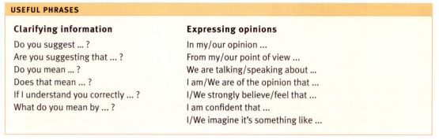
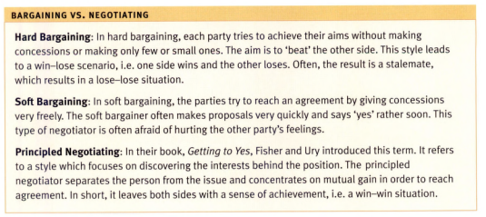
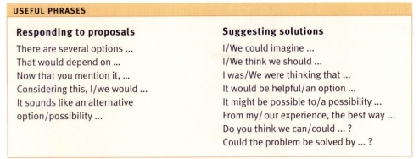
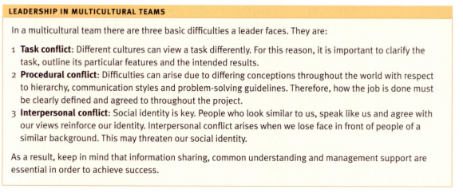
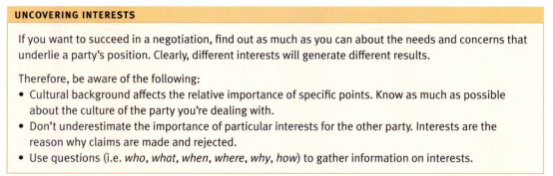
EXERCISE: Students do all of the exercises in the unit 5
ANSWER KEY
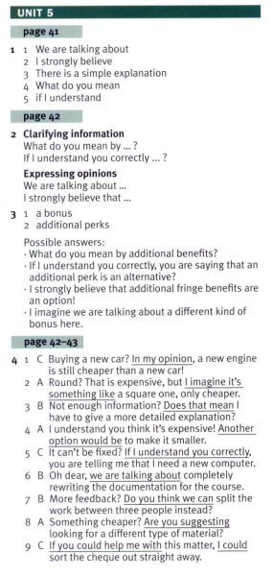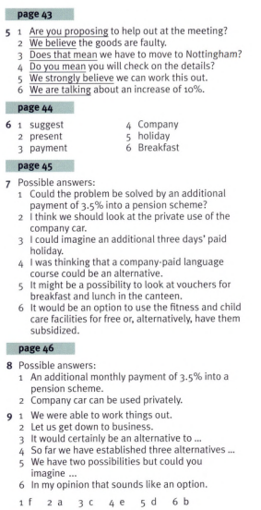
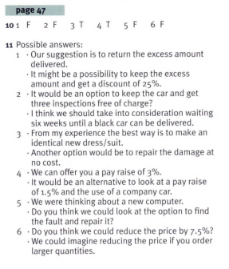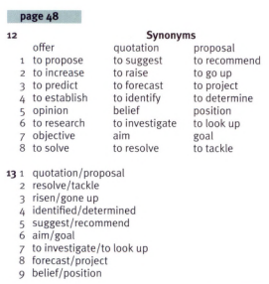
UNIT 6: DEALING WITH DEADLOCK

Dealing With Deadlock

Collin Schaefer

Attorney at Ogden Glazer + Schaefer
Published Feb 24, 2017
"Sure 50\50 ownership is fine," the potential clients said to me as they looked across my desk - nervously catching each others glances through the corner of their eyes. "We haven't really talked about it, but I guess its fair. Do you think that's best?"
Entrepreneurship is my jam - I love it! Over the past few years, I have met with many nascent entrepreneurs - all with various legal and business related questions - but, on the subject of how equity should be split - their questions usually take the form of the example above. This post deals with ownership of equity in a new business, and specifically, how some equity decisions will lead to deadlock and therefore, require carefully planned mechanisms to defeat it and bring about a resolution.
What is Deadlock?
In the context of a business, "Deadlock" means that a majority (i.e. 51%) of those shareholders with decision making power cannot come to an agreement in regard to a choice that needs to be made for the Company. This kind of situation doesn't come up all that often in the totality of business disputes - but in the context of a new company, especially a closely held company with few shareholders, the likelihood is pretty high
How and Why Does Deadlock Occur?
Deadlock occurs when the equity in a Company is split so that no shareholder has majority control (51%) and therefore, coalitions between them (i.e. agreement) are required to make a decision. If there is no agreement, there is no decision, and therefore, deadlock. But why deadlock occurs is the important question,
In my experience with new entrepreneurs - the biggest reason deadlock occurs is because the shareholders in the Company fail to discuss their responsibilities and expectations - and to avoid that (oftentimes) uncomfortable conversation, they agree "just to split it down the middle." Meaning, everyone has to agree, and nobody is clear about their roles - not a recipe for success in friendship or in business.
How To Avoid Deadlock
There are various solutions to avoiding and\or dealing with deadlock, here are a few to think about:
- Make someone the majority shareholder. If someone owns 51% of the Company, deadlock cannot occur (unless a Super Majority or Unanimous consent is needed for some actions of the Company.)
- Designate a Manager - To reduce deadlock, and to make decision making easier - the Company might consider appointing a "Manager" who is tasked with day to day decision making - and has the power to do so. If only larger Company decisions are subject to Majority Consent (rather than ALL decisions), the likelihood of deadlock is reduced,
- Create A Deadlock Busing Process - Maybe 50\50 ownership and not designating a Manager are right for your Company - if that's the case, you should discuss what will happen in the event of (the inevitable) deadlock. The process can be as complicated or as simple as you wish. Sometimes, clients want to appoint a disinterested third person (like an accountant) to make the final decision, sometimes, clients are happy with a coin flip or Rock Paper Scissors (my personal favorite).
- DISCUSS, DISCUSS, DISCUSS - The Company will work best when everyone is getting along. The most important aspect of avoiding deadlock is TALKING about it, discussing what everyone's roles and expectations are, and realizing - early on - that disagreements will occur. When those disagreements happen, how will they be resolved - and by whom?
Have these discussions early and often - because the Company's future - depends on it.
https://www.linkedin.com/pulse/dealing-deadlock-collin-schaefer

Advanced Negotiation Skills: Dealing with Deadlock
Deadlock is many negotiators’ worst nightmare. It happens where there may well be a deal to be done but neither side seems willing to move towards the other in order to bridge their differences. If you are not used to this, it can be psychologically very uncomfortable.
In fact, creating deadlock on purpose is a key part of the armoury of hard-ball negotiators. They do it to make sure they have drained every last drop of advantage for themselves before agreeing any deal. And, because they do this habitually, they are often very good at it. For them, there is no apparent concern at all about being stuck in impasse. They are only waiting for you to blink first.
Analysis
In the last article in this series, on the importance of signalling in a negotiation, we confirmed that if you seem too willing to do a deal, you are almost certainly going to be taken advantage of. Your positon will inevitably be seen as one of weakness.
However, if you are too keen to show-off your negotiating power, you may either frighten away the other side before you ever reach a negotiation - and lose what could have been a good deal; or you will encourage them to come out with all guns blazing, ‘to get their retaliation in first’.
This style of negotiating can be wearying, time-consuming and frustrating. It can indeed produce really bad deals for both sides, or even no deal at all. But, it can also produce spectacularly good results – at least, for one side.
So how to defend against this?

Ten Tips
- Decide how badly you want this deal
It may not be worth fighting over.
Or, it may be well worth threatening to walk out unless they move towards your needs. This is often a great tactic, but you must walk out if they are intransigent. (And it is usually smart to leave both parties negotiating space to walk back in, too!)
- Remember your ‘Must Haves’!
In the first two articles in this series, we stressed the importance of separating your ‘Must Haves’ from your ‘Would Likes’, at the outset.
This is especially relevant during deadlock. If your ‘Must Haves’ really were just that, don’t let the other side persuade you otherwise!
- Keep ‘the whole package’ in mind
Deadlock can, nevertheless, arise from quite trivial disagreement.
When this happens, both sides may need reminding what their core objectives really were. (Including yours?)
- Reward only their ‘good behaviour’
This means not collapsing when they put extra pressure on you. That would be to reward bad behaviour!
Note: negotiation is about both sides trading concessions; not just one side donating them. So make it your Golden Rule: never give something for nothing. And encourage them to make counter-proposals, rather than just saying ‘No’.
- Don’t ignore their signals
This can only prolong argument. (See the third article in this series).
So explore their signals, rather than reject their position outright, and consider making conditional proposals. ( Eg: “If you will…, we could consider…”)
- Agree a change
Change the topic, agenda, venue, team, timescale, or anything else within reason.
It can be remarkably refreshing!
- Agree a deadline
This is often how international diplomacy works.
It also works especially well in more commercial negotiations!
- Agree a recess
This is one of the most powerful tools possible when deadlock looms. And unlike many may think, it need not be a sign of weakness.
Quite the opposite in fact. It can be a great opportunity to make the other side reconsider their position too.
- Will you need to ‘fight fire with fire’?
Hard-ballers are often bullies, and bullies hate weakness in others. (That is often why they are bullies.)
But note: if you want a fight, there will be no place for fine feelings, and you will need to start as you mean to continue.
- Stay calm
Some negotiators enjoy conflict and actively seek to destabilise the other side emotionally. Don’t let them!
Stay cool, calm and firm, and don’t play their games of insult, threat or provocation.
Important Lessons
You can’t make another side negotiate a ‘win-win’ deal. And although deadlock may be created intentionally to achieve a ‘win-lose’ deal (great for one side, awful for the other), it can easily result in either no deal at all, or even a mutually-bad ‘lose-lose’ outcome.
If this is your natural negotiating style, you will probably be very good at it! But while you may win some exceptionally good deals, you may also lose many more. If this isn’t your preferred style however, you are only at a disadvantage if you are taken by surprise and don’t know how to deal with it.
Far better for all styles of negotiating in fact, and especially for critical longer-term and repeat deals, is to learn how to deal with deadlock professionally and to resist the inevitable psychological pressures that you (or your team) may well not be accustomed to.
The essence of this is to be fully prepared, and one of the best ways is to role-play all possible scenarios with your team beforehand. Not only will you then understand the other side’s real position far better, as opposed to their rhetoric, you will also find out how best you might respond to all possibilities - and even which members of your team may be the most appropriate to field.
https://blog.vistage.co.uk/advanced-negotiation-skills-4-dealing-with-deadlock
NOTES:
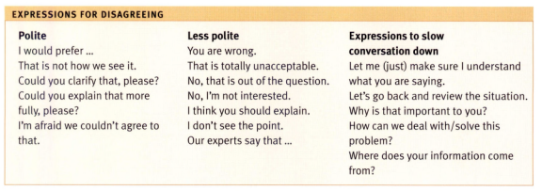
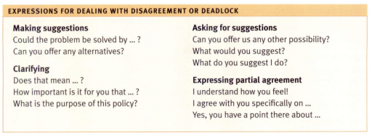
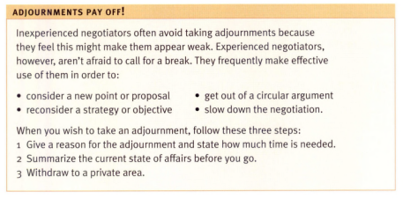
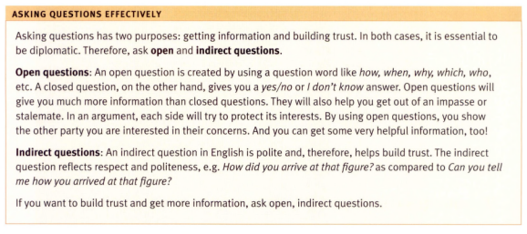
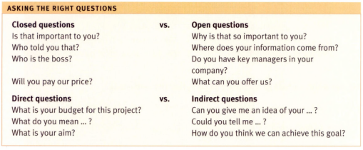
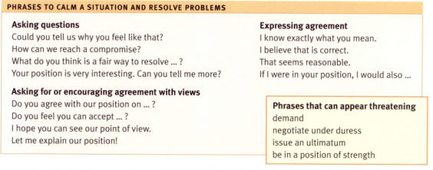
EXERCISE: Students do all of the exercises in unit 6
ANSWER KEY


