QUY TRÌNH XÂY DỰNG KỊCH BẢN AI CHATBOT TRONG DẠY HỌC
MÔN HÓA HỌC
THE PROCESS OF DEVELOPING AI CHATBOT SCENARIO FOR TEACHING CHEMISTRY

Keywords: |  | TÓM TẮT:
Teacher, Artificial Intelligence, Education, AI Chatbot, Teaching methods, Chemistry |  | Bối cảnh: Giáo dục phổ thông truyền thống, người dạy không thể vừa dạy vừa bổ trợ, giải đáp kiến thức cùng một lúc cho nhiều học sinh, với sự hỗ trợ của trí tuệ nhân tạo là AI Chatbot sẽ giúp giáo viên vượt qua được những giới hạn đó.  Kết quả: Bài viết tổng quan nghiên cứu các định nghĩa AI chatbot, kiến trúc cơ bản của chatbot thông minh, các công bố quốc tế về ứng dụng của AI Chatbot dạy học, làm cơ sở khoa học để hoàn thiện quy trình xây dựng kịch bản AI chatbot trong dạy học.  Trọng tâm bài báo cũng là tính mới, đóng góp mới của tác giả là thông qua nghiên cứu số hóa cơ sở dữ liệu môn hóa học, sự tương thích giữa AI chatbot với nội dung dạy học môn hóa học đã đề xuất Quy trình xây dựng kịch bản AI Chatbot trong dạy học cho các môn học nói chung và môn hóa học nói riêng nhằm góp phần phát triển năng lực tự học, tự chủ, tự khám phá kiến thức cho học sinh.  Bàn luận: Nhờ quy trình xây dựng kịch bản AI chatbot này, với phương tiện dạy học mới, giáo viên mới đó chính là trợ lý ảo AI chatbot, công việc dạy học trở nên dễ dàng hơn. Kịch bản là linh hồn của AI Chatbot niệc xây dựng kịch bản cho AI chatbot là rất quan trọng, nó quyết định sự thông minh và hiệu quả dạy học của AI chatbot.  ABSTRACT:  Context:  In traditional general education, teachers cannot both teach, support and answer knowledge at the same time for many students, with the support of artificial intelligence, AI Chatbot, which will help teachers overcome these limitations. that term.  Result: The study analyzes the definitions of AI chatbots, the basic architecture of intelligent chatbots, international publications on the application of AI Chatbots for teaching, as a scientific basis for completing the AI chatbots scripting process in teaching.  The focus of the study is also on novelty, the author's new contribution is through the study of digitizing the chemistry database, the compatibility between AI chatbot and the proposed chemistry teaching content. Since then, we have proposed the process of building AI Chatbot scenarios in teaching subjects in general and chemistry in particular in order to contribute to the development of self-study, self-control and self-discovery capacity for students.  Discussion:  Thanks to this AI chatbot scripting process, with a new teaching medium, the new teacher is the AI chatbot virtual assistant, making teaching easier. Script is the soul of AI Chatbot, building a script for AI chatbot is very important, it determines the intelligence and teaching effectiveness of AI chatbot.

1. Overview of AI chatbot in education
1.1. Introducing AI Chatbot
1.1.1. Artificial intelligence (AI)
AI is a branch of computer science, also known as human-programmed artificial intelligence, so it relies on computer systems to create products with human-like intelligence such as: learning and problem solving.
The advent of AI technology helps create great changes in the field of education. Educational activities such as grading or teaching can be automated thanks to AI technology. Many games and educational software were born to meet the specific needs of each student, helping students improve their learning at their own pace. [7].
The mention of artificial intelligence brings to mind a supercomputer, a computer with immense processing capabilities, including adaptive behavior, such as inclusion of sensors, and other capabilities, that enable it to have human-like cognition and functional abilities, and indeed, which improve the supercomputers interaction with human beings. Indeed, different motion pictures have been made to showcase the abilities of AI, such as in smart buildings, such as the ability to manage air quality in a building, temperatures, and or playing music depending on the sensed mood of the occupants of the space. Within the education sector, there has been increased application of artificial intelligence, going over and above the conventional understanding of AI as a supercomputer to include embedded computer systems. For example, embedded into robots, AI, or computers and supporting equipment enable the creation of robots that improve the learning experience of the student, from the most basic unit of education, early childhood education [2].
1.1.1. Artificial Intelligence in Chatbot [1]
Artificial intelligence (AI) is a branch of computer science, also known as human-programmed artificial intelligence, so it relies on computer systems to create products with human-like intelligence. The underlying technologies for chatbots are machine learning, natural language processing (NLP), and AI. NLP is the foundation of AI based chatbots. By using NLP's sophisticated algorithms, chatbots can process input text: understand, conclude and determine what has been said or written and then state a list of all the appropriate actions.
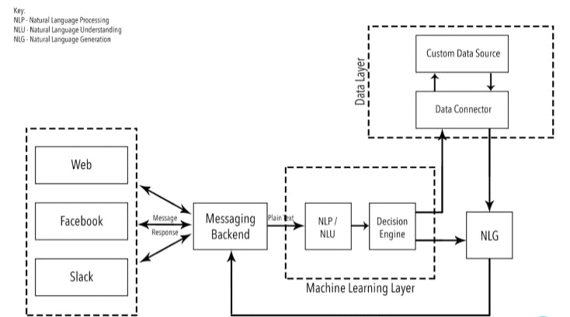
Figure 1. Artificial Intelligence concepts in a chatbot
Natural Language Processing acts as a fundamental pillar for recognition of language, which is used by Apple’s Siri and Google. It allows technology to recognize human natural language text and speech-based commands and include two major components natural language generation (NLG) and natural language understanding (NLU)
Natural Language Understanding is responsible for handling and converting formless data into a proper form that the system can easily understand. NLP has further five main steps if we want that message should be easily understandable by a chatbot. These steps are: Lexical analysis, Syntactic analysis (parsing), Semantic analysis, Discourse integration, Pragmatic analysis.
Natural Language Generation involves text realization and text planning to generate an understandable response. In simple words, language generation is responsible for the formation of linguistically correct sentences and phrases. The key challenge faced by NLP is to understand the complications of natural human language.
Automatic Speech Recognition (ASR) comes under computational linguistics, which develops technologies and methodologies that enable the identification and translation of user speech into text with the help of computers.
1.1.2. Fundamental Architecture of Smart Chatbot
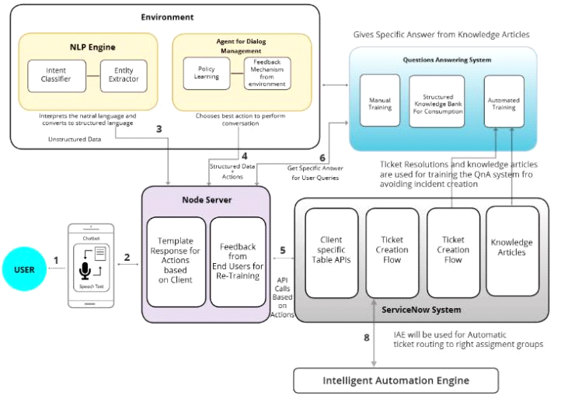
Figure 2: General architecture of a smart chatbot
1) Environment
The place where the fundamental Natural Learning Process (NLP) engine and context clarification occurs.
2) Questions and Answers System
It is a fundamental component to answer the users frequently asked questions. This system understands the user's questions properly and responds to those questions with the related answers stored in the knowledge base.
3) Plugins/Components
Plugins provide smart chatbot automation components and chatbot solution APIs for those chatbots which are used inside of the companies such as field worker and HR management chatbots.
4) Node Server / Traffic Server
A server that is responsible for handling the user’s request and then route it to the suitable components. This server also directs the response of the internal component back to the front-end system.
5) Front-End Systems
Several systems that has a client-facing platform can be candidate to develop the frond-end. These systems can be the chatbot interfaces that exist in many platforms.
1.1.3. Operating procedure of chatbots
- Receiving: Users raise questions, requests for help, Chatbot receives information in the form of natural language and proceeds to the next step.
- Translation: Natural language is converted into computer language for the computer robot to understand. This determines whether the Chatbot is smart or not.
- Processing: Chatbot's AI technology processes information and searches for answers in the database.
- Feedback: Chatbot will give answers, in the form of natural language messages.
1.2. Teaching AI chatbots
1.2.1 Features of Chatbot in Education [3]
AI chatbots built from teaching scenarios of subjects, lessons or courses is called AI chatbot teaching or virtual teacher and has the following features:
- Accurate information: Instead of information being exchanged through word of mouth, students can get accurate answers from the school itself.
- Timely communication: Overall, 64% of internet users consider 24-hour service to be the best feature of a chatbot. For schools, most of which are not available 24/7, chatbots are a way for students and parents to get immediate answers at any time.
- Serving multiple students at the same time: Chatbot can answer the questions of many students at the same time with endless patience
- Personal Access: A chatbot that allows you to personalize messages for each student while sending out bulk notifications. Chatbot approaches and stores the history of each individual's learning activities to provide appropriate suggestions and support for learning.
1.2.2 Applications of AI Chatbot in Education [1]
- Providing information quickly and accurately
Application to provide information such as class schedule, timetable, exam schedule, school announcements, teachers to students... in the fastest and most accurate way. Because, the information will come directly to students without having to go through intermediaries or word of mouth, paper announcement.
- Effective teaching assistant
A teacher in a class can teach from 30 to 50 students, when imparting knowledge will be mass for the whole class, in order to support students in the effective teaching process, the teacher will be overloaded. , will always put pressure on both teachers and students. At this time, AI Chatbot can act as a talented and dedicated tutor to personalize each learner. Chatbot will assist teachers in answering students' repeated questions during lessons, courses and subjects. Chatbot also suggests and offers appropriate learning content for each student.
- Chatbot learning assistant
The AI ​​chatbots can assess the learning style and ability of the students to use them. In this way, the AI ​​Chatbot can tailor lessons for each student to help them learn more easily. Chatbots can be used:
- In the classroom: Chatbot can provide explanation and support according to the needs of each student.
- Out of the classroom: Chatbot can help students study and review the material they have studied, learn, and discover more new related knowledge.
One major benefit to using chatbots is promoting inclusiveness in education. Not all students learn in the same way and have the same perception, many students cannot understand the lesson and to increase the ability to learn, it is necessary to study one-on-one.
A common application of AI Chatbots is to create intelligent tutoring systems that provide personalized learning environments for students by analyzing their responses and how they go through the learning content. As a result, Chatbots with AI technology can be brought in to teach students by passing a lecture through a series of messages, images and videos, and assist students with the background of the lesson as they learn. not yet stable. Chatbots continuously assess students' understanding and offer appropriate follow-up lessons.
- Smart and instant support
Personalizing data in AI Chatbot, will help send notifications, tips, reminders, and motivation to each student easily and instantly. AI Chatbot helps to answer questions instantly for students 24/7 completely intelligently and automatically.
2. The scientific basis of the AI chatbot scripting process [5]
The author based on international publications on the benefits and applications of AI Chatbot for teaching over the past 10 years in prestigious journals to perfect the process of building AI chatbot script in teaching.
2.1. Scenario:
Scenario - as defined by the British Dictionary is:
+ A summary of the plot of a play, ... including information about characters, scenes, etc.
a predicted sequence of events;
+ An outline of the plot of a dramatic work of art, with specifics about scenes, characters, situations, etc.
+ An imagined or projected sequence of events, which can be detailed plans or projections of any possibility.
2.2 Pedagogic Scenario ( PS):
According to James Cook University (Australia), pedagogical (teaching-learning) scenarios are created primarily to help teachers meet their expectations, allowing learners to seek or demonstrate knowledge, skills, attitudes degree, know how to learn. PS can take the form:
• A set of instructions, case descriptions, questions, etc., in complete or incomplete form, expressed in words, images, audio, or video, given by a teacher to a teacher. learner
• A text that outlines situations with 'gaps' for students to complete on their own
• A detailed summary of the roles, positions, roles and attitudes, tasks, relationships and responsibilities of teachers and students in the teaching-learning process.
2.3 Classification of pedagogical scenarios
There are several types of pedagogical scenarios. The teacher must choose, decide, create a new pedagogical script suitable for his specific context, the most important thing is that the teaching script is to facilitate effective teaching and learning. and make it easy for learners. Pedagogical scenarios are classified according to the following criteria:
Classification according to the form of expression
- Process scenario: presented in the form of models/drawings/diagrams/processes/text listing the main activities.
- Scenario teaching specific content: is a scenario that contains as fully and specifically as possible the content of all elements of a scenario, including:
+ A list of the order of teaching and learning
+ The specific contents of each step in the sequence are planned, compiled, edited in advance by the teacher, etc.
Classification according to the nature of the content, the nature of the subject, the way of teaching
- Integrated teaching scenario
According to professors at Stanford University (www.stanford.edu/
group/design_education), after 4 years of researching and implementing the project on SBL, proposed a model of the stages and activities that need to be done when you want to implement SBL to teach thematically integrating 2 contents of technical design. technical and business, ... , in which there are 2 stages:
+ Building a Scenario-based learning curriculum (SBLC) with 4 pedagogical modules - Figure H1:
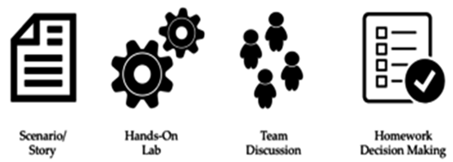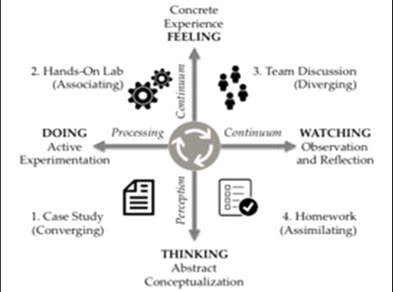
H1 H2
+ Organizing teaching and learning activities
Is the rotation of implementation (according to H2) 4 pedagogical modules aimed at forming and consolidating in learners the following 2 continuous learning processes: – a perception continuum and “constantly doing” (a). processing continuum): “Continuity of perception” will help learners move from “thinking” – the process of generalizing concepts to “feeling” on the basis of experiences. “Continually doing” encourages students to move from the act of “Watching” – the process of observing and reflecting on – to the action of “doing” – a positive reinforcement of the learner experience. will form a learning preference with four characteristics: Converging, Associating, Diverging, and Assimilation (Learning can represent “digestion”) – and this study habit is used for other content in the course of learning the subject.
- In addition, according to Karla Gutierrez, there are other types of teaching scenarios: Skill-Based Scenario, Problem-Based Scenario, Situation-Based Scenario /Issue-Based Scenario), Speculative Scenario, Game-Based Scenario (Gaming Scenario).
2.4. The meaning of the teaching scenario
In all contexts, the pedagogical scenario (teaching - learning) is always important and irreplaceable because of the benefits it brings to both learners, teachers, and administrators:
For learners
To learn and know how to self-study, self-assess, evaluate each other in a humane and scientific way to:
+ Forming core humanistic competencies and qualities;
+ Developing high-level competencies;
+ It doesn't take much time for the transition from school knowledge and skills to be applied to what you need/should do in your career and life in the future.
For teachers and educational administrators
A detailed teaching - learning scenario - helps
+ Teachers do not omit content (even to each word) - maintain a balance in teaching-learning quality in different types of training and training spaces;
+ Organize interactive, diverse and rich teaching and learning, helping learners know how to learn the subject;
+ Achieving a balance in the evaluation of training quality by the three parties School-Society-Employer;
+ Reduce pedagogical labor pressure, save pedagogical labor time in updating and renewing content, teaching methods, ... according to the general trend (or regulations), ...
A good teaching scenario - help
+ The coordination between teaching and learning workers is in the right direction with pedagogical goals;
+ Shorten the training time for the next class of lecturers;
+ Teachers continuously improve and improve the quality of pedagogical workers according to TQM (Total Quality Management);
+ Quickly change teaching methods while ensuring training quality. …
3. Innovating teaching methods [1]
Over the past few years, along with the appeal of instant messaging, chatbots and pedagogical agents have pushed educators to integrate messaging tools in teaching and learning.
Compared with current teaching methods, the application of AI Chatbot in teaching teaching innovation follows:
- Current students enjoy interacting through messaging and exchanging information through chat applications. Grasping this "taste", the application of Chatbot in teaching is a new step, bringing effective teaching and improving the quality of teaching and learning.
- Teaching through AI Chatbot provides answers, instant support and personalization creating a more engaging learning experience, promoting positivity, initiative, creativity and enhancing self-learning ability for students.
- Teachers who teach through teaching methods without applying technology will take a lot of time and effort. AI Chatbot that is both an assistant for teachers and an assistant for students will make the teaching process easier than ever.
4. AI Chatbot scenario building process
4.1. Definition
AI chatbot scenario is a pedagogical scenario built to teach on AI chatbot with teaching content transmitted to students through a virtual teacher, which is an AI chatbot to improve students' self-learning ability and improve self-learning ability. high quality teaching.
4.2. AI Chatbot scenario constructing process
The process of building AI chatbot scenario to demonstrate through the following steps:
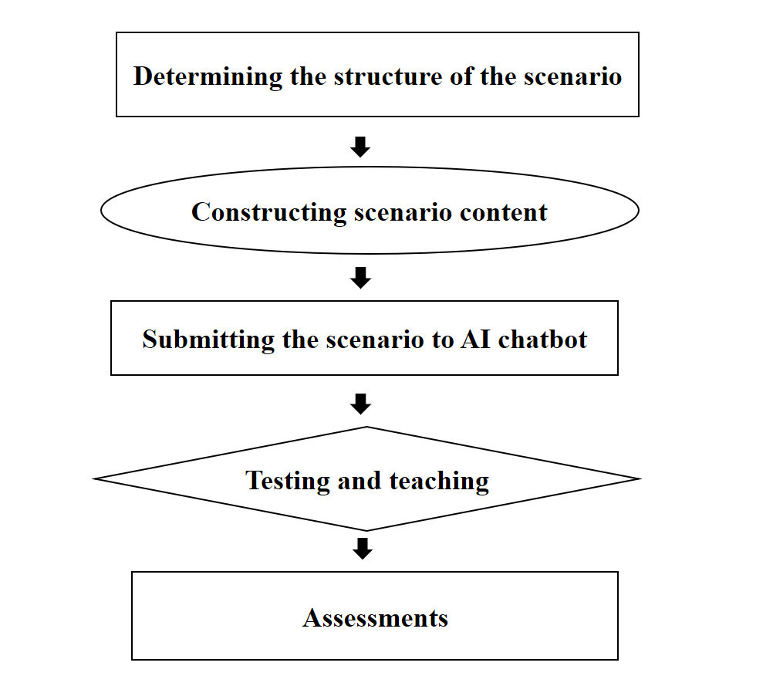
Figure 3. AI Chatbot scenario constructing process
Step 1: Determining the structure of the scenario
- Defining teaching goals
- Preparation and selection: Resources related to the lesson, subject
- Anticipate quotes, situational sentences, interactive questions, test exercises and teaching - learning - assessment - feedback strategies.
- Structure the teaching script in the direction of personalized learners.
- Select AI chatbot suitable for the teaching scenario.
Based on the objectives of the subject and the curriculum, use the course outline to build a teaching scenario. Determine the arrangement of the content and organize the content within the teaching script to meet the goals of skills and attitudes, and how to implement and evaluate the content.
This teaching script can be changed and adjusted to suit many learning objects such as each, subject, class or each course.
Step 2: Constructing scenario content
The development of a scenario for a lesson needs to ensure that the contents of the teaching program are fully individualized, helping students to learn by themselves and acquire knowledge in the most effective way. In each step of the script, the content must always be strictly, scientifically and accurately controlled. A teaching script consists of 3 parts:
- Heading
Focusing on the general overview and content structure will be presented such as: Introduction to the content overview, concepts, issues to be discussed, quotes from practice to enter the concepts and theory included in the lecture.
- Development section
In this part, focus on the core content and the expanded content of the lesson: Explain concepts, definitions, properties, how to apply, give illustrative examples, pictures, videos... give extended cases, exercises, solve sample exercises… Develop skills, attitudes and awareness for students.
- The end
This part is the part that emphasizes the main content of the lecture, tells learners the end and results of the teaching process, as well as shows the purpose and ultimate meaning of the lesson content. From there to remind, assign exercises and apply the lesson in practice at the end of the lesson.
Step 3: Submitting the scenario to AI chatbot
- Before putting the teaching script on AI chatbot, it is necessary to divide and digitize the script to be compatible with AI chatbot, also known as building a database for AI chatbot.
- Submitting each scenario content to the AI ​​chatbot must follow the correct sequence of the script structure and the scenario built in step 1 and step 2.
- At the same time, adding background knowledge for each content in the above teaching scenario for AI chatbot (conjectured and built by the teacher) when students need it, the lookup will be answered immediately. This is very important, very useful and characteristic feature of AI chatbot.
Step 4: Testing and teaching
After uploading the teaching script to the AI ​​chatbot (bot), we will have a virtual teacher who teaches the content according to the previously built teaching scenarios. At this point, we need to check the (intelligent) operation of the AI ​​chatbot by asking the bot (entering random content in the teaching scenario) to see if the bot answers correctly, completely and correctly. If not, we re-check the entire digitization process and put the built-in teaching scenario data to make appropriate changes and corrections. The process of checking until the bot is proficient (intelligent) then stops.
After testing the bot, we conduct teaching - learning many times before going into formal teaching to detect mistakes to adjust and at the same time accumulate and add new knowledge for AI chatbot to Bots are getting smarter and smarter.
This is the step to test the qualifications of virtual teachers before conducting "contracting" for formal teaching.
Step 5: Assessments
Evaluating teaching scenarios is also assessing the teaching quality and effectiveness of AI chatbots to improve scenarios, adjust, and improve the quality and effectiveness of teaching.
5. The process of building Ai chatbot scenarios in teaching chemistry

5.1. Location and characteristics of chemistry [6]
Chemistry - is the study of the composition, structure, properties, and changes of matter, elements, compounds, atoms, molecules, and the chemical reactions that occur between those components .
Theory with experiment is the basic feature of Chemistry. Chemistry gives students vivid scientific knowledge, helping us to explain many interesting phenomena in nature and in everyday life. Chemistry also helps students practice and improve themselves essential skills such as: observation, judgment, comparison, analysis, etc., bringing passion to the students for this subject.
5.2. Aims and content of chemistry [11]
5.2.1. Aims of chemistry
The educational objective of Chemistry is to form and develop in students chemical competence; at the same time, contributing together with other educational subjects and activities to form and develop in students the main qualities and common competencies, especially the scientific worldview; interest in learning and research; honesty; respectful attitude respect the laws of nature, behave with nature in accordance with the requirements of sustainable development; the ability to choose a career in accordance with their own capacity and interests, conditions and circumstances.
5.2.2. Content
The content of Chemistry is designed into topics that both ensure to strengthen the content circuits, develop knowledge and practical skills, and help students have a deeper understanding of the general basic knowledge of chemistry. , as a basis for studying, working and researching.
Chemistry curriculum with 3 core content circuits: General basic knowledge of chemistry; inorganic chemistry and organic chemistry. The main development axis of the Chemistry program is the system of basic chemical knowledge about the structure of substances and the process of chemical transformation. Knowledge of the structure of atoms, chemical bonds, chemical energy, rate of chemical reactions, redox reactions, balance by chemistry, electric batteries and electrolysis, the periodic table of chemical elements is the main theoretical basis for students to explain the nature and study the laws of chemistry in the contents of inorganic chemistry and chemistry. organic chemistry to a certain extent.
5.2.3. The most outstanding new features of the Chemistry program
The most important new point in the Chemistry curriculum is the emphasis on practicality; avoid a computational bias; Focusing on equipping tools with concepts and methods of using tools, especially helping students to have practical experimental skills, skills to apply chemical knowledge in understanding and solving at high level. certain problems of practice, meeting the requirements of life.
5.3. Methods and means of teaching chemistry
5.3.1. Methods of teaching [8]:
Most high schools use chalkboards and textbooks in the teaching process. These means are still not enough for teachers to transmit knowledge to students, so it is necessary to design teaching media suitable for students, with the school's conditions and to respond immediately and immediately to the process. Effective teaching is very important and necessary.
5.3.2. Teaching tool [11]
The innovation of chemistry teaching methods in the direction of competence is the focus of the Program. The Chemistry curriculum pays special attention to the orientation of capacity development through the design of teaching activities for each learning content and topic. Educational methods are mainly selected according to the following orientations:
- Activity orientation: Students' learning activities are based on experiential activities; Applying, connecting with practice and orienting to solve practical problems to enhance students' interest, contribute to the formation and development of the quality and capacity of the students that the subject is responsible for.
- Positive teaching orientation: Increase the use of teaching methods to promote positivity, initiative, creativity and suitability with the formation and development of qualities and capacities for learners. practice, experience in teaching contents, especially when studying inorganic and organic substances, which have many practical applications through learning projects.
- Combining STEM education in teaching to develop students' ability to integrate knowledge and skills of Math - Engineering - Technology and Chemistry subjects into research to solve some real-life situations .
- Use chemistry exercises that require critical and creative thinking (open exercises, multiple solutions,...), exercises with practical content, enhancing the nature of chemistry, and reducing problems. Mathematical calculation exercises.
- Diversify learning forms, use information technology and teaching devices appropriately and effectively in teaching chemistry.
5.4. The process of constructing AI chatbot scenario in teaching chemistry
From the location, characteristics of chemistry, and the benefits of AI Chatbot, researchers found that AI Chatbot integrated with a chemistry teaching scenario is very suitable to easily achieve the goal of teaching, improving High efficiency in teaching and learning Chemistry.
The AI chatbot scenario process in teaching chemistry is built based on the AI chatbot scripting process:
Step 1: Determining the structure of the scenario
- Determining the goal of teaching chemistry
- Preparation and selection: Resources related to the lessons in the chemistry program.
- Anticipate quotes, situational sentences, interactive questions, test exercises and teaching - learning - assessment - feedback strategies.
- Structure the script for teaching chemistry in the direction of personalized learners.
- Choose AI chatbot platform: fpt.ai for chemistry teaching scenario.
Step 2: Constructing scenario content
Building a scenario for a lesson or a whole chemistry program according to the amount of knowledge from basic to advanced to serve each student's level and individual level. Later graders can relearn previous grade chemistry knowledge to regain old knowledge, background knowledge whenever they need it right on AI chatbot. Pretty good students can self-add more advanced and specialized knowledge.
Natural Language Processing is a core AI feature of the FPT.AI Conversation platform. In order for the Bot to be able to understand the students' sentences, the teacher designing the bot needs to teach the bot a specific amount of knowledge according to the content of each lesson in chemistry.
In FPT.AI, the scenario (Scenario) is a topic that the bot relies on to answer students. Step (Step) is a sub-topic. A script consists of several steps with the same topic. These steps can be linked together by buttons.
The design of scenarios that answer each intent. With the intention that the sample sentence contains no entities, the Bot only needs to give a single answer. However, with the intention that the sample sentence contains an object entity, the Bot needs to give different answers based on that entity. In this case, we use the condition of the variable.- - Heading
Introduction of overview content, concepts, issues to be discussed, quotes from practice to enter concepts and theories contained in chemistry lectures by steps and suggested content buttons for students to choose from.
- Development section
+ Theory: Build concepts, definitions, physical properties, chemical properties of substances by steps, in the steps will be nodes containing the content of concepts, reaction phenomena, how to apply Use, give illustrative examples, relate to real life in the form of writing, images or videos...
+ Experiment: Digitize chemical lab experiments into images and videos. In this section, the steps will be steps in the experiment such as: preparation, safety, conduct ..., each step will include buttons containing small contents in each step of the experiment.
+ Exercises: Each step is an exercise, solving sample exercises, exercises go from easy to advanced. The buttons will be answer options or suggestions or move to the next sentence. To develop students' skills, attitudes and awareness.
- The end
Develop key steps of the lesson such as: Concepts, physical properties, chemical properties and practical applications, assign homework.
For the most logical scenario design, describe the sub-scenarios and divide them into conversation flows in the form of a tree map.
Step 3: Submitting the scenario to AI chatbot
- Create scenario flow for Chatbot: Break down and digitize each teaching content in a chemistry lecture by step 1 and step 2 into small topics according to Sample Sentences (Questions that learners use to ask about problems they need answers to). From there, what is the intention (purpose, intent of the questions) of the learners in each sub-topic? At the same time, build Keywords (The important and necessary information in the sentence, helping the bot understand the problem that the learner is talking about to give a suitable answer). Building the Entity (Denoting the meaning of the above Keywords) in the Sample Sentences (Sample), the set of Sample Sentences (Sample) is the sentence that learners will ask related to each problem to teach the bot.
Example:
Sample sentence: I want to solve exercise 2, 8th grade chemistry, page 30
Intent | Key words | Entity Type
Solving exercise | 2 | Number exercise
 | Chemistry | Subject
 | 8th grade | Class
 | Page 30 | Page
Sample sentences are very important for chatbots. Therefore, teachers should add as many sample sentences as possible. The variety of sample sentences will help the chatbot to understand many different sentences of learners.
- The Intents that are of most interest to users should be identified based on the learners' experiences as well as questions, queries, or chat history. Then add as many and varied sample sentences to those intentions.
- Submitting each scenario content to the AI ​​chatbot must follow the correct sequence of the script structure and the scenario built in step 1 and step 2.
- At the same time, add background knowledge such as reaction equations, valency, formulas, chemical formulas... for each content in the above teaching scenario for AI chatbot (as guessed by the teacher. and construction) when students need it, the lookup will be answered immediately. This is very important, very useful and characteristic feature of AI chatbot.
Step 4: Testing and teaching
Test the bot's intelligence by asking the bot random questions about valence, chemical properties, formula or chemical equations and see how accurate the bot is when answering. Check for errors and fix them from the digitization step to the final step of putting the teaching script on the bot until the accuracy is 100%, then conduct a trial lesson.
The trial teaching many times before going into formal teaching to detect mistakes to adjust and at the same time accumulate and add new knowledge for AI chatbot so that the Bot gets smarter and smarter.
Step 5: Assessments
Evaluating the quality and effectiveness of AI chatbot teaching chemistry through achieving the goal of teaching chemistry, thereby improving the scenario, adjusting, and improving the quality and effectiveness of teaching.
6. Conclusion
With the great benefits of AI chatbot in education, teaching is now easier with a new teaching tool, the new teacher is the AI chatbot virtual assistant. Script is the soul of AI Chatbot, building a script for AI chatbot is very important, it determines the intelligence and teaching effectiveness of AI chatbot.
Chemistry is a subject with logical and complementary knowledge, so the application of teaching chemistry through AI Chatbot is appropriate and improves the efficiency and quality of teaching. replicate this model in teaching activities to expand to many other subjects.

References
Nguyễn Minh Giám, Ngô Tứ Thành (2020). AI Chatbot application innovates teaching methods. Tạp chí thiết bị giáo dục, số 209 kỳ 2-1/2020.
Chen, L., Chen, P., & Lin, Z. (2020). Artificial intelligence in education: A review. Ieee Access, 8, 75264-75278.
Boudhir Anouar Abdelhakim, Soufyane Ayanouz (2020). A Smart Chatbot Architecture based NLP and Machine Learning for Health Care Assistance (April 2020).
Nikoletta Bika (2020). Get Schooled by AI: Use Cases of Chatbots for Education (Tháng 6/2020).
Nguyễn Tiến Dũng. Xây dựng kịch bản và Dạy-Học theo kịch bản bước chuẩn bị vững chắc để thực hiện tốt Electronic/Mobile Learning. ĐHSPKT TP.HCM.
Nguyễn Minh Giám (2015). Dạy học theo hướng tối ưu hóa môn hóa học lớp 12 tại TTGDTX tỉnh Bình Dương. Luận văn thạc sĩ, Đại học sư phạm kỹ thuật Tp.HCM, 2015.
Pavel Smutny, Petra Schreiberova (2020). Chatbots for learning: A review of educational chatbots for the Facebook Messenger (Tháng 7/2020).
http://hcm.edu.vn/GDTrungHoc/Hoa/129/Hoa-THPT
Nền tảng fpt.ai
Sách giáo khoa Hóa Học, 2020, NXB Giáo Dục
Bộ giáo dục và đào tạo (2018). Chương trình giáo dục phổ thông mới: tìm hiểu chương trình môn hóa học.

