DẠY HỌC MÔN TOÁN QUA TRÒ CHƠI SỐ CHO HỌC SINH
BẬC TIỂU HỌC

TEACHING MATHEMATICS THROUGH DIGITAL GAMES TO STUDENTS
IN PRIMARY SCHOOLS

Keywords: |  | TÓM TẮT:
Teacher, Artificial Intelligence, Education, AI Chatbot, Digital games, Teaching methods, students in primary schools |  | Bối cảnh: Nhiều trò chơi hấp dẫn đáp ứng được các yêu cầu cơ bản của môi trường học tập và có thể hỗ trợ cho quá trình dạy và học. Khác với các trò chơi truyền thống, việc sử dụng trò chơi số trong dạy học là một sự đổi mới trong phương pháp dạy học, mang lại nhiều lợi ích cho học sinh và tạo ra một góc nhìn mới trong văn hóa học tập.  Kết quả: Bài viết này tổng hợp, phân tích các nghiên cứu của các tác giả trên thế giới cho thấy hiệu quả của việc sử dụng trò chơi số trong dạy học, từ đó có cơ sở khoa học để đưa ra các nguyên tắc xây dựng, quy trình xây dựng và các bước tiến hành trò chơi số trong dạy học môn toán bậc Tiểu học tại Việt Nam.  Bàn luận: Các nghiên cứu cho thấy, dạy học qua trò chơi số giúp mang lại hứng thú và động lực tham gia cho học sinh. Giáo viên cần có cái nhìn khác về việc sử dụng trò chơi trong dạy học nhằm giúp học sinh tiếp thu kiến thức một cách nhẹ nhàng, tự nhiên và hiệu quả.  ABSTRACT:  Context:  Many fascinating games meet the basic requirements of the learning environment and support the teaching and learning process. Different from traditional games, the use of digital games in teaching is an innovation in teaching methods, bringing many the interests to students and creating a new perspective in learning culture.  Result:  This article summarizes and analyzes the researches of authors around the world showing the effectiveness of using digital games in teaching, from which there is a scientific basis to give the rules of construction, construction procedure and steps to implement digital games in teaching mathematics in primary school in Vietnam.  Discussion:  Studies show that teaching through digital games helps bring excitement and motivation to students. Teachers need to have a different view on using games in teaching to help students absorb knowledge in a gentle, natural and effective way.

1. Introduction
Digital games are becoming an important part of students' learning activities because they promote positivity, initiative and creativity in accordance with students' psycho-physiological characteristics: "Learn to play, play to learn". Digital games take advantage of digital technology elements, so they help enhance students's interactive activities with teaching content and interactions between students and with teachers. Thanks to that, digital games create excitement, attract students to learn knowledge in the most natural and easiest way, reduce learning pressure and contribute to improving teaching quality. Traditional games, folk games... are often less changed and improved, so it's easy to get bored. Thanks to digital technology, digital games are always upgraded and innovated, creating beautiful graphics and exciting sounds so they appeal to teenagers.
Besides the great advantages, digital games also have downsides, especially when the COVID epidemic takes place, unable to go to school, unable to participate in fun activities, if misuse of number games can affect the health and mental health of students. Therefore, there is a great need for scientific researches to build digital games that are both a teaching tool and an attractive game, meeting specific learning goals, appropriately designed and evaluated, so that the digital games becomes a positive and healthy learning environment.
In order to implement the content set out above, the article will study the documents, analyze the effectiveness of using digital games in teaching that countries around the world have applied, combined with analysis the latest digital technology trends to come up with a new definition of digital games in the digital environment. Finally, the focus of the article is to present the process of building and how to conduct digital games in teaching Mathematics at primary school.
2. Research content
2.1. Definition of digital games in teaching
2.1.1. What are teaching games?
Author Nguyen Ngoc Tram considers that: "Teaching games are one of the effective means to develop intellectual abilities, in which the ability to generalize is a peculiar ability of human ability.” Trâm.N.N. (2003)
Teaching games are created and used by teachers and adults based on the recommendations of teaching theory, especially teaching theory of specific subjects. They reflect the teachers' theories, ideas, and goals, which is one of the educational activities that do not follow rigid rules like lessons. Hưng, Đ. T. (2002)
Through different conceptions, it can be understood: Teaching games are games used in teaching and learning activities, have clear rules, the content of the game is associated with the teaching content, created by teachers or educators to help learners absorb knowledge gently, naturally and effectively.
2.1.2. Definition of digital games in teaching
Up to now (February 2022), Vietnam has not had any published scientific researches on digital games. According to foreign documents [Gros, B. (2007)], [Lieberman, D. A., Fisk, M. C., & Biely, E. (2009)], [Prensky M, (2001)], a digital game is defined as: is a series of digital applications characterized by some common elements such as the gaming environment, the strong participation of the gamer, the element of interactivity, and an increased use of multimedia. More specifically, digital games in teaching are computer software applications that design engaging learning experiences corresponding to specific learning goals and outcomes, encouraging the development of logical thinking, acquisition of knowledge and skills.
“Games that essentially require hardware and software to be executed, and which contain the following characteristics: Rules; Variable and quantifiable result; Valuing the result; Effort of the player; Bond of the player to the result and negotiable consequences.” Ramos, D. K., Brito, C. R., Pimentel, F. S. C., Anastácio, B. S., & da Silva, G. A. (2022)
However, the above foreign documents only limit the application of information technology to create digital games, not exploiting the latest developments in digital technology to apply to create digital games. As we all know, the three revolutions 1,2,3 are machines replacing manual labor, Industry 4.0 is intelligence, machines replacing human brain labor, forming intelligent production that allows people to calculate real digital control systems on digital environment. In education, smart manufacturing is the application of digital technology with AI (artificial intelligence) as the core to create smart schools and smart teaching. Thus, to innovate teaching and learning methods in the digital environment is to switch to intelligent teaching with the use of digital technology, so digital games in teaching must also be understood as smart digital games.
Therefore, the author defines digital games: Digital games in teaching are intelligent games in the digital environment, where teaching and learning activities associated with teaching content, are designed by teachers to create a modern, interesting and effective learning medium, helping students to be more interested in learning, thereby easily achieving teaching goals.
2.2. Characteristics and functions of digital games in teaching
2.2.1. Characteristics of digital games in teaching (Abdellatif, A. J., McCollum, B., & McMullan, P. (2018, March))
- The purpose of designing digital games in teaching is to help students acquire knowledge naturally through the act of playing, so the content of these games must adhere to the teaching content and topics in order to contribute to the aims of teaching goals
- Games must have clearly defined rules, with rewards and punishments
- Digital games in teaching have a strict structure including elements: playing tasks (playing to acquire knowledge), playing actions, the rules of the game, playing objects, processes, situations and relationships
- Games must be aesthetically pleasing, age-appropriate, and have certain effects on the formation and development of students' psychology, personality, and intelligence.
- Digital games can be evaluated through several factors: game design, user interface, interactivity, enjoyment, usability, playability, usefulness, perceived behavior knowledge, pedagogical aspects and learning outcomes. Abdellatif, A. J., McCollum, B., & McMullan, P. (2018, March)
2.2.2. Functions of the game [A. Calvo. (1997)]
Calvo (1997) asserts that games can enhance functions both personally and socially:
- Motor development: Most games will have something to do with movement; They stimulate precision, coordination of movements and speed.
- Intellectual development: Games can also involve understanding how things work, solving problems, coming up with strategies, and more.
- Affective development: Games have a major function in the emotional development of the individual. They stimulate students to form, understand life experiences and help them grow.
- Social development: Games are also a way to connect with other people. In addition to the socialization aspect, the game makes them effective transmitters of prominent values and attitudes of the society.
2.3. The effectiveness of using digital games in teaching
According to educators, students can learn through games. There is no doubt that the game is used at almost all levels even universities. Teachers not only use games to educate children but: “Games are devised for language learning, for adult education, and even in organizations”
2.3.1. Achievement
According to Cunningham (2015): “The most common indicator of achievement generally refers to a student’s performance in academic areas such as reading, language arts, math, science and history as measured by achievement tests” Cunningham, J. (2015, June)
Students achievement depend on many different factors and one of the most important factors is teaching methods and teaching aids. Teachers and educators always try to use advanced and appropriate teaching methods and teaching aids to bring high efficiency to the teaching process and thereby help students achieve good results.
In recent years, many countries around the world have tried to use game-based learning methods supported by mobile technology in teaching. The results show that the integration of mobile learning and game-based learning can be an important factor affecting student achievement [Chang, C. Y., & Hwang, G. J. (2019)]. Byun and Joung (2018) also performed a meta-analysis to examine the effect of digital game-based learning on students achievement in math, and the results showed that digital games help for more effective math learning, students achieve better results.[Byun, J., & Joung, E. (2018)] Other studies show that the learning efficiency, specifically the mathematical achievement of students, when using video games in teaching is much higher than that of games and traditional teaching methods. In addition, through some studies, the group of students taught by using games on mobile devices achieved higher learning results than the group of students who learned by conventional methods. [Chang, C. Y., & Hwang, G. J. (2019)] Digital games also help in the development of logical thinking, making it easier to acquire knowledge and skills. Tokac, U., Novak, E., & Thompson, C. G. (2019)
In addition, digital games help promote students to learn concepts, problem-solving skills, co-operation, and practical participation more effectively than other learning media. Digital games create a virtual world context that helps students develop a common understanding of social realities and their own way of thinking.
In the area of mathematics, teachers assess digital games very positively, they find digital games as an easy-to-use and potential educational tool. In particular, digital games help achieve two goals in teaching math “to familiarize the child with the basic structure of skills and mathematical thought, and to learn and apply basic mathematical contents, focusing on the areas of arithmetic and geometry” Gros, B. (2007).
2.3.2. Engagement and motivation
According to Irvin, Dukes and Meltzer (2007) “Motivating students is important - without it, teachers have no point of entry. But it is engagement that is critical, because the level of engagement, over time is the vehicle through which classroom instruction influences student outcomes” . Irvin, J., Dukes, M., & Meltzer, J. (2007)
Motivation is very important because motivation is an orientation towards learning, it affects a learner's ability to give up or move forward. Motivation fosters creativity and critical thinking, helps foster resilience and self-assurance, helps students strive for their goals and thus achieves good academic results.
The use of digital games in teaching has been shown to be successful in encouraging student participation and maintaining contribution to the lesson. The growth of game-based learning is becoming important for virtual learning environments. Many results show that students feel more joyful when playing games and thereby acquire new knowledge and skills more easily than with traditional approaches. Chang, C. Y., & Hwang, G. J. (2019)
Digital games attract, create learning motivation for students, thereby helping students easily absorb knowledge during play and quickly achieve teaching goals. Creating interest in learning for students can be said to be a difficult problem, but teachers are always trying to find learning methods and means of learning to attract students' attention. But for primary school students, the ability to pay attention and concentration is not high, so any method is not effective. So if teachers know how to create learning games according to the learning content and know how to skillfully combine them with other teaching methods, it will be a great method to attract attention for this age group.
Besides contributing to the interest of learning, digital games also bring effectiveness in forming habits and self-study capacity. Self-study is also one of the issues that teachers and educators pay special attention to because it is a necessary and important competency today and needs to be formed at the first levels of education. The digital games are designed on electronic devices such as laptops, Ipads or mobile phones, students can completely play by themselves without the guidance or organization of teachers like traditional games. Besides playing, students are aware of acquiring knowledge through that game and can self-acquire knowledge through overcoming challenges of the game. When students do not pass the challenges or the ranking position in the statistical results at the end of the game is not high, students will have the mentality of wanting to study harder to achieve better results. higher position in the rankings, from there will try to study, review to achieve better results in the next games.
Learning through games helps students reduce learning pressure, students can both play for fun and acquire knowledge. Students will have more time to participate in other activities with family, friends, participate in social activities. From there, students form close relationships with those around them, form necessary skills for life, and gradually develop to become more complete in many aspects instead of just absorbing the knowledge in books.
The results of the game help teachers easily assess students through each lesson, each learning topic, thereby capturing the learning situation to promptly help and support students in the learning process (Figure 1). Not only that, whether playing in any form, individual or team, online or homework, the results of playing on digital devices make it easy for teachers to send results to parents when needed. It helps parents to grasp the learning situation of their childrenand will cooperate with teachers to remind and motivate their children to study.
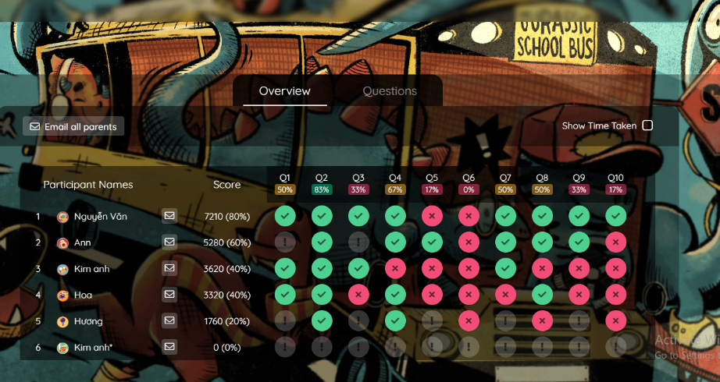
Figure 1. Results after playing by students
2.4. Using digital games in teaching mathematics in primary school
Primary education students are an age with special psycho-physiological characteristics. At this age, the ability to remember and pay attention intentionally has not been strongly developed, hyperactivity; children remember very quickly and forget quickly; visual memory develops predominance over verbal-logical memory. Therefore, the use of games as an auxiliary teaching medium in combination with other methods, helping students learn by playing, play by learning, will attract attention to the teaching content and increase interest learning for children rather than just imparting one-way knowledge according to traditional teaching methods.
Mathematics is considered a difficult subject by most students. Many students who do not understand the lesson gradually have feelings of fear, depression and lack of confidence when learning math, thereby losing interest in learning, leading to worse results and many gaps in knowledge. Therefore, it is very important to use which teaching method and which means of teaching to help students understand the lesson and be interested in learning. If teachers design games that help students learn while playing, learning will become easier and games will be an effective learning medium for this age group.
Each teaching method and teaching medium has certain advantages and drawbacks. The combination of teaching methods or teaching media together will bring expected results. In addition to the teaching methods that teachers often use, the combined use of digital games in teaching will certainly bring excitement and learning motivation to students, thereby helping students to continue learning. acquire knowledge easily and achieve good learning results.
Digital games have the ability to stimulate interest and attract students' attention by engaging students in the learning process through play activities, which is different from the traditional teaching methods being used by most schools. Students can play comfortably, without pressure, and absorb knowledge at the same time, consolidate knowledge and grasp the content of the lesson easily.
Teachers can use a combination of games in teaching in many different ways, at different times. If teachers incorporate games in teaching flexibly, elementary students will be more interested in math. For example, after the teacher finishes a lesson, it is possible to help students consolidate their knowledge by organizing the whole class to play at the same time to do exercises to apply the newly learned knowledge in individual or team forms , the group. The teacher will send the game link (Already created on Quizizz) and the code to the students for students to participate in (Figure 2). Students just need to click on the link and enter the code, enter the name to join the game, while the students play, the teacher can monitor how each student participates in the game (Figure 3). After the game ends, through the results table (Figure 1), the teacher can briefly assess the student's understanding of the lesson, detect mistakes, etc., thereby promptly supporting students.

Figure 2. Teacher's screen when organizing students to play online


Figure 3. The teacher monitors the playing progress of each student
Not only playing directly in class, instead of students having to do homework to review and consolidate knowledge, teachers can put the review content into games and send it to each student (Figure 4). The teachers will set the time to complete the game for students to participate on time. Thus, students no longer think about doing homework but simply play an attractive game. Not only that, playing a game over and over again helps students consolidate knowledge more effectively than students doing the exercise once, sometimes just to complete the assigned task.

Figure 4. Exercises are included in the game
Especially in the conditions where students study completely online (such as when the COVID-19 epidemic takes place), students do not go to school, can not participate in traditional games, the use of digital games in teaching is very important and suitable. Students can completely participate in the game themselves to acquire knowledge and consolidate lessons right on electronic devices without the need for teacher's organization. These games will help increase the interaction between students with each other, with teachers, increase students' interaction with teaching content in the digital environment when there is no direct interaction.
2.5. Constructing digital games in teaching
2.5.1. Rules of constructing digital games in teaching
Rule 1: The game must contribute to the achievement of teaching goals.
As a learning game, so the first rule to ensure is to achieve the teaching goal towards. If it does not contribute to the achievement of the teaching goal, the game is simply to play and entertain.
Depending on the goal to be achieved for each lesson or each specific topic, teachers flexibly build different types of games to suit the teaching content.
Rule 2: The game must have clear rules, rewards and punishments
Any game needs rules. Game rules are basic instructions to help students know how to participate in the game, so the rules of the game need to be short and easy to understand. To increase the motivation to play (also the motivation to learn) and to make the game more attractive, the game needs to have clear reward and punishment rules for good players and bad players.
Rule 3: The game must be competitive, challenging
In order to easily achieve the game effect (teaching content), the game that the teacher designs must be competitive between players (students) and challenge players to discover new knowledge. Competition and challenge help students put more effort into the learning process as well as the playing process, thereby acquiring new knowledge easily and quickly achieving the lesson content quickly.
Rule 4: The game must have interaction between students and the teaching content, between students and between students and teachers
Interactivity is extremely important in most teaching and learning activities. The stronger the interaction, the higher the teaching effectiveness in particular and the higher the educational effectiveness in general. The interaction between students and the teaching content helps students quickly acquire new knowledge and increase their interest in learning; Interactions between students with each other and with teachers will help strengthen relationships, better cooperation, form emotional attachment and support the formation of good qualities for students.
Rule 5: The game must be educational, aesthetic, positive, progressive
Learning games must first of all be educational, that is, the game is not only for entertainment, but the main purpose is to achieve the goal of teaching, students playing, and discovering, forming and cultivating knowledge. In addition, learning games must be aesthetically pleasing to attract students' participation and must be positive and progressive to help develop students' qualities and abilities.
Rule 6: The game must be appropriate for the age and usability of the player
For primary education students, where visual thinking prevails, the design of games with beautiful graphics and vivid sounds will attract more children's participation. Besides, the design of games that are attractive but should be simple, easy to play, suitable for children's ability to use.
2.5.2. The process of constructing a digital game in teaching
Step 1: Finding the characteristics, needs of learners and the aims of subject
Before designing a game, teachers need to find about the needs and characteristics of learners in order to set out the goals and content of the game suitable for learners, age groups, and psychological characteristics, existing competencies and skills.
Each age group has its own characteristics so finding about this age helps teachers and educators to have orientations for their designs to have age-appropriate games and engage students.
Learning about the goals of the subject helps teachers have the right orientation for the design of games so that it is easy to achieve the teaching goals.
Step 2: Offering the aims of the game
Each game must have a specific goal built on the goal of each lesson because the purpose of building a game is to achieve the goal of teaching. When there is a clear goal for the lesson, there will be a goal of the game towards, thereby building the questions in the game to be most effective.
Setting specific aims for each game helps teachers design questions for the game without deviation and helps teachers easily achieve teaching goals, helping students easily achieve learning goals.
Step 3: Determining the game content based on the teaching content to provide to students
After determining the aims of the game, it will proceed to determine the game content based on the lesson content to be provided to students. The content of the game is the questions related to the lesson to review and reinforce the lesson. The content of the questions will be built according to levels from easy to difficult, from applied questions to questions that need thinking to be able to solve.
Step 4: Offering rules, rewards and punishments
Each game needs to have clear rules, rewards and punishments that are set by default from the beginning. Because students play games on their own on digital devices such as mobile phones, Ipads or computers, teachers need to provide detailed but concise and easy-to-understand rules so that students can easily follow them that rule of the game. In addition, the game also needs to have rewards for students who perform well to encourage morale and increase students' interest in participating in the game, there are penalties for students who do not perform well to learn. Students see that they need to try harder in their studies, thereby completing the game for better results.hơn.
Step 5: Designing to create a complete game that follows the rules of game building
After obtaining the goal, content as well as specific rules of the game will proceed to build a set of questions for each game. The questions must follow the established rules and must follow the levels from easy to difficult, from basic to advanced to easily assess the student's understanding of the lesson. Unlike normal entertainment games, learning games require students to understand the content of a lesson or a specific topic to be able to participate and complete the game well. Teachers need to stick to the lesson content to give a set of questions that cover the entire learning content, go to "every nook and cranny" of the lesson content and apply the lesson content in practice to help students learn. Students can solve practical problems in life related to the content of the lesson. After having a set of questions for the game, the teacher will "digitize" that set of questions into an attractive game on electronic devices.
Step 6: Checking and editing the game
After designing a game, before proceeding for students to play, it will be necessary to check and edit the game if there are some errors.
Compared with ordinary entertainment games, teaching games require not only entertainment but also accuracy, rationality, and aesthetics. Therefore, the re-examination of the newly designed game helps teachers and educators detect errors in the design process such as content, rules, sounds, images and stuff. From there, timely edit before completing and letting students play.
2.6. The process of constructing and using digital games in teaching mathematics in primary school
2.6.1. The process of constructing digital games in teaching mathematics in primary school
From the process of constructing digital games in teaching in general mentioned above, the author proposes a process of designing digital games for mathematics in primary school with 6 steps (Figure 5) as follows:
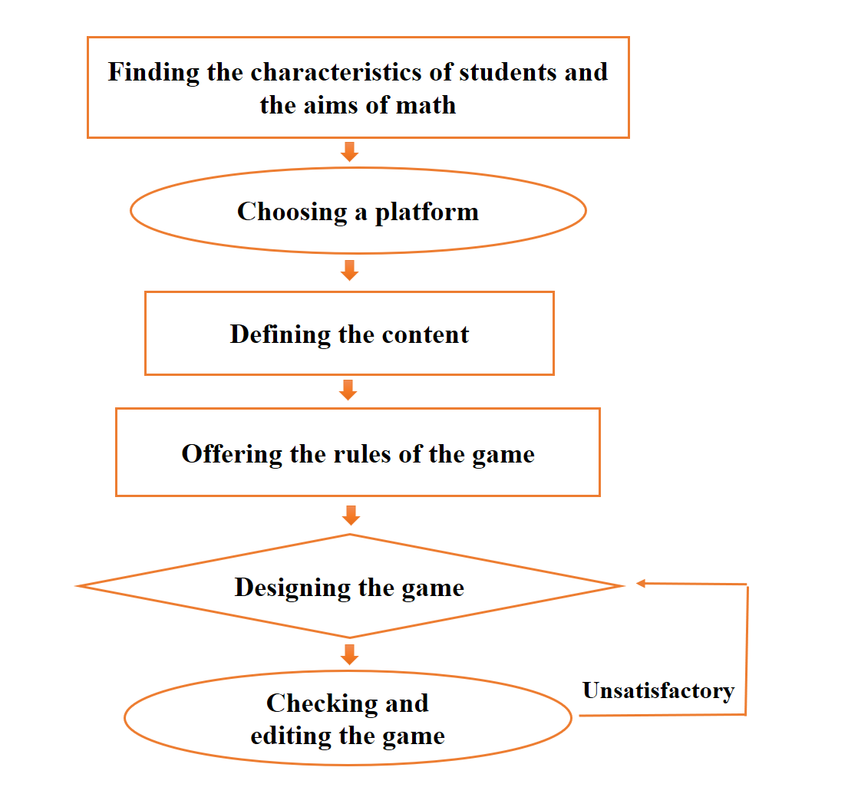
Figure 5. The process of constructing digital games in teaching mathematics in primary school

Step 1: Finding the characteristics of primary education students and the aims of mathematics
Primary education students's thinking is full of emotions and intuitive thinking prevails. Thinking qualities gradually shift from concrete to general abstract thinking. Therefore, teachers and educators can develop children's thinking and imagination by turning "jejune" knowledge into games with vivid images and sounds, so that children can excitement, motivation to develop their cognitive processes comprehensively.
The aim of mathematics in primary school is to contribute to the formation and development of mathematical competence; have basic and practical knowledge and skills to perform simple mathematical tasks, thereby solving basic problems in practice. Therefore, the goal of the game must be closely aligned with the goal of teaching Math. From there determine specific goals for each game (based on the goal of each lesson or each topic).
Step 2: Choosing a platform to construct a digital game
The selection of a platform to construct a digital game is very important, based on the following criteria: popularity, ease of manipulation, compatibility with the ability of teachers to operate and design, and easy access and participation by students. The platforms that teachers can choose to design learning games for students are software, apps or websites.
Step 3: Defining the content and naming the game
After determining the goal of the game, it will proceed to determine the specific content for each game based on the content of the lesson to be provided to students.
Based on the types of knowledge and types of math problems, teachers can design games with different forms suitable for each type of exercise.
The name of the game should be short, concise, and arouse students' interest in learning math.
Step 4: Offering the rules of the game
The rules of the game need to be clearly defined. In order for students to understand the rules of the game, the rules given should be simple, easy to remember and easy to implement. In addition, teachers need to give rewards for students with good playing results (achieve good academic results) and have punishments for students who do not play well to motivate them in the future. next play.
Step 5: Designing the game
Once the digital platform has been selected to design the game, the teacher designs the game based on the principles of game building, the characteristics of the primary school age, the specific goals and content of each lesson or for each math topic. To match each type of lesson, the teacher will choose different game types and question types to put in the game.
Step 6: Checking and editing the game
Checking the game after designing helps the teacher once again to see if the game has fully met the requirements set out initially and has any errors that need to be corrected.
2.6.2. Using digital games in teaching mathematics in primary school
Teachers can use digital games to teach in different ways, at different times, for different topics. However, in general, it is possible to use digital games in teaching according to the following process (Figure 6):
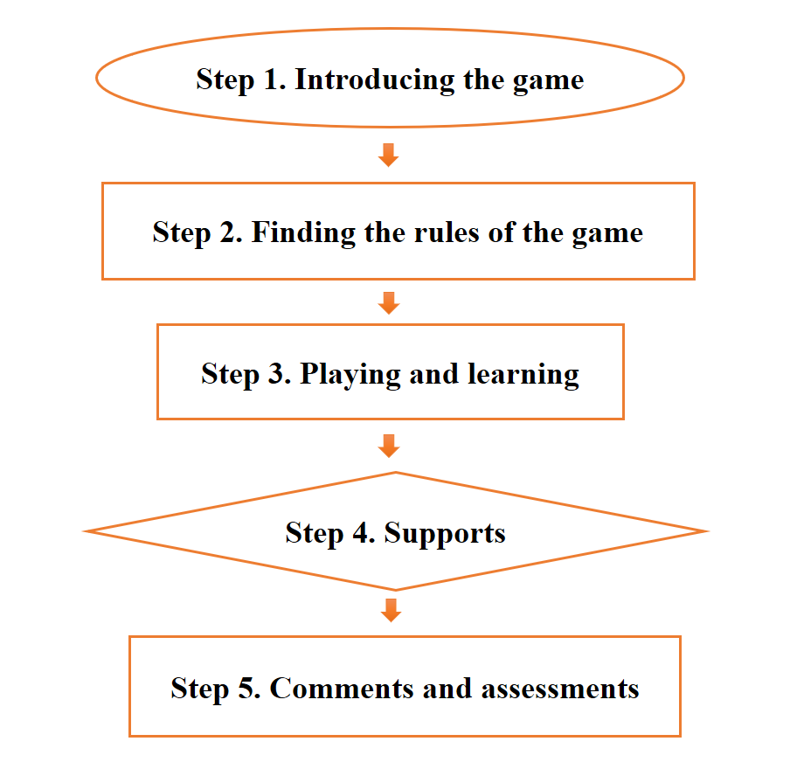
Figure 6. Using digital games in teaching mathematics in primary school
Step 1: Introducing the game
After finishing a lesson, the teacher will lead the students to participate in the game to consolidate the knowledge they have just learned or to review the knowledge they have learned, the teacher can "assign homework" with the formula asks students to play a game. The game is introduced by the teacher in an attractive way, attracting students to participate in the game and stating the purpose of the game to help students identify their tasks while playing.
The way teachers introduce games is also an important factor in promoting individual student participation. Teachers who introduce attractively will attract students to participate, otherwise students will not be interested. In addition, giving the purpose of the game is also extremely important, it helps students see the importance of playing, not only for entertainment but also for specific learning purposes thereby changing the mindset in the process of playing.
Step 2: Finding the rules of the game
Each game will have specific rules, the digital game will have built-in rules in each game, the teacher will guide the game rules before letting students play or students will learn the available rules and then ask the teacher if students do not understand the rules.
Understanding the rules of the game will help students orient the playing process, help students not break the rules and best perform the playing tasks (learning tasks) thereby easily achieving good results.
Step 3: Playing and learning
Depending on the form of the game, individually or online simultaneously, if playing online, the teacher will monitor the playing progress of each student to easily grasp what content each student is having difficulty in. If it is a game to review knowledge, students can play it over and over again to firmly grasp the knowledge.
Tracking the progress of students' play is important, it not only can help teachers evaluate results, but teachers can also support struggling students in a timely manner. Thereby helping students to firmly grasp the knowledge and not have any knowledge gaps.
Step 4: Supports
During the game, students can ask for the help of teachers or virtual teachers AI chatbot to complete the game screen. Teachers only help when the assigned tasks are too difficult for students to overcome. It is also a teacher's duty to help form knowledge and skills for students.
Step 5: Comments and assessments
After finishing the game, based on the results of each student, the teacher comments and assesses the achieved results through the results of the game. From there, teachers can grasp the difficulties that each student encounters through the content of each question to promptly support and help, so that students do not have any gaps in the acquisition of knowledge. In addition, remind students of previously learned knowledge related to the content they are studying if they forget.
A utility of the digital games is that teachers can easily send game results (learning results) to parents so that parents can also grasp their child's learning situation, thereby reminds students to study.
3. Conclusions
There is no doubt about the role of digital games in teaching because they bring a lot of benefits not only to students but also to teachers. Understanding the rules of building games, the process of building games and the steps to play games, teachers easily build for students interesting games to integrate into the teaching process. If teachers know how to skillfully combine digital games with other teaching methods, mathematics will become more interesting and engaging, students will be more enthusiastic about math, and more passionate about numbers. anhydrous and easy to apply mathematical knowledge in practice.
The content presented in section 2.4 is the result of the author's theoretical research to build digital games in mathematics. Due to the limited scope of the paper in the conference, the specific product of the science-based number game in 2.4 will be presented in another paper by the author.

References
A. Calvo. (1997). "Ocio en los noventa: los videojuegos," Universitat de les Illes Balears (doctoral dissertation).
Abdellatif, A. J., McCollum, B., & McMullan, P. (2018, March). Serious games: Quality characteristics evaluation framework and case study. In 2018 IEEE Integrated STEM Education Conference (ISEC) (pp. 112-119). IEEE.
Al Khateeb, M. A. (2019). Effect of Mobile Gaming on Mathematical Achievement among 4th Graders. International Journal of Emerging Technologies in Learning, 14(7).
Byun, J., & Joung, E. (2018). Digital game-based learning for K-12 mathematics education: A meta-analysis. School Science and Mathematics, 118(3-4), 113-126.
Chang, C. Y., & Hwang, G. J. (2019). Trends in digital game-based learning in the mobile era: a systematic review of journal publications from 2007 to 2016. International Journal of Mobile Learning and Organisation, 13(1), 68-90.
Chen, M., Tseng, W., & Hsiao, T. (2018). The effectiveness of digital game-based vocabulary learning: A framework-based view of meta-analysis. British Journal of Educational Technology, 49(1), 69-77.
Cunningham, J. (2015, June). Student achievement. Retrieved from
http://www.ncsl.org/documents/educ/CharterSchoolStudentAchievement.pdf
Hưng, Đ. T. (2002). Dạy học hiện đại: Lí luận-Biện pháp-Kĩ thuật. NXB Đại học Quốc gia Hà Nội.
Gros, B. (2007). Digital games in education: The design of games-based learning environments. Journal of research on technology in student, 40(1).
Irvin, J., Dukes, M., & Meltzer, J. (2007). Taking action on adolescent literacy: An
implementation guide for school leaders. Alexandria, Va.: Association for
Supervision and Curriculum Development.
Kaimara, P., & Deliyannis, I. (2019). Why should I play this game? The role of motivation in smart pedagogy. In Didactics of smart pedagogy (pp. 113-137). Springer, Cham.
Liao, C-W., Chen, C-H., & Shih, S-J. (2019). The interactivity of video and collaboration for learning achievement, intrinsic motivation, cognitive load, and behavior patterns in a digital game-based learning environment. Computers & Education, 133, 43-55.
Lieberman, D. A., Fisk, M. C., & Biely, E. (2009). Digital games for young children ages three to six: From research to design. Computers in the Schools, 26(4), 299-313.
Trâm.N.N. (2003). Xây dựng và sử dụng trò chơi học tập nhằm phát triển khả năng khái quát hóa của trẻ mẫu giáo lớn. Luận án tiến sĩ giáo dục. Viện KHGD Hà Nội.
Prensky M, (2001), Digital Game-Based Learning. New York, NY: McGraw-Hill.
Ramos, D. K., Brito, C. R., Pimentel, F. S. C., Anastácio, B. S., & da Silva, G. A. (2022). Integration of Digital Games Into Pedagogical Practice: Contributions and Challenges to Teacher Training. In Impact of Digital Transformation in Teacher Training Models (pp. 73-92). IGI Global.
S.B. Enconhin (Thanh Ha translate) (1998). Game Psychology, Ho Chi Minh City Press
STANČIN, K., HOIĆ-BOŽIĆ, N., & SKOČIĆ MIHIĆ, S. (2020). Using Digital Game-Based Learning for Students with Intellectual Disabilities–A Systematic Literature Review. Informatics in education, 19(2), 323-341.
Tokac, U., Novak, E., & Thompson, C. G. (2019). Effects of game‐based learning on students' mathematics achievement: A meta‐analysis. Journal of Computer Assisted Learning, 35(3), 407-420.

