XÂY DỰNG HỆ THỐNG QUẢN LÝ PHÒNG THÍ NGHIỆM TẠI TRƯỜNG
ĐẠI HỌC CÔNG NGHỆ THÔNG TIN VÀ TRUYỀN THÔNG
VIỆT NAM – HÀN QUỐC
BUILDING A LABORATORY MANAGEMENT SYSTEM AT VIETNAM – KOREA UNIVERSITY OF INFORMATION AND COMMUNICATION TECHNOLOGY

Keywords:  Laboratory management; schedule lab; equipment management; questionnaire design; SPSS and AMOS software | Abstract:  Computer labs in educational institutions often face numerous challenges in terms of security, operations management, schedule coordination, and managerial decision-making. These challenges lead to substantial losses, primarily caused by issues such as insufficient access control and limited communication between lecturers and lab personnel. Moreover, costs are incurred due to workstation downtime, suboptimal work schedules, inadequate employee supervision, and ineffective occupancy management.  To tackle these issues, this research proposes the implementation of an integrated Computer Lab Management System, designed to automate and optimize manual lab management processes. By providing comprehensive information on hardware, software, and schedules for each laboratory, this system aims to benefit both staff and lecturers involved in hardware lab management.  The proposed system has been developed and rigorously tested at Vietnam – Korea University of Information and Communication Technology, successfully meeting the criteria for an effective lab management solution. Through the adoption of this system, educational institutions can improve overall efficiency, enhance security measures, streamline scheduling, and enable informed managerial decision-making in computer labs. This study contributes to the advancement of lab management practices, paving the way for a more productive and seamless learning environment.

- Background Information
Computer labs in educational institutions often face challenges in terms of limited functionality and operational efficiency. This research identifies several key limitations in the current computer lab management system. The existing system primarily relies on a module integrated into the schedule on the official website of the academic affairs department, lacking an integrated module for lab room staff on the mobile platform. Consequently, crucial management functions, including tracking broken machinery, facilitating effective communication between lecturers and lab room staff, managing software installations, and monitoring student activities, remain unaddressed.
This study highlights the importance of computerizing the essential processes involved in running a computer lab to overcome these limitations. By developing an integrated Computer Lab Management System, the proposed research aims to provide lab room staff with effective tools to maintain and query a list of users known for malicious activities. Additionally, the system aims to enhance equipment maintenance by enabling lab assistants to identify instances where students cause damage to valuable equipment. Improved room occupancy management is also a focus, allowing lab room staff to efficiently allocate workstations, avoid scheduling conflicts, and accommodate users on a waitlist.

To evaluate the proposed system's feasibility and acceptance, a questionnaire was designed and administered to lecturers and lab room staff. The survey data, collected from Vietnam - Korea University of Information and Communication Technology, was analyzed using SPSS and AMOS software. The results demonstrate the system's potential to significantly improve the management and efficiency of computer labs.
While acknowledging the limitations of a relatively small sample size, future research should aim to collect more extensive data to ensure the generalizability of the findings. Additionally, it is important to conduct comparative studies across different college and university settings to assess the system's effectiveness and adaptability. Overall, this research contributes to the advancement of computer lab management by addressing existing limitations and proposing an integrated system that enhances operational efficiency, communication, and resource allocation within computer labs.

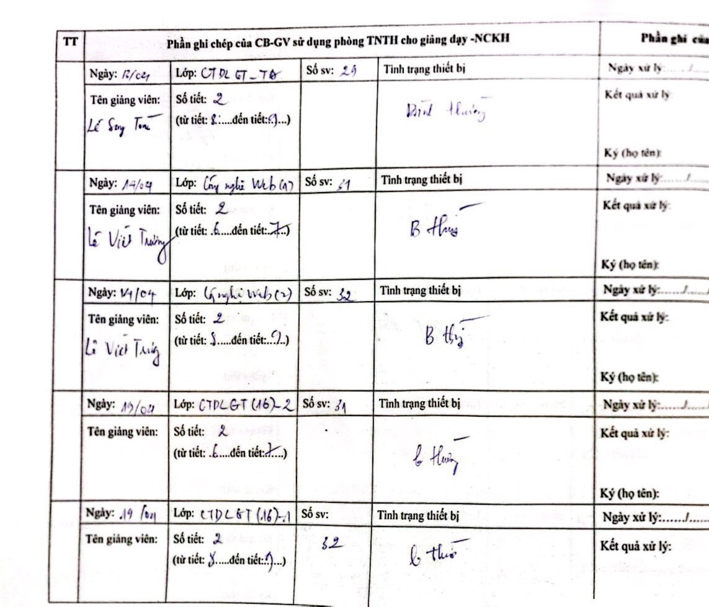
Fig 1. The borrowings - check out the lab, lecturers have to write on papers
- Related work
A Laboratory Information Management System (LIMS) is an application that manages the data that is digested or produced in a laboratory setting and include support for many laboratory-specific needs [6]. Currently, the lab room management software for lab room staff is available in two kinds:
  - Integrated Module
Software is a module that integrates into an overall training management system. This module allows lecturers and laboratory staff to know specific laboratory information such as: study time, LAB room location, number of students, teacher name [4]. tmProx [5] is software for job management and training in high-end universities that follows the signal generation process. Software management support catalog data management (faculty, students, industry - curriculum framework, ...), training plan, scheduler, learning fee and fees, point management and handling of professional training; Therefore, Lab and Resource Scheduler [7] is designed to give educational organizations an easy and quick way to schedule rooms, labs and other resources such as projectors, digital cameras.
  - Software
Software is a commercially available or open source laboratory and laboratory management (Laboratory Information Management System). Its main function is to manage information and control the use of student computer room such as Classroom Management [8] which powerful software for lab management with license. According to [9] iTALC is a famous open source for lab management system, LabStats [10] is the computer lab management software choice for 80% of the top 20 US universities. It is the most and easiest economical software solution for tracking computer usage in universities. Designed specifically for environments of networked computer
These systems are most stable running modules integrating training schedules on the website, no integrated module for computer room engineers integrated on the platform. In addition, some of the management functions necessary for lab room staff not meet such as tracking the number of broken machinery; interaction between the trainer and the lab room staff when there is a holiday message, what software to install.
- System design and implementation
  - Requirement Functionality
Implementation of a professional quality and fully integrated Computer Lab Management System can significantly increase the efficiency, security, and cost-effectiveness of computer lab operations. Build a website management system that allows lecturers to easily control his or her schedule and be able to know which staff will be available at any given time. If lecturers meet some sudden incidents that they cannot come to the lab, they can post a notice directly on the system, so lab rooms’ staff will promptly notify to students. Website system can also manage facilities in lab rooms. Thanks to the system, the lab room’s staff will be more convenient to manage the equipment in the lab room. In the event of a failure, lecturers may directly make notes on the system detailing the failure so that lab room’s staff can easily fix these problems quickly. The system facilitates the interaction between lab room’s staff and lecturers.
Table 1. Requirements for a proposed system
Function | Requirement
1. Equipment management | Lecturers may request repairs, loan management.  Calculate the time spent  Damage statistics to plan timely repairs
2. Lab room scheduling | Check in, check out, lab room, equipment scheduling
3. Interactive faculty with lab room staff | Lecturer notice to do inform IT  Lecturer request for software installing
- Equipment management (1): The system can help Lab room’ staff to control some features of lab room including number of equipment managing, equipment warranty period. Staff thank to this function can manage hardware equipment in order to save time and work; lecturers is easier in requesting loan or repairing equipment.
- Lab room scheduling (2): This function help lecturers stop using manual work like usual to check in - check out from the lab rooms. It also may help staff to control the equipment borrowing status from lecturers.
- Interaction (3): With this function, the interaction between staff and lecturer can be easier and more convenient. Lecturers can inform quickly to staff if they cannot come to lab room, so staff can notice to the students in time. Moreover, lecturers can book a lab room in the system that lets staff take the initiative in scheduling.
  - Developing the web-based
- HTML5: This script language is used because of its cross-browser support. The language also has the ability to deliver everything from animation to graphics. Fig 2 shows the interface of the proposed system.
Fig 2. Demonstration of laboratory equipment management function
- CSS3: This style sheet language is used for the site’s design. It also offers browser compatibility that makes the designing faster and easier.
- JQuery: This cross-platform JavaScript library is utilized because it makes things like HTML document traversal and manipulation, event handling and animation much simpler with an easy-to-use API that works across a multitude of browsers.
- Framework: In developing the system, framework is used to add system functionalities as well as improving the design. Laravel, a proven agile and open source PHP web application framework is used because it offers a good code separation and keep things clean. It is based on the Model-View-Controller development pattern. MVC is a software approach that separates application logic from presentation.
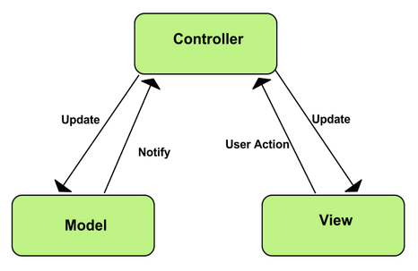
Fig 3. Laravel MVC diagram
- Database: MySQL database system is used because it is open source and it is widely available in the market with no ownership cost and is also easy to learn and operate.
- Experiment and Survey
  - Research Hypotheses
We have developed a web-based interactive system and subsequently implemented an experimental setup using the proposed system. Additionally, we conducted a survey to gather system function requirements from both lecturers and lab room staff. The survey data was analyzed using SPSS and AMOS software to determine the acceptance of the system by the lecturers. The conceptual model of this study is depicted in the figure below:
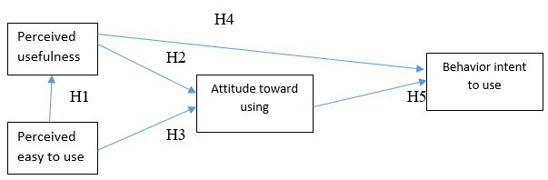
Fig 4. Conceptual model of the survey

Based on the above conceptual model the following five hypotheses will be used to check:
- H1: Perceived ease to use will have positive effect on perceived usefulness in the computer lab management system.
- H2: Perceived usefulness will have positive effect on attitude toward using in the computer lab management system.
- H3: Perceived ease to use will have positive effect on attitude toward using in the computer lab management system.
- H4: Perceived usefulness will have positive effect on behavioral intention to use in in the computer lab management system.
- H5: Attitude toward using will have positive effect on behavioral intention to use in in the computer lab management system.
  - Questionnaire Design
The questionnaire design process followed a sequential step-by-step approach. Initially, the study reviewed relevant literature to design the questionnaire items for the survey. Subsequently, a pre-test was conducted with lecturers who would be using the computer lab management system.
The questionnaires were designed to assess the lecturers' perceptions of usefulness, ease of use, attitude towards using, and behavioral intention to use the computer lab management system. The final questionnaire consisted of 15 items, all measured on a 5-point Likert scale. The scale ranged from 1 for "extremely disagree," 2 for "disagree," 3 for "neutral," 4 for "agree," to 5 for "extremely agree."
Table 2. Survey questionnaire items
Construct | Reference | Item
Perceived usefulness | PU  (1) | I think the computer lab management system are useful to my teaching time.  The computer lab management system improves my work performance.  The computer lab management system enhances the effectiveness of my teaching.  The computer lab management system helps my teaching more convenient.
Perceived ease to use | PEU  (1) | I found that the computer lab management system easy to use.  Using the computer lab management system does not require a lot of computer skills.  It is easy for me to remember how to using the computer lab management system.  My interactions with the computer lab management system are clear and understandable.
Attitude toward using | ATU  (2) | I think using the computer lab management system is beneficial to me.  I think using the computer lab management system is a good idea.  I feel excited when I use the computer lab management system.
Behavioural intention to use | BI  (1) ;(3) | I intend to continue using the computer lab management system in future  I intend to the computer lab management system as often as possible  I will continue to use the computer lab management system if I have access to the service  I will recommend my colleagues to use the computer lab management system

The next step is testing the structural model through AMOS software. The structural model determines the interaction between the constructs or latent variables.
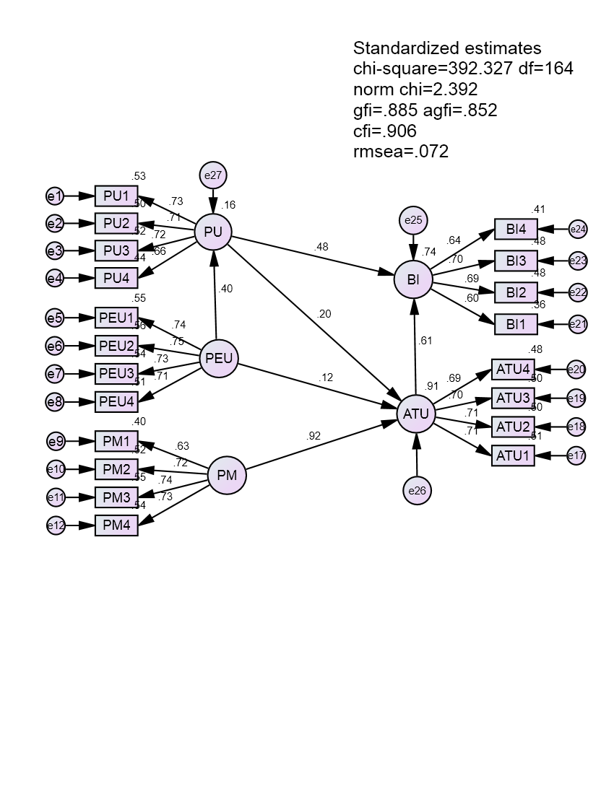
Fig 5. Structural model result through AMOS
The hypothesis will be statistically significant when the CR (t-value) great than 1.96 and P-value less than 0.05. The Figure presents the result of structural equation modelling (SEM) analysis. The result indicated that perceived ease to use had significant positive effects on perceived usefulness (H1, β = 0.401, t-value = 5.155, p-value < 0.001). In addition, perceived ease to use also positive effects on attitude toward using (H3, β = 0.128, t-value =2.373, p-value < 0.05). Can easily see, the impact of the perceived ease to use to attitude toward using is smaller impact of perceived ease to use to perceived usefulness, it is similar to what Davis (1993) had mentioned. Perceived usefulness is found to have significant relationship with attitude toward using (H2, β = 0.201, t-value = 3.538, p-value < 0.001). Behavioral intention to use was significant positive influence from perceived usefulness and attitude toward using (H6, β = 0.476, t-value = 6.562, p-value < 0.001; H7, β = 0.611, t-value = 7.952, p-value < 0.001).
  - Discussion
Hypothesis one is perceived ease to use will have positive effect on perceived usefulness the computer lab management system. Hypothesis two is perceived usefulness will have positive effect on attitude toward using in the usefulness the computer lab management system. Hypothesis three is perceived ease to use will have positive effect on attitude toward using in usefulness the computer lab management system. Hypothesis four is perceived usefulness will have positive effect on behavioral intention to use in the computer lab management system. Hypothesis five is attitude toward using will have positive effect on behavioral intention to use in use the computer lab management system. The hypotheses of this study indicate that VKU lecturers has a positive behavior in the using the computer lab management. The behavior of users was strongly affected by perceived usefulness and attitude toward using.
This research has some limitation such as: First, the sample size of this study is not really big as there is not enough time to collect larger sample size, so the sample size of the research only has averaged allows approved for use to conduct research. With a larger sample size, the research will be achieved with higher reliability and validity levels. Future research should collect more data to produce results in order to reflect more accurately about study. Second, the study was conducted with data collected in Vietnam – Korea University of Information and Communication Technology only. The study’s results might be different if the model was retested in a different college of universities.
5. Conclusion
The article proposes the development of a lab management system to support various tasks involved in managing laboratory rooms at Vietnam - Korea University of Information and Communication Technology. The system addresses several existing limitations and fulfills requirements that the current lab management system cannot handle. Experimental evaluations have been conducted, assessing the system based on various criteria and gathering feedback through surveys from lecturers. The collected survey data has been analyzed using AMOS and SPSS software, demonstrating that the system meets the initial criteria. The next step is to further enhance the system by incorporating additional platforms, such as mobile or offline capabilities, to provide better support for laboratory management. Implementation of this system will greatly reduce paperwork and introduce electronic workflows. Users of the system have noticed significant improvements compared to the traditional paper-based approach, as the system offers functionalities and results that were previously unavailable.

References
Davis, F. (1989). “Perceived usefulness, perceived ease of use, and user acceptance of information technology.”, MIS quarterly, 13(3), 319-340.
Davis, F. (1993). “User acceptance of information technology: system characteristics, user perceptions and behavioral impacts.”, International journal of man-machine studies, 38.
Davis, F., Bagozzi, R., & Warsahw, P. (1989). “User acceptance of computer technology: a comparison of two theoretical models.”, Management science, 35(8).
Software Development Center - University of Da Nang (SDC), (2014), “Training management software UD. Train”, http://software.sdc.udn.vn/en/industries/education
VietIntel Software Solutions, (2007), “TmProx training management software”, http://www.vietintel.vn/default?key=tmprox
Sapio Sciences, (2010): Laboratory Information Management: So what is a LIMS?, http://sapiosciences.blogspot.com/2010/07/so-what-is-lims.html
LPC Inc, (2014), Lab and Resource Scheduler System, http://labandresourcescheduler.com/
Classroom Management, (2005), "Netop School and Netop Vision Pro",http://www.netop.com/
Tobias Doerffel, (2004), “iTALC - OpenSource classroom management, https://sourceforge.net/u/tobydox/profile/
LabStats Software, (2004), “Computer Lab Monitoring and Reporting Software”, http://www.labstats.com

