ỦY BAN NHÂN DÂN TP.HCM CỘNG HÒA XÃ HỘI CHỦ NGHĨA VIỆT NAM
TRƯỜNG CĐ LÝ TỰ TRỌNG TPHCM Độc lập – Tự do – Hạnh phúc
********** ******

ĐỀ THI GIỮA HỌC PHẦN LÝ THUYẾT
HỌC KỲ: I NĂM HỌC: 2023 - 2024 Thời gian: 45’
Đề 1

Bậc đào tạo: Cao đẳng (22C1) Học phần: TIẾNG ANH 1

PHIẾU TRẢ LỜI TRẮC NGHIỆM

TÊN: _________________________________________________________
LỚP: ___________________
Tô đen những câu trả lời đúng bằng bút mực. Mỗi câu chỉ tô 1 đáp án.

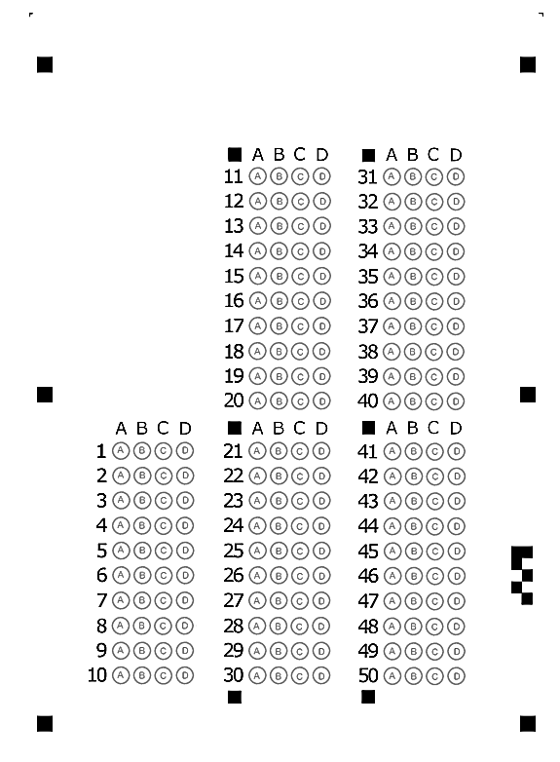

ỦY BAN NHÂN DÂN TP.HCM CỘNG HÒA XÃ HỘI CHỦ NGHĨA VIỆT NAM
TRƯỜNG CĐ LÝ TỰ TRỌNG TPHCM Độc lập – Tự do – Hạnh phúc
********** ******

ĐỀ THI GIỮA HỌC PHẦN LÝ THUYẾT
HỌC KỲ: I NĂM HỌC: 2023 - 2024 Thời gian: 45’
Đề 2

Bậc đào tạo: Cao đẳng (22C1) Học phần: TIẾNG ANH 1

PHIẾU TRẢ LỜI TRẮC NGHIỆM

TÊN: _________________________________________________________
LỚP: ___________________
Tô đen những câu trả lời đúng bằng bút mực. Mỗi câu chỉ tô 1 đáp án.

1/ He ____ a better job.
a may gets b may
c may get d mays get
Đề 1

2/ If he had had time, he ____ joined us.
a could have b can have
c certainly had d had
3/ Sustainable ____ is a key indicator of the long-term health of the economy.
a to produce b productivity
c produce d product
4/ You can take both ____ them.
a at b in c of d on
5/ I ____ like to see his daughter right now.
a would b shall c could d will
6/ When he was ____, he would sit under this tree.
a children b young c child d youth
7/ ____ tired, he went to bed early.
a Feel b Feels
c To feeling d Feeling
8/ She was ____.
a surprisingly b surprise
c to surprise d surprised
9/ Located in the heart of the city, the Plaza Ville Hotel is the most ____ luxury hotel in town.
a located b central
c best d center
10/ If you feel ____ after a busy week of work, why not check into the Plaza Ville for some rest and relaxation?
a tiring b tire c to tire d tired
11/ The boss was ____ to fire his secretary.
a determined b determine
c determination d determining
12/ Extremely ____ from the hard work, he couldn't walk an inch.
a exhausted b busy
c happy d excited
13/ He expects ____ soon.
a arrival b to arrive
c arriving d arrive
14/ I'm sorry about ____ their feelings.
a hurt b I hurt
c to hurt d hurting
15/ Most people expect to wake up if there is a fire, ____ poisonous fumes from smoke kill hundreds of people every year.
a where b when c why d but
16/ Ask your local fire station for ____.
a advices b advising
c advice d advise
17/ When we arrived, the film was about ____.
a started b start
c starting d to start
18/ I'm looking forward ____ her tomorrow.
a see b to seeing c to see d seeing
19/ So far, there ____ no word from them.
a has b has been c was d is
20/ I have recently received several ____ from parents about teachers being late for class.
a complain b complaining c complaints d complains
21/ As you know, school policy is for all teachers to be in their classroom five minutes before the ____ of a lesson.
a start b finish
c end d introduction
22/ I went to Los Angeles fifteen years ____.
a before b ago c next to d since
23/ The couple must need a ____ because they have just returned from a long journey.
a discontinuation b rest
c pause d stop
24/ While Steve was washing his car, he ___ some dents in the doors.
a has discovered b is discovering
c was discovering d discovered
25/ John ___ the movie twice.
a sees b has seen
c have seen d saw
26/ It’s been raining here ___ we arrived.
a since b for
c when d Both a&c are correct.
27/ Look! A mouse ___ through the door.
a runs b is running
c has run d has running
28/ We ___ to London three times.
a went b have been
c have went d had gone
29/ The bus ___ every twenty minutes.
a running b runs
c are running d run
30/ She ___ on the phone when I came in.
a was talking b had been talking
c has been talking d Both a&b are correct.
31/ He has a(n) ___ this afternoon with his dentist.
a arrange b punish
c promises d appointment
32/ Mr. Lee ___ his house two months ago.
a has sold b was selling
c sold d Both a&c are correct.
33/ I ___ play in the park when I was young.
a am used to b used to
c get used to d got used to
34/ She ___ to Canada on Saturday.
a has been flying b has flying
c flying d is flying
35/ Yesterday, I met a friend, saw a movie, and ___ home late.
a came b had come
c coming d have come
36/ Would you ___ rowing for a while?
a remind b minds
c mind d reminded
37/ Please ___ me to stretch before I exercise.
a remind b minded
c reminded d mind
38/ We ___ having more cookies. They're delicious!
a look forward b can’t help
c can stand d get up
39/ The manager ___ us to return the DVD before noon today.
a would like b likes
c is liking d like
40/ It is difficult ___ from England to France.
a rowed b to row
c row d row to

1/ Please ___ me to stretch before I exercise.
a mind b reminded
c remind d minded
2/ Sue ___ the bus to school.
Đề 2

a get on b takes
c take d gets on
3/ I am interested in ___ to France.
a travel b travelling
c travels d to travel
4/ My father has recently stopped ___ due to his health problems.
a to smoke b smoking
c smoke d Both a&b are correct.
5/ My back is sore because I forgot ___ before I exercised.
a stretch b to stretch
c stretched d stretching
6/ She ___ live by the sea when she was young.
a is used to b used to
c used d Both a&c are correct.
7/ We went ___ yesterday.
a shopped b shopping
c shop d shops
8/ Columbus discovered America ___1492.
a of b in c at d on
9/ I used to live ___ a house.
a in b to c from d on
10/ When I arrived at my aunt’s home, she ___ her kitchen floor.
a had sweeping b sweep
c sweeps d was sweeping
11/ I'm eating lunch ___.
a right now b already
c sometimes d ago
12/ She ___ at 123 Main Street.
a live b lives
c living d Both a&b are correct.
13/ What ___ you ___ at school tomorrow?
a do/ study b do/ studying
c are/ studying d Both a&c are correct.
14/ The bus ___ every twenty minutes.
a are running b runs
c run d running
15/ She ___ on the phone when I came in.
a was talking b had been talking
c has been talking d Both a&b are correct.
16/ He ___ a lot of money with him now.
a has b had had
c is having d have had
17/ He ____ went out shouting.
a sudden b suddens
c suddenly d suddenness
18/ Wholesale and ____ sales registered negative growth last month.
a part b retail
c division d gross
19/ The baby was about to fall asleep because it was ____.
a small b funny
c excited d bored
20/ The boss was ____ to fire his secretary.
a determining b determine
c determined d determination
21/ He has his shoes ____ every day.
a made b put on
c shined d bought
22/ Extremely ____ from the hard work, he couldn't walk an inch.
a busy b exhausted
c excited d happy
23/ He expects ____ soon.
a arriving b arrival
c to arrive d arrive
24/ He is making every possible effort to ____ his opponent.
a best b well c better d good
25/ When we arrived, the film was about ____.
a started b to start
c start d starting
26/ They needed to practice ____ the ball.
a caught b catching
c catches d catch
27/ I'm looking forward ____ her tomorrow.
a see b to seeing
c to see d seeing
28/ The secretary was working ____ that night.
a overwork b extra work
c overhours d overtime
29/ He ____ the subway every day.
a take b is taken
c took d takes
30/ He ____ the subway now.
a takes b does taking
c is taking d taking
31/ Everyone must be ____ time.
a on b at c for d to
32/ These pills will surely ____ your pain.
a easily b easy
c ease d easiness
33/ He has studied English ____ he was in elementary school.
a during b since
c as long as d while
34/ Ever since he arrived, he ____ quietly in the corner.
a has been sitting b is sitting
c sits d sat
35/ Keep out of the reach of children and do not ____ to children under 6 years of age.
a have given b give
c gave d giving
36/ I will open the door ____ you.
a at b for c over d on
37/ Can fish live ____ the river?
a at b on c in d for
38/ She traveled ____ Europe.
a in b into c on d for
39/ I ____ like to see his daughter right now.
a would b shall
c will d could
40/ I'm ____. Would you lend me some money?
a rich b broke
c borrow d poor

¤ Đáp án của đề thi 1
1[ 1]c... 2[ 1]a... 3[ 1]b... 4[ 1]c... 5[ 1]a... 6[ 1]b... 7[ 1]d... 8[ 1]d...
9[ 1]b... 10[ 1]d... 11[ 1]a... 12[ 1]a... 13[ 1]b... 14[ 1]d... 15[ 1]d... 16[ 1]c...
17[ 1]d... 18[ 1]b... 19[ 1]b... 20[ 1]c... 21[ 1]a... 22[ 1]b... 23[ 1]b... 24[ 1]d...
25[ 1]b... 26[ 1]d... 27[ 1]b... 28[ 1]b... 29[ 1]b... 30[ 1]d... 31[ 1]d... 32[ 1]c...
33[ 1]b... 34[ 1]d... 35[ 1]a... 36[ 1]c... 37[ 1]a... 38[ 1]b... 39[ 1]a... 40[ 1]b...

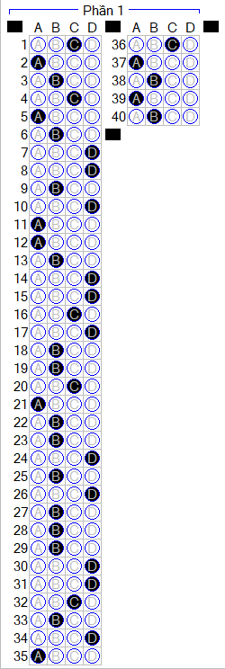

¤ Đáp án của đề thi 2

1[ 1]c... 2[ 1]b... 3[ 1]b... 4[ 1]b... 5[ 1]b... 6[ 1]b... 7[ 1]b... 8[ 1]b...
9[ 1]a... 10[ 1]d... 11[ 1]a... 12[ 1]b... 13[ 1]d... 14[ 1]b... 15[ 1]d... 16[ 1]a...
17[ 1]c... 18[ 1]b... 19[ 1]d... 20[ 1]c... 21[ 1]c... 22[ 1]b... 23[ 1]c... 24[ 1]a...
25[ 1]b... 26[ 1]b... 27[ 1]b... 28[ 1]d... 29[ 1]d... 30[ 1]c... 31[ 1]a... 32[ 1]c...
33[ 1]b... 34[ 1]a... 35[ 1]b... 36[ 1]b... 37[ 1]c... 38[ 1]a... 39[ 1]a... 40[ 1]b...


