UBND THÀNH PHỐ HỒ CHÍ MINH | CỘNG HÒA XÃ HỘI CHỦ NGHĨA VIỆT NAM
TRƯỜNG CAO ĐẲNG LÝ TỰ TRỌNG | Độc lập - Tự do - Hạnh phúc
THÀNH PHỐ HỒ CHÍ MINH

ĐỀ THI KẾT THÚC MÔN HỌC
HỌC KỲ: I NĂM HỌC: 2023 – 2024
Bậc đào tạo: CAO ĐẲNG
Mã đề 001

Môn học: TIẾNG ANH
Khóa/Lớp: 20C2________ Ngày thi: _______ / _______ / 2023
Thời gian thi: 60 phút (không kể thời gian phát đề)
Sinh viên không được sử dụng tài liệu, nộp lại đề sau khi thi.
Đề thi này gồm 50 câu, mỗi câu 0.2 điểm.

Multiple-choice
1/ He ____ a better job.
a may b may get c mays get d may gets
2/ If he had had time, he ____ joined us.
a could have b certainly had c can have d had
3/ He asked her, "____ you like some more coffee?"
a Would b Do c Shall d Will
4/ The baby ____ be hungry, because he just had milk.
a cannot b isn't c wasn't d must
5/ Please keep this medicine refrigerated. Do not ____ temperatures above 15 degrees Celsius.
a having b store c take d remain
6/ Keep out of the reach of children and do not ____ to children under 6 years of age.
a gave b giving c give d have given
7/ In the case of an ____, take the patient to the emergency room immediately.
a overnight b overcome c overtime d overdose
8/ Consult your doctor ____ you are already taking other medications.
a if b but c what d where
9/ The government wants to accelerate the ____ of Internet commerce.
a growing b grow c grows d growth
10/ Take the time to fully prepare yourself for interview ____.
a succeeding b succeed c succession d success
11/ He ____ the subway every day.
a is taken b takes c take d took
12/ He ____ the subway now.
a is taking b taking c does taking d takes
1 3/ We'll start when he ____ ready
a be b is c will is d will be
14/ He has ____ cut himself.
a always b just c yet d ago
15/ We ____ at a party two months ago.
a meeting b meet c have met d met
16/ Everyone must be ____ time.
a at b to c on d for
17/ So far, there ____ no word from them.
a has been b has c was d is
18/ When I called on her, Mary ____ her room.
a was cleaning b clean c cleaning d cleans
1 9/ They have ____ work late.
a at b to c in d for
20/ I have recently received several ____ from parents about teachers being late for class.
a complaining b complain c complains d complaints
21/ I forgot ____ the lights off. I actually didn't turn it off.
a turning b to turning c to turn d turn
22/ I forgot ____ the lights off. I actually turned it off but I forgot that I had done that.
a turning b turn c to turning d to turn
23/ He expects ____ soon.
a to arrive b arriving c arrive d arrival
24/ All I want is ____ to return safe.
a for him b of him c him d he
25/ I'm sorry about ____ their feelings.
a to hurt b I hurt c. hurting d hurt
26/ Christine promised to meet ____ at the theater.
a our b us c ours d we
27/ A smoke detector is an easy way ____ your family.
a protect b protected c protecting d to protect
28/ It is very easy ____ one.
a to installing b installing c to install d install
29/ Most people expect to wake up if there is a fire, ____ poisonous fumes from smoke kill hundreds of people every year.
a but b where c why d when
30/ A smoke detector will give your family a chance to escape ____ a fire.
a in the case of b for the case c at case of d in case

Questions 31 through 34 refer to the following memo.
To: All employees
From: The Accounts Department
Re: Taxes
It will soon be time to file your tax returns. We will not be issuing financial statements
automatically to ------- employees as we have done in the past. If you need a statement of
31. (A) all (B) every (C) each (D) much
your income for the past year, please apply ------- writing to the Accounting office as soon as
32. (A) to (B) with (C) in (D) at
possible. Please give the accounting office the following information:
- full name
- social security number
- employee number
- company department
- home address
We will mail all statements to your home address. If you wish to receive your statement at a
different address, please be sure to inform us. Because we anticipate a large response to this memo, we have ------- a deadline of March 15". You must send your ------- by this date, or we cannot guarantee your statement.
33. (A) set (B) put (C) held (D) designed
34. (A) application (B) applying (C) apply (D) applicable

Questions 35 through 36 refer to the following letter.
The Orange Cat Coffee Shop
Dear Customers,
Beginning next month, we will no longer be accepting Orange Cat Coffee Coupons.
The recent increasing price of coffee beans has made it difficult to keep both the everyday low prices that our customers have come to expect and the high quality of our drinks. We have decided not to raise prices. Instead, we will do away with the coupon system. We will continue to accept coupons until the end of the month.
Thank you for choosing The Orange Cat.
Sincerely,
The Management

35. What is the name of the coffee shop?
(A) The Valued Customer (B) The London Coffee Shop
(C) The Orange Cat (D) The Open Letter

36. What does the coffee shop plan to stop using?
(A) Coffee (B) Coffee coupons (C) Coffee beans (D) Low prices

Questions 37 through 40 refer to the following letter.
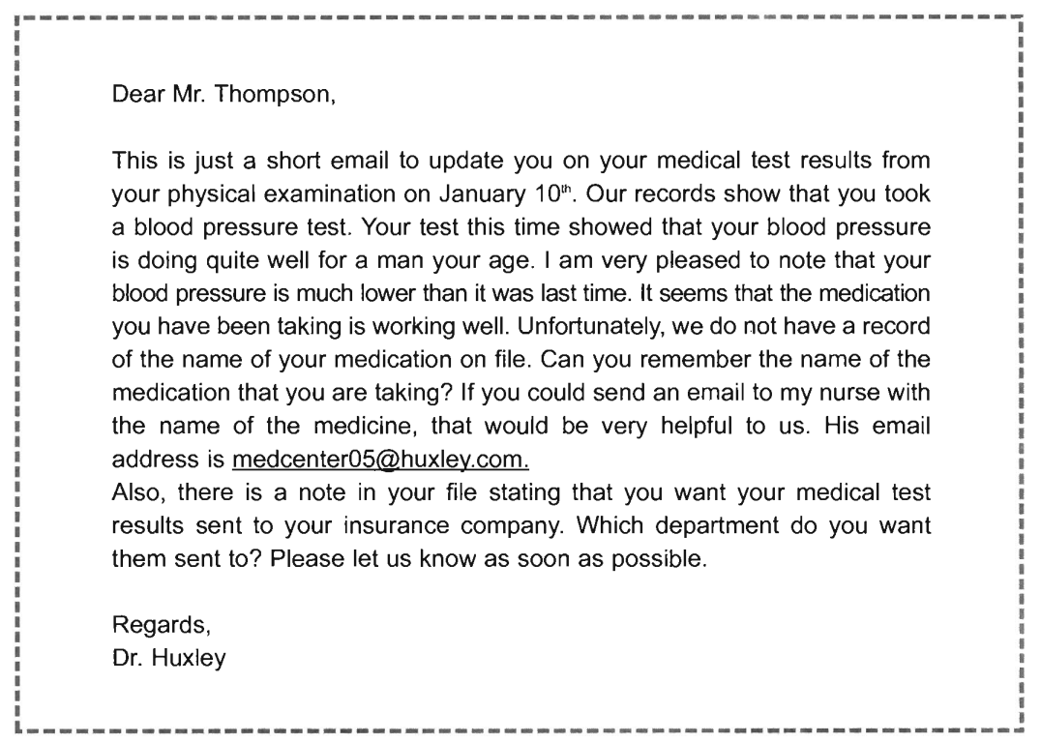
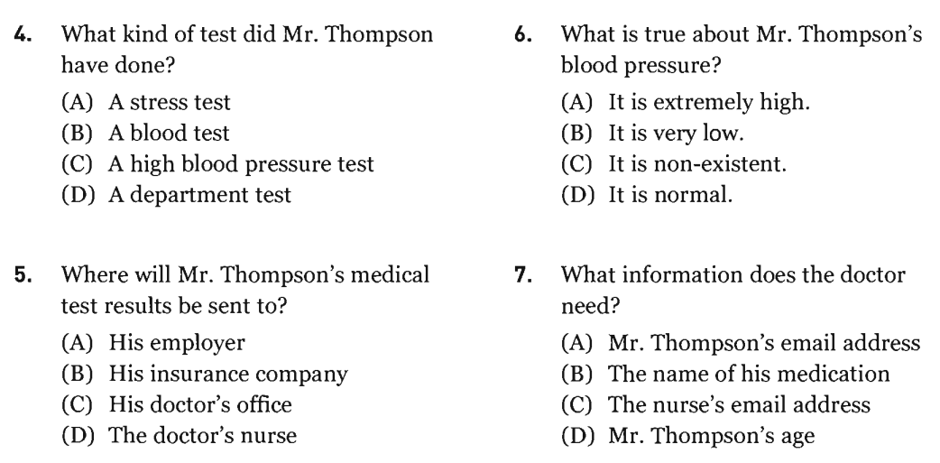
37.
39.
40.
38.

50.
49.
48.
_______Hết_______

GHI CHÚ: CÁN BỘ COI THI KHÔNG ĐƯỢC GIẢI THÍCH GÌ THÊM.

TRƯỞNG KHOA TRƯỞNG BỘ MÔN GIẢNG VIÊN RA ĐỀ
(Ký tên và ghi rõ họ tên) (Ký tên và ghi rõ họ tên) (Ký tên và ghi rõ họ tên)

UBND THÀNH PHỐ HỒ CHÍ MINH | CỘNG HÒA XÃ HỘI CHỦ NGHĨA VIỆT NAM
TRƯỜNG CAO ĐẲNG LÝ TỰ TRỌNG | Độc lập - Tự do - Hạnh phúc
THÀNH PHỐ HỒ CHÍ MINH

HỌC KỲ: I NĂM HỌC: 2023 – 2024
Bậc đào tạo: CAO ĐẲNG
Mã đề 002

Môn học: TIẾNG ANH 1
Khóa/Lớp: 20C2________ Ngày thi: _______ / _______ / 2023
Thời gian thi: 60 phút (không kể thời gian phát đề)
Sinh viên không được sử dụng tài liệu, nộp lại đề sau khi thi.
Đề thi này gồm 50 câu, mỗi câu 0.2 điểm.

Multiple-choice

1/ _____, America depends on Africa for 40% of its oil imports.
a Interesting b Interestingly c Interest d Interested
2/ Sustainable ____ is a key indicator of the long-term health of the economy.
a productivity b product c to produce d produce
3/ I will open the door ____ you.
a for b at c on d over
4/ They could have won, ____ they didn't.
a when b as c but d while
5/ We used ____ talk every day.
a in b to c for d at
6/ I will be there ____ 8.
a in b on c at d for
7/ Can fish live ____ the river?
a in b at c for d on
8/ She traveled ____ Europe.
a into b on c for d in
9/ ____ the Spring, I would plant flowers.
a To b In c On d At
10/ She had bought that book _____ she met me.
a before b where c after d while
11/ Everyone must be ____ time.
a at b to c on d for
12/ So far, there ____ no word from them.
a has been b has c was d is
13/ When I called on her, Mary ____ her room.
a was cleaning b clean c cleaning d cleans
14/ They have ____ work late.
a at b to c in d for
15/ I have recently received several ____ from parents about teachers being late for class.
a complaining b complain c complains d complaints
16/ As you know, school policy is for all teachers to be in their classroom five minutes before the ____ of a lesson.
a start b introduction c finish d end
17/ We cannot expect our students to be _____ if we are late ourselves.
a punctual b intrude c power d punch
18/ All teachers must ____ school policy.
a came back b observe c listen d look
19/ All things ____, Professor Kim is the best instructor I've ever had.
a considering b to consider c considered d considerable
20/ I'm quite sure this business will ____.
a paid b pay off c pay for d paying
21/ Ask your local fire station for ____.
a advising b advice c advices d advise
22/ He is making every possible effort to ____ his opponent.
a well b better c good d best
23/ When ____ to resign his position, the manager reacted badly.
a asked b ask c asking d to ask
24/ When we arrived, the film was about ____.
a to start b started c start d starting
25/ The prince was married to the Duchess of Kent and _____ by his brother.
a succeeded b succeeding c to succeed d successfully
26/ Who is responsible for ____ the dishes tonight?
a doing b to do c will do d do
27/ She forced him ____ the work.
a does b do c did d to do
28/ We ____ to inform you that the position has been filled.
a apology b regret c sorry d apologize
29/ Would you mind ____ the window?
a if opening b opening c to opening d to open
30/ Does she remember ____ the report to the secretary last week?
a to give b gives c give d giving

.

Questions 31 through 34 refer to the following memo.
To: Molly Green and Alistair Debrett
From: Health and Safety Department
Re: First Aid Training
It has come to our attention that you have not ------- completed a basic first aid training course.
31. (A) still (B) yet (C) until (D) after
All employees must have first aid training ------- two years. You must attend a training course
32. (A) every (B) each (C) most (D) all
on March 27". The course will start at 9 a.m. and will finish at 6 p.m. We will inform your
department. You will be paid one hour of overtime because it ------- later than your regular
33. (A) commences (B) finishes (C) opens (D) exceeds
work hours. If you do not attend the course you will lose one day’s salary. If you really cannot attend on March 27, you must inform us immediately or it will be too late to change the date.
Thank you for your -------.
34. (A) cooperate (B) cooperating (C) cooperates (D) cooperation
Questions 35 through 37 refer to the following advertisement.
Stay at the Svinkaire Hotel in Oslo
Winter Wonderland Special

A little taste of luxury at affordable prices.
The Svinkaire Hotel and Restaurant is the oldest family-run hotel and restaurant in Iceland. For over one-hundred years the Svinkaire family has been providing the best service and comfort that the Northern Hemisphere has to offer.
Escape the cold with a Svinkaire Winter Wonderland Special Deal. From December 15 through March 15. We are offering a discount rate on all our rooms. Up to 50%cheaper than our regular rates! Enjoy our top of the range sauna cabins, made of the finest quality wood. Or why not release your stress in one of our aromatherapy steam rooms? If you like sports why not try your hand at reindeer wrestling? Or if you are an artist at heart, you could try ice sculpture taught by Iceland’s leading ice sculpture instructor, Sven Boorntorg.
Our rooms are all equipped with TVs and DVD players. The hotel offers a full range of DVDs to rent, including the latest releases. We also provide Internet access. The Winter Wonderland Special includes your choice of a free buffet breakfast or dinner, and an evening sleigh ride to see the snow-capped mountains of Blintstroom.
Call 9223-8872 to make a reservation, or check out the Svinkaire website:
www.svinkaire.com.

35. How long will this deal last?
(A) One month (B) Three months (C) One week (D) One year
36. What is the hotel offering for free?
(A) DVDs (B) A room (C) One meal (D) A reservation
37. Which of the following is NOT mentioned in the advertisement?
- Internet access (B) Saunas (C) Room service (D) Breakfast

Questions 38 through 40 refer to the following letter and reply.

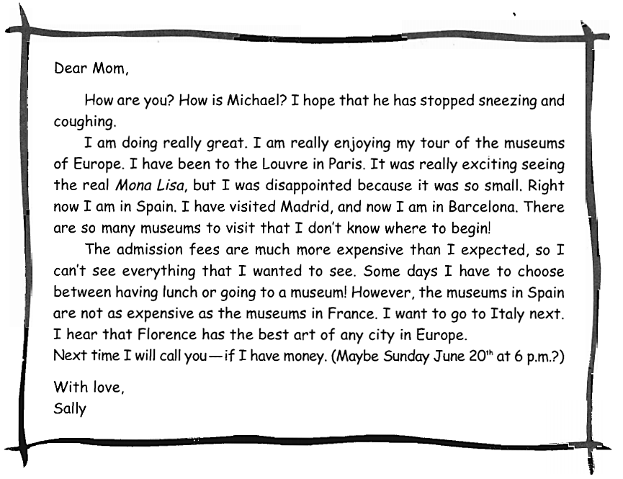

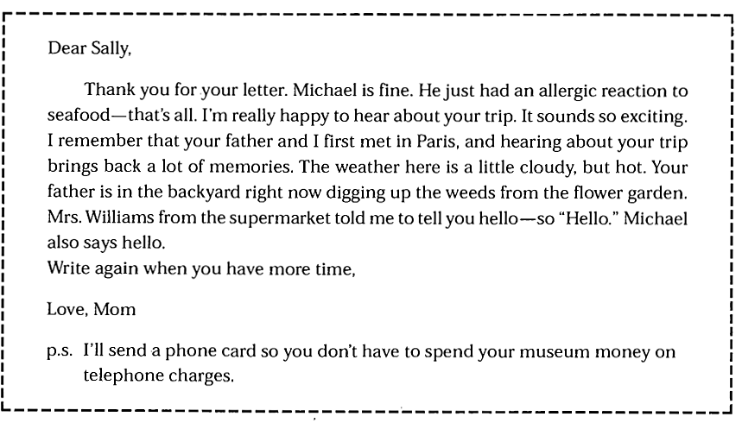
38. Why does the writer want to go to Italy?
(A) It is cheaper than France. (B) Her mother is in Italy.
(C) She went to France. (D) Italy is the best country for art.
39. What was probably wrong with Michael?
(A) We do not know. (B) He doesn’t like museums.
(C) He had a cold. (D) He had a bad reaction to some food.
40. How will the writer next contact her mother?
(A) She will send an email. B) She will telephone her.
(C) She will send a postcard. (D) She will not contact her again.

______Hết_______

GHI CHÚ: CÁN BỘ COI THI KHÔNG ĐƯỢC GIẢI THÍCH GÌ THÊM.
TRƯỞNG KHOA TRƯỞNG BỘ MÔN GIẢNG VIÊN RA ĐỀ
(Ký tên và ghi rõ họ tên) (Ký tên và ghi rõ họ tên) (Ký tên và ghi rõ họ tên)

.

UBND THÀNH PHỐ HỒ CHÍ MINH | CỘNG HÒA XÃ HỘI CHỦ NGHĨA VIỆT NAM
TRƯỜNG CAO ĐẲNG LÝ TỰ TRỌNG | Độc lập - Tự do - Hạnh phúc
THÀNH PHỐ HỒ CHÍ MINH
ĐÁP ÁN ĐỀ THI KẾT THÚC MÔN HỌC
HỌC KỲ: I NĂM HỌC: 2023 – 2024
Bậc đào tạo: CAO ĐẲNG
Môn học: TIẾNG ANH
Khóa/Lớp: 20C2________ Ngày thi: _______ / _______ / 2023
Thời gian thi: 60 phút (không kể thời gian phát đề)

NỘI DUNG
Câu  số | 001 | 002
1 | b | b
2 | a | a
3 | a | a
4 | a | c
5 | b | b
6 | c | c
7 | d | a
8 | a | d
9 | d | b
10 | d | a
11 | b | c
12 | a | a
13 | b | a
14 | b | b
15 | d | d
16 | c | a
17 | a | a
18 | a | b
19 | b | c
20 | d | b
21 | c | b
22 | a | d
23 | a | a
24 | a | a
25 | c | a
26 | b | a
27 | d | d
28 | c | b
29 | a | b
30 | a | d
31 | a | b
32 | c | a
33 | a | b
34 | a | d
35 | c | b
Câu  số | 001 | 002
36 | b | c
37 | c | c
38 | b | d
39 | d | c
40 | b | b

_______Hết_______

TRƯỞNG BỘ MÔN GIẢNG VIÊN RA ĐỀ
(Ký và ghi rõ họ tên) (Ký và ghi rõ họ tên)

