ỦY BAN NHÂN DÂN TP.HCM CỘNG HÒA XÃ HỘI CHỦ NGHĨA VIỆT NAM
TRƯỜNG CĐ LÝ TỰ TRỌNG TPHCM Độc lập – Tự do – Hạnh phúc
********** ******
PHIẾU TRẢ LỜI TRẮC NGHIỆM
15’ TEST – TA – UNIT 1+2

Họ và tên: ____________________________ Lớp: 20C2-
3
Môn thi: ______________ Mã đề:

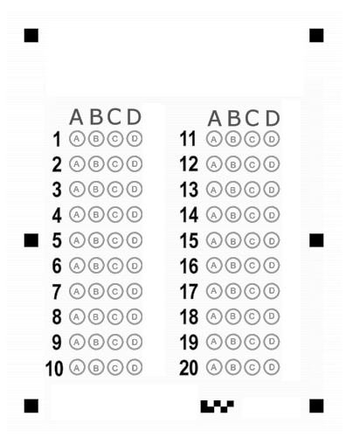

ỦY BAN NHÂN DÂN TP.HCM CỘNG HÒA XÃ HỘI CHỦ NGHĨA VIỆT NAM
TRƯỜNG CĐ LÝ TỰ TRỌNG TPHCM Độc lập – Tự do – Hạnh phúc
********** ******
PHIẾU TRẢ LỜI TRẮC NGHIỆM
15’ TEST – TA1 – UNIT 1+2

Họ và tên: ____________________________ Lớp: 21T4______
4
Môn thi: ________ Mã đề:

1/ He ____ a better job.
a may b may get
c mays get d may gets
2/ If he had had time, he ____ joined us.
a could have b certainly had
c can have d had
3/ He asked her, "____ you like some more coffee?"
a Would b Do
c Shall d Will
4/ The baby ____ be hungry, because he just had milk.
a cannot b isn't
c wasn't d must
5/ Please keep this medicine refrigerated. Do not ____ temperatures above 15 degrees Celsius.
a having b store
c take d remain
6/ Everyone must be ____ time.
a at b to
c on d for
7/ So far, there ____ no word from them.
a has been b has
c was d is
8/ When I called on her, Mary ____ her room.
a was cleaning b clean
c cleaning d cleans
9/ They have ____ work late.
a at b to
c in d for
10/ I have recently received several ____ from parents about teachers being late for class.
a complaining b complain
c complains d complaints
11/ I will be there ____ 8.
a in b on
c at d for
12/ Can fish live ____ the river?
a in b at
c for d on
13/ She traveled ____ Europe.
a into b on
c for d in
14/ ____ the Spring, I would plant flowers.
a To b In
c On d At
15/ She had bought that book _____ she met me.
a before b where
c after d while
16/ He ____ the subway every day.
a is taken b takes
c take d took
17/ He ____ the subway now.
a is taking b taking
c does taking d takes
18/ We'll start when he ____ ready
a be b is
c will is d will be
19/ He has ____ cut himself.
a always b just
c yet d ago
20/ We ____ at a party two months ago.
a meeting b meet
c have met d met

