ỦY BAN NHÂN DÂN TP.HCM CỘNG HÒA XÃ HỘI CHỦ NGHĨA VIỆT NAM
TRƯỜNG CĐ LÝ TỰ TRỌNG TPHCM Độc lập – Tự do – Hạnh phúc

TEST 15'
HỌC KỲ: II NĂM HỌC: 2023 - 2024 Thời gian:
Đề 01

Bậc đào tạo: TRUNG CẤP (21T4 - ) Học phần:

( Unit 05 )

PHIẾU TRẢ LỜI TRẮC NGHIỆM

TÊN: _____________________________________________
LỚP: ___________________
Tô đen những câu trả lời đúng bằng bút mực. Mỗi câu chỉ tô 1 đáp án.
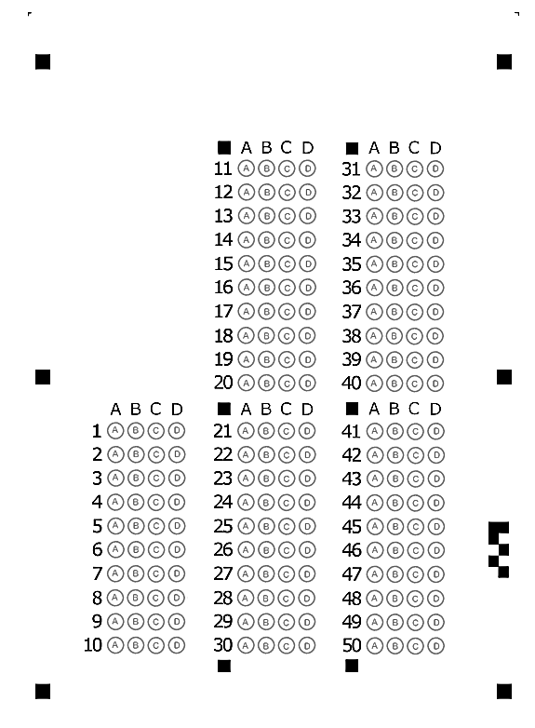
1/ His job is to ____ an advertisement in the local paper.  a. visit c. take  b. run d. regret  2/ All people have the right to speak out ____ their country.  a. from c. to  b. with d. against  3/ The old office equipment should ____.  a. be replace c. be replacing  b. be replaced d. replace  7/ The new project allows ____ other country very often.  a. her visit c. her to visit  b. her visiting d. her to visiting  8/ You must complete the personal information form, ____ you can download from our website.  a. whose c. what  b. which d. that  9/ We expect ____ the old building by the end of April.  a. to demolish c. demolishing  b. being demolished d. to be demolished  10/ I'm sorry about ____ their feelings.  a. to hurt c. hurting  b. I hurt d. hurt  11/ This year, we expect to see thousands of people ___ the classic car show ___ Chicago.  a. on/on c. at/ in  b. at/at d. on/at  12/ ____ target customers in their 20s, Ashley's Dinning has changed its marketing strategy.  a. In spite of c. Because  b. Therefore d. In order to  13/ When we arrived, the film was about ____.  a. to start c. started  b. start d. starting | 4/ ____ its new products, Jim's Electronics will be having a special sale this month.  a. Celebrated c. To celebrating  b. For celebrate d. To celebrate  5/ The government wants to increase taxes ____ alcohol and unhealthy food.  a. at c. to  b. on d. by  6/ Sally wants to work at a cosmetic company as a sales _____.  a. representative c. benefit  b. headquarter d. appointment  14/ She asked which chapter _____.  a. reading c. to read  b. read d. reads  15/ Does she remember ____ the report to the secretary last week?  a. give c. gives  b. to giving d. giving  16/ We are glad ____ you a job as a representative.  a. to make c. to offer  b. offer d. make  17/ IHD ___ more than 20 employees last month.  a. take c. laid off  b. changed d. attracted for  18/ ____ your first day of work, we need you to prepare three forms of documents and bring them ____ you.  a. Because/ with c. For/ to  b. With/ for d. For/ with  19/ He expects ____ soon.  a. to arrive c. arrive  b. arriving d. arrival  20/ Ask your local fire station for ____.  a. advise c. advising  b. advice d. advices

