ỦY BAN NHÂN DÂN TP.HCM CỘNG HÒA XÃ HỘI CHỦ NGHĨA VIỆT NAM
TRƯỜNG CĐ LÝ TỰ TRỌNG TPHCM Độc lập – Tự do – Hạnh phúc

TEST 15'
HỌC KỲ: II NĂM HỌC: 2023 - 2024 Thời gian:
Đề 02

Bậc đào tạo: TRUNG CẤP (21T4 - ) Học phần:

( Unit 05 )

PHIẾU TRẢ LỜI TRẮC NGHIỆM

TÊN: _____________________________________________
LỚP: ___________________
Tô đen những câu trả lời đúng bằng bút mực. Mỗi câu chỉ tô 1 đáp án.
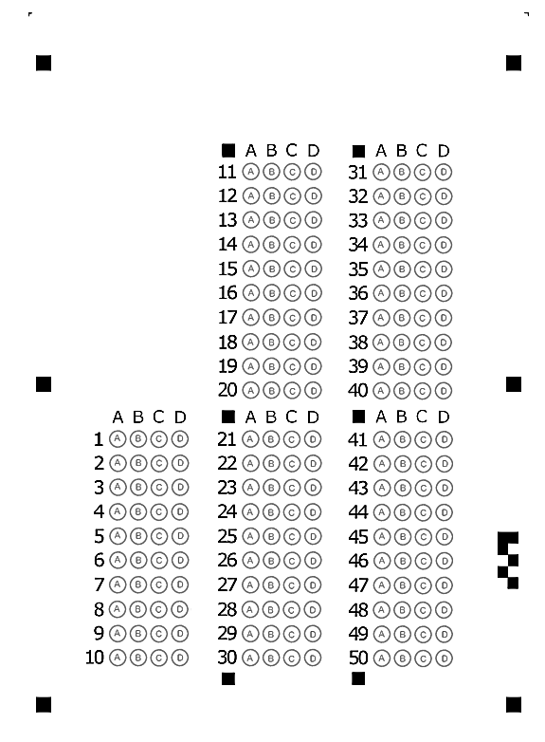
1/ The city council has been discussing ways to ____ the old school into a museum.  a. take c. please  b. convert d. announce  2/ Mark failed to ____ the appointment with his boss.  a. schedule c. run  b. take d. visit  3/ We are very pleased ____ the best salesman of the year.  a. announce c. to announce  b. announcing d. announced  7/ Who is responsible for ____ the dishes tonight?  a. doing c. will do  b. do d. to do  8/ They'd like to have a(n) ____ to visit the headquarters in London.  a. advertisement c. opportunity  b. representative d. competent  9/ To provide better service, the hotel receives feedback ___ its guests.  a. in c. from  b. to d. at  10/ Avon Imports will trade with ____ distributors to satisfy its customers.  a. any c. none  b. not d. Both a & b are correct.  11/ At Comfy Sofas, our goal is____ the most comfortable chairs and sofas.  a. to designing c. designed  b. to be designed d. to design  12/ A copy of your passport or driver's license and proof of your address, ____an electric bill, are also needed.  a. despite c. with  b. such as d. in addition to  13/ A smoke detector is an easy way ____ your family.  a. protected c. protect  b. protecting d. to protect | 4/ PK Bank has requested the customers _____ their password regularly.  a. changes c. to change  b. changing d. has changed  5/ I need to renew my GJA Golf Club Membership, which ____ on June 17.  a. have designed c. expires  b. advised d. demolishes  6/ All I want is ____ to return safe.  a. of him c. for him  b. he d. him  14/ Frank has been really busy ____ the new products ready for the exhibition.  a. get c. to get  b. getting d. to getting  15/ I'm looking forward ____ her tomorrow.  a. to see c. to seeing  b. seeing d. see  16/ When ____ to resign his position, the manager reacted badly.  a. ask c. asking  b. asked d. to ask  17/ Would you mind ____ the window?  a. if opening c. to opening  b. to open d. opening  18/ We encourage all the staff members ____ a course on basic economics.  a. taking c. to take  b. taken d. take  19/ We ____ to inform you that the position has been filled.  a. sorry c. regret  b. apology d. apologize  20/ It was necessary that she ____ her father the truth.  a. tell c. tells  b. does tell d. to tell

