Example 1: Computer Architecture (IT Program)
SUBJECT NAME | Computer Architecture
SUBJECT CODE
TRAINING HOURS | 60
Pre – requisite Needed | No
Subject Aims and Synopsis | 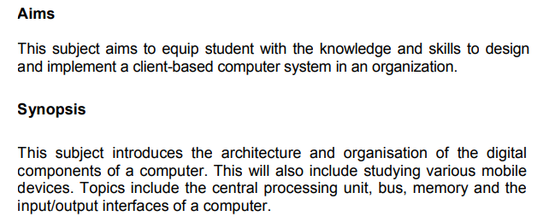
Subject Scope and Learning Outcomes | 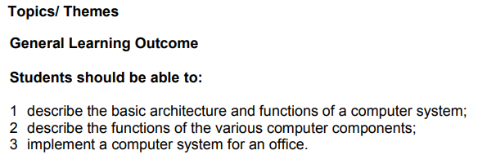
Learning and Teaching Methods | 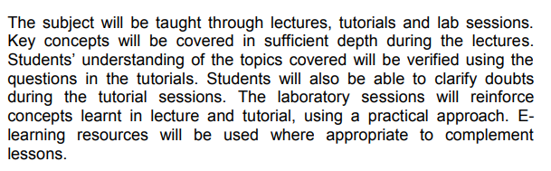
Formative Assessments | 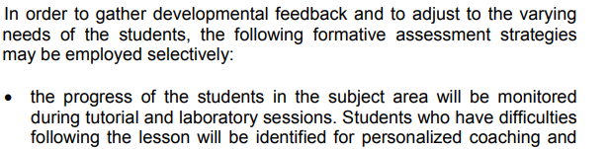  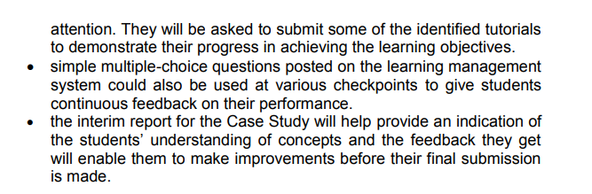
Summative Assessments | Assessment Methods:  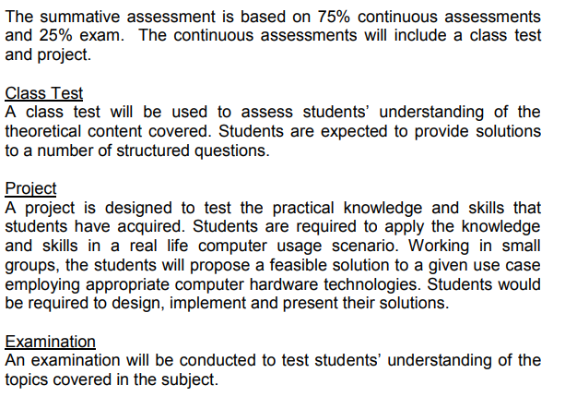
Assessment Schemes: | 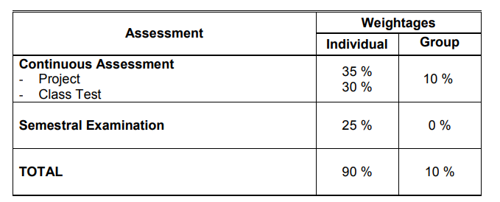
Learning Resources

Example 2: Computer System and Application (Business IT Program)
SUBJECT NAME | Computer System and Application
SUBJECT CODE
TRAINING HOURS | 60
Pre – requisite Needed | No
Subject Aims and Synopsis | 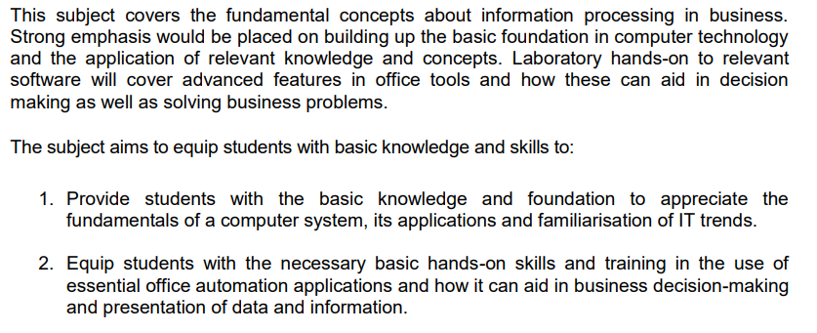
Topics | 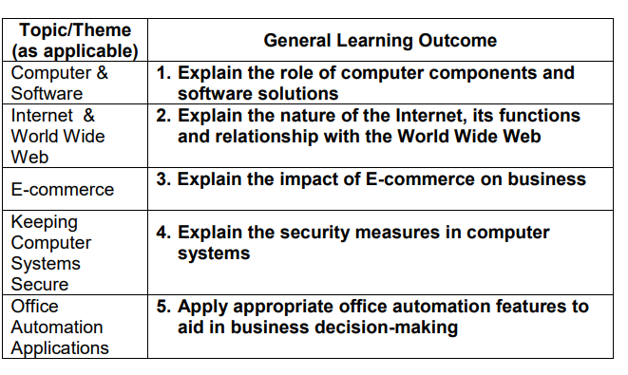
Learning and Teaching Methods | 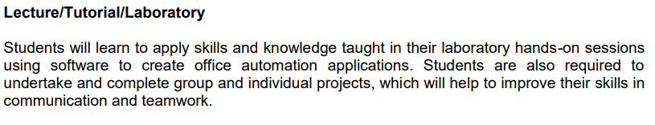  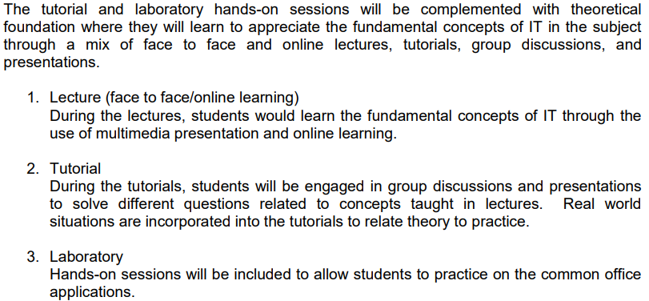
Formative Assessments | 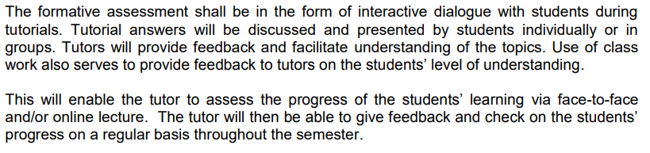
Summative Assessments | Assessment Methods:  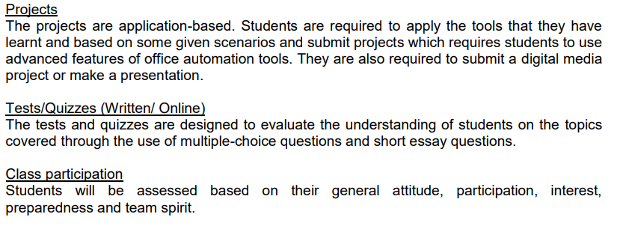
Assessment Schemes: | 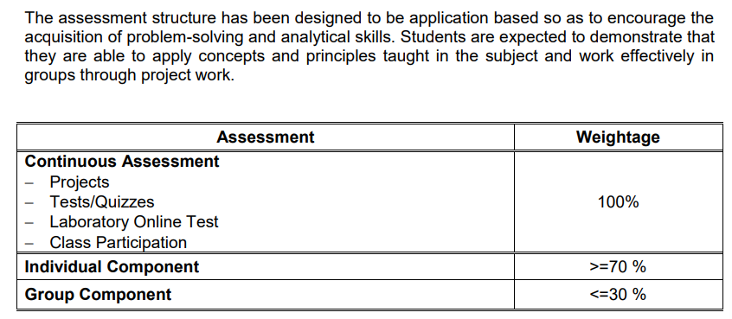
Scheme of Work | 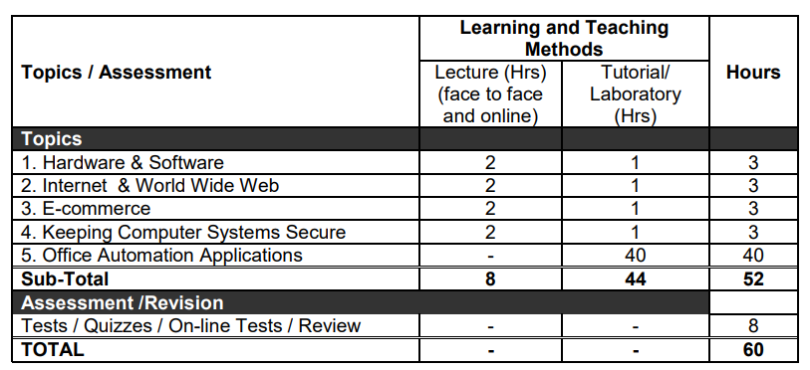
Learning Resources

Example 3: FOOD PRODUCTION QUANTITY AND QUALITY CONTROL (Culinary Program)
SUBJECT NAME | FOOD PRODUCTION QUANTITY AND QUALITY CONTROL
SUBJECT CODE
TRAINING HOURS | 200
COURSE DESCRIPTION | The subject encompasses the skills provided to the student to be able to:  - practice food production quantity and quality control activities to ensure food produced meet the required result in accordance with food standard set by the establishment and to provide food for guest satisfaction.
LEARNING OUTCOME | Upon completion, the student will be able to: -  - Identify quality, consistencies and quantity of food production  requirement  - Obtain quality and quantity control checklist  - Prepare daily food production quantity and quality control activities  summary report  - Maintain monthly food production quantity and quality control  activities document
TOPICS | - IDENTIFY QUALITY, CONSISTENCIES AND QUANTITY OF FOOD PRODUCTION REQUIREMENT  1.1 Related Knowledge  - Introduction types of food production requirement  - Quality  - Consistencies  - Quantity  1.2 Related Skills  - Determine types of quality, consistencies and quantity of food production requirement  - Adhere quality, consistencies and quantity of food production requirement  - OBTAIN QUALITY AND QUANTITY CONTROL CHECKLIST  2.1 Related Knowledge  - Quality and quantity control specification  - Portioning  - Costing  - Presentation  - ii. Standard Operating Procedure (SOP)  - Checking techniques  - Visual  - Manual  - Data entry  - Types of quality control checklist  - Colour  - Odour  - Flavour  - Texture  2.2 Related Skills  - Determine quality and quantity control checklist and report  - Determine Standard Operating Procedure  - Check product specification requirements  - Quality and quantity control specification  - Produce product meet the require set  - Provide Immediate feedback  - PREPARE DAILY FOOD PRODUCTION QUANTITY AND QUALITY CONTROL  ACTIVITIES SUMMARY REPORT  3.1 Related Knowledge  - Types of daily food production quality and quantity control summary report  - Opening report  - Inter-shift report  - Closing report  - Summary report of daily food production quality and quantity control  - Manual  - Database  3.2 Related Skills  - Determine types of daily food production quality and quantity  control and summary report  - Fill up daily food production quality and quantity control  summary report  - Submit daily food production quality and quantity control  summary report to relevant department  - MAINTAIN MONTHLY FOOD PRODUCTION QUANTITY AND QUALITY CONTROL ACTIVITIES DOCUMENT  4.1 Related Knowledge  - Introduction types of monthly food production quality and  quantity control and summary report  - Method of filling monthly food production quality and quantity control summary report  4.2 Related Skills  - Identify types of monthly food production quality and  quantity control summary report  - Update monthly food production quality and quantity control  summary report  - Compile monthly food production quality and quantity control  summary report  - Submit monthly food production quality and quantity
REFERENCE

