MORE PRACTICE
I/ Additional listening practice: Answer the following questions:
- What does the speaker’s mother want to do after she retires?
_______________________________________________________________________
- Who is the gift for?
_______________________________________________________________________
- How often does his father play tennis?
_____________________________________________________________________
- What does the salesclerk suggest a gift card?
_____________________________________________________________________
- Why does the woman decide not to buy a dictionary?
_____________________________________________________________________
- Why does the man buy pink roses?

II/ Read some gift-giving occasions and fill in the blanks. Then listen again to check the answers.
1. Vannessa is going to buy a ____________ for her mother. She’s retiring __________. She got really interested in __________. And she wants to spend more time _____________ after she retires. The gift is so ______ and thin, looks like a ___________.
2. The woman needs a gift for her _____. She has high school ________ in June. She wears a lot of __________ such as necklaces, bracelets, earrings. So the woman will buy an item which has a nice _____ and her niece could put a lot of things in it. She thinks she will buy the pretty _____ one.
3. Steve is looking for something for ___________. His father plays sports ______. He’s out on the _______ almost every weekend. He loves to be ________, and he loves to _________.
4. The woman is looking for a ___________ for her grandson. He really loves music. But she doesn’t know what kind of music her grandson likes and who his favorite ________ are. So that she gets him one of these, then he can choose his own _______. She’ll take one for _______ dollars.
5. The man is going to get something for Professor Wang. She’s been so ______ to her this year, and she wants to _____ her. She knows that her professor is always _________ before class. So she’ll get her a _____ one.
6. It is their __________ today. They have been married for _____ year. He wants to get something ______ for his wife. They are beautiful and _____. He chooses that color because it’s her _______ color. And he would like to buy ______, a dozen.

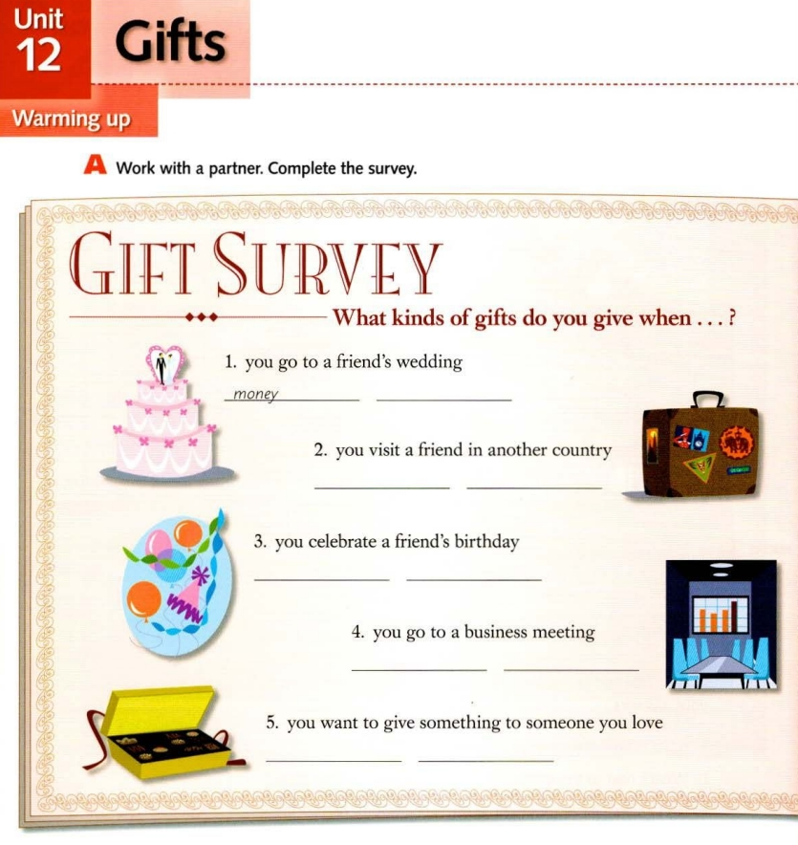
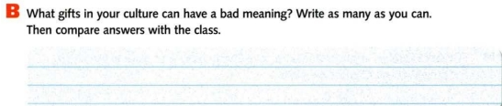
55

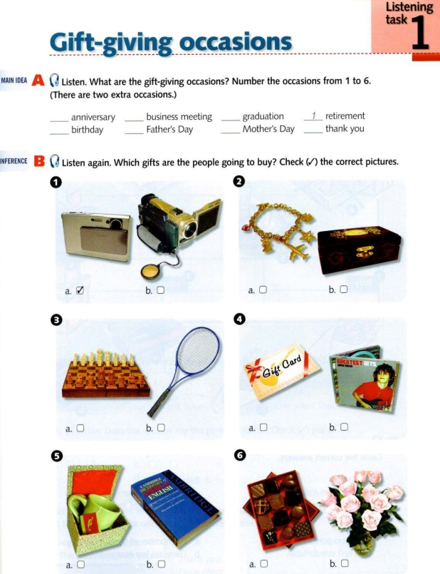

55

