Cambridge Professional English

Infotech
English for Computer users
Fourth Edition
Student's Book
Santiago Remacha Esteras

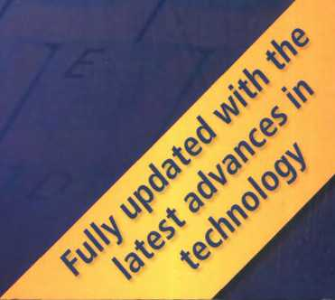

Map of the book  Thanks and acknowledgments | iv viii
Module 1 Computers today  Unit 1 Living in a digital age  Unit 2 Computer essentials | 1 Moduleó Creative soítvvare 99  2 Unit 20 Graphics and design 100  7 Unit21 Desktop publishing 105
Unit 3 Inside the System  Unit4 Buying a Computer | 11 Unit22 Multimedia 110  16 Unit 23 Web design 114
Module 2 Input/Output devices  Unit 5 Type, click and talk! | 21 Module7 Programming / Jobs in ICT 119  22 Unit24 Program design and Computer languages 120
Unit 6 Capture your favourite image  Unit 7 Display screens and ergonomics  Unit8 Choosing a printer  Unit 9 Devices for the disabled | 27 Unit25 Java™ 125  32 Unit26 JobsinlCT 129  37  42 Module8 Computers tomorrovv 134  Unit27 Communication Systems 135
Module 3 Storage devices  UnitlO Magnetic storage  Unit 11 optical storage  Unit12 Flash memorỵ | 47 Unit28 Netvvorks 140  48 Unit 29 Video games 145  52 Unit30 New technologies 150  57  Appendix: a model cv 155
Module4 Basic software | 62 Glossary 156
Unit 13 The operating System (OS)  Unit 14 Word Processing (WP)  Unit15 Spreadsheets and databases | 63 Irregular Verbs 166  68 Acronyms and abbreviations 168  73
Module5 Faces of the Internet | 78
Unit 16 The Internet and email | 79
Unitl7 TheWeb | 84
Unit 18 Chat and coníerencing  Unit19 Internet security | 89  94

 | UN1T | LISTENING | READING |  | s
Module 1  Computers today | 1 Living in a digital age | Computers at work | The digital age  The magic of computers |  | £ d
 | 2 Computer essentials | Different types of Computer | Advertising slogans What is a Computer? |  | [
 | 3 Inside the System | A PC System | Technical specihcations What is inside a PC System? How memory is measured |  | í  <
 | 4 Buying a Computer | In a Computer shop Choosing the right Computer | Computer adverts  Technical speciíications
Module 2  Input/Output | 5 Tỵpe, click and talk! | Describing input devices  Mouse actions | Interacting with your Computer Speech recognition Systems
devices | 6 Capture your íavourite image | Scanners | The eyes of your Computer Press release: a digital camera
 | 7 Display screens and ergonomics | Choosing the right display device  Ergonomics | How screen displays work
 | 8 Choosing a printer | Multi-íunction printers | Which type of printer should I buy?  Printer adverts | 1
 | 9 Devices for the disabled | Assistive technologies for the blind | Computers for the disabled
Module 3  Storage devices | 10 Magnetic storage | Buying a portable hard drive | Magnetic storage
 | 11 optical storage  12 Flash memory | CDs and DVDs  Flash drives | optical discs and drives  Memory in a flash! Ị
Module 4  Basic software | 13 The operating System (OS)  14 Word Processing (WP)  15 Spreadsheets and databases | Windows Vista  The Cut and Paste technique  The Excel spreadsheet program | GUI operating Systems  WP tools  An invoice and covering letter  Databases 1

SPEAKING | WRITING | LANGUAGEWORK | VOCABULARY
Discussing what computers do | A short summary of a discussion | Collocations 1 | Basic Computer terms, computers in education, banks, offĩces, airports, libraries, entertainment, etc.
Describing a diagram | An email explaìning the benehts of laptops and tablet PCs | Classifying | Basic hardware and software terminology
Describing your ideal Computer System | Notes about your ideal Computer System | Dehning relative clauses | Processor, chip, control unit, ơrithmetic logic unit, etc.  Units of memory: KB, MB, GB, etc.
Role play - buying a Computer | An email recommending a Computer | Language íunctions in a Computer shop | Vocabulary tree: revision of vocabulary írom Module 1
Describing input devices |  | Describing íunctions and íeatures | Input/Output devices, groups of keys, mouse actions
Describing a camera |  | Superlatives  Suffixes | Scanners, cameras
Discussing which display devices you would most like toown | Guidelines for an ergonomic school or office | Instructions and advice | Display screens, ergonomics
Choosing the right printer | An email to a íriend comparing two printers | Connectors 1  Comparatives | Types of printer, printer technology
Discussing assistive technology | An email summarizing the different assistive technologies available | Noun phrases | Devices for the disabled
Discussing how to protect your data | An email explaining hard drive precautions | Precautions  Word building | Types of magnetic storage, technical details of magnetic storage
Choosing storage devices  Describing f)ash drives | A post on a forum discussion about format wars  A text message to a friend explaining the difference between MP3 and MP4 | Connectors 2  Word building | Types of optical storage, technical details of optical storage  Types of flash drive, technical details offlash memory
Comparing user interíaces  Giving instructions for carrying out tasks in Word | Asummary oíatext  Instructions for using Find and Replace in Word | Countable and uncountable nouns  Articles  Giving and following instructions | GUIs, the WIMP environment, desktop íeatures, etc.  Functions and íeatures of word processors
Discussing the software you use at home and at work | Afax of complaint | Plurals | Functions and íeatures of spreadsheets and databases

UNIT |  | LISTENING | READING
Module 5  Faces of the Internet | 16 The Internet and email | Internet basics | Internet FAQs  Email íeatures
Module 5  Faces of the Internet | 17 FheWeb | E-commerce and Online banking | A typical web page  The colíectives of cyberspace
Module 5  Faces of the Internet | 18 Chat and coníerencing | At a cybercaíé | Virtual meetings Netiquette
Module 5  Faces of the Internet | 19 Internet security | Safety Online for children | Security and privacy on the Internet  The history of hacking
Module 6  Creative software | 20 Graphics and design  21 Desktop publishing  22 Multimedia  23 Webdesign | The toolbox  Steps in a DTP publication  Components and System requirements  Designing a website | Computer graphics  What is desktop publishing? Steps in a DTP publication  Multimedia magic!  Web page design
Module 7  Programming / Jobs in ICT | 24 Program design and Computer languages | Steps in programming | Computer languages
Module 7  Programming / Jobs in ICT | 25 Java™ | Thehistory of Java | Java applets  The Java language
Module 7  Programming / Jobs in ICT | 26 Jobs in ICT | IT professionals Ajob interview | Job adverts  A letter of application
Module 8  Computers tomorrow | 27 Communication Systems | VolP technology | Channels of communication
Module 8  Computers tomorrow | 28 Networks | Small netvvorks | Networking FAQs I
Module 8  Computers tomorrow | 29 Videogames | Present and future trends in gaming | Game genres
Module 8  Computers tomorrow | 30 New technologies | RFID tags | Future trends

Thanks and acknowledgements
The author vvould especially like to express his gratitude to Paz, Marina and Vroleta. My special thanks to Nick Robinson for his invaluable teedback and for editing the typescript and to Tony Garside for his input and expertise. Thanks are also due to the teachers and students of Pilar Lorengar High School, Zaragoza. Thanks to Cambrídge Universìty Press for their Vision, support and faith in the project, to Matt Robinson for hìs generous contributíon on video games, and to Angel Benedí and Elena Marco for their help and advĩce.
We are grateíul to all the teachers who provided ĩnput and advĩce during the development of this new ediũon.
The authors and publishers acknowledge the following sources of Copyright material and are grateíul for the permissions granted. While every effort has been made, it has not always been possible to identiíy the sources of all the material used, or to trace all Copyright holders. If any omissions are brought to our notice, we will be happy to include the appropriate acknowledgements on reprinting.
p. 31 Kodak Easy Share C663 Press Release 3 lanuary 2006, © 2003-2007 Ketchum Inc.; p. 41 adapted text describing Canon SELPHYCP750 Photo Printer, © Canon 2007; p. 41 adapted text descrĩbing Vutek UltraVu II 5330 írom www.efi-vutek.com/products; p. 41 Brother UK Ltd íor text describing Brother HL Network Colour Laser Printer HL 2700 CN. www.brother.com.au; p. 59 Amazon for description of Olympus WS-320M, www.amazon.com, © 1996-2007, Amazon.com, Inc. and its affiliates; p. 67: text adapted from www.linux.org, content available under terms of GFDL License; p. 72: adapted text 'Spellcheckers' and p. 105 adapted artĩcle, 'Desktop publishĩng' reprinted trom Understanding Computers by Nathan 5heldroff, J Sterling Hutto and Ken Fromm, 1993; p. 84 article adapted from 'Tour the collectives of cyberspace' hom BusinessWeek Online, 20 June 2005; p. 146; artlcle adapted írom 'Game genres'. www.ringsurf.com.
The publishers are grateful to the following for permission to reproduce Copyright photographs and material:
Key: I = left, c = centre, t = top, b = bottom
ACE STOCK LIMITED/Alamy for p. 2(tl), lan Shaw/Alamy for p. 2(tr), Wayne Eastep/Getty Images for p. 2(bl), Julĩet Brauner/Alamy for p. 2(br), Elizabeth Whiting & Associates/Alamy for p. 5. Mark M, Lawrence/Corbĩs for p. 8(1). Geri Lavrov/Alamy for p. 8(r), Courtesy of Dell Inc. for p. 11 (l),Tahesi Takahara/Science Photo Library for p. 11 (r). Intel Corporation, 2007 for p. 12(bl), PCWotld for p. 16(t), David Paul Morris/Getty Images for p. 16(c), Profimedia International S.r.o/Alamy for p. !6(b), Photo courtesyoí Sun Microsystems, Inc.íorp. 18,Gateway, Inc.íor p. 19(t), for p. 19(c), Courtesy of Dell Inc. for p. 19(bl), (br), Playstation and the Playstation logo, PSP and PLAYSTATION 3 are trademarks or registered trademarks of Sony Computer Entertainment Inc. for p. 23(t), www.CartoonStock.com ĩor p. 25. Source; Nuance Communications íor p 26. Paul Hardy/Cọrbis for p 30, © Kodak for p. 31. Image courtesy of NEC Display Solutions for p, 34(tl), Courtesy of Dell Inc. íor p. 34(tr), © Cambridge University Press, ỉmage courtesy thephotounit for p. 34(cl), with compliments of Pioneer GB Ltd for p. 34(cr), Canon Compact Photo Printer SELPHY CP750 for p. 41 (I), Picture courtesy of EFI-Vutek for p. 41 (tr), Image of Brother HL-4040CN provided courtesy of Brother Industries UK for p. 41 (br), Sally Lancaster/Format Photographers for p. 42(tr), (cl), De Repentlgny, Publiphoto Diffusĩon/ Science Photo Lĩbrary for p. 42(cr), AbilityNet for p. 42(bl), ImageState/Alamy for p. 43. Textlink 91 OOMobile fot p. 44(cl), AbilityNet for p. 44(bl), Najlah Feanny/Corbis íor p. 46(t). Picturé courtesy of: GW Micro, Inc lor p. 46(b), for p. 48(b), Photograph courtesy of Toshiba for p. 49, Vadym Kharkivskiy/Alamy for p. 52. for p. 53. p 55, Photo courtesy of D-Link Coporation for p. 57(tl), for p. 57(tlc),The EDGETech Corp for p. 57(tcr), © SanDisk for p. 57(tr), for p. 57(bl), The EDGE Tech Corp for p. 5 7(br), © SanDísk for p. 58, © Olympus for p. 59, © SanDisk for p. 60(r), © Creative Technology Limited for p. 60(l), Graĩn Belt Píctures/Alamy for p. 82, varĩo ĩmages GmbH & Co.KG/Alarny for p 88, Tony Metaxas/Getty Images for p. 89, AFP/Getty Images for p. 90, www.CartoonStock.com for p. 92. Hekimian Julìen/ Corbis Sygma for p. 93.
Steve Allen/Alamy for p. 10l(br). Microsoít Encarta Premium 2007 box shot reprinted with permission from Microsoft Corporation íor p. 110, Patrick Steel/Alamy for p. 111. Helen King/Corbis for p. 113(tr), Marcus Mok/Getty Images for p. 113(br), Helen King/Corbis for p. 117. WoodyStock/Alamy for p. 130, Teletext for p. 135(tl), Christoph Rosenberger/ Alamy for p. 135(tcr), TomTom GO 720 images íor p. 135(tr), Jack Sullivan/Alamy for p. 135(bl), Eurotech Ltd for p. 135(br), Nokia for p. 138(t), Jim Goldstein/Alamy for p. 139(br), Kim Kulish/Corbìs tor p. 145(t), Electronic Arts Limited for p. 145(tcr), Microsoft Xbox 360 box shot reprĩnted with permissĩon from Mlcrosoít Corporation for p. 145(tcl), Justin Leighton/Alamy for p. 145(cr). 5.T Yiap Conceptual/Alamy for p,145(br), Mictosoít Game Studios for p. 146. © Honda for p. 150(tl). Don Farrall/Getty Images tor p. 152, Cartoon by Patrick Blower íor p 154.
Logos and screenshots
p. 65 Microsoít Windows Vlsta ultimate Desktop screenshot reprinted with permĩssion from Mícrosott Corporation; p. 84 screenshot http://www.cambridge.org/elt/resources/professional/, © Cambridge Universỉty Press 2005; p. 85 eBay screenshot These materlals have been reproduced with the permissĩon of eBay Inc. © EBAY INC All Rlghts Reserved. p. 85 Facebook screenshot, Pacebook © 2007; p. 85 MySpace screenshot,© 2003-2007 MySpace. All Rights Reserved. p. 90 Microsoít Live Messenger logo. © 2007 Microsott Corporation: p. 114: Yahoo! screenshot, reproduced with permission of Yahoo! Inc. © 2007 by Yahoo! Inc. YAHOO! and the YAHOO! logo are trademarks of Yahoo! Inc. p. 118 The TPS report screenshot, www.tpsreport.co.uk, Matthew Robinson © 2007; p. 125 Java Powered logo with permĩssion of Sun Microsystems, Inc. Java and the Java Coffee Cup logo are trađemarks or regĩstered trademarks of Sun Microsystems, Inc. in the United States and other countríes and are used by permĩssion p. 145:World ofWarcraft screenshot. © 2007 8lizzard Entertainment Inc All Rights Reserved. All Microsoft product screenshots reprìnted wĩth permìssion from Microsoít Corporation.
Trademarks and registered trademarks are the property of their respective companies.
Designed and produced by eMC Desígn Ltd, www.emcdesign.org.uk
Picture research by Veena Holkar. Audio productíon by Penelope Reíd.
Computers today
Unit

page
- Living in a digital age 2
- Computer essentials 7
- Inside the System 11
- Buỵing a Computer 16

Learning objectives
In this module, you will:
- talk and write about Computer applications in everyday life.
- study the basic structure of a Computer System.
- study the differences between certain types of Computer.
- learn how to classiíy Computer devices.
- learn about the structure and íunctions of the CPU.
- learn how to distinguish between RAM and ROM.
- learn about how memory is measured.
- learn and use relative pronouns.
- learn how to enquire about computers in a shop.
- learn how to understand the technical specs of different computers.

Unit 1 Living in a digital age
The digital age
Match the captions (1-4) with the pictures (a-d).
- In education, computers can make all the diííerence
- Using a cashpoint, or ATM
- The Internet in your pocket
- Controlling air traffic
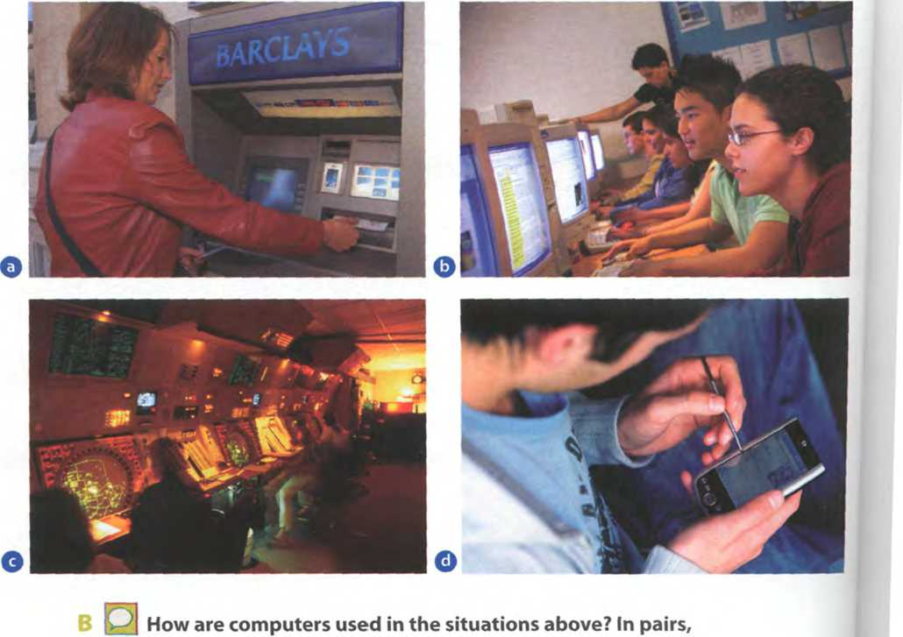
discuss your ideas.
c Read the text and check your answers to B.

Thedigĩtal age
We are now living in what some people call the digitalage, meaning that computers have become an essential part of our lives. Young people who have grown up with PCs and mobile phones are
5 often called thedigitalgeneration. Computers help students to períorm mathematical operations and improve their maths skills.They are used to access the Internet, to do basic research and to
communicate with other students around the world.
10 Teachers use projectors and Interactive whiteboards to give presentations and teach Sciences, history or language courses. PCs are also used for administrative purposes - schools use word processors to write letters, and databases to keep records of students
15 and teachers. A school vvebsite allows teachers to publish exercises for students to complete Online.
Students can also enrol íor courses Via the website and parents can download official reports.
Mobiles let ỵou make voice calls, send texts, 20 email people and download logos, ringtones or games. With a built-in camera you can send pictures and make video calls in face-to-face mode. New smartphones combine a telephone with web access, video, a games console, an MP3 player, a personal 25 digital assistant (PDA) and a GPS navigation System, all in one.
In banks, computers store information about the money held by each customer and enable staíí to access large databases and to carry out financial
30 transactions at high speed. They also control the cashpoints, or ATMs (automatic teller machines), vvhich dispense money to customers by the use of a PIN-protected card. People use a Chip and PIN
card to pay for goods and Services. Instead of using a 35 signature to verity paỵments, customers are asked to enter a four-digit personal identification number
I (PIN), the same number used at cashpoints; this System makes transactions more secure. With Online banking, clients can easily pay bills and transfer 40 money from the comíort of their homes.
Airline pilots use computers to help them control the plane. Forexample, monitors display data about fuel consumption and weather conditions. In airport control towers, computers are used to
45 manage radar Systems and regulate air traffic. On the ground, airlines are connected to travel agencies by Computer.Travel agents use computers to find out about the availability of ílights, prices, times, stopovers and many other details.

When you read a text, you wìll often see a new word that you don't recognize. If you can identiíy what type of word it is (noun, verb, adjective, etc.) it can help you guess the meaning.
Find the words (1 -10) in the text above. Can you guess the meaning from context? Are they nouns, verbs, adjectives or adverbs? Write n, V, adj or adv next to each word.
1 períorrh (líne 6)™.
2 word processor (line 13)
3 Online (line 16)
4 download (line 18)
6 built-in (line 21)
5 digital (line 25)
7 store (line 27)
8 hnancial (line 29)
9 monitor (Iine42)
10 data(line42)

a keep, save
b execute, do
c monetary
d screen
e integrated
f connected to the Internet
F
1
2
Match the words in D (1-10) with the correct meanings (a-j).
g collection offacts or íigures
h describes iníormation that is recorded or broadcast using computers
i program used for text manipulation
j copy íĩles from a server to your PC or mobile
< 2 In pairs, discuss these questions.
How are/were computers used in your school?
How do you think computers will be used in school in the future?
Language work: coliocaĩìons 1
Look at the HELP box and then match the verbs (1-5) with the nouns (a-e) to make collocations from the text on pages 2-3.
Use collocations from A and the HELP box to complete these sentences.
HELPbox
1 | give | a | money
2 | keep | b | aPIN
3 | access | c | databases
4 | enter | d | presentations
5 | transíer | e | records
Collocations 1
Verbs and nouns often go together in English to make set phrases, for example access the Internet These word combinations are called collocations, and they are very common. Learning collocations instead of individual words can help you remember which verb to use with which noun. Here are some examples írom the text on pages 2-3: perỉorm operations, do research, make calls, send texts, display dato, vvrite leưers, store information, complete exerãses, carry out transactions.
1 Thanks to Wi-Fi, it's now easy to.__ from cafés, hotels, parks and many
other Public places.
2 Online banking lets you
3 Skype is a technologỵ that enables users to
between ỵour accounts easily and
- over the
securely.
Internet
for free.
- In many universities, students are encouraged to using PovverPoint in order to make their talks more visually attractive.
- The Web has revolutionized the way people - with sites such as
Googleand Wikipedia, you can find the information ỵou need in seconds.
- Cookies allow 0 website to „ on a user's machinc and later rctrieve it;
when you visit the website again, it remembers your preíerences.
- With the latest mobile phones, you can with multimedia
attachments - pictures, audio, even video.
Computers at work
£ Listen to four people talking about how they use computers at work. Write each speaker's job in the table.
electrical engineer secretary librarian composer
Speaker | Job | What they use computers for
1
2
3
4
bij Listen again and write what each speaker uses their Computer for.
Other applications
In small groups, choose one of the areas in the diagram below and discuss what you can do with computers in that area. Look at the Useful language box
below to help you.

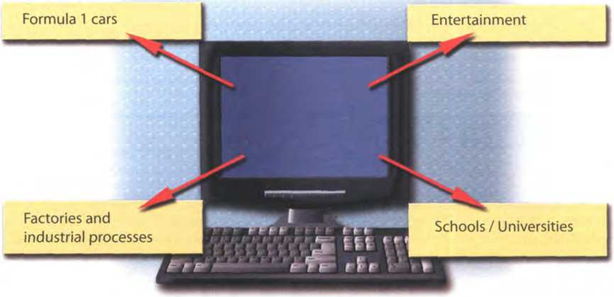

Useful language
Formula 1 cars: design and build the car, test Virtual models, control electronic components, monitor engine speed, store (vital) iníormation, display data, analyse and communicate data
Entertainment: dovvnload music, burn CDs, play games, take photos, edit photos, make video clips, vvatch movies on a DVD player, watch TV on the Computer, listen to MP3s, listen to the radio vía the Web
Factories and industrial processes: design Products, do calculations, control industrial robots, control assembly lines, keep record ofstocks (materials and equipment)
School/University: access the Internet, enrol Online, search the Web, prepare exams, write documents, complete exercises Online, do research, prepơre presentations
Computers are used to...
A PCcan also be used for...
Peopleusecomputers to...
Write a short presentation summarizing your discussion. Then ask one person from your group to give a summary of the group's ideas to the rest of the class.

Unit2 Computer essentials
Computer hardware
In pairs, discuss these questions.
A 1
2 3
Have ỵou got a Computer at home, school or work? What kind is it? How often do you use it? What do you use it for?
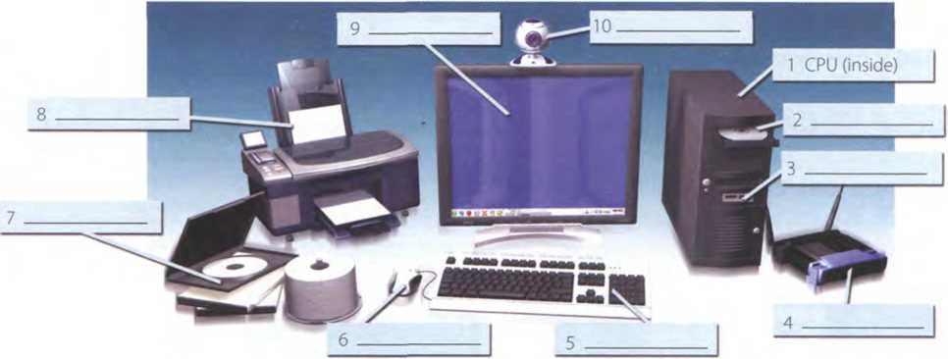
What are the main components and íeatures of your Computer System?
In pairs, label the elements of this Computer System.

Read these advertising slogans and say which Computer element each pair refers to.

Point and click here for power
Displays your ideas with perfect brilliance
lt's quiet and fast a
Obeys every impulse as if it were an extension ofyour hand
See the difference - Sharp images and a íantastic 0 range of colours
... it's easy to back up your data before it's too ỉate
Power and speed on the inside
Let your computers brain do the work
... a big impact on the production of text and graphics
Just what you need: a laser powerhouse

D Find words in the slogans with the following meanings.
- to press the mouse button
- clear; easy to see
- to make an extra copy of something
- selection
- shows
2 What is a Computer?
Read the text and then explain Fig. 1 in your own words.
What is a Computer?
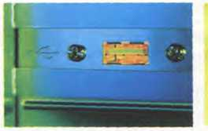

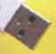
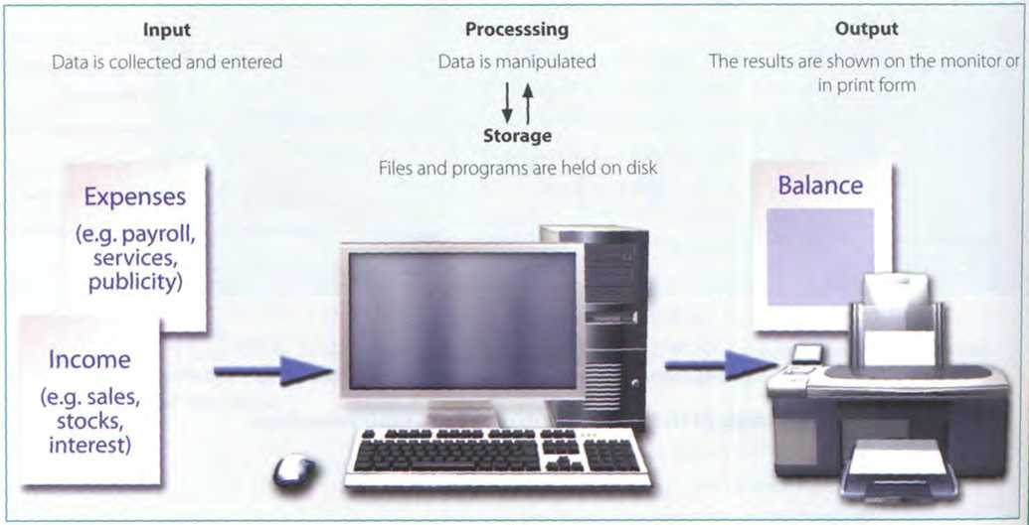
A Computer is an electronic machine which can accept data in a certain form, process the data, and give the results of the Processing in a speciíied íormat as iníormation.
First, data is fed into the computer's memory.Then, when the program is run, the Computer períorms a set of instructions and processes the data. Fina)ly, we can see the resulĩs (the output) on the screen or in printed form (see Fig. 1 below).
A Computer System consists of two parts: hardware and software. Hardware is any electronic or mechanical part you can see or touch. Software is a set of instructions, called a program, which tells the Computer what to do. There are three basic hardware sections: the Central Processing unit (CPU), main memory and peripherals Perhaps the most iníluential component is the Central Processing unit. Its íunction is to execute program instructions and coordinate the activities of all the other units. In a way, it is the 'brain'of the Computer. The main memory (a collection of RAM chips) holds the instructions and data which are being processed by the CPU. Peripherals are the physical units attached to the Computer. They include storage devices and input/ output devices.
Storage devices (hard drives, DVD drives or fìash drives) provide a permanent storage of both data and programs. Disk drives are used to read and write data on disks. Input devices enable data to go into the computer's memory. The most common input devices are the mouse and the keyboard Output devices enable us to extract the finished product from the System. For example, the Computer shows the output on the monitor or prints the results onto paper by means of a printer
On the rear panel of the Computer there are several ports inío which we can plug a wide range of peripherals - a modem, a digital camera, a scanner, etc. Theỵ allow communication between the Computer and the devices. Modern desktop PCs have USB ports and memory card readers on the front panel.
A USBport

A USB connector
Fig. I
ĩ Computer euentiali
Match these words from the text (1-9) with the correct meanings (a-i).
- software
- peripherals
- main memory
- hard drive (also known as hard disk)
- hardware
- input
- ports
- output
- Central Processing unit (CPU)
a the brain of the Computer
b phỵsical parts that make up a Computer System
c programs which can be used on a particular Computer System
d the information which is presented to the Computer
e results produced by a Computer
f input devices attached to the CPU
g section that holds programs and data while they are executed or processed
h magnetic device used to store information
i sockets into which an external device may be connected

Different types of Computer
E Listen to an extract from an ICT class. As you listen, label the pictures (a-e) with words from the box.
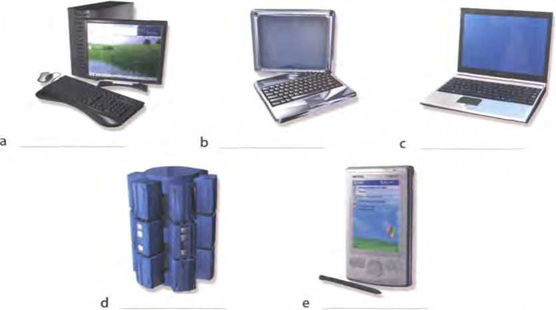

laptop desktop PC
mainírame
tablet PC
Listen again and decide whether these sentences are true or false.
Correct the false ones.
- A mainírame Computer is less powerful than a PC.
- A mainírame is used by large organizations that need to process enormous amounts of data.
- The most suitable computers for home use are desktop PCs.
- A laptop is not portable.
- Laptops are not as powerful as desktop PCs.
- Using a Stylus, ỵou can write directly onto the screen of a tablet PC.
- A Personal Digital Assistant is small enough to ht into the palm of your hand.
- A PDA does not allow ỵou to surf the Web.
c
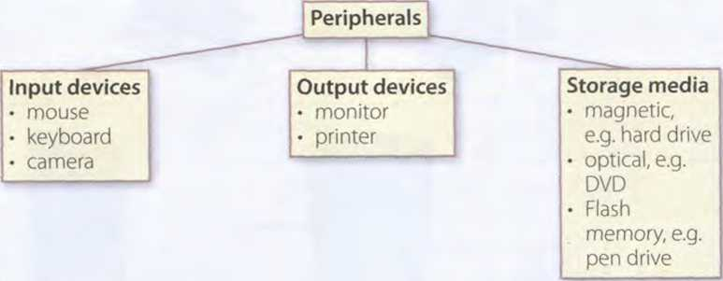
HELP box
Language work: classifying
A Look at the HELP box and then use suitable classiíying expressions to complete these sentences.
- A Computer hardware and software.
- Peripherals three
types: input, output and storage devices.
- A word Processing program software which lets the user create and edit text.
- of network
atchtecw. peeMo-peer₍where aW computers have the same capabilities, and client-server (e.g. the Internet), where servers store and distribute data, and clients access this data.
'ì In pairs, describe this diagram, using classiíying expressions from the HELP box. Makẽrefẽrence to your own devices.
Classifying
Classiíying means putting things into groups or classes. We can classify types of computers, parts of a PC, etc. Some typical expressions for classitying are:
- ... are classihed into X types/categories
- ... are classihed by ...
- ... can be divided into X types/categories
Digital computers can be divided into five main types: mainírames, desktop PCs, laptops, tablet PCs and hơndheld PDAs.
- ... include(s)...
- ... consist(s) of...
The bơsic configuration ofa maintrame consists ot a Central System which processes immense amounts oídata very quicklỵ.
- There are X types/classes of...
- X is a type of...
A tơblet PC is a type oínotebook Computer.
Beneíits oflaptops and tablet PCs
I Your school is considering buying tablet PCs to use in the classroom. Write an email to your teacher explaining the benehts for the students and the school.
or
Your company is considering replacing all of the office PCs with laptops. Write an email to your boss explaining the benehts for the employees and the company.

Unit3 Inside the System

Tech ni ca I speciíĩcơtions

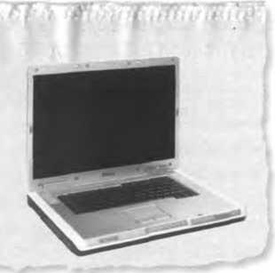
Read the advertisement and translate the technical specihcations into your own language.
Dell Inspĩron 9200
o Intel Core 2 Duo processor at 2.4GHz
o 2048MB RAM, expandable to 4GB
o 500GB hard drive
o Comes with Windows_Vista Home Premium

In pairs, answer these questions. If necessary, look at the Glossary.
1 What is the main íunction of a computer's processor?
- What unit of írequency is used to measure processor speed?
- What does RAM stand for?

What is inside a PC System?

Read the text on page 12 and then answer these questions.
- What are the main parts of the CPU?
- What does ALU stand for? What does it do?
- What is the function of the System clock?
- How much is one gigahertz?
- What type of memory is temporary?
- What tỵpe of memorỵ is permanent and includes instructions needed by the CPU?
- How can RAM be increased?
- What term is used to refer to the main printed Circuit board?
- What is a bus?
- What is the beneíĩt of having expansion slots?

Look at these extracts from the text. What do the words in bold refer to?
- This is built into a single chip. (line 2)
- ... which executes program instructions and coordinates... (line 3)
- ... that is being executed. (line 22)
- ... performance of a Computer is partly determined by the speed of its processor. (line 25)
- ... the CPU looks for it on the hard disk ... (line 35)
- ... inside the Computer to communicate with each other. (line 52)
5
10
15
20
25
30
35
What is inside a PC System?
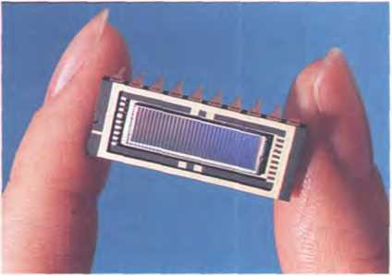
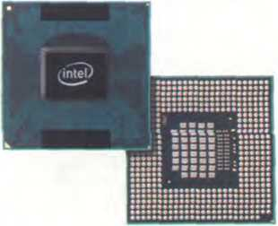
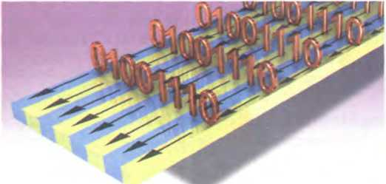

Processing
The nerve centre of a PC is the processor, also called the CPU, or Central Processing unit. This is built into a single chip which executes program instructions and coordinates the activities that take place within the Computer System. The chip itself is a small piece of Silicon with a complex electrical Circuit called an integrated Circuit.
The processor consists of three main parts:
- The control unit examines the instructions in the user's program, interprets each instruction and causes the circuits and the rest of the components - monitor, disk drives, etc. - to execute the íunctions speciíĩed.
- The arithmetic logic unit (ALU) performs mathematical calculations (+, -, etc.) and logical operations (AND, OR, NOT).
- The registers are high-speed units of memorỵ used to store and control data. One of the registers (the program counter, or PC) keeps track of the next instruction to be períormed in the main memory.The other (the instruction register, or IR) holds the instruction that is being executed (see Fig. 1 on page 13).
ROM (read only memory) is non-volatile, containing 40 instructions and routines for the basic operations
of the CPU. The BIOS (basic input/output
System) uses ROM to control communication with peripherals.
RAM capacity can be expanded by adding extra 45 chips, usually contained in small Circuit boards called dual in-line memory modules (DIMMs).
The power and períormance of a Computer is partly determined by the speed of its processor. A System clock sends out signals at íìxed intervals to measure and synchronize the flow of data. Clock speed is measured in gigahertz (GHz). For example, a CPU running at 4GHz (four thousand million hertz, or cỵcles, per second) will enable your PC to handle the most demanding applications.
The Intel Core 2 Duo processor; otherchip manuíacturers areAMDand MotQCQla

Buses and cards
The main Circuit board inside your System is called the motherboard and contains the processor, the memory chips, expansions slots, and controllers 50 for peripherals, connected by buses - eíectrical channels which allow devices inside the Computer to communicate with each other. For example, the front side bus carries all data that passes from the CPU to other devices.
55 The size of a bus, called bus width, determines how much data can be transmitted. It can be compared to the number of lanes on a motorway - the larger the width, the more data can travel along the bus. For example, a 64-bit bus can transmit 64 bits of data.
60 Expansion slots allow users to install expansion cards, adding features like sound, memorỵ and network capabilities.

RAM and ROM
The programs and data which pass through the processor must be loaded into the main memory in order to be processed.Thereíore, when the user runs a program, the CPU looks for it on the hard disk and transíers a copy into the RAM chips. RAM (random access memory) is volatile - that is, its information is lost when the Computer is turned off. However,
A data bus

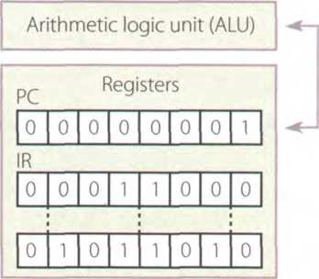
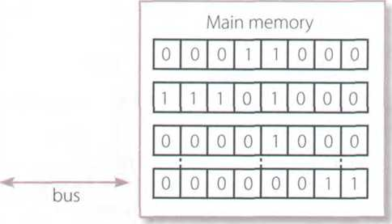
Central Processing unit (CPU)
Control unit
Fig. 1: Organization ofa simple Computer; the CPU is built into a single microprocessor chip
HELPbox
Dehning relative clauses
- We can deíĩne people or things with a dehning (restrictive) relativeclause.We use the relative pronoun who to refer to a person; we can also use that.
A blogger is a person who/that keeps a web log (blog) orpublishes an Online diary.
- We use the relative pronoun which (or that) to refer to a thing, not a person.
This is built into a single chip which/that executes program instructions and coordinates the activities that take place vvithin the Computer System.
Relative pronouns can be left out when they are the object of the relative clause.
The main Circuit board (which/that) you have insideyour System is called the motherboard...

Language work: detìning relative clauses
Look at the HELP box and then complete the sentences below with suitable relative pronouns. Give alternative options if possible. Put brackets round the relative pronouns you can leave out.
- That's the Computer l'd like
to buy.
- Core 2 Duo is a new Intel processor contains about 291 million transistors.
- A webmaster is a person
designs, develops and maintains a website.
- A bus is an electronic pathway carries signals between Computer devices.
- Here's the DVD you lent me!
- Last night I met someone works for GM as a software engineer.

How memory is measured

Read the text and then answer these questions.
- How many digits does a binary System use?
- What is a bit?
- What is a collection of eight bits called?
- What does ASCII stand for?
- What is the purpose of ASCII?
Bitsandbytes
Computers do all calculations using a code made of just two numbers - 0 and 1. This System is called binary code. The electronic circuits in a digital Computer detect the difference between two States: ON (the current passes through) or OFF (the current doesn't pass through) and represent these States as 1 or 0. Each 1 or 0 is called a binary digit, or bit.
Computers use a Standard code for the binary representation of characters.This is the American Standard Code for Iníormation Interchange, or ASCII - pronounced /'aeski/. In order to avoid complex calculations of bytes, we use bigger units such as kilobytes, megabỵtes and gigabỵtes.
We use these units to describe the RAM memorỵ, the

Bits are grouped into eight-digit codes that typically represent characters (letters, numbers and symbols). Eight bits together are called a byte.Thus, each character on a keỵboard has its own arrangement of eight bits. For example, 01000001 for the letter A, 01000010 for B, and 01000011 forC.
storage capacity of disks and the size of a program or document.
Note: bit is pronounced /bít/; byte is pronounced /bait/
I, 10,11 ,100...
One bít
Exomple ofa byte
Unit of memory | Abbreviation | Exact memory amount õ
Binary digit | bít, b | ^{1 Or0} A
Byte | B | 8 bits AÍ
Kilobyte | KB orK | 1,024 bytes (2'°)
Megabyte | MB | 1,024 KB, or 1,048,5 76 bytes (2²⁰)
Gigabyte | GB | 1,024 MB, or 1,073,741,824 bytes (2³⁰)
Terabyte | TB | 1,024 GB, or 1,099,511,627,776 bytes (2⁴⁰)

Complete these descriptions with the correct unit of memory.
- A is about one trillion bytes - about as much text as the books and
magazines in a huge library.
- A is about one million bỵtes - about as much text as a 300-page novel.
- A is about one thousand bytes - equivalent to one sheet of A4.
- A is about one billion bytes - about as much text as 1,000 books.
- A can store a single character, such as the letter /1 or number 7.

A PC System

Complete this diagram of a PC System. Look at Units 1,2 and 3 to help you.
bij Listen to a teacher explaining the diagram to her class and
check your answers.
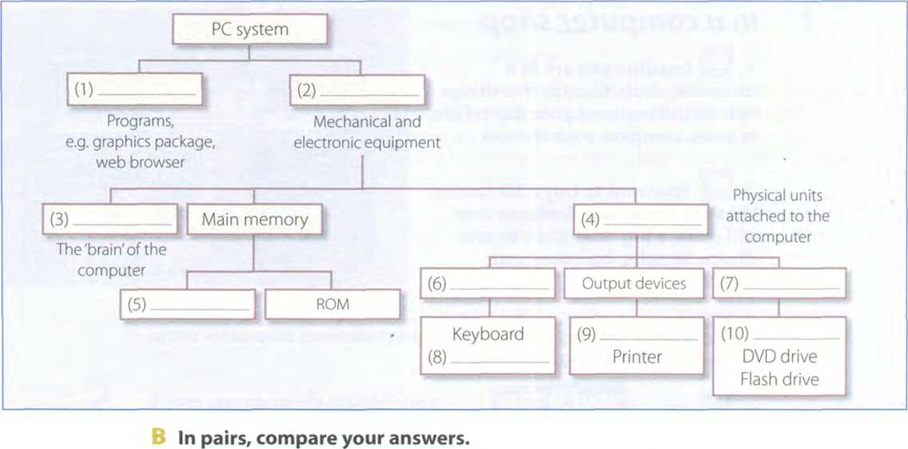

Ổ Your ideal Computer System
Make notes about the features of the Computer that you would most like to have. Think about the íeatures in the box.
CPU speed optical disc drives Wireless connectivity Minimum/maximum RAM
Monitor Ports and card memory slots Hard disk Software
In pairs, describe your ideal Computer System. Give reasons
for your choices.
Useful language
lt's got...
It's very fast. Itruns at...
The Standard RAM memory is... and it's expandable...
The hard disk can hold...
I need a large, flat LCD screen because...
As for the Internet,...

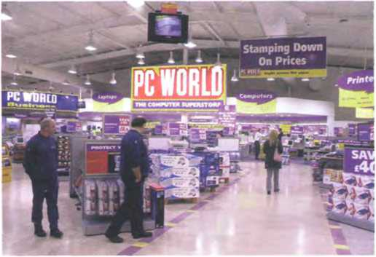

Unit4 Buying a Computer

In a Computer shop
A 0 Imagine you are in a Computer shop. Choose fìve things that would improve your digital life. In pairs, compare your choices.
3 You want to buy a Computer. Think of three basic features that will make a big difference to your choice. In pairs, compare your choices.
liu Listen to two people making enquiries in a Computer shop.
Do they buy anything?
MU Listen again and complete the product descriptions.

MacBook
Processor speed
RAM
Hard drive capacity DVD drive included?
operating System Includes internet software
Price £1,029
iMac
Processor speed 2.33GHz
RAM
Hard drive capacity DVD drive included? Yes Operating System Includes internet software
Price
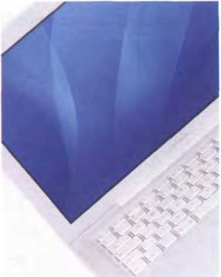
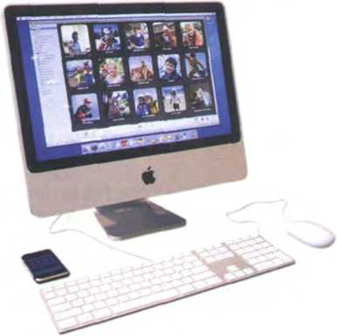

E Listen again and complete the extract írom the conversation.
Assistant: Do ỵou need any (1)?
Paul: Um, ỵes, we're looking for a Mac Computer. Have ỵou got any fairlỵ basic ones?
Assistant: Yes, sure. If you'd like to come over here.
Paul: What different (2)are there?
Assistant: At the moment we've got these two models: the iMac, which is a desktop Computer with an Intel Core 2 Duo processor (3)at 2.33 gigahertz, and the portable MacBook, which has a processor (4)at 2.0 gigahertz. Core Duo technology actually means two cores, or processors, built into a single chip, offering up to twice the speed of a traditional chip.
Sue: So they're both very (5) , then. And which one has more memorỵ? I mean,
which has more RAM?
Assistant: Well, the iMac has two gigabỵtes of RAM, which can be (6) up to three
gigabytes, and the MacBook has One gigabyte, expandable to two gigabytes. It all depends on your needs.The iMac is (7)for home users and small offices. The MacBook is more (8)if ỵou travel a lot.
- Language functìons in a Computer shop
_{HEL}p _{box} 1®=®K3K
Look at the language functions in the HELP box and then correct one mistake in each of these sentences. Decide which functions are being expressed in each sentence.
- The Ulysses SD is a power, expandable Computer that offers high-end graphics at a low price.
- A laptop is likely to be more expensive than the equivalent desktop, but a laptop is less practical if you travel a lot.
- Where's the storage capacity of the hard drive?
- l'm looking a desktop PC that has good graphics for games.
- Do you need the help?
- And how many does the PDA cost?
- This workstation is a Pentium processor with dual-core technology, 1,024 gigabỵtes of RAM, and 1 terabyte of diskspace.
Language functions useful to a sales assistant
- Greeting and offering help
Good morning. Do you need any help?
- Giving technical speciíications (specs)
The MacBook has a processor running at 2.0 gigahertz.
The iMac has two gigabytes of RAM.
They feature a camera built into the display.
- Describing
Both computers are very fast and reliable.
- Comparing
The MacBook is more practical ifyou travel a lot.
PDAs are cheaper than laptops but laptops are more powerful.
Language íunctions useful to a customer
- Explaining what you are looking for
We're looking for a personal Computer. Have you got any fairly basic ones?
- Asking for technical specs
What's the storage capacity ofthe hard drive?
Do they have a DVD drive?
- Asking the price
How much do they cost?
How much is it?

Role play - buying a Computer
^1 Work in pairs. One of you wants to buy a Computer, the other is the shop assistant. Use the prompts and product descriptions below to role play the conversation.
Shop assistant Customer
Greet the customer and offer help.
Explain what you are looking for.
Show the customer two possible models.
Ask for some technical specs.
Give technical specs (describe the processor, RAM and storage capacity). Compare the two diííerent models.
Ask about any further technical specs (DVD drive, monitor, Communications, etc.).
Give the iníormation required. Compare the two models.
Ask the prĩce.
Answer, and mention any final details that might persuade the customer to buy the Computer.
Decide vvhich Computer to buy or leave the shop.
Toshiba SatelIite gi^lBI^H^H laptop 2.0GHz Core 2 Duo processor 2GB RAM expandable to 4GB 160GB hard drive
Super Multi drive (double layer) 15.4" wide XGAdisplay Wireless LAN.Wi-Fi compliancy £1,099
Dell desktop PC
AMD Athlon at 2.4GHz 1GB RAM expandable to 4GB 320GB hard drive DVD+/-RW drive 17" LCD monitor
£680
Palm TX handheld
™ ..»’“' “‘^{ta!ri} p^or 128 MB Flash memory (non-voĩatiĩe) Support for memory cards
320x480 TFT touch screen Wi-Fi and Bluetooth
Lithium-ion battery
£216

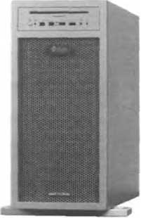

Choosing the right Computer
G Listen to four people talking about their Computer needs and take notes. In pairs, read the descriptions from the Computer shop website and choose the most suitable Computer for each person. Give reasons for your choices.
Speaker 1 Speaker 3
Speaker 2 — Speaker 4
Sun workstation
Two AMD Opteron processors at 3.0GHz 4GB RAM; 32GB maximum
1 terabyte hard drive and dual DVD drive 19" Sun TFT flat-panel LCD Supports several graphics íormats
Allows ỵou to handle your toughest technical, scientiíic, and business-critical applications
Supports Solaris, Windows and Linux £3,249
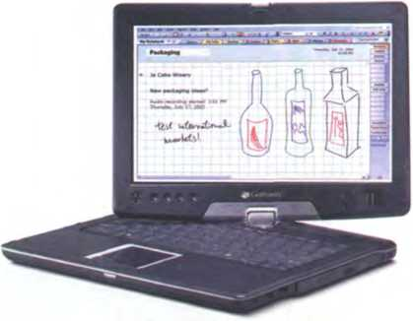
Gateway C-120 convertible notebook Intel Core 2 Duo ULV processor at 1.06GHz 12.1" WXGA TFT touch screen Gateway Executive Stylus pen 1024MB DDR2SDRAM 80GB serial ATA hard drive DVD-ROM drive (optical DVD burner) Integrated modem and Bluetooth Windows Vista Home Premium Thin and lightweight (1.17”, 2.4 kg) £805
Sony Vaio AR laptop (VGN-AR51E)
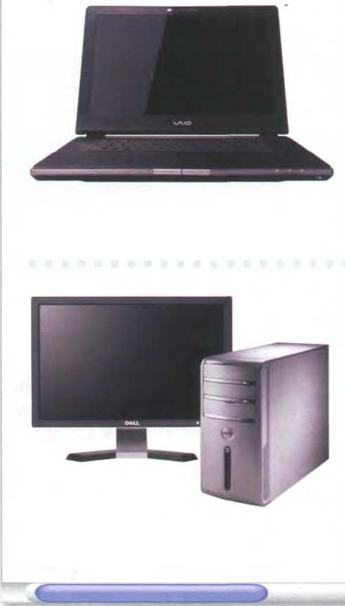
Intel Core 2 Duo Processor at 2GHz
2GB DDR2 SDRAM
200GB hard drive
DVD+/-RW optical drive
17" WXGA high-deíinition LCD screen
Memory Stick Slot
Three USB 2.0 ports
Integrated wireless LAN
Built-in 'Motion Eye’ digital camera
Lithium-ion battery
Windows Vista Ultimate
£899
Dell Inspiron 531 desktop PC
AMD Athlon 64 X2 Dual Core Processor
3072MB DDR2 SDRAM
Dell 22” Wide Flat Panel
256MB NVIDIA GeForce 8600GT video card
- .0TB Hard Drive
16x DVD+/-RW Drive
Integrated 7.1 Channel High Detinition Audio
Windows Vista Home Premium
Optional íeatures: Windows Media Center, integrated TV Tuner, and a Blu-ray disc drive íor high-definiton content
From £849 A
⁷ Look at the notes you made about your ideal Computer System in
B
Unit 3 task 6 (page 15). What did you want? Look again at the descriptions of the computers above and choose the one that is closest to your ideal. In pairs, discuss your choices.

5 Vocabulary tree
Designing word trees and spidergrams can help you build up your own mental 'maps' of vocabulary areas. Look at the list of terms in the box and put each one in an appropriate place on the word tree below. The first one has been done for you.
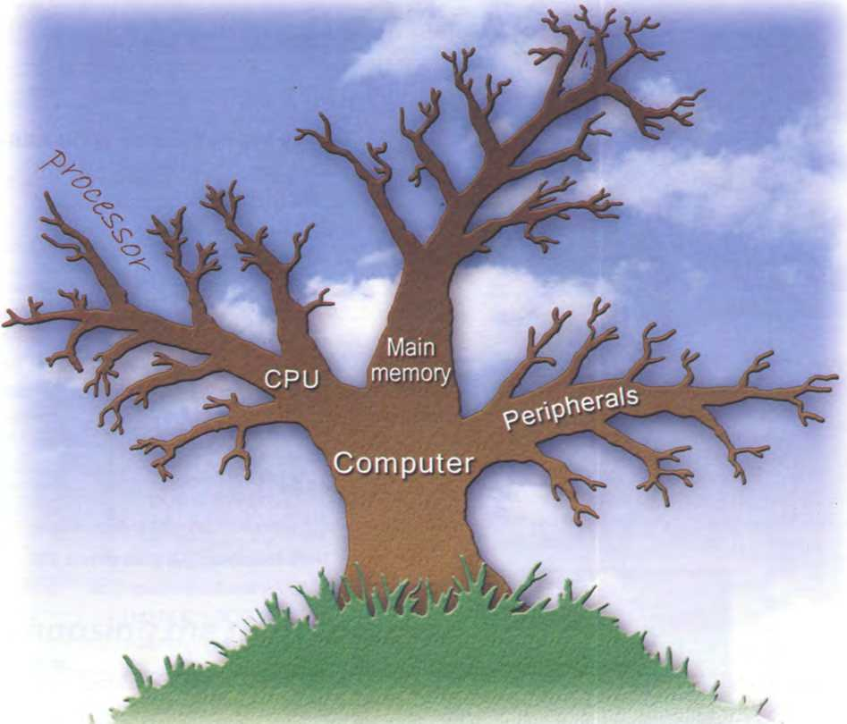
processor ROM expandable memory ALU DIMMs hard drive RAM Computer brain bỵte DVD System clock keỵboard mouse gigahertz printer megabyte webcam registers

Recommending a Computer
Ẽ A friend has asked you to recommend a Computer that suits his needs. He needs to be able to access the Internet, play games and work with graphics, music and video fìles. Write an email describing its technical features and saying why you recommend ìt.
www.
Now visit www.cambridge.org/elt/ict for an Online task.


Unit page
5 Tỵpe, click and talk! 22
6 Capture your favourite image 27
- Display screens and ergonomics 32
- Choosing a printer 37
9 Devices for the disabled 42
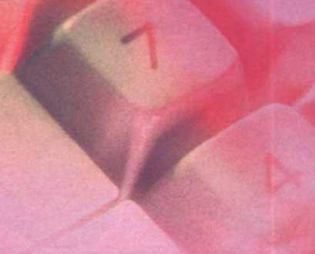

Learning objectives
In this module, you will:
- describe input and output devices.
- identiíy the different keys on a keyboard and explain their íunctions.
- distinguish between íacts and opinions in advertisements.
- learn how to understand the technical specs of digital cameras, printers and display devices.
- learn and use the superlative form of adjectives.
- practise recommending the most suitable display device for particular people.
- learn how to understand and give instructions and advice for the use of computers and monitors.
- compare different types of printer.
- learn and use discourse connectors.
- learn about what sort of input/output devices disabled people can use.

Unit5 Type, click and talk!

ìnteracting with your Computer

Read the description of input devices and then label the pictures (1-8) with words from the text.
Input devices are the pieces of hardvvare which allow interact with a Computer bỵ using One of these: a light us to enter iníormation inĩo the Computer.The most pen, a scanner, a trackball, a graphics tablet, a game common are the keyboard and the mouse. We can also controller or a microphone.
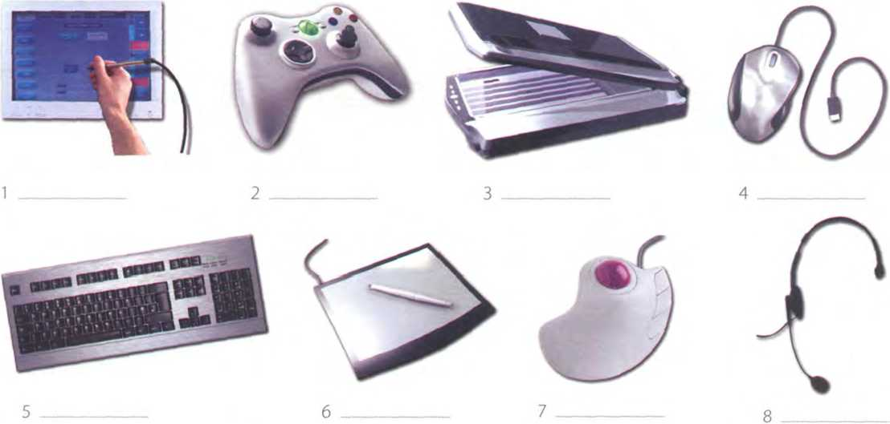

Describing input devices

Q Listen to a Computer technician describing three input devices. Write which devices he's talking about.
1 1 2 3

B £ Listen again and complete these extracts.
- This device is enter iníormation into the Computer.
- ... it may also íunction keỵs and editing keys special purposes.
- This is a device the cursor and selecting items on the screen.
- Itusually two buttons and a wheel.
- ... the User activate icons or select items and text.
- It detecting light from the Computer screen and is used by pointing it directly at
the screen display.
- It the user answer multiple-choice questions and ...

Describing functíons and features

A Look at the HELP box and then use the notes below to write a description of the Sony Playstation 3 controller.
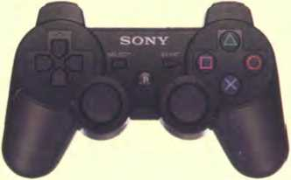

Sony Playstation 3 controller
Functions
- control video games
- hold it with both hands, use thumbs to handle directional sticks and face bu ttons
Features
- six-axis sensing System (capable of sensing motion in six directions: up, down, left, right, forwards and backwards)
- vvireless controller (Bluetooth)
- USB mini port and cable for wired play and automatic battery charging
B p In pairs, choose one of
these input devices and describe its f u nctions and íeatures. Try to guess which device your partner is describing.

HELP box
Describing functions
In the listening, the mouse was described using for + gerund:
This is a device for controlling the cursor and selecting items on the screen.
There are other ways of describing a device's function:
- used + to + infi nitive lt's used to control.
- relative pronoun + verb
This is a device which Controls ...
- relative pronoun + used + to + iníĩnitive This is a device which/that is used to control..
- work by + gerund
It works by detecting light from the Computer screen.
Describing features
We can describe íeatures like this:
An optical mouse has an optical sensor instead of a ball underneath.
It usually features two buttons and a wheel.
You can connect it to a USB port.
A vvireless mouse vvorks/operates vvithoutcables.
It allows the user to answer multiple-choice questions and...

Bar code reader
Touchpad on a portable PC
Webcam
Touch screen
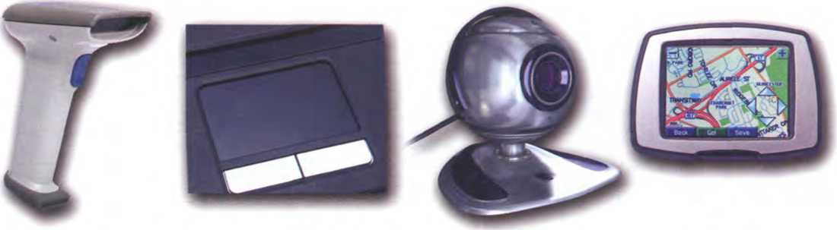

The keybocưd

Label the picture of a Standard keyboard with the groups of keys (1-5).
- Cursor control keys include arrow keỵs that move the insertion point up, down, right and left, and keỵs such as End, Home, Page Up and Page Down, which are used in word Processing to move around a long document.
- Alphanumeric keys represent letters and numbers, as arranged on a typewriter.
- Function keys appear at the top of the keỵboard and can be programmed to do special tasks.
- Dedicated keys are used to issue commands or to produce alternative characters, e.g. the Ctrl key or the Alt key.
- A numeric keypad appears to the right of the main keỵboard. The Num Lock keỵ is used to switch from numbers to editing keỵs.

b
a
/
Num Cjps Sen* / lock Lock Lock /
BgKHỊ^gÈMnnnnBn DDg BnnáH
aaaa naan DDDD

A PC-compơtible keyboơrd
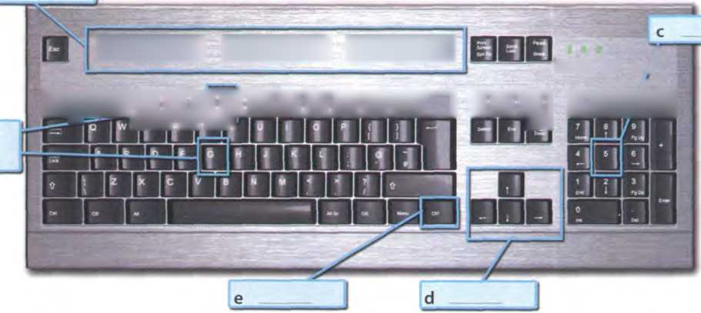

a arrrovv keys b return/enter c Caps Lock d shift e tab f space bar g backspace h Ctrl

Match the descriptions (1-8) with the names of the keys (a-h).Then fĩnd them on the keyboard.
- A long keỵ at the bottom of the keỵboard. Each time it is pressed, it produces a blank space.
- It moves the cursor to the beginning of a new line. It is also used to coníìrm commands.
- It works in combination with other keys. For example, you press this key and c to copy the selected text.
- It removes the character to the left of the cursor or anỵ selected text.
- It produces UPPER CASE characters.
- It produces UPPER CASE letters, but it does not affect numbers and sỵmbols.
- It moves the cursor horizontally to the right for a tixed number of spaces (in tabulations and data íìelds).
- They are used to move the cursor, as an alternative to the mouse.

Mouse actions

Complete this text about the mouse with verbs from the box.
click double-click drag grab select move control
Mouse actions
IA mouse allows ỵou to (1)the cursor and move around the screen very quickly. Making the same movements with the arrow keys on the keyboard would take much longer. As ỵou (2) the mouse on ỵour desk, the pointer on the screen moves in the same direction. The pointer usually looks like an l-bar, an arrow, or a pointing hand, depending on what you are doing.
A mouse has one or more buttons to communicate with the Computer. For example, if ỵou want to place thè insertion point or choose a menu option, ỵou just (3) (press and release) on the mouse
button, and the option is chosen.
The mouse is also used to (4)text and
items on the screen. You can highlight text to be deleted, copied or edited in some way.
The mouse is widely used in graphics and design. When you want to move an image, you position the pointer on the object you want to move, press the mouse button, and (5)the image to a new location on the screen. Similarly, the mouse is used to change the shape of a graphic object. For example, if you want to convert a square into a rectangle, you (6) one corner of the square and stretch it into a rectangle.
The mouse is also used to start a program or open a document: you put the pointer on the file name and (7)on the name - that is, ỵou rapidlỵ press and release the mouse button twice.

6oop. NoW, SAT THE AAOQSe
ooẽ^ The C*T fooÕ PiSH \co\>
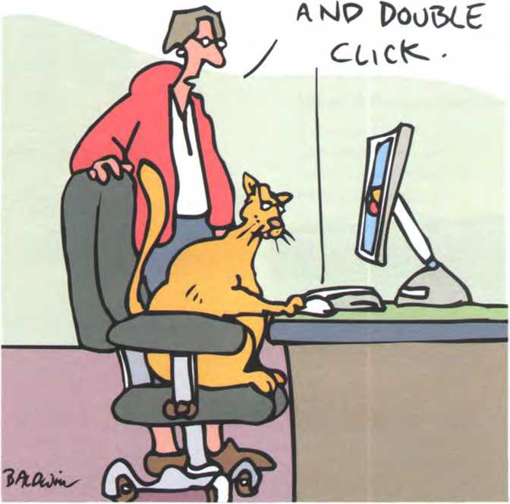
www.CartoonStock.com


Speech recognition Systems
You talk, it types - speech recognition $oftware lets you operate computers by voice commơnd

£ Listen to an interview with Anne Simpson, an expert in voice input technologies and tick (✓) the features she mentions.
speech recognition Systems:
Q need a good sound card and a microphone.
□ can take dictation with accuracy.
□ allow you to create and compile a Computer program.
□ allow you to execute programs and navigate around menus using voice commands.
Q allow you to surf the Web by speaking.
□ allow you to design graphics.

B M Listen again and answer these questions.
- What do people usually use to communicate with a Computer?
- How do you get the best results from speech rềcognition software?
- What rate of accuracy is possible with the software?
- How can ỵou train the software to be more accurate?
- What kinds of words aren't in the software's dictionary?

In groups, discuss these questions.
What are the benehts of speech recognition software?
What kind of tasks would ỵou find speech recognition useful for?
Who would beneíit most from advances in speech recognition technology?

What is the íuture of this kind of technology? Do you think it will ever be possible to control ỵour Computer using onlỵ ỵour thoughts?
4
1
2
3

Unit 6 Capture your favourite image

The eyes ofyour Computer

A In pairs, discuss how many ways there are of capturing an image on a

Computer.

B Read the text and see how many things from your list are mentioned. Read the text again and answer these questions.
- Which device is used to input text and graphic images from a printed page?
- How does a scanner send iníormation to the Computer?
- How do digital cameras store photographs?
- What íeature allows mobile phone users to take pictures?
- Which device would you use to take digital video?
- What kind of software is used to manipulate video clips on the Computer?
The eyes of your Computer
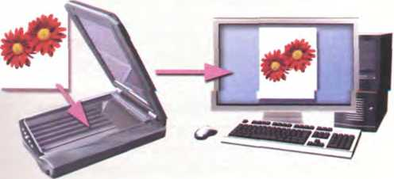
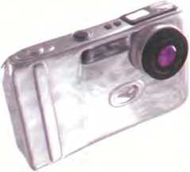
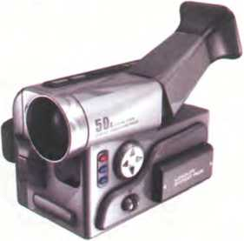

What does a scanner do?
A scanner'sees'images and converts the printed text or pictures into electronic codes that can be understood by the Computer. With a fìatbed colour scanner, the paper with the image is placed face down on a glass screen, as with a photocopier. Beneath the glass are the lighting and measurement devices. Once the scanner is activated, it reads the image as a series of dots and then generates the digitized image that is sent to the Computer and stored as a file.
The scanner operates bỵ using three rotating lamps, each of which has a different coloured filter: red, green and blue.The resulting three separate images are combined into one bỵ appropriate software.

What does a digital camera do?
Adigital camera takes photos electronicallỵ and converts them into digital data (binarỵ codes made up of 1 s and Os). It doesn't use the film found in a traditional camera; instead it has a special light-sensitive Silicon chip.
Photographs are stored in the camera's memorỵ card before being sent to the Computer. Some cameras can also be connected to a printer oraTV set to make viewing images easier. This is usually the case with camera phones - mobile phones with a built-in camera.

What does a camcorder do?
A camcorder, or digital video camera, records moving pictures and converts them into digital data that can be stored and edited bỵ a Computer with special video editing software.
Digital video cameras are used by home users to create íteMíi? Oíe>^{r}, ữ^^ữtoiiaĩdì^ liĩ Computer art and video coníerencing.
Theỵ are also used to send live video images Via the Internet. In this case they are called vveb cameras, or vvebcams.

Scanners


Listen to a conversation between Vicky Cameron, an Iníormation Technology

(IT) lecturer, and one of her students, and complete the student's notes.
The Lechnology used Ln scanners Ls slcndar Lo LhaL osed Ln a
TLe scanned Lcnoge Ls SenL Lo Lhe , ushere gOu can manlpulaLe CL. Tò scan LexL, gOu need SpecLal soíLcoare called RaLbed scanners can scan
Ahandheld scanner íorscanning text, bar codes and handwritten numbers
or Rim negaLCveS.
s Sli.de scanners are used Lo scan
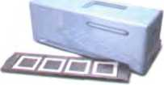
Co HandLeld scanners are osed Toe capLurCng
Aslidescanner

Facts and opinions

What is the difference between facts and opinions? Complete these dehnitions.
- are real, objective information.
- usuallỵ include emotive words and subjective statements.

Read these advertisements and underline the íacts and ícircle the opinions.

ColourScan XR
from Sunrise
The ColourScan XR from Sunrise is a flatbed scanner with 1,200 dots per inch (dpi) of resolution and 9"x15" of scanning area.
Just think of the possibilities.
You can enter data and graphic images directly into your applications (word processors or databases). You can get crisp, clean scans for colour compositions, video and animation work.
The ColourScan XR comes complete with its own image-capture software, which allows for colour and grey retouching. And it's easy to use. What more could you want for only £79? It couldn't be cheaper.
In the field of ílatbeds, the ColourScan XR is the clear winner.

StanPress DF
The ScanPress DF is a self-calibrating Aatbed scanner with 2,400 dpi of resolution.You can scan everything from black and white to 24-bit colour. The package includes a hardware accelerator for JPEG compression and decompression. JPEG technology saves disk space by compressing images by up to 50 to 1.
In creating the ScanPress DF, we have chosen the most advanced technology to give you the best scans with the least effort. It produces images with high colour definition and sharpness. And it comes with OCR software and Adobe Photoshop, so you can manipulate all the iniages you capture.
The ScanPress DF is a íantastic machine that you will love working with. And at only ,£309, an excellent investment.

4
HELP box
Superlatives
- We form the superlative of one- syllable and most two-sỹllable adjectives by adding -est.
cheap —I► the cheơpest clever —► the cleverest
- Some two-syllable adjectives (including those ending in -ing, -ed. -ful and -less) form the superlative with the most/least
advanced —► the mostadvanced
- Adjectives with three or more syllables also take the most/least.
fơntơstic —► the most íantastic powerful —► the least powerful
- But two syllable adjectives ending in -y (for example, noisy) take -est and theychanges toi.
noisy —► the noisiest
- Note the irregular forms:
good —► the best bad —► the worst little —► the least
(with amounts, notsize)
In small groups, compare your answers and decide about the following.
1 Which text uses more persuasive language?
2 Which text is more íactual or objective?

Language work: superlatíves
Apart from catchy slogans and other persuasive techniques, advertisements often use the superlative form of adjectives and adverbs. Read the following examples from advertisements for input devices. What can you say from these examples about how superlatives are formed? Look at the HELP box to check your answers.
- We have chosen the most advanced technology ...
- The fastest personal scanner...
- The most revolutionarỵ Computer peripheral...
- The best scans with the least effort...
Complete these sentences with the superlative form of the adjectives in brackets.
- Alwaỵs buy the (fast) scanner with the (high) resolution you can afford.
- They have created the (revolutionary) camera to date.
- FotoFinish is the (easy) photo editing software for ỵour digital camera.
- This scanner gives you the (good) scans with the (little)effort.
- Our university has bought the (modern) Computer equipment.
' ; In pairs, discuss who or what you think is:
- the most difficult Computer game you’ve ever played.
- the most exciting him you've ever seen.
- the íunniest programme on TV.
- the most dangerous Computer virus.
- the best blogger or webmaster on the Web.
- the most popular web browser.

Language work: suffixes
HELPbox
Suffixes
A Lookat the HELP box and then use suitable suffìxes to make adjectives or nouns from these words. In some cases, you can make more than one word. Use a dictionary to help you.
1
2
3
4
5
6
7
colour proíession photograph wire
blur innovate underexpose
B
Complete these sentences with the word
in brackets and one of these noun suffíxes: -tíon, -er, -ing, -logy, -ness. Use a dictionary to help you.
1
2
Kodak is a (manuíacture) equipment.
To avoid red eỵes, use the camera's red eỵe (reduce) íeature.
- Suffixes change the class of the root word. For example, by adding the suffĩx -al, the noun digit is changed into the adjective digital. Suffixes can help ỵou tell if a word is a noun, an adjective or a verb.
Common adjectival suffĩxes are: -y, -able, -ible, -ive, -al, -ed, -ful, -ic, -less, -ing
Common noun suffìxes are: -er, -or, -ion, -tion, -ation, -ment, -ness, -ity, -ant, - logy, -ing, -y, -ure, -sion
- When using suffixes, always check in your dictionary to see if ỵou need to change any other letters.
scan —► scanner (double n)
of photographic and imaging
- (Crop)a photograph means cutting out the parts of an image you don't need.
- The (Sharp)of a photograph is a combination of resolution and acutance - the ability to represent clear edges.
- Digital (techno)is evolving so rapidlỵ that some cameras have a resolution of 12 megapixels - that's 12 million pixels.
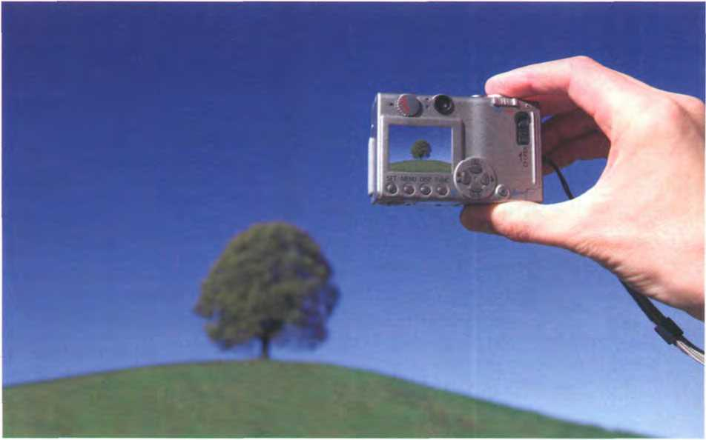


Press release: a digital camera

Complete the press release with words from the box.
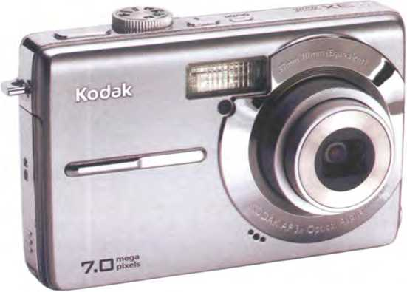
colour megapixels shot video optical brighter reduction
Kodak has introduced the EasyShare M753 digital camera, vvith 7.0 (1)resolution, a huge 2.5-inch LCD screen, and a protessional 3x (2)zoom lens. It is the tirst camera to incorporate proprietary Kodak Pertect Touch Technology. • At the touch of a button, this innovative teature creates better, (3)
pictures by bringing out detail in shadovvs without attecting
lighter areas. It’s ideal for underexposed pictures caused by shooting beyond the ílash range or in adverse lighting conditions.
The M753 uses the exclusive Kodak Colour Science chip for phenomenal image quality with rích (4)and accurate skin tones. Seventeen programmed scene modes (e.g. party, fireworks, children) and five colour modes (high, low, natural, sepia, and black and white) help capture the best (5) with the
least ettort.
Other íeatures include cropping, auto picture rotation, digital red-eye (6), and blurry picture alert. For capturing more than just still pictures, the camera also teatures high-quality (VGA) (7)capture and playback.


Describing a camera

In pairs, describe your digital camera, webcam or video camera. Think about

these questions.
- What do ỵou use the device for?
- Why did you buy that particular make/model?
- Whatareỵourfavouritefunctions?
- What improvements would you make to the device?
Display screens and ergonomics
Unit 7

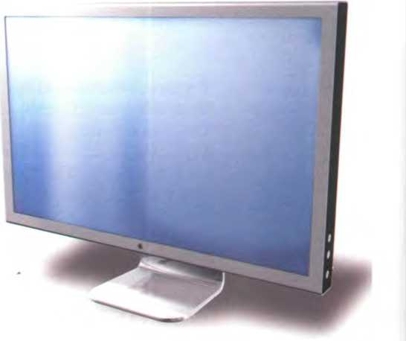
Your Computer screen
In pairs, discuss these
questions.
- What type of displaỵ do ỵou have: a cathode ray tube or an LCD flat screen?
- What size is the screen?
- How can you change the picture using the Controls?
- Can you watch TV on your PC monitor?
An Apple Mũc flat
screen monitor

Howscreen displays work

Complete these definitions with words from the box.Then read the text on page 33 and check your answers.
resolution pixel aspect ratio colour depth video adapter plasma screen
- - the smallest unit on a display screen or bitmapped image (usually a coloured dot)
- - an expansion card that generates the video signal sent to a Computer display
- - the vvidth of the screen in proportion to its height
- - also called gơs discharge display
- - the number of pixels contained in a displaỵ, horizontally and vertically
- - the number of bits used to hold a colour pixel; this determines the maximum number of colours that can be displayed

Read the text again and answer these questions.
- What do CRT and LCD stand for?
- How is the screen size measured?
- What technology is used by active-matrix LCDs?
- Which unit of írequency is used to measure the brightness of a display?
- What substance produces light and colour when hít by electrons in a CRT monitor?
- What are the three advantages of OLED displays?
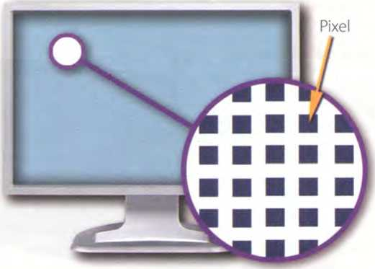
Displays, often called monitors or screens, are the most-used output device on a Computer. They provide instant feedback bỵ showing you text and graphic images as ỵou work or play.
Most desktop displays use Liquid Crystal Display (LCD) or Cathode Ray Tube (CRT) technology, while nearly all portable computing devices, such as laptops, incorporate LCDs. Because of their slimmer design and lower energy consumption, LCD monitors (also called flat panel or flat screen displays) are replacing CRTs.

Basic íeatures
Resolution reíers to the number of dots of colour, known as pixels (picture elements), contained in a display. It is expressed by identiíying the number of pixels on the horizontal and vertical axes. A typical resolution is 1024x768.
4 pixel is ơ combinatìon ofred, green and blue subpixels
Two measurements describe the size ofyour display: the aspect ratio and the screen size. Historically, Computer displaỵs, like most televisions, have had an aspect ratio of 4:3 - the width of the screen to the height is four to three. For widescreen LCD displays, the aspect ratio is 16:9, verỵ useful for viewing DVD movies, plaỵing games and displaỵing multiple windows side by side. High- dehnition TV also uses this íormat. The viewable screen size is measured diagonally, so a 19"screen measures 19" from the top left to the bottom right.
Inside the Computer there is a video adapter, or graphics card, which processes images and sends signals to the monitor. CRT monitors use a VGA video graphics adapter) cable, which converts digital signals into analogue signals. LCD monitors use a DVI (digital video interface) connection.
Colour depth refers to the number of colours a monitor can display. This depends on the number of bits used to describe the colour of a single pixel. For example, an old VGA monitor with an 8-bit depth can generate 256 colours and a SuperVGA with a 24-bit depth can generate 16.7 million colours. Monitors with a 32-bit depth are used in digital video, animation and video games to get certain effects.

Display technologies
An LCD is made of two glass plates with a liquid crystal material between them. The crystals block the light in different quantities to create the image. Active-matrix LCDs use TFT (thin hlm transistor) technology, in which each pixel has its own switch.The amount of light the LCD monitor produces is called brightness or luminance, measured in cd/m² (candela per square metre).
A CRT monitor is similar to a traditional TV set. It contains millions of tinỵ red, green and blue phosphor dots that glow when struck bỵ an electron beam that travels across the screen and create a visible image.
PCs can be connected to video projectors, which project the image onto a large screen. They are used for presentations and home theatre applications.
In a plasma screen, images are created by a plasma discharge which contains noble (non-harmful) gases. Plasma TVs allow for larger screens and wide viewing angles, making them ideal for movies.
Organic Light-Emitting Diodes (OLEDs) are thin-film LED displaỵs that don't require a backlight to íunction. The material emits light when stimulated by an electrical current, which is known as electroluminescence.They consume less energy, produce brighter colours and are ílexible - i.e. they can be bent and rolled up when they're not being used.
33
How screen displays work
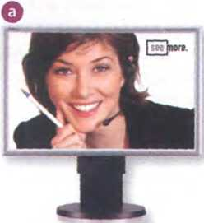
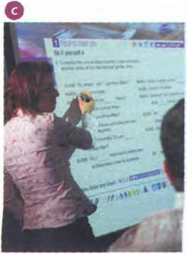
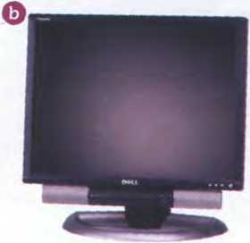
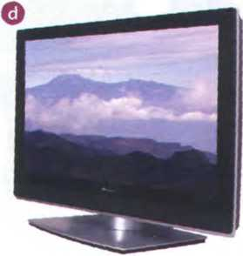
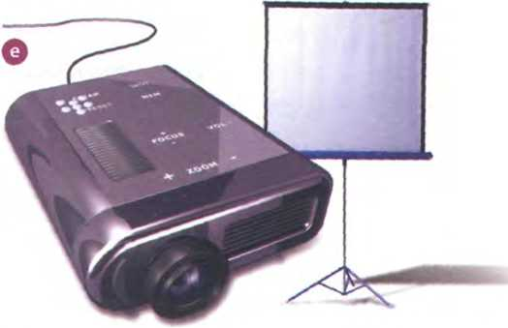
NEC MultiSyn LCD Monitor
Screen size: 17"
Resolution: 1280x1024
(SXGA)
Aspect ratio: 5:4
Brightness: 400 cd/m²
Pioneer 50" Plasma TV
Resolution: 1280x768 (XGA)
Blu-ray Disc recorder
5.1 surround sound System (Five audio channels plusone subwoofer)
Give reasons for your choice.

Choosing the right display device

Listen to five customers in a Computer shop describing their display device needs. Which device (a-e) would you recommend to each person? In pairs, discuss your choices and give reasons for them.
Speaker1 Speaker4
Speaker 2 speaker 5
speaker 3
Dell UltraSharp LCD monitor
Widescreen 24"fìat panel
Resolution: 1920x1200
Colour support: 16.7 million
Multiple video inputs, fìash- card slots and USB ports
Cambridge- Hitachi Interactive whiteboard
Allows interaction with a projected Computer image
Board size: 78"
Connected to the PC vía USB
Pointing device: cordless pen
Portable projector
DLP (Digital Light Processing) technology
Resolution: 1024x768
Projection screen

In pairs, discuss which of the display devices you would most like to own.
2 Display ureens and ergonomtcs

Ergonomics

A bij Listen to Tony Clark, an expert in Computer ergonomics, talking to some office workers about Health and safety. What health problems associated with Computer use do the office workers mention?

Listen again and complete these extracts.
1 Get a good chair, one that your lower back and is
- Ma ke su re ỵour feet rest íìrmlỵ or on a footrest.
- Position the keỵboard your elbows, with your arms
:. the worksuríace ...
- ... position the monitor at, or just below,
- You should sit at from the front of the monitor, about 50 to 70
centimetres away.
- ... a kind of stand that letsyou movethe monitor , soyou can useit
at the correct angle and height'.

Match the extracts above (1-6) with the correct parts of the diagram (a-f).
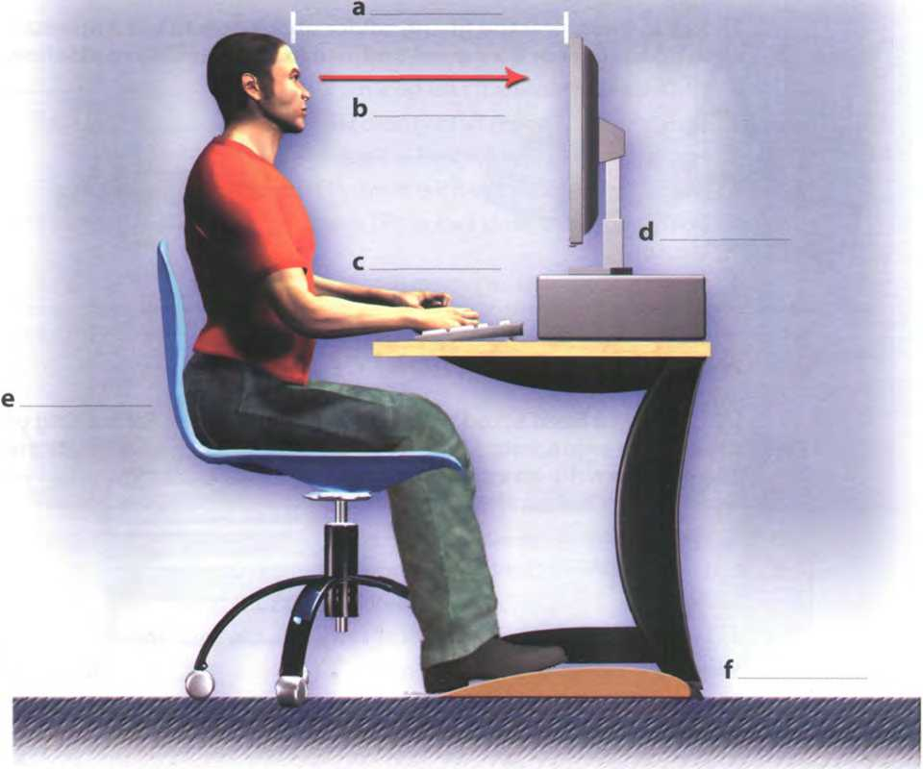
Ergonomics - the study ofhow people interact safely and efficiently with machines and their work conditions


Language work: ìnstructions and advice
Look at the HELP box and then complete these health and safety guidelines with should/shouldn't.
- lf ỵou type a lot at your Computer each day, you buỵ an ergonomic
keyboard; it can help reduce the risk of repetitive strain injurỵ.
- You place ỵour mouse
within easy reach and support your íorearm.
- lf you decide to build ỵour own PC, protect yourselí from electric shocks. You touch any components unnecessarilỵ.
- You always use a
copyholder if ỵou are working from
HELP box
Instructions and advice
- We use the imperative to give instructions.
Get ơn ũdju$tơble chơir.
Don't putyour monitor in frontofa window.
- We use should and shouldn't + iníinitive to give advice or to talk about what we think is a good or bad idea.
You should look down ơt the monitor, not up.
You shouldn't use ũ monitor thads fuzzy or distorts the image.
- We can also give advice by using set phrases like lt's a good idea to or lt's a bad idea to + inhnitive.
It's a good idea to have a monitor vvith a ti/t- and-swivel stand.
documents.The best position is betvveen the screen and the keyboard, or at the same height as
the screen; this can reduce neck, back and eyestrain.
5 Irresponsible disposal of electronic waste can cause severe environmental and health problems. You just throw your old monitor or video System into the bin.
^I In pairs, practise giving advice about how to use a monitor safely using should/shouldn't or lt's a good/bad idea to. Look at these guidelines for help.
- Don't open the monitor. It's dangerous.
- Don't stare at the screen for long periods of time.
- Position the monitor at eye level or just below.
- Leave enough space behind the monitor for unobstructed movement.
- Don't sít near the sides or back of CRT monitors. Use LCD screens instead - they're free from radiation.
- Keep the screen clean to prevent distorting shadows.

An ergonomic school or offíce
tia You have been asked to write a list of guidelines for making your school or office more ergonomic. Look at the dehnition of ergonomics at the bottom of page 35 and then write an email to your teacher/manager explaining your guidelines.
Consider 1-8 below.
- Physical layout of the work site: desk areas, Computer equipment, fìling cabinets, etc.
- Lighting (overhead lights, desk lamps), glare and ventilation
- Computer and office furniture: ergonomic chairs and desks
- User-friendlỵ and ergonomic devices: keỵboards, mice, monitors, wrist rests, copyholders, etc.
- Location and íeatures of telephones
- Layout of cables and switches for a wired network
- Wireless internet access and wireless network
- Maintenance and technical repairs


nít8 Choosing a printer

Types oỉprinter

How many types of printer can you think of? Make a list.

Read the article on page 38 and then label the types of printer (1-5). Which types of printer aren't pictured?

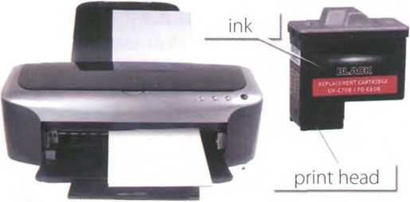

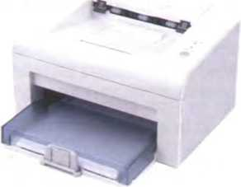
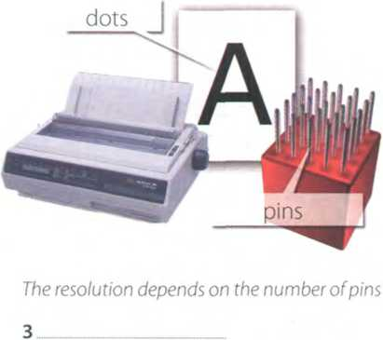
1
The quality (resolution) oíthe images goes up to 2,400 dots per inch (dpi)
Provides high quality output: a resolution of 1,200-2,400 dpi
2

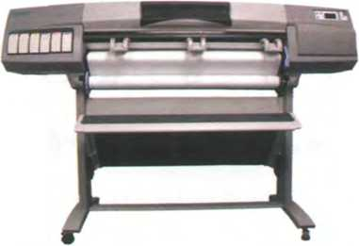
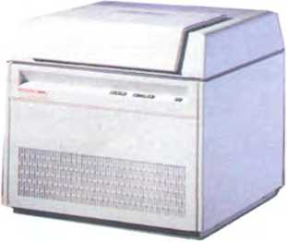

Provides high quality for linework (lines and curves)
Provides the highest resolution: more than 3,000 dpi



WHICH TYPE OF i^Ễsỉĩừsh SHOULD I BUY?
Printing is the final stage in creating a document. Since the results you can obtain with different types of printer \vill vary substantially, here is a guide to help you decide which one is most suitable for your needs.
5 To hegin u/ith, you should take into account that printers vary in cost, speed, print quality, and other factors ÍUCỈỈ as noise or printing method. Technology is evolving so quickly that there is always a printer for every application or need.
Dot-matrix printers use pins to print the dots required to shape a character. They can print text and graphics; however, they produce relatively low resolution output - 72 to 180 dots per inch (dpi).They are useđ to print multi-part forms, self-copying paper 15 and continuous-form labels.They are slower than laser printers (see below) but much cheaper.
Inkjet printers operate by projecting small ink droplets onto paper to form the required image. Colour and hues are created by the precise mixing 20 of cyan, magenta, yellow and black inks. Inkjets are fairly fast, quiet, and not as expensive as laser printers. Nevertheless, you can still expect high quality resnlts because there are some inkjet printers on the market with a resolution of 2,400 dpi.
Laser printers produce output at great speed and with a very high resolution of 1,200—2,400 dpi. They scan the image \vith a laser beam and transíer it to paper with a special ink powder called toner. They are constantly being improved. In terms of speed and image quality, laser printers are preferred by experts for various reasons; /ôr instance, they have a wider range of scalable fonts than inkjets, can emulate different language Systems, and can produce high- quality graphics; hovvever, they are still expensive for home users.
Thermal transfer printers are used to produce colour images by transíerring a wax-based ink onto the paper.They are popular for printing bar codes, labels and medium-resolution graphics.
Imagesetters produce very high-resolution output (tip to 3,540 dpi) on paper or on the actual film for making the printing plates. In addition, they are extremely fast. Imagesetters are most often used in desktop publishing (DTP). Although they produce the highest quality output, they have one important disadvantage: they are too expensive for homes or small oíĩìces.
In modern lithographic printing, images are created on a DTP Computer and then output directly to the printing plates, without requiring ftlm as an intermediate step.This technology is called Computer to plate, or CTP, and the machine used is called a platesetter.
Finally, we have plotters. Plotters use ink and fine pens held in a carriage to draw very detailed designs on paper. They are used for construction plans, engineering drawings and other technical illustrations. Nówadays, traditional plotters are being replaced with wide-format inkịets.

Find words in the article with the following meanings.
- designs and images used in magazines, books, etc. (lines 10-15)
- output quality, measured in dots per inch (lines 10-15)
- a particular colour within the colour spectrum (lines 15-20)
- an ink powder used in laser printers and copiers (lines 25-30)
- set of characters that can be resized (enlarged or reduced) without introducing distortion (lines 30-35) __
- a rectangular pattern of black lines of magnetic ink printed on an object so that its details read by a Computer System (lines 35-40)
- suríace that carries a reproduction of the image, from which the pages are printed (lines 45-50)
8 in-between; middle (lines 50-55)

Language work: connectors 1
A Look at the HELP box and then put the words in italics from the article on page 38 into the correct column of the table.
Giving examples | Listing/Sequencing | Giving reason/cause

B Try to add some more connectors to each column. How do you say these connectors in your language?
HELP box
Connectors 1
Connectors are linking words and phrases which join ideas and help us organize our writing. Connectors can be used for giving examples, listing or sequencing, and giving reason or cause.
... forinstance, theyhavea widerrơngeof...
To begin with, you should take into ơccount that printers vary in cost...
Some common connectors appear in italics in the article on page 38. For more on other uses of connectors, see Unit 11.
c c Write a paragraph describing the printer(s) you use at home or at work.Try to use some connectors. Think about these aspects: type, speed, resolution, print quality, memory, cost, print consumables (ink cartridges etc.).

Choosing the right printer
A ^] In pairs, choose the most suitable printer for each of these situations. Give reasons for your choices.
1
2
3
4
You want to print documents, web pages and occasional photographs at home.
A small companỵ needs a printer which will be shared by various users on a local area network (LAN).
A proíessional team of architects and engineers need to create accurate representations of objects in technical drawings and CAD.
A graphic arts business needs a printer to produce catalogues, brochures and other publications.

o In pairs, describe the features of your ideal printer.
B

4 Multi-function printers
^

Listen to an extract from a consumer technology podcast about multi-function printers. What two disadvantages of multi-íunction printers are mentioned?

Listen again and answer these questions.
1 What is a multi-function printer?
2 Why are multi-function printers so popular?
3 What is the main advantage of PictBridge technology?
- Apart from sheeĩs of paper, what other things can multi-function printers print?
- What software do you usually get when you buy a multi-íunction printer?
- What advice does Mr Kelly give on ink cartridges?
- What type of device does he recommend for home users?
- What type of device does he recommend for businesses?
HELP box
Comparatives
• We form the comparative of one- syllable adjectives by adding -er.
slow —► slower
lnkjet printers are slower than laser printers, bui much cheaper.
• Two-syllable adjectives usually take more/less.

Language work: comparatives

Look at the HELP box and then complete these sentences using the comparative form of the adjective in brackets.
1 A laser printer is generally (quiet) than a low-cost inkjet printer.
2 Multi-function printers are now only slightlỵ (expensive)than * conventional printers, and offer much (great) versatility.
- The print quality of this network printer is noticeably (good) than
any inkjet, and as (good)
as similar laser prínters.
- The Agfa platesetter is (reliable) and (easy)
to use than most printers of its type.
- Your printer is onlỵas (good) as the paper you use.
- The final result is always (accurate) ....... than the original image.
- An imagesetter is (heavy) than a laser printer.
modern —► more modern
They're designing a more modern version ot the moment.
- Adjectives ending in -y (for example, noisy) take -er and the y changes to i.
Dot-matrix printers are noisier than inkjets.
- We form the comparative of adjecĩives with three or more syllables by adding more/less
versatile —► more versatile
... they're cheaper and more versatile than standalone Products.
- Note the irregular forms:
good —► better bad —► worse little —► less
lfyou want better results, you'11 need specialized software.
- Equality is expressed by using as as. Diííerence can be shown by using not as . as.
This is as fast as many other printers in its class.
Inkjets are not ơs expensive as laser printers.
ĩ choosing a printer

Ổ Reading quiz - printer adverts
In pairs, read the adverts and then answer these questions. See who in your class can fìnish first.
- How many inkjet printers are advertised?
- Which printer would you recommend to someone who wants to print advertising graphics?
- lf ỵou have the wide-format printer from Vutek, what kinds of material can you print on?
- Which technology lets ỵou print directly from your digital camera without needing a Computer in between?
- A page description language, or PDL, describes how to print the text and pictures on the page. Can you find two laser printer languages?
- What is the resolution of the Brother HL Network Colour Laser Printer?
- How fast is the Brother HL Network Colour Laser Printer?
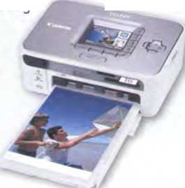
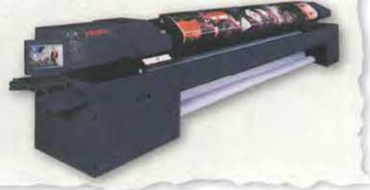
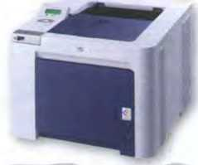
Canon Compact Photo Prìnter SELPHY CP750 Photo Prìnter
The Vutek UltraVu II5330 provides the ultimate combination of highest print speed and best print quality in a five-metre printer.
- ■ Wide-format proíessional inkjet printer
An inkjet photo printer with a 2.4" colour LCD for easy viewing, editing and printing of perfect borderLess photos. With PictBridge, you can print directly from digital cameras, memory cards or camera phones (vía IrDA or optional Bluetooth unit) without connecting to a PC.
Resolution: 300x300 dpi
Software: Easy-PhotoPrint Dimensions: 179x127.1x63 mm
Weight: 960g
- Prints on a wide variety of substrates, induding vinyl, and pressure- sensitive paper, mesh and textiles
- VUTEK Low Friction Kít allows for difficult materials to be run more easily
- Prints up to 16.4 feet (5 metres) wide
Up to 330 dpi resolution produces images that
are Sharp, crisp and consistent Prints up to 2,230 square feet (207 square metres) per hour Applications: banners, exhibition graphics, bus shelters, etc.
Brother HL Network Colour Laser Printer
The HL-4040CN delivers the pedect balance of quality, workgroup, colour A4 laser printing.
It boasts outstanding colour output: 2,400 dpi class colour printing with exceptionally crisp, high-resolution text and graphics driven by Brother's exclusive printing enhancement technologies.
Print Speed: up to 31 ppm (pages per minute) mono, 8 ppm colour (A4)
Compatibility: PCL and PostScript languages
Paper tray capacity: 250 sheets
Memory size: 64MB
High-speed USB
B A íriend has emailed you asking for advice about which printer to buy, the Canon SELPHY CP75O or the Brother HL Network Colour Laser Printer. Write an email to your friend comparing the two printers. Use the HELP box on page 40 to help you.

Unit9 Devices for the disabled

Assistíve technology

A E In pairs, look at the words in the box and use as many of them as you can to describe the photos. You will not need all the words.
adapted keyboard on-screen keyboard voice recognition System screen-pointing device screen reader
blind person motor-impaired person screen magniíier Braille printer adaptive switch touch screen
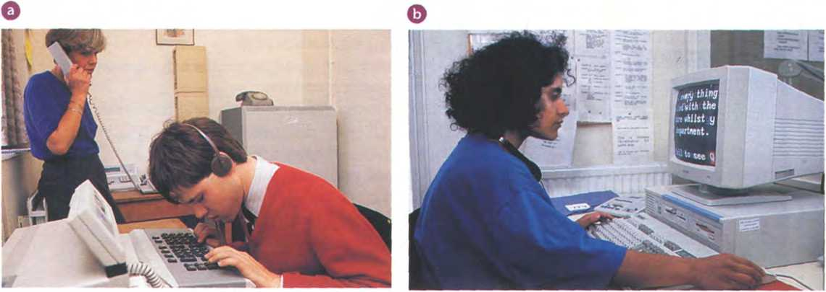
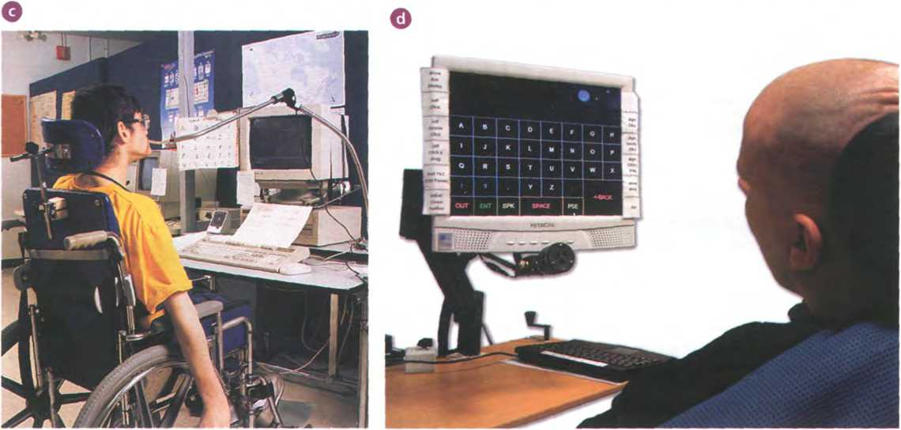
pneumatic switch (sip and puff)
Unit9

In pairs, discuss these questions.
B
1
2 3
What sort of difficulties do you think are experienced bỵ Computer users with limitations of Vision or mobility?
What types of device could be helpíul to blind users?
How can a person with mobility limitations communicate with a Computer?

Computers for the disabled

Read the text and fìnd the following.
- the laws which ensure equal opportunities for people vvith disabilities in the USA and the UK
- how the blind student in the photo interacts with the machine
- the Systems which type on the screen what is being said in meetings
- the tỵpe of software which reads printed material, recognizes the text and then sends it to the PC
- the System which is activated by the user's eye movements
- the switch which can be used by someone with quadriplegia
- the íunction ofvoice recognition devices

Computers íor the disabled
Computers have taken a dominant role in our society, meaning most jobs now require access to computers and the Internet. But what happens if a person is blind, deaí or motor-disabled? They needn't worry. The latest assistive technologỵ is designed to help them use computers and do their jobs in the office, learn at school, or interact wiĩh their íamilies at home. In addition, new laws oblige companies to adapt the vvorkplace to accommodate disabled people. For example, the Americans with Disabilities Act (ADA) and the UK's Disability Discrimination Act make it illeqal for employers to discriminate against people with disabilities.
To work effectively, most blind users need to have their computers adapted with technologies such as Braille, screen magniíiers, speech synthesis and Optical Character Recognition (OCR).
Braille keyboards have Braille lettering on keỵboard overlaỵs, allowing the blind user to easily identify each key. For output, there are printers, called Braille embossers, ĩhat produce tactile Braille symbols on both sides of a page at high speed.
For someone with limited but usable Vision, a screen magniíier may be appropriate. This tỵpe of software can enlarge text and images appearing on the screen by up to lótimes.
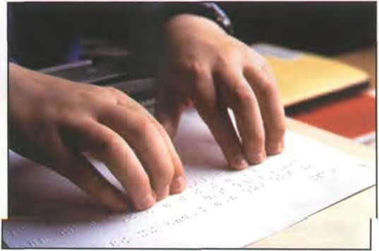
A Braille embosserprints a hard copy ofơ text document in Braille

A speech sỵnthesis System is used to read aloud the work on the Computer. It has a speech sỵnthesizer, which produces the audio output, and a screen reader - the program which reads aloud text and menus from word processors, databases and the Web.
OCR uses a flatbed scanner and specialized OCR software to read printed material and send the text to the Computer. The PC can then produce a copy ofthe text in Braille, a magniíied copỵ, or a version that can be read aloud by a speech synthesis System.
Deaf Computer users can overcome many communication difficulties with the aid of visual alerts, electronic notetakers and textphones. Visual alerts are indicators that alert the deaf user when theỵ receive new mail or when there is a System error. So instead of hearing a sound, the User is alerted by a blinking menu bar or by a message on the screen. Electronic notetakers use software that types a summary of what is said in meetings onto the Computer screen.
Textphones allow the deaí to tỵpe and read phone conversations. They are also called TDDs (Telephone Devices for the Deaf) or TTYs (TeleTypevvriters). They can be used in combination with relay Services, where an operator says what the text user types, and tỵpes what a voice phone user says. Deaf people can also communicate vía SMS and instant messaging.
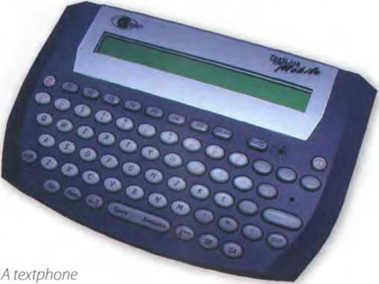

Motor-impaired vvorkers unable to tỵpe on a Standard keyboard can employ expanded or ergonomic keyboards, on-screen keyboards, adaptive switches and voice recognition Systems.
On-screen keyboards are software images of a keyboard that appear on the screen and may be activated with a trackball, touch screen, screen-pointing device, or eye movements. In an eyegaze System, the keỵs on the Virtual keỵboard are activated by the user's eỵes when theỵ pause on a key for two or three seconds.
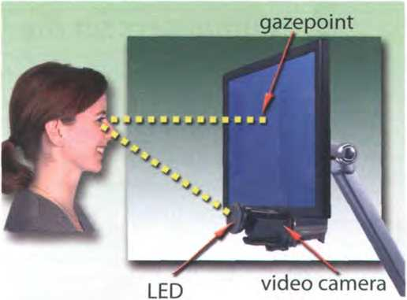

Eyegaze technology consists ofơ video cơmera and image Processing software, which determines the eye's gơzepoint on the screen
Switches come in many shapes and sizes.They are operated bỵ muscle movements or breath control. For example, a pneumatic switch - known as a sip and puff - allovvs someone with quadriplegia to control the PC by puffing and sipping air through a pneumatic tube. People with quadriplegia can also use sip and puff íoysticks.
Einally, there's voice recognition, vvhich allovvs the Computer to interpret human speech, transíorming the vvords into digitized text or instructions.

A specialized keyboard forchildren with physical disơbilities
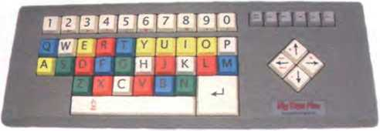

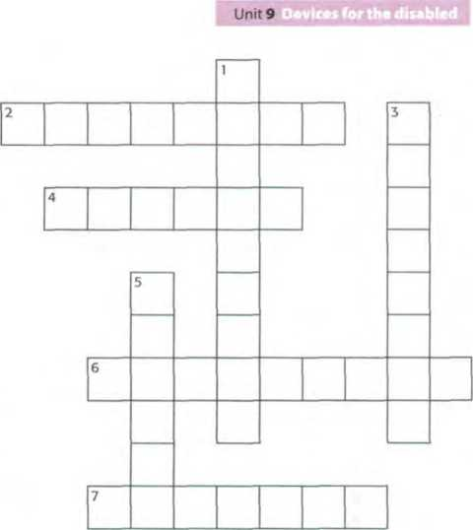

B Complete the crossword with words írom the text on pages 43-44.
ACROSS
- An keyboard presents a
graphic representation of a keỵboard on the desktop screen and allows people with mobilitỵ impairments to tỵpe data using a joystick or a pointing device.
- Visual — ailow deaf users to be notihed of incoming mail or error messages without hearing a tone.
- A screen makes the Computer
screen more readable for users with poor Vision.
- A System of reading and writing using raised dots, which enables blind people to read bỵ touch.
DOWN
- Unlike a Standard telephone, a has a
small screen and a keyboard that transcribes a spoken voice as text. It is used for text communication Via a telephone line, ideal for people who have hearing or speech difficulties.
- A Braille is an impact printer that prints
text as Braille, by punching dots onto paper.
- A speech synthesizer is used in conjunction with a screen to convert screen contents into
spoken vvords.
Look at the HELP box and then the noun phrases 1 -6. Decide what type of modiher (a-d) is placed beíore the 'head' in each case.
1 | disabled worker | a | adjective
2 | rehabilitation engineer | b | present participle
3 | employee's abilities | c | 's genitive
4 | adapted keỵboard | d | noun

HELP box

Language work: noun phrases
- voice-activated Computer
- pointing device

B Explain the noun phrases in A.
Example:
disabled worker = a worker who is disabled
Noun phrases
A noun phrase is a phrase that has a noun as its head.This noun can be accompanied by a modiher that gives iníormation about the head.
modiher head
speech recognition
compatible Computer
A noun phrase can íunction as the subject or object of a verb. It can contain the following range of modiíiers:
- adjectives
I have ơ portable Computer.
= a Computer vvhich is portable
- present participles
I use this drawing program.
= a program that draws
- 's genitive
The fí/es ơre on the director's
Computer.
= the Computer which belongs to the director
- nouns
I need to buy a colour scanner.
= a scanner which uses colour
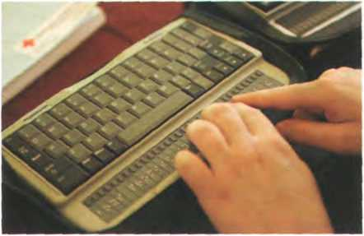
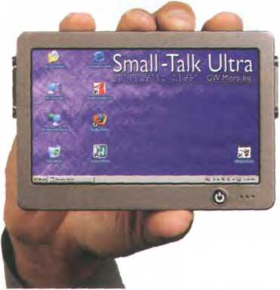
A Brơille Computer keyboơrd
Smơll-Tơlk Ulưa, a talking Computer from GW Micro, which includes Window-Eyes - ơ screen reơder for the blind

Assistive technologies for the blind
A £ Listen to an interview with Mike Hartley, the director of the Assistive Technology Project for the Blind in Washington DC. Make notes about these topics.
I TUe uxxk Chat. Múce uS currenHg Lnvo»ved un'.
- . AsstsLtve LechnotogueS toe btnd uSers
■3 The dutíerence betuoeen ựoLce recOgnut-i-On and speech SgntheScS
- - The goa' o£ the u)eb AcceSSLbúU-Ly Ini.Li_at.Lve'
- Compani.eS developung asscstuve LechnơOgg prodocts
L' . In pairs, help each other to improve your notes and then listen again to make sure you have included all of the important information.

Investing in assistive technologies
Your school/company has decided to invest some of its annual IT budget in assistive technology. Write an email to your director of studies / manager, summarizing the different technologies available and the kind of people they can help. If possible, use the Internet to find suppliers of these technologies in your countrỹ.
^ Now visit www.cambridge.org/elt/ict for an Online task.
Storage devices


page
Unit
10 Magnetic storage 48

11 Optical storage | 52
12 Flash memory | 57

Learning objectives ______________
In this module, you will:
learn about different types of magnetic drive and disk.
give instructions and advice on how to protect data.
use technical vocabulary associated with optical storage devices and media.
learn and use more discourse connectors.
learn about the technical details of flash memory and its uses.
learn different ways of making new words: affixation, conversion and compounding. describe flash-based devices.

Unit 10 Magnetic storage

Types of magnetic drive

A Look at the pictures and descriptions below and fìnd the following.
- the name of the hard drive on a PC platform
- the type of hard drive that plugs into a Socket at the back of a Computer
- the System that works in sequential format
- the size and storage capacitỵ of a floppy disk

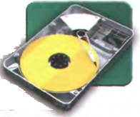
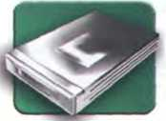
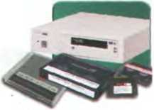
The inside of a hard drive
Most PCs have one
A portable external hard drive
External
hard drives
Magnetic tapes and drive
writes data on tapes. It is
A 3.5"
Aoppy 1
drive and 1
^{d}'^{ske}"^{e} 1
A Aoppy disk drive uses 3.5"disks, which can store 1.44MB of data; it is
usually assigned to the A: drive. Floppỵ drives are becoming increasingly rare.
internal hard drive, usually called C: drive. It is used to store the operating System, the programs and the user's files in a convenient way. A hard drive can hold hundreds
of gigabytes of data.
are connected to the USB or FireWire port of the Computer. They can be as small as a wallet but can have as much capacity as internal drives; they are typically used for backup or as secondary storage.
Atape drive reads and
sequential-access - i.e. to get to a particular point on the tape, it must go through all the preceding points.Tapes can hold hundreds of gigabytes of data and are used for data collection,
backup and archiving.

A

Sue (see Unit 4) wants to buy a new drive. Listen to her conversation with

the sales assistant. Does she buy anything?

B Complete these sentences with words from the box.
capacity storage archiving hold secondary
1 There are basically three types of magnetic device available to the Computer
user - hard drives, diskettes and tapes.
2 The ofa 3.5"fìoppydiskisonly 1.44MB.
- Hard drives can hundreds of times more data than floppy disks.
- A portable hard drive is a good choicefor storage.
- Magnetic tapes are used for information that you no longer need to use regularly.

Buying a portable hard drive


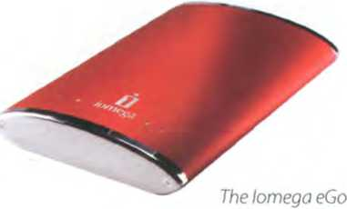
portable hard drive.

Listen again and answer these

questions.
- What is the storage capacity of the Iomega eGo portable hard drive?
- How much information can be stored on the Edge DiskGo model?
- Which hard drive is good for mobile proíessionals?
- How much does the Iomega eGo drive cost?
- How much does the Edge DiskGo cost?

Magnetic storage

A Read the text and then identify a sector and a track in Fig. 1.

B Read the text again and decide whether these sentences are true or false. Correct the false ones.
- A hard drive spins at the same speed as a íloppỵ disk drive.
- lf you format a hard drive that has files on it, the files will be deleted.
- Hard drives cannot be partitioned to run separate operating Systems on the same disk.
- Seek time and trơnster rate mean the same thing.
- Disk drives are not shock resistant, especially in operating mode.
Magnetic storage

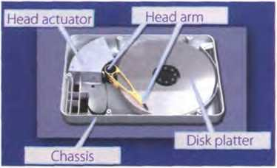

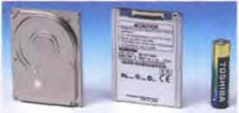
The insìde ofa hard drive
Fig. 1
Toshiba's 1.8" hard drive; mini hard drives are used in small gadgets, such as PDAs and wristwatches
Magnetic storage devices store data by magnetizing particles on a disk or tape.
A floppy disk is so called because it consists of a Aexible sheet of plastic, coated with iron oxide— a magnetizable material. A fìoppy disk drive spins at 360 revolutions per minute (rpm), so it's relatively slow. However, a hard drive spins at over 7,200 rpm and
Stores data on a stack of metal rotating disks called platters. This means ỵou can store much more data and retrieve information much faster.
New disks need to be formatted before ỵou can use them, unless they come preformatted from the manufacturer. When the disk is íormatted, the operating System (OS) organizes the disk surface into circular tracks and divides each track into sectors. The
os creates a directory which will record the specinc
location of fìles. When ỵou save a file, the os moves the read/write head of the drive towards empty sectors, records the data and writes an entry for the directory. Later on, when you open that file, the os looks for its entrỵ in the directory, moves the read/write heads to the correct sector, and reads the
file in the RAM area. However, formatting erases anỵ existing files on a disk, so do not íormat disks on which data that you don't want to lose is stored.
The os allows you to create one or more partitions on your hard drive, in effect dividing it into several logical parts. Partitions let ỵou install more than one operating System (e.g. Windows and Linux) on your Computer. You may also decide to split your hard drive because you want to store the os and programs on one partition and your data files on anoĩher; this allovvs you to reinstall the os when a problem occurs, without affecting the data partition.
The average time required for the read/ write heads to move and íĩnd data is called seek time (or access time) and it is measured in milliseconds (ms); most hard drives have a seek time of 7 to 14 ms. Don't
coníuse this with transíer rate - the average speed required to transmit data from the disk to the CPU, measured in megabytes per second.
How to protect your hard drive
- Don't hit or move the Computer while the hard drive is spinning. Hard drives are very sensitive to vibration and shocks, especially when theỵ are operating; when the read/write head touches the rotating disk, it can scratch and damage the disk surface. This is known as head crash.
- You shouldn't turn your Computer off and on quickly. Wait at least ten seconds to ensure that the drive has stopped spinning.
- Check ỵour hard drive regularly for logical and physical errors.To check and repair a drive, you can use a disk diagnosis utility like Windows ScanDisk.
- To minimize the risk of data loss or corruption, you should install an up-to-date virus scanner. You should also back up ỵour hard drive regularly.

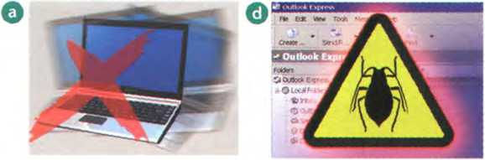
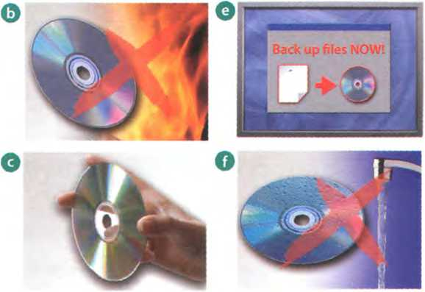
- formatted
- directory
- read/write head
- head crash
- back up
HELP box

Match these words (1-5) with the dehnitions (a-e).
a a file System that dehnes the structure for keeping track ofthe files
b the part of a drive that reads and records data on a disk
c to make a copy of data or software in case the original disk is damaged d initialized; when the tracks and sectors on magnetic disks are set e a serious disk malíunction; when the read/write head touches the rotating disk

Language work: precautìons

A Look at the HELP box and then match the instructions (1-6) with the pictures (a-f).
- Do not expose discs to heat or direct sunlight.
- Check for viruses before opening íiles you receive from the Web or vía email.
- Make backup copies of your íiles.
- Don't shake or move the Computer violently while the hard drive is spinning.
- Keep ỵour discs away írom vvater and humidity.
- Hold discs by the edges, or by one edge and the centre hole.
Precautions
- We use the imperative to give
precautions and warnings.
Check your hard drive regularly for logical ơnd physical errors.
... íormatting erases ơny existing files on a disk, so do not format disks on which data thatyou dorít wơnt to lose is stored.
- We use should + inhnitive without to to give advice or to talk about what we think is right.
... you should install an up-to- dơte virus scanner.
- We use shouldn't + inhnitive without to to give advíce or to talk about what we think is
wrong.
You shouldn't turnyour Computer offand on quickly.
B \ ;| In pairs, discuss what you should or shouldn't do to protect your data. Use the suggestions below.
Example: discs on top of each other (stack)
You shouldn't stơck discs on top ofeơch other. /Dorít stack discs on top ofeơch other.
- your anti-virus program regularly, since new viruses are created everyday (update)
- discs in a protective case (store)
- passwords and securitỵ devices to protect coníĩdential iníormation (use)
- on discs with permanent marker pens (write)
- the disc into the disc drive careíully (insert)
- Aoppies or hard drives near magnets; they can damage the data stored on them (leave)
Note: disc (optical media); disk (magnetic storage media)

Word building
Look at the words in the boxes. Are they nouns, verbs, adjectives or adverbs? Write n, V, adj or adv next to each word and then complete the sentences below. For more about word building, see Unit 12.
magnet magnetic magnetically
magnetism magnetize magnetized
1 is the Science of magnetic phenomena and properties.

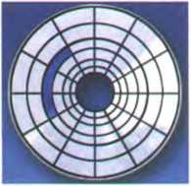
2 Floppy disks and hard drives are storage devices.
3 Data is recorded on a disk in the form of spots called bits.
íragment | íragmentation
deíragmenter | fragmented

4 After you create, delete and modiíy a lot of files, the hard drive
becomes with bits and pieces spread all over the disk.
In a íragmented disk, a file is stored in non-continuous sectors
- slows down the speed at which data is accessed because the disk drive has to work harder to find the parts of a file stored in many different locations.
- To reorganize your hard drive, you can use a disk optimizer or ; this will reorder your files into continuous clusters.
!n a dehagmented disk, a file is stored in neighbouring sectors
6

Explainỉng hard drive precautions
A friend has sent you an email explaining that she has just lost all of the information on her PC because of a head crash. Write a reply explaining the following.
- Why the head crash happened
- What precautions she should ĩake with her new PC to avoid similar problems in the íuture
- What steps she could take to back up her fĩles

Unitn Optical storage

CDs and DVDs

A In pairs, discussthesequestions.
1 What do CD and DVD stand for?
2 What is the main advantage of using DVDs instead of CDs?

B How do you say these expressions in your language?
1 optical disc
- laser beam
- backward-compatible

c pij Paul (see Unit 4) wants to buy some blank discs. Listen to his conversation

with the sales assistant and check your answers to A.
D E

Listen again and decide whether these sentences are true or false.

Correct the false ones.
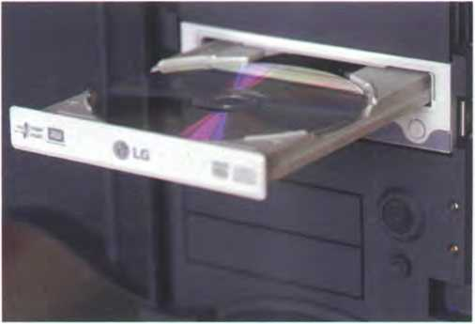
A DVD drive with disc
- A DVD is an optical digital disc that can be used for video, audio and data storage.
- The dimensions of a CD and a DVD are the same: 1.3 mm thick and 13 cm in diameter.
- The data on a DVD is read with a laser beam.
- A basic DVD can hold 3.7 gigabỵtes.
- You need a hard drive to read DVDs.
- DVD-Video discs can hold full-length movies.
- A DVD Writer is not compatible with old CD-ROMs.
Note: disc (opĩical media); disk (magnetic storage media)

Optical discs and drives
- Read the text on page 53 and fìnd the following.
- the advantages and disadvantages of optical discs over magnetic disks
- the storage capacity of a double-sided, dual laỵer DVD
- the diííerence between a DVD burner and a DVD recorder
- the íeature of a portable DVD player which allows the user to play different íormats
- two possible successors to DVDs
- where the Blu-ray format gets its name from
Optical discs and drives
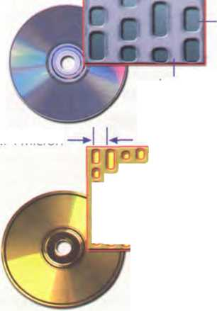
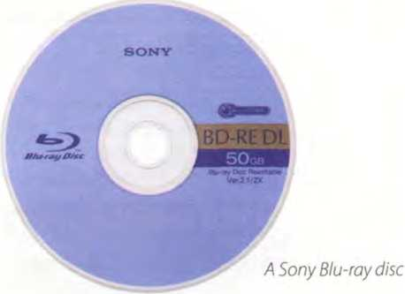
Optical discs can store data at much higher densities than magnetic disks.They are therefore ideal for multimedia applications where images, animation and sound occupỵ a lot of disc space. Furthermore, optical discs are not affected by magnetic íĩelds, meaning that they are secure and stable, and can be transported through airport metal detectors without damaging the data. However, optical drives are slower than hard drives.

CDsand DVDs
At first sight, a DVD is similar to a CD. Both discs are 120 mm in diameter and 1.2 mm thick. They also both use a laser beam to read data. However, theỵ are very different in internal structure and data capacity. In a DVD, the tracks are very close together, thus allowing more tracks.The pits in which data is stored are also smaller, so there are more pits per track. As a result, a CD can hold 650-700MB, whereas a basic DVD can hold 4.7GB. In addition, a DVD can be double-sided and dual layer, with a capacity of 17GB.
1.6 Micron —►
Close-up ofa CD
Pit (hole)
Land (flat area)
Close-up ofa DVD
0.74 Micron
_{r}rfr^rr
rprrrrrr
rrrPÒọẹC
CDs come in three different formats:
- CD-ROMs (read-only memory) are read-onlỵ units, meaning you cannot change the data stored on them (for example, a dictionary or a game).
- CD-R (recordable) discs are write-once devices which let you duplicate music CDs and other data CDs.
- CD-RW (rewritable) discs enable you to write onto them many times,just likea hard disk.
DVDs also come in several íormats:
- DVD-ROMs are used in DVD Computer drives. They allow for data archiving as well as Interactive content (for example, an encyclopedia or a movie).
- DVD-R or DVD+R can only be recorded on once.
- DVD-RW or DVD+RW discs can be erased and re- used many times. They are used to back up data files and to record audio and video.
The DVD drive used in computers is also called a DVD burner because it records information bỵ burning vía a laser to a blank DVD disc. However, a DVD recorder typically refers to a standalone unit which resembles a video cassette recorder. New DVD recorders can play all CD and DVD íormats.There are also portable DVD players - handheld devices which let you watch movies orTV, play games and listen to music, wherever you are. They come with a built-in DVD drive and vvidescreen (rectangular 16:9 format) LCD display.They usually support multi-format playback - that is, they can play many file íormats, including DVD-video, DivX, CD audio discs, MP3 music and JPEG images.

HD-DVD and Blu-ray discs
These two competing íormats are expected to replace current DVD as the Standard for vvatching movies at home. On one side are Toshiba, Microsoít and the DVD Forum, who support the High Definition-DVD (HD- DVD). Sony, Panasonic, Samsung, JVC and many movie studios are behind the Blu-ray format.
A Blu-ray disc has a capacity of 25GB (single layer), 50GB (dual layer) and 100GB (four layer). Unlike DVDs, which use a red laser to read and write data, Blu-ray uses a blue- violet laser, hence its name. Blu-ray discs can record and play back high-definition television and digital audio, as well as Computer data.
B Look at the HELP box and check your answers. How do you say these

B Read the text again and make notes about the features of CDs, DVDs and Blu- ray discs.
 | Capacity and formats | Possible uses
CD
DVD
Blu-ray

Language work: connectors 2

A Look at these extracts from the text and put the words in italics into the correct column of the table.
- Theỵ are therefore ideal for multimedia applications...
- Furthermore, optical discs are not affected bỵ magnetic íields.
- However, they are verỵ different in internal structure and data capacitỵ.
4 As a result, a CD can hold 650-700MB, whereas a basic DVD can hold 4.7GB.
- In addition, a DVD can be double-sided and dual laỵer...
Indicating addition | Making contrasts | Explaining the results or effects of something

connectors in your language?

Choose the correct word in brackets to complete these sentences.
- (Although/Consequentlỵ) CDs and DVDs are similar in size and shape, their data structure is very different.
- DVDs hold more data than CDs.The pits burnt into the disc are smaller than on a CD, and the tracks are closer together. (On the other hand / As a result), DVDs can have up to four recording layers.
- A Blu-ray disc drive costs a lot of money (buưso) you should use it careíully.
- Blu-ray is expected to replace DVD over the Corning years (because/besides) it offers much greater storage capacity.
- Both Blu-ray (and / in addition) HD-DVD devices are backward-compatible with current CDs and DVDs, meaning you can play your old discs on the new players.
- Sony has invested millions of dollars in the development of Blu-raỵ technology.The success of Blu-ray is (whereas/ thereíore) vital for the company's íuture.
HELP box
Connectors 2
In addition to the uses of connectors covered in Unit 8, we also use connectors for the following purposes:
- Indicating addition íurthermore in addition
besides moreover
and
- Making contrasts however whereas
although but
on the other hand
- Explaining the resultsor effects of something thereíore as a result
so thus
consequently because

Choosing storage devices
^{J} In pairs, look at the Products in the Computer catalogue and choose the most suitable device for the purposes (1-6). Give reasons for your choices.Try to use some connectors from the HELP box on page 54.
- to keep the operating System and the programs on a home Computer
- to watch a movie on a plane or in the back Seat of a car
- to hold your íavourite photos and music
- to make backup copies and to transport files between computers in a big company
- to hold historical records in the National Library
- to read, write and re-write high-definition video and TV

Seagate hard drive
Supertast 8ms hard drive. Capacity ranges from 80GB to 1TB.

Iomega portable hard drive
160GB, 2.5” external hard drive. An attordable way to back up all your data, from business documents to emails.

LaCie DVD drive
16x DVD writer with tree Nero DVD burning software. Can play and record both DVD+R and DVD-R discs, plus their rewritable counterparts, as well as all types of CD.

Panasonic portable DVD player
8” portable LCD DVD Player with Car Kít. Compatible with DVD-Video, CD, JPEG image CD and MP3-formatted audio CD.

Sony Blu-ray disc drive
Sony’s Vaio AR laptop is the tirst portable Blu-ray studio, which includes a Blu-ray disc drive and aTV tuner, alongside a 17” widescreen display and a 2GHz Intel Core Duo processor.

Toshiba USB tlash drive
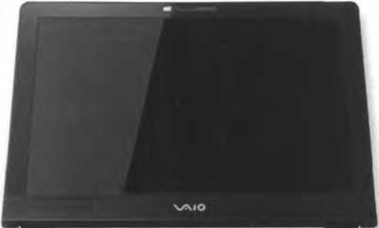
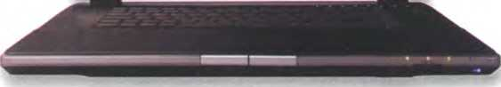
High-speed 16GB pen drive with a built-in MP3 player. Plugs directly into any USB connection.
Useful language
Sony's Vaio AR íaptop
For this use, the... is the mostappropriate because...
The... has ...so Td choose it for...
Hovvever,... isgoodfor... because...
In a big company, it vvould be a goodidea to...
Well, thatdepends on...
lagree/ldisagree.

Format wcưs

Read these posts from a forum about the topic of'Blu-ray versus HD-DVD' and
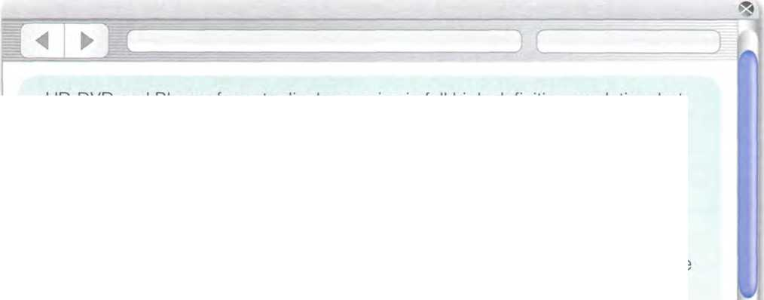
I hate íormat wars. This situation reminds me of the Beta versus VHS war in the early days of the video market, and more recently DVD-R versus DVD+R.
then add your response, giving your opinion on the topic.
Samsung and Toshiba are selling hybrid players that can play both tormats.
Sony and NEC are also releasing dual-format players. This may be the end of the tormat war. Will both sides produce a unitied Standard?
News.net, March 15th at 12:30 am
HD-DVD and Blu-ray íormats display movies in íull high-definition resolution, but they are incompatible; HD-DVD cannot play the Blu-ray discs, and vice versa. People say that Blu-ray discs can hold more data and video, but that they are more expensive and complex. Who will be the winner in this tormat battle?
Consumers ezine, March 10th at 5:40 pm
I don’t want to invest money in equipment that quickly becomes obsolete or incompatible. Why can’t someone create a universal player that plays all tormats, from CDs to high-definition video discs?
Posted by Adam, March 15th at 4:15 pm

Name:
Submit comment

Uniti2 Flash memory

Flash-based gadgets

Flash memory is used in many handheld devices. Match the descriptions (1-6) with the pictures (a-f).
- This handheld console lets ỵou play games stored on ROM game cards, which have a small amount of ílash memorỵ to save user data, for example high scores.
- This flash memorỵ card is used asdigital fiIm'to store images on a digital camera.
- This wireless LAN card allows laptop and PDA users to access the Internet from any Wi-Fi access point.
- This USB ílash pen drive is the latest mobile drive for ỵour Computer.
- It looks like an ordinary watch, but this USB drive from Edge Tech can store up to 1GB of flash memory. It will let ỵou save and transíer your photos, songs and data files easily.
- This flash-based player provides everything you need to play music and store data on the go. It also comes with a built-in FM radio and voice recorder.
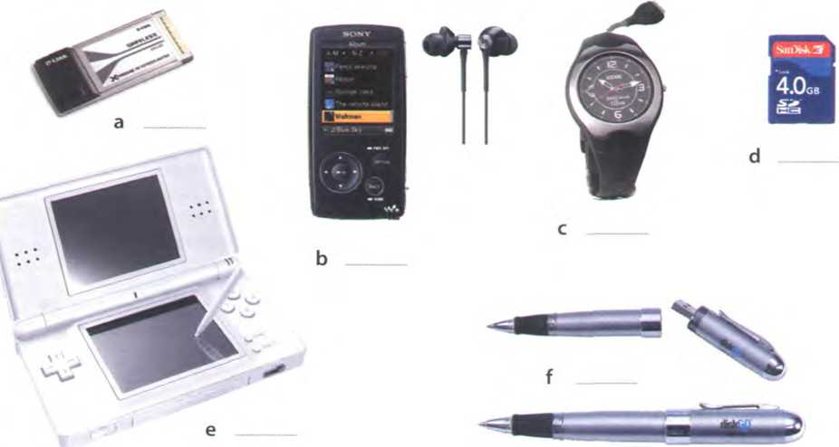

Memory in a fíash!

A Look at the title of the text on page 58. Why is it a suitable title for an article about flash memory? Read the fìrst paragraph of the text to fìnd out.

B Read the whole text and answer these questions.
- What is flash memory?
- What are the differences between RAM memory and flash memory?
- What can devices which use multi-level cell technology do?
- What are the differences between flash drives and external hard drives?
- What is the advantage of using U3 technologỵ in flash drives?
- How much data can a ílash memory card hold?
- What is the name of the ílash card created by Sony for its digital cameras?
Memory in a Aashỉ
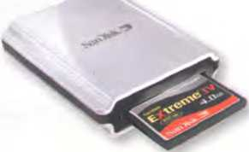
Flash memorỵ is a tỵpe of non-volatile memory that can be electronicallỵ erased and reprogrammed. Its name was invented by Toshiba to express how much íaster it could be erased - 'in a flash', which means
5 'verỵ quickly'.
Unlike RAM, which is volatile, flash memory retains the iníormation stored in the chip when the power is turned off.This makes it ideal for use in digital cameras, laptops, network switches, video game 10 cards, mobile phones and portable multimedia
players. In addition, it offers fast read access times (although not as fast as RAM), with transíer rates of 12MB per second. Unlike ROM chips, fìash memory chips are rewritable, so you can update programs Via 15 software.
Inside the chip, data is stored in several Aoating gate transistors, called cells. Each cell traditionally Stores one bít of data (1 = erased and 0 = programmed). New devices have a multi-level cell structure so
20 they can store more that One bit per cell.The chips are constructed with either NOR or NAND gates. NOR chips function like a computer's main memory, while NAND works like a hard drive. For example, in a camera, NOR flash contains the camera's internal
25 software, while NAND flash is used to store the images.
Flash memory is used in several waỵs:
- Many PCs have their BIOS (basic input/output System) stored on a ílash memory chip so it can 30 be updated if necessary.
- Modems use flash memorỵ because it allows the manuíacturer to support new protocols.
- USB ílash drives are used to save and move MP3s and other data files between computers.
35 They are more easily transported than external hard drives because they use solid-state technology, meaning that they don't have fragile moving parts that can break if dropped. However, USB flash drives have less storage
40 capacity than hard drives.
- New U3 smart drives allow users to store both applications and data. Theỵ have two drive partitions and can carry applications that run on the host Computer without requiring 45 installation.
- Flash memory cards are used to store images on cameras, to back up data on PDAs, to transíer games in video consoles, to record voice and music on MP3 players or to store
50 movies on MP4 plaỵers. Theỵ are as small as a stamp, and capacity can range from 8MB to several gigabytes. The only limitation is that flash cards are often not interchangeable between devices. Some íormats include:
55 CompactFlash, Secure Digital, MultiMedia Card, miniSD card, and xD-Picture Card. Sony has its own product called the Memory Stick, used in its digital still cameras, video camcorders and the Playstation Portable.The photos stored in a
60 digital camera can be offloaded to a Computer vía cable or wirelessly. Another option is to have a flash card reader permanentlỵ connected to your PC; you simply eject the card from the camera and put it into the reader instead of
65 having to plug the camera in.
The íuture of hard
drives may be hybrid hard drives. Hybrid hard drives 70 combine a magnetic hard disk and flash memory into one device. This allovvs computers to boot, or 75 start, more quickly, and also reduces power consumpĩion.
5anDisk's card readers reơd and write to just about every íìásh memorycơrd

Find words or phrases in the text with the following meanings.
- permanent; able to hold data vvithout power (lines 1 -5)
- able to be rewritten manỵ times (lines 10-15)
- different sections of a disk drive or storage area (lines 40-45)
- to make a copy of a íile so that the original is not lost (lines 45-50) -
- transíerred to another device (lines 60-65)
- a peripheral device that reads ard writes flash memory cards (lines 60-65)
- a product that integrates two different technologies (lines 65-70) — -

Language work: word building

A Look at the HELP box and then, using athxation, conversion and compounding,

try to make as many words as you can from blog, mai/and print. Use a dictionary and the Internet to help you.
blog | mail | print
blogger(d person who writes a blog) | to mail (the verb form) | printout (the pages produced by the printer)

B Choose the correct word in brackets to complete this description of a digital voice recorder. Use a dictionary to help you.
Olympus WS-320M digital voice recorder
Slim, attractive, and highly functional, the Olympus WS-32OM digital voice recorder packs 1GB of internal flash memory into its 1 (lighted/lightweight/lighten) housing, letting you record up to 277 hours of high-quality audio in WMA
HELP box
format. It's ideal for 2 (record/recordable/recording)
notes or long lectures, interviewing people, or capturing song ideas beíore they disappear. As an added bõnus, the WS-320M can store up to 266 WMA or MP3 songs for high-quality stereo 3 (player/ playback/playoff).
The WS-32OM features five separate file 4 (folds/ folding/folders), capable of holding 199 fìles each, so you can organize nearly 1,000 files by subject, theme or other category. Users also have the choice of four recording modes: HQ for high-quality audio, LP and SP for extended recording times, and ST HQ for stereo recording. And thanks to the voice 5 (activation/activate/active) option, users don't need to press a single button to start recording - the WS-320M will record as soon as the built-in microphone picks up sound.
Perhaps the most convenient íeature, however, is the built-in USB 6 (connector/connect/connected), which eliminates the need for a USB cable. Once this is connected, you can 7 (downloadable/download/ upload) music íìles, images or documents from your PC, in effect turning the recorder into a small hard drive. You can even transfer voice recordings to your Computer for 8 (store/storage/storeroom) or multimedia use.
Word building
We can create new words from existing words in three main waỵs:
- Affixation (adding a prefìx or suffix)
Adding a prefix: volatile —► non-volatile date —► update
Adding a suffix:
erase —► erasable install —► instollation
- Conversion (turning a noun into a verb, or a verb into a noun, etc.)
netvvork (noun) —► to network (verb)
We netvvorked all the PCs in the office.
We created (J network ofall the PCs in the ofíice.
- Compounding (putting two or more words together) hand + held —► hondheld
I bought a new handheld last week.
Compounds can be written as two separate words (ílash card), as two words joined with a hyphen (solid- state), or as one word (handheld). Uníortunately, there are no rules, and some compounds even change spelling over time. For example, web site began as two words, then became hyphenated (web-site) and is now written as one word - website. Always check ỵour dictionary or Google if you are not sure.
In pronunciation, compounds normally have the main stress on the first part, and the secondary stress on the second part, for example 'video ,game.
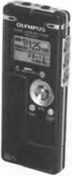

Describing flash drives

A Q Listen to a salesperson at his stand at a consumer electronics show describing two flash Products to a potential customer. Which product (a or b) is the visitor most interested in?
a The Dragon flash drive
b The Dragon MP4 player

B Q Listen again and tick (✓) which features the salesperson mentions for

each device.
Peatures
DragonAash drive
Dragon MP4 player

Back up Computer data Transport íìles between PCs Audio and video playback FM radio tuner
Voice recorder
Games

bij Listen again and answer these questions.
1 What is the storage capacity of the Dragon ílash drive?
2 How do ỵou connect it to the Computer?
3 According to the salesperson, what are the advantagcs of a USB flash drive over a DVD or an external hard drive?
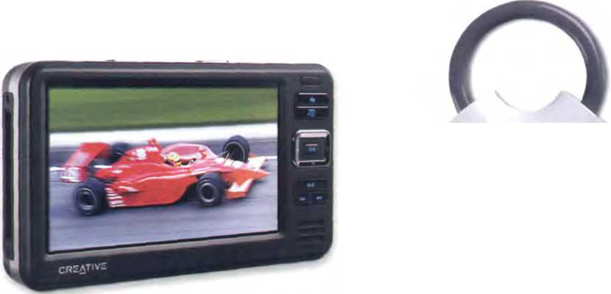
4 Some portable media players are also known as MP4 plaỵers. Whỵ?
5 What is the screen size of the Dragon MP4 player?
6 How long does the battery last?
An MP4 player USB drives ơre typicơlly designed
to ơttơch to a key ring. such as the
Cruzer Preedom USB tìash drive

0 Lsl In pairs, choose a flash-based device that you own and describe it. Use the Useful language box and the íeatures and questions from the listening text to help you.
Useful language
E E
You have received a text írom a friend at a
Computer show. Write a short reply.
Hi. At the Computer show in town. Need a new media player. What's the difference between MP3 & MP4 players? What íeatures should I Look for? Thanks!
ít has a storage capacity of...
It features... and...
It supports multiple formats: ...and...
You can ... and...
Its battery lifeis...
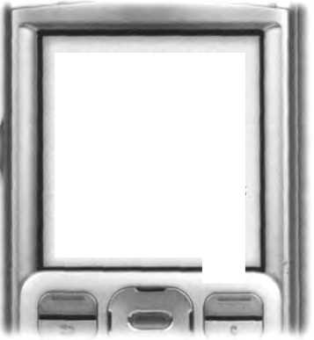
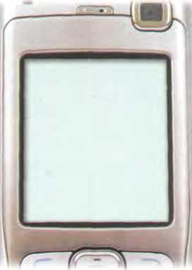

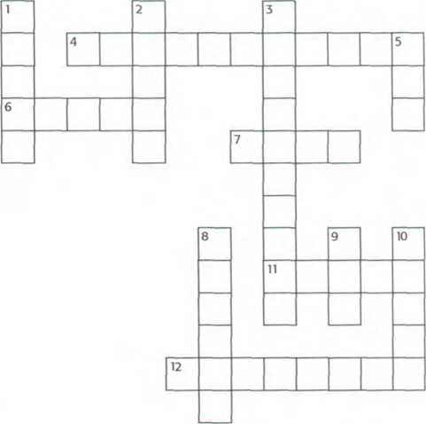
the Computer.

Vocabulary revision
Solve the clues and complete the puzzle. Look at Units 10-12 to help you.
Across
4 Thousandth of a second, abbreviated to m5, used to measure the access time of hard drives.
- Ploating gate transistors are called in flash memory technology.
- Prehx meaning very lũrge or one thousơnd million.
- Acronym for light ampliỉication bystimulơted emission oíradiơtion.
- Capable of being deleted.
Down
- Concentric ring on the suríace of a disc when the disc is íormatted.
- memory retains its data when the power is switched off.
- CD-RW means Compact Disc
- Abbreviation of digital versatile disc.
- To write iníormation on a disk or storage area.
- Type of external bus or connector that plugs ii
- The physical mechanism that accepts, reads and writes data on a disk.
- Now visit www.cambridge.org/elt/ict for an Online task.
uosoít '
p»m* ipob 1sM» ®^{nd}°*' -

Dear SimonTTT"
Basic software

Unit

13

14

15
The operating System (OS) Word Processing (WP) Spreadsheets and databases
page
63
68
73
Sales presentatĩon
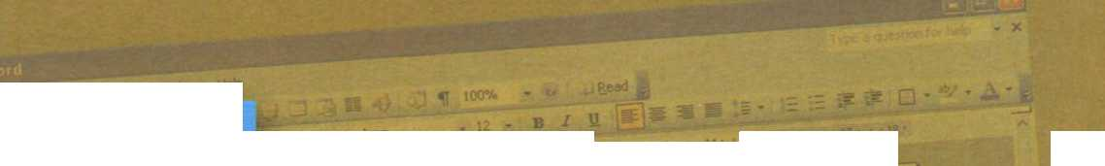


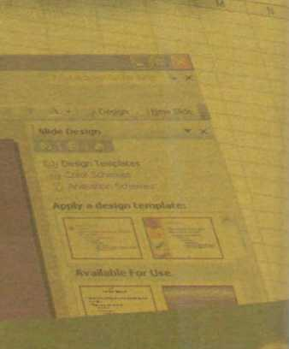



Learning objectives
In this module, you will:
learn about the íunction of the operating System.
learn about the features of a graphical User interíace, or GUI.
practise using the correct determiners with countable and uncountable nouns.
learn how to summarize a written text.
learn about the basic íeatures and applications of word processors.
learn how to give and follow instructions.
study the basic features and applications of spreadsheets and databases.
practise íorming and pronouncing plurals.
5
10
15
20
25
30
GUI operating Systems
The term user interíace reíers to the Standard procedures that the user follows in order to interact with a Computer. In the late 1970s and early 80s, the way users accessed Computer Systems was very complex.They had to memorize and type a lot of commands just to see the contents of a disk, to copy files or to respond to a single prompt. In fact, it was only experts who used computers, so there was no need for a user-friendly interíace.
In 1984, Apple produced the Macintosh, the first Computer with a mouse and a graphical user interíace (GUI). Macs were designed with one clear aim: to íacilitaĩe interaction with the Computer. A few ỵears later, Microsoh launched Windows, another operating System based on graphics and intuitive tools. Nowadays, computers are used by all kinds of people, and as a result there is a growing emphasis on accessibility and user-friendly Systems.
A GUI makes use of a WIMP environment: windows, icons, menus and pointer.The background of the screen is called the desktop, which contains labelled pictures called icons.These icons represent fĩles or íolders Double-clicking a folder opens a window which contains programs, documents, or more nested folders. When you are in a folder, you can launch a program or document by double-clicking the icon, or you can drag it to another location. When you run a program, your PC opens a window that lets ỵou work with different tools. All the programs have a high level of consistency, with similartoolbars, menu bars, buttons and dialog boxes. A modern os also
provides access to networks and allows multitasking, which means ỵou can run several programs - and do various tasks - at the same time.
35 The most popular operating Systems are:
- The Windows family - designed by Microsoít and used on most PCs.The most recent version is Windows Vista.
- Mac os - created by Apple and used on
40 Macintosh computers.
- Unix - a multi-user System, found on mainírames and workstations in corporate installations.
- Linux - open-source software developed under the GNU General Public License.This means
45 anỵbody can copy its source code, change it and distribute it. It is used in computers, appliances
' and small devices.
- Windows Mobile - used on most PDAs and smartphones (PDAs incorporating mobile
50 phones).
- Palm os - used on Palm handheld devices.
- RIM - used on BlackBerrỵ communication devices. Developed by Research In Motion.
- The Symbian os - used by some phone makers, 55 including Nokia and Siemens.
These Computer platforms differ in areas such as device installation, network connectivity or compatibility with application software.

D Translate these terms and expressions into your own language. Use a dictionary or the Internet to help you.
- User interface (line 1)
- procedures (line 2)
- commands (line 6)
- tools (line 16)
- desktop (line 21)
- nested íolders (line 25)
- launch a program (line 26)
- source code (line 45)

Label the interíace features (a-j) on the screenshot of Apple's Mac os X operating System with words in bold from this list.
- desktop: the background screen that displays icons and folders
- window: a scrollable viewing area on screen; it can contain files or folders
- icon: a picture representing an object; for example, a document, program, folder or hard drive icon
- folder: a directory that holds data, programs and other folders
- menu bar: a row of words that open up menus when selected
- drop-down (pull-down) menu: a list of options that appears below a menu item when selected
- scroll bar: a horizontal or vertical bar that is clicked and dragged in the desired direction
- dock: set of icons at the bottom of the screen that give you access to the things ỵou use most
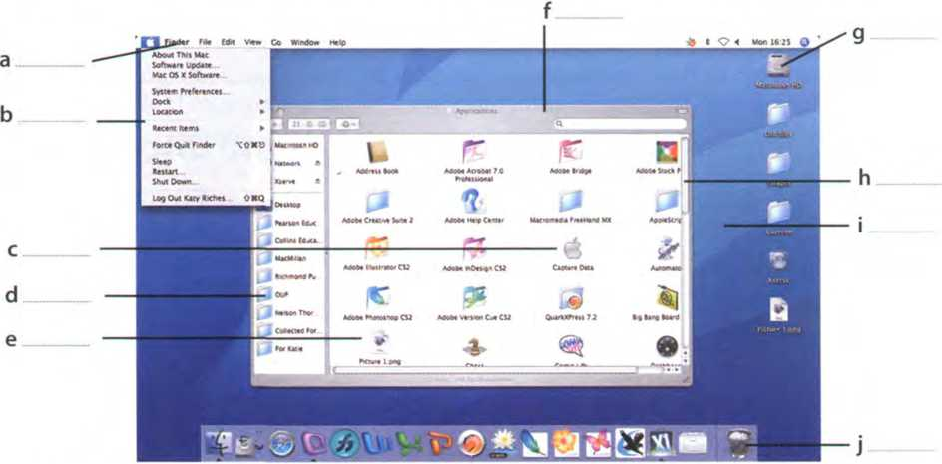


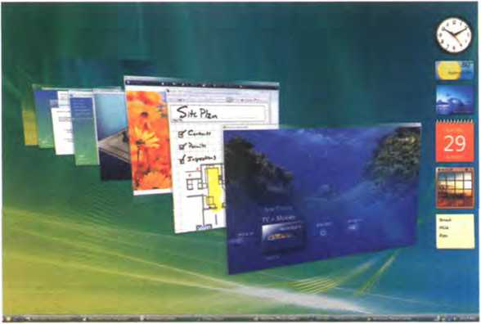
Windows Vista

. >1 Compare the Mac os X User interface with a Windows or Linux interíace. What are the similarities and differences? Which íeatures do you prefer from each interíace?

Windows Vista

Listen to a podcast interview with Bill Thompson, a program developer, and answer these questions.
- Why is Windows so popular? Give two reasons.
- Which WindowsVista edition is aimed at high-end PC users, gamers and multimedia proíessionals?

B liu Listen again and completethisfactfìle.
Windows Vista editions | Other íeatures | Internet and security | Windows programs
designed for users with basic needs, such as email and internet access.  Home Premium is for advanced home computing and (2) . __  The Business edition is ideal for(3)  The Ultimate edition is the most complete. | The User interíace has been redesigned with new icons and a new  (4).  It offers support for the latest technologies, from DVD creation to  (5) | Internet Explorer is more reliable and secure.  The Security Centre includes an (6)  program called Windows Deíender, and a firewall that protects your Computer from (7) í - - | The most popular is still (8U....„.^  a suite that includes the ^...^^.....^  Word; an email program; the Excel spreadsheet program; and the  (10)  program, PowerPoint.

Language work: countable and uncountable nouns

A Look at the HELP box and decide if these nouns from the fact fìle in 3B are countable, uncountable or either, depending on the context. Write c, u, or cand u.
User email computing
editìon entertainment interface
icon technology security spỵware
HELPbpx
Countable and uncountable nouns
- Countable nouns are people or things that we can count.They have a singular and a plural form (e.g. file, program, System, application).
- Uncountable nouns are things that we can't count. They have no plural form (e.g. software, music, robotics, multimedia, networking, storage).
A lot ofsoftware these days is open-source.
Not: A lot Oi softwares these days are open-source.
- Some words are countable in many languages but uncountable in English, and are used with a singular verb (e.g. advice, damage, equipment, íurniture, research, news, progress, homevvork).
The advice he gơve me wơs very useíul.
- Countable nouns must have a determiner (a, the, my, this, etc.) in the singular, although this is not necessarỵ in the plural.
/ deleted the file yesterday.
I lost more thơn 300 files when my Computer crơshed.
We use a before a consonant sound and an beíore a vowel.The dehnite article the means you know which one/ones I mean.
An icon is a small graphic.
The icons on the toolborare used to...
We don't use a/an with uncountable nouns.
Not:orotofa
We don't use the in generalizations with uncountable nouns or plural countable nouns.
/ like music
Not: I li ke the music.
Computer programs are expensive.
Not: The Computer programs are expensive.
Countable and uncountable nouns take different determiners.
Many, few, a few onlỵ go with countable nouns.
There are many versions of Windows Vista.
Much, little, a little, a great deal of onlỵ go with uncountable nouns.
I have a little time free this afternoon ifyou want to meet.

B Complete this text with a, an, the or nothing.
Linux is (1)
operating System and it was initially created as
(2)
hobby by a young student, Linus Torvalds, at the
University of Helsinki in Finland. Version 1.0 of the Linux Kernel
was released in 1994. (3)
Kernel, at the heart of all Linux
Systems, is developed and released under GNU General Public License, and its source code is treely available to everyone.
Apart from the íact that it’s treely distributed, (4)
Linux’s
íunctionality, adaptability and robustness has made it the main alternative for proprietary Unix and Microsott operating Systems. IBM, Hewlett-Packard and other giants of the computing world have embraced Linux and support its ongoing development. More than (5) decade after its initial release, Linux is being adopted

worldwide, primarily as (6)
server plattorm. Its use as a
home and office desktop operating System is also on the rise. The operating System can also be incorporated directly into
(7)
microchips in a process called (8)
embedding, and
it is increasingly being used this way in appliances and devices.
*The Kernel provides a way for software and other parts of the os to communicate with hardware.

Writing a summary
r Summarize the text on page 64 in 90-100 words. Follow these steps:
- Read the text again.
- Underline the relevant iníormation in each paragraph.
- Make notes about the main points. Leave out details such as examples.
- Make sentences from the notes and link the sentences with connectors (and, but, because, thereíore, etc.).
- Writeyourfirstdraft.
- Improve ỵour íĩrst draft by reducing sentences. For example:
- Cut out unnecessary phrases
Mơcs were designed with One cleơr aim: to facilitate interaction with the Computer.
- Omit qualiíying words (adjectives or modiíying adverbs) veiỵ complex
- Transíorm relative clauses into ùng participle clauses
Double-clickingơ folderopensa windowvvhichcontainsprograms, documentsor...
Double-clickinga folderopensa vvindovvcontainingprograms, documentsor...
- Write the final version of your summary. Don't forget to check the spelling and grammar.

Unit!4 Word Processing (WP)

Word Processing features

In pairs, discuss these questions.
A
- What is a word processor?
- What kind of tasks do people use word processors for?
- How manỵ different word Processing programs can ỵou name? Which do you think is the most popular?

B Look at this screenshot from Microsoft Word and translate the labelled features and functions into your own language.
Typeíace Formatting Toolbar MenuBar Increase Indent
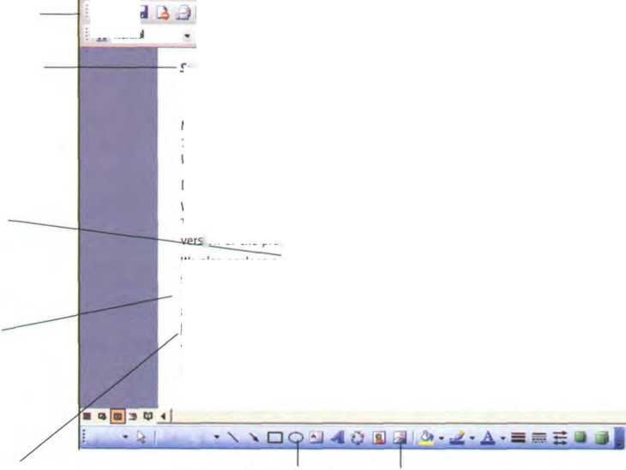
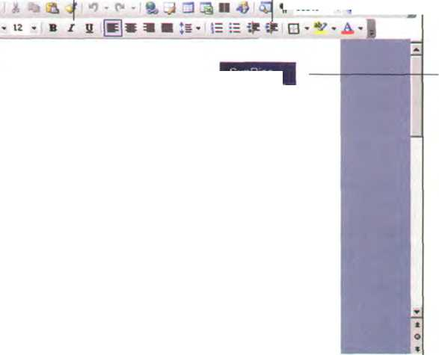
Standard
Toolbar
Italic text
Hyperlink
0e [dt Í8W insert Fữn«t look Tâbte Wnbw Help
41 Normal
Times Ne* Roman
Header
Software update
Bold text
Dravving tools
Insert picture
Mr Fred Jones
15 Callis Road
Leeds LS2 63U
Yours sincerely, Barry Stephens
Mailings
7 Union Street Glasgow G9 3TA
SunRise
Computers
Inserted picture
Dear Mr Jones,
We are pleased to intorm you that an updated version of Top Proịect is now availabte. To obtain your copy, simply call us and weĩl send you, absolutely free, the latest
Ịon of the program.
We also enclose a catalogue with the new range of SunRise machines and the latest software Products. There are special offers for all our clients, including the book The basics of budgeting and balancing your /inances. To order by phone, call 01332 8430477. To order vía the Internet, visit our website at: http://www.sunrisecomps.coiTi
T ỵp* ỏ questoo lor help « X
11 100% . «1 ^ÊNd 1
Footer

Complete these sentences with the correct features and tunctions above.
- The Standard lists the icons to save or print a document, spell check, etc. The
Toolbar is the area for changing font, alignment, indentation, etc.
- A font consists of three elements:type stỵle and type size. For example, Palatino bold at 10 points.
- Tỵpe style refers to a visual characteristic of a typeface, for example B for / for and ưfor underlined.
- lf ỵou need to change indentation - the space between the page margin and where the text aligns - you can click the Increase or Decrease buttons.
- The and commands allow you to speciíy customized texts at the
top and bottom of everỵ page.

Word Sudoku

In pairs, read the instructions and complete the puzzle.
Instructions
This Word Sudoku is a variation on the normal Sudoku. Instead of using the numbers 1 to 9, we are using words and icons. There are nine WP functions and their equivalent icons, so we are playing with nine pairs. In order to complete the grid, you can use each íunction or the equivalent icon only once in each row, each column, and in each of the 3x3 boxes.The icons can only be used in the coloured boxes.
Word Processing íunctions and icons
sr | Align Left | £ | Insert Hỵperlink
A | Print Preview | 8® | Columns
H | InsertTable | K) * | Undo
 | Drawing | fâ | Open
•••*- | Bullets

 | Drawing | Columns | Bullets |  |  | M
Align  Left |  |  | Insert  Table |  |  |  | 4r
 |  | Undo |  |  | Print Preview | B
 | Print Preview |  |  | • Mm  !**“ • »•■) |  | Insert  Hyperlink
 |  |  |  |  |  |  |  | Columns
Undo | Insert Hyperlink | Open |  |  |  |  |  | Drawing
 | H |  |  |  |  | Open | Bullets
M |  |  | Columns |  |  |  |  | Insert Hyperlink
 |  |  |  | Insert  Table | Insert Hyperlink | Drawing

The Cut and Paste technique

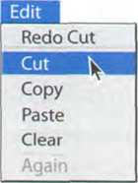



bij Listen to two íriends, Anna and Ben, talking about how to move text in Word. How many steps are involved in carrying out the Cut and Paste task?
Undo Cut
Cut
Copy
Paste

B Lã- Listen again and complete the dialogue.
Anna: Ben, do ỵou know how I can move this paragraph? I want to put it aĩ the end of this page.
Ben: Er... I think so. (1), use the mouse to select the text ỵou want
to move. (2)choose the Cut command from the Edit menu.
Anna: (3)?
Ben: Yes.The selected text disappears and goes onto the clipboard.
(4)you find where you want the text to appear and you click to position the insertion point there.
Anna: Mm, OK. Is that (5) ?
Ben: Yes, if that's where ỵou want it. (6) , choose Pơste from the Edit
menu, or hold down Ctrl and press V. (7), check that the text has appeared in the right place.
Anna: OK, l've (8) . Is that (9) ?
Ben: Yes, that's it. If you make a mistake, you can choose Undo from the Edit menu, which will reverse your last editing command.
Anna: Brilliant! Thanks a lot.
Ben: That's OK, it's mỵ pleasure.
Moving text is a process ofcutting and pasting, as ifyou were using scissors and glue
How to
edit text
Cut
How to
edit text
Paste
document in window
Clipboard
(temporary storage
inside Computer)
in window
How to
edit text

Language work: giving and following instructions

Look at the HELP box and then correct six mistakes in this dialogue.
- I need a photo for my curriculum vitae. How do I insert one into this Word document?
- Well, now choose Insert on the Menu bar.
- Asthis?
- Yes. From the Insert menu, select Picture. As you can see, this displays a drop-down menu with different options: ClipArt, From File, From Scanner, Chart, etc. Select From File and you'll get a dialog box.
- OK. I've done that now. What last?
- OK. Now I navigate your hard drive's contents and find the picture that you want to insert.
- Right. rd like to include this one.
- OK, good. Now click Insert and the photograph will be inserted into your document.
- Here it is. Is that write?
- Yes. First, right-click with the mouse and select Format Picture to adjust the size and other properties.
A: Brilliant, thanks!
Insert [ Esrmat Took Tj> Break...  PaọeNymbers... | >te ttmdow Help  ^7 ^ ’ ■ * ^ ²  B z u gw 9 ■ *
Ptctưe ► | Ã1 ƠPArt-
0 Oiagram...  Text Box ►  Me-  ó**...  Bookmark...  4 HypeẠik... Qrl+K | J EromRte...
^ From ẫcânner a Camera...
4) NewDrdwoọ
<§> ẠutoShapes
41 WordArt...
JĨ3 Qrọanaatan Chart
ik ^

HELPbox
Giving ínstructions
- To give instructions, we use the imperative form of the verb and sequence words such as first, next, then, after that, hnally, etc.
First, use the mouse to select the text.
Then choose the Cut command from the Edit menu. Next, choose Paste from the Edit menu.
Finơlly, check thơt the text has ơppeơred in the right place.
We can also use the present simple with you.
Now youhnd where you wont the text to appear and you dick to position the insertion point.
Following instructions
- lf you want to check that you have understood instructions, you can use expressions like:
Like this?
Is that right?
- lf you want to signal that ỵou are ready to move on to the next step, ỵou can use expressions like:
OK, l've done that now.
What next?
- lf you want to ask if the process is completed, you can use expressions like:
Isthat everything?
Anything else?

B Complete these instructions for how to Copy and Paste in Word with verbs from the box.
click(x2) select position right-click drag
- First,the text you wish to copy. To select text, the mouse over the
portion of the text that you want to copy.This part should then be highlighted.
- Then on the Copy icon on the Standard Toolbar. This copies the selected text to an
invisible clipboard.
- Next,the cursor where ỵou want the text to appear.
- Finally, — the Paste icon.This inserts the content of the clipboard at the insertion
point. As well as the icons on the toolbar, you can use the keys Ctd+ c for Copy, and Ctrl+Vfor Paste. These options also come up if you the selected text.
8 0 0 Find and Replace
I Write instructions for using Find and Replace based on this dialog box.
, Find ỊỊạlltt Go To ; ,
Rnd what: Computer programmer
Replace with: soféware developer I
D , Work in pairs. Student A: Give your partner instructions on Creating a document and saving it on disk. Student B: Give
0 ( Replace All ; ( Replace 7 Cancel ế Find Next '

your partner instructions on How to insert a picture from the Web into a Word document. Use words and expressions from the HELP box on page 71.

WP too/s

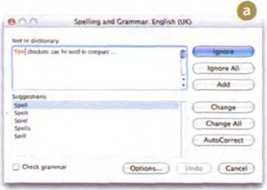
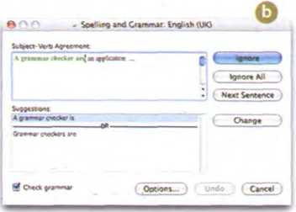
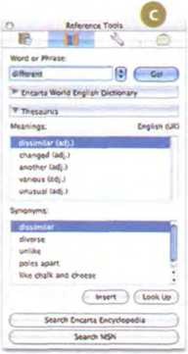
A Scan the descriptions of three WP tools (1-3) - a spell checker, an Online thesaurus and a grammar checker - and match them with the dialog boxes (a-c).
Many word processors include an Online thesaurus with which users can look up different words to use in similar instances.Their power comes not írom knowing everỵ grammatical rule, but from questioning the writer about certain parts of the text. Some even include information about pronunciation and the history of a word.
Spell checkers can be used to compare words in the program's dictionarỵ to those used in the user's document. The spell checker points out any words it cannot match, notiíĩes the user, and allows them to make any changes; it even suggests possible correct spellings. Like a conventional thesaurus, this database of words contains deíinitions and
suggestions of words with similar and opposite meanings. A word may be spelled correctly but still be wrong (too instead of two, for instance). This is a good hrst step at prooíing a document because it can find many common errors, but users will still need to proofread documents to ensure complete accuracy.
Grammar checkers are applications that attempt to check more than just ộ spelling. They count words in sentences to flag possible run-on sentences.
They look for words that show possible conílicts between verbs and subjects, and they offer advice about corrections. Grammar checkers are a step beyond spell checkers, but they are still not a substitute for a human editor. However, this does not mean that all the words in the document are spelled correctly. They give the writer another chance to think about what he or she has written.The Computer can alert writers to problems that wouldn't be obvious to them otherwise.

B Read the descriptions more careíully. Find three sentences that have been printed in the wrong text and decide where they should go.

Correct the three mistakes in this sentence and decide if they would be found by the spell checker or the grammar checker.
Mailmerge combine a form leter with a database file to create customized copỵs of the letter.

Uniti5 Spreadsheets and databases

Spreadsheet programs
In pairs, discuss these questions.
A n
1 What is a spreadsheet?
2 What are spreadsheets used for?
B Lookatthe worksheetand label a, b Then answer these questions.
- What types of data can be keỵed into a cell?
- What happens if ỵou change thẹ value of a cell?
c
This work$heet shows the income and expenses ofơ company. Amounts are given in $millions.
The terms worksheet and spreadsheet are often used interchangeably. However, technicơlly, a worksheet is a collection oícells grouped on ơ single layer of the fĩle. A spreadsheet refers to both the Computer program thơt displays data in rows and columns, and to the table which displays numbers in rows and columns.
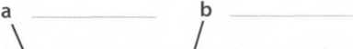
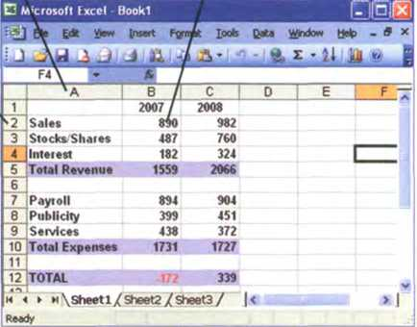
c bij Listen to Lucy Boyd giving a training course on basic Excel and check your answers to A and B.
and c with column, row and cell.
D E
the false ones.
Listen again and decide vvhether these sentences are true or false. Correct
- A spreadsheet displays iníormation in the form of a table with a lot of columns and rows.
- In a spreadsheet you can onlỵ enter numbers and formulae.
- You cannot change the width of columns.
- Spreadsheet programs can generate a variety of charts and graphs.
- Spreadsheets cannot be used as databases.
Look at the worksheet above and decide whether these sentences are true or íalse. Correct the false ones.
1 The value of the cell C12 is the result of applỵing the formula C5-C10.
2 The value of cell B5 is the result of adding the value in cells B2 and B3.
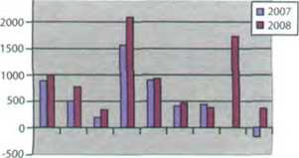
3 lfỵou tỵpe the valueổớớ in C3, the value in cells C5 and C12 will be recalculated.
[ In pairs, discuss the advantages and disadvantages of showing the information above as a graph, rather than as a worksheet.
Graphic representation ofthe work$heet ơbove

An invoice, a business letter and a fax

A Spreadsheets are also used to generate invoices. Complete the invoice below with words from the box. If you have a spreadsheet program, try to produce a similar invoice.
Quantity Description Price VAT (value added tax) Product Grand total Companỵ
Name: Ruth Atkinson |  | (1)
Address: 38 High Street, Galway |  |  | Media Market
Telephone: 5 742 9165 |  |  | Fax: 1 662 2367
Date: 16 May 2008  (2) | (3) | (4) | (5)
Ulysses Classic | 2GB of RAM, 1TB HD | 4 | 850€ | 3,400€
Flat LCD screen | Colour 19" | 4 | 170€ | 680€
Portable Ulysses | 2GB of RAM, 250GB HD | 2 | 975€ | 1,950€
D5 database | DBMS, relationat database | 1 | 245€ | 245€
Antidote JP | Anti-virus, anti-spyware | 6 | 60€ | 360€
Laser printer CQ | 2,400 dpi, PostScript | 1 | 230€ | 230€
 |  |  | Sub-total | 6,865€
 |  | (6) | (21%) | 1,441€
 |  | (7) | — | 8,306€

B Look at this letter which accompanies the invoice. Complete the letter with phrases írom the box.
Yours sincerely I am writing to Dear Ms Atkinson We would be grateful ifyou could I am enclosing Please contact us
16 May 2008
Ruth Atkinson
38 High Street
Galway

- coníirm that we have sent you four desktop PCs
ptus screens, two laptops and a laser printer, along with a D5 database, and an antì-virus program for each of the computers. Please allow two weeks for delivery.
(3)two copies of your invoice.
- make your payment by cheque or directly to our bank account through the Internet.
We are also delighted to inform you that we are offering our clients an Online course catled A paperless office, free of charge. (5)if you require any íurther information.
(6)
lan Pegg
B Lookattheillustration, which represents a database fìle. Can you identify a record and a field?
c Read the text on page 76 and check your answers to B.
Record
Namc:
Aàỉresr. c
]dentifiaatú>n;[
Occupation.:[
]Salarft
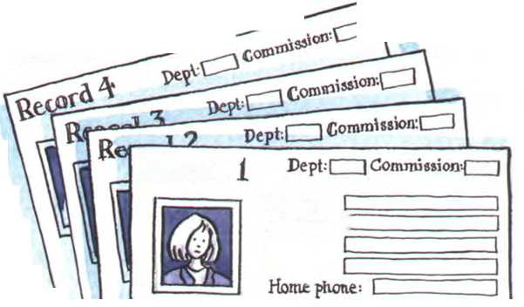
c Imagine you are Ruth Atkinson. When you try to use the laser printer, it gives continuous error messages. You are also having problems installing the database. Write a fax to Media Market to complain. Ask for a new printer and an upgraded version of the database. Look at the Usefullanguage box to help you.
FAX MESSAGE
To: Media Market
Fax: 1 662 2367
From: Ruth Atkinson
Subject: Faulty Products
Dear Mr Pegg,
Number of pages: 1
Please call if you experience any transmission problems.
Useful language
Iam writing tocomplainabout doesn'twork Iam unable to...

Databases
A In groups, make a list of as many possible applications for databases as you can think of.
Example: Companies use databases to store iníormation ”
about customers, suppliers and theừown personnel.
Databases
A database is a collection of related data, and the software used in databases to sĩore, organize and retrieve the data is called the database management System, or DBMS. However, we often use the word database to cover both meanings. A database can manage any type of data, including text, numbers, images, sound, video and hyperlinks (links to websites).
Iníormation is entered into the database vía fields Each field holds a separate piece of iníormation, and the íields are grouped together in records.Therefore, a record about an emploỵee might consist of several fĩelds which give their name, address, phone number, date of birth, salary and length of employment with the company.
Records are grouped together into hles which hold large amounts of iníormation. Files can easily be updated - you can always change fields, add new records or delete old ones. An electronic database is much faster to consult and update than a card index System and occupies a lot less space. With the right software, you can keep track of stock, sales, market trends, orders and other information that can help your company stay successíul.
A database program lets you create an index - a list of records ordered according to the content of certain fields. This helps you to search the database and sort
records into numerical or alphabetical order very quickly. Modern databases are relational - that is, they are made up of related files: customers and orders, vendors and purchases, students and tutors, etc.Two database íiles can be related as long as they have a common field. A file of students, for example, could include a field called Tutor ID and another file with details of the tutors could include the same held.This key field can be used to relate the two fĩles. Databases like Oracle, DB2 and MySQL can manage these relationships.
A database query íunction allows you to extract iníormation accordíng to certain conditions or criteria. For example, if a managing director vvanted to know all the customers that spend more than €8,000 per month, the program would search on the name field and the moneỵ field simultaneously.
The best database packages also include net work íacilities, which can make businesses more productive. For example, managers of different departments can have direct access to a common database. Most aspects of the program can be protected by user-defined passwords and other security devices. For example, if ỵou vvanted to share an employee's personal details but not their commission, you could protect the commission field.

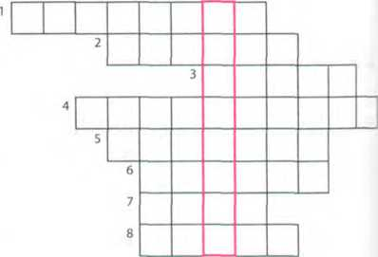

D Complete these statements about databases using iníormation from the text.
- A database management System is used to
- Iníormation is entered into a database vía
- Each field holds
- updating a file means
- Some advantages of a database program over a manual fjling System are:
- Access to a common database over a network can be protected by using

Solve the clues and complete the puzzle.
- A collection of data stored in a PC in a systematic way.
- A unit of a database file made up of related íields.
- A single piece of information in a record.
- A database maintains separate, related
fìles, but combines data elements from the files for queries and reports.
- Some companies have several computers sharing a database over a
- To look for speciíĩc iníormation, for example the name of an employee.
- To classiíy records into numerical or alphabetical order.
- A tool that allows you to extract iníormation that meets certain criteria.

f pl In pairs, discuss what fìelds you would include in a database for your music collection.

Language work: plurals
A Look at the HELP box and then write the plural of these words.
1 Client
2 key
3 query
4 businessman
5 fax
6 salary
7 mouse
8 virus

HELP box
Plurals
- In most cases, we form the plural in English by adding -s.
record—^records
- lf a word ends in -s, -sh, -X or -ch, we add -es.
ơddress —► ơddresses index —► indexes
- lf a word ends in a consonant + y, the y becomes i and we add -es.
company —► companies íacility—^íacilities
- However, if the y follows a vovvel, we add only -s.
birthday —► birthdays
- There are several irregular plural forms:
man/womơn —► men/women
child—^children
analysis —► analyses
íormula —► tormulae (or tormulas)
criterion —► criteriơ
mouse —► mice
- The -s is pronounced as:
/s/ after One of these sounds.7p/, /t/, /k/, /f/ or /0/ (e.g. amounts, hyperlinks)
/iz/ after one of these sounds: /s/, /z/, /J/, /t]7 or
/dV (e.g. businesses, devices, images)
/z/ in most other cases (e.g. fĩles, fìelds, customers, columns)

B Put the plurals into the correct pronunciation column.

databases | passwords
laptops | graphs
orders | switches
taxes | networks
tables | packages
spreadsheets | Systems

/s/ | /iz/ | /z/

5

Software at home and at work
. >1 In pairs, fìnd out as much as you can about the software your partner uses at home or at work. Ask about spreadsheet programs, databases, word processors, videoconíerencing, business accounting, email, and web browsers. Look at the Useful language box to help you.
Usetul language
Iwww.
Now visit www.cambridge.org/elt/ict
for an Online task.
What kind ofspreadsheet program do you use?
What do you use it for?
Do you use it at home or at work?
What's your favourite...?
What features do you like most about it?
Howdoyou...?

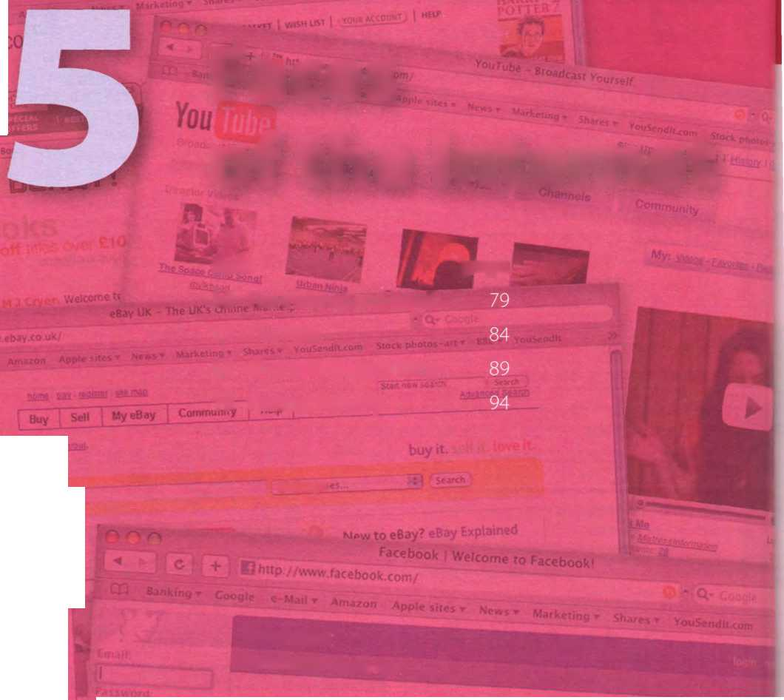
textbooks/b/'^’⁰^-^ ; _{c}
vouSrnãttCom S«xK phu-.os ■
GỠ09H
_{Wa}i» ▼ Amaron
amazon(
Faces of the Internet

Unit
page
c + :
.nk«ng* Cooglc

b .co.uk
16 The Internet and email
17 TheWeb
18 Chat and coníerencing
19 Internet securitỵ
What are you looking for?
Alt Caiego'
Have you visìted⁷

I) Motors
Oíies
íacebook
Wcome to Paceb Ịok!
,_{s} a ^ „_{w lb>}, _{t}
racebook ú made un . ^{p p c around} M“.
^{p} niMy n«work₁. _{each ba$ed}
- s going on Mth
Learninq obiectives

In this module, you will:
study vocabulary related to the Internet and email.
learn how to form different types of question.
learn aboutthe basic íeatures oftheWeb.
learn and use collocations related to the Internet.
learn and use vocabulary related to the Web, e-commerce, Online banking, Online chatting and videoconíerencing.
learn and use abbreviations in Online chats.
learn about the basic ideas related to security and privacỵ on the Internet, discuss controversial issues related to the Internet.
D K

Uniti6 The Internet and email

Internet basics

A |Ó| In pairs, discuss how you would defìne the Internet.

B o Make a list of all the things you can use the Internet for.

c hu Listen to a conversation between a customer buying a PC and a sales assistant. Why do you think the sales assistant has to explain so much about the Internet?

Listen again and complete the customer's notes.
To cơw\acttơ tha ĩ^\tar^at frũh^ hoh^a, ĩ ^aad:
(f) ơ ■ ơkxd (2) &
pMso k\aad ơky ơccơisrxt ivtth «M (^)fa cơhspơruy thơt offar$ cơkM^aatíoi^ fơr & h^oi^thíiợ faa).
ĩf I^ƠƠỊ kVơkxtto cơ/^(^act ^ơts of cơhơpơítar^ Mthơi/it ưsthỹ cơbías, 1701^ cơkx 1/ise. 0! (p)roarter.
Mĩ-pý' ơi?as Cỹ)tvơva? bo ?a/^d dơtơ oựar /v^adrhh^- r&^ga dtstơncas.
Thrhý$ íỹơM CƠM dơ OM tha ỈMtcrMct-

'Wab'or 'iMterMat'? Tha Wcb: hnga coííacttbM of (7)
storad OM cơh^pơttar? ơtf ovar tha MlorM. Tha ỉhtcrMat- tha MathJorb Mjhích coMMacts ơd tha coh^pi/ttars.

Internet FAQs

A Read Part 1 of the Internet FAQs on page 80 and choose the correct answers.
- The Internet was
a invented in the mid-90s. b popular in the 1960s. c probably created in the USA.
- Which term describes any fast, high-bandwidth connection?
a broadband b dial-up connection c Wi-Fi connection
- The power-line Internet provides broadband access through a telephone lines. b satellites. c electrical power lines.
- Which device converts Computer data into a form that can be transmitted over phone lines? a ADSL b a mobile phone c a modem
- The Standard protocol that allows computers to communicate over the Internet is called a an IP address. b TCP/IP. c HTTP.
- The geographical region covered by one or several access points is called a a wireless access point. b hotspot. c wireless network device.
ì

Internet FAQs: Part 1
How old is the Internet (the Net)? When was it created?
It’s hard to say exactly. The research that led to what we now know as the Internet was begun in the 1960s.
Who created the Internet?
Again, it’s hard to say exactly who created it. The initial research was carried out by the Advanced Research Projects Agency in America, tunded by the us government.
Did the Internet become popular quickly?
It took many years íor the Internet to become popular around the world. It’s only really since the mid-90s that the Internet has been a part of our daily lives.
How do you get Online?
To get connected, you need a Computer, the right connection software and a modem connected to the phone line. You also need an account with an Internet Service Provider (ISP), which acts as a gateway between your PC and the rest of the Net.
How fast are today’s internet connections?
Today, ISPs otíer a broadband, high-speed connection.The most common types are cable - ottered by local cable TV companies - and ADSL (Asymmetric Digital Subscriber Line), which works through phone lines. They are both taster than the traditional dial-up telephone connection. Broadband access is also ottered by some electricity networks. This competing technology, known as power-line Internet, provides low-cost access vía the power plug, but is still in development.
How long has broadband existed?
Since the late 1990S.
How much does broadband access cost?
It depends on which company you choose. Nowadays, some companies even offer free broadband.
Why do you need a modem?
A modem (modulator/demodulator) converts digital signals into analogue signals so that data can be transmitted across the phone or cable netvvork.
What does TCP/IP mean?
The language used for data transler on the Internet is known asTCP/IP (transmission control protocol/ Internet protocol).This is like the internet operating System. Every Computer connected to the Net is identitied by a unique IP address.
Are there other ways of accessing the Internet?
Other methods of internet access include Wi-Fi, satellite, mobile phones and TV sets equipped with a modem. Wi-Fi-enabled laptops or PDAs allow you to connect to the Net if you are near a wireless access point, in locations called hotspots (for example, a Wi-Fi café, park or campus). Satellite Services are used in places vvhere terrestrial access is not available (for example, on ships at sea). High-end mobile phones provide access through the phone network.

B In pairs, discuss which of the internet Systems (1-6) you would use to do

the tasks (a-í).Then read Part 2 of the FAQs on page 81 and check your answers.
1 | Email | a | transíer íiles from the Internet to your hard drive
2 | The Web | b | send a message to another person vía the Internet
3 | Newsgroups | c | have a live conversation (usually tỵped) Online
4 | Chat and IM | d | connect to a remote Computer bỵ entering instructions, and run a
5 | FTP |  | program on it
6 | Telnet | e | take part in public discussion areas devoted to specihc topics
 |  | f | dovvnload and view documents published on the Internet

Internet FAQs: Part 2 ^

Email
Email lets ỵou exchange messages with people all over the world. Optional attached tiles can include text, pictures and even audio and animation. A mailing )ist uses email to communicate messages to all its subscribers - that is, everyone that belongs to the list.
Which email program is the best?
Outlook Express is a popular program, but many users use web-based email accounts such as Hotmail.

The Web
The Web consists of billions of documents living on web servers that use the HTTP protocol. You navigate through the Web using a program called a web browser, which lets you search, view and print web pages.
How otten are web pages updated?
It depends entirely on the page. Some are updated thousands of times a day.

Chat and Instant Messaging (IM)
Chat and Instant Messaging technologies allow you to have real-time conversations Online, by typing messages at the keyboard.

FTP
FTP, or íile transíer protocol, is used to transíer tiles over a TCP/IP network. Nowadays, this íeature is built into Web browsers. You can download programs, games and music íiles írom a remote Computer to your hard drive.

Telnet
Telnet is a protocol and a program used to log onto remote Computer Systems. It enables you to enter commands that will be executed as if you were entering them directly on the remote server.

Newsgroups
Newsgroups are the Public discussion areas which make up a System called Usenet. The contents are contributed by people who post articles or respond to articles, creating chains of related postings called message threads. You need a newsreader to subscribe to nevvsgroups and to read and post messages. The newsreader may be a stand-alone program or part of a web browser.
How many newsgroups are there?
There are approximately 30,000 active newsgroups.
Where can you find newsgroups?
Your newsreader may allow you to download the newsgroup addresses that your ISP has included on its news server. An alternative to using a newsreader is to visit web torums instead, which períorm the same tunction but without the additional software.
ÌSãMMMMSãíÌd — - - . <►

c Find words and phrases in Part 2 with the following meanings.
1 a System usedĩo dứMb^&?w;^/%&/?s<^^^ ("1 ẺmơTTpdĩòỹĩdp^
2 a program used for displaỵing web pages (in The Web paragraph)
3 to connect to a Computer bỵ typing ỵour username and password (in Telnet paragraph)
4 a series of interrelated messages on a given topic (in Newsgroups paragraph)
5 a program for reading Usenet newsgroups (in Nevvsgroups paragraph)
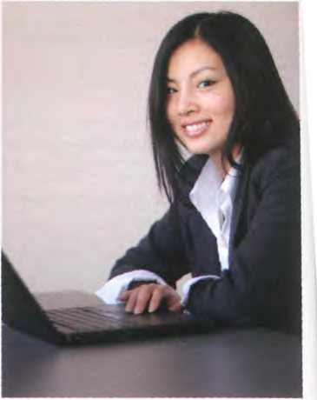
Sue Clơrke
Place
Where cơn you fjnd newsgroups?
Time
When was it creơted?
How often are web pages updated?
How long has broadbơnd existed?
Reason
Why doyou need a modem?
Quantity
How much does broadband ơccess cost?
How many newsgroups ơre there?
Manner
How do you get Online?
Others
How fast ơre today's internet connections?
How old is the Internet?

Lơnguage work: questions

A Look at the HELP box and then make a question about Sue Clarke for each of her answers.
1
l'm 23 years old.
2
l'm an Online researcher.

I use the Internet to íind iníormation requested by clients.

l've been doing this job for six months.

I graduated from university in 2006.
HELPbox
Questions
- In questions, we normally place the auxiliary verb beíore the subject.
Are there other wơys oíaccessing the Internet?
- lf there is no other auxiliary, we use do/does (present simple) or did (past simple).
Did the Internet become popular quickly?
- There are many question words in English which we use to find out more iníormation than just yes or no.
People
Who created the Internet?
Things
What does TCP/IP mean?
VVhich emơil progrơm is the best?

B ^ In pairs, make questions using these prompts.Then practise asking and answering the questions.
Example: When / first / use the Internet When didyou fir$t use the Internet?
- What type of internet connection / have at home?
- How fast / your internet connection?
- How much / pay for broadband access?
- How often / access the Internet?
- Which email program / use?
- Who/send email to?
- Do / use your mobile phone to access the Internet?
- Do / use the Internet in public spaces using Wi-Fi?
- Do/playgames Online?
- Hovv manỵ newsgroups / subscribe to?

Email feơtiưes
A Read the text and fìnd the following.
- the place where your ISP Stores your emails
- the type of program used to read and send email from a Computer
- the part of an email address that identiíies the user of the Service
- the line that describes the content of an email
- the Computer file which is sent along with an email message
- facial symbols used to indicate an emotion or attitude
- the name given to junk mail

B Write a reply to Celia's email below.
Email features
When you set up an account with an Internet Service.Provider, ỵou are given an email address and a password The mail you receive is stored on the mail server of your ISP - in a simulated mailbox - until you next connect and download it to your hard drive.
There are two ways to get email over the Internet. One is by using a mail program (known as an email Client) installed on your Computer, for example Eudora or Outlook Express. The other waỵ is to use web-based email, accessible from any web brovvser. Hotmail and Gmail are good examples.
You can make the message more expressive by including emoticons, also called smileys. For example,;-) for wink, :-) for happy, :-0 for surprised, :-D for laughing, etc. You may also like to add a signature file, a pre-written text fìle appended to the end of the message. The name given to unsolicited email messages is spam.
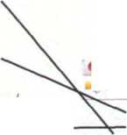
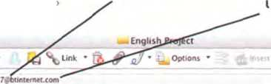
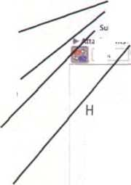
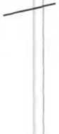

The anatomy of an email
The header
From: name and address oíthe - sender
The username (ơ persorís name or nickname)
©oe
To. nơme and address of the recipient
The @ sign, which means at
:z Cateọones • Proiectỉ •
The domain name or network address - thatis, the mail server where the ơccount is located. The hna\ part adds information about it, for example com = company uk = United Kingdom, fr = Frơnce, etc.
Cc. carbon copy sent to another person
Bcc. blind carbon copy
Subịect topic of the message
Attachment. íiles ơdded to the message
Send Now
Ffom
Bcc
John,
ư ngh$h P'O)«t
9jh*rtley994
9 cc<uz34óp<e*ewe«com
9 tbioggs 1976 drbunternet com
9 jdoe777fthotmiil.com
achmcnts First_thoughts.doc font • Pont Size
I have to prepare a project for my EngLish class about the hỉstory of the Internet and how ít's used in our day-to-day lives. Do you have any thoughts about what I should include? I've included my hrst thoughts here as an attachment. Could you send me some more ideas?
AU the best,
Celia
The body contains the message itself
Unit 17 TheWeb

A typìcal web page

A Look at the screenshot of a typical web page. How many of the íeatures (a-k) can you say in English?
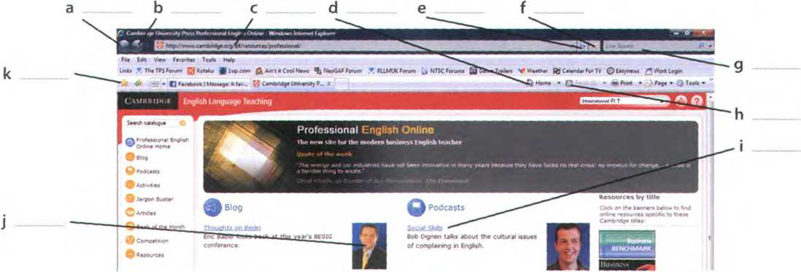
A screenshot from Internet Explorer 7, a leading web browser.

B Read the text and label the features on the screenshot with the terms in bold.
A typical web page
At the top of the page is the URL address. URL means Uniíorm Resource Locator - the address of a file on the Internet. A typical URL looks like this: http://www.bbc.co.uk/radio/.
In this URL, http//means Hypertext Transíer Protocol and tells the program to look for a web page. www means world wide web. bbc.co.uk is the domain name of the server that hosts the website - a company based in the UK; other top-level domains are .com (commercial siĩe), .edu (education), .org (organization) or .net (netvvork); rơdio is the directory path where the web page is located.The parts of the URL are separated by . (dot), / (slash) and: (colon). Some sites begin ftp//, a file transíer protocol used to copy íiles from one Computer to another.
The toolbar shows all the navigation icons, vvhich let you go back one page or go forward one page You can
also go to the home page or stop the current transfer when the circuits are busỵ.
Tab buttons let you view different sites at the same time, and the built-in search box helps you look for iníormation. lí the feed button lights up, it means the site offers RSS feeds, so ỵou can automatically receive updates. When a vveb page won't load, you can reíresh the current page, meaning the page reloads (downỉoads again). If you want to mark a website address so that you can easily revisit the page at a later time, you can add it to ỵour íavourites ựavorites in American English), or bookmark it. When you want to visit it again you simply click show íavourites.
On the web page itself, most sites íeature clickable image links and clickable hypertext links. Together, these are known as hyperlinks and take you to other web pages when clicked.

Listen to three internet addresses and write them down.
2
3

The collectives of cyberspace

A Read the article and fìnd websites for the following tasks.
- to search for iníormation on the Web
- to buy books and DVDs
- to participate in political campaigns
- to view and exchange video clips
- to manage and share personal photos using tags
- to buy and sell personal items in Online auctions
- to download music and movies, sometimes illegally
Tour the Collectives of Cyberspace
The Internet isn’t just about email or the Web anymore. Increasingly, people onlme are taking the power of the Internet back into their own hands.The/re posting opinions on Online journals - weblogs, or blogs; theyre organizing political rallies on MoveOn.org: they're trading songs on illegal fìle-sharing networks; theyre volunteering articles íor the Online encyclopedia Wikipedia; and the/re collaborating with other programmers around the world. It’s the emergence of the ‘Power of Us'.Thanks to new technologies such as blog software, peer-to-peer networks, open-source software, and wikis, people are getting together to take collective action like
never beíore.
ctY.
eBay, for instance, wouldn't exist without the 61 million active members who list, sell, and buy millions of items a week. But less obvious is that the whole marketplace runs on the trust created by eBay's unique íeedback System, by which buyers and sellers rate each other on how well they carried out their half of each transaction. Pioneer e-tailer Amazon encourages all kinds of customer participation in the site - including the ability to sell items alongside its own books, CDs,
txttex*
DVDs and electronic goods. MySpace and Facebook are the latest phenomena in social networking, attracting millions of unique visitors a month. Many are music fans, who can blog, email íriends, upload photos, and generally socialize. Theres even a 3-D Virtual world entirely built and owned by its residents, called Second Lite, where real companies have opened shops, and pop stars such as U2 have performed concerts.
Some sites are much more specialized, such as the photo-sharing site Flickr. There. people not only share photos but also take the time to attach tags to
their pictures, which help everyone else fmd photos of, for example, Florence, Italy. Another successíul example of a site based on user-generated content is YouTube, which allows users to upload, view and share movie clips and music videos, as well as amateur videoblogs. Another example of the collective power of the Internet is the Google search engine. Its mathematical íormulas surí the combined judgements of millions of people whose websites link to other sites. When you type Justin Timberlơke into Google’s search box and go to the star’s offìcial website,the site is listed first because more people are telling you it’s the most relevant JustinTimberlake site - which it probably is.
Skype on the suríace looks like software that lets you make íree phone calls over the Internet - which it does. But the way it works is extremely clever By using Skype, you're automatically contributing some of your PCs computing power and Internet connection to route other people’s calls. It’s an extension of the peer-to-peer network software such as BitTorrent that allow you to swap songs - at your own risk if those songs are under Copyright. BitTorrent is a protocol for transíerring music, fìlms, games and podcasts. A podcast is an audio -ecording posted Online. Podcasting denves írom the words iPod and broadcasting.Ỵoo can fìnd podcasts about ỉlmost any topic - sports, music, politics, etc.They are distributed through RSS (Really Simple Syndication) íeeds Miich allow you to receive up-to-date iníbrmation without having to check the site for updates. BitTorrent ;reaks the files into small pieces, known as chunks, and distributes them among a large number of users; when
'OU download a torrent, you are also uploading it to another User.
Adơpted [rom ỀusinessWeek Online
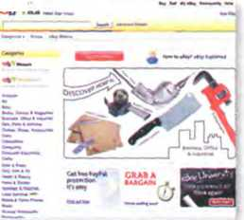
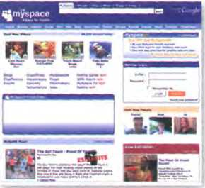
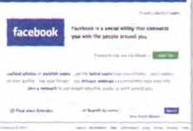
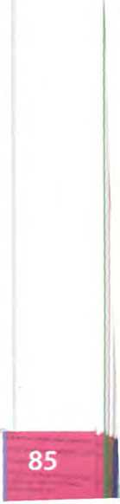

B Read the article again and match the correct endings (a-e).
- A weblog, or blog, is an electronic journal
- A peer-to-peer System allows
- You can use a search engine to find
- BitTorrent is a peer-to-peer protocol used
5 RSS keeps you constantly informed

sentence beginnings (1-5) with the
a web pages on a particular subject.
b for downloading hles over the Internet.
c users to share files on their computers.
d about fresh, new content on ỵour íavourite vvebsites.
e that displays in chronological order the postings of one or more people.

Find words in the article with the following meanings.
- open-source, editable web pages (lines 5-10)
- the same as electronic retailer, or Online store (lines 10-15)
- a blog that includes video (lines 25-30)
- a program that allovvs ỵou to make voice and video calls from a Computer (lines30-35)..______
- an audio broadcast distributed over the Internet (lines 35-40)
D R Write a short article (80-120 words) íor your school/university/work newsletter about the latest internet phenomena (MySpace, eBay, etc.). Talk about any other sites you think are important or will be important in the future.

Language work: collocations 2
A Look at the HELP box on page 87 and then match the words on the left (1 -6) with the words on the right (a-f) to make collocations. There may be more than one possible answer.
1 | Online | a | friends
2 | ta ke | b | photos
3 | email | c | action
4 | upload | d | website
5 | portable | e | encyclopedia
6 | official | f | player

B In pairs, make sentences using the collocations above.
Find the collocations in these sentences and say what type they are.
- Once you are Online, you can browse the Web, visit Chat rooms or send and receive emails.
- Instant messaging can be a great way to communicate wiĩh íriends.
- This software may not be fully compatible with older operating Systems.
- Most webcams plug into a USB port.
- This highly addictive game will keep you playing for hours.
- Companies are starting to use Virtual reality on their websites.
HELPbox
Collocations 2
A collocation is a pair or group of words that are often used together. For example, we say make phone calls, not do phone calls.
Here are some common types of collocation:
- verb + noun (see Unit 1)
surftheWeb dovvnload music
- verb + particle
hack into o Computer log onto a bơnk account
- adverb + adjective
highly sensitíve information
freely ơvailable on the Web
- adjective + noun
mathematical íormulas up-to-date information
The word Online often collocates with other words and can íunction as adjective or adverb.
Adjective: They post opinions on Online journals.
Adverb: A podcơst is ơn ơudio recording posted Online


E-commerce and Online banking
A
s

Listen to two extracts from a monthly podcast called Money Matters. What

is each speaker talking about?
Speaker 1 Speaker2

Listen again and make notes under these headings.
‘SpeaKer l 5peaKe-r 2-
ĩhinạs people bu^ Online Thinạs ^u can do with Online banttnậ
Steps íor Hing Online ^<99^ issue wth Online bantíng
Precautions Precautions
- Complete the extracts with words from the box
authorization fake internet auction shopping cart browse log in steal
- Occasionally I also buy things on sites such as eBay, where people offer and
sell thỉngs to the highest bidder.
- First you enter a site dedicated to e-commerce and their Products.
- Then you put the items you want to buỵ into a Virtual- a program that lets ỵou select the Products and buỵ with a credit card.
- You may have to with a username and a password ...
- ... for some transactions, you vvill be required to use a TAN, a transaction number.
- Be aware of phishing - you may receive emails claiming to be from your bank and asking for personal iníormation or account details in an attempt to ỵour identitỵ.
87

D liu Listen again and checkyour answers.

Language work: the prehxes e- and Cyber-

Look at the HELP box and then complete these sentences.
- A is an employee who
uses his companỵ's internet connection during work hours to Chat with fríends, play games, etc.
- An is a postcard sent vía
the Internet.
- An is a small magazine or
newsletter published Online.
- Ina you can use
computers with internet access for a fee.
- Examples of include
internet fraud, digital piracỵ, theft of conhdential iníormation, etc.
- In the future, all elections will be carried out using
- You can now sign legal documents Online using an
- will revolutionise the
waỵ we take exams.

HELPbox
The prehxes e- and cyber-
- The e- prehx means electronic, and we add it to activities that take place on computers or Online, for example e-business/e-commerce - business conducted over the Internet. Other examples include: e-card, e-learning, e-zine, e-voting, e-signature, e-assessment, e-cash, e-book and e-pal
There are often spelling variations, with or without a hyphen, so always check your dictionary.
- The Cyber- prehx comes from cybemetics, and we use it to describe things related to Computer networks, for example cybercafé - an internet café. Other examples include: cybercrime, cyberculture, cyberslacker and cyberspace
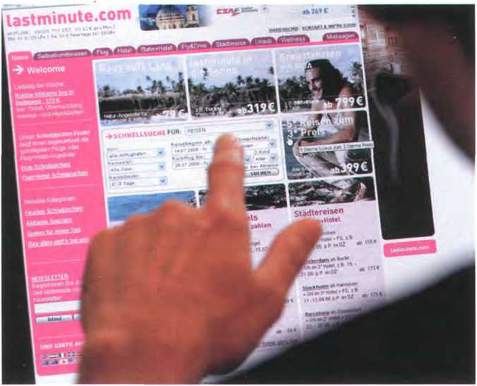
6
- can be used on some
websites instead of real money to make purchases. It reduces the risk of fraud.
- An is like the paper version, but in digital form.

What do you use the Web for?

In pairs, discuss these questions. Give reasons for your answers.
- What is your íavourite search engine to fĩnd iníormation on the Web? Why?
- Do you dovvnload musicorvideo clips from the Web? Do you pay for them?
- Doyou buy things Online? Is it better to buy Online or go toa shop?
- Have you ever listened to the radio or watched TV Online?
- Do you use the Web to do school/university assignments or projects? How?

Uniti8 Chat and conferencing

Online chatting

In pairs, discuss these questions.
Windows Live

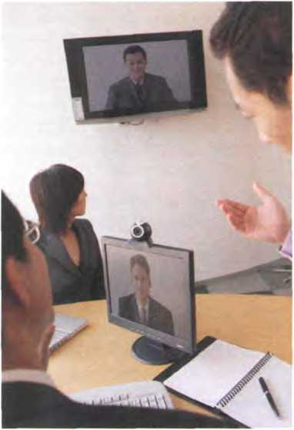
Windows Live Messengeris One oíthe wodd's mostpopularchat ptogrơms
- What is your favourite waỵ to Chat on the Internet?
- How much time do you spend chatting?
- Do you give out personal details in Chat rooms? Whỵ should you be careíul about this?

Virtual meetìngs

A Read the text and match the headings (1-5) with the gaps at the start of each paragraph (a-e).
- Cheap calls over the Internet
- Virtual worlds and Online communities
- Chat rooms on the Web: join the crowd!
- Real-time videoconferencing
- Private chats with IM Services
A videoconferencing System combines datơ, voice and video
Virtual meetings
a
Imagine you want to assemble a group of people from around the world for a brainstorming session. Coníerencing programs such as NetMeeting or CU- SeeMe allow Virtual vvorkgroups to communicate
5 vía the Internet.To videoconíerence you'll need a webcam. Participants see each other's íaces in small windows on their monitors and hear each other's voices on the Computer speakers. You can use just audio, video and audio simultaneously, or the screen- 10 sharing capabilitỵ to collaborate on documents without audio or video.
b
Internet telephony, also known as VolP (Voice over Internet Protocol), almost eliminates long-distance phone charges, allowing ỵou to call nearlỵ anywhere
15 in the world íorthe priceofa local call. Ifyou have flat-rate internet access, you can't beat the price - it's practically free.
With internet telephony, you can make a voice call from your Computer to another person's Computer,
20 landline, or mobile phone. You can download telephonỵ software such as Skype or Net2Phone from the Net, and it’s even free!
c
People also use more traditional Chat conferencing or bulletin board Systems (BBSs) to communicate
25 Online. Note that during Chat sessions, participants type messages to each other rather than communicate bỵ voice. Chat software can be used on the Web with your browser to conduct Online Chat sessions with other users and can accommodate
30 between 50 and 1,000 users simultaneously. Some companies even use Chat coníerencing on their vvebsites to íacilitate communication with customers.
Chat rooms can be good venues to meet people and discuss topics of mutual interest. But what if you want to Chat privately with a friend, familỵ member or business colleague?Then Instant Messaging, or IM, is the way to go. Many IM Services now offer audio and video capabilities, so if you have a microphone and a webcam, you can Chat and see who you're talking to. The four most popular IM Services are ICQ and AIM (from AOL), Windows Live Messenger, and Yahoo! Messenger. They all work similarly. First, you enrol in the Service by creating a username - which is also ỵour screen name - and a password. Next, you build what is known as a buddy list - a list of people that ỵou want to communicate with. When any of the contacts on your list is Online, you can start a private Chat with that person.
How do you know who's Online? When you launch your IM software, it connects with the service's IM server and logs you on. The server checks your buddy list to see if any of your contacts are also logged on. Your list updates to show who is currently Online. By clicking on a name you can send text-based messages to thaĩ person. After you type your note and click on the Send button, the message travels to the IM server, then immediatelỵ forwards to your
buddy's Computer. This all happens in realtime - instantly.
e
60 You can also Chat in incredible 3-D worlds that are built by other users, for example SecondLife. In these Virtual reality environments ỵou can plaỵ 3-D games and interact with other users vía avatar identities. Avatars are 3-D graphical representations
65 of the participants.
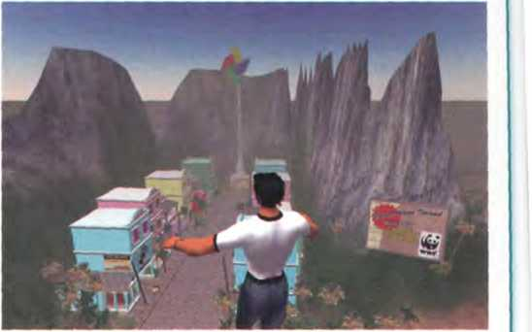

Avơtors cơn rưn,jump. fly. dance and even enable you to express emotions
35
40
45
50
55
Paragraphs a-d adapted from www.learnthenet.com

B Read the text again and answer these questions.
- Why is videoconíerencing so useíul for Virtual workgroups?
- What special hardvvare and software do you need to videoconíerence?
- Which technology enables people to make phone calls over the Internet?
- What is the diííerence between web Chat rooms and Instant Messaging?
5 How do you log on to an IM server?

c Find terms in the text with the following meanings.
1 at a fĩxed price (lines 15-20)
2 a Central System that provides information about whether users are Online and passes instant messages betvveen them (lines 35-40)
3 a friend list or contact list (lines 45-50)
4 happening immediately and without delaỵ (lines 55-60)
5 artihcial reality; a 3-D space generated by the Computer (lines 60-65)
6 characters used when interacting with people Online (lines 60-65)

Netiquette

A In pairs, do this netiquette quiz. Read about netiquette rules on the Web if necessary.
1 Netiquette, or net etiquette, is a general code 5 of behaviour for communicating Online.
o True
o False
2 TYPING IN CAPITALS LETTERS looks like:
c the message is very important. 6
o you're shouting.
3 What should you avoid doing in Chat rooms?
c Being respectful ₇
o Giving out personal or hnancial information
4 Spamming means
c posting stupid comments in Chat rooms.
c posting unsolicited advertising messages.


B } Have you ever experienced bad netiquette? Tell your partner what
Beíore asking questions in a Chat room or posting messages to íorums, you should always
c read the FAQs (Frequently Asked Questions).
o introduce yourselí and posta test message.
Avoid ílame wars. Flames are
c angry responses or offensive comments.
o people who break the rules of netiquette.
Keep messages short and to the point, and check spelling and grammar.
c True
c False

happened.

R u free 4 a Chat?

A Rewrite this IM Chat, using full íorms instead of abbreviations. Then look at the HELP box on page 92 to check your answers.
Abby: BTW, where r u going for ur holiday?
By the way, where areyou going íoryour holiday?
Sue: Girona. Have u been?
Abby: Yes. I went 2 Girona last summer.
Sue: Did u have a good time?
Abby: lt's great, IMO. How r u going 2 travel?
Sue: We'ref)ying.
Abby: Where r u staying?
Sue: In a youth hostel.
Abby: IC. IOW, the cheapest place possible!
Sue: LOL! Yes. BTW, any recommendations?
Abby: Let me think. ru send u a msg ASAP.
Sue. TIA!
Abby: Got 2 go. BFN!
B Rewrite this IM Chat using abbreviations.
c £ In pairs, practise having an Online conversation. Write a short note and give it to your partner. Use abbreviations as necessary. Your partner will write a short response and give ít back to you. Continue the conversation and try not to talk. Choose one of these topics.
Paulo: | By the way, are you free on Saturday?
Emma: | Sure - it would be good to meet face to íace. Shall we go for a coffee?
Paulo: | Good plan. Café Moka makes the best coffee, in my opinion.
Em ma : | It's the closest to your house in other words!
Paulo: | Laughing out loud! Yes, youYe rìght! But the coffee really ìs good.
Emma: | See you at 4?
Paulo: | Great. Bye for now.

- Your plans for the vveekend
- What you did last night
- Your holidaỵ plans
- What happened at school/work today
- Music/TV/The Web
D In pairs, discuss these questions. Give
HELP box
Chat abbreviations
We often use abbreviations in Online chats and Instant Messaging. Some common examples are:
ASAP As soon as possible
BBS Be back soon
BFN Bye for now
BTW By the way
F2F Face to face
GL Good luck
H&K Hug and kiss
IC Isee
ILU I love ỵou
IMO Inmyopinion
IOW lnotherwords
LOL Laughing out loud
TIA Thanks in advance
msg Message
ur ỵour/you're
2 to
4 for
b be
c see
r are
u ỵou
lt's OK to use Chat abbreviations, but trỵ not to relỵ on them too much - theỵ can make a conversation diííìcult to follow. Theỵ are also verỵ iníormal.
reasons for your answers.
- Which program do ỵou use to Chat with friends?
- Do you use abbreviations when you Chat Online or when you send text messages?
- Do ỵou use voice or video while chatting? How?
- Have you ever used the Internet to make cheap calls?
- Does Instant Messaging distract ỵou from work?
- Do you use your real name or a nickname in Chat rooms?
- Do you talk to strangers during web chats? Whỵ shouldn't you?
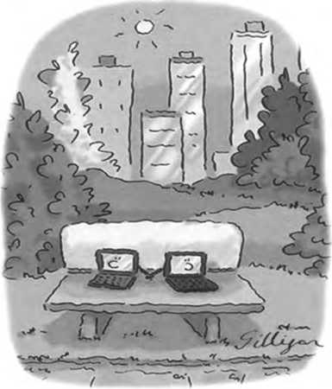
- Would you ever go on a date with somebody you'd met on the Net?
www.CartoonStock.com
Computer ũoting

5 Ata cybercafé

A ũ In pairs, discuss these questions. Give reasons for your answers.
1 Do you ever go to cybercaíés?
2 What Services would you expect a cybercafé to offer?

B E Listen to an interview with Daniel Sturdy, the manager of a cybercafé in London. Does Daniel like where he works?

c Listen again and decide whether these sentences are true or false. Correct the false ones.
1 A cybercaíé is a café where you can have access to the Internet and related Services.
2 You can talk to people over the Internet using internet telephony at Daniel's café.
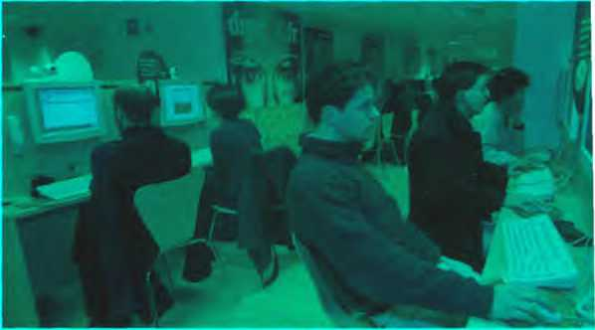
3 They don't help people who have problems while using the Internet.
A cybercaíé
- Using a Computer with internet access costs £2 per hour or £80 for a week.
- At the moment theỵve gota lotof international customers.
- You have to paỵ long-distance phone rates on the Internet.
- In the café area you can sít, drink coffee and Chat to people.

6 Plan your own cybercafé

A ^] In small groups, plan how you would open a cybercafé in your town. Consider these areas.
- Money needed
- Type of customer
- Location
- Services you will offer (just internet access? food and drinks? nevvspapers and magazines? tutorials?)
- Furniture and decoration
- How to create a nice atmosphere (music, lighting, private areas, etc.)
- What type of hardware and software you need
- What type of internet connection you need
- How much you will charge
- A name and slogan for ỵour cybercaíé

B >^| Present your plan to the class, using PowerPoint if possible.

Unit!9 Internet security

On alert

In paỉrs, discuss these questions.
A
1 What is a hacker?
2 How easy do you think it is to inhltrate the Internet and steal sensitive iníormation?
3 How can you protect your Computer from viruses and spyware?

B Match the captions (1-4) with the pictures (a-d).
- A secure website can be recognized in two ways: the address bar shows the letters https and a closed padlockor key is displayed at the bottom of the screen.
- You have to type your username and passvvord to access a locked Computer System.
- This program displays a message when it detects spyware and other unwanted software that may compromise your privacy or damage your Computer.
- Private netvvorks use a software and/or hardware mechanism called a firewall to block unauthorized traffĩc from the Internet.
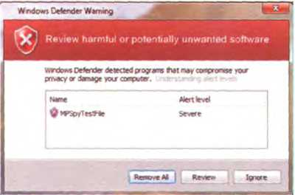
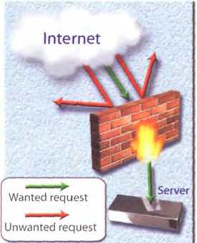


Authcntỉcation R«quir«d
£m«r uiemame and p*stwofd fo< ’EísyN«w»' Ít bctp //membefỉ.«asyncwi.co<T)
UMílUn*
PatMMxd
( CM«I ) g^
https://www.bankinter.com/ -ạ

Security and privacy on the internet

A Read the text quickly and see how many of your ideas from 1A Question 3

are mentioned.

B Read the text more carefully and answer these questions.
- Why is security so important on the Internet?
- What security features are offered by Mozilla Firefox?
- What security protocol is used by banks to make Online transactions secure?
- How can we protect our email and keep it private?
- What methods are used bỵ companies to make internal networks secure?
- In what ways can a virus enter a Computer System?
- How does a worm spread itself?
Security and privacy on the Internet
There are many benehts from an open System like the Internet, but one of the risks is that we are oíten exposed to hackers, who break into Computer Systems just for fun, to steal iníormation, or to spread viruses (see note below). So how do we go about making our Online transactions secure?

Security on the Web
Security is crucial when you send conhdential iníormation Online. Consider, for example, the process of buying a book on the Web. You have to type your credit card number into an order form whích passes from Computer to Computer on its way to the Online bookstore. If one of the intermediary computers is iníĩltrated by hackers, your data can be copied.
To avoid risks, you should set all security alerts to high on ỵour web browser. Mozilla Firefox displays a lock vvhen the website is secure and allows you to disable or delete cookies - small íiles placed on ỵour hard drive bỵ web servers so that they can recognize your PC when you return to their site.
If ỵou use Online banking Services, make sure they use digital certificates - files that are like digital identihcation cards and that identiíy users and web servers. Also be sure to use a brovvser that is compliant with SSL (Secure Sockets Layer), a protocol which provides secure transactions.

Email privacy
Similarlỵ, as your email travels across the Net, it is copied temporarily onto many computers in between.This means that it can be read by people who illegallỵ enter Computer Systems.
The only way to protect a message is to put it in a sort of Virtual envelope - that is, to encode it vvith some form of encryption. A System designed to send email privately is Prettỵ Good Privacy, a freeware program written by Phil Zimmerman.

Network security
Private networks can be attacked by intruders who attempt to obtain iníormation such as Social Security numbers, bank accounts or research and business reports.To protect crucial data, companies hire securitỵ consultants who analỵse the risks and provide Solutions. The most common methods of protection are passwords for access control, firewalls and encryption and decryption Systems. Encryption changes data into a secret code so that only someone vvith a key can read it. Decryption converts encrypted data back into its original form.

Malware protection
Malware (malicious software) are programs designed to iníiltrate or damage your Computer, for example viruses, vvorms, Trojans and spyware. A virus can enter a PC vía a disc drive - if ỵou insert an iníected disc - or Via the Internet. A vvorm is a selí-copying program that spreads through email attachments; it replicates itselí and sends a copy to everyone in an address book. ATrojan horse is disguised as a useíul program; it may affect data security. Spỵvvare collects iníormation from your PC without ỵour consent. Most spỵware and adware (software that allovvs pop-ups - that is, advertisements that suddenly appear on ỵourscreen) is included with'free'downloads.
If you want to protect your PC, don’t open email attachments from strangers and take care when dovvnloading files from the Web. Remember to update your anti-virus software as oíten as possible, since new viruses are being created all the time.
Note: Origĩnally, all Computer enthusiasts and skilled programmers were known as hackers but during the 1990$, the term hacker became synonymous with cracker - a person who uses technology for criminal aims. Novvadays, people often use the word hacker to mean both things. In the Computer industrỵ, hackers are known as whitehati and crackers are called black hats or darkside hơckers.

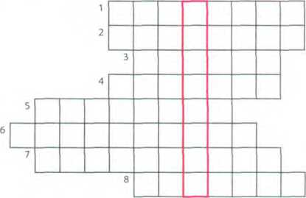

c Solve the clues and complete the puzzle.
- Users have to enter a togain
access to a network.
- A protects a companỵ intranet
from outside attacks.
- A is a person who uses their
Computer skills to enter computers and netvvorks illegally.
- can infect your files and corrupt
ỵour hard drive.
- You can dovvnload from the Net; this type of software is available free of charge
but protected by Copyright.
6 Encoding data so that unauthorized users can't read ít is known as
7 This company uses techniques to decode (or decipher) secret data.
8 Most is designed to obtain personal information vvithout the user's permission.

Safety Online for children

A E Listen to an interview with Diana Wilson, a member of the Internet Safety Foundation. Which answers (a or b) best describe what she says?
1 Parents should make children aware of
a the benehts and risks of the Internet. b the risks of the Internet.
2 A web hlter program can be used to
a prevent access to sites with inappropriate content.
b rate web content with labels (s milar to the way movies are rated).
3 lf kids spend too much time Online or suffer from internet addiction, parents should
a stop them using the Internet. b look for help from specialists.

B Listen again and complete the interviewer's notes.
'Risks
Manipulation of children
Invasions of(l)
Distribution of indecent or (2) materĩaì
Violence and racist (ĩ)

4 The history of hacking
Solutions
There are websites (d) at children.
Internet (5) programs ỉet
parents block objectionable websites.
Mebsites should (é) — - — their
content ^/itb a label. from cbild-triendly to overlẵ only.

A Read Part 1 of the text and answer these questions.
1 Which hacking case inspired the film WũrGames?
2 When did Cơptain Zơp hack into the Pentagon?
3 Why was Nicholas Whitelỵ arrested in 1988?
4 How old was the hacker that broke into the us defence Computer in 1989?
The history of hacking - Part 1
1971 - John Draper discovered that a whistle offered in boxes of Cap’n Crunch breakíast cereal períectly generated the 2,600Hz signal used by the AT&T phone company. He started to make íree calls. He was arrested in 1972 but wasn’t sent to prison.
1974 - Kevin Mitnick, a legend among hackers, began hacking into banking networks and altering the credit reports of his enemies. He didn’t expect that his most íamous exploit - hacking into the North American Deíense Command in Colorado Springs - vvould inspire the film War Games in 1983.
1981 - lan Murphy, a 23-year-old known as Captain Zap on the networks, hacked into the White House and the Pentagon.
1987 -The IBM international network was paralysed by a hacker’s Christmas message.
1988 - The Union Bank of Switzerland almost lost £32 million to hackers. Nicholas Whitely was arrested in connection with virus spreading.
1989 -A fìfteen-year-old hacker cracked the us deíence Computer.
1991 - Kevin Poulsen. known as Dark Dante on the networks. was accused of stealing military fìles.

Bí I In pairs, discuss which of the cases in Part 1 you had heard of.

Which do you think is the most important?

Language work: the past simple

A Look at the HELP box and then complete Part 2 of the text with the past simple form of the verbs in the box.
show spread steal launch attempt overwrite be iníect affect
The history of hacking - Part 2
1992 - David L Smith (I) prosecuted íor vvriting the Melissa virus, which was passed in
Word files sent Via email.
1997 - The German Chaos Computer Club (2) — onTV hovv to obtain money írom
bank accounts.
2000 -A Russĩan hacker (3) to extort $100,000 from Online music retailer CD Universe.
A Canadian hacker (4) ^ a massive denial of Service attack against vvebsites like
Yahoo! and Amazon.
The ILoveYou virus, cleverly disguised as a love letter, (5) so quickly that email
had to be shut dovvn in many companies.The worm (6) image and sound files vvith a copy of itselí.
2001 - The Code Red worm (7) _ tens of thousands of machines.
2006 - Hackers (8) the credit card details of almost 20,000 AT&T Online customers.
Hovvever, subscribers to its Service (9) (not)
HELP box
Past simple
- We use the past simple to talk about a complete action or event which happened at a specihc time in the past.
Past 1 Now
He begơn hơcking in 1974.
- We form the past simple of regular verbs bỵ adding -(e)d to the infinitive,
John Draper discovered ihot a whistle...
We form questions and negatives using did/didn't.
When did Captain Zap hack in to the Pentagon?
He didn't expect thot his most famous exploit...
There are many verbs which are irregular in the past simple.
Kevin Mitnick began hơcking into...
For a list of irregular verbs, see page 166.
We form questions and negatives for irregular verbs in the same waỵ as for regular verbs. The exception is be (see belovv).
When didKevinMitnick begin hacking ìnto ...1 He didn't begin hacking until ì 974.
We form the past passive with the past simple of be + the past participle.
IBM international was paralysed by hơckers.
He wasn't sent to prison.
Why was Nicholos VVhitely arrested in 1998?

B Read these landmarks in the history of the Internet and prepare at least fìve questions in the past simple.
txartyp\e:What happened in 1969?WhatdidRayTomlinsondoin 1971?
1969 - The us Deíense Department establishes ARPANET, a network connecting research centres.
1971 - Ray Tomlinson of BBN invents an email program to send messages across a network. The @ sign is chosen for its at meaning.
1981 - IBM sells the first IBM PC. BITNET provides email and file transíers to universities.
1982 - TCP/IP is adopted as the Standard language of the Internet.
1988 - Jarkko Oikarinen develops the System known as Internet Relay Chat (IRC).
1991 - CERN {Conseil Européen pour la Recherche Nucléaire') creates the World Wide Web.
1998 - The Internet 2 network is born. It can handle data and video at high speed but is not a public network.
1999 - Online banking, e-commerce and MP3 music become popular.
2001 - Napster, vvhose software allows users to share downloaded music, maintains that It does not perpetrate or encourage music piracy. However, a judge rules that Napster's technology is an iníringement of music Copyright.
2004 - Network Solutions begins offering 100-year domain registration.
2006 - Americans spend over Sì00 billion shopping Online.

c r^l In pairs, ask and answer your questions.

Ổ Internet issues

A rì In small groups, look at the list of cybercrimes and discuss these questions.
- Which crimes are the most dangerous?
- Is it fair or uníair to paỵ for the songs, videos, books or articles that ỵou download? Should Copyright iníringemenĩ be allowed Online?
- What measures can be taken by governments to stop cybercrime?
- Do you think governments have the right to censor material on the Internet?
- Personal iníormation such as our address, salary, and civil and criminal records is held in databases by marketing companies. Is our.privacy in danger?
Cybercrimes
- Piracy - the illegal copy and distribution of copyrighted soítvvare, games OI music íiles
- Plagiarism and theft of intellectual property - pretending that someone else's work is your own
- Spreading of malicious software
- Phishing (passvvord harvesting fìshing) - getting passvvords for Online bank accounts or credit card numbers í by using emails that look like they are from real organizations, but are in fact fake; people believe the message ! is from their bank and send their security details
- IP spoofing - making one Computer look like another in order to gain unauthorized access
- Cyberstalking ■ Online harassment or abuse, mainly in Chat rooms or newsgroups
- Distribution of indecent or offensive material

Write a summary of your discussion on PowerPoint and present it to the
rest of the class.

Now visit www.cambridge.org/elt/ict for an Online task.
Creative software
Unit
page
20 Graphics and design 100
21 Desktop publishing 105
22 Multimedia 110
23 Webdesign 114

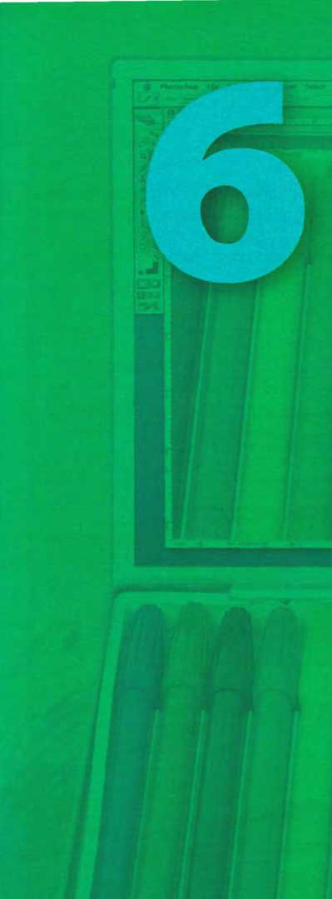
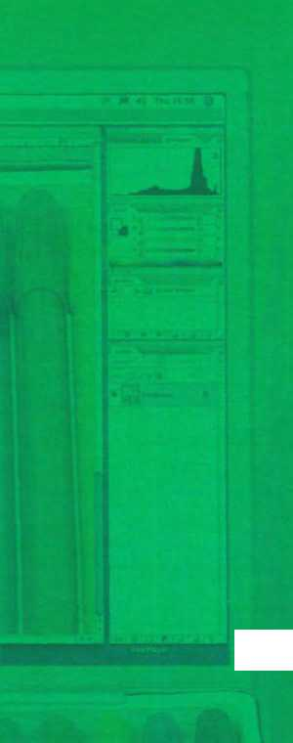

Learning objectives
In this module, you will:
learn and use vocabulary related to graphics software.
learn how to describe graphics.
study the basic íeatures and vocabulary related to desktop publishing.
discuss the pros and cons of e-publishing versus paper publishing.
write a letter to a newspaper.
learn about the main components and applications of multimedia Systems.
learn how to use conditional sentences.
study the basic principles of web page design.
learn how to use common modal verbs.
design a mock home page for a college or company.

unit20 Graphics and design

Computer graphics

A I- j In pairs, look at the Computer graphics (a-d) and discuss these questions.
1 Which of these Computer graphics are three-dimensional (3-D)?
2 What are the advantages of creating 3-D images?
3 Which types of proíessional might use the Computer graphics (a-d)?
4 Who else uses Computer graphics in their job? How do theỵ use them?
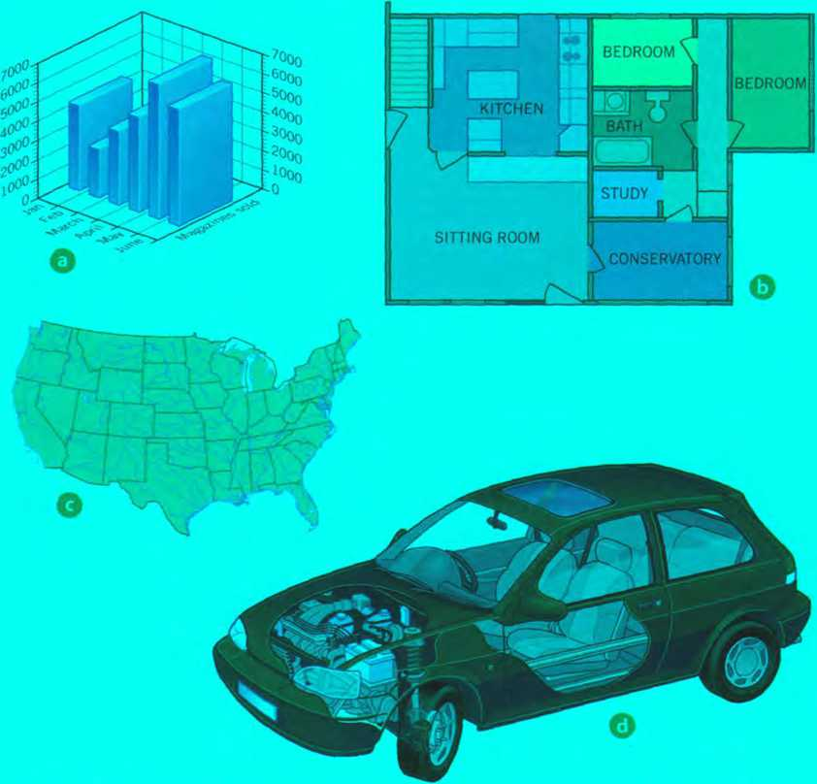

B Read the text on page 101 and check your answers to 3 and 4 in A.

c Read the text again and answer these questions.
- What are the diherences between rơster graphics and vecror graphics?
- Which graphics fĩle formats are mentioned?
- What is compositingỊ
- What does CAD stand for?
- What are the benehts of using graphics in the car industrỵ?
- What tỵpe of graphics software is used to make maps or 3-D models of the Earth?
- Who uses Computer animation? How?
Computer graphics

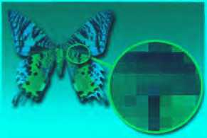
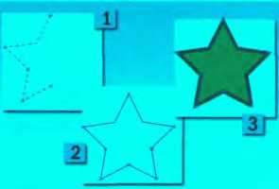
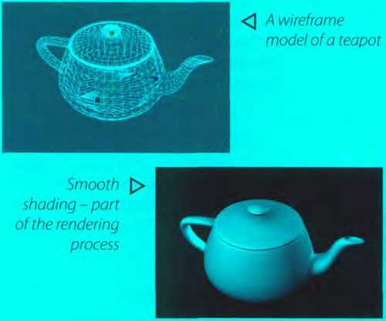
Computer graphics are pictures and drawings produced by Computer. There are two main categories:
Raster graphics, or bitmaps, are stored as a collection of pixels. The sharpness of an image depends on the density of pixels, or resolution. For example, text or pictures that are scaled up - that is, made bigger - may show jagged edges. Paint and photo-editing programs like Adobe Photoshop focus on the manipulation of bitmaps. Popular raster íormats are JPEG, GIF and TIFF.
Vector graphics represent images through the use of geometric objects, such as lines, curves and polygons, based on mathematical equations.They can be changed or scaled without losing quality. Vector data can be handled by dravving programs like Adobe lllustrator, Corel Draw or Macromedia Freehand. EPS is the most popular file format for exchanging vector drawings.
<3 Bitmapgraphics are composed of pixels, each of which contains speciíic colour information
Vector graphics [> consist oípoints, lines and curves vvhich, when combined, can form complex objects
Almost all Computer users use some form of graphics. Home users and proíessional artists use image-editing programs to manipulate images. For example, you can add íilters (special effects) to your íavourite photos, or you can composite images. Compositing is combining parts of diííerent images to create a single image. Graphic artists and designers use drawing programs to create freehand drawings and illustrations for books or for the Web. Businesspeople use presentation graphics to make iníormation more interesting visually - graphs and diagrams can be more effective ways of communicating with clients than lists of íĩgures. Electrical engineers use graphics to design circuits in order to present data in a more understandable form. Mechanical engineers use CAD (Computer Aided Design) soítvvare to develop, model and test car designs before the actual parts are made.This can save a lot of time and money.
CAD is also used in the aerospace, architecture and industrial sectors to design everything from aeroplanes and buildings to consumer Products. Designers start a project by making a wireframe, a representation shovving the outlines of all edges in a transparent drawing.They then speciíy and íĩll the suríaces to give the appearance of a 3-D solid object with volume. This is known as solid modelling. Next, theỵ add paint, colour and fĩIters to achieve the desired 'look and feeF: this is called texturing the object. Pinally, theỵ render the object to make it look real. Rendering includes lighting and shading as well as effects that simulate shadows and reílections.
Computer art, or digital art, is used in adverts and TV programmes. Artists and scientists use special graphic applets to create amazing íractals. Fractals are geometrical patterns that are repeated at small scales to generate irregular shapes, some of which describe objects from nature. Government agencies use GIS (Geographic lnformation Systems) to understand geographic data and then plan the use of land or predict natural disasĩers. Cartographers use GIS to make detailed maps. Animators use Computer animation software to create animated cartoons or add effects in movies and
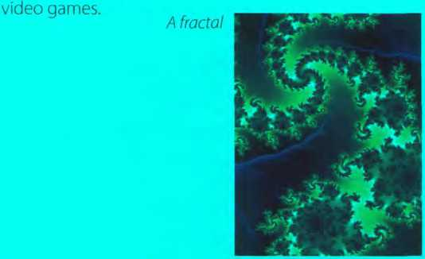
D
1 2
3
4
5
6
Match the words (1-6) with the dehnitions (a-f).
resolution jagged filters wireframe renderĩng íractals
a
b
d
e
f
special effects that can be applied to pictures
a technique that generates realistic reílections, shadovvs and highlights geometrical hgures with special properties
irregular or uneven
the number of pixels in an image
the drawing of a model by using íeatures like edges or contour lines
E
In pairs, discuss which application of Computer graphics you think is the
most important or useíul. Give reasons for your answers.

2 Language work: the -ing form

A Look at the HELP box and decide if the -ing forms in these sentences are gerunds, present participles or adjectives. Write g, pp or a.
- PCs generate graphics by períorming mathematical calculations on data.
- Businesspeople use graphics to make iníormation more interesting visually.
- Graphs and diagtams can be more effective ways oícommunicating with clients than lists of íĩgures.
- She is designing a logo íũf the company.
- lí you need to make a presentation, I suggest using PowerPoint.
- The Internet is a network linking other networks.
B Correct the mistakes in these sentences.There are seven mistakes in total.
- Computer animation is the process of create objects which move across the screen.
- Texturing involves add paint, colour and hlters to drawings and designs.
- You can open the colour palette by click on the corresponding icon.
- CAD programs are very fast at to períorm drawing func tions.
- A lot of ti me and moneỵ is saved bỵ tesĩ a car design before to make the product.
- To render refers to the techniques used to make realistic images.

HELPbox
The -ing form
We use the -ing form in three ways:
l Rendering ìncludes lighting andshading
- We are designing a new car on Computer.
- ĩhey use special applets ro creơte amazing íractals.
- In I, rendering is a gerund (see below), acting as the subjecĩ. Lighting and shading are also gerunds, acting as the obýecrs A gerunơ reíers to an activity or process.
- In 2, designing s a present participle. This is used in continuous tenses (in the above example, the present continuous) and reduced relatĩve clauses.
... a represenỉation shovving theoutlinesofolledges.
(= which shows theoutlines...)
- In 3,amazing is an adjective.
We use gerunds in the following ways:
- As the subject of a verb
Compositing is combining parts ofdifferenĩ images to create a single imơge.
- As the complement of the subject
Compositing is combining parts ofdifferent images
- As the object of a verb / enjoy editing pictures.
- After a preposition
Dedgners statt a proịect by making a wireframe.
- As the complement of a verb
This course involves painting and drawing in various media.
- Some verbs are followed by the gerund, not by the iníinitive (e.g. avoid, íancy, íĩnish give up hate, imagine, involve, keep, look forward to. mind suggest enjoy)

1
2
3
4
8

3 The toolbox

A E Listen to an extract from an Online tutorial about graphics programs and ansvver these questions.
What is a toolbox in graphics software?
What are graphics primitives?
What sort of ơttributes. or characteristics, can be used in graphical objects?
What does translơtion mean?

E Listen again and complete this extract from the web version of the tutorial.

Graphics programs usually have a toolbox - a collection of drawing and (1) tools
that enable you to type, (2) , draw,
paint, edit, move, and view images on the Computer.
The basic shapes which are used to (3) graphical objects are called prímitives. These are usually geometric, such as tines between two points, arcs, circles, polygons, ellipses and even text. Furthermore, you can specity the attríbutes of each primitive, such as its colour, line type, fill area, interior style and so on.
The various tools in a toolbox usually appear together as pop-up icons in a menu or palette. To use one, you
activate it by (4) on it. For exampte,
if you want to (5) a rectangle, you
activate the rectangle tool, and the pop-up options give you the possibility of (6) rectangles with square or rounded corners.
You can transform an object by translating, (7) or scaling it. Translation means
moving an object to a different location. Rotation is (8) the object around an axis. For
example, you may need to rotate an object 90 or 180 degrees to fit the drawing. (9) is
making the object larger or smaller.

c Match the tools from the Photoshop toolbox (1-10) with the functions (a-j).
a cut down the dimensions of a picture
1
2
3
4
5
6
7
8
9
10
Marquee select tools
Move tool
Crop tool
Paintbrush, pencil
Eraser
Paint bucket
Tỵpe tool
Colour picker (Eyedropper)
Zoom
Colour tools and palette
b select a particular part of an image (you can choose different shapes for selection)
c hll in an area with a colour
d control the íoreground and background colour
e select a specihc colour in a photo
f magniíy areas of an image when you are domg close, detailed work
g delete the part of the picture you drag it over
h insert text into your docurnent
i draw and paint in different shapes and patterns
j move a selection or entire layer by dragging it with your mouse

Choosing graphics software
Work in pairs. Student A chooses a task from the list (1-6) and describes ít. Student B chooses the most appropriate graphics software íor the task (a-f) and gives reasons for his or her choice. Swap roles. Look at the text on page 101 and the Useful language box to help you.
1 to edit and retouch photos
- to create illustrations and dravvings for a magazine
- to prepare slideshovvs for training sessions or coníerences
- to make mechanical designs and architectural plans
- to create dynamic simulations and special effects for films, TV, advertisements and games
- to analyse geographic data and make maps
a Computer animation software, for example
3-D Studio Max
b GIS software, for example ArcView
c Presentation software, for example PovverPoint
d A CAD package, for example AutoCAD
e Vector graphics software, for example Freehand
f A paint and image-editing program, for example Photoshop

Describing graphics
Useíul language
lflneed to..., whatsoftware vvould you recommend?
For that kind oftask, the best thing vvouldbe...
It allovvs you to... and...
I wouldn't recommend... because...
A goodprogram ofthis type is ...
Look at the images (1-4), which show the stages involved in drawing a plane using Computer software. Write a short description of stages 2,3 and 4. Look at the text on page 101 and the Useful language box to help you.

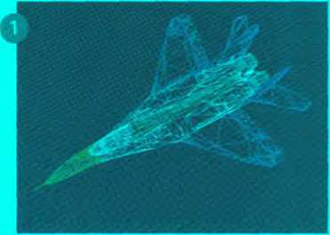
Wireframe
This drst image shows ơ wireframe model, probơbly made using CAD software. A wireframe is a dravving with edges andcontourlinẽs. The parts of the plơne ơre shown in different colours (violet, green, blue, etc).

Useful language
This picture shovvs...
In this (next) stơge...
The designer has used...
This stage is called...
Rendering techniques include...
As ơ hnishing touch,...

Solid modelling Texturing the model Rendering
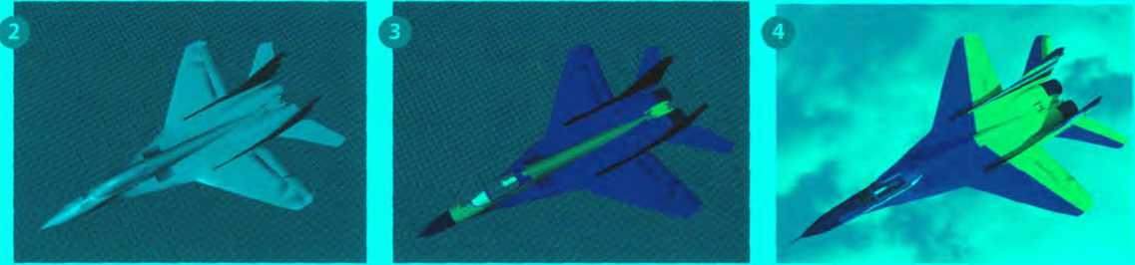

Unit2i Desktop publishing

What is desktop publishing?

A I In pairs, discuss these questions.
- What kind of documents can be produced with a desktop publishing System?
- Page laỵout software is the key component of a desktop publishing System. Which file types can be imported into a page layout program?

B Read the text and check your answers to A.
What is desktop publishing?

Desktop publishing (DTP) refers to the use of computers to design and publish books, brochures, newsletters, magaãnes and other printed pieces. DTP is really a combination of several different processes including word Processing, graphic design, information design, output and pre-press technologies, and sometimes image manipulation.
DTP centres around a page layout program. Typically, a layout program is used to import texts created in word Processing programs; charts and graphs from spreadsheet programs; drawings and illustrations created in CAD, drawing or paint programs; and photographs. The program is then used to combine and arrange them all on a page. It is this ability to manipulate so many different items and control how they are used that makes layout software so popular and useíul. However, modern word processors also have publishing capabilities, meaning the line separating such programs from DTP software is becoming less clear. In general, though, powerful new publishing Systems use high-quality scalable fonts and give you control over tỵpographic íeatures such as kerning (adjusting the spaces between letters to achieve even, consistent spacing). Another key feature of DTP software is text flow the ability to put text around graphic objects in a variety of ways.
Once composed, DTP documents are printed on a laser printer or on a high-resolution imagesetter (see Unit 8). For transíer to a commercial printer, the documents are generally saved in their native page layout format (such as Adobe InDesign or QuarkXPress) or as PDF íìles. PDF stands for Portable Document Format and allows people to view, search and print documents exactlỵ as the publisher intended - you don't need to have the software and íonts used to create it. PDF íiles can be published and distributed anywhere: in print, attached to email, posted on websites, or on DVD. To open a PDF file, only the Adobe Acrobat Reader (a free download) is required.
In modern commercial printing, DTP íiles are output directly to the printing plates without using film as an interrnediate step.This new technology is known as Computer-To-Plate (CTP) or direct to plate, and the machine that generates plates for a printing press is called a platesetter. CTP machines are expensive, so most people take their íĩles to a Service bureau, a company that specializes in printing other people's íiles. Service bureaux offer a full range of scanning and printing Solutions.

- Read the text again and answer these questions.
- What type of software is used for the creation of DTP documents?
- What are three differences between DTP software and word processors?
- What is a PDF and what can it do?
- Which program do you need to view a PDF document?
- Why do people send their DTP files to Service bureaux?

Find words in the text with the following meanings.
D
1
2
3
4 5
E
shape, styleandsizeofatypeface, forexampleCourier at lOpt the process of adjusting the space between characters
íeature that enables you to wrap text around images on the page metal surtaces that carrỵ the image to be printed
a machine that creates the printing plates

In pairs, discuss the question VVhatis desktop publishing? in as much

detail as you can. Then look back at the text on page 105 to see how much you remembered.

Language work: order ofadjectives

A Look at the HELP box and then make phrases using the words in the correct order.
Example: Computer programmer / ỵoung / clever a cìever, young Computer progrơmmer
- software / desktop pubiishing / user-íriendly
- hardvvare company / reliable / young
- German / industry / graphic design
- word Processing / applications / modern
5 Sony / new / music player / portable
HELP box
Order of adjectives
- Adjectives usually come beíore the noun (also known as the headword).
They give you control over typographic íeatures
Portransíertoa commercial printer, thedocumentis...
- However, adjectives come after certain verbs (e.g. be, look, become, seem, sound), complementing the subject of the sentence.
CTP machines are expensive
- Adjectives can also complement the object of the sentence.
This makes layout software popular and useíul
- This is the usual order of adjectives before a noun:
Opinion | Description | Origin/Place | Material | Purpose | Headword
povveríul | new |  |  | publishing | Systems
high-quality | scalable |  |  |  | fonts
 | thin | American | aluminium | printing | plates

Adjectíves are ordered from the most subjective (e.g. nice) to the most objective (e.g. Silicon).
Brand names iMicrosoít Sony, etc.) are considered adjectives of origin/place.
If there is more than one adjective in a sentence, they are usually separated by commas, unless the adjective forms an integral part of the headword (A íantastic, thin, SonyMP3 plơyer.ì

B Translate these sentences into your own language. How does the use of adjectives differ from English? Think about word order and whether the form of the adjective changes or not.
- DTP refers to the use of personal computers to produce high-quality printed documents.
- A page layout application is used to import text from word Processing programs and pictures from painting and dravving programs.
- In modern commercĩal printing, DTP lĩles are output directly to the printing plates.

c In pairs, choose an object in your classroom or office and think of three words to describe it. Put the words into the correct order and make a sentence.
Example: PC: black, old, DELL
On my desk l've got an old, black, DELL PC.

Steps in a DTP publỉcatỉon

A Look at this extract from an Online tutorial for DTP publishing. Put the steps in the creation of a DTP document (a—f) into the correct order.
10 2 □ 3 □ 4 □ 5 □ 6 □
0 First, the DTP designer decides the )
First, the DTP designer decides the basic íorm of the document (the type of document, general design, colour, fonts, images required, etc.).
0 VVhen the text has been edited, the designer imports the pictures and uses precise tooLs to position, scale, crop and rotate all the items.

0 The last step is to ta ke the files to a Service bureau, which will print the publication.
o The next step is to type the text directly or to import it from a word Processing program like VVord or WordPerfect.

Q To create the DTP document, the designer begins by selecting a template or by specifying the settings of a new document (the page size, margins, columns, paragraph stytes, master pages, etc.).
o Once the file is composed and saved, the
designer has to prepare it for printing,
which involves veritying the colour
specitication, creating a PostScript or PDF file, exporting the file in HTML format for the Web, checking prooís, etc.

B Ik] Listen to the audio from the Online tutorial and check your answers to A.

Label the íeatures of this page designed with Adobe InDesign (1-6) with words írom the box.
toolbox layout of master pages dimensions guide horizontal ruler scanned photo
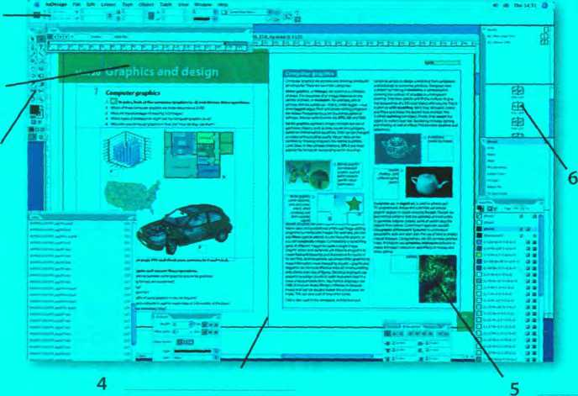
1
2
3

Wrìting a letter

A Although most written communication these days is carried out by email, letters are still appropriate for more formal correspondence. Look at this letter. What is the writer asking for?
Rhondda High School
31 Prospect Place, Cardiff, Wales
0 The Editor 0 28th March 2008
El Independiente
Moratin, 7
28006 Madrid
Spain
ộ Dear Sir/Madam,
0 We are writing to ask if you can heLp us with our school project. We are doing a survey of the major newspapers in the European Union to find out which Computer Systems and desktop publishing programs they use.
o We would be very grateíul if you could tell us which hardware, graphic design and page layout software you use at El Independíente. Could you also tell us how long your Online edition has been running for? Thank you very much in advance.
0 We look forward to hearing from you.
0 Yours faithfully,
Ktftheríi*e PữìA/eM
Katherine Powell, student representative
B Match the parts of the letter (a-h) with the descriptions (1 -8).
1 0 For example, 28^{lh} March 2008, or 28 March 2008, or 28/03/2008.
- o This is usually in the top right corner of the letter, but can be in the centre if it's a printed letterhead.
- o State the reason for writing: /am/ We are writing to .../We are currently...
- o This should be included on the left hand side of the page, beíore the greeting.
- ũ Sldrt w\th DearSir/Mơdam or DearMr/Mrs/Ms... Use Ms ifỵou are not sure if the recipient is married or not. It is oíten best to ưse Ms, as Mrs can cause offence.
- o Make any requests or askany questions you need to: We wou!dbegratefulifyoucould..., Could you also ...
- o Request íurther contact, if necessary: We/I look forwơrd to hearing from yoư./Pleơse contact usby...
- ũ Ityou have started the letter with the person's name (for example, DearMrRobinson), then end with Yours sincerely. If you do not know the name of the recipient, end with Yours faithfully.
c ^2 Write a letter to a local newspaper, asking for iníormation about the hardware they use in their production, the page layout software they use, and the data Communications Systems they use. Use A and B above to help you.

E-publishing versus paper publishing
A Look at this web extract about e-publishing. What examples of e-publishing can you fìnd in the text?
◄ ►
Publishing has existed in its current form for centuries. Ever since paper was fìrst invented, human beings have found ways of using it to pass on messages to each other. Books, magazines and newspapers are now part of our everyday lives, but with the invention of the Internet and the speed of new technological advances, the world of publishing is changing. Online newspapers and magazines, blogs, and even e-book readers are changing the way we get iníormation. But will we ever stop picking up a good old-fashioned newspaper?
E-publishing versus paper publishing - who will win?
B Work in teams. Team A prepares a list of the advantages of traditional publishing over e-publishing. Team B prepares a list of the advantages of
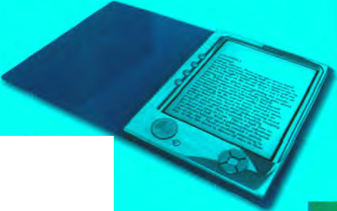
e-publishing over traditional publishing. Use your dictionary, the Internet and your teacher to help you.
c I- I Debate your ideas. Which team has the most convincing position?
An e-book, the electronic equivalent ofa printed book
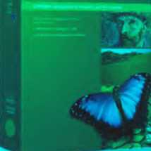

Unit22 Multimedia

Multiple forms oímedia
EncartaX
Prenium

Bin

pairs, discuss these questions.
- What different types of content are combined in multimedia applications?
- How many Products can you think of that incorporate multimedia? Makea list.

Components and System requirements
A E

Listen to a sales assistant in a Computer shop explaining to a customer the

System requirements needed to run multimedia software. Which answers (a or b) best describe what she says?
- Multimedia is deíĩned as
a the integration of video and telecommunications with traditional computing.
b the integration of text, graphics, audio, video and animation in a single application.
- With multimedia encyclopedias,
a ỵou have more fun but ỵou learn more slowly.
b you get much more involved than with print encyclopedias.
- Interactive games
a use multimedia and Virtual reality íeatures.
b do not require much RAM memory.

Listen again and complete this diagram of a multimedia System.
Multimedia System
Software
Hardvvare
(1)
CPU and a lot of RAM
Peripherals
Windows Media Player or Apple QuickTime
- monitor
DVD drive
(3)__ ca rd
Adobe Plash for
- ________ media
Large hard drive
Stereo
(4) or
(5)__
Audio, videoand
- ___ software
Hypermedia databases
CD and DVD
(9) ______
(6)

Multimedia magic!

A Read the text and match the headings (1-4) with the gaps at the start of each paragraph (a-d).
- Sound, Music, MIDI
- Products full of pictures, action and sound
- Creating and editing movies
- The potential of multimedia
Multimedia magicỉ
a
Multimedia applications are used in all sorts of helds. For example, museums, banks and estate agents often have iníormation kiosks that use multimedia; companies produce training programs on optical discs; businesspeople use Microsoít PovverPoint to create slideshows; and teachers use multimedia to make video projects or to teach subjects like art and music. Theỵ have all found that moving images and sound can involve viewers emotionally as well as inform them, helping make their message more memorable.
The power of multimedia software resides in hypertext, hypermedia and interactivity (meaning the user is involved in the programme). lf you click on a hypertext link, ỵou can jump to another screen with more iníormation about a particular subject. Hypermedia is similar, but also uses graphics, audio and video as hypertext elements.
b
As long as ỵour Computer has a sound card, you can use it to capture sounds in digital íormat and play them back. Sound cards offer two important capabilities: a built-in stereo synthesizer and a sỵstem called MIDI, or Musical Instrument Digital Interíace, which allows electronic musical Instruments to communicate with computers. A Digital Audio Workstation (DAW) lets you mix and record several tracks of digital audio.
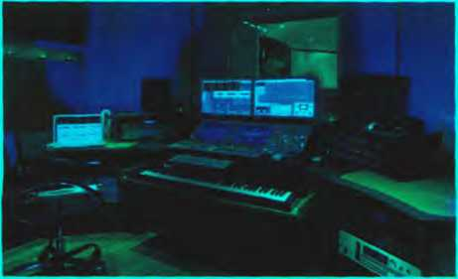

MIDI allows your Computer to communicate with electronic keyboards and otherdevices
You can also listen to music on your PC, or transíer it to a portable MP3 player. MP3 is short for MPEG audio layer 3, a Standard format that compresses audio files. If you want to create ỵour own MP3 files from CDs, ỵou must have a CD ripper, a program that extracts music tracks and saves them on disk as MP3s.
Audio is becoming a key element of the Web. Many radio stations broadcast live over the Internet using streaming audio technology, which lets you listen to audio in a continuous stream while it is being transmitted. The broadcast of an event over the Web, for example a concert, is called a vvebcast. Be aware that you won't be able to play audio and video on the Web unless you have a plug-in like RealPlayer or QuickTime.
c
Video is another important part of multimedia. Video computing reíers to recording, manipulating and storing video in digital íormat If you wanted to make a movie on your Computer, íirst you would need to capture images with a digital video camera and then transíer them to your Computer. Next, you would need a video editing program like IMovie to cut your íavourite segments, re-sequence the clips and add transitions and other effects. Finally, you could save your movie on a DVD or post it on websites like YouTube and Google Video.
d
Multimedia is used to produce dictionaries and encyclopedias.They often come on DVDs, but some are also available on the Web. A good example is the Grolier Online Encyclopedia, which contains thousands of articles, animations, sounds, dỵnamĩc maps and hỵperlinks. Simílarlỵ, the Encyclopedia Britannica is now available Online, and a concise version is available for IPods, PDAs and mobile phones. Educational courses on history, Science and toreign languages are also available on DVD. Pinallỵ, if you like entertainment, youll love the latest multimedia video games with surround sound, music soundtracks, and even him extracts.

B Correct the technical mistakes in these sentences.
- Multimedia training software is distributed on magnetic disks.
- You need to have MIDI on your Computer to hear speech and music.
- A stereo sỵnthesizer allows your Computer to communicate with electronic musical Instruments.
- A CD ripper converts CDs to live streams.
- The Encyclopedia Britannica is only available on DVD.

c Match the words (1-5) with the dehnitions (a-e).
a the process of manipulating video images
- hypertext
- hypermedia
- streaming
- webcast
- videoediting
b lext with links vvhich take you to other pages
c a technique for playing sound and video fĩles while theỵ're downloading
d a live event broadcast over the Internet
e a form of enriched multimedia which allows an Interactive and dynamic linking of visual and audio elements

¹ í Language work: conditional sentences

A Look at the HELP box and then complete these sentences with the correct form of the verbs in brackets.
- lf you (bring)your digital video camera, we can make a movie on my PC.
- You won't be able to play those video files if you (not have) the correct plug-in.
- lf the marketing manager (have) PovverPoint, she could make more effective
presentations.
- lf I could aííord it, I (buỵ) a new game console.
- lf I had the money, I (invest) in some new multimedia software.
HELP box
Conditional sentences
We use conditional sentences to express that the action in the main clause can onlỵ take place if a certain condition is íulhlled (see below for examples).They are introduced by if, unless and as long as. Unless means if • not and as long as means provided/providing (that).
You won't be able to play audio and video on the Web unless ỵou have a plug-in like RealPlayer or QuickTime.
(= if you don't have a plug-in ...)
There are two types of conditional sentence.
• The first conditional (for real or possible situations).
If A happens B will happen
(present simple) (will in positive or negative + verb)
lfyou like entertainment, you will love the latest multimedia video gơmes.
In the main clause, we can also have a modal (for example, can or must) or an imperative.
líyou want to createyour own MP3 Tdes from your CDs, you must have a CD ripper.
The second conditional (for more hypothetical situations).
If A happened B vvould happen
(past simple) (would in positive or negative + verb)
líyou vvanted to make ơ movie onyour Computer, hrst you would/you'dneed to...
In the main clause, we can also use other modals (e.g. could, should, might), depending on the meaning.
lí the verb be appears in the if clause, we often use were instead of was, even if the pronoun is I, he, she or it
lf I were you, Td get a new MP3 player.

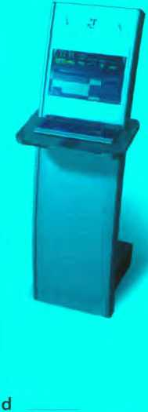
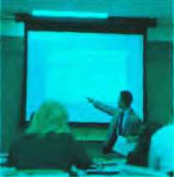
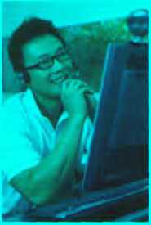
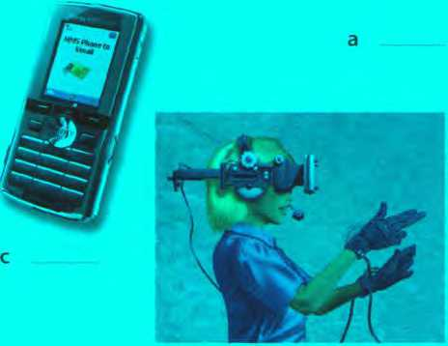
bD
b
5 An MMS mobile phone
B In pairs, discuss how multimedia is used in the situations above and then present your ideas to the rest of the class. Look at the Useỉul language box to help you.

In pairs, discuss these questions. Use the second conditional.
What would you do if...
1 ỵou had a digital video camera?
Ifl had ơ digital video cơ me ra, Id...
2 you had a home recording studio?
3 you couldn't afford an iPod but you wanted an MP3 player?
4 ỵou won the lotterỵ?
5 someone stole your laptop?

Applications otmultímedia

A Match the descriptions (1-5) with the pictures (a-e).
1 Virtual reality
2 Distance learning
3 A business presentation
4 A touch screen information kiosk
Useful language
!n distancelearning, multìmediơ is used to...
Information kiosks take advantage ofmultimedia in order to...
In Virtualreality, the use oímultimedia allowsyou to...
With 3G mobile phones, you can ...
Slide presentations integrate ơ wide range oímediơ, such as...
c A írỉend who writes a blog has asked you to contribute a post about the use of multimedia now and in the íuture. Write a post (80-120 words) summarizing what multimedia is, what it can do, and your predictions for what it might be able to do in the future. Try to use at least two conditional sentences.

Unit23 Webdesign


A typicơl home page

In pairs, discuss these questỉons.
1 Why do companies have websites?
2 What is the diííerence between a website and a web pogel
3 What is a home page?
4 Do you have a blog or personal website? Describe the home page to your partner.
T&ỈỈQPt
ƯKXTRXLAKD
G« a Gveibon? AM n on xahooĩ An»wer>
Wab mao* VMM Local 8hop(M>0 mota
Search:
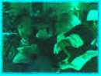
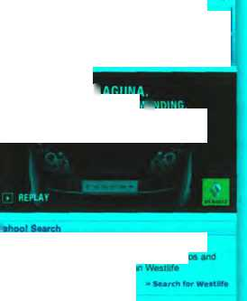

The Yahoo! home pơge
Q Antw>r* C-
Chat
<7 BMMa
9 rinance
- • >**r
9 Gamei ặ«~- Q Ho«o*<oo»i
UTmm ữ HHM w Hy Vahool
Ẹ?».w.
15 Propenv □ »«■*»“-““• ®SK« 5"
(3 Tr«wl
All Yahoo! Sarvỉcoa
Advertiae with ua
■ Saerch Advertìsing
• Međia Solutiont
Poatumđ SarviQM
UKoeỊy
’»«eow^ ’
• 4 heí Om uoa 0« the CnmtmM «we teMOR
HH movio or Xmaa turkey?
Christmas-thameti movie Vrod Claus' kicks oH the leetive season ai ctnema* thu WMk. but II <t worth Maing? - More â 'Haman’ - lee the V»|*< • inía*v<w A •A»**M<n4t«n of )e»e ỉamei - »c
R»OM Mr M man u<!»
I wew wwnan "engHih’
Mma spon Entertainment VMao
- Puntkng scanOal hiti Labour* rabnga
- Proteiten đemand dMth ÍOÍ UK teocher
- Domnad Turidah aKnar k*s 57
- Bhutto gears !<x Paktatani poR 0* Shanl <or boycott
- EU says disappointeơ wtth Iran nucloar taiks
- Schooiflirt to be burted »fl« 16 yaars
- Murđeređ UK atudenCí tlatmale mainU/ci innocence
- Mo^ UK M~I woKd n«wi Oữđrv enough VI AMwera
Man<«* nse ÍOO: M3J ( : JI'.) stndi Quom: I ao I
MartaiplaQO
EJ "•" I @-“'"H' | Ồ Wtllhtr I

Chack ycur mau status Sign in Prao mart Sign Up
Yahoo! Search
www.nowlaguna.co.uk
Yahoo! Pulaa
NEWRENAULTLAGUNA YOU CAN HE«R BE T00 DEMANDIHG.
Be A Better Mưsic Bu«
Get the lataat muBic videos anc rníormaticn on Wéstlrfe
Pay nothing until Sọnng 2006 Most Popular Videos on Yahoo! Mưsic
Tum over a ne* laaf at Preeơom Pinance this Autumn .
.. - — n I enn» I Mi«

2 l/Keb page design

A Read the text on page 115 and find the following.
- the language used to create web documents
- the type of software that lets you design web pages without vvriting HTML codes
- the format invented by Adobe to distribute text files over the Internet
- a method of displaying multiple HTML documents in the same browser window
- three common graphics formats used on websites
- three popular íormats used to store and play back video
Web page design



HTML and web editors
The code behĩnd most web pages is HTML (hypertext markup language), which consists of commands called tags.Tags are placed around pieces of text to tell the web browser how to displaỵ text or pictures.You can view the source HTML code of a web page by choosing the Pũge Source option in ỵour web browser. But ỵou needn't learn HTML in order to build your own website. Instead, you can use a word processor with web design capabilities or a dedicated web editor like Macromedia Dreamvveaver or Microsoít ProntPage. Web editors are user-íriendly and WYSIWYG (Whơt You Seels Whaĩ You Get). Different buttons and menu items let you design a page without writing HTML.
HTML files have this basic structure:
start with <HTML>
have heading text that begins with <HEAD>, which has a title enclosed between tags and ends with </HEAD>
have body text that starts with <B0DY>, where you place the contents of the actual document (i.e. text, images, links, etc.) and ends with </B0DY>
end with </HTML>
You can create links to other web pages by using the tag <A HREF="filename">active text</A>
Some basic HTML source code
Hil I lỉv« in Madrỉd. bin I
W.M bom in ĨSIMỊOĨA
Marina’s web page
ỉsngoa, Iht txausìl City
My Hobbies ...
I lĩke nnisic and Computer!: I can play the Spamsh giitar and I love I.abn daucnm I have a uioiuitaui bike bnt 111) íavounte sport is íootball
My studles...
I shidy at Polilciiiica Uiũvenáty. Madnd My íavoiuite mibjeclK ae Matbs. Physics. Aeromnitks and EnạlislL I have studied Enạlish toi ten years In the hitiưe 1 would lĩke to be an engineer
My ravoiulte City ...
Zara?oza ú a BiuUicuUural uioderu and ancicnt City. witb 700.000 inhabĩtants and over 2000 years oi history Muslims. CliristiaiK and Jews Ined toỊetiiei ni peace fot many ceutnries II is Êunoiis for its niiidgai style. Uie Pilai Basilica. and the channũis chai aclei of its people
HTML file displơyed as a web page

Web page elements
There are a number of different elements that you can use on a web page:
- Text - displayed in a variety of íonts and sizes. Most text files are available in two íormats: HTML or PDF (the portable document íormat that can be viewed with Acrobat Reader).
- Background - the underlying colours and pattems of a web page
- Tables - with columns and rows, used to position images and text on a page
- Frames - rectangular areas that allow the display of different pages in the same browser window
- Cascading Style Sheets (CSS) - a mechanism for adding styles to web documents. You could use HTML code to speciíy the font, text styles and background colour. Nowadays, however, it is more common to use CSS.This makes it easy to apply presentation changes across a website.
- Graphics, clip art, icons, background templates, wallpaper, and transparent images - common íormats are .jpg Qoint photographic experts group), ideal for pictures with many colours, .gif (graphics interchange format), ideal for pictures with fewer colours, and .png (portable netvvork graphics), which supports 16 million colours.
- Hyperlinks - highlighted text or pictures (buttons, image maps, etc.) ĩhaĩ act as links to other pages. If you want to share iníormation with people, you can use RSS feeds and provide readers with a link to the feed. RSS allows subscribers to receive updates of blogs, news, podcasts, etc. Beíore going live, you should check thaĩ all the links work.

Audio, video and animation
Manỵ websites now incorporate audio íìles, and if you're designing a site, you may like to insert songs, podcasts, etc. The most common audio íormats are: .wav (Windows wave audio format), .ra (RealAudio file) and .mp3 (MPEG-1 Audio Layer-3).
Full-motion video is stored in these formats: .avi (audio video interleave), .mov (QuickTime movie) and .mpg (moving picture experts group).
lí ỵou want to inject something special into your web pages, ỵou can use Adobe Flash to include interactive animations and streaming audio. Additionally, you can insert Java applets - small programs that enable the creation of Interactive files. Animations are made up of a series of independent pictures put together in sequence to look like moving pictures. To see or hear all these files, you must have the right plug-in, an auxiliary program that expands the capabilities of your web browser.

B Read the text again and then match the sentence beginnings (1-6) with the correct endings (a-f).
- Instructions in HTML
- Cascading Stỵle Sheets are the way
- A hyperlink is any clickable text,
- A plug-in is a small program
- Java applets are used to provide
- RSS feeds are summaries of web content
a image or button that takes you to another place on the Web.
b used for handling audio, video and animation íìles.
c are called tags.
d Interactive íeatures to web applications.
e to dehne the presentation of web pages, from fonts and colours to page layout.
f published in the Really Simple Syndication íormat for download.

Language work: modal verbs

A Underline all the modal verbs ỉn the text on page 115 and then look at the HELP box. Which modal verb from the HELP box does not appear in the text? Can you think of any other modal verbs?
HELP box
Modal verbs
We use modal verbs to add extra meaning to the main verb.They are followed by iníinitive without to. Modal verbs are used in the following ways:
- To express a possibility
You can/could use Adobe Plash to include interactive animations.
You may like to insert songs, podcasts, etc.
The price of Dreamweaver might go down next month.
Can and could are oíten interchangeable when talking about possibility. May and might are used to express weaker possibilities and often come beíore the verb like to mean Itispossibleyou vvilllike.
- To ask for permission
Can/Could/May I useyour mobile phone?
- To talk about ability
They ơre looking for artists who can draw and design web pages.
Could is the past tense of can and is used to talk about ability in the past.
- To talk about obligation or necessitỵ
To see or hear all these fìles, you must hơve the rightplug-in.
... you needn't learn HTML in order to build yourown vvebsite.
Needn't means don't need to or don't have to and is used to express a lack of obligation.
- To give advice (see Unit 7)
Before going live, you should check that all the links work.
May is more formal than can or could
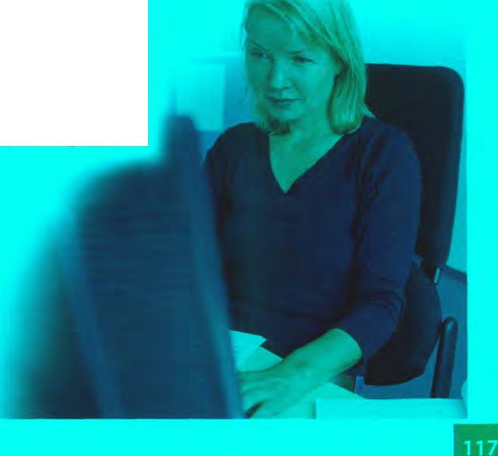
A web designer ơt work

B Complete these sentences with suitable modal verbs írom the HELP box. There may be more than one possible answer.
- With Java, I include some attractive banners on mỵ website.
- With a web editor, you .... create a web document easilỵ.
- These daỵs, you learn how to use complicated HTML codes. Modern web design
software is user-friendly and converts a visual layout into HTML code.
- Once live, you update your vvebsite regularlỵ.
- To view a PDF file, you have Adobe Acrobat Reader.
- Websites with graphics are more inviting than those vvritten in plain text, so ỵou like to insert some graphics into your documents.
- I use your laptop? I need to print out this report.

c n In pairs, dỉscuss at least two things
- you can now do more easily because of the Internet.
- you could do better if you had a faster internet connection.
- that may/might happen to the Internet in the next ten years.
- you must consider when designing a website.
- you should take into account when choosing which PC to buy.

4 Designing a website

A ^] In pairs, think about your favourite websites and discuss these questions.
- Do you like the way they are designed? Give reasons for your answer.
- What elements do you think a good website should have? Make a list.

B BiJ Listen to an interview with a web designer describing how to design a website and put these steps into the correct order.
n Write and format the text
i I ] Decide the content and structure for the website
Q Publish the website
0 Insert Computer graphics and sounds
Q Keep the website updated
Q Link related pages to each other using hyperlinks
c Q Listenagainanddecidewhetherthesedesignguidelinesarerightor wrong. Tick the correct box.
1
2
3
4
5
6
7
8
 | Right | Wrong
Plan your website careíully. | ũ
Use a web editor. It will make it easier to create your pages.
Insert photos or animations just to make the pages look attractive.
Place a large number of graphics on your pages.
Use very bright colours.
Put a lot of links on one page. |  | □
Check that all the links on your web pages are correct.
Once they are published, update your pages regularly.

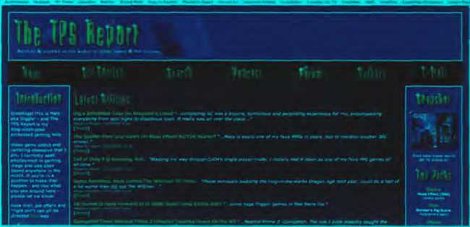
A screenshot from wwwApsreport.co.uk
own blog - to write a diary of your thoughts or to share your
D In small groups, collect information about your college or company and design a home page for it. Follow the instructions from the interview with the web designer.

3 Blogs
A ri In pairs, discuss these questions.
- What is a blog?
- Which blogs do you read regularly?
B Look at the screenshot from tpsreport.co.uk, a popular gaming blog. Can you see any design differences between blogs and normal websites?
c u Imagine you wanted to start ỹour own blog. In pairs, discuss these questions.
- Why would ỵou start your
expertise on a partĩcular topic?
- What types of media would you include - text, phoĩos, video, audio (including podcasts)?
- Would you insert links to other blogs? Which ones?
- Would you focus on a particular suoject or have a mix of several topics?
- Which site would you use to host your blog?
D L Write an entry íor the blog you've described in c (80-100 words). Introduce
the blog to the world and talk about why you've started it.
Now visit www.cambridge.org/elt/ict for an Online task.

Unit24 Program design and Computer languages

Programming
#include <stdio.h>
main()
{

A O In pairs, discuss what you think programming is.
printf("good morning\n"); }
B Look at the dehnition of programming in the Glossary. Is it similar to yours?
Steps in programming ĩhis c program tells the
Computer to print the

A Match the words (1-5) with the dehnitions (a-e). messơge'good morning'
- flowchart
- source code
- compiler
- machinecode
5 debugging
a Program instructions written in a particular Computer language
b The techniques of detecting and correcting errors (or bugs) which may occur in programs
c A diagram representing the successive logical steps of the program
d A special program which converts the source program into machine code - the only language understood by the processor
e The basic instructions understood by computers; it consists of 1 s and Os (binary code)

students on a training course about how a program is written and check your answers to A.

c HU Listen again and put these steps ìnto the correct order.
ũ Write instructions in a programming language
ũ Prepare documentation
E Understand the problem and plan a solution
□ Make a flowchart of the program
ũ Compile the program (to turn it into machine code)
D Test and debug the program

D £ Listen again and make detailed notes. In pairs, use your notes to write a short explanation of what each step in c means.

Computer languages

A Read the text. How many high-level Computer languages are mentioned?
Computer languages
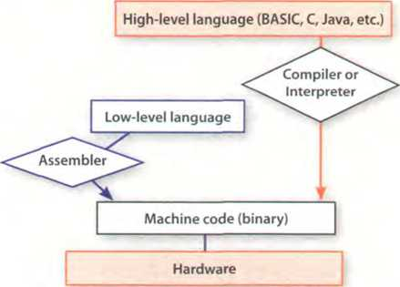
Uníortunately for us, computers can't understand spoken English or anỵ other natural language.The only language they can understand directly is machine code, which consists of 1 s and Os (binarỵ code).
Machine code is too diíhcult to write. For this reason, we use sỵmbolic languages to communicate instructions to the Computer. For example, assembly languages use abbreviations such as ADD, SUB, MPY to represent instructions.The program is then translated into machine code bỵ a piece of software called an assembler. Machine code and assembly languages are called low-level languages because they are closer to the hardware. They are quite complex and restricted to particular machines.To make the programs easier to vvrite, and to overcome the problem of intercommunication between different tỵpes of Computer, software developers designed high-level languages, which are closer to the English language. Here are some examples:
- FORTRAN was developed by IBM in 1954 and is still used for scientiíic and engineering applications.
- COBOL (Common Business Oriented Language) was developed in 1959 and is mainlỵ used for business applications.
- BASIC was developed in the 1960s and was widely used in microcomputer programming because it was easy to learn. Visual BASIC is a modern version of the old BASIC language, used to build graphical elements such as buttons and windows in Windows programs.
- PASCAL was created in 1971. It is used in universities to teach the fundamentals of programming.
- c was developed in the 1980s at AT&T. It is used to write System software, graphics and commercial applications. C++ is a version of c which incorporates object-oriented programming: the programmer concentrates on particular things (a piece of text, a graphic or a table, etc.) and gives each object íunctions which can be altered wiĩhout changing the entire program. For example, to add a new graphics format, the programmer needs to rework just the graphics object. This makes programs easier to modiíy.
- Java was designed by Sun in 1995 to run on the Web. Java applets provide animation and Interactive íeatures on web pages. (See Unit 25)
Programs written in high-level languages must be translated into machine code bỵ a compiler or an interpreter. A compiler translates the source code into object code - that is, it converts the entire program into machine code in one go. On the other hand, an interpreter translates the source code line by line as the program is running.
It is important not to coníuse programming languages with markup languages, used to create web documents. Markup languages use instructions, known as markup tags to format and link text files. Some examples include:
- HTML, which allows us to describe how iníormation will be displaỵed on web pages.
- XML, which stands for EXtensible Markup Language. While HTML uses pre-defined tags, XML enables us to deíìne our own tags; it is not limited by a fixed set of tags.
- VoiceXML, which makes Web content accessible vía voice and phone. VoiceXML is used to create voice applications that run on the phone, whereas HTML is used to create visual applications (for example, web pages).
<xml>
- name> Andrea Finch </name>
- homework> Write a paragraph describing the c language </homework>
</xml>
In this XML example we hơve creơted two new tags: <name> and <homework>

B Read the text again and answer these questions.
- Do computers understand human languages? Whỵ? / Why not?
- What is the fu nctĩon of an ơssembler?
- Whỵ did software developers design high-level languages?
- Which language is used to teach programming techniques?
- What is the difference between a compiler and an interpreter?
- Why are HTML and VoiceXML called mơrkup languages?

Complete these sentences with a Computer language from the text.
- allows us to create our own tags to describe our data better. We aren't constrained by a pre-defìned set of tags the way we are with HTML
- IBM developed in the 1950s. It was the first high-levellanguage in data
Processing.
- applets are small programs ĩhat run automaticallỵ on web pages and let you
watch animated characters, play games, etc.
- is the HTML of the voice web. Instead of using a web browser and a keyboard, you
interact with a voice browser by listening to pre-recorded audio output and sending audio input through a telephone.
- This language is widely used in the business community. For example, the statement ADD VAT to NET-PRICE could be used in a program.

" Word building

Look at the words in the boxes. Are they nouns, verbs or adjectives? Write n, V or adj next to each word.There may be more than one possible answer. Complete the sentences with words from the boxes.
program programmers programming programmable
- is the process of writing a program using a Computer language.
- A Computer is a set of instructions that tells the Computer hovv to do a speciíĩc
task.
- Most Computer make a plan of the program before theỵ write it.
- A keyboard allows the user to coníigure the layout and meaning of the keys.
compile compiler compilation
- Programs written in a high-level language require - that is, translation into
machine code, the language understood by the processor.
- A source program is converted into machine code by software called a
- Programmers usually their programs to generate an object program and diagnose
possible errors.
bug
debug debugger debugging
- Any error or malfunction of a Computer program is known as a
- A is a program used to test and other programs.
- The process of going through the code to identiíy the cause of errors and fixing them is called
c to períorm
the simulation.

Language work: the inhnitive

A Look at the HELP box and then make sentences using these prompts.
- not easy / write instructions in COBOL lt's not easy to write instructions in COBOL.
- expensive / set up a data-processing area
- advisable/test the programs under different conditions
- unusual / write a program that works correctlỵ the first time it's tested
- important / use a good debugger to fix errors
- easy / learn Visual BASIC

B Choose the correct words (a-c) to complete these sentences.
- We use high-level languages because machine code is too difficult
, understand and debug.
a read b reading c to read
- I went on the course how to be a better programmer.
a learn b to learn c for to learn
- l'm not interested in that
Computer language.
a learn b learning c to learn
- He reíuses the project
with me.
a do b doing c to do
- The engineers warned the emploỵees not the cables.
a touch b touching c totouch
- They may not to the coníerence.
a come b Corning c tocome
- spyware can make your PC a períorm b períorming
- This program is too slow a do b todo c fordoing

HELPbox
The inhnitive
The infìnitive with to is used in the following ways:
- To express purpose
We use symbolic languơges to communicate instructions to the Computer.
(= in order to communicate...)
Not:... for to communicate
- After adjectives
BASIC was vvidely used in the pơst because it was easy to learn
Mơchine code is too difficult to write
(= not easy enough to write)
- After certain verbs (e.g. afford, demand, plan, agree, expect, promise, appear, hope, refuse, arrange, learn, try, decide, manage)
A lot oícompanies are now trying to develop voice applications for web access.
- After the object of certain verbs (e.g. advise, encourage, allow, expect, tell, ask, invite, want, enable, order, warn)
HTML allows us to describe how iníormation will be displayed on web pơges.
The bare inhnitive (without to) is used in the following ways:
- After modal verbs (e.g. can, could, may, might, will, would, must, should)
Uníortunately, computers can't understand spoken English.
High-level languages must be translated into machine code.
- After the object with the verbs make and let
Programs make computers pertorm specidc tasks.
more slowly.

c ¹ In pairs, discuss something
- you can't aííord to buy at the moment.
- you've arranged to do this weekend.
- you've learnt to do in the lasr year.
- you'd advise someone to do beíore buying a new PC.
- youd expect to be mcluded with an antì-virus package.
- you can do with Java applets.

6 Visual BASIC and VoiceXML

Work in pairs. Student A reads about Visual BASIC, Student B reads about
VoiceXML. Try not to look at your partner's text. Complete your part of the table.

Student A
Visual BASIC vvas developed by Microsoít in 1990. The name BASIC stands for Beginner's All-purpose Symbolic Instruction Code. The adjective Visual refers to the technique used to create a graphical user interíace. Instead of writing a lot of instructions to describe interíace elements, you just add pre-dehned objects such as buttons, icons and dialog boxes. It enables programmers to create a variety of Windows applications.
Student B
VoiceXML (EXtensible Markup Language) was created in 2000 to make web content accessible Via the telephone. For input, it uses
I voice recognition. For output, it uses pre- recorded audio content and text-to-speech.
Applications:
- voice portals, where you can hear iníormation about sports, news, tralTic, etc.
- voice-enabled intranets (private networks)
- voice e-commerce
- home appliances controlled by voice

Visual BASIC VoiceXML
What does Visual BASIC / VoiceXML stand for?
When was it developed?
What are its main features?
What is it used fbr?

Ask your partner about the other language and complete the table.

Java applets

A Match the examples of Java programs, known as applets, (a-e) with the descriptions (1-5).
- This Land Rover applet allovvs you to change the look of the vehicle.
- The Pythagoras theorem applet gives the proof of the pỵthagorean theorem vviĩhout words. It allows ỵou to manipulate triangles and go through the steps of the geometrical proof.
- The Jman for Java applet permits medical researchers to view sequential MRI (Magnetic Resonance Images) of the brain.
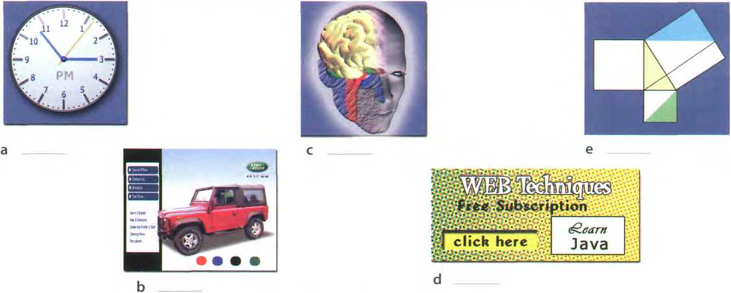
4 An analogue clock applet displays the time according to the web user's Computer and lets ỵou set the colours and style of the hands and numbers.
5 A banner applet displays graphic images on websites in order to advertise Products or Services.


TheJavơlogo

B Match the terms (1-5) with the dehnitions (a-e).
- Java
- applet
- plug-in
- platíorm-independent
- object-oriented programming
a an auxiliary program that enables web browsers to support new content, for example animation
b software that can run on any operating System
c an island in Indonesia, coffee (in American slang), and a programming language for internet applications
d a Computer programming technique that allovvs the creation of objects that interact with each other and can be used as the íoundaĩion of others; used to create graphical user interíaces
e a small Java application, usually designed to run automaticallỵ within a web page

The Java language

A These statements about Java are all false. Read the text and correct them.
- Java was invented by Microsoít.
- With the interpreter, a program is first converted into Java bỵtecodes.
- Java is not compatible with most computing platíorms.
- The Java language is single-threadec, one part executing at a time.
- Java has no competitors.
- Flash files are called animơtions.
The Java language
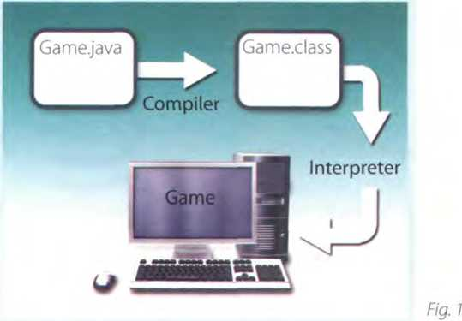
Java is a programming language developed by Sun Microsystems, speciallỵ designed to run on the Web. Java programs (called applets) let ỵou vvatch animated characters and moving text, play music, and interact with iníormation on the screen (for example, control animations and select options).

Characteristics of the Java language
Java is an object-oriented language, similar to C++, but more dynamic and simpliíied to eliminate possible programming errors. A Java program is both compiled and interpreted (see Unit 24). First, the source code (a file with a java extension) is compiled and converted into a format called bytecode (a file with a .class extension), which can then be executed by a Java interpreter (see Fig. I). Compiled Java code can run on most computers because there are Java interpreters, known as Java Virtual Machines, for most operating Systems.
Java is multi-threaded, meaning a Java program can have multiple threads (parts) - that is, many different things Processing independently and continuouslỵ.This enables the program to make the best use of available CPU power.

Why is Java popular?
Most programmers like Java because it allows them to write applets which make web pages more Interactive and attractive. Theỵ can create graphical objects (for example, bar charts and diagrams) and new Controls (for example, check boxes and push buttons with special properties). A web page that uses Java can have sounds that play in real time, music that plays in the background, cartoon-stỵle animations, real-time video and Interactive games.
The Java Micro Edition platíorm (Java ME) is used in mobile devices. It provides Aexible tools to create applications that run on mobile phones, PDAs.TV set- top boxes and printers. Nowadaỵs, most phones are conhgured to use Java games.

Alternatives to Java
One alternative to Java is Microsoft's c#, pronounced 'C Sharp', a .NET language based on C++ with elements from Visual Basic and Java. There are no substantial differences betvveen c# and Java. When software developers do measurements on pieces of code, sometimes Java is íaster, sometimes c# is.
Another competitor is Adobe Flash technology, which supports graphics, a scripting language called ActionScript, and the streaming of audio and video. Flash is used to create animation and advertisements, to integrate video into web pages, and to develop rích internet applications such as portals. Flash íiles, ĩraditionally called flash movies, have a .swf file extension. Theỵ may be an object on a web page or be played in the stand-alone Flash Player.

B Match the words (1 -6) with the words (a-f) to make technical terms from the text.
1 | Java | 4 | web | a | applet | d | System
2 | operating | 5 | source | b | page | e | object
3 | programming | 6 | graphical | c | code | f | language

c Complete the sentences with words from the box.
interpreted animated coníigured used pronounced object-oriented compiled
- Java lets you watch characters on web pages.
- Javaisan language, similartoC++butmoredynamic.
- First, the source code of a Java program is into an intermediate íormat called bytecode. This is then bỵ any System possessing a Java interpreter.
- The Java ME platíorm is widely in mobile devices.
- Nowadays, most mobile phones are to use Java games.
- Microsoft's c# is a simpliíied version of c and C++ for the Web. It’s 'C Sharp'.

Language work: the -ed form

A Look at the HELP box and then put these verbs into the correct column.
stopped | asked
described | decided
produced | called
watched | executed
published | object-oriented
programmed | persuaded
conhgured | converted
arranged | designed

/t/ | /d/ | /id/

HELP box
The -edíorm
We use the -ed form in the following ways:
- To make the past simple (affĩrmative) of regular verbs
Sun Microsystems developed Javũ in 1995.
Remember that not all verbs in the past simple end in -ed. See page 166 for a list of irregular verbs. See Unit 19 for more about the past simple.
- To make the past participle of regular verbs
Plash is used to create animation.
- To make the adjectival form of some verbs
Java applets letyou wơtch animated characters.
The -ed is pronounced as:
- /t/ after voiceless sounds: /p/, /k/, /0/, /s/, /f/, /J7or /t]7. (e.g. developed, talked, pronounced)
- /d/ after voiced sounds: /b/, /g/, /ồ/, /z/, /v/, /dy, /I/, /r/; nasal consonants: /m/, /n/, /ỉ]/; and vowels (e.g. compiled, designed, simplified)
- /id/ after /t/ or /d/ (e.g. interpreted, mu/ti-threơded)

B Complete this extract from a lecture handout about Java with the correct form of the verbs in the box.
call be begin can decide rename have support develop base
The idea forJava started in 1990, when a team of software engineers at Sun Microsystems (1)to create a language for a handheld device that could control and interact with various kinds of electronic appliances, ranging from Nintendo Game Boys to VCRs and TV set-top boxes. They (2) an object-oriented prograrniTiing language that one of the
engineers, James Gosling, (3) - Oak, after the tree outside his
window. The device even (4)an animated character named Duke, who would go on to become Java’s mascot.
With the advent of the Web in 1993, the company made a web browser (5) - on the Oak language. Later on, this ỉanguage was adapted
to the Internet and (6) Java. The 1.0 version of Java was officially introduced by Sun in May 1995.
At that time, web pages (7) only display text, pictures and
hyperlinks. With the arrival of Java, web designers (8)able to include animation and Interactive programs on web pages. The first major application created withjava was the Hotjava browser. Thejava language (9) - - to attract serious attention from the internet community
and was soon (10)by Netscape Navigator and MS Internet Explorer. Today, Java is a hot technology that runs on multiple platforms, including smart cards, embedded devices, mobile phones and computers.
c tod Listen to an extract írom the lecture and check your answers to c. Listen careíully to the pronunciation of the verbs that end in -ed.

Your experience with computers
4

A Make notes about the different stages in your Computer history. Add more stages if you want to.

Example: 1990: Playedmyíirst Computer game. Itwơs...
Possible stages:
- First Computer game
- First Computer lesson at school/college
- First programming language learnt
- First software used
- First Computer course/qualiíication
- First job involving computers
- First steps on the Internet
- First Chat Online
Useful language
B . Aska partnerabout their Computer history.
Look at the Useful language box to help you.
Whendidyou fìrst...?
Hovvlong agodidyou ...?
Howold wereyou when...?
I started ...in...
I learnt... vvhen I was...
/ didn't use the Internet until...

Unit 26 Jobs in ICT

IT professionals

A Complete these definitions with jobs from the box.
software engineer Computer security specialist blog administrator helpdesktechnician DTPoperator hardware engineer networkadministrator webmaster
- A designs and develops IT devices.
- A vvrites Computer programs.
- A editsanddeletespostsmadebỵcontributorstoablog.
- A usespagelayoutsoftwaretoprepareelectronícfilesfor
publication.
- A manages the hardware and software that comprise a
network.
- A designs and maintains websites.
- A workswith companies to build secure Computer Systems.
- A helps end-users with their Computer problems in person,
by email or over the phone.

B BÍJ Listen to four people on a training course introducing themselves and talking about their jobs. Which job in A does each person do?
Speaker 1
Speaker 3
Speaker 2
Speaker 4

Job advertìsements

A In pairs, read the two job advertisements on page 130 and tick (✓) the

most important qualities and abilities (1 -10) for each job. Add more to the list if you can. Which three things do you think are most important for each job?
Senior programmer
- logical reasoning
- patience and tenacity
- being good with íigures
- imagination
- self-discipline
- accuracy
- leadership skills
- efficiencỵ
- creativity
- drawing skills
DTP operator
□

Discuss if you would like to apply for one of the jobs. Give reasons íor your

answers.


DIGITUM-UK
SENIOR PROGRAMMER required by DIGITUM- UK, a leading supplier of business Systems to the Insurance industry.
You will be able to work on the íull range of software development activities - analysis, design, coding, testing, debugging and implementation. At least two years’ experience oí COBOL or C++ is necessary.
As we are active in Europe. íluency in French, Italian or another European language is desirable.
Don’t miss this opportunity to learn new skills and develop your career.
Send your cv to CHRIS SCOTT, PERSONNEL MANAGER, DIGITUM-UK, 75 PARKSHILL STREET, LONDON SW14 3DE
You can visit our website at www.digitum-uk.com
' I - iii i ìa*,
DTP operator
required for a leading Ịinancial magazine.
We are Looking for a bright, competent QuarkXPress operator with at least three years' experience in design and layout. SkilLs in Photoshop, Freehand or Illustrator an advantage.
Ability to work in a team and to tight deadtines is vital.
Please apply in writing, with cv and samples of your work, to Tom Parker, Production Manager, Financial Monthly, Stockton Street, London EC1A 4WW Or apply Online:
Apply now

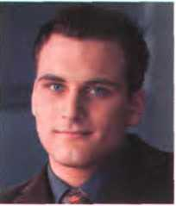

c Look at the Online profìle for Charles Graham. Which of the jobs above is most appropriate for him?
Charles Graham 22 years oLd
Professional summary
I graduated in 2004 with A levels in English, Art and Maths, and went on to do a course in graphic design and page layout at Highland Art School. Since 2006 Tve been a graphic designer for PromoPrint, a company specializing in publishing catalogues and promotional material, and have used Adobe InDesign and other DTP software.

A letter of applìcation

A Read the letter of application on page 131 and answer these questions.
- Which job is Sarah Brown applying for?
- Where did she see the advertisement?
- How long has she been working as a software engineer?
- What type of programs has she written?
- When did she spend three months in Spain?
Dear Mr Scott,
I am writing to apply for the position of Senior Programmer, which was advertised on 28th March in
The Times.
I graduated in May 2002 and did a work placement with British Gas as part of my degree. Beíore taking my present job I worked for a ỵear with NCR. I stayed in this job (I) March
2004
(2)the last three years I have been working as a software engineer for Intelligent Software. I have designed four programs in COBOL for commercial use, and (3)
January I have been writing programs in c for use in large retail chains.These have been very successful and we have won several new contracts in the UK and Europe on the strength of my team's success.
Two years (4)I spent three months in spain testing our programs and also made several visits to Italy, so I have a basic knowledge of Spanish and Italian. I now feel ready for more responsibility and more challenging work, and would welcome the opportunity to learn about a new industry.
I enclose my curriculum vitae. I will be available for an interview at any time.
for, since, ago, until
I look forward to hearing from you.
Yours sincerely,
5óxr^h ốroiAJ*n
Sarah Brown
B Look at the HELP box and then complete the letter with for, since, ago or until.
* ỉ A job interview
HELP box
- We use for to refer to a period of time.
Tve lived in Liverpool for dveyears.
- We use since to refer to a point in time.
Tve been unemployed since May 2005.
- We use ago with the past simple to say when something happened. We put ago after the time period.
I got married tìveyears ago
- We use until to mean up to a certain ti me.
I stayed at high school until I wơs 18.

Chris Scott, the Personnel Manager at Digitum-UK, is interviewing Sarah
5

Brown. Listen to part of the interview and complete his notes.
Name: Sarab Brown
Qua/ibìcations:
Degree in (ĩ)
Mston ơniựersity)
Languages: Basic Spanish and /ta//an
Work experience:
NCR: (2)(one year)
Software for:
Rrograms for: —
Database know/edge:
(5)
Rresentyob Nbrks for Intelligent Software Mriting programs in COBOL- and c
Reasons /or app/y/ng:

Language work: the present perỉect

A Look at the HELP box and then choose the correct words in brackets to complete these sentences.
1 He ('s never liked /'s never been liking) Maths.
2 They ('ve worked / 've been vvorking) on the project all day.
3 John ('s used /'s been using) the Computer for hours - he looks really tired.
4 How many emails (have you written / have you been writing) today?
5 She ('s written /'s been writing) this essay since 9 0'clock.
6 Theỵ ('ve interviewed / 've been interviewing) fìve candidates today.

HELPbox
Present períect simple
We form the present períect simple with have has + past participle.
I've used Microsoít Access for mơnyyears.
I hơven’t used Microsoỉt Access íoryeơrs.
We use this tense to talk about:
- States that started in the past and continue to the present.
Since 2006, l've been a Computer operator for PromoPrint.
- Past actions that continue to the present, where we put an emphasis on quantity (howmany).
I have designed four progrơms in COBOL.
- Personal experiences, especially with ever and never.
Have you ever worked with datơbơses?
I've never worked with databases.
Present perfect continuous
We form the present perfect continuous with have/has been + present participle.
Since Januơry l’ve been writing progrơms in c.
We use this tense to talk about:
- Actions which started in the past and are still happening.
For the last threeyeơrs l've been working as ơ software engineer for Intelligent Software.
- Past actions that continue to the present, where we put an emphasis on duration (how long).
She's been working all moming.
Contrast with the past simple
We use the past simple to talk about events that happened at a specihc time in the past that are now íinished.
/ graduated in May 2003.
Not: I hơvegradttatedin ...
I stơyed in this job untíl March 2004.
Twoyears ogo, I spent three months in spain.

B Put the verbs in brackets into the present perfect simple or past simple.
1 She (be)a software engineer since 2004.
- After graduation I (work)for a year with NCR.
- (you ever work)as an IT consultant?
- I (lose)mỵ PDA.
- I (send) my cv last Monday. Have you received it ỵet?
Unit 26
JcbsintCT

Applying for a job
A Lookatthejob advertisement for a webmaster at eJupiter. María Quintana is interested in applying. Use her curriculum vitae on page 155 to write a letter of application. Follow these steps:
Paragraph one: reason íor writing I am writing to apply for the position of...
Paragraph two: education and training
/ graduated in (date)... Icompleteda coursein...
Paragraph three: work experience For the pơst X years I hơve been ... Since XI have been...

cM Make questions using these prompts. In pairs, ask and answer the questions.
- ever / live or work in another country?
- ever / have a bad job intervievv?
- ever/do a job you hated?
- how long / study English?
- how long / use computers?
- how many emails / receive todaỵ?
- howmanyjobs/applyforthisyear?
Vacancies at eJupiter.co.uk
VVebmaster
We are seeking a Webmaster for eJupiter.co.uk, a company dedicated to e-commerce.
The successful candidate WĨU manage our website.
You will be responsible for making sure the web server runs properly, monitoring the traffic through the site, and designing and updating our web pages.
Experience of using HTML and Java is essential. Experience of Adobe PDF and Photoshop is an advantage. The successíul candidate will also have knowledge of web editors - MS FrontPage or equivalent.
Send your cv and a covering letter to dames Taylor,
eJupiter Computers. 37 Oak Street, London SW10 6XY
Paragraph four: personal skills
I spentxmonths in (country)... ,sol have knovvledge of(foreign languages).
I can ...
Paragraph five: reasons why ỵou are applỵing for this job
I now feelready to... and would vvelcome the opportunity to...
Paragraph six: closing / availability for interview
/enclose... Ilook forward to... I willbe available for an intervievv...

B Write your own cv in English, using María's cv as a guide.

Think of your ideal job and write a letter of application íor it. If you preíer, look on the Internet for real jobs and practise applying for those.

Ễ Now visit www.cambridge.org/elt/ict íor an Online task.
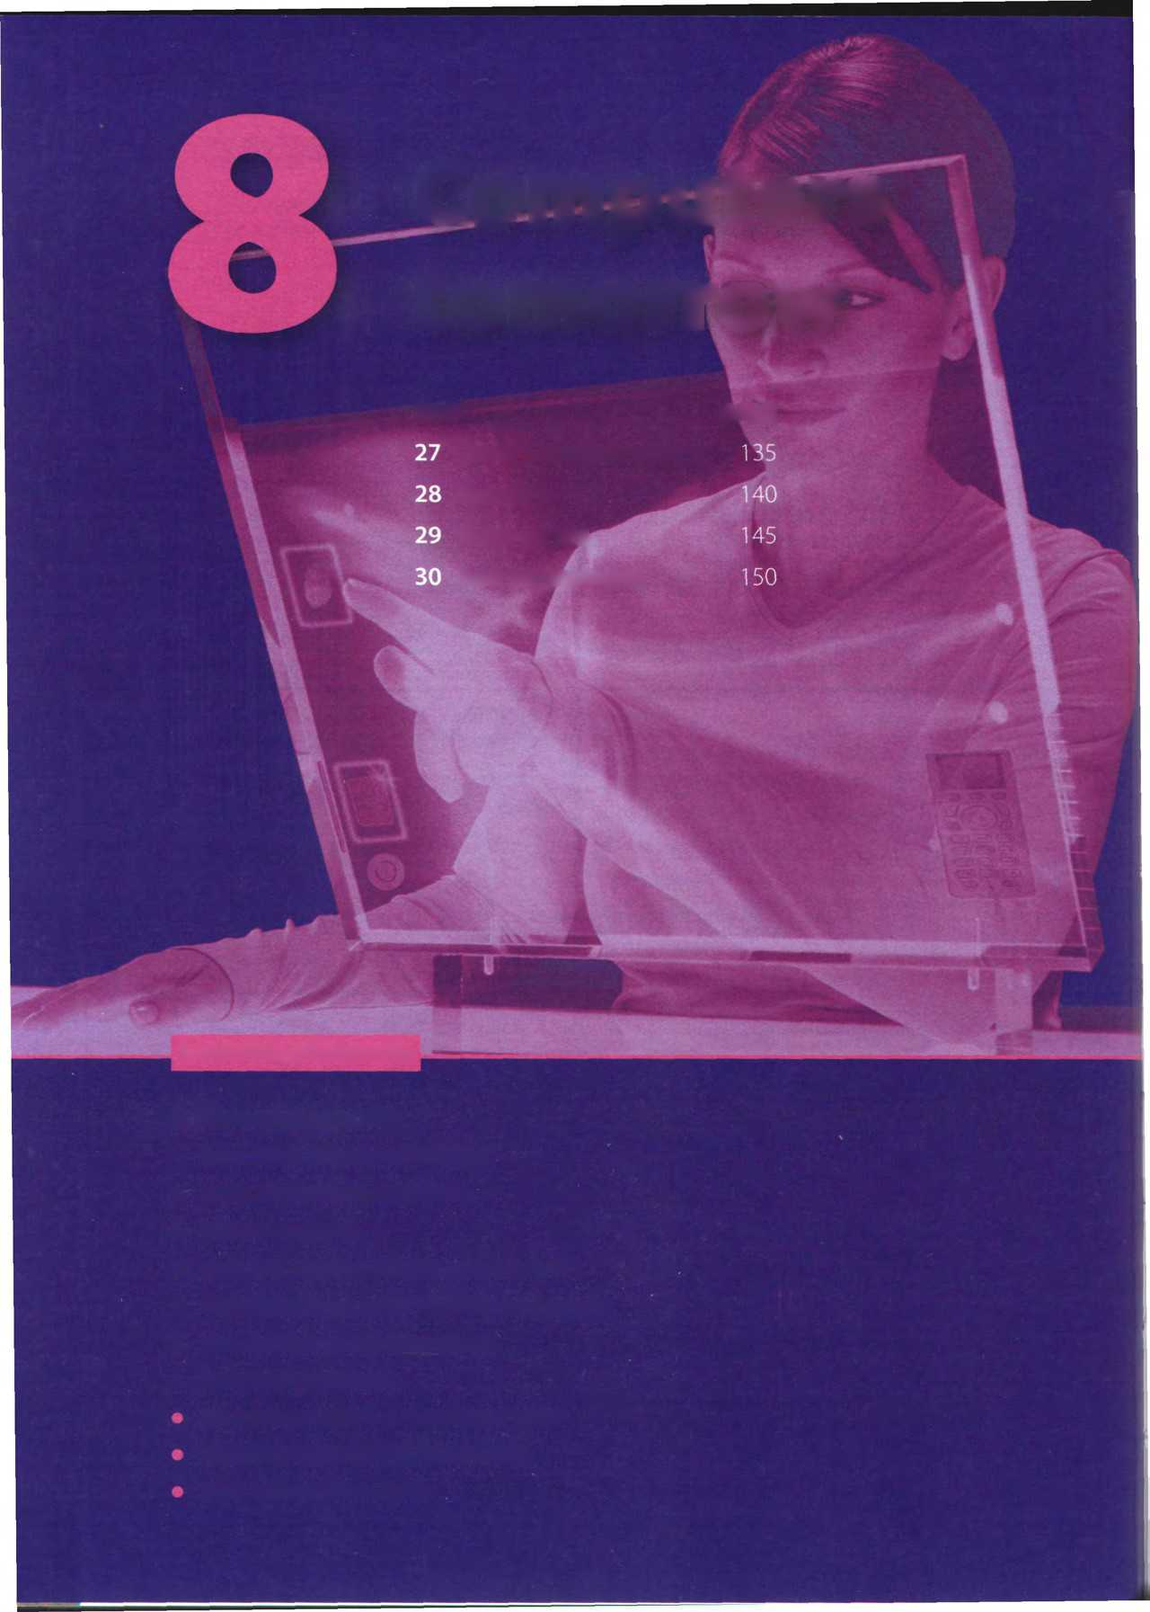
Computers
tomorrow
Unit
page
Learning objectives
Videogames; i New technologies
learn how to write a PorơndAgainst essay. make predictions about future trends. learn and use future forms.
Communication Systems Networks
In this module, you will:
• learn about different ICT Systems.
• study the basics of networking.
• describe networks.
• learn and use phrasal verbs common in ICT.
• describe diííerent game platíorms and genres.
• giveopinionsaboutvideogames.
• learn and use adverbs.
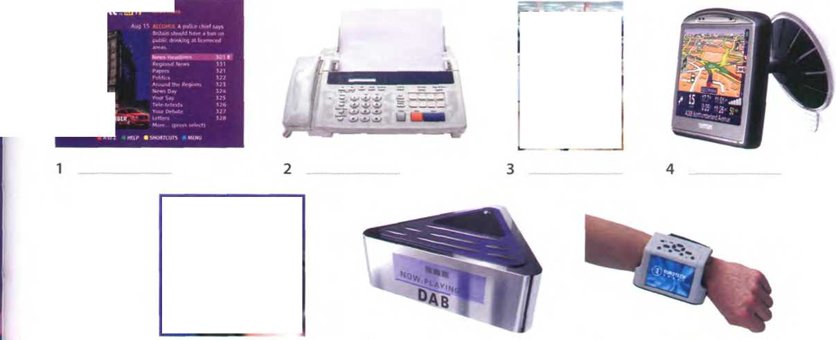
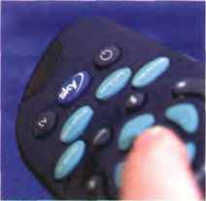
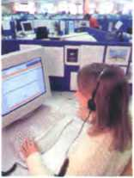
A
1
2
3
B
JJ
Ato2 rtP ■ SMMTCUTS
DOaaK
Fax GPS Callcentre Digital radio Teletext Wearable Computer Digital TV
tclctcxt C31I
PJOO

Unit27 Communication Systems

Informatỉon and Communications technologies (ICT)

I In pairs, discuss these questions.
What is an ICT System?
How many tỵpes of ICT System can ỵou think of? Make a list.
How can a PC be connected to another Computer?

Label the pictures (1-7) with the ICT Systems and Services in the box.

c Complete these sentences with words and phrases from B and then read the text on page 136 to check your answers.
- Digital Audio Broadcasting, or DAB, is the technology behind DAB is
intended to replace FM in the near íuture.
- are designed to be worn on the body or integrated into the user's clothing.
- Most existing TV sets can be upgraded to by connecting a dígital decoder.
- My grandíather is 75 and he still watches on TV to find out share prices, weather íorecasts and sports results.
- I work in a I receive incoming calls with iníormation inquiries. I also make
outgoing calls for telemarketing.
- Please complete this form and send it by or normal mail.
- I have a navigation System in my car but I don't use it very often. My town is small and I know it well.
Channels of communication

What are telecommunications?
Telecommunications reíers to the transmission of signals over a distance for the purpose of communication. Information is transmitted bỵ devices such as the telephone, radio, television, satellite, or Computer networks. Examples could be two people speaking on their mobile phone, a sales department sending a fax to a Client, or even someone reading the teletext pages onTV. But in the modern world, telecommunications mainly means transferring iníormation across the Internet, vía modem, phone lines or wireless networks.
Because of telecommunications, people can now work at home and communicate with their office by Computer and telephone. This is called teleworking. It has been predicted that about one third of all work could eventually be performed outside the workplace. In call centres, assistance or support is given to customers using the telephone, email or Online chats. They are also used for telemarketing, the process of selling goods and Services over the phone.

Digital TV and radio
In recent years, TV and radio broadcasting has been revolutionized bỵ developments in satellite and digital transmission. Digital TV is a way of transmitting pictures bỵ means of dĩgital signals, in contrast to the analogue signals used bỵ traditionalTV. Digital TV offers Interactive Services and pay multimedia - that is, it can transmit movies and shows toTV sets or PCs on a pay-per-view basis. It is also widescreen, meaning programmes are broadcast in a native 16:9 íormat instead of the old 4:3
íormat. Digital TV provides a better quality of picture and sound and allovvs broadcasters to deliver more channels.
Digital Terrestrial TV is received vía a set-top box, a device that decodes the signal received through the aerial. New technologies are being devised to allow you to vvatch TV on your mobile. For example, DMB (Digital Multimedia Broadcasting) and DVB-H (Digital Video Broadcast-Handheld) can send multimedia (radio,TV and data) to mobile devices.
Audio programs (music, news, sports, etc.) are also transmitted in a digital radio íormat called DAB (Digital Audio Broadcasting).

Mobile Communications
Thanks to vvireless connectivity, mobile phones and BlackBerrys now let ỵou check ỵour email, brovvse the Web and connect with home or company intranets, all vvithout wires.
The use of GPS in cars and PDAs is vvidespread, so you can easilỵ navigate in a íoreign City or find the nearest petrol station. In the next few ỵears, GPS chips vvill be incorporated into most mobile phones.
Another trend is vvearable computers. Can you imagine wearing a PC on your belt and getting email on ỵour sunglasses? Some devices are equipped with a vvireless modem, a keypad and a small screen; others are activated by voice.The users of wearable technology are sometimes even called cyborgs\The term was invented by Maníred Clỵnes and Nathan Kline in 1960 to describe cỵbernetic organisms - beings that are part robot, part human.

D Read the text again and fìnd the following.
- the device that allovvs PCs to communicate over telephone lines
- the practice of vvorking at home and communicating with the offìce by phone and Computer
- the term that reíers to the transmission of audio signals (radio) or audiovisual signals (television)
- five advantages of digital TV over traditional analogue TV
- two Systems that let you receive multimedia on your mobile phone
- the term that means vvithout wires
- devices that deliver email and phone Services to users on the move
- the meaning of the term cyborg

Language work: the passive

A Look at the HELP box. How do you make the passive in your language? How different is it to English?
HELPbox
The passive
We form the passive with the verb be + the past participle of the main verb. When we mention the agent, we use by.
The passive is often used in technical writing to give an objective tone.
- Present simple passive lnformơtion is transmitted by devices such as the telephone, radio, TVor
- Present continuous passive
New technologies are being devised to allowyou to vvơtch TVonyourmobile.
- Past simple passive
The term cyborg was invented by M Clynes and N Klinein 1960.
Past continuous passive
My TV was beìng repaired, so I couldrít watch the match.
Present períect passive
It has been predicted that about one third ofall work could eventuơlly be períormed outside the workplace.
Past períect passive
The System had been infected by ơ virus.
Future simple passive
In the next fewyears, GPS chips will also be incorporated into most mobile phones.
Modal verbs in the passive
It has been predicted that about one-third ofall work could eventuơlly be performed outside the workp!ace.

B Read the article and underline all the examples of the passive. What tenses are they?

A HACKER has been sent to jail for íraudulent use of credit card numbers. Nicholas Cook, 26, was arrested by police oíììcers near a bank cashpoint last month.
Eight months earlier, he had been caught copying hundreds of Computer
programs illegally. After an oíhcial inquiry, he was accused of software piracy and fined £5,000.
It is reported that in the last few years Cook has been sending malware (malicious software) to phone operators and attacking mobile phones to steal business and personal
iníormation. Cook has now been sentenced to three years in prison for stealing passwords and obtaining money by credit card fraud.
Government oíììcials say that new anti-hacking legislation will be introduced in the EU next year.

c Complete these sentences with the passive form of the verbs in brackets.
1 Microprocessors (make) of Silicon.
2 Call centres (use) to deal with telephone enquiries.
3 In recent ỵears, most mobile phones (equip) with Bluetooth.
4 GPS (develop) in the 1970s as a militarỵ navigation System.
- Sorry about the mess - the computers (replace)at the moment.
- In the near íuture, the Internet (access) more írequently from
PDAs and mobile phones than from desktop computers.
- Networks (can connect) vía satellite.
- I had to use my laptop this morning while my PC (fix)

VolP technology

A £ Listen to an interview with Sue Reid, a specialist in telecommunications. What i$ her prediction about the future of VolP?

B LéJ Listen again and answer these questions.
- What exactly is VolP?
- Does the recipient need anỵ special equipment?
- Whaĩ is an ATA? What is its íunction?
- What is the advantage ofV\/i-Fi phones over mobile phones?
- Do you need to have a VolP Service provider?
- What is spit?

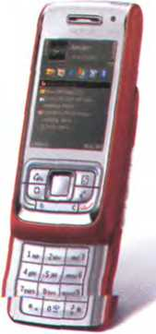
Using the diagram, explain VolP technology in your own words.
A wireless VolP phone

Wi-Fi phone
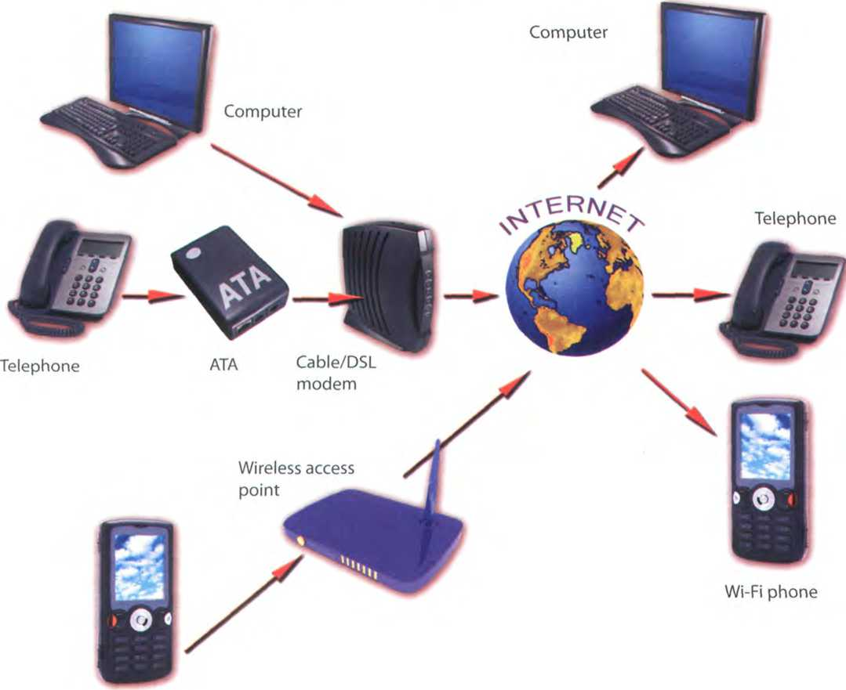

* í Mobile phones

A Label the mobile phone with features írom the box.

LCD screen Brand Built-in camera
Changeable faceplate
SIM card (Subscriber Identity Module)
Wireless support Keypad Ringtone

B

In pairs, describe your mobile phone.

Use A and the Usefullanguage box to help you.
Useful language
Myphoneisa... It'sgota... With the..., Ican...
The bestỉeatureis... I neverusethe... I mostly use itfor...
c

In pairs, discuss these questions.
- How much money do you spend on ỵour mobile?
- Can you send MMS (multimedia messages) from your mobile?
- Do you access the Internet from your mobile? Which sites do you visit?
- Can you listen to music and watch TV on your mobile?
- Do you use your mobile phone for business? Do you think it is secure to carry out íĩnancial transactions vía mobile phones?
- Do you ever use your phone while driving?
- Have you ever had to use your phone in an emergency?
- Do you think that prolonged use of mobile phones can affect our health (for example cause fatigue and headaches, emit radiation, excite brain cells, etc.)?
An Apple IPhone combines three Products - a mobile phone, ơn iPod, ơnd ơn internet device with email, web browsing, mơps ơnd seơrching

D Write a summary of the discussion in c as if you were posting it on a blog. Show your summary to other members of your class so that they can add comments.
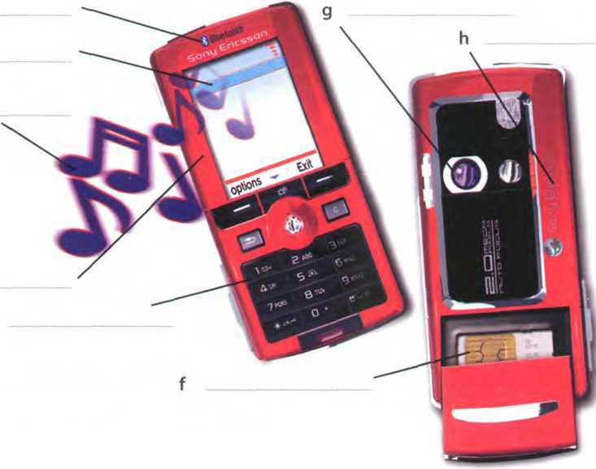
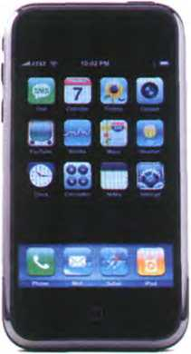

Unit28 Networks


Small networks
- In pairs, discuss these questions.
A
1 What is a Computer network?
2 What are the beneíits of using networks?

B Líu Listen to an extract from a lecture on networks and answer these

questions.
1 What does LAN stand for?
- Where are LANs usually located?
- What is the difference between a wired LAN and a wireless LAN.

c khu Listen again and label the elements of this LAN.
(1)A wired and wireless LAN
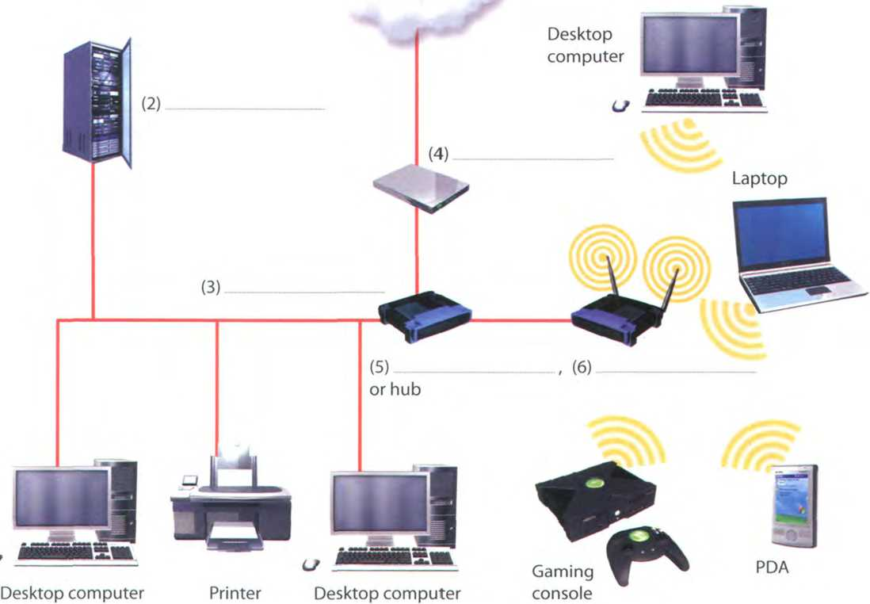
Internet

Networking FAQs

A Look at the FAQs (i-vi) without reading the whole text. In pairs, try to answer as many of the questions as you can.

B Read the whole text and answer these questions.
- What does PAN stand for?
- What is a network protocol?
- How do ỵou log on to an Internet Service Provider?
- WiMAX is a type of wireless netvvork. What is it used for?
- What equipment do you need to set up a wireless LAN?
- What are the advantages and disadvantages of wireless networks?
Networking FAQs

i How many types of network are there?
Netvvorks are classiíied according to diííerent criteria:
- Geographical area: PANs (Personal Area Networks) typically include a laptop, a mobile phone and a PDA; LANs cover a building; MANs (Metropolitan Area Networks) cover a campus or a City; WANs (Wide Area Netvvorks) cover a country or a continent.
- Architecture: In a client-server network, a Computer acts as a server and Stores and distributes iníormation to the other nodes, or clients. In a peer- to-peer network, all the computers have the sãme capabilities - that is, share fĩles and peripherals without requiring a separate server Computer.
- Topology, or layout: In a bus network, ãll the computers are connected to a main cable, or bus. In a star network, all data flows through a Central hub, a common connection point for the devices in the netvvork. In a ring netvvork, all devices are connected to one another in a continuous loop, or fing.
- Network protocol: This is the language, or set of rules, that computers use to communicate with each other. Networks use different protocols. For instance, the Internet uses TCP/IP.

ii How do I install a wired modem router?
A modem router is a device that connects your Computer or home LAN to the Internet.
- Plug one end of the phone cord directly into a phone jack, and the other end into the ADSL port on the router.
- Plug one end of the Ethernet cable into your computer's netvvork port and the other end into an Ethernet port on the router.
- Turn on your Computer. To set up, or coníigure, the router, you'll need to input some parameters, for example your ISP's name and phone number.
NOTE: A router has various Ethernet ports, so you can connect various PCs to the router vía Ethernet cables. If you already have a hub or svvitch conneđmg a LAN, you only neéd one cable to connect the hub to the router.

iii How do I log on to the Internet Service Províder?
You need to type in your username and password. Once you are Online, you can get email, look for iníormation on the Web, look up IT words in dictionaries, try out new software, and sign up for RSS íeeds, newsletters, etc. It is important that you remember to log off aíter using the Internet. An open line increases the risk of viruses, and hackers might break into your Computer to steal contidential data.

ív What is wireless netvvorking?
Wired networks are linked by Ethernet cables, phone lines and high-speed íibre optic cables. VVireless netvvorks, however, use electromagnetic vvaves, such as radio vvaves, to transmit data. These are the main types of wireless networks:
- Satellites - for long distances
- WiMAX - for connecting Wi-Fĩ hotspots
- Wi-Fi - for medium-range distances
- Bluetooth - for short distances
- GSM - for mobile phones

V what do I need to set up a home vvireless LAN?
You'll need computers equipped with a wireless adapter or wireless card, a vvireless access point (a wireless router) and a broadband internet connection.

vi Which is better, a wired or vvireless LAN?
Wired LANs are more difficult to install, but they are cheaper, íaster and more reliable. Wireless networks let you move, or roam, írom one access point to another, but they are less secure and subject to interíerence.

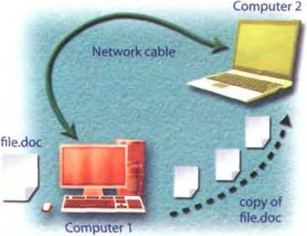

In 0 basic network, two computers are connected by cable to allovv file sharing
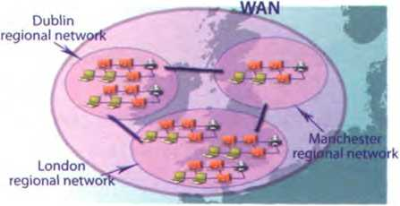

WANs covera large geographic area, like a country oreven multiple countries. They are built by lơrge telecommunication companies. The largest WAN in existence is the Internet.

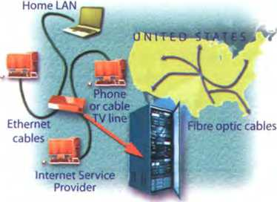

In many homes, Ethernet cables ơre used to connect computers. Phone or cơble TV lines then connect the home LAN to the ISP. Much of the Internet uses high-speed hbre optic cable ro send data over long distances.
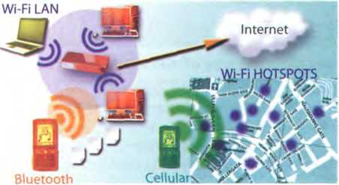

Wi-Fi i$ the Standard technology for building wireless
LANS and public hotspots Bluetooth networks allow handhelds, mobile phones and other devices to communicate over short distances. Cellulơr networks are used in mobile phone Communications. A

c In pairs, do this network quiz. See which pair can fìnish íĩrst.
- This network tỵpicallỵ consists of two or more local area networks, covering a large geographical area.
a LAN b WAN c Intranet
- This type of network does not have a dedicated server; all the computers are independent.
a peer-to-peer b client-server c Metropolitan Area Network
- On this topologỵ, all devices are connected to the same Circuit, íorming a continuous loop. a star b ring c bus
- The language used bỵ computers to communicate with each other on the Internet is called a Ethernet. b ADSL c TCP/IP.
- Which cables are used to transíer iníormation for the Internet over long distances at high speeds?
a telephone lines b Ethernet cables c íĩbre optic cables
- Which device allows several computers on a local netvvork to share an internet connection?
a an ADSL port b a router c an Ethernet port
- Which device serves as a common connection point for devices in a wireless netvvork?
a wireless access point b wired router c wireless adapter
- Bluetooth is a wireless technology that uses radio vvaves to transmit data over
a long distances. b medium-range distances. c short distances (ten metres or less).

Languơge work: phrasal verbs

A Look at the HELP box. Do you have the equivalent of phrasal verbs in your language? How do you say the phrasal verbs in the HELP box?
HELP box
Phrasal verbs
- The meaning of some verbs with particle (often called phrasal verbs) can be easilỵ understood from its two parts.
Lookatthephotos.
A network consists oftwo or more...
Separate netvvorks are linked over a Public network, the Internet.
- However, many phrasal verbs have an idiomatic meaning, not predictable from the meaning of its parts.
carry (= transport); carry out (= execute)
Computers carry out the programs...
- Certain particles have similar meanings, regardless of the verb (on/off in/out, etc.).
turn on / switch on
(= start the operation of something) turn off / switch off
(= stop the operation of something)
- Other common phrasal verbs in computing include:
plug into (= connect)
Plug one end of the pho ne cord in to the phone jack.
set up (= establish)
What do I need to set up a wireĩess LAN? sign up (= register, enrol in a Service) Once connected, you can sign up for RSS íeeds, newsletters, etc.
try out (= test or use experimentally) You can try out new software on their site.
find out (= learn, discover)
Search the Web to fìnd out more Iníormation about WiMAX.
take up (= occupy)
Fibre optic cables take up less space than copper cables.
make up (= constitute, form)
Several LANs connected together make up a WAN
fill in (= write the necessary information) You need to fill in this Online form.
When the verb has a preposition associated with it, the preposition must precede the object:
You can look for information on the Web. (not: loơk iníormation for)
Hackers might break in to your PC.
(not: breakyout PC into
When the particle is an adverb, it can precede or follow the direct object:
You need to type in your username/
... type your username in
You can look up words in a dictionary/
... look words up in a dictionary.
Turn on the Computer. /
Tum the Computer on.
If the direct object is a pronoun, the: particle must follow it
You need to type it in
(not: typeinntì

B Complete these sentences with the correct form of a phrasal verb from the HELP bõx.
- To join the Club,this form and send it to our office.
- The CPU all the basic operations on the data.
- Digital music a lot of space - about 10 MB for every minute of stereo sound.
- Thousands of networks the Internet.
- You can use newsgroups to about the latest trends, customer needs, etc.
Match the questions (1-6) with the answers (a-f).
- Why was the hacker arrested?
- Is it OK to log on to my bank account using Public computers in a cybercaíé?
- How do I set up an internet connection at home?
- Can I download software from your site?
- How can I add video to instant messaging?
6 What do I need to do to sign up for a Yahoo! email account?
a Yes, buĩ always remember to log off after you've ended your session.
b Yes, you can even try the programs out for a period before you buy them!
c Because he broke into a Computer System and stole coníĩdential data.
d Simply install this program and plug the webcam into your Computer.
e You need to install the software for your router. Follow the instructions provided by your ISP, probably in the form of a ,pdf hle on a CD.
f You have to create a username and password and then give some personal details.

WANs and satellites
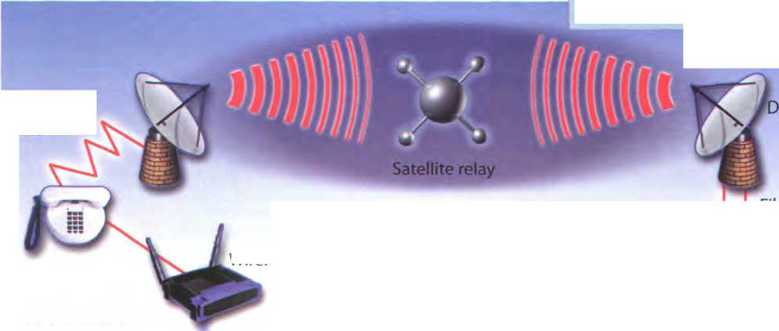
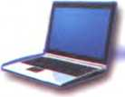
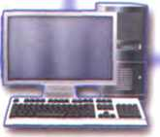
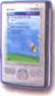
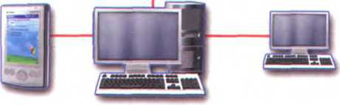
A L Prepare a description of the network below to present to the rest of the class. Use PowerPoint if possible. Use the Useful language box, the HELP box on page 143 and the text on pages 141 -142 to help you.
Useful language
The diagram represents/shovvs...
This network is made up of/consists of...
Two networks are connected Via ...
The computers are linked upto...
The satellite receives signơls from ...
The signals are sent onto...
Thepurposeof... isto...
LOSANGELES
ish aerial
Modem
Telephone lines
Wireless router
Fibre optic cable
Laptop
Central Computer
PDA
PDA Central Computer PC

B Present your description to the rest of the class.
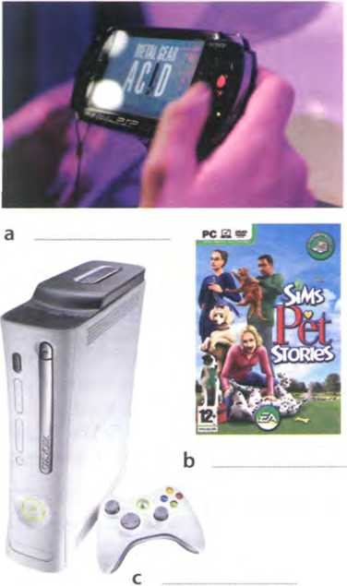
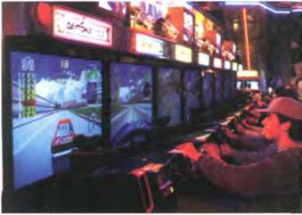
3
4
5
6
Some are programmed d

Unit29 Videogames

Game plattorms
A C z In pairs, discussthesequestions.
- Do ỵou play video games?
- What are your íavourite games? Make a list.
B Label the pictures (a-f) with the types of game in the box.
PC games Console games Arcade games
Handheld games Mobile phone games
Massively multiplayer Online games
c Video games are played on a variety of electronic devices, or platforms. Complete these sentences with game platforms írom the box and types of game írom B.
Personal Computer Video game consoles
Portable gaming devices 3G mobile phones
1 are played on , such as the Sony PS3
or Microsoft Xbox 360. In the past, these electronic devices were just connected to a Standard TV or video monitor; now they can also be connected to the Net, vía cables or wirelesslỵ.
2 are played on, such as the Sony PSP
and the Nintendo DS. You can also play games on some graphing calculators and watches.
Don't worry if ỵou don't have a game console. You can still play on a . The graphics are even more impressive ifyou have a high- resolution monitor. You can buỵ games on CDs and DVDs, or download them from the Internet.
allow you to play against other users in other parts of the world using the Internet - something unique to electronic gaming. Players connect to a game server hosted by an ISP, a game company, or an individual enthusiast.
to run natively on the chip of
For
instance, Snake is installed on manỵ Nokia phones. Many Java-based games are also available vía download.
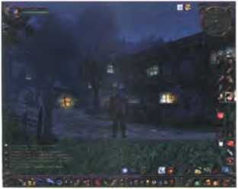
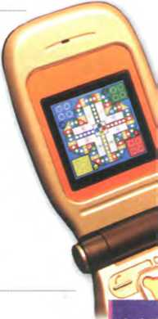
are plaỵed on coin-operated machines, typically installed in restaurants, bars and amusement arcades. For example, you can fly an aircraít or a spaceship using ajoystick.

Dy In pairs, discuss these questions. Give reasons for your answers.
- Which is your íavourite game platform? What advantages and disadvantages does it have over other game platíorms?
- Which game platíorm would you most like to own?
- Do you play games on ỵour mobile phone? What is the experience like?

í Game genres

A How many different game genres can you think of? In pairs, make a list and then read the text to see how many genres from your list are mentioned.

Game genres
There are so many different genres and mixes of genres that it's difficult to put each game into a specifìc category. In the following article weĩl cover the basic genres that differentiate between games.
5 The First-person shooter (FPS) and Action genres are currently the most popular. Games Like Half-Life, Halo and Call of Duty are the most popular games in the FPS category. For Action, innovative titles like the Grand Theft Auto series, Gears of War and Splinter 10 Cell are huge successes.
The Role-playing game (RPG) genre has remained strong throughout the entire history of console and PC gaming. Current hits like Final Fantasy XII, Oblivion and the Knights ofthe Old Republic series
15 are all based on RPG roots. The recent development of massively multiplayer Online RPGs has been made possible by widespread broadband access, allowing gamers to play internationally with thousands of people across the globe in a constant Virtual world.
20 Adventure games and Puzzle games remain strong despite being limited in scope and technology. The new concept oĩ party games - where people play together in multiplayer mode - has recently injected new life into this genre. Titles like Zelda and Wario-
25 Ware are Tamiliar names.
Sports games are an increasingly popular portion of the gaming industry. Electronic Arts (EA) have been making games licensed from the NBA, NFL and MLB for over a decade. Another sector of the Sports 30 industry is the entire racing sub-genre. Massive
hits like the Burnout and Need for Speed series are hugely exciting, and the crashes can be realistic and terriíying.
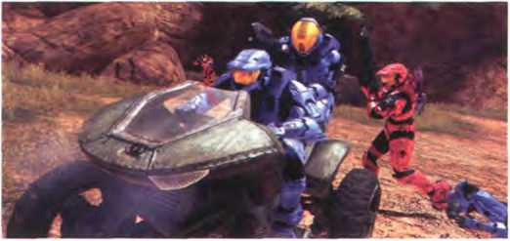
Halo 3 is very popular on the Xbox console; millions ofpeople aìso play the game Online

The Simulation genre has enjoyed wild success, 35 including the best-selling PC games of all time: The
Sims & The Sims 2. The entire Sims series, designed by Maxis, is dominant in this genre. Jet hghter and flying sims are also important types of simulation game.
40 Strategy is a genre mainly restricted to PC, largely because the mouse and keyboard are Central to gameplay. There are a few good Strategy games for console, however. Big names in Strategy include Warcraft III, Starcraft, Command and Conquer and
45 Warhammer 40,000.
Finally, we have the Fighting genre. Developed from early hit games like Street Fighter II, Fighting games have enjoyed a renaissance as theyve been updated fully to include 3-D characters and arenas. Titles
50 like Dead or Alive, Tekken and Soul Calibur are big favourites.
So what kind of game player are you? Chances are that if you're a PC gamer, you prefer FPS, RPG, Simulation, and strategy games. The console gamer 55 typically enjoys Sports, Racing, Fighting, RPGs, and a few FPS titles. 0f course, many people own both a console and a PC, thereíore combining the best of both worlds.

B These statements about gaming are all false. Read the text again and correct them.
- Role-plaỵing games are currently the most popular.
- Massively multiplaỵer Online RPGs have been made possible bỵ widespread internet access.
- Oblivion is an Action game.
- The Sims series is the least popular in the Simulation category.
- Strategy games are mainly restricted to game consoles.
- Wơrcraft belongs to the Pighting genre.
- Console gamers typicallỵ preíer Simulation and Strategỵ games.

c Find words or phrases in the text with the following meanings.
1 now; at this time or period (lines 5-10)
2 existing or happening in many places and/or among many people (lines 15-20) _____
3 in spite of; notwithstanding (lines 20-25)
4 more and more (lines 25-30)
5 a smaller categorỵ within a particular genre (lines 30-35)
6 big successes (lines 30-35)
7 sold in very large numbers (lines 35-40)
8 modernized (lines 45-50)

In pairs, discuss these questions. Give reasons for your answers.
1 What is your favourite and least íavourite genre of game?
2 What are your favourite games? Describe them to your partner.

Language work: adverbs

A Look at the HELP box on page 148 and then complete these sentences with the adverbial form of the words in brackets.
- Simulation games are (wide)used in both universities and businesses.
- Massively multiplaỵer Online RPGs have (recent) become more popular, mainly
due to faster internet connections.
- Strategy is a genre (main) restricted to PC.
- Video games often come with a clear seĩ of motivation tools, such as scores and moving to higher levels when a player períorms (good)
- Cheap PCs don't process data (fast) enough to support high-end games.

B Are the words in bold adjectives or adverbs? Write adj or adv.
- Atari's platform was the most popular early video game console, and manỵ developers emulated Atari games to attract customers.
- The chess game ended early, at the 24"' move.
- On theTPS Report gaming blog, you will find reviews, a forum and a monthly podcast.
- The podcast is broadcast monthly
- You have to work hard to succeed in the gaming industry.
- Some experts say that hard work makes people happy.
HELPbox
Adverbs
- We use adverbs to give information about an action. Adverbs of manner, time and place describe how, vvhen or where something happens.
They've been updated fully to include 3-D characters. (= manner, i.e. how)
TheAction genre ofgơmes is currently the most popular. (= time, i.e. when)
... ơllowing gamers to play internationally... (= place, i.e. where)
We also use adverbs to modiíy adjectives.
Sports gơmes ũ re an increasingly popular portion oíthe gaming industry.
- We usuallỵ form an adverb bỵ adding -ly to an adjective.
typical —► typically
The console gamer typically enjoys Sports,...
- With adjectives ending in -y, we change the y to i beíore adding the ending -ly.
easy —► easily
The Nintendo Wii connects easily to the Internet.
- Note that not all words that end in -ly are adverbs. These words are adjectives: friendly deadly, lovely, lonely
- The adverb from good is well
His French is very good He speaks Trench well
- Some vvords have the same form as an adjective and an adverb (e.g. fast, hard, early, late, daily, monthly).
Nevvgơmes reguire a fơst processor. (= adjective)
The processor speed tells you how íastyour PC executes instructions. (= adverb)

Present and future trends in gaming

A Listen to an interview with Matt Robinson, the administrator of the TPS

Report gaming blog. How many game platforms does he mention?
(5

These statements about video games are all íalse. Listen to the interview

again and correct them.
- Video games are popular because they are fun and addictìve.
- Well-known Hollywood actors appear in video games.
- The Nintendo Wii is aimed at hardcore gamers.
- lt's free to play World ofWarcraft.
- Holography is an advanced form of photographỵ that uses lasers to produce two-dimensional images.
- In the íuture, gesture recognition Systems will produce photo-realistic images.

c |kJ Listen again and complete these extracts from the interview with adverbs.
- With a game you are in control of the action.
- Games are now even more life-like and attractive.
- A lot of modern games draw inspiration from íilms and even TV.
- Their released Wii console has an inexpensive, simplistic, pick up 'ríplay feel to ít.
- Wii is the most popular of the three machines.
- Logging ontoan separate universe to meet and play alongside your íriends has enormous attraction.
- Mobile gaming has been about easy, simplistic 2-D games.

D

In pairs, discuss if you agree with everything that Matt says in his interview

about the future of gaming. What are your own predictions?

The pros and cons of ga ming

A |p| In pairs, look at the statements about gaming (1-4) and say if you agree or disagree with them. Give reasons for your answers.
- TV and video games are amusing and can be educational. But too much of this kind of entertainment can be addictive and make children become accustomed to violence.
- Massively multiplaỵer Online games are Interactive and fun.
- Video games have negative effects on children and distract them from school and homework.
- Modern games and simulations offer a great deal of adventure and challenge. In addition, they can teach skills such as strategic thinking, interpretative analysis and problem solving.
B VVrite an essay calỉed The pros and cons oígaming (80-120 words).
Use these steps and the Usefu!languagebox to hẽip ỵoũ.
- The opening (paragraph one):
Present the topic in one or two sentences.
- The body (paragraphs two and three):
Give pros (arguments in favour) with facts and examples. Give cons (arguments against) with facts and examples.
- The closing (paragraph four):
Summarize your main ideas and give your opinion.
Useful language
To add arguments:
In addition,... Furthermore,...
To introduce opposing ideas:
On theone hand,... On the otherhand,...
Some people say... Others say... Hovvever,...
To express opinions:
/n my opinion,... Ibelieve that...
Itseems to methat... It's dear that...
To conclude:
In conclusion,... To sum up,... In short,...

unit30 New technologies

Future trends

In pairs, discuss these questions.
A
1 What do you think a ưend is?
2 What trends in ICT do ỵou think will affect our lives in the future? Make a list.

B Match the texts (1-5) with the pictures (a-e). Which trends from your list in A are mentioned?
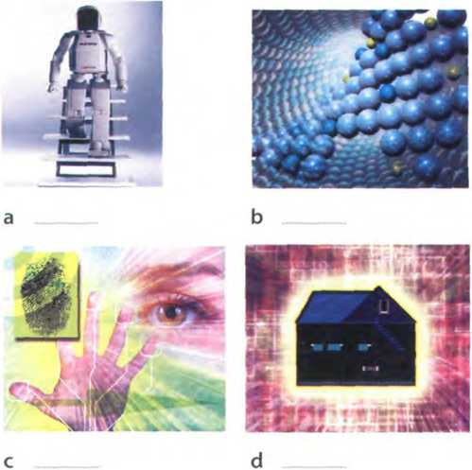
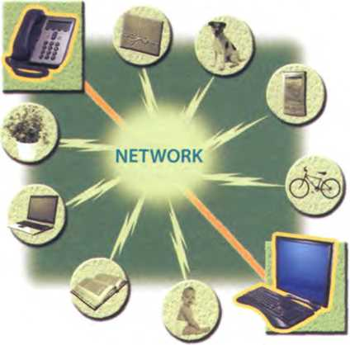
e
By all accounts, nanotechnology - the Science of making devices from single atoms and molecules - is going to have a huge impact on both business and our dailỵ lives. Nano devices are measured in nanometres (one billionth of a metre) and are expected to be used in the following areas.
- Nanocomputers: Chip makers will make tiny microprocessors with nanotransistors, ranging from 60 to 5 nanometres in size.
- Nanomedicine: Bỵ 2020, scientists believe that nano-sized robots, or nanobots, vvill be injected into the body's bloodstream to treat diseases at the cellular level.
- Nanomaterials New materials will be made from carbon atoms in the form of nanotubes, which are more ílexible, resistant and durable than Steel or aluminium. Theỵ will be incorporated into all kinds of Products, for example stain-resistant coatings for clothes and scratch-resistant paints for cars.

Artiíicial Intelligence (AI) is the Science of making intelligent machines and programs. The term originated in the 1940s, when Alan Turing said: 'A machine has artificial intelligence when there is no discernible difference between the conversation generated by the machine and that of an intelligent person.'A typical AI application is robotics. One example is ASIMO, Honda's
intelligent humanoid robot. Soon, engíneers will have built different tỵpes of android, with the form and capabilities of humans. Another AI application is expert Systems - programs containing everything that an 'expert' knows about a subject. In a few years, doctors will be using expert Systems to diagnose illnesses.

Imagine ỵou are about to take a holidaỵ in Europe. You walk out to the garage and talk to your car. Recognizing your voice, the car's doors unlock. On the waỵ to the airport, you stop at an ATM. A camera mounted on the bank machine looks you in the eye, recognizes the pattern of your iris and allows ỵou to withdraw cash from ỵour account.
When you enter the airport, a hidden camera compares the digitized image of ỵour face to that of suspected
criminals. At the immigration checkpoint, you swipe a card and place your hand on a small metal surface.The geometry ofyour hand matches the code on the card, and the gate opens. You're on your waỵ.
Does it sound íuturistic? Well, the future is here.
Biometrics uses Computer technology to identiíy people based on physical characteristics such as íĩngerprints, facial íeatures, voice, iris and retina patterns.
Adapted from the Richmond Times-Dispơtch
Ubiquitous computing, also known as pervasive computing, is a new approach in which Computer functions are integrated into everyday life, often in an invisible way. Ubiquitous devices can be anything from smartphones to tiny sensors in homes, offices and cars, connected to networks, which allow information
to be accessed anytime and anywhere - in other words, ubiquitously. In the future people will interact naturally with hundreds of these smart devices (objects containing a microchip and memory) every day, each invisibly embedded in our environment and communicating with each other without cables.
0—— 7 ——
In the ideal smart home, appliances and electronic devices work in sỵnc to keep the house secure. For example, when a regular alarm System senses that someone is breaking into the house, it usually alerts the alarm company and then the police. A smart home System would go íurther, turning on the lights in the home and then sending a text message to the owner's phone. Motorola Homesight even sends images captured by vvireless cameras to phones and PCs.
Smart homes can remember ỵour living patterns, so if you like to listen to some classical music when ỵou come home from work, ỵour house can do that for you automatically.They will also know when the house is empty and make sure all appliances are turned off. All home devices will be interconnected over a home area network where phones, cable Services, home cinemas, touch screens, smart mirrors and even the reírigerator will cooperate to make our lives more comíortable.
Adapted from www.businessweek.com

c Read the texts again and answer these questions.
- Which unit of measurement is used in nanotechnologỵ?
- What are the advantages of nanotubes over regular materials?
- What will doctors use expert Systems for?
- What features are analysed by biometrics?
- Which trend reíers to computers embedded in everyday devices, communicating with each other over wireless netvvorks?
- What will the alarm System do if someone breaks into a smart home?
- How will devices be interconnected inside the smart home?

D Find words in the texts with the following meanings.
- a microscopic robot, built with nanotechnology (text 1)
- a robot that resembles a human (text 2)
- biological identification of a person (text 3)
- integrated; inserted into (text 4)
- electrical devices, or machines, used in the home (text 5)

E r Write a suitable caption for each picture on page 150.

RFID tags
A

Listen to Sarah Wood, an ICT

teacher, giving a class about RFID tags. Which defìnition (a-c) best describes

RFID?
a a smart technology worn on the user's body so that they can email and access the Web
b a technology that uses radio waves and chip-equipped tags to automaticallỵ identify people or things
c a technology that uses microchips and bar codes to track people or things at a distance

Listen again and decìde which
^

answers (a or b) are correct.
1 RFID stands for
a Radio Frequency Identihcation.
b Radio Frequency ldentification Download.
2 Radio tags
a can only be attached to or embedded
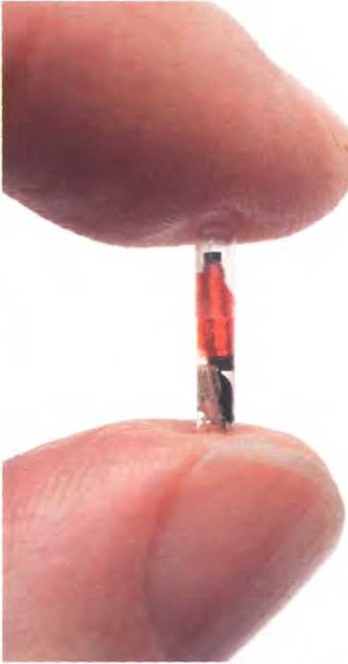

into Products.
An RFID micro chip
b can be attached to or embedded into Products,
animals and humans.
- Active RFID tags
a have a communication range of several hundred metres.
b have a communication range of five metres.
- RFIDchips
a will help us track ordinary objects like car keys or books.
b won't be able to locate objects when they are lost or stolen.
- Radio tags may be implanted under the skin
a to contĩrm a patient's identity and cure illnesses.
b to give doctors instant access to a patient's medical history.
- According to consumer organizations, RFID tags
a could be used to track consumers or to steal a person's identity. b are secure and private; there is no need for concern.
p

In pairs, discuss how secure you think RFID is. Do you agree with the

consumer organizations or the manufacturers? Give reasons for your answers.

I

3 Language work: future forms

A Look at the HELP box and then choose the correct words in brackets to complete these sentences.
- In the íuture, I hope we ('II have/'re going to have) robots in the home to help us with the housework.
- Hey, Nick, be careful, you ('re going to spill /'II spill) that coffee on the Computer!
- lt's John's birthday next week. We ('II give/'re going to give) him a mobile phone.
- - My laptop has crashed!
- Don't worry. I ('II lend /'m going to lend) you mine.
- The Internet (will probably change / is probablỵ going to change) the publishing industry in the waỵ that TV changed the movie industry.
- Futurists predict that smart technology (will be / is going to be) incorporated into fabrics, so you'll be able to email from ỵour coat!
HELP box
Future forms
We use the íuture simple (will/won't + verb) in the following ways:
- To make predictions when you don't have present evidence that something will happen
Nanobots will be injected into the body's bloodstream to treot diseases.
- To talk about hopes and promises, especially with the words expect, think, hope and probably
They hope that people will interơct naturally vvith hundreds oísmart devices at a time.
- To describe an instant decision, often when we make an offer
Sure, 1'11 help you with your homevvo/k.
- To talk about facts that will inevitably happen
Shell be 2Ì in May.
We use be going to + verb in the following ways:
- To describe future intentions
She's going to write a book about ubiquitous computing.
- To make predictions when you have present evidence that something is going to happen
By ơll accounts, nanotechnology is going to havea huge impact on business and our daily lives.
We use the future continuous (will be + -ing form of the verb) to talk about actions in progress at a specihc time in the future.
In a fewyears, doctors will be using expert Systems to diagnose illnesses.
We use the future períect (will have -I- past participle) to talk about actions íĩnished at a specihc time in the íuture.
Soon, engineers will have built different types ofandroid.

B Complete these sentences with the correct future form of the verb in brackets. Use the future continuous or future perfect.
- Thanks to ICT, by the ỵear 2030 we (find) cures for the major
diseases of our time.
- In twenty years'time, some people (live) in space, perhaps
inside a computerized colonỵ.
- By thistime next week, I (work) íorlBM.
- By this time next month, I (buy) that BlackBerry that l've been
wanting to buy for months.
- Scientists predict that in twenty ỵears' time nearly everyone (live) in smart houses.

c ỉ* I In paỉrs, discuss these predictions. Do you agree or disagree? Give reasons for your answers. Look at the Useful languơge box to help you.
- Some day, we'll be talking to computers naturally, like friends.
- Microchips implanted ìn our arms will serve as ID cards and contain our medical records.
- Robots will learn to build themselves, without human help.
- Smart homes will be voice-activated.
- Computers will be ubiquitous and almost invisible, embedded into our homes and integrated into our lives.

Making predictions

Useíul language ■■■■■
I think that...
Whơtdoyou thinkaboutnumber... ?
I'm not sure that... WÍU...
/ completely agree/disagree with ...

A § Write your own predictions about these topics.
- Work/Jobs
Exa m ple By the year 2030, hu man labour in industry will have been replaced by robots.
Your prediction: „ — . -
- Money
Example Cash will be replaced by electronic money.
Your prediction: _ .
- Education
Example By the end ofthìs century, every student in every school will have a PC.
Your prediction: ... .
- The Internet
Example: People in every country will have high-speed access to the Internet within five yeơrs.
Your prediction: — . — . —. - .....

B

In pairs, compare your predỉctions.

Find out more about your partner's

predictions.

Now visit www.cambridge.org/elt/ict

for an Online task.
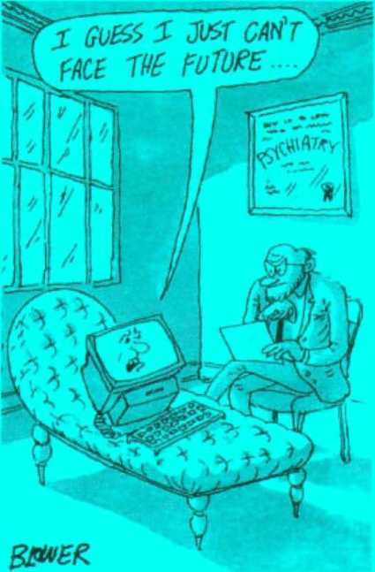

Appendix: a model cv
Curriculum vitae
Personal information
Name: María Quintana
Address: Avda Séneca, 5, Madrid 28040
Telephone: 00 34 91 5435201
Email: mquintana0782@telefonica.net
Date of birth: 28/07/82
Education and Training
2006 Online diploma in web-based technology for business, www.elearnbusiness.com
2005 Course in web design at the Cybernetics College, London: HTML, Java and
Macromedia Dreamweaver
2004 Course in Computer hardware and networking at the Cybernetics College, London
1999-2004 Degree in Computer Science and Engineering, University of Madrid
Work experience
Part-time Webmaster at www.keo.es; responsible for updating the site and using Adobe Flash to create animations
danuary 2006 - present
May 2005 -
December 2006
IT consultant at Media Market, specializing in e-commerce and IT strategies
IT skills
Knowledge of multiple Computer platíorms (Windows, Mac and Linux); strong database skills (including the popular open source MySQL database); complete understanding of graphics íormats and Cascading Style Sheets
Personal skills
Social and organizational skills
Good communication skills
Languages
Spanish mother tongue; English (Cambridge CAE); Arabic (fluent)
Hobbies and Interests
Web surhng, Listening to music and travellỉng
Reíerences
Miguel Santana, Manager, keo.es
Sam Jakes, Lecturer, Cybernetics CoLlege

Glossary

A
@ /at/ The’at'sign that separates the recỉpient's name from the domaìn name in an email address.
Acrobat Reader .iekrabíet 'riida/ n Adobe's ftee software for displaying and prĩnting PDF hles.
ADSL/eidi:es'el/ n Asymmetric Digital Subscriber Line. A broadband communicatìon technology desĩgned for use on telephone línes; it allows a smgle phone connection to be used íor both internet Service and voice calls at the same time.
■APẴL.mntteiv ,^ ;^ublẤ9roWdí^{í}v«.'í?■ used to connect One or more computers to an ADSL phone line.
adware /'<edwea/ n Soitrtăie devised to display advertĩsements; some may include spyware.
alphanumeric keys /,telfanju:menk
'ki:z/ n Keys that represent letters and numbers. arranged as on a typewriter.
Amazon.com /'atmazan ,dnt ,kom/ IIA popular Online shopping site.
android /'amdraid/ n A robot that resembles a human.
animations/anr'meijanz/ n Images made up of a series of independent pictures put together in sequence to look like moving pictures.
applet /'teplat/ n A small Java application, usually designed to run automatically within a web page.
application software /a:pli‘keijan ,sofwea/ n Programs that let you do specihc tasks, such as word Processing, database management or hnancial planning.
arcade game /a:'kerd ,getm/ ri A game played in a coin-operated machine, typically installed in pubs, restaurants and amusement arcades.
arithmetic logic unit (ALU) /a,n0mattk 'lndjik ju:nit/ n A component of the CPU which períorms the actual arithmetic and logical operations asked for by a program.
ARPANet /'atpanet/ n Advanced Research Proịects Agency Metwork. Developed in the early 70s by the us Department of Defence.This was the precursor to the Internet.
Artihcial Intelligence/a:ti,fijal tn'telid3ans/ n The study of methods by which a Computer can simulate aspects of human intelligence.
ASCII code /'aaski: ,kaud/ n A Standard System íor the binary representation of characters. ASCII, vvhich stands for American Standard Code for Iníormation Interchange, permits computers from different manuíacturers to exchange data. aspect ratio /'iEspekt ,reijìau/ n The width of the screen divided by its height, e.g. 4:3 (Standard PC monitor or TV set) and 16:9 (high-definition TV). assembler/a'sembla/ n A special program that converts a program written in a lovv-level language into machine code.
assembly language /a'sembli ,lasggwrds/ n A low-level language that uses abbreviations, such as ADD, SUB and MPY, to represent instructions. ATA adaptor/'eiti:er a.drepta/ n An analogue telephone adaptor, vvhich converts the analogue signals oíyour traditional phone into digital signals.
Athlon /'tcOlon/ n A processor manuíactured by AMD.
attachment /a^teựmant/ n A file that has been included as part of an email message attributes /*aetnbju:ts/ n Characteristics that affect the vísual representation of lines and polygons, e.g. line styles, rectangle colour, etc. authentication /a:,0enti'keijan/ n Veriíying the identity of a user loggĩng onto a netvvork,- ways of authentication include passwords, digital certilìcates and biometrics.
avatar/'®vatu:/ n An object which represents a 3MrtLciRant.)n.?.3LDxhã'.cpom
B
back up /,bak ¹ Ap/ V To copy files írom one disk to another,
backbone/'barkbaon/n High-speed lines or connectĩons that form the major access pathvvays within the Internet.
backup /'b;ek Ap/ n A copy of data or software, usually kept in case the original diskis damaged. bandwidth /'btendwit0/n The quantity of data that can be transmitted through a network. measured in bits per second (bps).
bar code reader /'borkaod ,ri:da/ n A specialized scanner used to read price labels in shops.
BASIC 'betsik/ n A high-level programming language developed in the 196ŨS, widely used in pragrammmg because it was Interactive and easy to use. Short for Beginner’s All-purpose Symbolic Inítruction Code.
binary code /'bainari ,kaud/ n A code made of just two numbers (0 and I).
binary digit /'bainari ,did3it/ nThe smallest unit oí ĩníormation in the binary System, 0 or 1. Also called a bít.
binary System /'bainari ,srstam/ n A notation System In which numbers are represented by the two digits: 0 and 1 .Thus the binary number 10 represents 2 in the decimal System, while 100 represents 4.
biometrics /baiao'metnks/ nThe Science that uses Computer technology to identity people based on physical teatures, such as hngerprĩnts or voice scans. From the ancient Greek: bĩos = |ife, metron = measure.
bit /brt/ n See binary digit
bit-mapped graphics/.bitmtept 'grteíiks/1'1 See raster graphics
BitTorrent /,btt 'tnrent/ n A protocol for transíerring music, films, games and podcasts. It breaks hles into chunks and distributes them among a large number of users; when you dovvnload a torrent, you are also uploading it to another user.
BlackBerry /'btekbari/ n A wireless handheld device, developed by Research in Motion, which provides email, phone, text messaging, web brovvsing, an organizer, as well as instant messaging and corporate data access.
blind carbon copy (Bcc) /,blaind ,ku:ban 'knpi/ n Addresses in the Bcc: line of an email program will receive a copy of the message. but the identity of the recipients will be kept secret.
blog /blog/1 n A user-generated website where people express theĩr opinĩons. The entries are displayed In a reverse chronological order.The term comes from web log, coined by Jorn Barge in 1997 to reíer to an Online diary 2 vTo wrrte entries in a blog.
blog administrator/,blog ad'mrnistrerta/ n Someone who edits and deletes posts or comments made by contributors to a blog. blogger /'blnga/ n A persơn who wrĩtes on a blog.
blogging /'blogig/ n Writing web logs. See •hlnp
blogosphere /'blogaosíta/ n The collectíve term induding đll blogs as a commun/ty.
Bluetooth /’blu:tu:0/n A vvireíess technology that allows handhelds, mobile phones and other peripheral devices to communicate over short distances.
Blu-ray disc /'blurrei ,drsk/ n A new optĩcal disc, created by Sony, which can record and play back high-dehnitionTV and Computer data. Unlĩke current DVDs, which use a red laser to read and vvrite data, Blu-ray uses a blue-violet laser, hence its name.
bookmark /'bokmurk/ n A saved link that takes users directly to a web address. Bookmarks are also called ĩavourites.
Braille /breil/ n A System of writing devised by Louis Braille for blind people. in vvhich combinations of raised dots representing letters and numbers can be identihed by touch.
Braille embosser /'breil im.bosa/ n An impact printer that produces tactlle Braille symbols. brightness /'braitnas/ n The amount of light produced by an LCD monitor, measured in cd/m2.
broadband /'brntdbtend/ n High-speed transmission, usually referring to internet access vía cable and ADSL; about 400 times íaster than dial-up access.
browser /'braoza/ n A program designed to íetch and display web pages on the Internet buddy list/'bAdi ,list/ n A list of people that you may want to communicate with vía instant messaging.
bug /bAg/ n An error in a Computer program. built-in /'biltin/ odj Integrated,- constructed as part of a larger unit.
bulletin board System (BBS) /.bolatin
,ba:d 'sistam/ n A System that enables its users, usually members ofa particular interest group, to share iníormation and programs.
burn /b3in/ vTo write data to a CD or DVD.
bus /bAs/ n An electrical channel, or highway, which carries signals betvveen units inside the Computer.
bus topology/,bAS tn'polad3Ì/ nOne of the three Principal topologies for a LAN, in which all Computer devices are connected to a main cable, or bus.
bus width /'bAs ,wrto/ nThe size of a bus, whkh determines how much data can be transmitted; for example, a 64-bit bus can transmit 64 bits of data.
byte /bait/ n A unit of Computer inlormation, conslsting of a group of eight bits. See also kilobyte, megabyte gigabyte terabyte
c
c/si:/ n A hĩgh-level programming language developed in 1972 at AT&T Bell Labs. It is used to wrĩte System software, graphĩcs and commercial applications.
c# /,si: 'Ja:p/ n A simplihed version of c and C++, developed by Mícrosoft for applĩcatĩons on theWeb.
C++ /,si: 'plAS 'pl as/ n An object-oriented version of c, widely used to deveiop enterptise and commercial applications. The programmer gives each object (e.g. a piece of text, a graphic or a table) íunctions whỉch can be altered vvithout changing the entire program.
cable modem /'keibal ,maudem/ n A modem designed to operate through a cableTV line. call centre /'ko:1 ,sent 3 / n A large office in which a company’s employees provide iníormation to its customers, or sell or advertise Its goods or Services by telephone.
carbon copy (Cc) /'ku:ban ,kopi/ n Addresses on the Cc: line of an email program wĩll receive the same message, and the recipíents will be able to see the identity of the other recipients. Cascading Style Sheets (CSS) /kíes'ketdig ,stuil Ji:ts/ n A mechanism for adding style (e.g. fonts, colours, spacĩng) to web documents.
cathode ray tube (CRT)
/'ksỡsud ,rei ,tju:b/ nThe picture tube ofold PC monitors, made of glass and containing a vacuum. In a colour monitor, the screen suríace is coated with triads of red, green and blue phosphor. Three electron beams energize the phosphor dots, causing them to emit coloured light from which the picture is íormed.
CD ripper/,si:di: Ttpa/ n A program that extracts music tracks and saves them on disk.
CD-R /,si:di: 'a:/ n A write-once CD which lets you duplicate music and data CDs. Short for compact disc recordable.
CD-ROM /,si:di: 'rnm/ n A'read-only'CD, meanĩng you cannot change data stored on it. Short for compactdisc read-only memory.
CD-RW /,si:di: ,u: 'dAbolju:/ n A CD that allows audio or data to be written, read, erased, and rewritten. Short for compactdiscre-wntable.
cell /sel/ n An intersection of a column and a row in a spreadsheet.
cell phone /'sel ,faun/ n American term for mobile phone. The term cell comes írom the fact that the phone calls are made through base stations (antennae) which divide the covetage area ĩnto cells. As you move from cell to cell, the calls are transterred to different base stations; this is called roaming.
Central Processing unit (CPU) /.sentral 'praosesig ,ju:nit/ nThe processor chip that períorms the basic operations of a Computer; like the'brain’of the Computer. Its basic components are the control unit, the arithmetic logic unit and the registers.
character /'kxrakta/ n A Symbol available on the keyboard (letter, numberor blank space). Chat 1Jìet/ n A real-time Interactive conversation on the Internet.
Chat room '1 Ja:t ,ru:m/ n A channel where users can communicate with each other in real tlme.
chip /tjìp/ n A tiny piece of Silicon containing complex electroníc circuits. Chips are used to make the hardware components of a Computer Chip and Pin /,tjip ,arnd 'pin/ n A secure method of paying wlth credlt cards. Instead of using a slgnature to verlíy payments, customers are asked to enter a four-digit PIN (personal identihcation number).
click /klik/ vTo press and release the lett button on a mouse.
Client program /'klaisnt ,praogram/ n Software runnlng on your PC. used to connect and obtain data írom a server.
client-server /'klaianl,s3:va/ n A network archltecture in vvhich various Client programs all connect to a Central server to obtain intormation or to communicate.
clip art/'khp ,a:t/n Ready-made pictures. clipboard Z'khpbo:d/ n A holdíng place for text or graphics that you have just cut or copied. COBOL /'kaubol/ n A high-level programmĩng language developed in 1959 and mainly used for buslness applications. Short for Common Buiinesi-Orienred Language.
coding 'kaodtg/ nThe process of writing instructions for a Computer.
colour depth /'kAb ,depfl/ n The number of bits used to hold a colour pixel; this determines the number of colours that a monitor can display.
colour palette /'kAb ,ptelat/ n The collection of colours available in a System.
colour picker /'kAb ,pika/ n A tool used to select a specihc colour in a photo; also called an eyedroppet.
column /'kAbrn/ n A vertical line of boxes labelled with d letter in d spreddsheet prugram command /ka'mu:nd/ n An ĩnstruction for a Computer.
compact disc (CD) /kam,p<ekt 'disk/ n A storage device which uses optical laser technology. Its storage capaclty is from 650MB to 700MB?
compatible /kom'paitibol/ ữííy The abillty of a device or program to work with another device or program.Two PCs are compatible if they can run the same software. Programs are compatible if they use the same data íormats.
compiler/kam'paib/ n A special program thai converts a source program (written in a high- level language) ínto object code (machine code) in one go.
compositing /kam'pDZitig/ n Combining parts of different images to create a single ĩmage. compression /kanTpreJbn/ nThe process which makes Computer data smaller so the information takes up less space and may be transmitted In less time. Compressed hles have extensions like ,zip, .arj, and .sit.
Computer security specialist /kam,pju:ta st'kjuarati ,spejalist/ n Someone who works with companies to build secure Computer Systems.
computer-aided design (CAD)
/kam,pju:ta ,eidid di'zain/ n 5oftware, and sometimes special-purpose hardware, used by engineers and architects to design everythlng from cars and planes to buildings and turniture. computer-to-plate (CTP) /kam,pju:t9 ta 'pleit/ n An imaging technology used in modern commercial printing, In which DTP Dles are output directly to the printing plates without using film as an intermediate step.
conhguration /kan,fjga'reij’an/ nThe components of a Computer System.
conhgure /kanTiga/ vTo set up a Computer device or a program to be used in a particular way.
console game /'konsaol ,getm/ n A game played on a video game cọnsole, such as Playstation or Xbox 360, and displayed on a television 01 similar audio-video System control unit (CU) /kanìraơl ,ju:nit/ n A component of the CPU which coordinates all the other parts of the Computer System. Thís unit is also responsible for íetching instructions from the main memory and determining thelr type cookies /'kukiz/ n Small files used by web servers to know if you have visited thelr slte beíore. Cookies can store User iníormation but do not read your hard disk.
cracker/‘krska/ n An Intruder who breaks intõ Computer Systems for tun, to steal intormaĩion, OI to propagate viruses. Compare wĩth hacker crash /kraeJ71 n A seríous tailure which usually requires operator attention betore the Computer System can be restarted 2 V When a hard disk tails, it is said to have crashed.
crop /krnp/ vTo cut down the dimensions of a picture.
cursorcontrol keys ,k3tsa kan'traol ,ki:z/ r> They include arrow keys that move the insertion point up, down, right and left, and keys such as End, Home. Pagé Up and Page Down, used wlthin a word processor to move arounđ a long document.
CU-SeeMe/,si: ,ju: ,si: 'mi:/n A video- conterencing program trom Cornell universĩty. cybercaíé 'saiba,k;vfei/ n A place whereyou can use computers with internet access tor a fee also called an ĩnteinet cafẽ.
cybercrime /'satba.kratm/ n Crimes perpetrated over the Net.
cyberculture /'saiba^Aựa/ n Cultuie emerging from the use of ICT Systems
cyberslacker /'saiba.skcka 7 n An employee who uses his company's Internet connectlon duríng working hours to Chat with íriends, play games, etc.
cyberspace /'saiba.speis/ n A term originated by William Gibson in his novel Neuiomancer, now used to reíer to the Virtual world of computers and the Internet.
cyberstalking /'sarba,sta:kig/ n Online harassment or abuse, mainly In Chat rooms and íorums.
cyborg /'satba:g/ n A term invented by M. Clynes and N. Kline in 1960 to describe a cybernetic organism, a belng that ĩs part robot, part human.

D
data /‘deita/ n Iníormation in an electronic form that can be stored and processed by a Computer data Processing /'deita ,praosesig/rtĩhe períorming of operations on data to obtain iníormation or Solutions to a problem.
data transíer rate/,deita 'transĩa: ,rcit/nThe average speed at which data can be transmitted from one device to another, often measured in megabytes per second, database /'deitabeis/ n A fileofỉtructured data. database program 'deitabeis .praơgrxm/ n An applications program used to store, organize
and retrieve a large collection of data, Among other íacilities, data can be searched, sorted and updated.
debug /,di:■ bAg/ VTo correct program errors, or bugi.
debugger /.didbAga/ n A program used to test and dẽbug other programs
debugging /,di:'bAgig/ nThe techniques of detecting and correcting errots (or bugiì which may occur in programs.
decryption /di'kripjan/ nThe process of decoding (decipheúng) secret data.
dedicated keys /'dedikeitid ,ki:z/ n special keys used ro issue commands or to produce alternative characters, e.g. the Ctrl key or the Alt key.
desk accessory/,de.sk ak'sesari/ n A mlni application avaìlable on the Apple Menu, e.g. a calculator. In Palm os, it is a progtam that you can launch from any program without havĩng to exit the runnĩng program.
desktop PC /‘desktop pi:,si:/ n A Computer designed to be placed on a desk, used as a home Computer or as a workstation for group work.
desktop publishing (DTP) /,desktnp
'pAblựig/ nThe use of a Computer System for all steps of document production, including typing, editing, graphics and printing,
device driver /di'vats ,drai va/ n A program that allows a hardware device, such as a printer, to communicate with a Computer
dial-up connection /'daialAp ka,nekjan/ n A form of internet access through which the Client uses a modem connected to ấ Computer and a telephone line to dial into an Internet Service Provider A dial-up connection is slower than a broadband connection like ADSL,
dialog box /'daialog ,hnks/ n A message box requiring iníormatíon from the User, digital /'didsitaư ữt^Describes a System that períorms operations by means of digits, represented as binary numbers (ls and Os).The opposite of digital is analogue.
digital camera ,did3itol 'kamara/ n Astill camera that records images in dịgítal form. Instead of using the film found in a traditional camera, it uses a flash memory card.
digital certibcate/,did5itol saìilìkat/ n A hle that identilìes a user or a web server; like a digital identiíication card.
digital radio /'didsital 'reidiao/ n Radio technologies vvhich carry Iníormation as digĩtal signals; also known as digitolaudio broadcasting (DAB)
digital TV /.didsital ti:'vi:/ n A way of transmitting pictures by means of dlgital signals, in contrast to the analogue signals used by traditional TV
digital videocamera/,dld3ital 'vidiau ,katnia ra/ n A camera that records moving images and converts them into digital data; also called a camcorder.
digitize /'did3itaiz/ vTo translate ìnto digital form, i e convert iníormation into binary codes (l s and Os) so that it can be processed by a Computer. It ĩs possible to digĩtĩze images, sound and vĩdeo,
directory /di'rektari/ n An alphabetical or chronologĩcal list of files on a disk. Also known as catalogue.
disk drive /‘disk ,draiv/ n A devĩce that reads and writes data on disks. Magnetic drives read
magnetic disks (e.g. hard disks), and optical drives use a laser beam to read optical discs (e.g, CDs and DVDs).
disk partitioning /'dtsk poi.tựanig/ nThe process of dividing a hard disk into isolateđ sections. In Windows, each partition will behave like a separate diskdnve.This ĩs particularly useíul lf you want to install more than one operating System (e,g. you can have one partition for Windows and another for Linux).
display /di'splei/1 n A screen or monitor. 2 V To show text and graphĩcs on a screen.
DivX /'divex/ n A tormat used to compress and dlstribute movies on DVD or over the Net.
Dock /dok/ n A set of icons at the bottom of the Macintosh screen that give you instant access to the things you use most.
domain name /da'metn ,neim/ n A name that identihes internet sites, consisting of two or more parts separated by dots. For example, in the web address http://www.ibm.com, the part on the left (,ibm) is the most specĩhc (a subdomain); the part on the rĩght (.com) is the most general (a primary domain); this can be a country (e.g. ,fr for France, ,uk for United Kingdom, ,es for Spain), or the type of organization (e.g. .com for commercial, ,org for organization, .edu for educatĩonal, ,net for netwõrk, or gov for government). An IP address (e,g. 194,17973.2) is translated into a domain name by a Domaĩn Name System.
dot-matrix /,dnt 'meitriks/ n A regular pattern of dots.
dot-matrix printer/,dnt .meitnks 'pnnta/n A pnnterthat uses pins to print an array of dots; used to print multi-part (orms, selí-copying paper and continuous-íorm labels.
double click 'dAÒal ,klik/ vTo press and release the left button on a mouse twĩce, In rapĩd succession.
download ẠdaonTaod/ V To copy hles from a host Computer to your own Computer; compare with upload
drag /draeg/ vTo select a block ol text or an object with the mouse button and then move the mouse while keeping the button pressed down.
Dreamvveaver /,dri:m'wi:va/ n A program from Adobe (originally created by Macromedia), used for building websites.
drop-down menu /,drnp ,daun 'menjut/ ỉ' A list of options that appears below a menu item when selected; also called a pull-down menu. DTP operator /di:ti:'pi: .opareita/ n Someone who uses page-layout software to prepare electronic files for publication.
dual-core processor/,dju:al ,ko: 'praosesa/ n A CPU that combines two executĩon cores (processors) onto a single chip
DVD /,dnvi:'dh/ n A Digital Versatile (or Vĩdeo) Disc that uses optical technology to store large amounts of audio-visual material. Whereas CDs use only one side, DVDs can be recorded on both sides as well as in dual laỵers. A basic DVD can hold 4,7GB, and a dual layer DVD can hold 17GB.
DVD burner /'dhvùdi: 'b3:na/ n A DVD drive that records iníormation by burning vía a laser to a blank DVD disc.
DVD-R /,di:vi:di: 'a:/ n A recordable (wrĩte- once) DVD, for both movies and data.
DVD-ROM /,di:vi:di: 'rnm/ n A read-only DVD disc used in DVD Computer drives for data
archlval as well as Interactive content (e.g. an encyclopedla, a movie, etc.),
DVD-RW /,di:vi:di: ,a: 'dAblju:/ n A re-writable (write-many) DVD. for movies and data.

E
eBay /'itbei/ n An Online auction and shopping website where you can buy and sell things. e-book /'itbok/ n The electronic counterpart of a printed book.
e-card /'i:ka:d/ n A digital greeting card.
e-cash /'Ĩ:ktej7 n Money available as an electronic account, used in internet commerce. e-commerce /,i:'kom3:s/ n The buying and selling of Products on the Internet edit /'edit/ vTo make changes and corrections to text and graphics. Well-known editing techniques are: select, undo, copy, cut, and paste. e-learning /,i:'13:nir)/ n Instruction Via computeis.
email /'iỉmeil/ n 1 n A íacĩlity which allows users to exchange messages electronically; short for electronic mall. 2 vTo send a message by emaĩl email address /'itmeil a.dres/ n A unique address used to receive and send email.This is a typical íórmat: jmartin1984@telefonica.net, where 'jmartin 1984' is the User name, @ means 'at','telefonìca'is the Internet Service Provider, and 'neCmeans the server is a network provider.
email Client /'itmeil .klaiont/ n A program used to read and send email from a Computer, embedded /im'bedid/ adj Inserted into; fixed into the surface of something.
emoticon /rmaotiknn/ n See smiley
encrypt /In‘knpt / vTo encode data so that unauthorized users can't read it.
encryption /in'knpjan/ n The process of saving and transmitting data in encoded forrn, Data encryption and passwords are important for network security, particularly when sending conlidential iníormation such as credit card numbers.
e-pal /'iiptel/ n A frĩend you vvrite email to. eraser/t'reizo/ n A tool used to delete the part of the picture you drag it over ergonomics/,3:ga'nnmiks/ nThe study of how people interact saíely and efficiently with machines and their work conditions.
e-signature /,i:'signatja/ n The electronic equivalent of a hand-written sĩgnature.
e-tailer /'itteila/ n An electronĩc retailer, or Online store.
Ethernet /'itOanet/ n A method of connecting computers in a LAN. Fast Ethernet can send data at 100 megabits per second. Most computers come with Ethernet ports that connect internally to circuits on the motherboard.
Excel /ik'séV n A spreadsheet program trom Microsoít.
execute /'eksikju:t/ vTo períorm an action, as ĩn executĩng a program or a command, the same as run.
expandable /rkSpamdabal/ adị Upgradeable; able to increase in size. For example, RAM is expandable in most computers. which means you can add extra chíps, usually contained in small Circuit boards called dual In-llne memory modules, or DIMMí.
expansion card /ik'spasnjan ,ku:d/ n A printed Circuit board that can be inserted into an expansion Slot to add íeatures like sound,

memory, and netvvork capabilities; the same as expansion board.
expansion slots /ik^psn/sn ,slnts/ n
The connectors that allow the user to install expansion cards to improve the computer’s perforrnance.
eyegaze System /'aigeiz ,sistam/ n A System activated by the user’s eye movements.
e-zine /'i:zi:n/ n An electronic magazine.

F
FAQ /,efei'kju:/ n Frequently Asked Questions, a hle or web page containing answers to questions asked by internet users or visitors to a website. fax /faiks/ n A íacsimile machine that operates by scanning a paper document so that the image is sent to a receiving machine which produces a copy of the original.
fibre optic communication /,faiba ,npt ik ka.nýurndkei/an/ n A way of transmitting iníormation at high-speed by sending light through an optical fibre (made of glass or plastic). Fibre optic cables are used to transmit internet, cableTV and phone signals.
field /fi:ld/ n A unit of iníormation in a record. In a database, iníormation is entered Via helds.
file /fail/ n 1 A collection of records in a database. 2 A section of iníormation stored on disk - a document or a program.
file server/'fail ,s3iva/ n A fast Computer that Stores the programs and data files shared by users in a network.
File Transfer Protocol (FTP) /,fail ,t ransf3: 'praotakol/ n A Standard for transferring files from one Computer to another over a nẽtvvork. hlter /Ttlta/ n A special effect that can be applied to picturcs.
hltering program /Tiltang ₍praograem/ n Software designed to restrict the access to speciAc aspects of the Web.
Find and Replace/,faind and ri'pleis/ n A command that lets you fĩnd a word or phrase in a document and change it to new text.
Firefox /'faiafnks/ n A web browser, part of the open-source Mozilla project.
firewall /'faiawo:l/ n A software and/or hardvvare device that allovvs limited access to an internal network from the Net.This prevents intruders from stealing or destroying contidential data.
firmware /'f3imwea/ n Permanent software instructions contained in the ROM.
ílame /fleim/ n An angry or insulting comment on a discussion group.
Flash /flaej/ rì 1 The Adobe Flash Player. 2 The Adobe Flash Proíessional multimedia authoring program, used to create animations and advertisements. It supports a scripting language called ActionScript, and the streaming of audio and video.
ílash card reader /Tia/ ,ku:d ,ri:da/ n A device that reads and writes a ílash memory card.
tlash drive /'fkej' ,draiv/ n A USB storage device, small enough to fit on a key ring, used to store and transport Computer data.
flash memory /,Fktf 'memari/ n A type of non-volatile memory that can be erased and reprogrammed.
flatbed scanner /Tlaetbed , skaena/ n A scanner with a glass scanning suríace on which objects are placed; similar to a photocopier.
flat-rate internet ,fketreit Tntanet/ n Access to the Internet at any time of the day, at a fixed and cheap tariff.
Flickr /TTrko/ n A website where users can share photos.
Aoppy disk /Tlopi ,disk/ n A disk made of a Bexible plastic material upon which data is stored on magnetic tracks. Also known as a diskette. A íloppy dìsk drive uses 3.5’disks. flowchart /Tlaơt Ju:t/ n A diagram which shows the logical steps of a Computer program folder/'faolda/ n A directory that holds programs, data hles and other tolders.
font/font/ nThe shape, styleand size of a particular typeíace, e.g. Times Bold at 1Opt íooter /Tuta/ n Customized text printed in the bottom margin of a document.
format /'íoimret/1 nThe laỵout of a document, including page numbers, line spaces, margins, paragraph alignment, headers and íooters, etc. 2 format a disk vTo prepare a disk for use. When a disk is initĩalized, the operating System marks tracks and sectors on ĩts suríace.
íormatting toolbar 'fa:m;etiij ,tu:lbai/ n A toolbar with icons that allow you to edit and style your text. For example, ỵou can change font, align text, increase or decrease indentation, etc.
íormula /'fa:mjab/ n A mathematical equation that helps you calculate and analyse data. FORTRAN /'fa:tra?n/ nThe first high-level programming language and compiler, developed in 1954 by IBM. Today, it is still used in mathematics, Science, and engineering. Short for FORmula TRANslation.
fractals /'ff3ektalz/ n Geometrical patterns that are rcpeated at small scales to generate irregular shapes, some of which describe objects from nature.
íragmentation ựraegmonìei/on/ nThe condition of a hard disk in which files are divided into pieces scattered around the disk. This occurs naturally after creating, deleting and moditying many files. When the operating System cannot find enough contiguous space to store a complete file, the file is divided into several separated íragments. As disk fragmentation increases, disk eííĩciency starts decreasing.
írames/freimz/n 1 Rectangularareasthat allow the display of different pages in the same browser window 2 Single pictures in films. Freehand /Triihtend/ n A Macromedia program for creating vector graphics, which use geometrical primitives such as points, lines, curves and polygons to represent images. freeware /'fri:wea/ n Soítvvare that is available free of charge, but protected by Copyright. FrontPage/,frAnt'peid3/n A web editor from Microsoít, used for designing web pages. function /'ÍAgk/an/ n A ready-to-use íormula that helps you perform a specialized calculation, e.g. SUM, AVERAGE, etc.
íunction keys/'fAgkJan ,ki:z/ n Keysthat appear at the top of the keyboard and can be programmed to do specỉal tasks.

G
gadget /'gaidsit/ n A small hardware device. Synonymous with gizmo (slang).
game controller/'geim kan.troola/ n A device used to control video games.
game genre Ageim '3ũ:nra/ n A speciíic type or category of game. For example, a game in which the player solves puzzles would fall into the Puzzle game genre. Other genres are: Action, Adventure, Fighting, First-person shooter, Role- playing, Simulation, Sports, Strategy, etc.
game platíorm /,geim 'pketíaim/ n An electronic devĩce on which video games are played. Examples are personal computers and game consoles.
Geographic Iníormation System (GIS) /d3Ì:a,gn£fik iní.Vmeựon ,sistam/ n Atype of graphics software that allows us to analỵse geographic data and then make maps, plan the use of land, predict natural disasters, etc. gigabyte /'gigabait/ n 1,024 megabytes.
gigahertz /‘gigah3its/ n A unit of one thousand million hertz, or cycles per second, used to measure processor speed.
Global Positioning System (GPS)
Ạgbubal pa'ztjanig ,sistam/ n A navigation System íormed by various satellites orbiting the earth and their corresponding receivers on the earth. It allows GPS receivers to determlne their location, speed and direction.
Google /'guigal/1 n A popular search engine on the Web 2 V To search the Web for something.
grammar checker /'gnema ,tjeka/ n A software utility that analyses the grammar of a wrítten text.
graphical User ìnterface (GUI) /,graftkal 'ju:za ,intafeis/ n A user-friendly interíace based on graphĩcs. A GUI uses a WIMP envlronment: windows, icons, menus and pointer. Typical examples are the Mac os and Microsoft Windows.
graphics tablet/'grarĩiks ,taeblat/ n An input device which allpws the User to enter drawings and sketches into a Computer

H
hacker "harko/ n Someone who invades a network's privacy. Originally, all skilled programmers were known as hackers, but in the 1990s, the term became synonymous with crocker, a person who breaks security on computers. Today, the general public uses hacker for both. In the Computer industry, hackers are known as white hots and crackers as black hati or darkiide hackers.
handheld game 'hivndheld ,geim/ n A game played on portable gaming devices, such as the Sony PSP and the Nintendo DS.
handheld scanner/'hi£ndheld .sktena/ n A scanner that is moved by hand, ideal for capturing small pĩctures, logos and bar codes. hard disk /'hu:d ,disk/ n See hard drive hard drive /'ha:d .draiv/ n A magnetic storage device that reads and Mites data on metal disks (called platters) inside a sealed case, A hard drive is commonly known as a hard disk. Strictly speaking, drive refers to the entire unit, containing multiple platters, a read/write head and a motor, while hard disk reíers to the storage medium itselí.
hardware/'hu:dwea/ nThe physical units which make up a Computer System. See software hardware engineer/'hu:dwea endsknia/ n Someone who designs and develops IT devices. header /'heda/ n Customized text printed in the top margin of a document.
help desk technician /'help ,desk tek.ni/an/ n Someone who helps end users with their Computer problems in person, by email or over the phone.
hertz /h3:ts/ n A unit of írequency equal to one cycle per second, named aíter Heinrich Hertz.
high-level language/,hai ,leval 'Iaeggwid3/n A language in which each statement represents several machine code instructions, e.g. COBOL, Pascal or c.
home cinema /,haom 'sinama/ n A System that tries to reproduce the cinema experience in the home. It is also called home theũtre and typically includes a large-screen TV, a hi-h System with speakers for surround sound, and a DVD recorder.
home page /'haom .peids? n 1 The hrst page on a vvebsite, that usually contains links to other pages. 2 The detault start-up page on which a web browser starts.
host /haost/ n A Computer containing data or programs that other computers can access vía a network or modem.
hotspot /'hntspot/ n The geographic boundary covered by a Wi-Fi wireless access point.
HTML /, eit Jt i:em'el/ n The language used to create hypertext documents (e.g. web pages); short for Hypertext Markup Languaỹe.
HTMLtags/,eitJti:cmel ‘taegz/nThecodes used to dehne tẽxt íonts, íormat paragraphs, add links, etc. HTML tags are surrounded by the angle brackets < and >.
HTTP ^eiựtiỉti^pũ/ nThe method by which web pages are transíerred from a website to your PC; http appears at the begĩnning of web addresses and means hypertext transíẽrprotocol. hybrid hard disk /,haibnd 'ha:d ,drsk/ n A hard disk with integrated flash memory, intended for new laptops and mobile PCs. hyperlink/'haipaligk/ n A text, image or button that, when clicked, takes you to other destinations on the Web.
hypermedia /'haipomitdio/ n A form of enriched multimedia which supports linking graphics, sound, and vĩdeo elements in addition to text elements.
hypertext /'haipatekst/ n Text that contains links to other documents.

I
icon /'aiknn/ n A picture representing an object, such as a document, program, íolder ór hard disk.
ICT System /,aisi:ti: 'sistam/ n A System that uses information and Communications technologies.
IM server/.aiem 'S3:va/ n A Central System that provides presence information about Online users, and passes instant messages between them.
iMac 7'aimaek/ n A desktop Computer from Apple, intended for home, school, and small oMces.
imagesetter/'imid3,seta/n A proíessional printer that generates high-resolution output on paper or microhlm.
inch /inj/ n The equivalent of 2.54 cm, or 72.27 points. It is represented by the Symbol indentation /,indcn'tcijan/ nThe space between the page margins and where the text aligns.
InDesign /'indizain/ n A desktop publishing program created by Adobe Systems.
ink cartridge. 'njk .kaitnds/ n A replaceable Container that holds the ink of an inkjet printer.
inkjet printer/’mkd3et ,printa/ n A printer that generates an image by spraying tiny drops of ink at the paper. By heating the ink within the print head, individual drops are expelled to make a matrix of dots on the paper.
input /ìnput/1 nThe process of transíerring iníormation into the memory from a peripheral unit. 2 V To transíer data, or program ínstructions, into the Computer.
input devices /'inpot di,vaisrz/ n Units of hardware which allow the user to enter iníormatìon into the Computer, e.g. the keyboard, mouse, voice recognitìon devices, etc.
Instant Messaging (IM) Ạinstant 'mesid3ig/ n Exchanging text messages in real-time between two or more people logged into IM Services such as AIM, Windows Live Messenger and Yahoo! Messenger. Modern IM Services also have audio and video capabilities.
Intel 'Intel / n The company that designs and produces the processors used in most PCs.
Intel Core 2 Duo/,Intel ,ko: ,tu:
'dju:au/ n Technology that includes two cores, or processors, into a single chip, offering twĩce the speed of a traditional chip.
Interactive whiteboard /inta.aektiv
'waitbo:d/ n A touch-sensitive projection screen that allows the User to control a Computer directly, by touching the board instead of using a keyboard. Used in presentation situations such as teaching.
interíace /'intaíeis/ n Channels and control circuits which provide a connection between the CPU and the peripherals. See also User interíace Internet "intanet/ n A global network of Computer netvvorks which offers Services such as email, hle transíer, Online chats, nevvsgroups, and iníormation retrieval on the Web. It evolved from the Arpanet of the 70s and uses theTCP/IP protocol.
internet auction /pntanet 'o:kjan/ n A website on vvhich bids are received and transmitted electronically.
Internet Explorer /,intanet ik'splo:a/ n A popular web brovvser from Microsoít.
Internet Service Provider (ISP) /.intanet 'S3t VIS prau.vaida/ n The company which gives you access to the Internet.
internet telephony/,intanet ti'lefani/ n See VolP
internetTV/.intanet ti:'vi:/n ATVset used as an internet device.
interpreter /in't3:pnta/ n A special program that translates the source code line by line, as the program is running.
Intranet /'intranet/ n A company network that uses public internet software but rnakes the website only accessible to employees and authorized users.
invoice/'tnvais/ n Adocument showing the items purchased, quantities, prices, etc., and requesting payment íor a credit order.
IP address /ai'pi: a.dres/ n A number which ỉdentihes a Computer on the Internet. Every Computer on the Net has a unique IP address, e.g. 194.179.73.2.
IP spoofìng/ai,pi: 'spu:fig/ n Making one Computer look like another to gain unauthorized access.
iPhone /'aifaon/ n A device from Apple that combines three Products in one: an iPod, a mobile phone and an internet communicator. iPod /'aipod/ n A íamily of portable media players from Apple. Popular models include the iPod Nano, the iPod Shuííle and the full-sized iPod that can also be used as a portable hard disk.
iTunes /'ait ju:nz/ n A program from Apple that lets you play and organize musíc and video hles, on Computer or on an iPod. With an internet connection, ITunes can also connect to the iTunes Store in order to download purchased music, videos and podcasts.

J
Java 'd3u:va/ nThe programming language from Sun Microsystems for building internet applications. Java programs (called applets) let you watch animated characters and moving text, play music, etc.
Java ME/,d3u:va e'miỉ/nThe Java platíorm, Micro Edition, used to create applications that run on mobile phones, PDAs.TV set-top boxes, and printers. For example, many phones are conhgured to use Java games.
joystick /'dsoistik/ n An input device with a vertical lever, used in Computer games.
JPEG /'dgeipeg/ n A Standard for compressing and decompressing image files; developed by the Joint Photographic Experts Group. A jpg extension is added to many image hles on the Web.

K
kerning 'kamig/ n The process of adjusting the spaces between letters to achieve even, consistent letter spacing.
keyboard/kiiboid/ n A set of keys on a terminal or Computer, includĩng the Standard typevvriter keys (íor letters and numbers), íunction keys and several special keys.
kilobit 7'kilabit/ n One thousand bits.
kilobyte /' kibbait/ n A unit for measuring the memory or disk space in thousands of bytes. Also called k. Equals 1,024 bytes.

L
laptop 7'laeptop/ n A small type of portable Computer.
laser printer/'leizo ,pnnta/ n A printer that uses a laser beam to fix the ink (toner) to the paper.
lightpen /'laitpen/ n A highly sensitive photo- electric device which uses the screen as the positioning reference. The user can pass the pen over the suríace of the screen to draw or modiíy images displayed on the screen.
link /lựik/ n See hyperlink
linkup/.ligk 'Ap/ vToíorm a connectĩon in order to opẽrate together.
Linux /'linaks/ n Open-source software developed under the GNU General Public License.This means anybody can copy its source code, change it and distribute it.
liquid crystal display /,likwid
'knstal di.splei/ n A flat-screen display made of two glass plates with a liquid crystal material between them.The crystals block the light in different quantities to create the image.
Active-matrix LCDs useTFT (thin film transistor) technology, producing very Sharp images.
lithium-ion battery ỤiOism ,aian 'baitari/ n A type of a battery composed of Lithium, a metallic Chemical element, used in PDAs, cameras and mobile phones.
load /laod/ ự To read program instructions ínto the main memory.
Local area network (LAN) /,bokol ,eorb 'netw3ik/ n A group of Computer devices interconnected within a small physical area, like a home or office building.
log in/on /,log 'in/ /,lng 'on/ vTo gain access to a Computer System or network.
log out/off/,log 'aot/ /,log 'of/ vTo sign off; to end a Computer session. The opposite of log in/on.
login/logon /'Ingin/ /Tngon/ n The process of identiíying yourselfwhen entering a Computer System or network. You usually type your user name and password.
Iow-level language /,bo ,leval 'Iíeggwid3/ n A programming language that is very close to machine language. See assembly language

M
Mac os /,msek ao'es/ n An operating System created by Apple and used on Macintosh computers.
MacBook /'maekbuk/ n A Macintosh notebook Computer.
machine code /ma'fi:n ,kaod/ n Binary code numbers; the only language that compúters can understand directly.
magnetic storage devices /mteg.netik 'sto: rtd3 di,vaistz/ n devices that store data by magnetiãng particles on a disk or tape (e.g. hard drive. tape drive).
magnetic tape /maỉg,netik 'teip/ n A sequential storage device used for data collection, backup and archiving. A tape consists of a magnetic coating on a thin plastic strip.
mail merging /'meil ,m3:d3ig/ n The process of combining a database file with a word processor to personalize a Standard letter.
mail server/'meil ,S3:va/ nThe Computer where your Internet Service Provider Stores your emails.
mailbox /'meilbnks/ n The place where your email program Stores new email for you.
mailing list/'metlig ,list/ n A System used to distribute email to many different subscribers at once.
main memory/,mein 'memari/ nThe section which holds the instructions and data currently being processed; also reíerred to as the immediate access ítore or internal memory. PCs make use of two types of main memory: RAM and ROM.
Macintosh /'markintnJ7n A popular Computer írom Apple, introduced in 1984; the first Computer with a graphical user interface. mainírame /'meiníreim/ n The largest and most povveríul type of Computer. Mainírames process enormous amounts of data and are used in large installations.
malware /'maelvvea/ n Malicious software, created to damage Computer data. It ĩncludes viruses, worms, Trojan horses and spyvvare.
markup language /'matkAp ,líeggwid3/ n A Computer languagethat uses instructions, called markup tags, to íormat and link web documents. marquee select tools/mu:,ki: siTekt ,tu:lz/ n Tools used to select a particular part of an image.
master page /'matsta ,peid3/ n A page you design which can be applied to any document page. You can place text and picture boxes, headers and footers, and page rules, etc. on a master page, which ensures a consistent look on all pages.
media player /'mitdia ,pleia/n Software that plays audio, video or animation files.
megabit /'megabit/ n A million binary digits (1,024 kilobits).
megabyte/'megabait/n 1,024 kilobytes.
megahertz/'mcgah3:ts/ n A unit of a million cycles per second, used to measure processor speed.
megapixel /'megapiksel/ n One million pixels. memory card /'memari ,ku:d/ n A removabie module used to store images in digital cameras, to record voice and music on MP3 players, or to back up data on PDAs.They are made up of ílash memory chips (e.g. CompactFlash, Secure Digital). See ílash memory
menu bar/'menju: ,bo:/n A rowofwords at the top of the screen that open up menus when selected.
message threads /'mestd3 ,0redz/ n A series of interrelated messages on a given topic.
microchip/'maikratJTp/ n See chip
Microsoít Access ,maikrasnft 'ỉekses/ n A relational database management System.
Microsoít Office/,maikrasoft 'ofis/ n
An integrated package that includes some combination of Word, Excel, PowerPoint, Access and Outlook, along with various internet and other Utilities.
MIDI /'midi/ n A Standard for connecting computers and musical Instruments. MIDI hles contain the .midi extension, short for Musical Instrument Digital Interíace.
millisecond /'mdt.sekand/ n One thousandth of a second.
mobile (phone) /'maobail/ n (US: cell phone) A phone connected to the telephone System by radio, rather than by a wire.
modem /'maodem/ n A device that converts the digital signals used by computers into the analogue signals used by the telephone lines, thus allowing access to the Internet. Short for MODulatoưDEModulator.
modem-router /'maudem ,ru:ta/ n A device that connects various computers (e.g. a home LAN) to the Internet.
monitor /'mnnita/ n An output device with a screen on which words or pictures can be shown. Also called a display screen.
motherboard /'mAdabaid/ nThe main Circuit board of a Computer, which contains the processor, memory chips, expansion slots and controllers for peripherals, connected by buses. mouse /maus/ n A small input device used to speciíy the position of the cursor or to make choices írom menus. A mechanical mouse has a rubber or metal ball underneath that is rolled by the user. An opticalmouse uses light (a laser) to detect the mouse's movement, and can be wired or wireless.
MP3 /.empidOri:/ n 1 A Standard format that compresses music files, enabling them to be transmitted over the Net more easily. 2 A lile containing a song or other audio data that is encoded using the MP3 Standard.
MP3 player/empi:'ỡri: ,plei3/ n A digital music player that supports the MP3 íormat.
MP4 player /empi:'fo:r ,pleia/ n A portable media player that plays video in the MPEG-4 tormat; it is like an MP3 player that can play video íiles.
MPEG /'empeg/ n A Standard for compressing and decompressĩng video files; developed by the Moving Pictures Experts Group.
multi-format playback/mAlti,fo:m<Et 'pleibaak/ n The íeature of a media player that makes it compatible with many file íormats, including DVD-video, DivX, MP3 music or JPEG images.
multi-íunction printer/mAltựAgk/an 'pnnta/ n An 'all-in-one' device that can work as a printer, a scanner, a fax and a photocopier.
multimedia /,mAlti‘miidia/ nThe integration of text, graphics, audio, video and animation in a single application.
multitasking /'mAlti,ta:skig/ nThe execution of several tasks at the same time.
multi-threaded /'mAlti,0redid/ adj Reíers to a Computer program that has multiple threads (parts), i.e. manỵ different thlngs Processing independently and continuously.This enables the program to make the best use of available CPU povver.
MySpace /'maispeis/ n A social networking site that allows users to share messages, interests, blogs, photos, music and videos with íriends.

N
nanobot /'naenau.bot/ n A microscopic robot, built by means of nanotechnology.
nanocomputer /,n<enaokam'pju:ta/ n A molecule-sized Computer, the size of a grain of sand, e.g. a quantum Computer, a DNA Computer, etc.
nanotechnology /,níenaotek'nnbd3Ì/ II The Science of making small devices from single atoms and molecules.
nanotube /'naenao.t ju:b/ n Extremely small tube made írom pure carbon. Nanotubes are expected to be used in the development of materials for buildings, cars, airplanes, clothes, etc.
netiquette /'netiket/ n'Net etiquette'; good manners when communicating Online.
NetMeeting /'net.Biiitig/ n AVolPand video- coníerencing program from Microsoít.
Netscape Navigator/,netskeip 'ntevigeita/ n A web brovvser developed by Netscape Communications.
network/'netw3:k/ n A System of Computer devices or'nodes'(e.g. PCs and printers), interconnected so that iníormation and resources can be shared by a large number of users.
network administrator/,netW3:k ad'ministreita/ n Someone who manages the hardware and software that compríse a network. newsgroups/'nju:zgru:ps/ nThe public discussion areas which make up Usenet. The contents are contributed by people who send articles (messages) or respond to articles. newsreader /'nju:z,ri:da/ n A program that reads and sends articles to newsgroups. nickname/‘nikneim/ rì A name used by a participant on mailing lists or Chat sessions instead of the real name.
node /naod/ n Any Computer device in a network.
non-volatile memory/non.vobtail 'memari/ n Permanent memory, able to hold data wìthout power. ROM and Flash memory are examples of non-volatile rnemory.
notebook Computer Ạnsutbuk kam'pju:t3/ n A light, portable Computer that is generally thinner than a laptop.
numeric keypad /nju:,menk 'kiiprcd/ n A small key section that appears to the right of the maĩn keyboard and contains numeric and editing keys.
o
object-oriented programming /,obd3ikt pưientid 'praogrỉemn)/ n A technique that allows the creation of objects that interact with each other and can be used as the íoundation of others. Used to develop graphical User interíaces. offline /,of'lain/ adj orũdv Not connected to the Internet.
Online /'nnlain/ adị or advConnected to the Internet.
Online banking /,onlarn 'bỉegkig/ n Períorming transactions and payments through a bank’s website. Also known as internet banking.
onscreen keyboard /nn,skri:n 'kitbotd/ n A graphic representation of a keyboard on the Computer screen, allowing people with mobility problems to type data using a joystick or polnting device.
open-source /bopan ,so:s/ adj Reíers to the source code (of software) that is free and available to anyone who would like to use it or modify ít.
operating System /'oporeitig ,sistam/ n A sét of programs that cõntrol the hardware and soítvvare of a Computer System. Typical íunctions include handling input/output operations, running programs and organizing lĩles on disks. optical character recognition /.opttkal 'kaerakta rekag,ntjan/ n Technology that allows computers to recognize text input ìnto a System with a scanner. After a page has been scanned, an OCR program identilies fonts, styles and graphic areas.
optical disc/,optikal 'disk/ n A storage devỉce in which data is recorded as microscopic'pits'by a laser beam. The data is read by photoelectric sensors which do not make active contact with the storage medium.
output/‘autput/1 nThe results produced bỵ a Computer. 2 vTo transíer information from a CPU to an output device.
outputdevices/'aotpot di,vaisiz/nThe units of hardware which display the results produced by the Computer (e.g. plotters, printers, monitors).
p
.pdf/,pi:di:'ef/ n A portable document íormat from Adobe, commonly used to distribute text files over the Internet, and read with Acrobat Reader.
page description language /,peid3 di'skripjan ,lteggwid3/ n A Computer language that describes how to print the text and images on each page of the document. Page-layout program /,peid3 'leiaot ,praograem/ n Application software used to ĩmport texts and illustrations, and to combine and arrange them all on a page; e.g. Adobe InDesign or QuarkXPress.
paint bucket /'peint ,bAkit/ n A tool used to fill in an area with a colour.
Palm os /,po:m ao'es/ n An operating System used on Palm hand-held devices.
palmtop /'patmtop/ n A hand-held personal Computer.
Pascal /p;es'ka;l/ rì A high-level language created in 1971, named after the mathematician Blaise Pascal Its highly structured design íacilitates the rapid location and correction of coding errors. Today, it's used in universities to teach the íundamentals of programming. password /'pa:sw3ỉd/ n A secret word which must be entered betore access is given to a Computer System or websìte.
paste /peist/ vTo insert a copy of text or graphics, held in the computer's memory, at a chosen position of a document.
PC /.piVsiỉ/ n A personal Computer, whìch carries out Processing on a single chip. PCs are often classified by size and portability: desktop PCs, laptops, tablét PCs and PDAs.
PC game /,pi:si: 'geim/ n A game played on a personal Computer.
peer-to-peer /,pm to 'pio/ n A network architecture in which all the computers have the same capabilities, i.e. share files and peripherals, without requĩrĩng a separate server Computer. peer-to-peerfile-sharing /,pio to ,pio Taiựesrig/ n A form of P2P networking which eliminates the need for Central servers, allowing all computers to communicate and share resources (music tiles, videos, etc.) as equals. pen drive /'pen ,dratv/ n See flash drive peripherals /po'nforolz/ n The units attached to the Computer, classihed into three types: input devices, output devices and storage devices.
Personal Digital Assistant (PDA) /,p3:sanal ,did3itol o'sistont/n A tiny Computer which can be held in one hand.The term PDA reíers to a variety of hand-held devices, palmtops and pocket PCs. For input, you type at a small keyboard or use a Stylus. It can be used as a personal organizer, a mobile phone or an internet device.
phishing /'íựig/ n Getting passwords of Online bank accounts or credit card numbers by using emails that look like real organizatĩons, but are in fact fake; short for paỉsword harvesting tishing. phosphor /'fnsfo/ n The material or substance of the CRT screen that lights up when struck by an electron beam.
Photoshop /'íoutoo/op/ n An image manipulation program developed by Adobe Systems.
PictBridge /'pikbrid3/ n A technology developed by Canon that lets you print images from a memory card in a digital camera or a camera phone directly to the printer (no Computer is necessary).
piracy /'pairosi/ n The illegal copying and distribution of copyrighted programs and files. pixel /'piksol/ n The smallest unit on a display screen or bitmapped image (usually a coloured dot).
plasma screen /'plí£zmo ,skri:n/ n A display that generates images by a plasma discharge, which contains noble, non-harmful gases. It allovvs ídr larger screens and wide viewing angles.
platesetter /'pleitseto/ n A machine that creates the printing plates.
platíorm-independent /,plaetfo:m indppendant/ adj Reíers to software that can run on any Computer System.
platter /'plaỉto/ n A magnetic plate, or disk, that constitutes part of a hard disk drive.There may be only One or several platters in a drive.
Playstation /'plei,steij’on/ n A video game console from Sony.
plotter /'plnto/ n A graphics output device which is used to make various types of engineering drawings.
plug-ins /'plAginz/ n special programs which extend the capabilities of a web browser so that ít can handle audio, video, 3D and animation elements.
podcast /'podkaist/ n An audio recording that is distributed bỵ subscription (paid or unpaid) over the Internet usìng RSS íeeds, for playback on mobile devices and PCs; coined from iPOD and broadCAST.
point /point/ n A unit used to measure font types and the distance between baselines. A point is a subdivision of a pica: there are 12 points in a pica and 72.27 poĩnts in an inch. pointer /'pointo/ n 1 A small picture that follows the mouse movements. 2 The cursor which locates the insertion point on the screen, i.e. indicates where the next character wlll be displayed.
port /po:t/ n A Socket or channel in the rear panel of the Computer into which you can plug a wide range of peripherals: modems, scanners, digital cameras, etc. See USB port
portable DVD player/,po:tobol di:vi:'di: ,pleio/ n A handheld device with a built-in DVD drive and a screen.
portable hard drive Ạppitabol 'hu:d ,draiv/ n An external hard drive that is connected to the USB or FireWire port of the Computer.
portable media player7,po:tobr>l 'mitdb ,pleia/ n A handheld device that plays audio and video files.
PostScript /'paossknpt/ n A page description or graphics language developed by Adobe Systems. A PostScript font is any font defined in this language, e.g. Times or Helvetica.
power-line internet /.paoalain 'intanet/ n A technology that provides low-cost internet access vía the power plug.
PowerPoint /'paoapoint/ n A presentation graphics program from Microsoít.
Pretty Good Privacy (PGP) /,pnti ,god 'pnvasi/ n A freeware program, written by Phil Zimmerman, designed to send email privately. primary colours/,praim3ri 'kAbz/ nThese are red, green and blue (RGB) in computers. Compare with the colours considered basic in inks (magenta. yellow and cyan).
primitives/'pnmitivz/nThe basic shapes used to construct graphical objects: lines, polygons, etc.
print preview /,pnnt 'pri:vju:/ n A íunction that shows how pages will look when printed. printer Sprinta/ n An output device which converts data into printed form. The output from a printer is reterred to as a print-out or hardcopy. printerdriverPpnnta ,draiva/ nAprogram installed to control a particular type of prĩnter.
printing plate /.printin 'pleit/n A metal suríace that carries the image to be printed. processor /'proosesa/ n The chip that processes the instructions provided by the software. See Central Processing unit (CPU)
program /'praugnem/ n A set of instructions that tells the Computer how to do a specihc task. The task can be anything from the solution to a Maths problem to the production of a graphics package.
programmer /'praogrxma/ n Someone who vvrites Computer programs.
programming /'praograemig/nThe process of writing a program using a Computer language. protocol /'praotakol/ n A set of rules which determine the íormats by which information may be exchanged between diííerent Systems, proxy /'prnksi/ n A Computer server which Controls the traíhc between the Internet and a private netvvork.

Q
QuarkXPress /,kwa:k ik'spres/n A page layout application produced by Quark.
query /'kwiari/ n A request for data; in a database, a tunction that allows you to extract data according to certain conditions or criteria. QuickTime /'kwiktaim/n Software from Apple that enables users to play, edit, and manipulate multimedia files.

R
radio tags 'reidiao ,tíegz/ n Microchips attached to, or embedded into, Products, animals or people, íor the purpose of identihcation.
radio-frequency identiíication (RFID) /,reidiao ₁fri:kwantsi ardentifi'keijan/ n Technology that uses radio waves and chip- equipped tags (called RFID tags) to automatically identity people or things.
random access memory (RAM)
/.rtendam 'atkses .memari/ n The part of the main memory which Stores iníormation temporarily while you are working. RAM requires a continuous povver supply to retain iníormation. Compare with ROM
raster graphics /'rursta ,gra:fiks/ n Images stored and displayed as pixels. which can become distorted when manipulated. Also called bit-mapped graphics.
read-only memory (ROM) /,ri:d'aonli ,memari/ n Chips of memory containing iníormation which is present and permanent. Also known as fìrmware.
read/write head /,ri:d ,rait 'hed/ nThe part of a disk drive that reads and writes data on a magnetic disk.
RealPlayer /Tialpleia/n A media player, created by RealNetvvorks, that plays a variety of audio and video íormats.
real-time /'naltaim/ adj Reíers to somethĩng live, simultaneous (without delay), e.g. real-time Chat.
reboot /ri:'bu:t/ vTo restart the Computer, record 'rekard/ n A unit of a file consisting of a number of interrelated data elements (fields). register /'redsista/ n The component in the processor or other chip which holds the instruction from the memory while it is being executed.
relational database/rPleựonol .deitabeis/ n A database System that maintains separate, related files (tables), but combines data elements from the files for queries and reports.
rendering /'rendarig/ n A technique that generates realistic reílections, shadows and highlights.
resolution /,rezaruỉjan/ nThe maximum number of pixels in the horizontal and vertical directions of the screen; also refers to the number of pixels per inch.
rewritable /ridraitohl/ adj Able to be rewritten manytimes.
right click/,rait 'klik/ vTo press and release the right button on a mouse; this action displays a list of commands.
RIM /rim/ n An operating System used on BlackBerry communication devices, developed by Research In Motĩon.
ring topology /,ng tn'pnlad3Ì/ n One of the three Principal topologies for a LAN, in which all devices are interconnected in a continuous loop, or ring.
ringtone /'ngtaon/ n A digital sound íile played by a telephone to announce an incoming call. ripping /'ripig/ n Converting music tracks from a CD to the MP3 íormat.
rotation /ra'teijan/ nTurning an object around its axis.
router /'ru :t g/ n A device used to transmit data betvveen two computers or networks. See also modem-router and wĩreless router
routine/ru:'ti:n/ n A piece of code which períorms a specihc task in the operation of a program or System.
row /rao/ n A horizontal line of boxes, labelled with a number, in a spreadsheet program.
RSS feed /o:es'es ,fi:d/ n A web feed íormat that allows subscribers to receive updates of blogs, news, podcasts, etc.
run a program /,TAn a 'praograem/ vTo execute a specific program; to use a program.
s
save /SCI v/ ự To copy information from the RAM to a storage device.
scale /skeil/ ự 1 To magniíy or shrink a particular font 2 To make an object larger or smaller in any direction.
scan /skam/ vTo digitize an image by passing it through a scanner.
scanner/'skxna/ n An input device that scans (reads) the image as a series of dots and introduces the iníormation into the computer's memory
screen magnifier/'.skri:n ,ma;gnifaia/n Software that enlarges text and images on the screen, making the content more readable for users with low Vision.
screen reader/'skri:n ,ri:da/ n Software for the blind that converts screen contents into spoken words.
Screensaver/'skri:n,seiva/ n A program that darkens the screen after you have not vvorked for several minutes. Designed to protect an unchanging image from burning into the screen. screen size /'skritn ,saiz/ nThe viewing area of a monitor; measured diagonaliy, in inches.
scroll /skraol/ vTo move a document in its window by using scroll bars so that text in another part of the document is visible.
scroll bar /'skraol ,ba:/ n A horizontal or vertical bar containing a box that is clicked and dragged to the desired direction.
search /S3:tj7 vTo look for specihc iníormation.
search engine /'satự ,end3in/ n A program that allows users to search a large database of web addresses and internet resources. Examples are Google and Yahoo!
Second Life/,sekand 'laif/ n A 3-D Virtual world on the Internet, entirely built and owned bỵ its residents.
sector 'sekta/ n A part of a track on a magnetic dlsk.
seek time/'si:k ,taim/ nThe average time required for the read/wrĩte head of a disk drive to move and access data, measured in milliseconds. Also called access time.
set up /,set 'Ap/ vTo install and conhgure hardvvare or software.
set-top box /,set ,tnp 'boks/ n A device that connects to a TV and to an external source of signal (e.g. a satellite dish or cableTV) and converts the signal into content then displayed on the TV screen.
Setup /'set Ap/ n The way in which a program or device is conhgured.
shareware /'feawea/ n Software distributed similarly to íreevvare, but requĩring payment after a trial period. Also known as'try beíore you buy' software.
shopping cart /'Jopự) ,ku:t/ n Software that lets you choose Products from a website and processes the order through the payment gatevvay.
sign up /,sain 'Ap/ vTo register in a Service, signature /'signatja/ n A file with personal iníormation that is automatĩcally attached at the end of an email message.
Silicon chip /'sdikan ,tjip/ n A device made up of a semi-conducting material (Silicon), which contains a set of integrated circuits.
simulation ^siưụaHei/an/ n Usĩng Computer models (programs) to imitate real liíe or make predictions.
sip-and-puff ,sip ,aend 'pAÍ/n A technology that allows someone with quadriplegia to control the Computer by sipping and puíhng air through a mouth-controlled tube or joystick.
site /sait/ n See website
Skype /skaip/n A program that allows you to make voice and video calls from a Computer, slide scanner /'slaid ,sk;vna/ n A device used to scan 35mm slides or film negatives; also called a Him icanner.
smart device /'smu:t di.vais/ n An object containing a microchip and memory.
smart home /'sma:t ,haum / n A home where all the Systems (security, lights, appliances, sensors, audio-video devlces, etc.) are ĩnterconnected to allow the automatic and remote control of the home.
smart phone /'smu:1 ,faon / n A mobile phone with advanced íunctions, providing voice Service as well as any combination of emaĩl, text messaging, web access, voice recorder, camera, MP3, TV or video player and organizer.
smileys /'smaili:z/ n Faces made from punctuation characters to express emotions in email messages, e.g.:-) for happy, :-0 for surprised, etc. Also called emoticons.
software /'snfwea/ n The set of program instructĩons that tell the Computer what to do. See hardware.
software engineer /'safwea end3i,nia/ n Someone who vvrites Computer programs; also known as programmer or programmẽranalyit.
Solaris /sa'la:ns/n A Unix-based operating System, developed by Sun Microsystems, which runs on SPARC computers and other vvorkstatĩons.
solid modeling /,snlid 'mrxblig/ n Atechnique for representing solid objects; this includes speciíying and íiHing the surfaces to give the appearance of a 3-D solid object with volume. sort /so:t/ vTo classiíy; to reorder data into a new sequence.
sound card /'saond ,ka:d/ n An expansion card that processes audio signals; also called a sound board.
source code /'so:s ,kaod/ n 1 Computer instructions vvritten in a high-level language like c or Pascal 2 The HTML codes of a web pãge. spam /sprem/ n ưnsolicited. junk email.
spamming /'spaemig/ n Posting unsolicited advertising messages.
speaker/'spi:ka/ n A device that provides sound output; also called a loudspeaker. A pair of speakers usually plug into the computer's sound card.
speech-synthesizer ,spi:tj' 'sin6asaiza/ n A device that produces audio output.
spell checker /'spel ,tJeka/ n A utility to correct typing mistakes.
spit /spit/ n Spam (unwanted messages) over internet telephony.
spooler/'spu:b/n A utĩlity which makes ìt possible to send one document to the printer (by creating a temporary file for it) so that the User can work on another.
spreadsheet /'spredjĩỉt/ n A program for hnancial planning which allows the User to analyse iníormation presented in tabular form, by manipulating rows and columns.
spyware /'spaiwea/ n A type of software that collects information írom your Computer without your consent.
Standard toolbar/'sta;ndad ,tu:lba:/ n A row of icons that, when clicked, activate certain commands of a program. For example, in a word processor, it allows you to save or print a document, include a hyperlink, check the spelling, etc.
star topology /,stu: to'pobd3Ì/ n One of the three Principal topologies for a LAN, in which all data flows through a Central hub, a common connection point for the devices on the network. storage device 'statrids di.vais/ n A hardware device used to record and store data, e.g. a hard disk, DVD or ílash memory card.
store /sta.7 ự To copy data from the Computer'; internal memory to a storage device, such as a disk, tape or ílash memory card.
streaming /'stritmig/ n A technique for transmitting sound and vĩdeo so that it can be processed as a continuous stream.The files are played while they are downloading.
Stylus /'staibs/ n A pen-shaped tool that is used to draw images or point to menus on pressure-sensltive screens (e.g. on PDAs).
subject /'sAbdgikt/ n The line that describes the contentoían email.
subroutine /'sAbru:,ti:n/ n A set of instructions which períorms a speciỄc íunction of the program,
surf/S3tf/ ự To navigate and search for iníormation on the Web.
Symbian os /,simbi:jan ao'es/ n An operating System used by some phone makers, including Nokia and Siemens.
System clock /'ststam ,klok/ n A clock that measures and synchronĩzes the flow of data.
System software/'sistam ,sofwea/ nThe programs that control the basic íunctions of a Computer, e.g. operating Systems, programming software, device drivers and Utilities.

T
tablet PC /.taebbt pi:'si:/ n A type of notebook Computer that has an LCD screen on whìch you can write with a Stylus or digital pen. The screen can be easily íolded or rotated.
telecommunications/,telrka_{l}mju:ni'keijanz/ nThe transmission of signals over a distance for the purpose of communication.
telegraph /'tehgra:f/ n A Communications System that transmits and receives simple electromagnetĩc ìmpulses. A message transmitted by telegraph is a telegram.
telemarketing /'teli,mu:kitig/nThe process of selling goods and Services over the telephone. teletext/'telitekst/ n A method of communicating information by using TV signals. An extra signal is broadcast with the TV picture and translated ĩnto text on the screen by a decoder.
teleworking /'teli,W3:kig/nThe practice of working at home and communicating with the oíhce by phone and Computer. Also called telecommuting.
Telnet /'telnet/ n A protocol and a program which is used to log directly into remote Computer Systems. This enables you to run programs kept on them and edit files directly. terabyte /'terobait/ n 1,024 gigabytes. terminal /'t3:minal/ n A hardware device, oíten equipped with a keybcard and a video screen, through which data can be entered or displayed. text flow /'tekst ,fbu/ n A íeature that enables you to wrap text around images on the page. textphone /'tekstíaon/ n A phone with a small screen and a keyboard that transcribes spoken voice as text; it is used by people with hearing or speech difficulties.
texturing /'tckst/nrự]/ n Adding paint, colour and íilters to an object in order to achieve a gíven look and feel.
thermal transfer printer/,03:mal 'traensf3t ,printa/ n A printer that produces colour images by adhering wax-based ink onto paper. thesaurus /0i's3:ras/ n A utility for searching synonyms and antonyms.
three-dimensional (3-D) /,Ori:di'menJanal/ adj Having three dimensions e.g. width, length, and depth. 3-D drawings represent objects more accurately.
tilt-and-swivel stand ựilt ,®nd ,swival ‘sta:nd/ n A kind of stand that lets you move the monitor up or around, so you can use it at the right angle and height.
toner /'toong/ n A special ink powder used in copy machines and laser printers. toolbar/'tu:lba:/n Arowof icons on a Computer screen that, when clicked, activate certain íunctions of a program. Toolbars are used in programs like MS Word or as add-ons for web browsers (e.g. the Google toolbar).
toolbox /'tutlbnks/ n A collection of drawing and painting tools.
topology /tn'pnbd3Ĩ/ n The layout or shape of a network. See bus. star and ring topologies touch screen /'tAự ,skri:n/ n A display screen that is sensitive to the touch of a finger or Stylus. Used in PDAs, portablegame consoles, and many types of iníormation kiosks.
touchpad /'tAtJ,paed/ n A pointing device consisting of a soft pad which is sensitive to linger movement or pressure. Used on portable PCs.
track /tr;ek/ n An area marked on the suríace of a disk. When a disk is initialized, the operating System divides its suríace ĩnto circular tracks, each one containing several sectors.Tracks and sectors are used to organize the iníormation stored on disk.
trackball /'traìkbo:1/ n A stationary device that works like a mouse turned upside down.The ball spins íreely to control the movement of the cursor on the screen. Used in laptops and CAD workstations.
translation /traenz'leij’an/ n Moving an object to a different location.
Trojan horse/,trgod39n 'ho:s/ n Malicious software disguised as a useíul program.
two-dimensional (2-D)/,tu:di'menjanal/ adj Having only two dimensions, length and width. 2-D drawings look flat.
type style /'taip ,stail/ n A visual characteristic of a typeíace, e.g. plain text, italk, bold, etc. typeíace /'taip,feis/ nThe design of a set of printed characters, such as Arial and Courier. The words typetace and font are used interchangeably, but the typeface is the primary desĩgn, while the íont is the particular use ofa typeíace, such as the size (e.g. 12 points) and style (e.g. normal, itohc, bold).
u
Undo /An 'du:/ n A command that reverses or erases the last editing change done to the document.
Uniform Resource Locator (URL) /,ju:nifo:m n‘zo:s bo,keita/ nTheaddressofa file on the Internet, e.g. http://www.bbc.co.uk/radio.
UNIX /’ju:niks/ n An operating System, designed by Bell Laboratories in the USA, íound on mainframes and workstations in corporate installations.
update/Ap'deit/ vĩo make something more modern or suitable for use now by adding information or changing its design.
upgradable /Ap'greidabl/ adj Can be upgraded or expanded.
upgrade /Ap'greid/ vTo add or replace hardware or software in order to expand the computer's power.
upload /Ap'bud/ vTo send fìles to a Central, often remote Computer. Compare with download.
USB /,ju:es'bi:/ n A Universal Serial Bus, a hardware interface that allows peripheral devices (disc drives, modems, cameras, etc.) to be easily connected to a Computer.
USB port /ju:es'bi: ,pg:t/ n A USB Socket on a Computer device into which you can plug a USB cable.
Usenet /'ju:znet/ n A large collection of discussion areas (called newsgroups) on the Internet.
user interface/,ju:Z3 'intaíeis/ nThe
Standard procedures for interaction with specihc computers.
user-íriendly /,ju:za 'frendli/ adị A System that is easy to learn and easy to use
username/'ju:zaneim/n 1 thepartoían email address that ídentiíies the user of the Service. 2 The name you use to identiíy yourselí when you log onto a Computer System or network; alsõ caĩled userlD.
utility /ju:'tibti/ n A small program designed to improve the períormance of the System. System utility refers to a diverse field covering anything hom software designed to help you back up your hard disk or locate hles, to anti-virus programs or routines used by the System.

V
Vector graphics /‘vekto ,graeftks/ n Images represented through the use of geometric objects such as lines, curves and polygons, based on mathematical equations.They can be changed or scaled vvithout losing quality.
video adapter/'vidỉoo a.daepta/ n A expansion card that processes images and sends the video signals to the monitor; also called video graphics bõard.
video editing /‘vidbu ,cditig/ nThe process of manĩpulating video images.
video projector/'vidiau pro.dgekta/ n A device that projects images on a large screen using a lens System.
videoblog /'vidboblog/ n A blog that includes video.
videoconíerencing /'vidiao.kDníarantsig/ n A technology that allovvs organizations to create Virtual meetings with partỉcipants in multiple locations, enabling them to talk to and see each other.
Virtual interface /.V3:tjual ‘intaíeis/ n A type of interface based on Virtual reality techniques. The user puts on a head-mounted display, and uses data gloves and other devices which make you feel as if you are in a 3-D world.
Virtual reality/,V3:t fual ri'aebti/ n A computer-generated space in vvhich the user interacts with artihcial objects through 3-D Computer simulation. This is done by using sensory perìpherals, such as data gloves and head-mounted displays, to give the íeeling of being immersed into an illusionary, yet sensate, vvorld.
virus /'vairas/ n A piece of software whĩch attaches itselí to a file. Once you run an iníected program, the virus quickly spreads to the System files and other sohvvare. Some viruses can destroy the contents of hard disks.
VisualBASIC /,V13U9Ỉ 'beisik/ n A high-level programming language, developed by Microsoít in 1990, used to create graphical user interíaces in Windows applications.
VolP /voip/ n Voice over Internet Protocol, which allovvs you to make phone calls using the Internet instead of the regular phone lines.
voice recognition /,VOIS rekag'nijan/ n A technology that allows computers to interpret human speech, converting spoken vvords into digitized text or instructions.
VoiceXML /,VOIS eksem'el/ n A markup language which makes web content accessible vía voice and phone. Short for Voice Extensible Markup Language.
volatile memory /.vobtail 'mcmari/ n Temporary memory (e.g. RAM); it doesn't hold its contents vvithout povver.
w
wearable Computer /,wearabal kam'pju:ta/ n A Computer that is worn on the body, or integrated into the user's clothing. Web /wcb/ n A netvvork of documents that vvorks in a hypertext environment, i.e. using text that contains links to other documents. It's also
known as the World Wide Web. www or W3. By using a special program known as a brovvser, you can find informatĩon on nearly any topic you can imagine.
Web Accessibility Initiative (WAI) /,web akseso‘bibti I,nijativ/ n A project that tries to make the Web accessible to people vvith disabilities.
web editor/'web ,edita/ n Software that lets you design web pages vvithout vvriting HTML codes.
web page /'web ,pcid3/ n An individual document on the Web, identihed by its own unique URL. Web pages contain different elements, such as text, pictures, video, links, etc. vvebcam /'webkaem/ n A web camera used to send live video images Via the Internet.
vvebcasting /'webku:stig/ n Sending audio and video live over the Internet.
webmaster/'web,ma:sta/ n Someone responsible for designing, developing, marketing or maintaining vvebsites.
vvebsite /'websait/ n A collection of web pages (usually including a homepage), set up by an organization or an individual, vvhích are usually stored on the same server.The pages are all linked together; you can move from One page to another by clicking on vvords or pictures called hyperlinks.
wide area netvvork (WAN) /,waid ,earia 'netw3:k/ n A netvvork that extends outsĩde a building or small area. For long distance Communications, LANs are usually connected into a WAN. The largest WAN is the Internet. Wi-Fi /'waifai/ n A term írom the Wi-Fi Alliance, vvhich certihes that netvvork devices comply with the IEEE 802.11 vvireless specihcatìons. A typical Wi-Fi Setup contains One or more wireless access points (base stations) and various Computer devices acting as clients.
Wi-Fi phone /,waifai 'faon/ n A mobile phone that can swìtch hom the cellular netvvork to a wireless VolP netvvork and vice versa.
Wii /wi:/ n A vìdeo game console hom Nintendo, introduced in 2006.
wiki /'wiki:/ n A collaborative vvebsite whose content can be edited by anyone who has access to it, e.g. WikiWikiWeb, Wikipedia, etc.
WiMAX 7'waimaeks/ n A technology that enables the delivery of vvireless broadband access as an alternative to cable and ADSL; short íor Worldwide Interoperability for Microwave Access.
window ' windoo/ n A scrollable vievving area on screen, which can contain hles or folders.
Windows /‘windaoz/nThe operating System hom Microsoft that runs on most PCs.The most recent versions are Windows 2000, Windows XP and Wìndows Vista.
Windows Mobile /,windaoz 'maobail/ n An operating System used on many PDAs and smartphones.
Windows Vista /,windaoz 'vista/ nThe new Windows, released in 2007. It includes security improvements, a new graphical user interíace, and new ways of searching iníormation wired /waiad/ adj Equipped with a System of vvires (cables).
wireframe /^aiaTreim/nThe dravving of a model by tracing íeatures like edges or contour lines.
vvireless Z'waiabs/ adj Having no vvires; vvithout the use of cables.
Wireless access point (WAP) z,waiabs hekses ,point/ n A device that connects vvireless communicatĩon devices together to form a wireless netvvork.
wireless adapter /,waiabs a'd;eptaZ n A device that adds vvireless connectivity to a Computer or PDA. It is attached Via a PC card or a USB port. There are three main types of vvireless adapters: Bluetooth, cellular (for mobiles) and Wí-Fi (for laptops and desktop PCs).
wireless LAN /,waiabs 'lam/ n A vvireless local area netvvork, linking two or more computers vvithout cables.
vvireless network/,waiabs 'netw3:k/ n Any type of network that uses electromagnetic vvaves, such as radio waves, to transmit data. These are the main types: satellites for long distances, WiMAX for connecting Wi-Fi hotspots, Wi-Fi for medĩum-range distances, Bluetooth for short distances, and GSM for mobile phones. wirelessrouter/,waiabs 'ru:ta/ nAdevice which allovvs computers to communicate vía radio vvaves. Also called wireless access point or ba se station.
Word /W3:d/ n A word processor hom Microsoít word processor Z'w3:d ,praosesa/ n An application that manipulates text and produces documents suitable for printing.
word wrap /'W3:d ,ra:p/ n An editing íacility which automatically moves a word to the next line if there is not enough space for the complete word on the current line.
vvorkstation Z'w3:k,steijan/ n 1 A high- períormance Computer, typically used for graphics, CAD, sohvvare development and scientihc applications. 2 Any Computer connected to a netvvork.
World Wide Web Z,w3:ld ,waid 'web/ n See Web
worm /W3:mz n A selí-copying program that spreads through email attachments; ít replicates itselí and sends a copy to everyone in a contact list.

X
Xbox 360 /,eksboks ,0ri: 'siksti/ n A video game console hom Microsoh.
XML /,eksem'el/ n Extensible Markup Language. While HTML uses pre-dehned tags, XML allovvs us to create our own tags to better descrìbe data.

Y
Yahoo! /ju:'hu:/ n A leading web portal, wĩth a mix of news, entertainment and Online shopping, as vvell as search engine, internet directory, email and IM Services.
YouTube /'ju:tju:b/ n A popular vvebsite vvhich lets users upload, view, and share video clips.
z
.zip /zip/ n An extension that identihes compressed hles.To decompress them you need a sharevvare program like WinZip.
zoom /zu:m/ n A tool used to magnity areas of an image vvhen you are doing close, detailed work.

Irregular verbs
These are the most important irregular verbs. They can be divided into the following groups (A-E):
A All three forms the same |  |  |  | c Past simple = Past |  | participle cont.
Base | Past simple | Past | Trơnslation | Base | Past simple | Past Translation
 | Past simple | participle |  |  |  | participle
bet | bet | bet |  | hear | heard | heard
cost | cost | cost |  | hold | held | held
cut | cut | cut |  | keep | kept | kept
hit | hit | hit |  | lay | laid | laid
hurt | hurt | hurt |  | lead | led | led
set | set | set |  | learn | learnt | learnt
let | let | let |  | leave | left | Ieft
put | put | put |  | lend | lent | lent
shut | shut | shut |  | light | lít | lít
spread | spread | spread |  | lose | lost | lost
read | read /red/ | read /red/ |  | ma ke | made | made
 |  |  |  | mean | meant | meant
B Base = | Past simple |  |  | meet | met | met
Base | Past simple | Past | Translatìon | pay | paid | paid
beat |  | participle |  | say | said | said
beat | beat | beaten |  | sell | sold | sold
c Past simple = Past participle |  |  |  | send | sent | sent
 |  |  |  | shine | shone | shone
Base | Past simple | Past | Translation
 | Past simple | participle |  | shoot | shot | shot
bend | bent | bent |  | sít | sat | sat
bleed | bled | bled |  | sleep | slept | slept
bring | brought | brought |  | spend | spent | spent
build | built | built |  | stand | stood | stood
buy | bought | bought |  | stick | stuck | stuck
catch | caught | caught |  | strike | struck | struck
deal | dealt | dealt |  | sweep | swept | swept
feed | fed | fed |  | teach | taught | taught
feel | felt | felt |  | tell | told | told
fight | íought | fought |  | think | thought | thought
find | found | found |  | understand | understood | understood
get | got | got |  | win | won | won
hang | hung | hung
have | had | had

E All three forms different cont.
D Base = Past participle
Base | Past simple | Past participle | Translơtion | Ba se | Pastsimple | Past participle | Translation
become | became | become |  | give | ga ve | given
come | came | come |  | go | went | gone
run | ran | run |  | grow | grew | grown
E All three forms different  Base Past simple Past |  |  | Translơtion | hide know lie overvvrite | hid knew  lay overvvrote | hidden known  lain overwritten
arise | arose | participle  arisen |  | ride ring | rode rang | ridden  rung
awake | awoke | awoken |  | rise | rose | risen
be | was/were | been |  | see | saw | seen
begin | began | begun |  | shake | shook | shaken
bite | bit | bitten |  | show | showed | shown
blow | blew | blown |  | shrink | shrank | shrunk
break | broke | broken |  | sing | sang | sung
choose | chose | chosen |  | sink | sank | sunk
do | did | done |  | speak | spoke | spoken
draw | drew | drawn |  | steal | stole | stolen
drink | drank | drunk |  | swear | swore | sworn
drive | drove | driven | ... | swim | swam | swum
eat | ate | eaten |  | ta ke | took | ta ken
fall | íell | fallen |  | tear | tore | torn
fly | flew | fìown |  | throw | threw | throvvn
íorbid | forbade | forbidden |  | wake | woke | woken
forget | forgot | íorgotten |  | wear | wore | worn
íorgive | íorgave | forgiven |  | withdraw | withdrew | withdrawn
freeze | froze | frozen |  | write | wrote | written

Acronyms and
abbreviations

ADSL Asymmetric Digital Subsơiber Line
AI Artificial Intelligence
AIM AOL Instant Messenger ALU Arithmetic Logic Unit AMD Advanced Micro Devices ASCII American Standard Code for Iníormation Interchange AT&T American Telephone& Telegraph company
ATA AnalogueTelephone Adaptor ATM Automated Teller Machine AVI Audio Video Interíace
BASIC Beginner's All-purpose Symbolic Instruction Code BBS Bulletin Board System Bcc: Blind carbon (or courtesy) copy
BIOS Basic Input/Output System bit binary digit bps bits per second
CAD Computer-Aided Design Cc: Carbon (or courtesy) copy CCD Charge-Coupled Devices CD Compact Disc
cd/m2 Candela per square metre CD-R Compact Disc-Recordable
CD-ROM Compact Disc-Read Only Memory
CD-RW Compact Disc-Rewritable CERN Conseil Européen pour la Recherche Nucléaire
COBOL COmmon Business- Oriented Language
CPU Central Processing Unit CRT Cathode RayTube
CSS Cascading Style Sheets CTP Computer To Plate CU Control Unit
( DAB Digital Audio Broadcasting
DAW Digital Audio Workstatìon DBMS Database Management
I System
DDR Double Data Rate (RAM) I DIMM Dual In-line Memory Module
₍ DLP Digital-Light Processing
DMB Digital Multimedia
( Broadcasting
DNS Domain Name System dpi dots per inch
I DTP Desktop Publíshing
DTTV Digital Terrestrial television DVB-H Digital Video Btoadcast- Handheld
RSI repetitive strain injury RSS Really Simple Syndicati Rích Site Summary
SDRAM Synchronous Dyn. Random Access Memory SIM (card) Subscriber Idenl Module
SMS Short Message Service SMTP Simple Mail Transíer I SQL Structured Query Lang SSL Secure Sockets Layer SXGA Super XGA (Extendec Graphics Array)
TAN Transaction Authorizat Number
TBTerabyte (1,024 gigabyte TCP/IP Transmission Contrc Protocol / Internet Protocol TFT Thìn Film Transistor (dis TIFFTagged Image File Eorr
UMTS Universal Mobile Telecommunications Systen URL Uniíorm Resource Loca USB Universal Serial Bus
VATValue AddedTax
VCR Videocassette Recorder VDU Visual Display Unit VGA Video Graphics Adapte VoiceXMLVoice Extensible Language
VolP Voice over Internet Prc VRML Virtual Reality Modelli Markup) language
,wav Windows vvave audio f W3 See Web m Glossary WAI Web Accessibility Initiat WAN Wide Area Netvvork WAP 1 vvireless access point 2 VVireless Application Protor Wi-Fi Wireless Pidelity VVĨMAX Worldwide Interope for Microvvave Access WIMP Window, lcon, Menu ( mouse) and Pointer WP Word Processing WWWWorld WideWeb WYSIWYG What You See Is V You Get
XGA Extended Graphics Arra XML Extensible Markup Lanc WXGA Wide XGA (Extended Graphics Array)
DVD-/+RW Digital Versatile Disc-
Revvritable
DVD Digital Versatile Disc or Digital
Video Disc
DVD-R Digital Versatile Disc
Recordable
DVD-ROM Digital Versatile Disc- Read Onlỵ Memory
DVI Digital Video Intedace
EEPROM i-lectrically Erasable
Programmable ROM
EPS Encapsulated PostScript
FAQ r requently Asked Questions FORTRAN FORmula TRANslation FTP FileTransfer Protocol
GB Gigabyte (1,024 megabytes)
GHz Gigahertz
GIF Graphic Interchange Format
GIS Geographic lnformation
System
GNU Gnu's Not UNIX
GPS Global Positioning System GSM Global System for Mobile communication
GUI Graphical User Interíace
HDD Hard Disk Drive
HD-DVD High Dehnition-Digital
Versatile Disk
HDTV High-definition 'Television
HP Hevvlett-Packard
HTML Hypertext Markup Language HTTP Hypertext Transíer Protocol Hz Hertz
1/0 Input/Output
IBM International Business
Machines
ICQlSeekYou
ICT Iníormation and
Communications Technologies
IM Instant Messaging
IP Internet Protocol
IR Instruction Register
IrDA Inírared Data Association
ISP Internet Service Provider
IT Iníormation technology
JPG (or JPEG) Joint Photographic
Experts Group
k 1 kilo, used to denote a thousand; 2 1,024 bytes
KB kilobyte (1,024 bytes)
LAN Local Area Netvvork
Laser Light Amplihcation by Stimulated Emission of Radiation
LCD Liquid-Crystal Display LISP List Processing
.mov QuickTime movie
Mac Macintosh Computer
MAN Metropolitan Area Netvvork MB Megabyte (1,024 kilobytes) MHz Megahertz
MIDI Musical Instrument Digital lnterface
MIPS Million Instructions Per Second
MMS Multimedia messages Modem MOdulator/DEModulator MP3MPEG-1 Layer3 Audio MPEG Moving Pictures Experts Group ms millisecond
NIC Netvvork Interíace Card NUI Netvvork User Identiíier
OCR Optical Character Recognition OLE Microsoft’s Object Linking and Embedding Standard
OLED Organic Lỉght-Emitting Diodes (display)
OOP Object Oriented Programming os operating System
, pdf portable document íormat PAN Personal Area Netvvork
PC 1 Personal Computer; 2 Program Counter
PCL Printer Control Language PDA Personal Digital Assistant PDL Page Description Language PGP Pretty Good Privacy
PIN Personal Identìíication Number pixel picture element png portable netvvork graphic ppm pages per minute ppp Point to Point Protocol
.ra RealAudio file
RAM Random Access Memory RGB Red, Green, Blue
RFID Radio-Frequency identiíication
RIM Research In Motion
RIP Raster Image Processor
RISC Reduced Instruction Set Computer
ROM Read Only Memory rpm revolutions per minute

