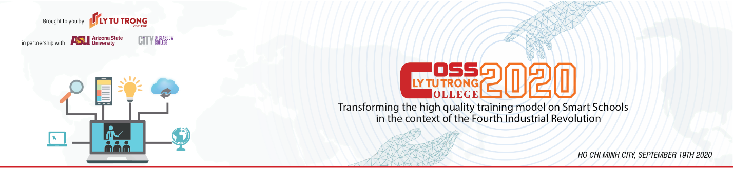
Ho Chi Minh City, September 4th 2020
Dear Mr. Nguyen Huynh Thy Khoa,

Warmest greetings from Ly Tu Trong College!
We are pleased to invite you to the 2020 Conference on Smart Schools (COSS2020), on September 19th, 2020, at the Ly Tu Trong College campus in Ho Chi Minh City, Vietnam, with the theme "Transforming high-quality training models in Smart Schools in the context of the Industrial Revolution 4.0"
Partnering with Ly Tu Trong College in organizing the conference are Arizona State University, USA, City of Glasgow College (UK), Schneider Electric Corporation (France), KONE Corporation (Finland), National Kunsan University (Korea), Chosun University (Korea), IEG Group, Sao Mai Group and other education institutions in Vietnam. The conference also will include guests of honor from the Directorate of Vocational Education and Training, Department of Labour - Invalids and Social Affairs, and the Department of Education and Training in Ho Chi Minh City.
The conference objectives are to:
Serve as a global platform of intellectual exchange to encourage scholars, academicians and researchers to present research regarding admin smart colleges in the context of the Fourth Industrial Revolution;
Update participants on trends and practices in smart schools emerging within the Fourth Industrial Revolution movement, and preparing higher education professionals to face challenges and seize opportunities in the movement;
Propose and discuss the development of quality innovations for smart schools to advance Technical and Vocational Education and Training (TVET) in Vietnam and strengthen Vietnam’s readiness to develop smart industry in the Fourth Industrial Revolution;
Provide participants, visitors, enterprises and students with the opportunity to update their knowledge of TVET smart technologies hands-on practices;
Establish networks and functional partnerships among Vietnamese and international education institutions, governmental and non-governmental organizations, business and advocacy groups for the development of smart institutions.
It is our honor to invite you as a call your paper. Your work in smart school development has left a great imprint in the education field and we would like to spotlight on your achievements. We will soon contact you to discuss this opportunity for collaboration. Should you have any questions about the event, please contact us at iro@lttc.edu.vn
Sincerely yours,

Meritorious Teacher Pham Huu Loc
Rector Ly Tu Trong College, HCMC

Appendix

This call for submission of papers and poster presentations for the COSS2020 Conference includes study findings and papers on the following sub-themes:

• High quality training model in the context of industrial revolution 4.0: current situation and solutions.
• Solutions to transform high-quality training models in Smart Schools
• Solutions for managing high-quality training activities in smart schools in the context of industrial revolution 4.0.
• Solutions to transform financial and resource management in the high-quality training model of the Smart Schools.
• Integrating development of enterprises in the model of high quality training in the context of Industrial Revolution 4.0.
• Solutions to support entrepreneurship, creative thinking in high quality training model in Smart Schools.
• Innovating teaching methods to meet the high-quality island model in the context of Industry 4.0.
• Application of Information Technology in high quality training in Smart School in the context of industrial revolution 4.0.
• Linkages and connections between enterprises, schools and students in smart schools to develop human resources for the Fourth Industrial Revolution.

The COSS2020 proceedings will be published by the National Institute for Vocational Training Education.

