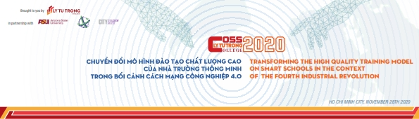

Dear ladies and gentlements, managers, scientists, teachers and students
On beside the Organizing Committee of the International conference of Smart Schools 2020, I would like to express my deepest thanks to all the distinguished guests, scientists, enterpreneurs, lecturers, and students who have cared, attended and shared valuable experiences today.
We hope that the workshop "Transforming the smart school's high-quality training model in the context of the Fourth Industrial Revolution" has gathered lessons learned from previous leaders in the field of school governance, information technology and vocational education 4.0, has provided useful information, recognizing the opportunities and challenges of school governance in the context of The Industrial Revolution 4.0 and its impact on the training of human resources so that there are leading solutions in the field of smart education to improve the quality of human resource training today for the country , meeting the requirements of society.
Industrial Revolution 4.0 has brought us, educators and scientists many challenges in school governance on the innovation of policies, advanced educational technologies and innovation governing the learning process of students, and our mission is to turn that challenge into an opportunity to further enhance learning, scientific research as well as regularly innovate and improve professional capacity and life skills in order to adapt to civilized, modern society and integrate into the community.
With 89 diverse articles, 04 reports of speakers and discussion sessions, the workshop aims to select solutions to innovate high-quality training models to build smart schools and develop the capacity of students to meet the requirements of society in the context of Industrial Revolution 4.0 and international integration, with the participation of more than 500 delegates who are experts in education and technology, scientists, representatives of the business and all teachers, students have contributed significantly to the success and effectiveness of today's conference.
We look forward to receiving more supports and participation from you in the future and on the path of building a smart school that develop our country.
On behalf of the Organizing Committee, we wish you - delegates, scientists, enterpreneurs, local and international guests, lecturers and students abundant health, happiness and success.
Thank you very much.

