UBND THÀNH PHỐ HỒ CHÍ MINH | CỘNG HÒA XÃ HỘI CHỦ NGHĨA VIỆT NAM
TRƯỜNG CAO ĐẲNG | Độc lập - Tự do - Hạnh phúc
LÝ TỰ TRỌNG TP. HỒ CHÍ MINH

ĐỀ THI KẾT THÚC HỌC PHẦN LÝ THUYẾT
HỌC KỲ: II NĂM HỌC: 2019 – 2020

Bậc đào tạo: CAO ĐẲNG (19C1)
Học phần: Tiếng Anh Kinh doanh
Lớp: 19C1-NNA1 Ngày thi: ____ / ____ / 2019
Thời gian thi: 60 phút (không kể thời gian phát đề)
Mã đề
192

-Thí sinh không được sử dụng tài liệu, nộp lại đề sau khi thi
-Bài thi này gồm 40 câu, mỗi câu 0.25 điểm.

I. There are three main types of e-commerce. Choose the correct answer for each statement.
1. If you try to get too near an American during a conversation, they will feel ………….
A. comfortable B. angry C. uncomfortable D. happy
2. One of the important sales techniques is …………
A. advertisement B. interest C. leaning to listen D. quality
3. After all these years she has decided to take early…………
A. leave B. finishing C. departure D. retirement
4. This graph shows that …………
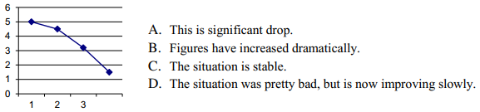
5. Which department is responsible for buying the materials the company needs to make its products.
A. Production C. IT
B. Finance D. Purchasing
6. It is ………… - the consumer buys goods or services from a company on the Internet.
A. Business to Consumer (B2C) C. Business to Business (B2B)
B. Consumer to Consumer (C2C) D. All are correct.
7. It is ………… - commerce between companies.
A. Business to Consumer (B2C) C. Business to Business (B2B)
B. Consumer to Consumer (C2C) D. All are correct.
8. Choose the correct answer which means:part of a company's capital owned by an investor.
A. profit B. award C. share D. punctual
9. ………… is one of Europe's leading electronic commerce businesses.
A. WHO B. QXL C. Amazon D. eBay
10. It is ………… - people sell and buy directly on sites such as eBay.
A. Business to Consumer (B2C) C. Business to Business (B2B)
B. Consumer to Consumer (C2C) D. All are correct.
11. Event organization and ticket sales create significant ………… , from local football matches to events like the Olympics.
A. business B. skills C. industry D. loan
12. Choose the correct answer which means:money a company earns after expenses, taxes, investment, etc.
A. loss B. profit C. award D. share
13. Which department organizes the maintenance of the buildings, including office space.
A. Human resources C. Facilities
B. Production D. Sales and Marketing.
14. The earnings per share last year was $19,980 and this year is $20,070. Which sentence can be used to compare and describe the figures?
A. It's worse than last year C. It's gone down
B. It's virtually the same D. It's slightly more than last year.
15. This supermarket is trying to …………young shoppers by offering fashionable clothes.
A. target B. persuade C. encourage D. trap
16. The project will start …………January the first 2020.
A. at B. on C. in D. about
17. Which is NOT a very usual way to say $7.90?
A. seven ninety C. seven dollars ninety
B. seven dollars ninety cents D. seven point ninety dollars.
18. ………… generates enormous profits for both sportspeople and the brand.
A. journalism B. personal trainer C. club D. sponsorship
19. This graph shows that
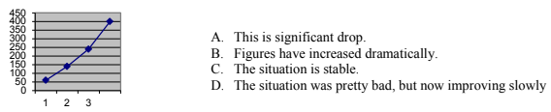
20. Do you want to ………… as a candidate in the local elections?
A. stand B. sit C. go D. try
21. We've decided to …………money in the new business. Hope it's successful!.
A. export B. import C. advertise D. invest
22. This is the time to spend at work after your normal working hours.
A. overtime B. working hours C. retirement D. flexible hours.
23. A person, company, or organization that pays someone to work for them as a member of their staff is a(n) …………
A. employer B. employee C. trainer D. trainee
24. I would be very interested in ………… for that job.
A. entering B. working C. applying D. writing
Choose the correct word or phrase that would best complete the sentence
25. Your business will make …………if your revenue for a year is less than your costs.
A. profit B. loss C. interest D. loan
26. Amazon.com is a (an) …………where people can buy a wide range of goods online.
A. website B. e-mail address C. social network D. market
27. The money you receive from selling a product or service is …………
A. interest B. capital C. profit D. revenue
28. Which department is responsible for recruiting and training new staff?
A. Distribution C. Human Resources
B. Finance D. Research and Development
II. Reading
A. Read the article and choose the correct answer
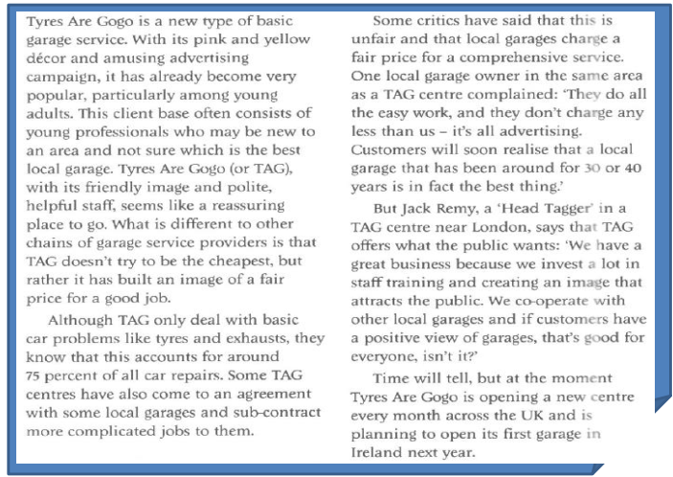

29.
A. TAG is very popular in Ireland.
B. TAG is opening twelve new UK centres each year.
C. TAG will be very successful in the future.
D. TAG will have garages in North America next year.
30.
A. TAG owns some local garages C. Local garages sub-contract work to TAG
B. TAG can send difficult work to other garages D. TAG never works with other garages.
31.
A. Most TAG customers are locals C. TAG employs young professionals
B. TAG customers often know a lot about cars D. Many TAG customers are in their twenties
32.
A. A spokesman for TAG thinks the public are wrong.
B. The boss of a central London TAG centre thinks that TAG has a good image.
C. A manager thinks that the public are wrong.
D. A supervisor says that TAG gives customers what they want.
33.
A. TAG offers good value for money C. TAG is cheaper than local garages.
B. TAG does work at a very low price D. TAG has an image problem.
34.
A. Local garages own TAG centres.
B. Local garage owners think TAG is too cheap.
C. Local garage owners like TAG's advertisement.
D. Local garage owners don’t like TAG centres near them.

B. Choose the correct word A-D below to complete the text
How should a company (35.) …………its products or services? Most big companies have an (36.) ………… budget. They advertise their brand on TV, radio, the internet or in (37.) ………… and magazines. Sales (38.) ………… such as free gifts or half price offers are often popular with customers. At conferences and exhibitons some companies put their (39.) ………… on merchandise such as T-shirts and key rings to advertise their (40.) ………… .
35. A. find B. market C. see D. explain
36. A. advertising B. creating C. idea D. publicise
37. A. telephones B. furniture C. newspapers D. colour
38. A. promotions B. meeting C. invoices D. presentation
39. A. drawing B. pens C. business D. logo
40. A. staff B. building C. brand D. competitor.

_______Hết_______

GHI CHÚ: CÁN BỘ COI THI KHÔNG ĐƯỢC GIẢI THÍCH GÌ THÊM.

TRƯỞNG KHOA TRƯỞNG BỘ MÔN GIẢNG VIÊN RA ĐỀ

